Website link : <http://yagel2.ravenmedia.co.il/>

Requirement:

1. Login using social media credentials (such as Facebook, twitter, google etc.) or create user by email. Have 2 types of users – Business Owner, basic user
2. Submit listing- create page for submitting new Items

Need to be available to any user that logged in the system with his own credentials

Or with social media credentials (such as Facebook, twitter, google etc.)

After the item has been submitted – the item will be on hold until it will be approved by website admin.

1. Item location – find an API or plugin to have all locations update from interface instead of entering it manually
2. Add the ability to add visit dates to the search (from date- to date) in order to view events in this location and dates
3. Fix the issue :

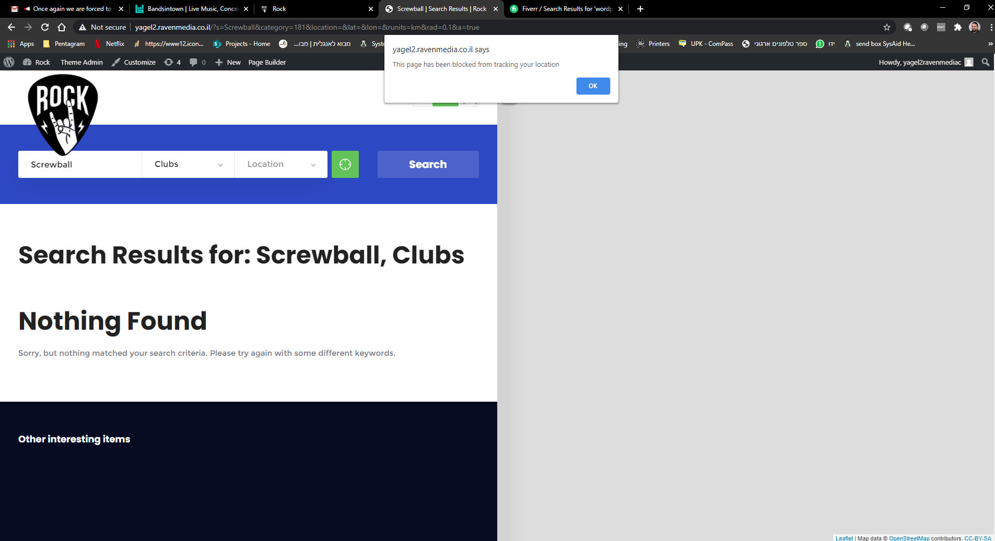

1. Have a rank of items by logged users (comments have already)
2. Create blocks for advertising –

Home page:

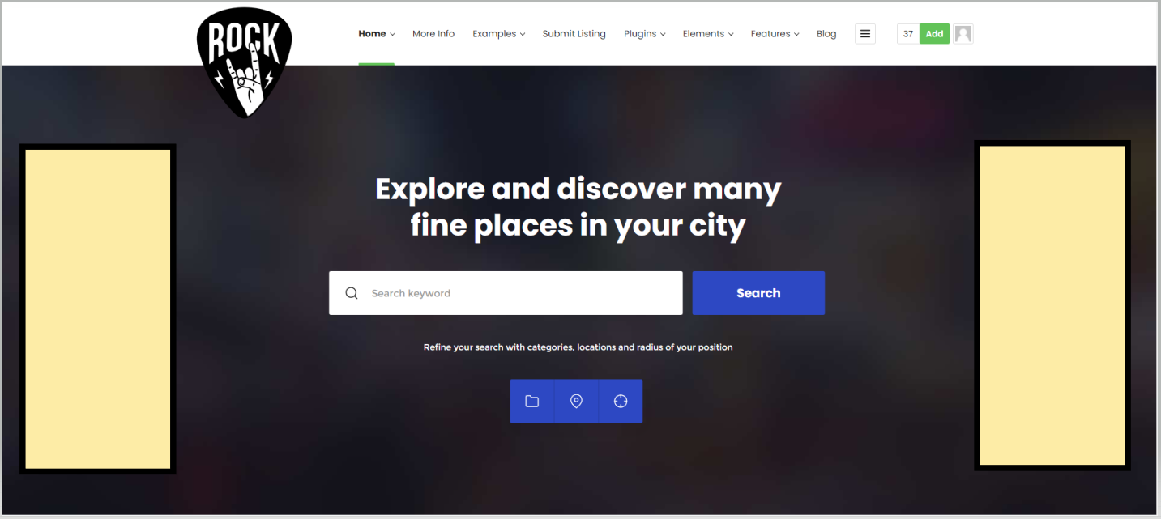

1. Find a way to add points to users for any new submitting item that approved and published