Project Details Are From Page 09

Ingress

Ingress Networking
Ingress networking in Kubernetes refers to the way external access to services within a Kubernetes cluster is managed. It provides a powerful mechanism to define rules that allow external HTTP and HTTPS traffic to reach your services. An Ingress resource defines these rules and allows for more complex routing, such as load balancing, SSL termination, and name-based virtual hosting.

Key Concepts
- Ingress Resource: A set of rules that allow inbound connections to reach the cluster services.
- Ingress Controller: A component that implements the Ingress resource, typically deployed as a pod within the cluster. It interprets the Ingress rules and routes traffic accordingly.
- Ingress Rules: Define the routing of HTTP/HTTPS traffic to various services within the cluster based on host, path, etc.
- Backend Services: Kubernetes services that Ingress resources route traffic to.

1. Start Minikube with Ingress Addon
Ensure that Minikube is started with the Ingress addon enabled.
minikube start --addons=ingress

2. Verify Ingress Controller
Check that the NGINX Ingress controller pods are running.
kubectl get pods -n kube-system | grep nginx

You should see the NGINX Ingress controller pods listed.

3. Create Sample Services and Deployments
Create sample deployments and services for demonstration.
# frontend-deployment.yaml
apiVersion: apps/v1
kind: Deployment
metadata:
name: frontend
spec:
replicas: 2
selector:
matchLabels:
app: frontend
template:
metadata:
labels:
app: frontend
spec:
containers:
- name: frontend
image: nginx
ports:
- containerPort: 80
---
apiVersion: v1
kind: Service
metadata:
name: frontend-service
spec:
selector:
app: frontend
ports:
- protocol: TCP
port: 80
targetPort: 80

# backend-deployment.yaml
apiVersion: apps/v1
kind: Deployment
metadata:
name: backend
spec:
replicas: 2
selector:
matchLabels:
app: backend
template:
metadata:
labels:
app: backend
spec:
containers:
- name: backend
image: hashicorp/http-echo
args:
- "-text=Hello from backend"
ports:
- containerPort: 5678
---
apiVersion: v1
kind: Service
metadata:
name: backend-service
spec:
selector:
app: backend
ports:
- protocol: TCP
port: 80
targetPort: 5678

Apply these YAML files to create the deployments and services.

kubectl apply -f frontend-deployment.yaml
kubectl apply -f backend-deployment.yaml

4. Create an Ingress Resource
Define an Ingress resource to route traffic to these services.

# ingress-resource.yaml
apiVersion: networking.k8s.io/v1
kind: Ingress
metadata:
name: example-ingress
spec:
rules:
- host: myapp.local
http:
paths:
- path: /frontend
pathType: Prefix
backend:
service:
name: frontend-service
port:
number: 80
- path: /backend
pathType: Prefix
backend:
service:
name: backend-service
port:
number: 80

Apply the Ingress resource.

kubectl apply -f ingress-resource.yaml

5. Update /etc/hosts
Add the hostname defined in the Ingress resource to your /etc/hosts file pointing to the Minikube IP.

sudo nano /etc/hosts

Add the following line (replace <minikube-ip> with the actual Minikube IP):

<minikube-ip> myapp.local

Get the Minikube IP using:

minikube ip

6. Access the Services
You should now be able to access the services via your browser or curl.
curl http://myapp.local/frontend
curl http://myapp.local/backend

Advanced Use Cases

1. Load Balancing with Sticky Sessions
Scenario: Distribute traffic across multiple instances of a service while maintaining session affinity.
Example:
Ingress Resource with Annotations:
apiVersion: networking.k8s.io/v1
kind: Ingress
metadata:
name: sticky-ingress
annotations:
nginx.ingress.kubernetes.io/affinity: "cookie"
nginx.ingress.kubernetes.io/session-cookie-name: "route"
spec:
rules:
- host: sticky.local
http:
paths:
- path: /
pathType: Prefix
backend:
service:
name: sticky-service
port:
number: 80

2. Path Rewriting
Scenario: Route traffic to a different path in the backend service.
Example:
Ingress Resource with Path Rewriting:
apiVersion: networking.k8s.io/v1
kind: Ingress
metadata:
name: rewrite-ingress
annotations:
nginx.ingress.kubernetes.io/rewrite-target: /
spec:
rules:
- host: rewrite.local
http:
paths:
- path: /oldpath/(.*)
pathType: Prefix
backend:
service:
name: new-service
port:
number: 80

nginx.ingress.kubernetes.io/rewrite-target: /
- Description: Replaces the path with the specified rewrite target (/). It effectively removes the matched part of the URL path.
- Example: If the original request path is /oldpath/something, it will be rewritten to /something before forwarding to the backend service.
nginx.ingress.kubernetes.io/rewrite-target: /newpath
- Description: Replaces the path with the specified rewrite target (/newpath). It substitutes the matched part of the URL path with the specified new path.
- Example: If the original request path is /oldpath/something, it will be rewritten to /newpath/something before forwarding to the backend service.
nginx.ingress.kubernetes.io/rewrite-target: /$1
- Description: Uses a capture group ($1) from the original path's regular expression match to dynamically construct the rewritten path.
- Example: If your Ingress path definition includes regex capturing groups like path: /oldpath/(.*), and rewrite-target: /$1 is specified, requests to /oldpath/something will be rewritten to /something.

Key Features of TLS:
- Encryption: TLS encrypts data to ensure that it remains private and secure during transmission. This prevents unauthorized parties from intercepting and reading the data.
- Authentication: TLS supports server-side and optional client-side authentication using digital certificates. This ensures that the parties involved in the communication are who they claim to be.
- Compatibility: TLS is widely supported and used across various applications and services, including web browsers, email clients, instant messaging, and more.

TLS Handshake Process:
TLS communication begins with a handshake process, where the client and server negotiate parameters for secure communication:
- ClientHello: The client sends a message containing the TLS version, supported cipher suites, and a random number.
- ServerHello: The server responds with its chosen TLS version, cipher suite, and a random number.
- Certificate Exchange: The server sends its digital certificate to prove its identity (if required).
- Key Exchange: The client and server agree on a shared secret key to be used for symmetric encryption during the session.
- Finished: Both parties exchange finished messages to confirm that the handshake was successful and communication can proceed securely.

Usage:
TLS is commonly used to secure HTTP connections (HTTPS), ensuring that sensitive information such as login credentials, payment details, and personal data transmitted over the internet remains confidential and integral.

Create a Secret for TLS Certificate
kubectl create secret tls tls-secret --cert=path/to/tls.crt --key=path/to/tls.key

Ingress Resource:
apiVersion: networking.k8s.io/v1
kind: Ingress
metadata:
name: example-ingress
annotations:
nginx.ingress.kubernetes.io/ssl-redirect: "true"
spec:
tls:
- hosts:
- myapp.local
secretName: my-tls-secret
rules:
- host: myapp.local
http:
paths:
- path: /frontend
pathType: Prefix
backend:
service:
name: frontend-service
port:
number: 80
- path: /backend
pathType: Prefix
backend:
service:
name: backend-service
port:
number: 80

Project Overview
Participants are required to deploy a simple static web application on a Kubernetes cluster using Minikube, set up advanced ingress networking with URL rewriting and sticky sessions, and configure horizontal pod autoscaling to manage traffic efficiently. The project will be divided into stages, with each stage focusing on specific aspects of Kubernetes ingress, URL rewriting, sticky sessions, and autoscaling.

Requirements and Deliverables

Stage 1: Setting Up the Kubernetes Cluster and Static Web App
- Set Up Minikube:
  - Ensure Minikube is installed and running on the local Ubuntu machine.
  - Verify the Kubernetes cluster is functioning correctly.
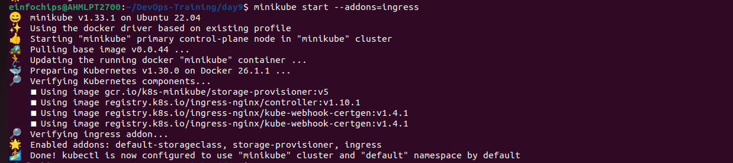
- Deploy Static Web App:
  - Create a Dockerfile for a simple static web application (e.g., an HTML page served by Nginx).
  - Build a Docker image for the static web application.
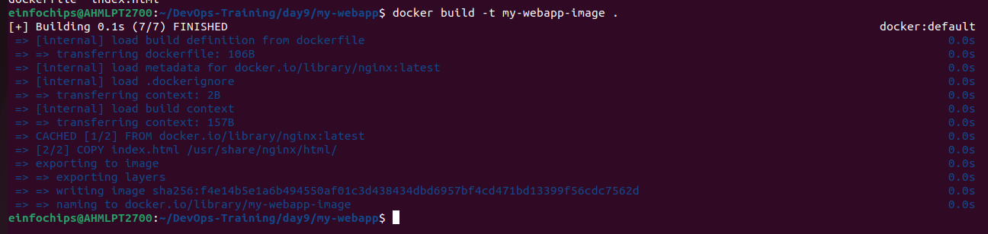
  - Push the Docker image to Docker Hub or a local registry.
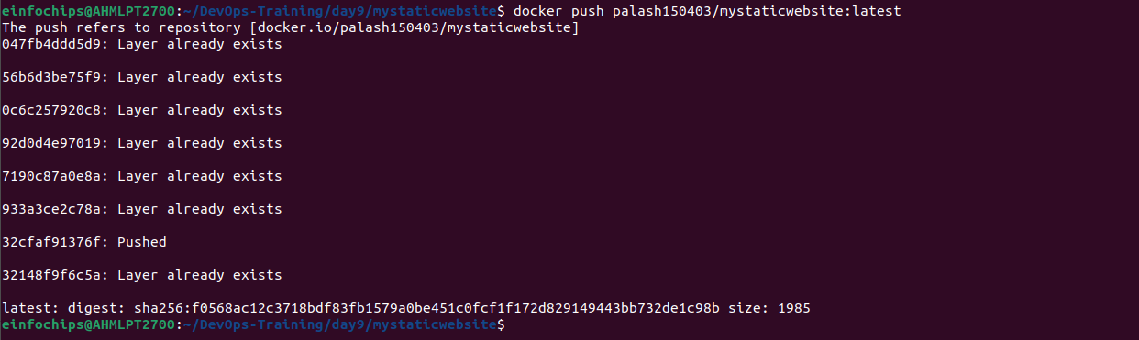
- Kubernetes Deployment:
  - Write a Kubernetes deployment manifest to deploy the static web application.
  - Wminikube service mystaticwebsite-service --url
  - 😿 service default/mystaticwebsite-service has no node port
  - ❗ Services [default/mystaticwebsite-service] have type "ClusterIP" not meant to be exposed, however for local development minikube allows you to access this !rite a Kubernetes service manifest to expose the static web application within the cluster.
  - Apply the deployment and service manifests to the Kubernetes cluster.
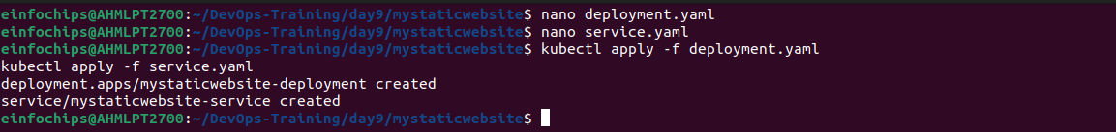
Deliverables:
- Dockerfile for the static web app
- Docker image URL
- Kubernetes deployment and service YAML files

Stage 2: Configuring Ingress Networking
- Install and Configure Ingress Controller:
  - Install an ingress controller (e.g., Nginx Ingress Controller) in the Minikube cluster.
  - Verify the ingress controller is running and accessible.
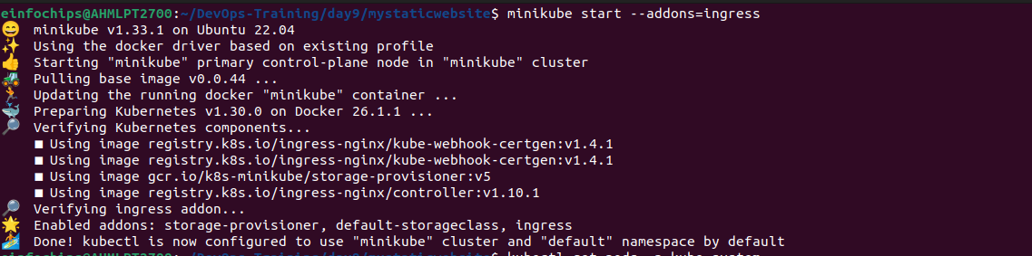
- Create Ingress Resource:
  - Write an ingress resource manifest to route external traffic to the static web application.
  - Configure advanced ingress rules for path-based routing and host-based routing (use at least two different hostnames and paths).
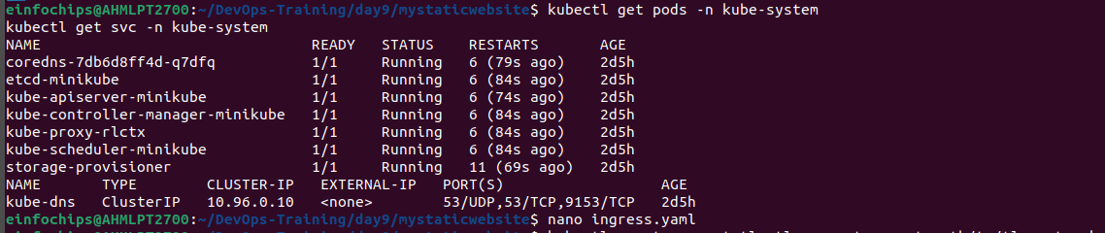
  - Implement TLS termination for secure connections.
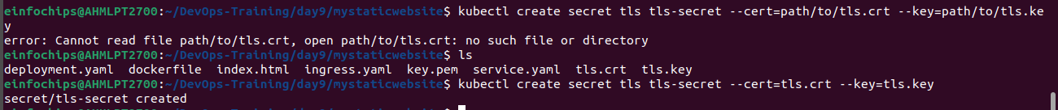
  - Configure URL rewriting in the ingress resource to modify incoming URLs before they reach the backend services.
  - Enable sticky sessions to ensure that requests from the same client are directed to the same backend pod.

Deliverables:
- Ingress controller installation commands/scripts
- Ingress resource YAML file with advanced routing, TLS configuration, URL rewriting, and sticky sessions

Stage 3: Implementing Horizontal Pod Autoscaling
- Configure Horizontal Pod Autoscaler:
  - Write a horizontal pod autoscaler (HPA) manifest to automatically scale the static web application pods based on CPU utilization.

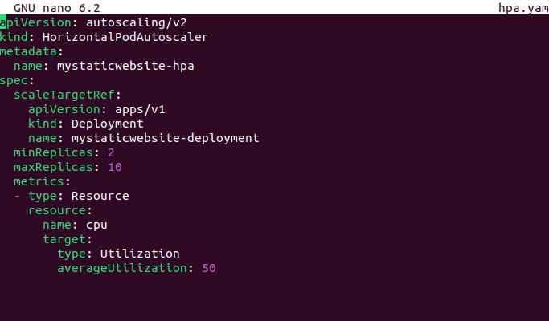
  - Set thresholds for minimum and maximum pod replicas.
- Stress Testing:
  - Perform stress testing to simulate traffic and validate the HPA configuration.
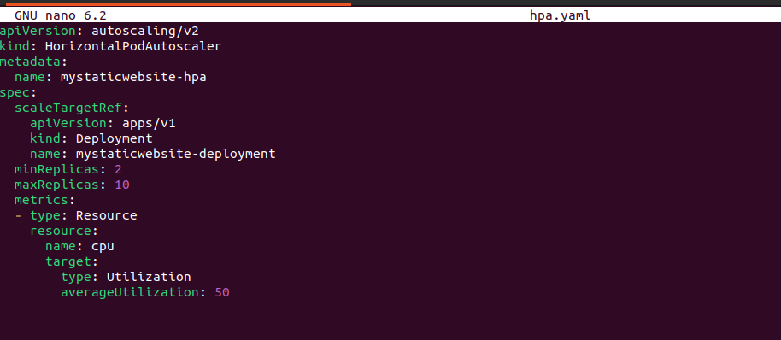
  - Monitor the scaling behavior and ensure the application scales up and down based on the load.
hey -z 5m -c 100 http://192.168.49.2/app1
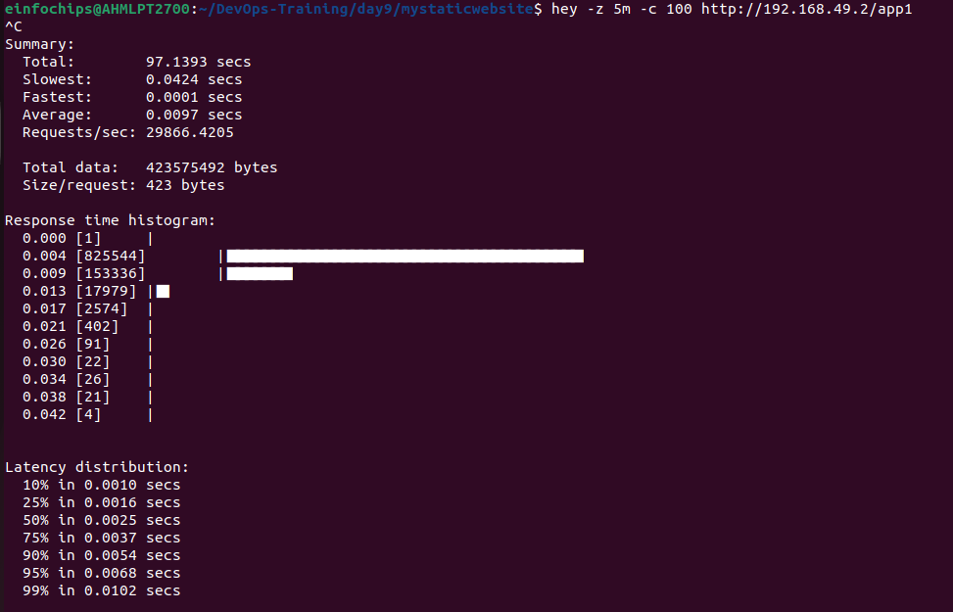
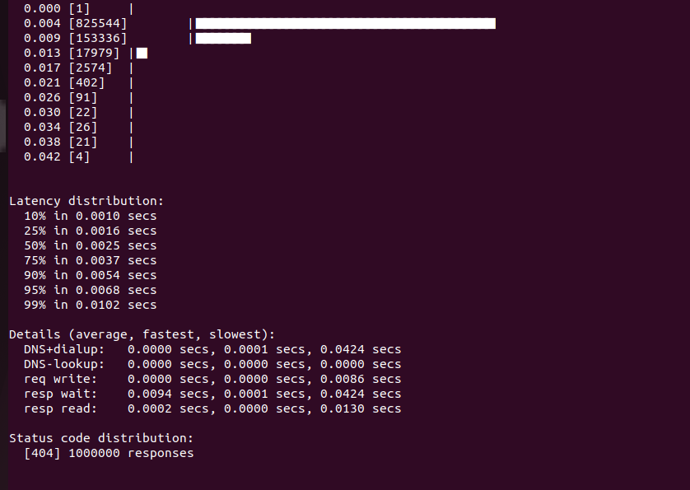

kubectl get hpa mystaticwebsite-hpa –watch
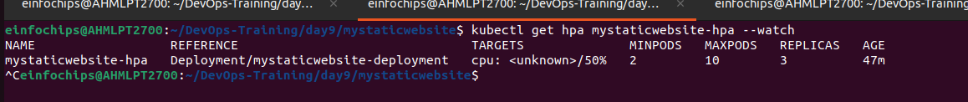
kubectl get pods -l app=mystaticwebsite -w
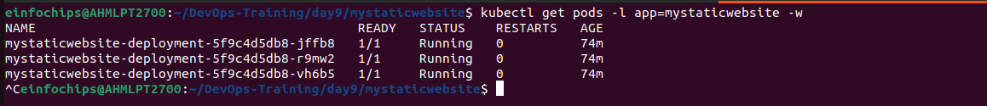
Deliverables:
- Horizontal pod autoscaler YAML file
- Documentation or screenshots of the stress testing process and scaling behavior

Stage 4: Final Validation and Cleanup
- Final Validation:
  - Validate the ingress networking, URL rewriting, and sticky sessions configurations by accessing the web application through different hostnames and paths.
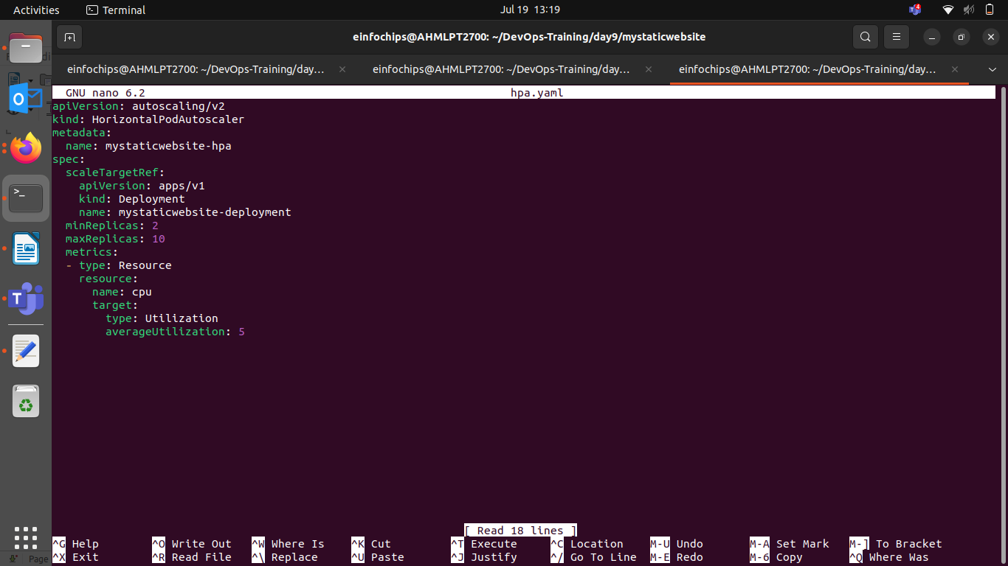
  - Verify the application's availability and performance during different load conditions.
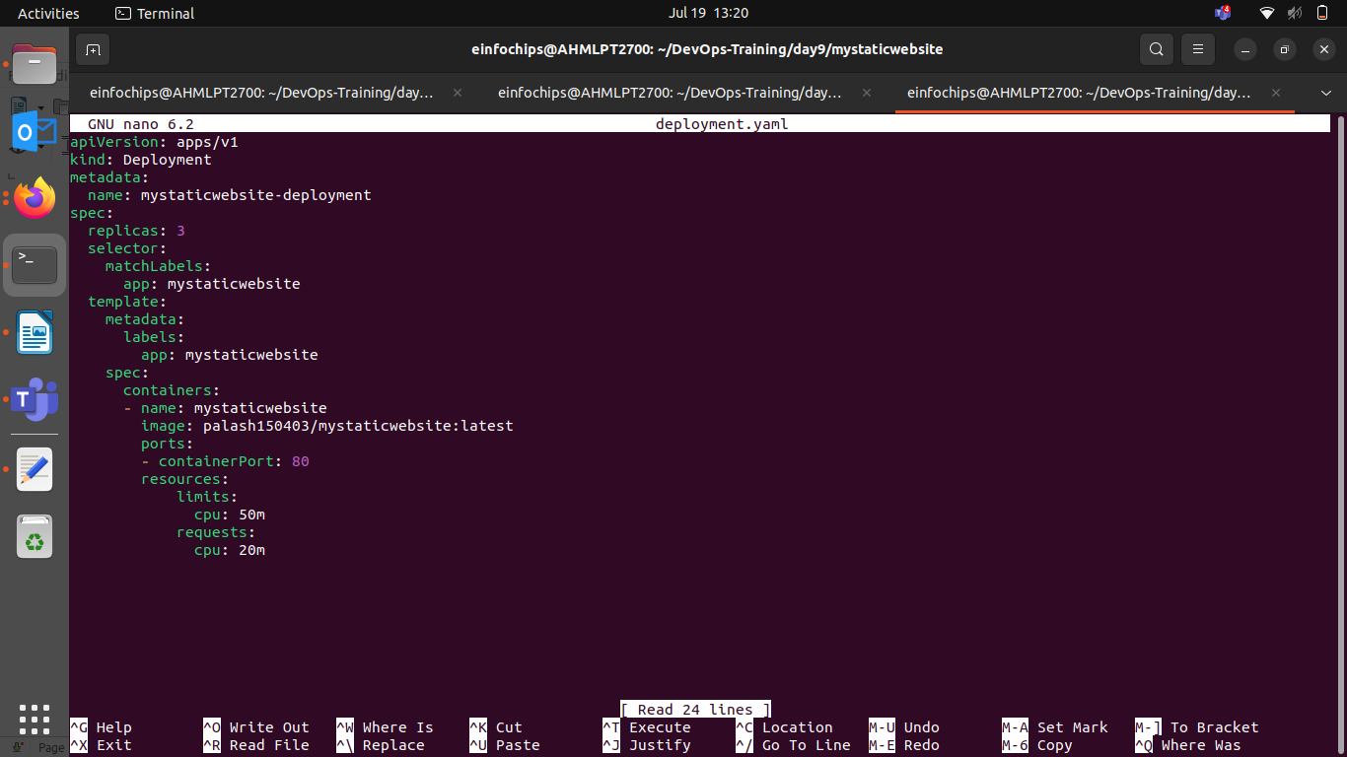
- Cleanup:
  - Provide commands or scripts to clean up the Kubernetes resources created during the project (deployments, services, ingress, HPA).

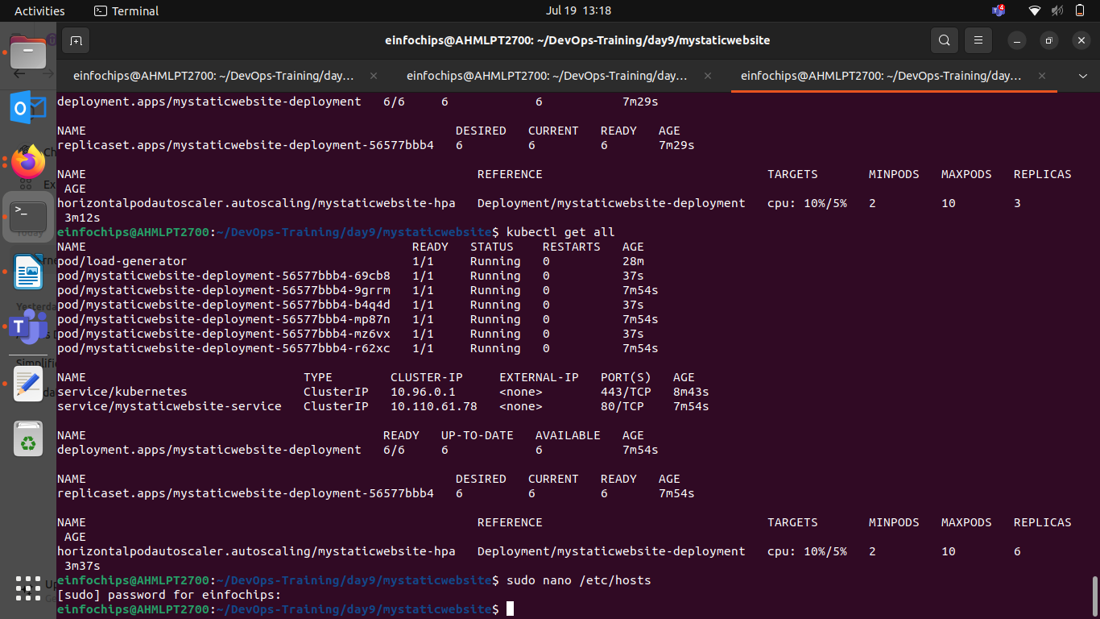
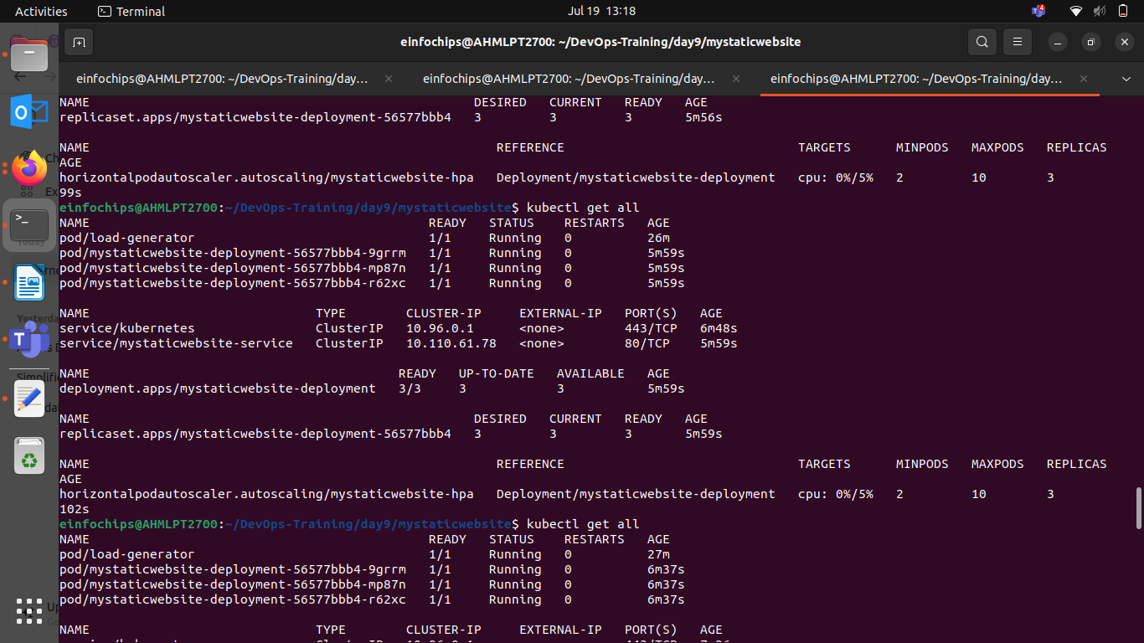
Deliverables:
- Final validation report documenting the testing process and results
- Cleanup commands/scripts
kubectl run -i --tty --rm load-generator --image=busybox --restart=Never -- /bin/sh
# Inside the pod, run the following command to generate load
while true; do wget -q -O- http://anotherexample.com/app1; done

