AMERICAN MODEL PORTAL  
WEBSITE ITEMS

HOME PAGE:  
- Remove Poll  
- Remove Newsletter  
- Create Sections on Sidebar for only “Banner Sections” -which I will place put in through dashboard: Models Wanted, Photographers Wanted, Babel models wanted. Linking capabilities needed.  
- Leave 1 space on bottom right sidebar for ADVERTISEMENT- I will change the ads from time to time and I will need linking capabilities.  
  
FOOTER:   
- Change Address to   
PO Box 39697 Phoenix, AZ 85069  
EMAIL: [admin@americanmodel.net](mailto:admin@americanmodel.net)  
No Phone

NEW MEMBERSHIP PLAN   
PAGE LAYOUT

As I mentioned recently in messages, we need to have a completely different layout done for the Membership Plans page as the one your developers did is 100% identical to our competitor’s. They are also the largest modeling site on the internet. EVERYBODY in this industry knows them. Additionally, I’ve had to hire and pay our graphic designer to do a professional layout that is suitable for our objectives in rolling out a state of the art, UNIQUE site.

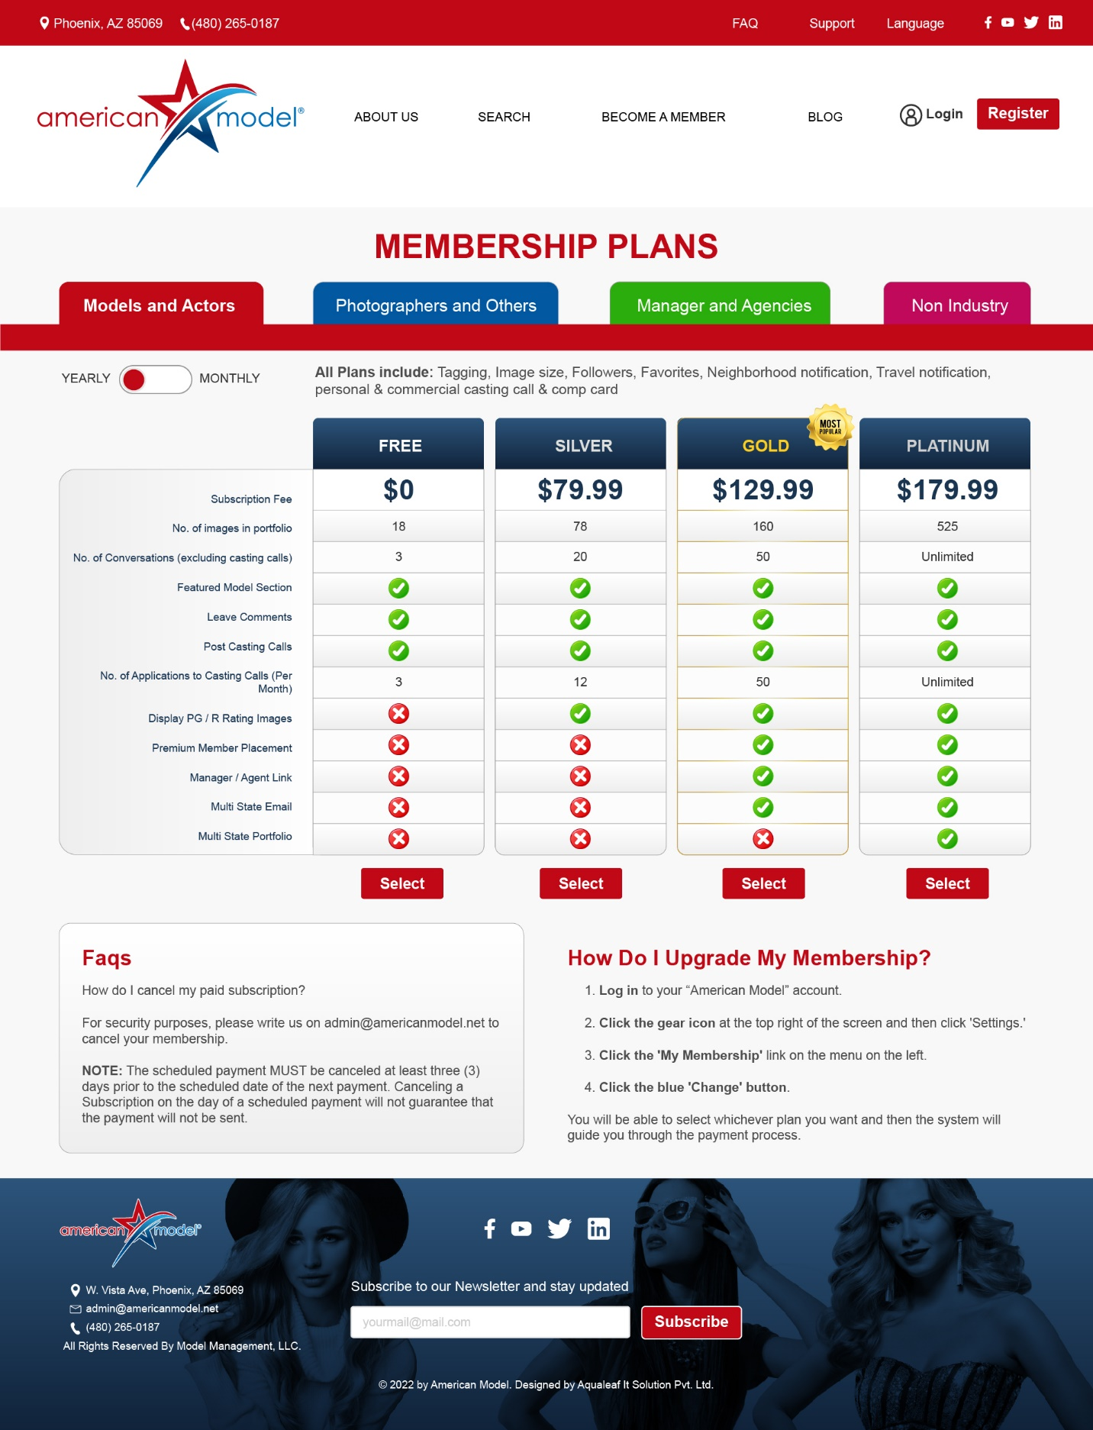

SEARCH PAGES

Please do all SEARCH PAGE layouts the same, like the MODELS Search below. Put the Search Options on left and then results on right.  
  
NOT LIKE THIS PLEASE  
  
  
But take these SEARCH CRITERIA (EXPERIENCE, LANGUAGE, AVAILABLE FOR) and use those, but again, put those on the left like all other search pages so the site is consistent

BROWSE ALL TALENT DIRECTORY

* Please add the options in a drop-down menu for:  
  Browse Models   
  Browse Photographers   
  Browse Child Models   
  Browse Makeup Artists Graphical user interface

  Description automatically generated  
    
  When they choose from the drop down for what they wish to browse for, the search results show either all photographers or MUA’s, child models in our database. Or they can browse by location (city and state for all types of talent. Again, this is just Browsing, not searching specifically, but just browsing the directory everyone that falls into a broad range. And especially while we’re new we won’t have a lot of models, photographers, etc. so browsing for all of what we have might be better starting out.

HEADER/FOOTER

* Please refer to MEMBERSHIP PLANS psd file for the official footer and header to use.

CASTING NOTICES / JOB POSTINGS

* So, I haven’t seen any mockup pages for Job postings, or forms for Posting a Job (Casting Notices)