**Business Plan of a Company: A case Study of MIGHTY Company**



Submitted to:

Dr. Md Mahbub-E-Noor

Associate Professor

Department of Computer Science and Engineering

University of Barishal

Submitted by:

Palash Mahmud Mithu

Batch: 31

Fundamentals of Computer (Office)

Date of Submission: 04/10/2024

Table of Contents

1 Executive Summary: 3

2 Products & Services: 4

2.1 Sanitary Products: 4

2.2 PVC Products 5

Upvc Door 5

Upvc Fittings 5

Upvc Pipe 5

Water Tank 5

3 Business Plan: 5

4.Month, product and area wise Sales 5

3.1 Sales Performance: 7

3.1.1 Annual Sales Growth: 7

3.1.2 Product Category Sales: 7

3.2 Cost Management: 7

3.2.1 Cost of Goods Sold (COGS): 7

3.2.2 Operational Expenses: 8

3.2.3 Research and Development (R&D) Investment: 8

3.2.4 Sustainability Initiatives: 8

3.3 Financial Highlights: 8

3.3.1 Total Revenue: 8

3.3.2 Gross Profit Margin: 8

3.3.3 Net Profit: 8

4 Conclusion: 8

**List of Table**

Figure 1: Smart Art 3

Figure 2: Picture 4

Figure 3: Flowchart 5

Figure 4: Chart 6

Figure 5: Chart 7

# Executive Summary:

Alpha Company is a premier manufacturing firm specializing in the production of high-quality Sanitary goods. Since our establishment, we have been driven by a vision to innovate and excel in the electronics sector. Through our dedication to quality, cutting-edge technology, and customer satisfaction, alpha Company has quickly risen to prominence, becoming a trusted and respected name in the industry. At Alpha Company, quality is at the core of everything we do. We believe that delivering exceptional products begins with rigorous quality control and meticulous attention to detail. Our state-of-the-art manufacturing facilities are equipped with advanced technology and operated by a highly skilled workforce. Each product undergoes stringent testing and quality assurance processes to ensure it meets the highest standards of performance and reliability. Innovation is the driving force behind Alpha Company's success. We are constantly exploring new technologies and methodologies to enhance our product offerings and stay ahead of industry trends. Our dedicated research and development team works tirelessly to develop innovative solutions that cater to the evolving needs of our customers. From the latest consumer electronics to specialized industrial components, our products embody the forefront of technological advancement.

# Products & Services:

Figure 1: Smart Art

Alpha Company boasts a diverse product portfolio that caters to a wide range of consumer and industrial needs. Our offerings include:

## Sanitary Products:

Batroom Fittings:



Figure 2: Picture

Gas Stove, Kitchen Sink, Taplon Tape, Water Pump, Personal Devices are also important part of our Alpha company.

## PVC Products

## Upvc Door

## Upvc Fittings

## Upvc Pipe

## Water Tank

# Business Plan:

Figure 3: Flowchart

# 4.Month, product and area wise Sales

Alpha Company is dedicated to maintaining transparency and providing comprehensive insights into our financial performance. Here, we present an overview of our sales and cost statistics, highlighting our financial health and operational efficiency.



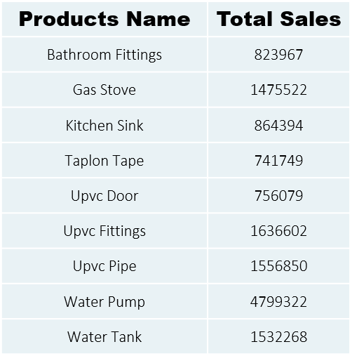

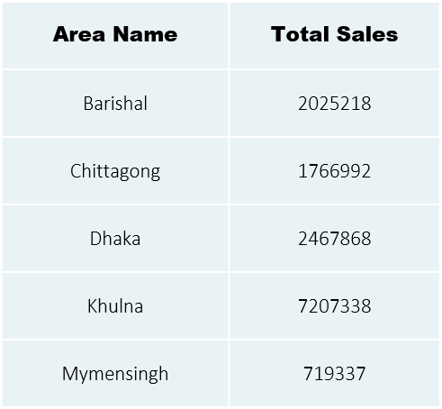

## Sales Performance:

Our sales performance reflects the strong demand for our high-quality sanitary and PVC goods. We continually strive to meet and exceed our sales targets by innovating our product offerings and expanding our market reach.

### Annual Sales Growth:

Over the past fiscal year, Alpha Company has experienced a significant increase in sales revenue, reflecting our expanding customer base and successful market penetration strategies.

### Product Category Sales:

Detailed sales statistics across various product categories, including consumer electronics, personal devices, home appliances, and industrial electronics, demonstrate balanced growth and diversification.

## Cost Management:

Effective cost management is crucial to maintaining profitability and ensuring sustainable growth. ALPHA Company is committed to optimizing our cost structure while maintaining the highest standards of quality and innovation.

### Cost of Goods Sold (COGS):

Our COGS includes the direct costs attributable to the production of our electronic goods. This includes raw materials, labor, and manufacturing overhead. We continuously seek to streamline our production processes to reduce COGS without compromising on quality.

### Operational Expenses:

These include costs associated with marketing, research and development, administration, and other operational activities. By implementing cost-control measures and improving operational efficiencies, we manage to keep these expenses in check while fostering innovation and market expansion.

### Research and Development (R&D) Investment:

A significant portion of our budget is allocated to R&D to drive innovation and stay ahead in the competitive electronics market. This investment ensures that we continue to offer cutting-edge products that meet the evolving needs of our customers.

### Sustainability Initiatives:

We also invest in sustainable practices, including energy-efficient manufacturing processes and eco-friendly product designs. These initiatives may incur additional costs, but they are essential for our long-term sustainability and corporate responsibility goals.

## Financial Highlights:

Here are some key financial metrics that provide a snapshot of El Company's financial performance:

### Total Revenue:

A clear indicator of our sales success, showing the total income generated from our product sales.

### Gross Profit Margin:

This metric reflects the efficiency of our production processes and our ability to manage production costs relative to sales revenue.

### Net Profit:

The bottom line that represents our profitability after accounting for all expenses, including COGS, operational expenses, taxes, and other costs.

# Conclusion:

That’s all about my business.