First we need to select an appropriate refrigerant.

The best way to deal with this would be to shortlist certain refrigerants commercially used (taking their environmental impacts into consideration) and then running the refrigeration cycle for each refrigerant to figure out which one gives the best results with highest efficiency. (Hit and trial method)

Modelling through Simulink should include 3 main blocks- 1. Environment subsystem

2. House Subsystem

3. Air-Condition system

The air conditioning system shall consist of further 4 blocks – i) Evaporator

ii)Compressor

iii)Condenser

iv)Throttle

Each is a steady flow device and should be modelled separately (using simscape) . Evaporator will be in contact with house subsystem while condenser will be in contact with Environment subsystem.

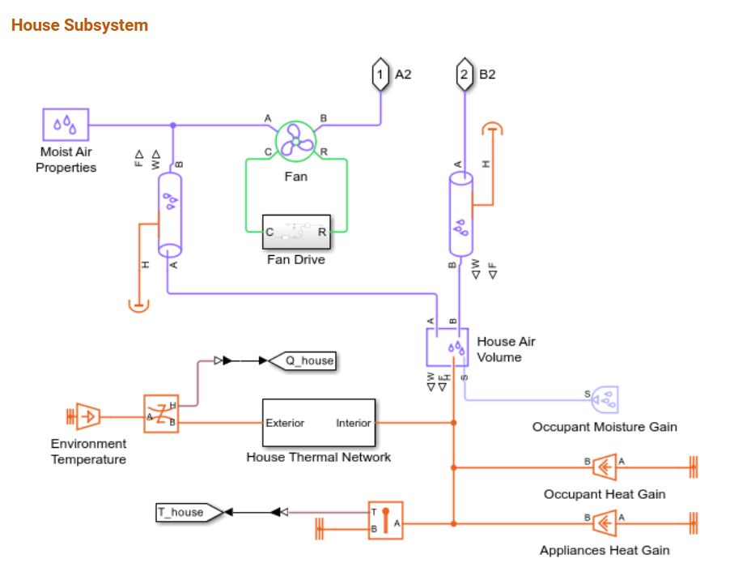

Here in the house subsystem, RPM at which fan rotates, volume of air, ambient temperature will be the inputs, and as mentioned in the PS, will be decided by the judges.

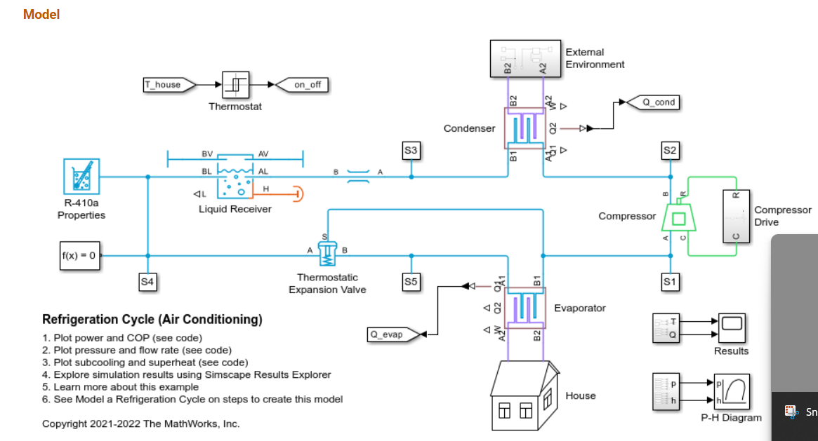

For designing compressor: <https://in.mathworks.com/help/hydro/ref/compressorg.html>