*Team: Solo – Palash A – e17cse069*

Lab01

1. Peel off rj45 using a wire stripper
2. Cut the inner supporting plastic of the wires
3. Cut the wires to ensure they have same length
4. Insert the wires all at once arranged in order to the connector
5. Crimp the connector using the crimping tool

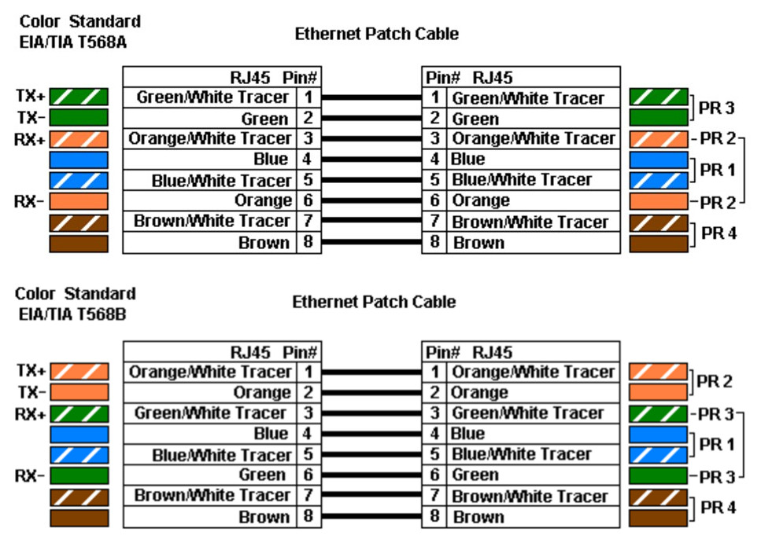

src: <http://www.fiber-optic-equipment.com/distinguish-t568a-t568b-rj45-ethernet-cable-wiring.html>