# Aim: Connect two PCs

Materials required

1. two PCs

2. one Copper cross over wire

Procedure

1. Connect the two PCs with the cross over wire

2. Set the IP of the first PC to 192.168.0.1

3. Set the IP of the second PC to 192.168.0.2

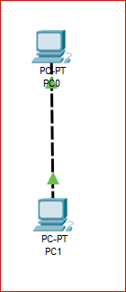

# Aim: Design network of 5 computers using hub/switch

Materials required

1. five PCs

2. one 2960 switch / one PT Hub

3. five Copper straight through wires

Procedure

1. Connect the five PCs to the switch/hub with copper straight through wires

2. Set the IP of the PCs to 192.168.0.x where x is the PC number in the network

Hub >

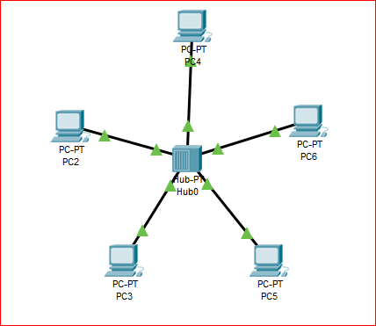

Switch >

