Aim: Implementation of different network topologies

Bus Topology

## Materials required

1. five PCs

2. five 2960 switches

3. four Copper cross-over connecting wires

4. five Copper straight-through connecting wires

## Procedure

1. Connect 5 PCs to 5 2960 switches with a copper straight-through wire each

2. Starting with the first PC, config the IPv4 address of FastEthernet0 to 192.168.0.n where n is the node number

3. Connect the 5 2960 switches with 4 copper cross-over wires

4. Send a message from a PC on the network to another to test the connection

5. The end network should look like the attached screenshot

Star Topology

## Materials required

1. five PCs

2. one 2950-24 switch

3. five copper straight-through connecting wires

## Procedure

1. Connect each PC's FastEthernet0 to a port on the switch using copper straight-through wires

2. Configure the IPv4 of the PCs to 192.154.2.n where n is the node number

3. Send a message from a PC on the network to another to test the connection

4. The end network should look like the attached screenshot

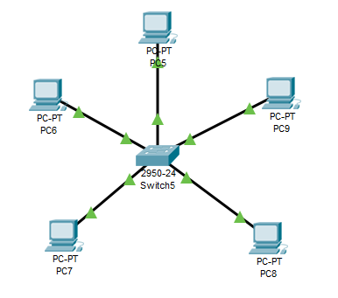

Mesh Topology

## Materials required

1. five PCs

2. five 2960 switches

3. five copper straight-through connecting wires

4. ten copper cross-over connecting wires

## Procedure

1. Connect each PCs FastEthernet0 to FastEthernet0/1 of each 2960 switch with the copper straight-through wires

2. Configure the IPv4 of each PC to 152.125.158.n where n is the node number

3. Connect each 2960 switch with one another with the copper cross-over wires

4. Send a message from a PC on the network to another to test the connection

5. The end network should look like the attached screenshot

Ring Topology

## Materials required

1. four PCs

2. four 2960 switches

3. four Copper cross-over connecting wires

4. five Copper straight-through connecting wires

## Procedure

1. Connect 4 PCs to 4 2960 switches with a copper straight-through wire each

2. Starting with the first PC, config the IPv4 address of FastEthernet0 to 192.168.2.n where n is the node number

3. Connect the 4 2960 switches with 4 copper cross-over wires, connecting each switch with the one adjacent to it

4. Send a message from a PC on the network to another to test the connection

5. The end network should look like the attached screenshot

Tree Topology

## Materials required

1. six PCs

2. five 2960 switches

3. one Server-PT

4. seven copper straight-through wires

5. four copper cross-over wires

## Procedure

1. Connect the FastEthernet0 of the server to a 2960 switch with a copper straight-through wire. This is the root of the network.

2. Configure the IPv4 of the server to 192.192.184.1

3. Connect the root switch to two other switches with two copper cross-over wires

4. Connect the right node of the root to three PCs with copper straight-through wires

5. Configure the IPv4 of the PCs to 192.192.184.n where n is the node number

6. Connect the left node of the root to two other switches with copper cross-over wires

7. Connect one of the nodes to one PC and the other to two PCs with copper straight-through wires

8. Configure the IPv4 of the PCs to 192.192.184.n where n is the node number

9. Send a message from a node on the network to another to test the connection

10. The end network should look like the attached screenshot

