# Aim: Connecting two different networks using a router

Materials required

1. ten PCs

2. two 2960 Switches

3. one 2911 Router

4. twelve Copper Straight through wires

Procedure

1. Connect five PCs to one 2960 switch with one copper wire for each connection

2. Starting with a PC at random, set its IP address to 192.168.1.1

3. Going clockwise, set the other IPs in the network by changing the last digit

4. Send and receive a message from one random PC to another in the network to test the connection

5. Connect the 2960 switch to the 2911 router with a copper wire

6. Configure the ipaddress of the router to 192.168.1.6 for the ethernet connection to the 2960 switch

7. Change the default gateway of the PCs on the network to 192.168.1.6

8. Repeat steps 1 through 7 for the other side, changing the IP address to 192.168.2.# where # is the node number in the network.

9. Send a message from one PC on the 192.168.1.# network to a random PC on the 192.186.2.# network to test the connection

10. The end network should look something like the attached screenshot(s).

***

## Screenshots

1. lab04_ipconfig.png : IP Configuration for one PC on the first network

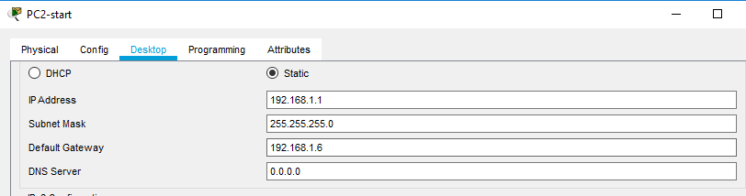

2. lab04_local.png : How the local network within the five PCs and one 2960 switch should look like

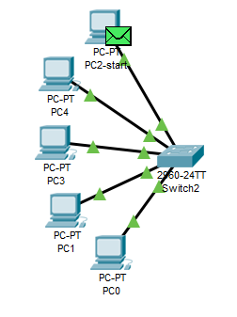

3. lab04_final.png : How the final network should look like with the two local networks connected via a router

