HINDUSTAN AERONAUTICS LIMITED
(An ISO 9001:2015 & AS9100D Certified)
AIRCRAFT DIVISION, OJHAR, NASHIK – 422207
(GOVERNMENT OF INDIA UNDERTAKING)

AI-BASED PREDICTIVE MAINTENANCE SYSTEM
FOR AIRCRAFT TURBOFAN ENGINE
REMAINING USEFUL LIFE PREDICTION
USING MACHINE LEARNING

Project Report
Submitted by
PREKSHA TUSHAR PETHAKAR
Fr. C. Rodrigues Institute of Technology (FCRIT)
Vashi, Navi Mumbai

Internship Organization
Hindustan Aeronautics Limited (HAL)
Aircraft Division
Ojhar, Nashik

Duration
15 June 2026 – 15 July 2026

Under the Supervision Under the Guidance of

CERTIFICATE
This is to certify that Ms. Preksha Tushar Pethakar, a Third Year student of Bachelor of Technology in Computer Engineering at Fr. C. Rodrigues Institute of Technology (FCRIT), Vashi, has successfully completed the project entitled:
"AI-Based Predictive Maintenance System for Aircraft Turbofan Engine Remaining Useful Life Prediction Using Machine Learning"
during her internship at Hindustan Aeronautics Limited (HAL), Aircraft Division, Ojhar, Nashik.
The objective of this project was to design and develop an Artificial Intelligence based predictive maintenance framework capable of estimating the Remaining Useful Life (RUL) of aircraft turbofan engines using the NASA Commercial Modular Aero-Propulsion System Simulation (C-MAPSS) benchmark dataset.
The work involved comprehensive data preprocessing, exploratory data analysis, feature engineering, implementation of multiple machine learning regression algorithms, comparative performance evaluation using standard regression metrics, and deployment of an interactive Streamlit-based dashboard for predictive maintenance analysis.
The project was carried out under proper guidance and supervision. To the best of our knowledge, the work presented in this report is original and intended solely for academic and educational purposes. No confidential, proprietary, or classified information belonging to Hindustan Aeronautics Limited has been disclosed in this report.
Place : Nashik
Date : ___________
Industrial Guide
(Signature)
Faculty Guide
(Signature)

ACKNOWLEDGEMENT
I would like to express my sincere gratitude to Hindustan Aeronautics Limited (HAL), Aircraft Division, Ojhar, Nashik, for providing me with the opportunity to undertake this project and gain valuable exposure to the practical application of Artificial Intelligence in the field of predictive maintenance for aerospace systems.
I am deeply thankful to my industrial mentor for their valuable guidance, continuous encouragement, and technical suggestions throughout the project. Their support helped me understand the challenges involved in developing intelligent maintenance systems for aircraft engines and applying machine learning techniques to solve real-world engineering problems.
I also extend my heartfelt gratitude to the faculty members of the Department of Computer Engineering, Fr. C. Rodrigues Institute of Technology, for their continuous encouragement and academic guidance throughout the duration of this project.
This project provided an excellent opportunity to strengthen my knowledge in data preprocessing, exploratory data analysis, feature engineering, machine learning model development, Remaining Useful Life prediction, regression model evaluation, and dashboard development using Streamlit. It also enhanced my understanding of how Artificial Intelligence can contribute to improving aircraft reliability, maintenance planning, and operational safety.
Finally, I would like to thank my parents, family members, and friends for their constant motivation, encouragement, and support throughout the successful completion of this project.

ABSTRACT
(300 words)
This project presents the design and implementation of an Artificial Intelligence-based Predictive Maintenance System for estimating the Remaining Useful Life (RUL) of aircraft turbofan engines using the NASA Commercial Modular Aero-Propulsion System Simulation (C-MAPSS) benchmark dataset. The objective of the project is to develop a data-driven maintenance framework capable of predicting engine degradation before failure, thereby supporting timely maintenance decisions and improving aircraft reliability.
The proposed methodology includes data preprocessing, exploratory data analysis, feature engineering, and machine learning-based regression modelling. Several regression algorithms, namely Linear Regression, Decision Tree Regression, Random Forest Regression, Support Vector Regression (SVR), and Extreme Gradient Boosting (XGBoost), are studied and comparatively evaluated using Root Mean Square Error (RMSE), Mean Absolute Error (MAE), Coefficient of Determination (R² Score), and NASA Scoring Function. The comparative analysis enables the identification of the most suitable regression model for Remaining Useful Life prediction.
To improve the practical interpretation of the NASA C-MAPSS dataset, representative engineering proxies are discussed for selected anonymous sensor channels, illustrating how similar measurements could be utilized within real aircraft engine health monitoring systems. These mappings are conceptual and intended solely for demonstrating potential deployment scenarios.
An interactive Streamlit dashboard was developed to visualize engine degradation trends, compare model performance, estimate Remaining Useful Life, and generate maintenance recommendations. The developed system demonstrates the potential of Artificial Intelligence in predictive maintenance by enabling condition-based maintenance strategies that can reduce operational costs, minimize unexpected failures, and improve aircraft availability and safety.
Overall, the project demonstrates the practical application of machine learning techniques for aerospace predictive maintenance while providing a scalable framework that can be extended to real-world aircraft health monitoring systems.

Keywords
Artificial Intelligence (AI), Machine Learning (ML), Predictive Maintenance, Remaining Useful Life (RUL), Aircraft Engine Health Monitoring, NASA C-MAPSS Dataset, Prognostics and Health Management (PHM), Regression Analysis, XGBoost, Random Forest, Support Vector Regression (SVR), Feature Engineering, Streamlit Dashboard, Aerospace Analytics, Condition-Based Maintenance (CBM).

TABLE OF CONTENTS
Chapter No. | Title | Page No.
Certificate |  | i
Acknowledgement |  | ii
Abstract |  | iii
Keywords |  | iii
Table of Contents |  | iv
List of Figures |  | v
List of Tables |  | vi
List of Abbreviations |  | vii
Chapter 1 | Introduction | 1
1.1 | Background
1.2 | Aircraft Engine Health Monitoring
1.3 | Artificial Intelligence in Aerospace
1.4 | Maintenance Strategies
1.4.1 | Reactive Maintenance
1.4.2 | Preventive Maintenance
1.4.3 | Condition-Based Maintenance
1.4.4 | Predictive Maintenance
1.5 | Problem Statement
1.6 | Objectives
1.7 | Scope of the Project
1.8 | Project Contributions
1.9 | Organization of the Report
1.10 | Chapter Summary
Chapter 2 | Literature Survey
2.1 | Introduction
2.2 | Evolution of Predictive Maintenance
2.3 | NASA C-MAPSS Dataset
2.4 | Review of Existing Research
2.5 | Machine Learning Algorithms for RUL Prediction
2.5.1 | Linear Regression
2.5.2 | Decision Tree Regression
2.5.3 | Random Forest Regression
2.5.4 | Support Vector Regression (SVR)
2.5.5 | XGBoost Regression
2.5.6 | Artificial Neural Networks
2.5.7 | Long Short-Term Memory (LSTM)
2.5.8 | Transformer-Based Models
2.6 | Comparative Analysis of Existing Work
2.7 | Research Gap
2.8 | Chapter Summary
Chapter 3 | Dataset Analysis and Methodology
3.1 | NASA C-MAPSS Dataset Overview
3.2 | Dataset Structure
3.3 | FD001 Subset Description
3.4 | Operational Settings
3.5 | Sensor Measurements
3.6 | Remaining Useful Life (RUL)
3.7 | Representative Engineering Proxies
3.8 | Data Preprocessing
3.9 | Exploratory Data Analysis
3.10 | Feature Engineering
3.11 | Machine Learning Pipeline
3.12 | Chapter Summary
Chapter 4 | System Implementation
4.1 | System Architecture
4.2 | Software and Hardware Requirements
4.3 | Project Folder Structure
4.4 | Machine Learning Models
4.5 | Model Training
4.6 | Model Evaluation Metrics
4.7 | Streamlit Dashboard
4.8 | Chapter Summary
Chapter 5 | Results and Discussion
5.1 | Experimental Setup
5.2 | Model Performance Comparison
5.3 | Evaluation Metrics Analysis
5.4 | Feature Importance Analysis
5.5 | Dashboard Results
5.6 | Discussion
5.7 | Chapter Summary
Chapter 6 | Conclusion and Future Scope
6.1 | Conclusion
6.2 | Industrial Applications
6.3 | Challenges Faced
6.4 | Future Scope
References
Appendix

LIST OF FIGURES
(Leave the page numbers blank for now.)
Figure No. | Title | Page No.
Figure 1.1 | Evolution of Aircraft Maintenance Strategies
Figure 1.2 | AI Applications in Aerospace
Figure 2.1 | Timeline of Predictive Maintenance Research
Figure 2.2 | Comparison of Machine Learning Algorithms
Figure 3.1 | NASA C-MAPSS Dataset Structure
Figure 3.2 | Data Preprocessing Workflow
Figure 3.3 | Overall Machine Learning Pipeline
Figure 3.4 | Feature Engineering Process
Figure 4.1 | System Architecture
Figure 4.2 | Training Pipeline
Figure 4.3 | Streamlit Dashboard Architecture
Figure 5.1 | Correlation Heatmap
Figure 5.2 | RUL Distribution
Figure 5.3 | Model Comparison
Figure 5.4 | Feature Importance
Figure 5.5 | Dashboard Screenshots

LIST OF TABLES
Table No. | Title | Page No.
Table 2.1 | Literature Survey Comparison
Table 2.2 | Machine Learning Algorithm Comparison
Table 3.1 | NASA C-MAPSS Dataset Description
Table 3.2 | Representative Engineering Proxies
Table 3.3 | Selected Features
Table 4.1 | Software Requirements
Table 4.2 | Hardware Requirements
Table 4.3 | Hyperparameter Configuration
Table 5.1 | Model Performance Comparison
Table 5.2 | Evaluation Metrics
Table 5.3 | Prediction Results

LIST OF ABBREVIATIONS
Abbreviation | Description
AI | Artificial Intelligence
ML | Machine Learning
PHM | Prognostics and Health Management
RUL | Remaining Useful Life
NASA | National Aeronautics and Space Administration
C-MAPSS | Commercial Modular Aero-Propulsion System Simulation
HAL | Hindustan Aeronautics Limited
SVR | Support Vector Regression
RF | Random Forest
XGB | Extreme Gradient Boosting
RMSE | Root Mean Square Error
MAE | Mean Absolute Error
R² | Coefficient of Determination
EMA | Exponential Moving Average
EDA | Exploratory Data Analysis
KPI | Key Performance Indicator
GUI | Graphical User Interface
API | Application Programming Interface
CBM | Condition-Based Maintenance
PdM | Predictive Maintenance
DT | Decision Tree
LR | Linear Regression
PHM | Prognostics and Health Management
FD001 | Fault Dataset 001
IoT | Internet of Things
SHAP | SHapley Additive exPlanations
CSV | Comma-Separated Values

CHAPTER 1
INTRODUCTION
1.1 Introduction

1.2 Aircraft Engine Health Monitoring

1.3 Artificial Intelligence in Aerospace

1.4 Maintenance Strategies

1.4.1 Reactive Maintenance

1.4.2 Preventive Maintenance

1.4.3 Condition-Based Maintenance

1.4.4 Predictive Maintenance

1.5 Problem Statement

1.6 Objectives

1.7 Scope of the Project

1.8 Project Contributions

1.9 Organization of the Report

1.10 Chapter Summary

  - Introduction

Content
Artificial Intelligence (AI) has emerged as one of the most transformative technologies across engineering disciplines, enabling intelligent decision-making through data-driven analysis and predictive modelling. In the aerospace industry, where aircraft systems operate under extreme environmental and mechanical conditions, ensuring the reliability and safety of critical components is of paramount importance. Aircraft engines are subjected to continuous thermal, mechanical, and operational stresses throughout their service life, making timely maintenance essential for preventing unexpected failures and maintaining operational readiness.

Traditional maintenance practices primarily rely on fixed maintenance schedules or corrective actions after component failure. Although these approaches have been widely adopted, they often result in unnecessary maintenance activities, increased operational costs, unexpected downtime, and reduced aircraft availability. The rapid advancement of machine learning and data analytics has facilitated the transition toward predictive maintenance, where the health of an engine can be continuously assessed using historical operational data to estimate its Remaining Useful Life (RUL). Such an approach enables maintenance to be performed only when necessary, thereby improving maintenance efficiency while enhancing aircraft safety and reliability.

This project presents the design and development of an AI-Based Predictive Maintenance System for aircraft turbofan engines using the NASA Commercial Modular Aero-Propulsion System Simulation (C-MAPSS) benchmark dataset. The proposed system applies machine learning techniques to analyse engine degradation patterns and predict the Remaining Useful Life of individual engines. The project incorporates data preprocessing, exploratory data analysis, feature engineering, regression-based machine learning models, comparative performance evaluation, and the development of an interactive Streamlit dashboard for visualization and maintenance decision support.
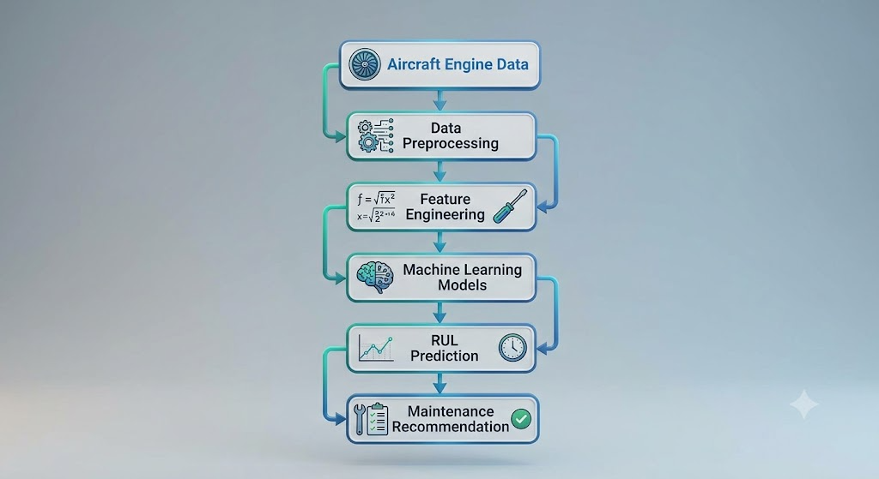

Figure 1.1 AI-Based Predictive Maintenance Workflow for Aircraft Engines

Multiple regression algorithms, including Linear Regression, Decision Tree Regression, Random Forest Regression, Support Vector Regression (SVR), and Extreme Gradient Boosting (XGBoost), are implemented and evaluated using widely accepted regression performance metrics such as Root Mean Square Error (RMSE), Mean Absolute Error (MAE), Coefficient of Determination (R² Score), and the NASA Scoring Function. Comparative analysis of these algorithms assists in identifying the most suitable predictive model for Remaining Useful Life estimation.
The developed system demonstrates how Artificial Intelligence can support modern aircraft maintenance by transforming raw operational data into meaningful maintenance insights. Although the NASA C-MAPSS dataset consists of simulated engine degradation data, the methodology adopted in this project closely reflects the workflow employed in real-world Prognostics and Health Management (PHM) systems. Consequently, the proposed framework provides a scalable foundation that can be extended to practical aircraft health monitoring applications using real Flight Data Recorder (FDR) or sensor data.
1.2 Aircraft Engine Health Monitoring

