Namaha VFX Studios values and protects your privacy. This Privacy Policy quoted relevant to our website at www.namahavfxstudios.com, and any of our content and services (collectively, the "Service").

This Privacy Policy elaborates on using any confidential information we collect about

you when you use the Services and **outlines the** **acceptable use of your information to prevent privacy disputes and infringement** **accusations.**

**Consent:**

**Your access to our website specifies that you grant our terms of use and privacy policy.**

**INFORMATION** **WE USE:**

**The information you provide shall** **be recorded, and we ensure to inform that you refer to the "user" as** **and when required to know the purpose behind the collective information.**

**Namaha VFX Studios shall receive** **additional information about you when you contact us directly, including the** **name, address, and phone number. You shall own the rights to choose the** **information you may provide in the form of a document or an attachment.**

**When you register your** **information in the inquiry, we may ask for your contact information in the** **following entities: name, company name, address, email address, and contact** **number.**

**How** **we use your information:-**

"Namaha VFX will make use of the information for the following attributions:-

-Provide, operate and maintain our website

-Improve, personalize, and upgrade our website

-Understand and analyze the user's actions on our page.

-Develop advanced products, services, features, and functionality

-Communicate with you, either directly or through one of our partners, including

for customer service, to provide you with updates and other information

relating to the website, and for marketing and promotional purposes

-Send you emails

-Observe and find if there are any security breaches encountered on our site.

**How** **we protect your information:**

Namaha VFX Studios takes prior measures in protecting the information that we collect from the user. We do not take control of your actions when you leave our site. Our website servers are built with security updating features, and we will perform security updating frequently to prevent further malicious activities and malware.

You are requested to check the privacy policy periodically to verify the update of

the terms in our privacy policy.

**Job listings:**

Our website contains an application feature enabling the candidates to learn about the job vacancy alerts. We may collect the following details from enrolling the candidates' information in our portal such as:

Name

Mail

Address

Candidates

Profile

Contact number

Namaha VFX Studios works with clients globally for projects, and our clients reserve all the rights to access the information we collect. We ensure that "Namaha VFX" does not contain any personal details of our clients or discloses any of your data. You may not attempt to modify the content in the website, such as the description of the product or services, as our website service provider maintains it.

**Log Files:**

We assure you that "Namaha VFX follows a static method for log files. These files consist of the information of our website visitors. The log file holds information about the internet protocol (IP) addresses, browser type, Internet Service Provider (ISP), date and time stamp, referring/exit pages, and the clicks range. We promptly analyze our records, and it does not contain any personally identifiable information. The data aims to analyze trends, administer the site, track users' movement on the website, and gather demographic information.

**Cookies:**

[www.namahavfxstudios.com](http://www.namahavfxstudios.com) Privacy policy does not apply to other advertisers or websites. Thus, we encourage you to consult the respective policy practices and instructions about opt-out of specific options. Namaha VFX collects your cookies related information for analyzing the users' requirements and track user activity in our browser to improve the performance of our website. Our browsing page details information on how we make use of the cookies that we collect for your better understanding.

**LINKS TO OTHER WEBSITES:**

Our website is not hyperlinked to any other website. Namaha VFX Studios are not responsible for webcasting or any other form of transmission received from any

hyperlinked website. Hyper-links are to be accessed at your own risk, and

information contained therein is relied upon at your own risk. Namaha VFX

Studios make no representations or warranties about the content, completeness,

or accuracy of any other hyperlinks or the websites that are hyperlinked to this

website or the information regarding or relating to their products and services.

**RIGHTS- UNDER PROTECTION: -**

We recommend that you be aware of your data protection rights. You own all the

rights to the following:-

**Right to the access**-The user can request copies of your data that we

store and protect. We endeavour to provide the information, and some charges

may incur for this Service rendered by us.

**Right to rectification-**You shall send us a request that we correct any information you believe is inaccurate along with that to complete the information you think is incomplete.

**Right to erasure-** Namaha VFX is liable to erase your data concerning your request made under certain conditions.

**Right to restrict processing: -** You shall request the other party in order to hold or restrict the processing of your personal data.

**Right to object to processing:-** You have all the right to express your objection to our processing of your data.

**Right of data portability:-**Namaha VFX is subjected to transfer the data that we have stored to you directly based upon the requestor when it is required to do so.

**PROPRIETARY RIGHTS TO CONTENT:**

The content published on the website, including but not limited to text, software,

music, sound, photographs, video, graphics, or other material contained in the

the site is presented to you by the ("Content") by Namaha VFX Studios. Copyrights, trademarks, service marks, patents, or other proprietary rights and laws protect it.

You hereby agree that you may not copy, reproduce, distribute or create derivative

works from the materials contained on our site. If any such conflicts arise,

Namaha VFX shall take charge of any such disciplinary actions and escalate

legal binding fully permitted the law to resolve the dispute among the parties.

**Request for modification:**

You are allowed to send us any request if you prefer changing any of the terms involved with our policy.

You may contact us through the mail, we would make sure to analyze and amend the

changes if it complies with our procedures.

**CONTACT US-**

For any enquires or to report an issue related to data security:-

Contact us at:

By email:

By postal mail:

Company address

**PLAGIARISM REPORT:**

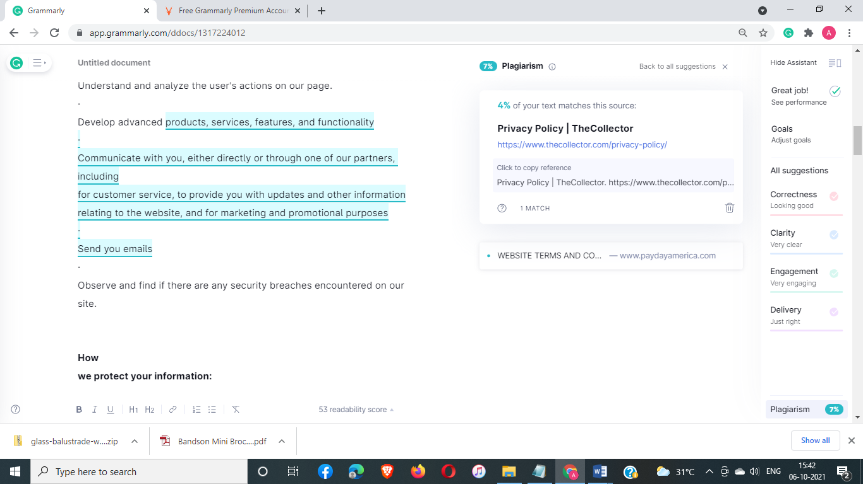

Plagiarism ratio is : 7%