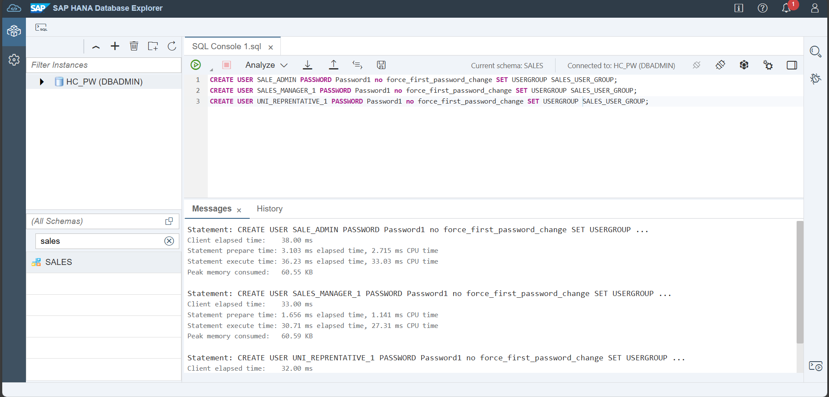
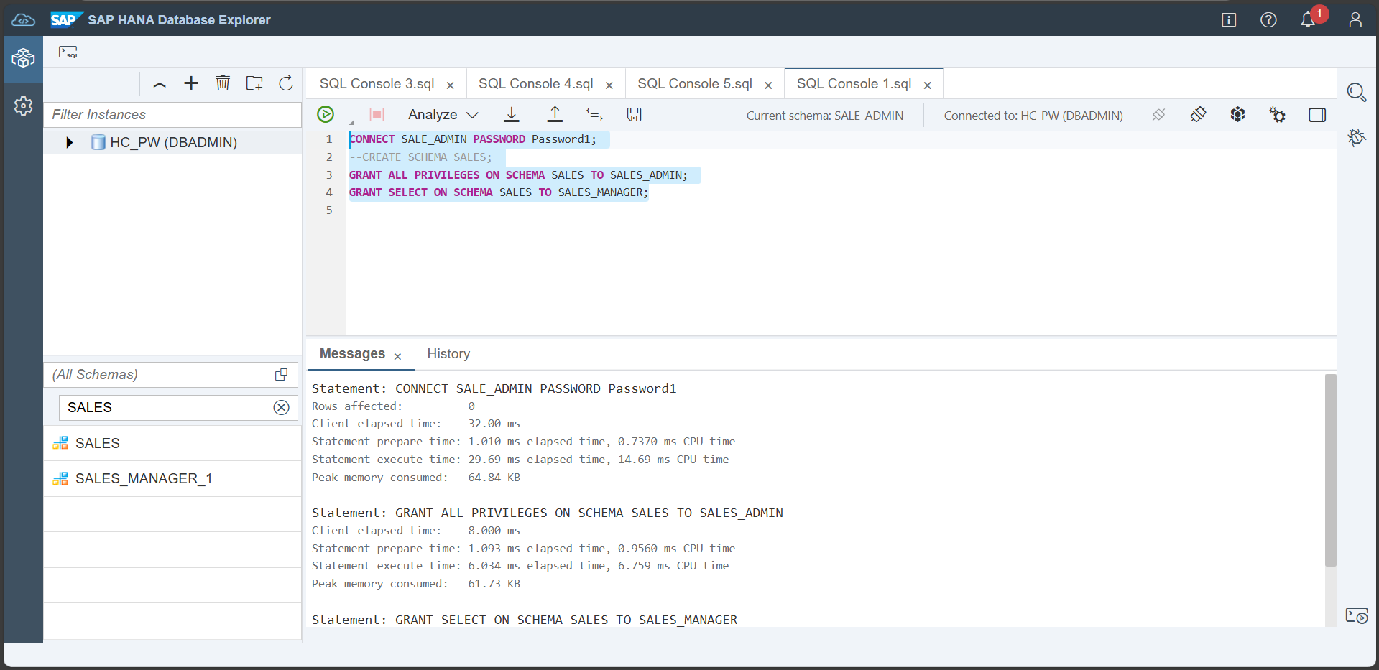
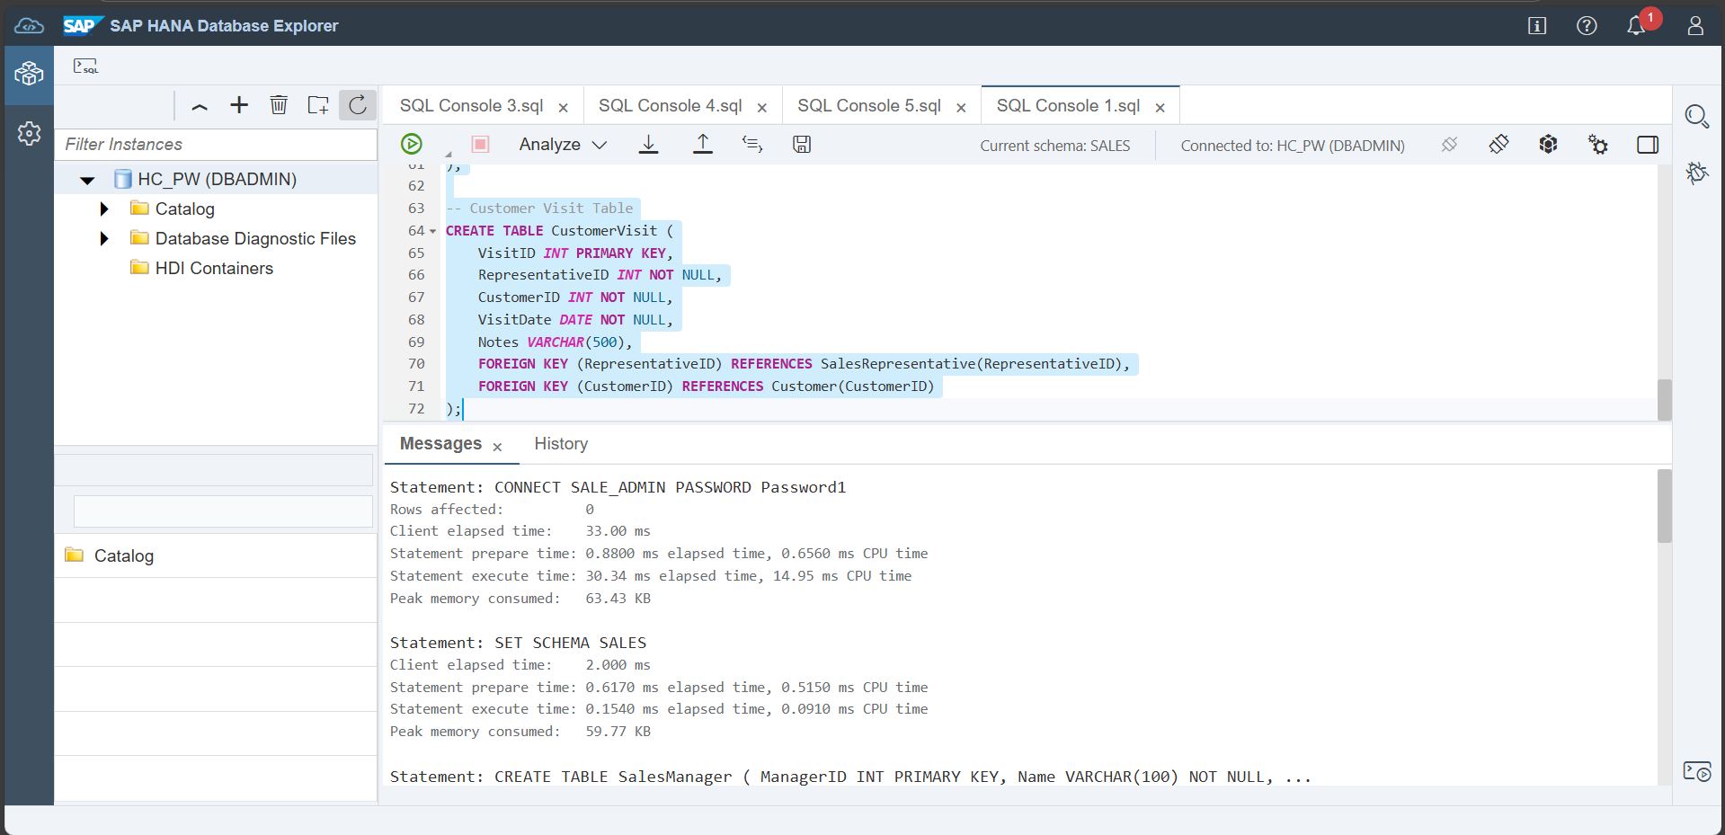
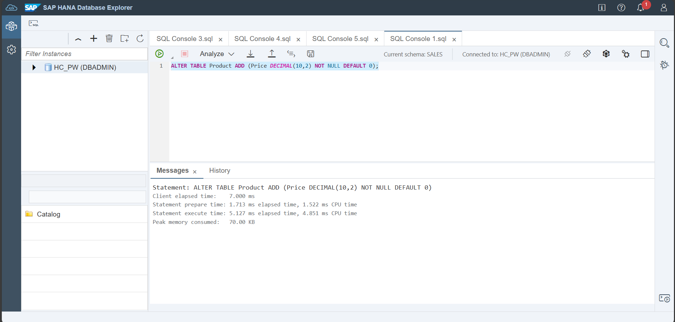

- Create role:
--Orignal
CREATE ROLE HOTEL_ADMIN;
CREATE ROLE HOTEL_READER;
--Assignment
CREATE ROLE SALES_ADMIN;
CREATE ROLE SALES_MANAGER;
CREATE ROLE SALES_REPRESENTATIVE;

- User Group:
--Orignal
CREATE USERGROUP HOTEL_USER_GROUP SET PARAMETER 'minimal_password_length' = '8', 'force_first_password_change' = 'FALSE';
--Assignment
CREATE USERGROUP SALES_USER_GROUP SET PARAMETER 'minimal_password_length' = '8', 'force_first_password_change' = 'FALSE';

- Create User:
--Orignal
CREATE USER USER1 PASSWORD Password1 no force_first_password_change SET USERGROUP HOTEL_USER_GROUP;
CREATE USER USER2 PASSWORD Password2 no force_first_password_change SET USERGROUP HOTEL_USER_GROUP;
--Assignment
CREATE USER SALE_ADMIN PASSWORD Password1 no force_first_password_change SET USERGROUP SALES_USER_GROUP;
CREATE USER SALES_MANAGER_1 PASSWORD Password1 no force_first_password_change SET USERGROUP SALES_USER_GROUP;
CREATE USER UNI_REPRENTATIVE_1 PASSWORD Password1 no force_first_password_change SET USERGROUP SALES_USER_GROUP;

- User Management & Grant
--Orignal
-- Role-specific
GRANTS GRANT TRUST ADMIN TO HOTEL_ADMIN; -- required to create a PSE
GRANT CERTIFICATE ADMIN TO HOTEL_ADMIN; --required to create a certificate
GRANT CREDENTIAL ADMIN TO HOTEL_ADMIN; --required to create a credential
GRANT EXPORT TO HOTEL_ADMIN; --required to enable export of data
GRANT IMPORT TO HOTEL_ADMIN; --required to enable import of data GRANT CREATE REMOTE SOURCE TO HOTEL_ADMIN; --allow setting the PSE purpose to REMOTE SOURCE and to create REMOTE SOURCES
GRANT RESOURCE ADMIN TO HOTEL_ADMIN; --allow viewing of diagnostic files
GRANT CATALOG READ TO HOTEL_ADMIN; --allow access to system views
GRANT INIFILE ADMIN TO HOTEL_ADMIN; --allow altering of system settings
-- User-specific
GRANTS GRANT CREATE SCHEMA TO USER1;
GRANT HOTEL_ADMIN TO USER1;
GRANT HOTEL_READER TO USER2;
-- Create Schema and corresponding rights
CONNECT USER1 PASSWORD Password1;
CREATE SCHEMA HOTELS;
GRANT ALL PRIVILEGES ON SCHEMA HOTELS TO HOTEL_ADMIN;
GRANT SELECT ON SCHEMA HOTELS TO HOTEL_READER;

--Assignment
-- Role-specific
GRANT TRUST ADMIN TO SALES_ADMIN; -- required to create a PSE
GRANT CERTIFICATE ADMIN TO SALES_ADMIN; --required to create a certificate
GRANT CREDENTIAL ADMIN TO SALES_ADMIN --required to create a credential
GRANT EXPORT TO SALES_ADMIN; --required to enable export of data
GRANT IMPORT TO SALES_ADMIN; --required to enable import of data GRANT CREATE REMOTE SOURCE TO SALES_ADMIN; --allow setting the PSE purpose to REMOTE SOURCE and to create REMOTE SOURCES
GRANT RESOURCE ADMIN TO SALES_ADMIN; --allow viewing of diagnostic files
GRANT CATALOG READ TO SALES_ADMIN; --allow access to system views
GRANT INIFILE ADMIN TO SALES_ADMIN; --allow altering of system settings
-- User-specific
GRANT CREATE SCHEMA TO SALE_ADMIN;
GRANT SALE_ADMIN TO SALE_ADMIN;
GRANT SALES_MANAGER TO SALES_MANAGER_1;
GRANT SALES_REPRESENTATIVE TO UNI_REPRENTATIVE_1;
-- Create Schema and corresponding rights
CONNECT SALE_ADMIN PASSWORD Password1;
CREATE SCHEMA SALES;
GRANT ALL PRIVILEGES ON SCHEMA SALES TO SALES_ADMIN;
GRANT SELECT ON SCHEMA SALES TO SALES_MANAGER;

