|  |
| --- |
| National Bank of Belgium |
| JD+ |
| Seasonality tests |
|  |
| **De Antonio David, Palate Jean** |
| **9/5/2016** |

### Introduction

JD+ contains numerous tests on seasonality.   
Some of them are used in the automatic model identification used in Tramo for testing the presence of a seasonal component in the Arima model. Other tests are used in the diagnostics panels of TramoSeats and of X13. All of them are proposed in the “Seasonality tests” panel of JD+, which is launched by means of the command “Statistical methods ->Seasonal adjustment->Tools->Seasonality tests”. So, we will describe the seasonality tests through that tool.

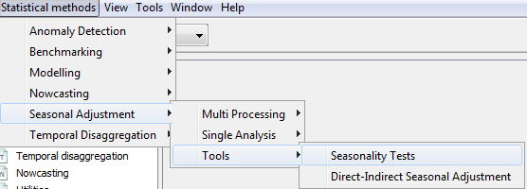

By default the tests are performed on the complete series in level, after a differencing of order 1. The user can select by means of the properties window a previous log transformation, another differencing order (0 should be used for stationary series like residuals…) or another time span (most tests in the diagnostics of X13 and of Tramo-Seats will take into account the last 8 years).

### Description

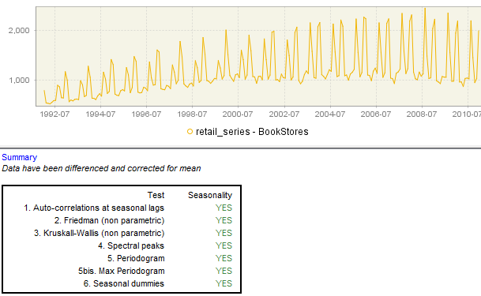

The tests are executed by dropping a time series in the upper part of the panel (or by a double click on some series, when that feature is enabled).

We describe shortly bellow the different tests (tests used in the AMI of Tramo are marked by an asterisk).

#### Auto-correlations at seasonal lags (*)

A Ljung-Box test is computed on the first two seasonal lags. The test is a Chi2 computed on the square of the auto-correlations at lags freq and 2*freq. Only positive auto-correlations are taken into account. Despite of its very simple structure, it has been found that this test is especially efficient and robust.

#### Friedman test (*)

The Friedman test is a non-parametric test based on the rank of the observations by year. It is computed as follows:

* The observations are replaced by their rank in each year
* A statistic similar to a one-way ANOVA is computed, using the ranks as values and the periods as groups.

In other words, the test will be positive if the rank of the observations in each year is significantly linked to their period.

#### Kruskall-Wallis test

The Kruskall-Wallis test is also a one-way analysis of the variance by rank. The ranks are computed in this case on all the observations and the one-way analysis of the variance tests their dependency against the period of the year they are related to.

#### Spectral peaks (*)

Two different diagnostics are considered. The first one is based on the estimation of the spectrum of a long auto-regressive model that fits the series. It is identical to the tests introduced in the X12/X13 algorithms. Further information can be found in the X13 reference manual.

The second diagnostic is based on the (smoothed) Fourier transform of the auto-correlations of the series.

The spectral peaks tests need sufficiently long series (>=8 years).

#### Periodogram

The tests are performed on the periodogram (Fourier transformation) of the series at the Fourier frequencies. A first test is based on the maximum of the periodogram on or around the seasonal frequencies. Another one is based on the sum of the values of the periodogram on or around the seasonal frequencies.

Strictly speaking, the statistical tests are only valid against the hypothesis that the (transformed) series is a white noise. As the spectral peaks, they don’t perform well for short series.

#### F-Test (regression with fixed dummies)(*)

An ARIMA model (0 1 1) (0 0 0) with mean and with seasonal dummies is estimated on the original (or log-transformed) series. Differencing orders are not taken into account.

The test is a joint F-test on the coefficients of the seasonal dummies.

This test is not suited to long series, with moving seasonality. However, it performs especially well for short series (4-6 years)

### Implementation of the seasonality tests

The seasonality tests are implemented in the classes indicated in the table below. People interested in the details of the tests should consult the corresponding files.

|  |  |  |
| --- | --- | --- |
| Test | Short description | Implementation classes |
| Qs Test | Test on the seasonal auto-correlations | ec.satoolkit.diagnostics.QsTest,  ec.satoolkit.diagnostics.  LjungBoxTest |
| F-test on seasonal dummies | Estimation of a model with seasonal dummies. Joint F-test on the coefficients of the dummies | ec.satoolkit.diagnostics.FTest |
| Friedman test | Non parametric test  (“ANOVA”-type) | ec.satoolkit.diagnostics.  FriedmanTest |
| Kruskall-Wallis test | Non parametric test on the ranks | ec.satoolkit.diagnostics.  KruskallWallisTest |
| “X12” test on seasonality | Combined test on the presence of identifiable seasonality | ec.satoolkit.diagnostics.  CombinedSeasonalityTest |
| Test on a Tukey spectrum | Identification of seasonal peaks on a Tukey spectrum | ec.satoolkit.diagnostics.  TukeySpectrumPeaksTest,  ec.tstoolkit.data.  BlackmanTukeySpectrum |
| Test on the auto-regressive spectrum | Tests on auto-regressive spectrum (Tramo or X12-like) | ec.satoolkit.diagnostics.  AutoRegressiveSpectrumTest,  ec.tstoolkit.timeseries.analysis.SpectralDiagnostic |
| Test on periodogram | Tests on the sum or the max of a periodogram at seasonal frequencies | ec.satoolkit.diagnostics.  PeriodogramTest |
| Seasonality tests | Entry point for several seasonality tests (Tramo-like) | ec.tstoolkit.modelling.arima.tramo.  SeasonalityTests |