Eötvös Loránd TudoMario

# Installation quickguide:

You should run the .appx file not the .exe one.



# Movement:

## 

|  |  |  |
| --- | --- | --- |
| Actions | Keyboard | Controller |
| Move left | A | D-pad left |
| Move right | D | D-pad right |
| Jump | W or Space | D-pad up or A |
| Toggle menu /Hide dialogbox | Esc | B |

Controller[1] recommmended for better gameplay experience.

# Menu:

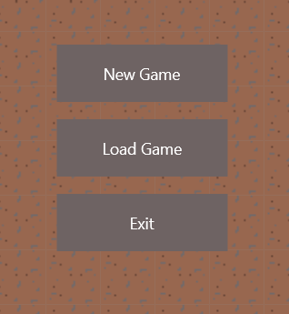 Starts a new game (loads the first level)

Loads the last played level /

Restarts the current level

Closes the game

We created this game from scratch: we wrote the game engine and designed every texture in the game. Please consider this 😊

# Some pictures from the game:

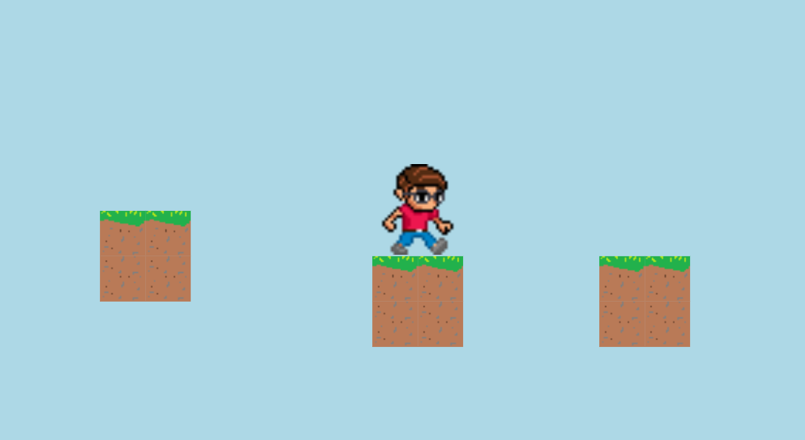

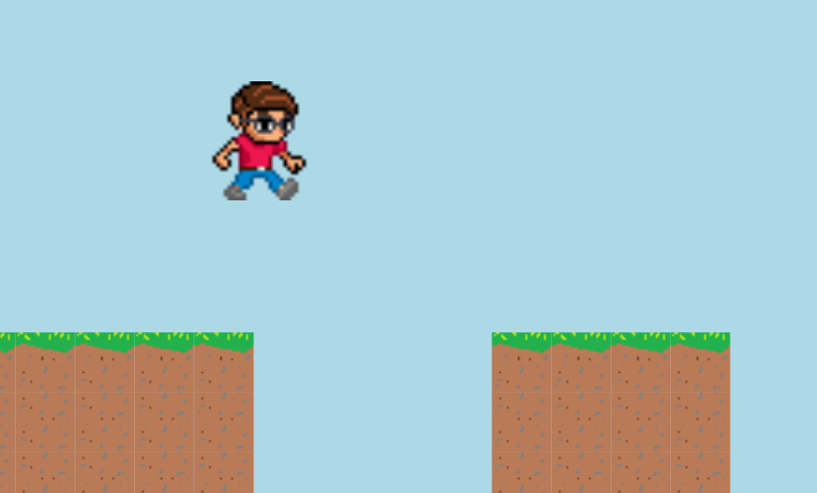

Creators: Ádám Srankó, Dániel Kriston, Patrik Nyolcas, Péter Soma Balázsi

1. Xbox One controller supported