Final Practice Problems

## Mixed practice.

1. How do you calculate the median of a dataset? (Please provide case-by-case scenarios.)
2. Below are several datasets. Please match the labels to the datasets depending on what type of test you could potentially use on them.

**Labels**  
Permutation Test $χ^{2}$ 
 test for independence $χ^{2}$ 
 Goodness-of-Fit test  
Two sample t-test  
One sample z-test

#### Dataset 1.

## kings warriors lakers  
## 1 5 20 17

#### Dataset 2.

## stanford berkeley  
## african american 843 421.92  
## asian 9990 1476.72  
## chicano/latino 3192 1125.12  
## native american/alaska native 186 70.32  
## pacific islander 65 70.32  
## white 7243 2531.52  
## other/decline to state 1137 70.32  
## mixed 2525 703.20

#### Dataset 3.

## farenheit outfit  
## 1 53.8 sweater  
## 2 57.1 sweater  
## 3 56 sweater  
## 4 54.6 sweater  
## 5 58.7 sweater  
## 6 53.8 sweater  
## 7 72.9 shirt  
## 8 72.2 shirt  
## 9 69.5 shirt  
## 10 70.6 shirt  
## 11 78 shirt  
## 12 75.6 shirt

#### Dataset 4.

This dataset is similar to Dataset 3 but actually includes 353 more rows that just weren’t printed!

## farenheit outfit  
## 1 57.7 sweater  
## 2 60.7 sweater  
## 3 55.9 sweater  
## 4 61 sweater  
## 5 53.5 sweater  
## 6 59.6 sweater  
## 7 71.4 shirt  
## 8 69.7 shirt  
## 9 77.7 shirt  
## 10 68.4 shirt  
## 11 69.2 shirt  
## 12 77 shirt

#### Dataset 5.

For some reason, you know, for sure, the true standard deviation of Chance the Rapper’s plays on Spotify. (What are the chances?) You also have these data.

## spotify_plays  
## 1 307507262  
## 2 35403776  
## 3 172425446  
## 4 166859476  
## 5 127965740  
## 6 46487943  
## 7 17032831  
## 8 15322923  
## 9 106902309  
## 10 114293608

1. If you know population standard deviation, then use a ________ test! If you don’t know the population standard deviation, then use a ________ test!
2. Surely, we always want our sample to be representative of our population. We do this by taking a _________ sample. Also, just to be clear, just because the samples are said to be just that, they are not taken haphazardly.
3. When we want to make a histogram using the library ______________, we use the function ________________.
4. In dplyr, we use the symbol %>% called the _____________________ to send our data into functions.

## Short Answer.

1. Because assumptions, such as large sample size, may be difficult to satisfy, we have alternative methods. We can evade the large sample size requirement when testing hypotheses by using a ____________ test instead of classical testing procedures.
2. When we construct a 95% confidence interval using the _____________ method, we have to find the 2.5th percentile and the 97.5 percentile of our approximate “sampling” distribution to capture ____% of the data within these bounds.

## Santa’s Little Statistician.

Directions: It is your job to talk to Santa’s elf. Your responses are shown in bold and you need to fill in the blanks.

Welcome to Santa’s Workshop! We really needed some help so we decided to invite you, a cheery statistician, to the North Pole! This year, we’re working on sending good folk as many presents as possible! That being said, Santa himself said we could only use 15 total presents to make a confidence interval about the weights (in pounds) of the presents. Why weight, you say? Well, Santa’s sleigh can only carry up to 1000 lbs! What? Did you think the sleigh was magic?

### Part a.

#### Median Weights.

First item on Santa’s stats wishlist today: he wants to know if we can test the hypotheses:

$H_{0}:$ Median weight of presents is 10 lbs. (He carries 100 presents per ride.) $H_{1}:$ 
 Median weight of presents is greater than 10 lbs.

To test the hypothesis, we will use the data below, based on presents chosen random by Santa.

The data frame for the sample of presents:

## present_weights destinations shipping  
## 1 5 north america priority  
## 2 9 south america economy  
## 3 6 africa priority  
## 4 8 asia economy  
## 5 3 europe priority  
## 6 2 australia economy  
## 7 2 europe priority  
## 8 7 north america economy  
## 9 10 south america priority  
## 10 12 africa economy  
## 11 14 asia priority  
## 12 13 europe economy  
## 13 4 australia priority  
## 14 2 europe economy  
## 15 12 north america priority  
## 16 11 south america economy  
## 17 6 africa priority  
## 18 1 asia economy

A histogram of the sample:

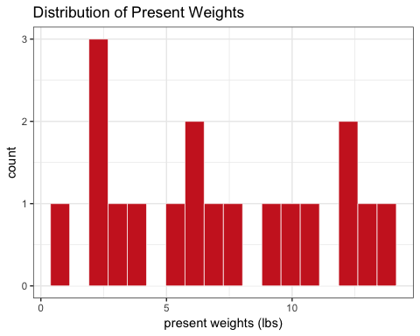

So, can we? (Select one by removing the boldface… I urge you to choose the first option so you can actually finish this worksheet).

**(a) Yes, we can using ___________________.**  
**(b) No, we can’t.**

[Hint: This question relies on your knowledge that a 95% confidence interval can be used to know whether the p-value for the corresponding two-sided test is < 0.05!]

#### Hypothesis testing with a confidence interval.

Great! Good to know since we really need to know about these gift weights… Rudolph’s back is beginning to hurt! From what I understand about the method you mentioned earlier, we are going to sample from our sample to calculate statistics. Why would we do that?

**We sample ___________ replacement from our sample because we want to estimate the ____________ distribution of the statistic we are interested in, which is what confidence intervals are normally based off of.**

What was the median of our original present weight dataset?

**Our sample’s median is _______** (numeric value).

Gotcha! Here are the 1000 medians (one for each of the resamples) you asked for in histogram format. I also illustrated the 5th percentile and the 95th percentile using vertical lines.

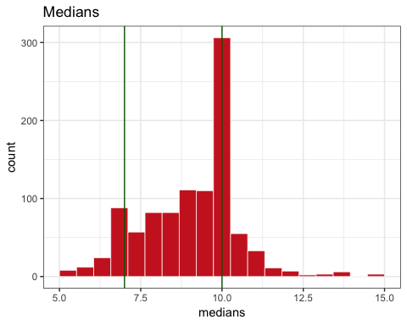

Here are the values for the 5th and 95th percentiles, which I think you might need to make your confidence interval.

median_quantiles

## fifth_perc ninetyfifth_perc  
## 1 7 11

So, what do you think about our original hypotheses? Do you think we need to stop loading our sleigh with 100 presents? (Use as much space as you need!)

**Based on our data, _______________________________________________.**

### Part b.

#### Weights between shipping methods.

Now, for Santa’s next item on his stats wishlist. He wants to know if there’s a difference between the average weights between presents under priority and economy shipping. It could give us a little more intuition to work off of when we load up the sleigh. We’re very much a data-driven business, you see!

You asked for the means of the two subsamples, which can also be considered as random samples. So, here they are!

## # A tibble: 2 x 3  
## shipping n mean  
## <fct> <int> <dbl>  
## 1 economy 9 7.22  
## 2 priority 9 6.89

What hypotheses can we test and how can we test them based off of these data?  
**We can test the null hypothesis that ___________________________________ using a ____________________. We are choosing this test because we don’t have that large of a sample size and need to simulate the case if we did. Our observed difference in means is __________________.**

How can we interpret the observed difference? **On average, we expect ______________________________________________.**

#### Simulating a null distribution.

Here’s a preview of the data we were looking at earlier, but subsetted to just see present weights and shipping methods.

## present_weights shipping  
## 1 5 priority  
## 2 9 economy  
## 3 6 priority  
## 4 8 economy  
## 5 3 priority  
## 6 2 economy

And here’s a preview (the first five columns only) of what the computer is giving us after running the code you wrote to shuffle the shipping labels.

## present_weights shipping shipping_i1 shipping_i2 shipping_i3  
## 1 5 north america priority priority economy  
## 2 9 south america economy economy priority  
## 3 6 africa priority priority priority  
## 4 8 asia economy economy priority  
## 5 3 europe priority priority economy  
## 6 2 australia economy economy priority

I understood how you shulffed the labels, but I actually don’t understand how you got to this next part with all these sample means. What exactly did you do and why?

## priority economy mean_difference  
## 1 6.888889 7.222222 -0.3333333  
## 2 7.000000 7.100000 -0.1000000  
## 3 6.454545 8.000000 -1.5454545  
## 4 8.166667 6.500000 1.6666667  
## 5 6.916667 7.333333 -0.4166667  
## 6 8.166667 4.833333 3.3333333

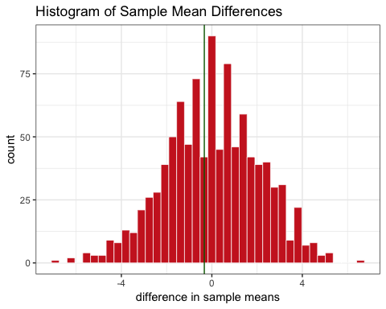

**We calculated the ______________________________ for each of the new relabels so that we could simulate the ___________ distribution. From this distribution, we can now calculate the _______________ which is the probability of observing our data or more extreme, given that ________________________!**

**Therefore, we can calculate our p-value by seeing how much data lie above our original difference.**

Here is the output from our calculation:

## prob_below_value prob_above_value   
## 0.432 0.568

**Because our p-value is _____________________, we ________________________ our null hypothesis. Therefore, when you pack up your next sleigh _________________________________________________.**

Well, that’s all great to know now! Santa will be pleased. Thanks for all your help, Cheery statistician! All of the North Pole thanks you for all your data skills. I have very few things on my wishlist this year… but I do truly wish that you have a super jolly winter break!