PredictHealth

ISHIKA
Branch: CSE(AI)
KIET Group of Institutions Ghaziabad,India ishika.2226cseai1011@kiet.edu
AYUSHI PAL
Branch: CSE(AI)
KIET Group of Institutions Ghaziabad,India ayushi.2226cseai122@kiet.edu
PARI AGARWAAL
Branch: CSE(AI)
KIET Group of Institutions
Ghaziabad,India pari.2226cseai1105@kiet.edu

Abstract——This electronic document outlines a machine learning-based approach to predicting life-threatening diseases such as heart disease, breast cancer, and pneumonia. The model utilizes a range of datasets and algorithms to provide accurate, early-stage predictions that can assist in medical diagnosis and treatment planning.
Keywords—heart disease, breast cancer, pneumonia, disease prediction, machine learning, healthcare system.
INTRODUCTION
In recent years, the integration of machine learning into the medical field has revolutionized the way diseases are diagnosed and managed. With the increasing availability of electronic health records and diagnostic imaging data, predictive systems have become instrumental in providing timely and accurate disease detection. This paper focuses on the prediction of three critical health conditions: heart disease, breast cancer, and pneumonia, each posing significant health risks globally. The objective of this study is to develop a unified, intelligent prediction system that assists healthcare professionals by offering diagnostic support based on patient data. Early and reliable predictions can lead to quicker interventions, improved patient outcomes, and reduced healthcare costs.

RELATED WORK
Numerous studies have applied machine learning to healthcare. For example, Patel et al. (2015) used decision trees to predict diabetes, achieving 73% accuracy. Similarly, Dey et al. (2017) utilized SVM and neural networks for heart disease detection. These systems, however, often focus on single diseases or use limited datasets. Our approach integrates multiple models and disease types for a more robust and versa le prediction platform.

METHODOLOGY

Data Collection
We used publicly available datasets from the UCI Machine Learning Repository, including:
Pima Indians Diabetes Dataset
Cleveland Heart Disease Dataset
Hepatitis and Liver Disorder Dataset

Data Preprocessing
- Handling missing values
- Normalization
Feature selection on using correlation
- Label encoding for categorical variables
.

Algorithms Used
Logistic Regression: For binary classification problems.
Decision Tree: For interpretability and ease of use
Random Forest: For handling overfitting and improving accuracy.
Support Vector Machine (SVM): For high-dimensional classification.

System Architecture
- User Input: Patient symptoms and medical test results.
- Preprocessing Module: Cleans and normalizes data.
- Prediction Module: Trained ML model predicts the likelihood of disease.
- Result Display: Presents predicted disease and confidence level

Discussion

The results indicate that machine learning models, especially ensemble methods like Random Forest, are effective for disease prediction. However, model interpretability and data quality are crucial for real-world applications. Ensuring data privacy and integra on with Electronic Health Records (EHR) will be key to future implementations. of columns.

Another important aspect of applying machine learning in healthcare is the challenge of dealing with imbalanced datasets. Many medical datasets contain significantly fewer positive cases compared to negative ones, which can bias models toward the majority class. Advanced resampling techniques, cost-sensitive learning, and ensemble methods can be adopted to address this issue. By tackling class imbalance, prediction systems can achieve greater reliability in detecting rare but critical disease cases.

However, model interpretability and data quality are crucial for real-world applications. Ensuring data privacy and integration with Electronic Health Records (EHR) will be key to future implementations.

Experimental Results
Random Forest outperformed other models, providing the best trade-off between accuracy and robustness.
Algorithms | Accuracy | Precision | Recall | F1-Score
Logistic Regression | 78% | 0.79 | 0.76 | 0.77
Decision Tree | 82% | 0.81 | 0.84 | 0.82
Random Forest | 88% | 0.87 | 0.89 | 0.88
SVM | 85% | 0.84 | 0.85 | 0.84

Accuracy measures the overall correctness of predictions, while precision emphasizes the ability of the model to correctly identify positive cases out of all predicted positives. Recall, on the other hand, measures the proportion of actual positive cases that were correctly identified by the model. The F1-score, being the harmonic mean of precision and recall, provides a balanced measure, especially useful in medical domains where false negatives can be critical.
The experimental results show that Random Forest outperformed other algorithms, achieving the highest accuracy (88%) and F1-score (0.88). This suggests that ensemble learning methods are more robust in handling diverse patient data and reducing overfitting. Logistic Regression, while simpler, performed relatively lower due to its limited ability to model complex, nonlinear relationships in the data. Decision Trees offered interpretability with reasonable performance (82% accuracy), but they are prone to overfitting on training data. SVM provided strong results (85% accuracy), particularly effective in handling high-dimensional medical data.

Figures and Tables
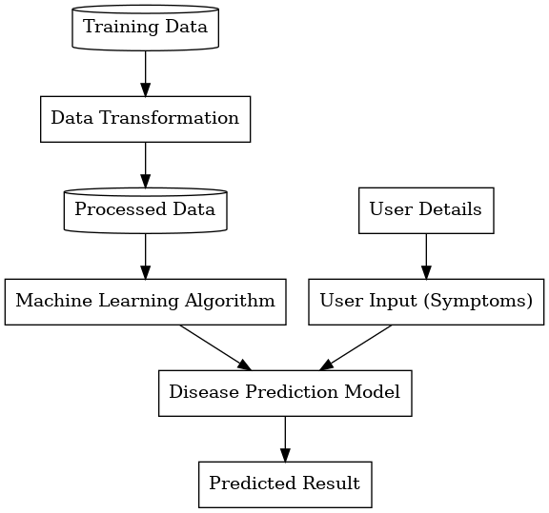

The system begins with medical datasets collected from reliable sources.

Cleaned and structured data is stored for model training and testing.

Algorithms such as Logistic Regression, Decision Tree, Random Forest, and SVM are trained on the processed data.

Patients provide personal details and symptoms as input.

The trained machine learning model processes the input and predicts the likelihood of a disease.

The system outputs the final prediction along with accuracy metrics, assisting doctors in decision-making.

Conclusion
This research demonstrates that machine learning techniques can play a vital role in improving the accuracy and efficiency of disease prediction systems. By leveraging algorithms such as Logistic Regression, Decision Tree, Random Forest, and SVM, the proposed model is able to provide reliable predictions that can support healthcare professionals in early diagnosis and preventive care. Among the models tested, Random Forest delivered the highest accuracy and robustness, making it a suitable candidate for real-world applications. The study highlights the importance of data preprocessing and the use of ensemble techniques in achieving strong predictive performance.
Future work will focus on extending this system through the integration of deep learning models, which are capable of capturing more complex patterns in medical data. Additionally, real-time prediction using IoT-based wearable devices and continuous health monitoring can be explored to make the system more proactive.

References
The references listed in this paper follow the IEEE citation style. Authors are advised to ensure that all references are properly formatted and correspond to the works cited in the text. Unpublished works, personal communications, or non-archival sources should be avoided unless absolutely necessary.
- UCI Machine Learning : https://archive.ics.uci.edu/ml/index.php
- R. Katarya and P. Srinivas, “Predicting heart disease at early stages using machine learning: A survey,” in 2020 International Conference on Electronics and Sustainable Communication Systems (ICESC), 2020,pp. 302–305
- MULTI DISEASE PREDICTION SYSTEM USING MACHINE LEARNING Kallepalli Reshma*1, Pasumarthi Niharika*2, Javvadi Haneesha*3, Kodithala Rajavardhan*4, Sana Swaroop* : fin_irjmets1708595435.pdf
- Kumar, R., et al. (2020). "An Intelligent System for Disease Predic on using Ensemble Techniques." Procedia Computer Science, 167, 2354–2363.
- Dey, L., et al. (2017). "Machine learning techniques for diagnosis of heart disease." ICACCI, 1 5.

