Local Handicap

August 2018 (version 2.3)

# Main Screen

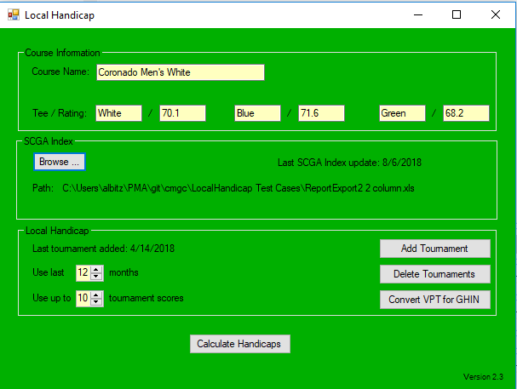

## Course Information

The course information provides basic information about the golf course.

## SCGA Index

This is the path to the Excel file containing the roster and SCGA index. The file can either the single column or two column formatting that the SCGA provides.

## Local Handicap

This is the data used to generate the local handicap. The default is to use the last 12 months data and last 10 tournament scores. Any data outside that range is ignored.

Buttons:

* Add Tournament – After completing a tournament, select the Vision Perfect scores file (.vpt) to add to the local handicap database. (The .vpt file is copied to the “db” sub-folder of the app. You don’t have to keep the original file since it is copied to the sub-folder.) In addition to copying the .vpt file to the sub-folder, an 2nd file is created (.data) that has the name of the tournament since the tournament name is not in the .vpt file.
* Delete Tournaments – Remove Vision Perfect files from the sub-folder (and tournament name files). Once the files are outside the 12 month range, you can remove them from the local handicap sub-folder by using this button. If you don’t remove them, there is no harm, but the app will become a little slower since it reads all the files in the sub-folder.
* Convert VPT for GHIN – Take a .vpt file and create a .csv file to send to the SCGA. The file is named with “_ForGHIN.csv”. The file contains the handicap adjusted score from the .vpt file and it places the entries for the green tees at the head of the file so the SCGA can separate the green tee data from the white tee data.

## Calculate Handicaps

This button takes the data from the “db” sub-folder and applies the limits for the number of months and number of tournament scores and calculates the local handicap.

## Local Handicap Tabs

This screen is divided into 3 tabs:

* Local Event Hcps – show data for all players
* Individual Details – show details data for a single player
* Summary – alternate way to show data for all players

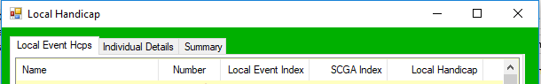

### Local Handicap Filters

Filters that apply to all tabs:

* Show only if player has a local handicap – reduce the list to only players with a local handicap
* Show only if player’s local handicap is lower than SCGA index – reduce the list to players with local handicaps lower than their SCGA index

Upper case names when saving: originally, the website showed names in only upper case. Now, when data is uploaded to the website, the names are converted to mixed casing, so this step isn’t necessary.



### Local Event Hcps Tab

This tab shows a list of all the players and their local and SCGA indexes. If you double click on a player, it switches to the Individual Details tab for that player.

Buttons:

* Save as CSV – Save the full list of players with their local and SCGA indexes. This file is uploaded to the website as well as loaded into Vision Perfect.
* Done – Return to the main screen.

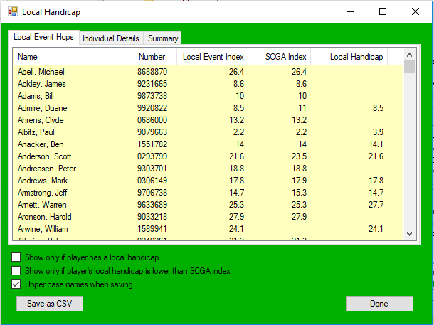

### Individual Details Tab

This tab shows the details for a single player. It shows the tee used, score, adjusted score, and handicap differential. The scores used for the local handicap are highlighted in yellow.

You may have to resize the app vertically to see all the scores. The scrollbar on the right moves you to the next player.

To find a player, start typing in the Search for Last Name textbox.

Buttons:

* Save as Text – Click this button to save this information to a text file that you can send to a player.
* Done – Return to the main screen.

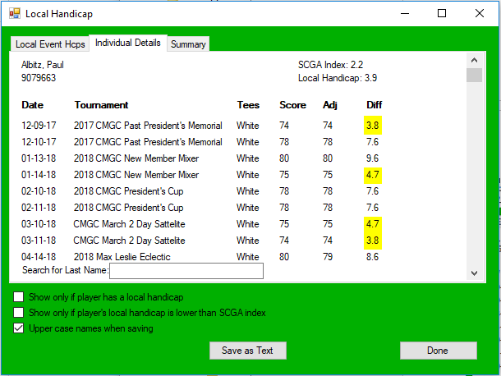

### Summary Tab

This tab is a combination of the Local Event Hcps tab and the Individual Details tab. It lists all the players and it shows the details of local handicap calculation horizontally. It was an experiment in how to display the data, but it has not proven useful.

This tab looks best if you stretch the app horizontally so you can see all the scores.

Buttons:

* Done – Return to the main screen.

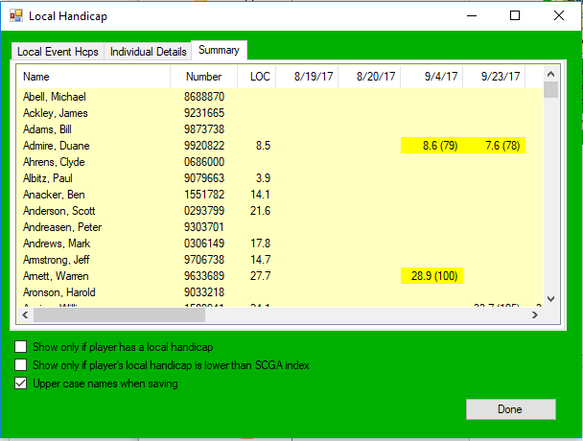

# Vision Perfect

To update the player’s handicaps in VP enter the lower of Local or GHIN index into the players record do the following:

1. Open VP (no tournaments selected)
2. Click Maintenance/Players/Player’s Database Maintenance
3. Press the “Import/Update all Players from GHIN” button
4. Select Handicap System Import Type “Comma Separated/Text File” then click Next
5. Navigate to LOCAL HANDICAPS/CSV Files for website folder for file of choice (e.g. Aug 1 2018 CSV.csv) open it select data layout entitled “Local Handicap CSV”. Make sure the following are checked: “The first row contains column headers”, All player are same sex, Male,  Club Number 73170, All handicaps are 18 hole, MDY, xx/xx/xx DOB format.
6. Press OK then press Finish.

Lower of GHIN or Local Index should load in the “Local Index” field of the player’s record.

# Input Files

## .VPT File Format

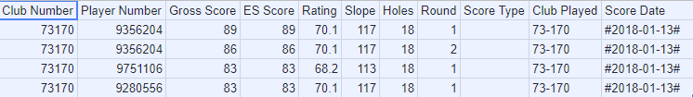

## SCGA Index File Format 1 Column

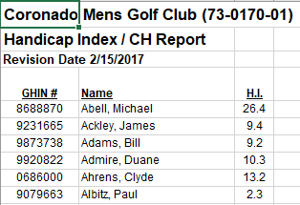

## SCGA Index File Format 2 Column

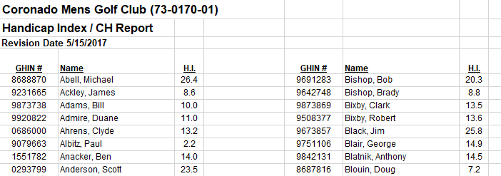

# OutPut Files

## Convert VPT for GHIN File Format

The scores for green, 68.2 course rating, are first.

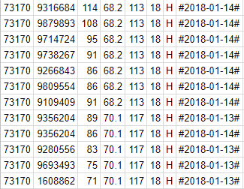

## Save as CSV File Format

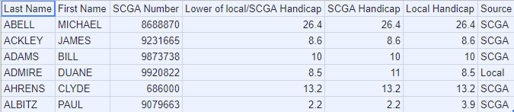

## Save Individual Details as Text File Format

