1. EDITING A VANILLA CONTROL XML

If you are creating a new SL, based on the functionality of your SL, you will need to select relevant XML from **sdk_utils > DBTool > src > 01_db_files > xml_files > 02_developer > service_level**

Often you might want to add new objects and parameters to vanilla control XMLs. You can select **File > Open** to edit your control xmls or add extra stuff

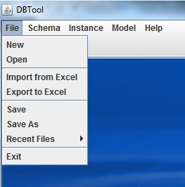

You can right click on objects and parameters to reveal operation that you can perform on them

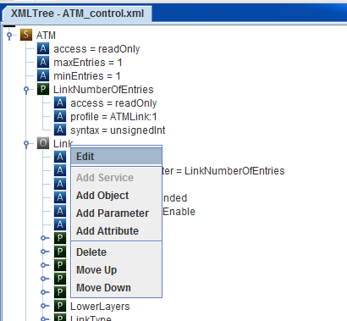

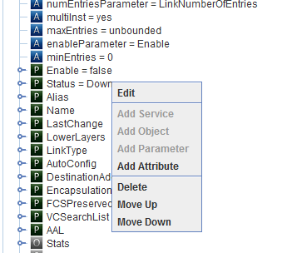

Don’t forget to **save** your edits before proceeding to next step.

Check X_LANTIQ objects and parameters in DeviceInfo_control_2.xml in examples.

1. GENERATING DATA XMLS

After you are done with the control xml, you need to generate a data XML from it which contains instances of an object as specified by the control XML

Select **Instance > Create** to select a control xml for which you want to generate data XML for

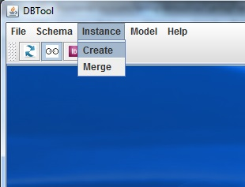

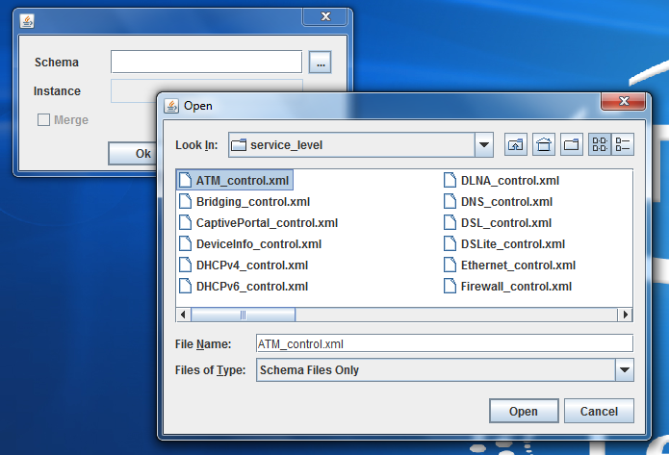

Above **open** only shows valid control XMLs

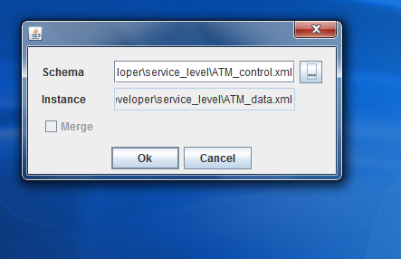

The above step will change the control XML to have IDs for each object and parameter and will generate a data xml with IDs in sync with the control XML.

After this step you won’t be able to edit the generated control and data XMLs. You need to generate original XML back from ID added XMLs to be able to edit them using GUI. (This is explained below)

1. GENERATING ID ADDED DATA AND CONTROL XMLS

In order to generate ID added Data and Control xml files, Follow the below steps.

1. Click on Generate Id icon present at DBTool’s “Tool bar”

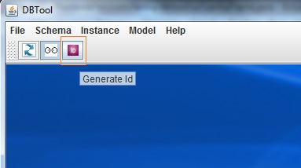

1. Select the Control.xml or Schema file which user wanted to generate the ID XML.
2. Depending upon the Control.xml provided, tool tries to locate the corresponding data.xml and takes the below action accordingly.
   1. If corresponding data.xml present/found, below prompt appears.

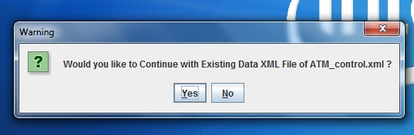

* 1. If user selects “yes”, It will generates the ID xml for both control and data XML.

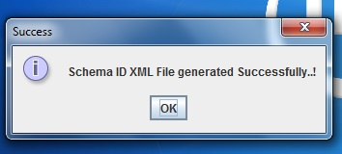

* 1. If corresponding data.xml not present, the tool will prompt as below.

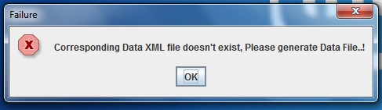

EDITING EXISTING ID CONTROL XML TO ADD/EDIT FEATURES

If you try to edit ID added control or data xml using GUI, you won’t be able to do it. There is a good chance that ID added data and control xmls go out of sync if you try to do so. Instead you need to generate original data and control XMLs back from ID added XMLs to do so.

Also you no longer should use vanilla control xml from **sdk_utils > DBTool > src > 01_db_files > xml_files > 02_developer > service_level**  because the id added control xml in your repo might have new objects and you need to make your edits only on top of these.

# STEP 1: REGENERATE ORIGINAL CONTROL AND DATA XML

**python genHdrnMergeXML.py –p default <SS>_control.xml**

**python genHdrnMergeXML.py –p default <SS>_data.xml**

# STEP 2: EDIT CONTROL XML AND REGENERATE ID ADDED CONTROL AND DATA XMLS

Make edits to the control xml generated from the above step and regenerate data xml as mention in SECTION 2.

This step will also merge all the values of previous data XML to newly generated data XML