INFM600: PBJ Documentation

# Ingredients/Tools

Following ingredients and tools are required for making a scrumptious peanut-butter and jelly sandwich:

* Peanut-butter
* Jelly or jam *( flavor of your choice)*
* 2 slices of bread *(type of your choice: brown, white, multi-grain, etc.)*
* Plain butter *(not necessary)*
* Butter knife
* Knife/ Scissors
* Sandwich Grill *(for grilled sandwich)*

# Directions

## Non-grilled Version

To make a non-grilled peanut-butter and jelly sandwich, follow the following steps:

**Step 0 *(can be skipped)*:** Carefully cut the edges of the bread slices using a knife or a pair of scissors. Scissors are recommended for safety purposes.

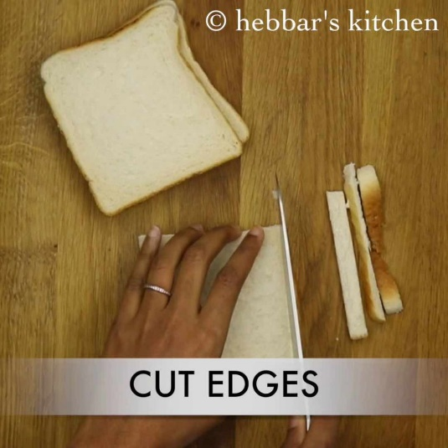

**Figure: Step 0** (Hebber’s Kitchen, 2016)

**Step 1 *(can be skipped)*:** Spread plain butter evenly on one side of a bread slice using the butter knife. Ensure you cover the entire surface. Do the same for the other slice. Adding plain butter enhances the taste of the other ingredients of the sandwich.

*Tip: If the butter is too hard, let it sit for some time before applying on the bread as it may tear the bread.* (sarahagius, 2015)

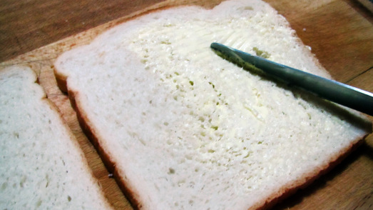

**Figure: Step 1** (sarahagius, 2015)

**Step 2:** Evenly spread peanut-butter using a butter knife on one side *(buttered side, if step 1 was followed)* of one of the bread slices. (Refer to Step 1 figure)

**Step 3:** Take the other bread slice *(not the one used in step 2)*. Now evenly spread out jelly/jam of your choice on one side of the slice *(buttered side, if step 1 was followed).* (Refer to Step 1 figure)

**Step 4:** Take the two bread slices and stack them such that the peanut-buttered side and the jelly side face each other.

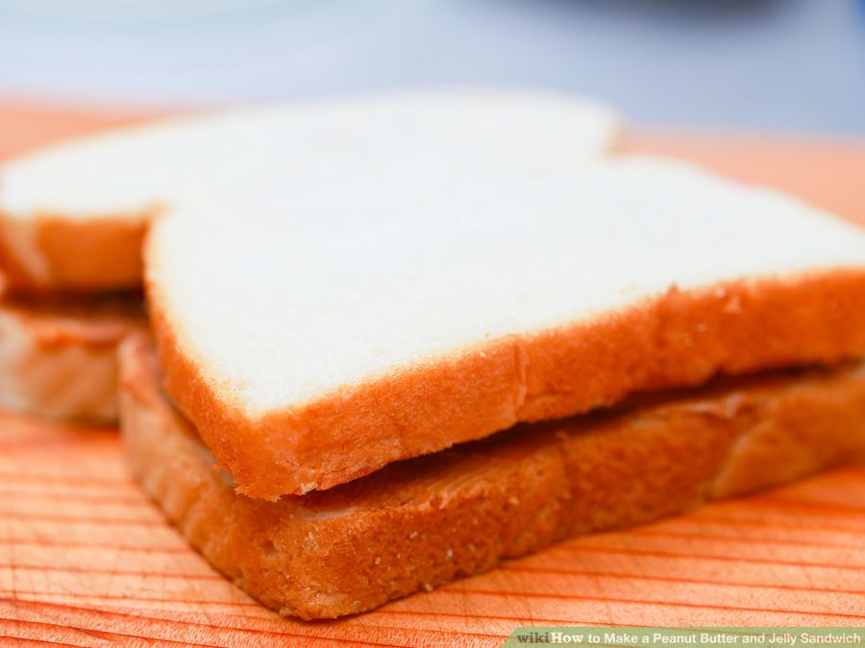

**Figure: Step 4** (“How to Make a Peanut Butter and Jelly Sandwich,” n.d.)

Your peanut-butter and jelly sandwich is ready!

## Grilled Version

Following are the steps for making a grilled peanut-butter and jelly sandwich:

**Steps 0-4:** Follow as mentioned above

**Step 5:** Spread some plain butter onto the outer sides of your sandwich.

**Step 6:** Plug in the sandwich grill and put the sandwich inside the grill.

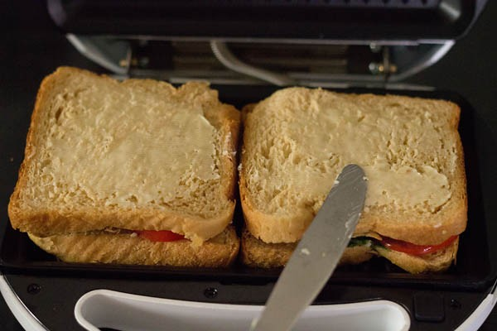

**Figure: Step 6** (Dassana, 2016)

**Step 7:** Leave the sandwich in for around 4-5 minutes. Once done, check if the sandwich looks golden-brown in color. If not, put it back into the grill for a few more minutes until it becomes golden-brown in color.

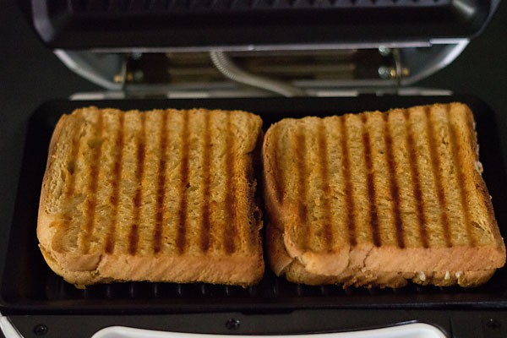

**Figure: Step 7** (Dassana, 2016)

**Step 8:** Once it is golden-brown, remove the sandwich from the grill carefully *(caution: it might be too hot)* and unplug the sandwich grill.

Your grilled peanut-butter and jelly sandwich is ready!

*Bonus Tip: If the sandwich is to be consumed after some time, to avoid sogginess due to jelly/jam, apply peanut-butter on one side of both the bread slices and then apply the jelly/jam between the two peanut-buttered slices.*

**Word Count: 457**

# References

[1] *sarahagius*. (2015, October 5). 50TH SPECIAL: HAM AND CHEESE SANDWICH Retrieved October 25, 2016, from <https://myplaceinthekitchen.files.wordpress.com/2013/08/img_3360.jpg?w=523&h=293>

[3] *Hebber’s Kitchen.* (2016, August 6). Bread 65 recipe | spicy bread 65 recipe – restaurant style. Retrieved October 25, 2016, from <http://hebbarskitchen.hebbars.netdna-cdn.com/wp-content/uploads/2016/08/bread-65-recipe-spicy-bread-65-recipe-restaurant-style-1-1024x1024.jpeg?x41292>

[4] *How to Make a Peanut Butter and Jelly Sandwich.* Retrieved October 25, 2016, from WikiHow, <http://pad2.whstatic.com/images/thumb/1/19/Make-a-Peanut-Butter-and-Jelly-Sandwich-Step-4.jpg/aid9853-728px-Make-a-Peanut-Butter-and-Jelly-Sandwich-Step-4.jpg.webp>

[5] *Dassana, A.* (2016, August 03). Veg grilled sandwich recipe. Retrieved October 26, 2016, from <http://photos.vegrecipesofindia.com/wp-content/uploads/2014/01/grilled-veg-sandwich-recipe6.jpg>

**Create Date:** 10/24/2016 1:35:00 PM

**Last Updated:** 10/26/2016 1:06:00 AM