INFM600 Information Environment

Team Exceptional

Project Summary

December 11, 2016

Project Scope

Our project focuses on finding out factors that might affect the crime rate in the District of Columbia. We aim to reach out to the residents of DC; say a common man residing with his family in any county of DC through our project. We focus on three main questions:

1. Does weather (temperature change) have any effect on the crime rate?
2. Is there a relation between number of nightclubs with the crime rate in a particular geographic unit (cluster)?
3. Is there a spike in the crime rate during the major public holidays?

We focus on all crimes together as well as different types of crimes (eg: assaults, etc.). Our results might just help them in making more informed decisions when it comes to their safety in their day-to-day life.

Data and Analysis

Our main dataset is the DC Metro Crime Rate (“Crime Incidents - 2011,” 2016, “Crime Incidents - 2012,” 2015, “Crime Incidents - 2013,” 2015, “Crime Incidents - 2014,” 2016, “Crime Incidents - 2015,” 2015) which contains a subset of locations and attributes of crime incidents reported to the District of Columbia Metropolitan Police Department (MPD). For each question, we have merged the crime dataset with different other datasets for carrying out different statistical analysis tests; Historical Weather data of DC (Question 1), Nightclubs of DC (Question 2) and National Holidays of USA (Question 3).

Research Question 1: Effect of Weather

*Description:* We are analyzing the trend of crime rate with respect to the changes in the temperature.

*Datasets used:* Crime dataset, weather dataset (“NOAA,” 2016)

*Statistical Tests:* Simple linear regression to figure out whether there is a relationship between the crime rate and the temperature.

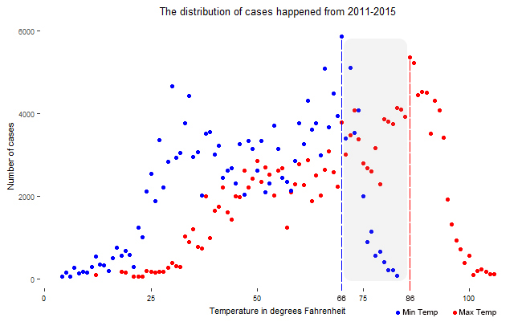

**Figure 1: Plot of temperature and number of crime-cases at that temperature**

*Results:* Overall, temperature is **positively** related to most of the crimes *(exception: arson cases)*. When the temperature ranges between 66 oF and 86oF, more crimes occur. So summer (July to September) sees the maximum crimes in the year. The reason may be that people are more prone to being agitated under the high temperature.

Research Question 2: Effect of Nightclubs

*Description:* We are analyzing the crime rate with respect to the number of nightclubs in each cluster.

*Datasets used:* Crime dataset, nightclubs dataset (“Night Club,” 2013)

*Statistical Tests:* Correlation test to figure out a relationship between the number of nightclubs and crimes.

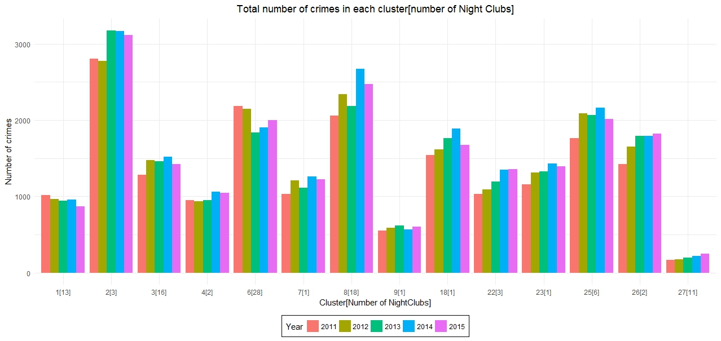

**Figure 2: Plot of number of crimes and nightclubs in DC**

*Results:* The rationale behind this question was that alcohol and nightclubs generally go hand-in-hand and so do, alcohol and crime. But, after the correlation tests, we determined that there is no relation between crimes and presence of nightclubs which is clearly evident from Figure 2.

Research Question 3: Effect of Holidays

*Description:* We are analyzing the crime rate during the public holidays to check if there is a spike.

*Datasets used:* Crime dataset, holidays’ dataset (“Holiday Schedules,” n.d.)

*Statistical Tests:* Simple t-tests to determine if crime rate spikes during holidays or not.

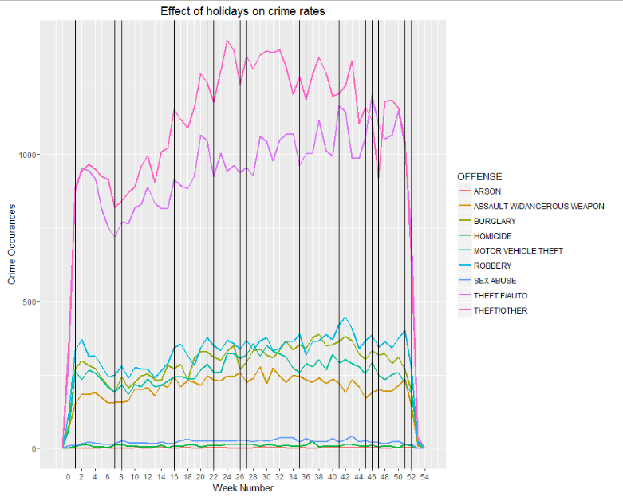

*Results:* From the plot some relation is apparent between weeks which had holidays in them and their crime rates. However, on further analysis through t-tests it was found that the differences were not significant enough to make a conclusion.

**Word Count: 539**

References

[1] *Crime Incidents - 2011.* (2016, August 23). Retrieved October 31, 2016, from DC.gov, <http://opendata.dc.gov/datasets/9d5485ffae914c5f97047a7dd86e115b_35>

[2] *Crime Incidents - 2012.* (2015, April 29). Retrieved October 31, 2016, from DC.gov, <http://opendata.dc.gov/datasets/010ac88c55b1409bb67c9270c8fc18b5_11>

[3] *Crime Incidents - 2013*. (2015, April 29). Retrieved October 31, 2016, from DC.gov, <http://opendata.dc.gov/datasets/5fa2e43557f7484d89aac9e1e76158c9_10>

[4] *Crime Incidents - 2014*. (2016, April 29). Retrieved October 31, 2016, from DC.gov, <http://opendata.dc.gov/datasets/6eaf3e9713de44d3aa103622d51053b5_9>

[5] *Crime Incidents - 2015.* (2015, December 17). Retrieved October 31, 2016, from DC.gov, <http://opendata.dc.gov/datasets/35034fcb3b36499c84c94c069ab1a966_27>

[6] *Holiday Schedules*. Retrieved November 1, 2016, from DC.gov, <http://dchr.dc.gov/page/holiday-schedules>

[7] *NOAA.* (2016). Historical Weather Data [Data file]. Retrieved November 10, 2016, <https://www.ncei.noaa.gov/orders/cdo/839080.pdf>

[8] *Night Club*. (2013, October 04). Retrieved October 22, 2016, from DC.gov, <http://opendata.dc.gov/datasets/4589d3e500404dc5a648dcdf3bc2732e_29>