Requirements:
- Install Winpython64-3.12.4.1: https://sourceforge.net/projects/winpython/files/WinPython_3.12/3.12.4.1/Winpython64-3.12.4.1dot.exe/download
- After that, install wxpython with pip

1. Run step1_find_disp.py
Input: This python script read a binary file (.bin, e.g., data.bin in the Google Drive Link), containing the following data type for identified single molecules:
data_type = np.dtype([('X', np.float32), ('Y', np.float32), ('Xc', np.float32), ('Yc', np.float32), ('Height', np.float32), ('Area', np.float32), ('Width', np.float32), ('Phi', np.float32), ('Ax', np.float32), ('BG', np.float32), ('I', np.float32), ('Category', np.int32), ('Valid', np.int32), ('Frame', np.int32), ('Length', np.int32), ('Link', np.int32), ('Z', np.float32), ('Zc', np.float32)]).
Parameter setting: The disp_thre means the searching radius for paired single molecules between consecutive frames. Unit is pixel.
Also, another script step1_find_disp_1-2and2-3.py can be used instead of the current one, if all consecutive frames are paired to obtain displacement
Output: Generate a file ending with dis6.bin (if “disp_thre” was set to be 6). containing the following data type for paired single molecules (e.g., data-dis6.bin in the Google Drive Link):
data_type = np.dtype([('x_start', np.float32), ('y_start', np.float32), ('x_end', np.float32), ('y_end', np.float32), ('frame', np.int32), ('disp', np.float32), ('angle', np.float32)])

2.Run step2_fit_Drate_pcBleed_PCA_shrinkbinrange.py
Input: The file generated via Step 1 ending with disX.bin (X is the value of “disp_thre” parameter, e.g. data-dis6.bin in the Google Drive Link).
Parameter setting:
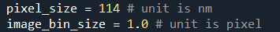
Pixel_szie: pixel size for the camera.
image_bin_size: radius used for the Gaussian Convolution Kernel
Min_points_percell: Only performed fitting if total molecule count is larger than this
Disp_thre: the number you used in the step1
Time_interval: the separation time of two consecutive frames
Hist_bin_num: histogram bin number for constructing displacement histogram
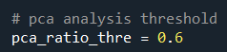
Pca_ratio_thre: for PCA analysis threshold. If all 2D, use 0.99. However, if there are some 1D motion. Use ~0.6
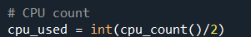
Cpu_used: How many CPU will you use for running this program
Output: a binary file (.bin, e.g. data-dis6-avePCABd57nm.bin in the Google Drive Link), containing the following data type for identified single molecules. The diffusion coefficients were stored in Zc, and the diffusion angles were stored in Z:
data_type = np.dtype([('X', np.float32), ('Y', np.float32), ('Xc', np.float32), ('Yc', np.float32), ('Height', np.float32), ('Area', np.float32), ('Width', np.float32), ('Phi', np.float32), ('Ax', np.float32), ('BG', np.float32), ('I', np.float32), ('Category', np.int32), ('Valid', np.int32), ('Frame', np.int32), ('Length', np.int32), ('Link', np.int32), ('Z', np.float32), ('Zc', np.float32)]).
The DREAM image can be reconstructed by opening the binary file with open-source SMLM image-processing software and rendering the localizations according to their Xc and Yc coordinates, with color assigned based on the Zc value. In the reconstructed image, the color encodes Zc, which represents the local diffusion coefficient.
Another output file ending with “.npy” (e.g. data-dis6-HistPCABd-Add1pt-bsize57nm-bnum18.npy in the Google Drive Link) stores all the displacement histograms for each single molecules.
All other files, including “WriteSTORMBin_XcYcZZcFrame”, “WriteSTORMBin”, “ReadSTORMBin_XcYcZZcFrame”, “ReadSTORMBin”, “hist_maker_PCA_shrinkbinrange”, “drate_fitter_PCA_shrinkbinrange”, and “disp_angle_calculator_pickone2”, are functions used by the scripts described above.

Examples of Raw data is shared via Google Drive, named with:
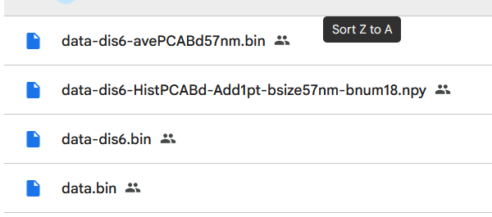
The link is:
https://drive.google.com/drive/folders/1u_QVBBYfihYaRlNL-dsmfcpZhbTPGtn1?usp=sharing
For example, to generate the image shown in Fig. 1D, plot the single molecules in “data-dis6-avePCABd57nm.bin” using “Xc” and “Yc” as the localization coordinates and “Zc” as the color-coded value. Note that Fig. 1D is a magnified view of the plotted image via “data-dis6-avePCABd57nm.bin”.

