1. step1_find_disp
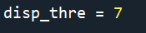 unit is pixel, meaning the searching radius
step1_find_disp_1-2and2-3, another version if we put pulse at the middle of each frame. So all consecutive frames can be used to calculate displacement
Input is the bin file from Insight3 from Prof. Xiaowei Zhuang’s Lab
generate a file ending with dis7.bin

2. step2_fit_Drate_pcBleed_PCA_shrinkbinrange
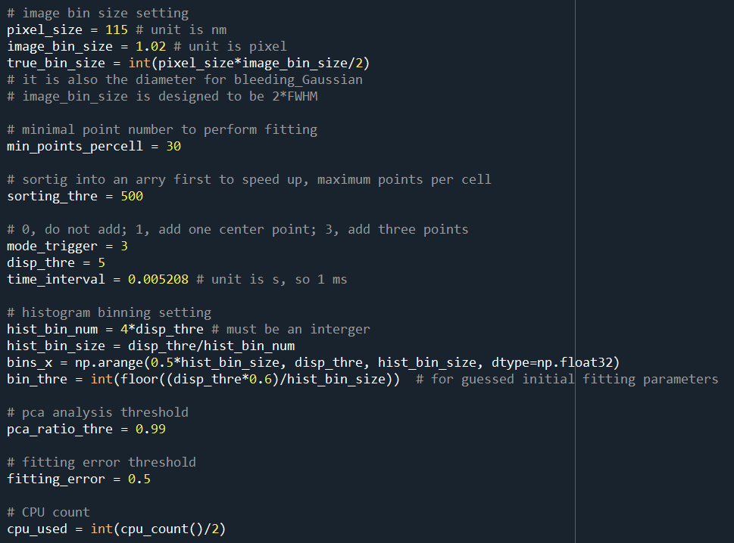
Image_bin_size: radius used for the Gaussian Bleeding Kernel
Min_points_percell: Only performed fitting if total molecule count is larger than this
Sorting_thre: Maximum molecule count. The larger the better. However, it costs lots of computer memory
Mode_trigger: Add X point to the displacement
Disp_thre: the number you used in the step1
Time_interval: the separation time
Hist_bin_num: histogram bin number for constructing displacement histogram
Pca_ratio_thre: for PCA analysis threshold. If all 2D, use 0.99. However, if there are some 1D motion. Use ~0.6
Fitting_error: not used here
Cpu_used: the Python program will use all your CPU. If you want to run other programs simultaneously. Here we used half of your CPU
The output is a bin file that can be loaded into insight3, with Zc is the diffusion rates

3. step3_visualization_pointcloud_TwoComp_1D2D
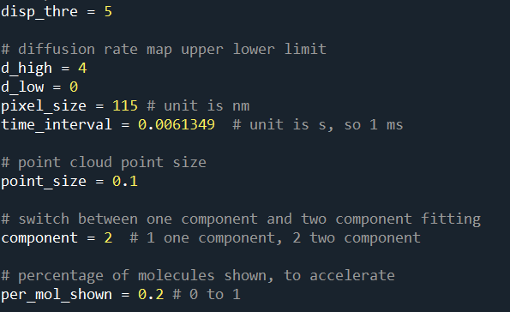
Disp_thre: the value you used in step1 and step2
D_high and low, the scale of D
Component: Do you want to use two-components fitting for your selected area?
Per_mol_shown: percentage of molecule shown in the figure. Smaller will make the program running faster.

