Thesis Progress Update — EEG Sleep Prediction
1. project recap

-goal : to predict average nightly sleep hours from EEG recorded during 36 cognitive tasks (Emotiv EPOC, 14 channels).
-83 subjects.
-main feature set is FFT band power: Theta, Alpha, BetaL, BetaH, Gamma — 70 features in total (14 channels × 5 bands).
-plan : train a Random Forest regression model using Leave-One-Subject-Out cross-validation.

2. Data pipeline

2a. Signal quality filtering
Each recording gets filtered before anything else is computed, drop rows where:
- any EEG channel has contact quality (CQ) < 2 (scale 0–4)
- CQ.Overall < 0.7
- the EEG.Interpolated flag is set

Result: 79 out of 83 subjects retain at least 18 clean task segments. The 4 edge cases are recording issues.
2b. Marker synchronisation
Initially : was syncing task segments by matching timestamps between data.csv and each subject’s marker.csv.

The fix: the data.csv file itself has a MarkerIndex column, positive values mark task starts, negative mark task ends = rewrote clean_whole_dataset.py to use that instead. All 83 subjects now go through the pipeline, giving 2,830 task segments total.

2c. FFT feature extraction
The Emotiv EPOC device computes FFT band power internally and outputs it directly as POW.* columns in each subject’s data.csv.
-clean_whole_dataset.py : after quality filtering, it finds each task segment using the MarkerIndex boundaries, then averages all the pre-existing POW.* values across the clean rows within that segment. The result is one row per task segment per subject stored in all_task_ready.csv ,70 features (14 channels × 5 bands), each being the mean Emotiv-provided band power for that segment. This file is the input for all EDA analyses.

3. EDA findings

3a. Sleep distribution is very narrow
The sample heavily clusters around 6–8 hours: 68 subjects in that range, 9 at ≥8h, and only 6 at <6h.
-it makes regression hard because there’s not much variance to explain.

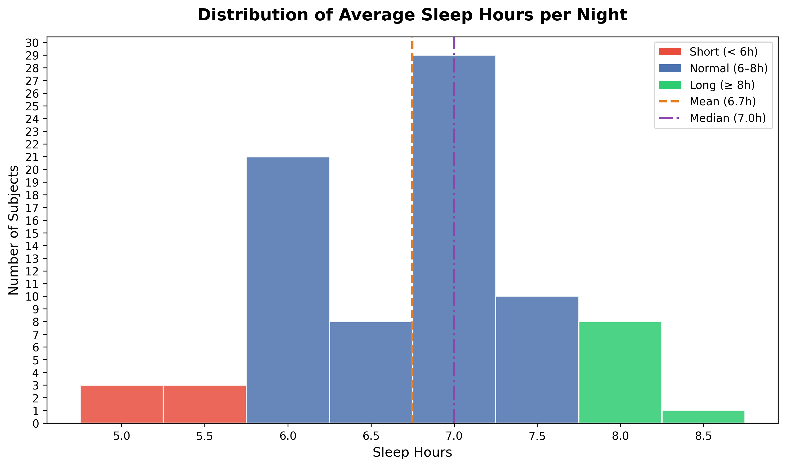
Figure 1: sleep_hours_distribution.png — Distribution of self-reported average nightly sleep across 83 subjects.

3b. Univariate FFT–sleep correlations
-averaged FFT power per subject across all tasks and computed Pearson r with Sleep_Hours:

the strongest correlations around r = ±0.15 to ±0.22. None survive correction for multiple comparisons. The direction is interpretable, more frontal Gamma/BetaH with more sleep, more frontal/parietal Theta/Alpha with less sleep.

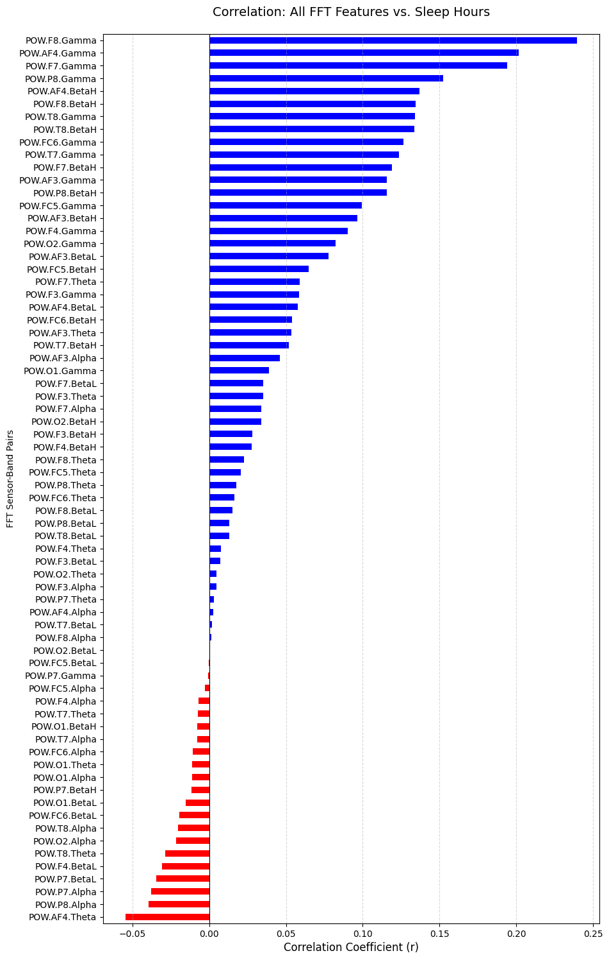
Figure 2: fft_sleep_correlation_bars.png — Pearson r between each FFT feature and Sleep_Hours (subject-level averages, n=83). Frontal Gamma and BetaH are the top positive correlates; frontal Theta and parietal Alpha are the top negative correlates.

The scatter grid below shows the top features individually:

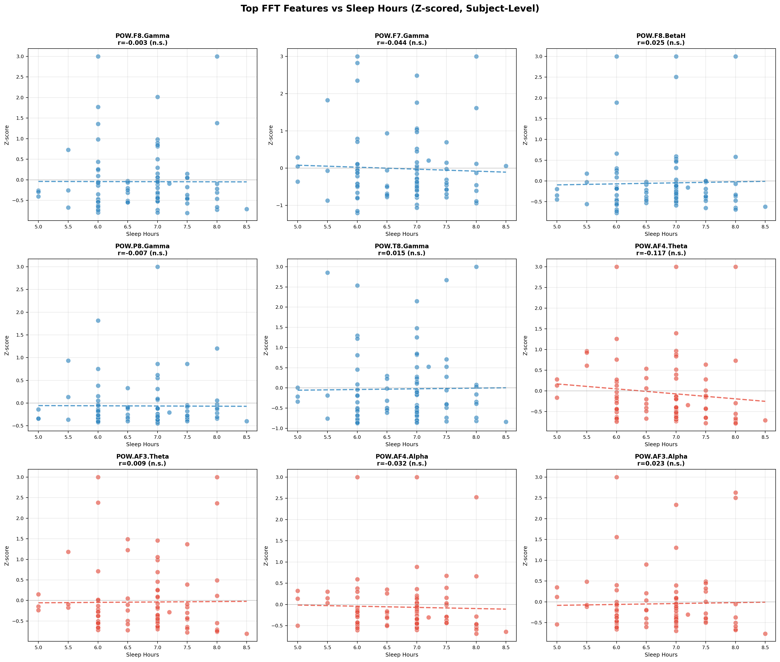
Figure 3: scatter_grid_top_features.png — Individual scatter plots for the top 9 FFT features vs Sleep_Hours. Each point is one subject.

3c. Sleep group comparisons
-split subjects into sleep groups and compared FFT features with Mann-Whitney U tests. One result was significant (AF4.Theta, p=0.009 in the 3-way split), but with 48 tests the Bonferroni threshold is α ≈ 0.001 ,so it doesn’t hold.
Conclusion: no robust group-level FFT differences with this sample size.

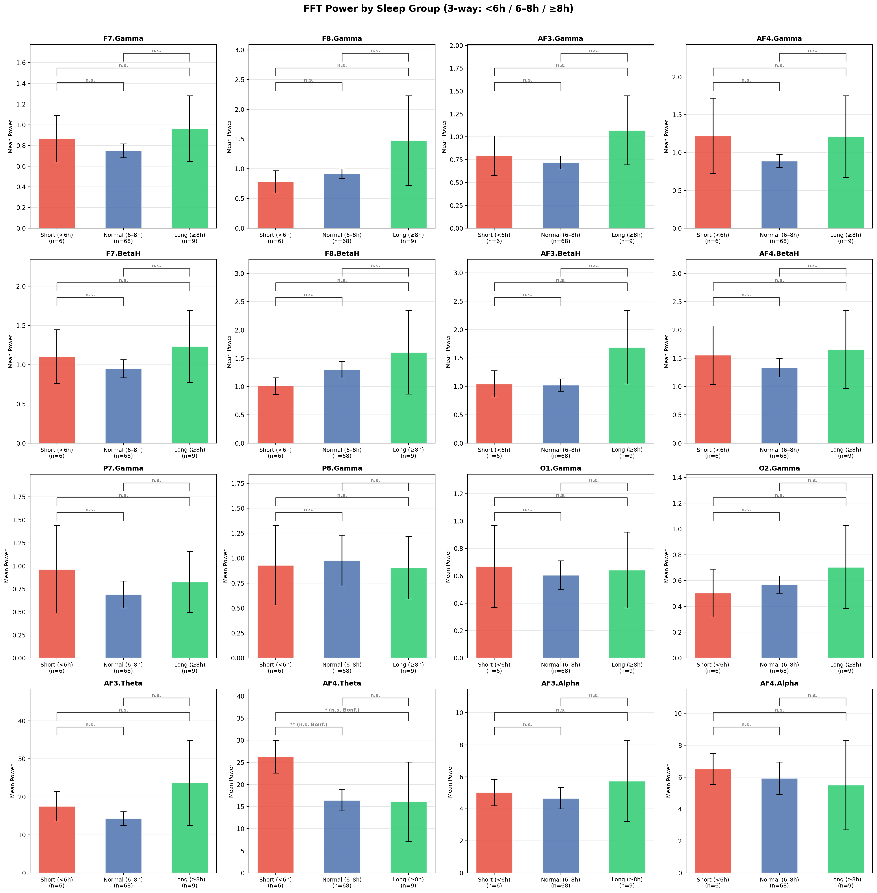
Figure 4: sleep_group_3way_fft.png — FFT band power across three sleep groups (<6h / 6–8h / ≥8h). Mann-Whitney U tests with Bonferroni correction; no result survives correction.

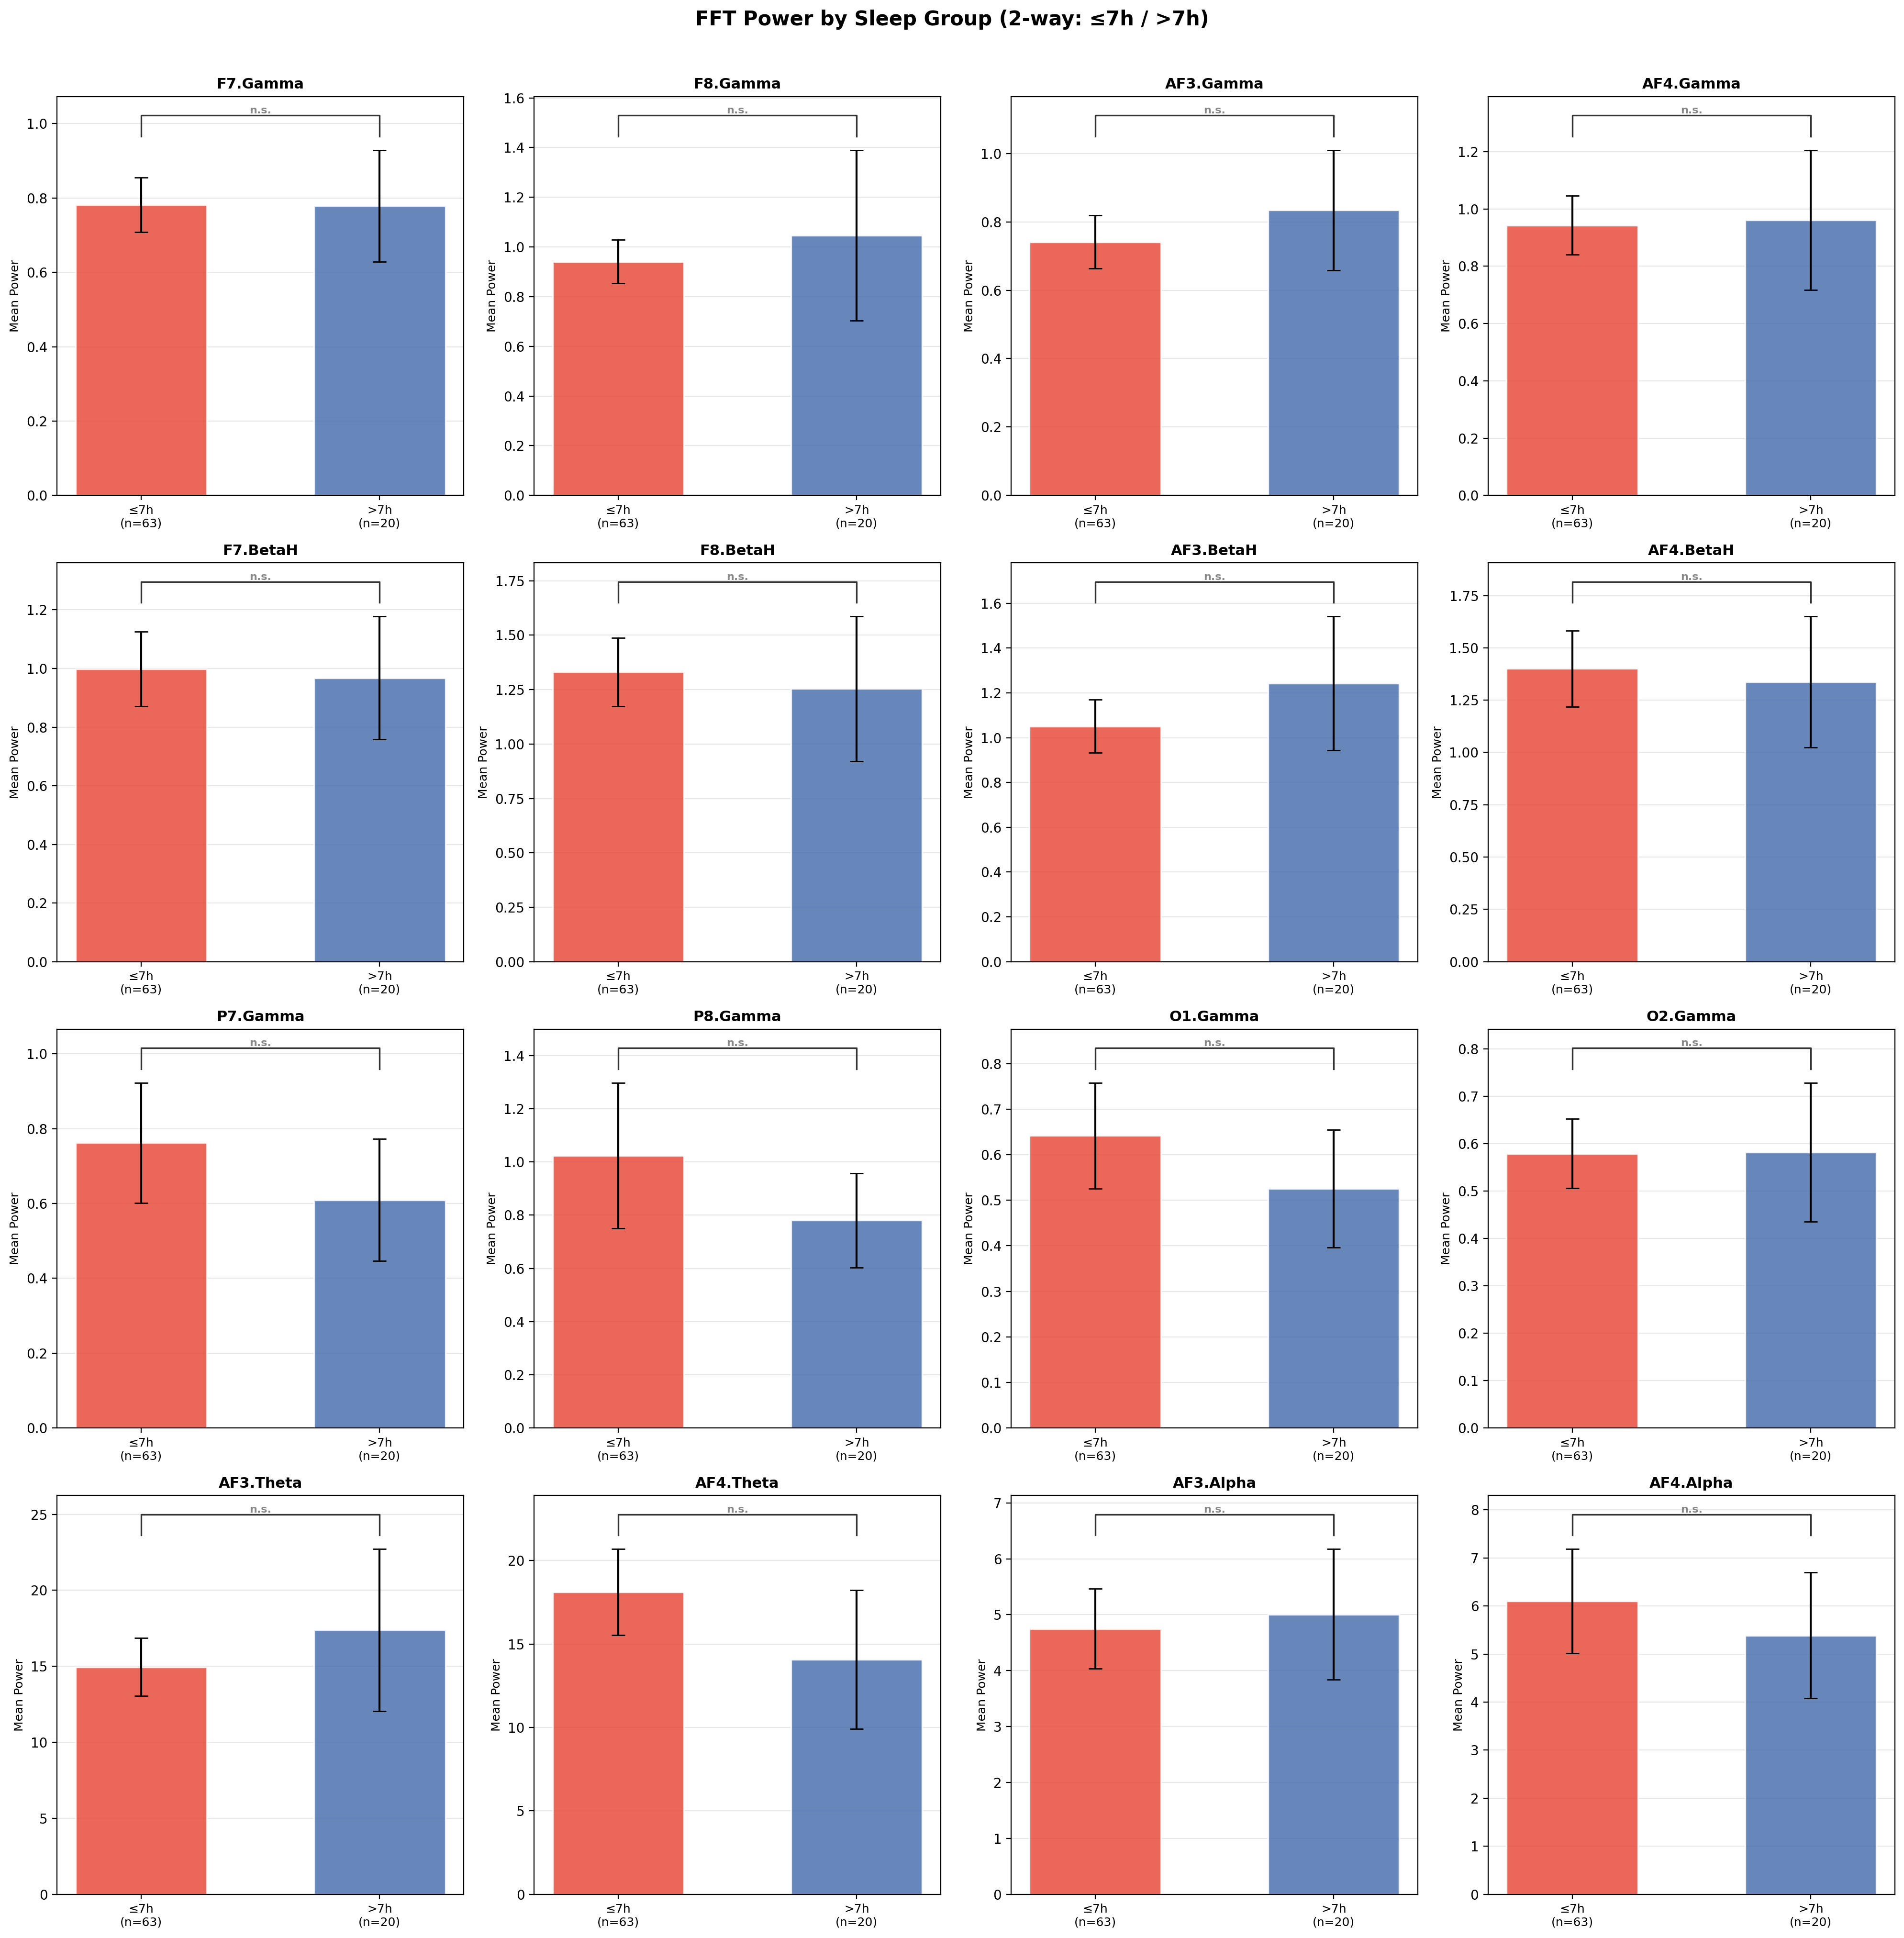
Figure 5: sleep_group_2way_fft.png — Same comparison with a 2-way split (≤7h / >7h). Better statistical power but still no significant differences after Bonferroni correction.
3d. Per-task analysis
-computed Pearson r between sleep hours and FFT power separately for each of the 36 tasks (always at the subject level, 83 data points per correlation). This gives ~2,520 correlations total.

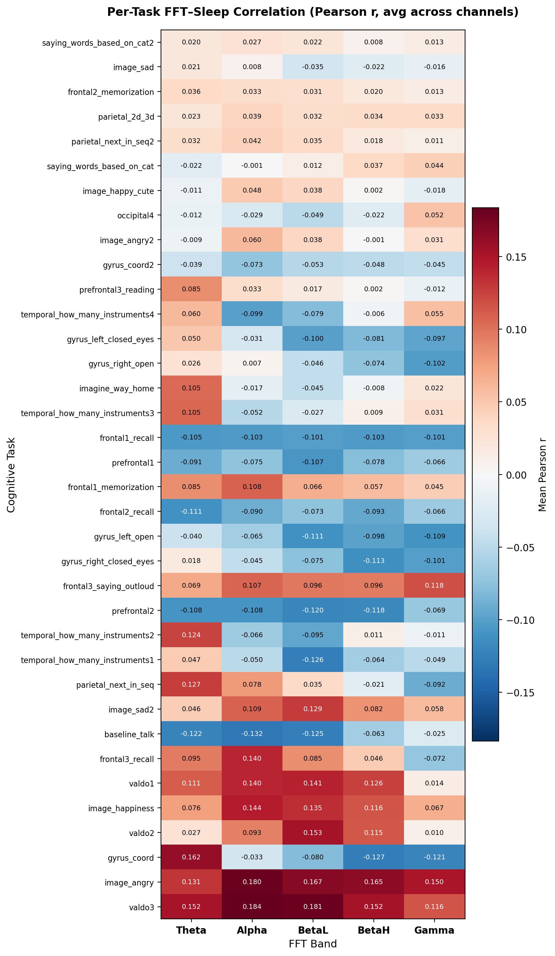
Figure 6: per_task_fft_heatmap.png — Mean Pearson r per task (rows) and FFT band (columns), averaged across 14 channels. Sorted by strongest absolute signal. Tasks at the top show the clearest sleep-related patterns.

Key result: T7 (left temporal) shows up in 6 of the top 10 strongest task-band-channel pairs, across completely independent tasks. Gamma at T7 consistently correlates negatively with sleep duration (r around −0.35 to −0.38).

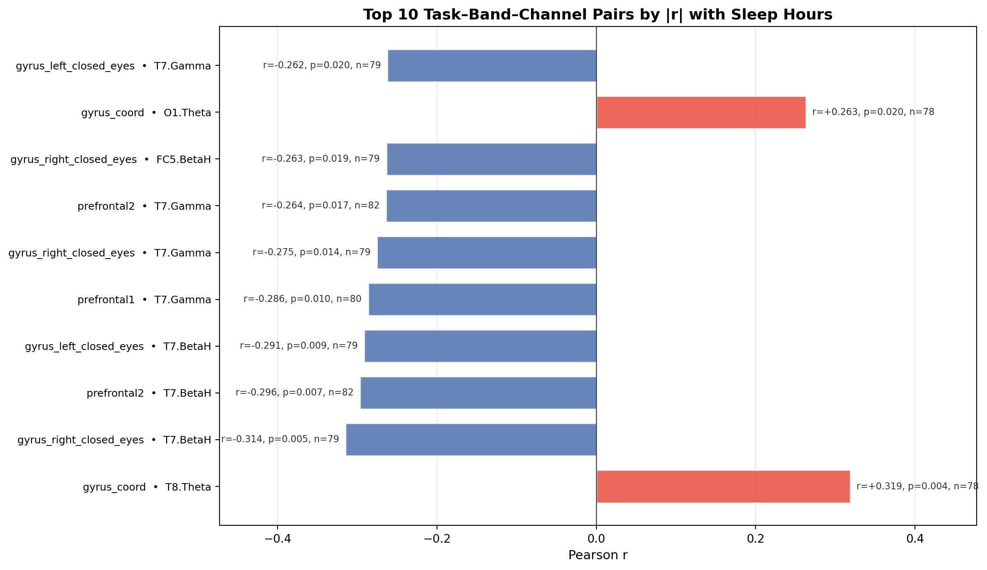
Figure 7: top_task_band_pairs.png — Top 10 individual task-band-channel pairs by absolute Pearson r. T7.Gamma dominates, appearing in 6 of 10 pairs across different tasks.

The fact that T7.Gamma replicates across independent tasks makes it more convincing than noise. The strongest effects appear in working memory and sustained attention tasks, which could reflect sleep-dependent temporal cortex processing of verbal/phonological content.
- RF model to confirm through feature importance

All 10 top pairs p < 0.05, NOT CORRECTED!:

# | Task | Feature | r | p
1 | gyrus_coord | T8.Theta | +0.319 | 0.004
2 | gyrus_right_closed_eyes | T7.BetaH | −0.314 | 0.005
3 | prefrontal2 | T7.BetaH | −0.296 | 0.007
4 | prefrontal1 | T7.Gamma | −0.298 | 0.010
5 | gyrus_left_closed_eyes | T7.BetaH | −0.291 | 0.009
6 | gyrus_right_closed_eyes | T7.Gamma | −0.275 | 0.014
7 | prefrontal2 | T7.Gamma | −0.264 | 0.017
8 | gyrus_left_closed_eyes | FC5.BetaH | −0.263 | 0.019
9 | gyrus_coord | O1.Theta | +0.263 | 0.020
10 | gyrus_left_closed_eyes | T7.Gamma | −0.262 | 0.020

T7 (left temporal) BetaH and Gamma dominate , 6 of the top 10 pairs across multiple task types, consistently negative with sleep hours. Motor/coordination tasks (gyrus_*) and prefrontal working memory tasks (prefrontal1, prefrontal2) are the most predictive. These task-channel combinations will be prioritised when building task-specific RF feature sets.

3e. Task-level EEG band activity: task_vs_bands_median.png
Z-scored median FFT band power per task, averaged across all 14 channels. Confirms the EEG data is physiologically valid: speech tasks show broadband activation (Theta + Beta + Gamma -expected EMG/muscle artifact), eyes-closed tasks show high Alpha, and passive image tasks are broadly suppressed.

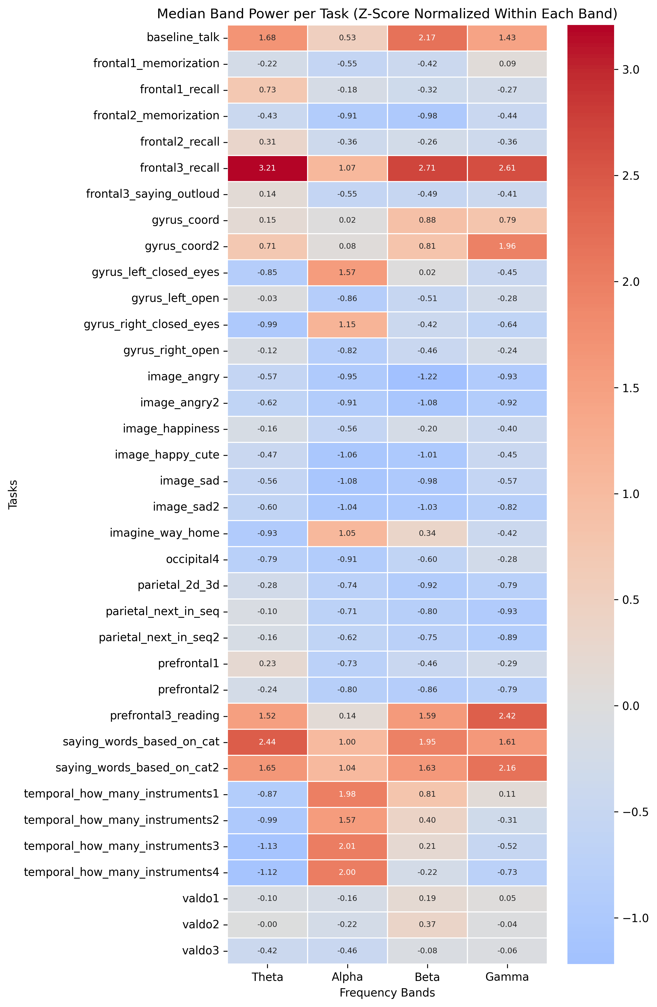
Figure 8: task_vs_bands_median.png — Z-scored median FFT power per task × band. Clear physiological patterns confirm signal validity.
Also generated: task_vs_channels_median.png — same analysis split by channel instead of band. Shows the same story spatially (frontal channels activate in speech tasks, occipital in auditory tasks).
3f. FFT vs Emotiv performance metrics — frontal region: fft_vs_metrics_frontal.png
Correlations between frontal FFT band power (AF3, F7, F3, FC5, FC6, F4, F8, AF4) and Emotiv’s performance metrics (Attention, Engagement, Stress, etc.).
Key finding: frontal Alpha negatively correlates with Engagement (r ≈ −0.21 to −0.23), alpha-blocking effect during cognitive engagement.
Stress correlates strongly with all frontal bands (r ≈ 0.24–0.33).

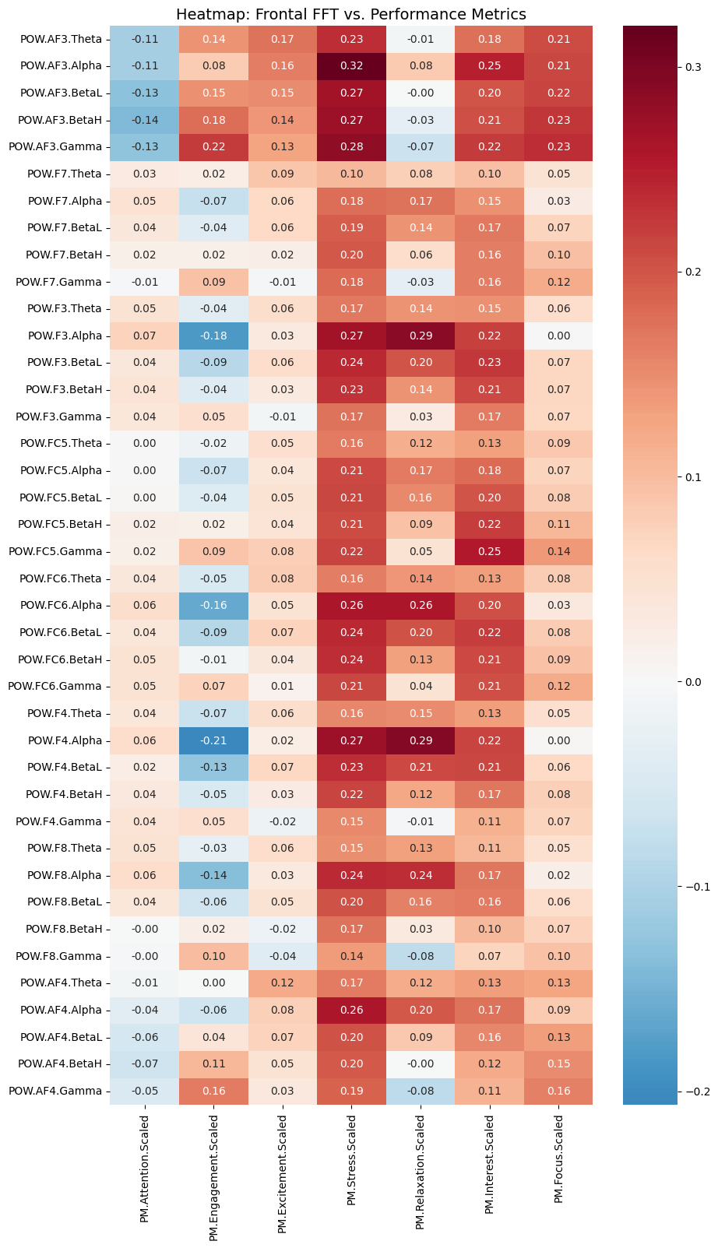
Figure 9: fft_vs_metrics_frontal.png — Pearson r between frontal FFT band power and Emotiv performance metrics. Frontal Alpha–Engagement link (r ≈ −0.22) is the clearest finding.
Also generated: fft_vs_metrics_parietal_occipital.png — same analysis for posterior channels (P7, P8, O1, O2). Strongest finding: P8.Alpha has the highest Relaxation correlation (r=0.41) confirming the alpha-relaxation link
3g. Graphs explored but not included

task_explainer_heatmap.png: category-level heatmap showing FFT–sleep correlations grouped by task category. Directionally interesting (Gamma/BetaH positive in Language tasks, negative frontal Theta in Motor tasks) but very dense. Superseded by the per-task heatmap (Figure 6) which gives individual task resolution.

complete_performance_heatmap.png :full correlation matrix of all Emotiv PM metrics vs each other and vs Sleep_Hours. Sleep_Hours row shows all r below |0.28|. The inter-metric correlations are high (Stress-Interest r=0.73) but just reflect Emotiv’s internally coupled proprietary metrics. Not a primary finding.

individual_graphs/ (clustered_map_BA*.png): Ward clustering dendrograms for 9 pilot subjects, from PM metrics only. BA51 retained ~9 segments vs ~36 for others, making comparisons inconsistent. No reproducible structure across subjects. From pilot data only.

visuals_tasks_per_metric/ (*_Comparison.png): 7 sleep-group bar charts based on pilot data (n=9) comparing PM metrics across coarse sleep groups. Superseded entirely by the full-dataset FFT group charts in visuals_sleep_groups/.

4. Model phase- currently

Feature aggregation strategy
Each subject contributes multiple recordings per task.
-aggregate per subject by computing the mean FFT feature across all recordings- giving one 70-dimensional feature vector per person.
-try task-specific feature matrices (83 × 70 per task) to see whether some tasks are more predictive, guided by the per-task heatmap above.

Model: Random Forest regression
The plan:
- LOSO-CV (Leave-One-Subject-Out) - 83 folds, one held-out subject per fold
- Metrics: RMSE, MAE, R² - all reported on the held-out predictions
- Feature importance plot (raw + permutation) to identify which channels/bands/tasks drive predictions
- Hyperparameter grid search within each fold (n_estimators, max_depth)

What I expect
R² will likely be modest given the narrow sleep distribution.
-targeting RMSE < 0.8h as a reasonable threshold.
-The more interesting output will be feature importance , if T7.Gamma and frontal Gamma/BetaH dominate, that aligns with the EDA.

if time allows:
- Add gender
- Add Emotiv Performance Metrics (Attention, Focus, Engagement, etc.) as additional features
- Try per-task models and compare task-level RMSE to identify which cognitive loads best reveal sleep state
- SVR or Ridge regression as comparison baselines

