EEG-Based Sleep Duration Prediction
Analysis Phase — Progress Report & Findings Summary

Student: Paola Carić
Mentor: dr.sc. Mateo Sokač, Algebra University
Date: April 2026
Status: Analysis complete — Modelling tables built — RF scripts ready to run

1. Project Overview
The goal of this thesis is to predict average nightly sleep duration (in hours) from EEG recordings collected during a structured cognitive task protocol. The prediction target is a continuous variable (Sleep_Hours) drawn from participant metadata, and the primary features are FFT band-power values computed per EEG channel and cognitive task, supplemented by proprietary performance metrics from the Emotiv headset.
The project follows a two-phase modelling plan agreed with the mentor:
- Phase 1 (Classical ML): Random Forest and Gradient Boosting on aggregated FFT features + demographic variables (Gender, and optionally medication/neurological history).
- Phase 2 (Deep Learning): RNN / GRU / LSTM on raw EEG time-series for the task types identified as most informative in Phase 1.
This document summarises everything completed through the end of the Analysis phase: data preparation, exploratory data analysis, all graphs produced, key findings, and what carries forward into modelling.

2. Dataset Description

2.1 Subjects and Target Variable
The full cohort consists of 83 subjects, all of whom are included in the analysis-ready dataset. The target variable is self-reported average sleep hours per night, ranging from 5.0 h to 8.5 h (mean = 6.7 h, median = 7.0 h, std = 0.78 h). The distribution is narrow and right-skewed, with the vast majority of subjects reporting between 6 and 7.5 hours.
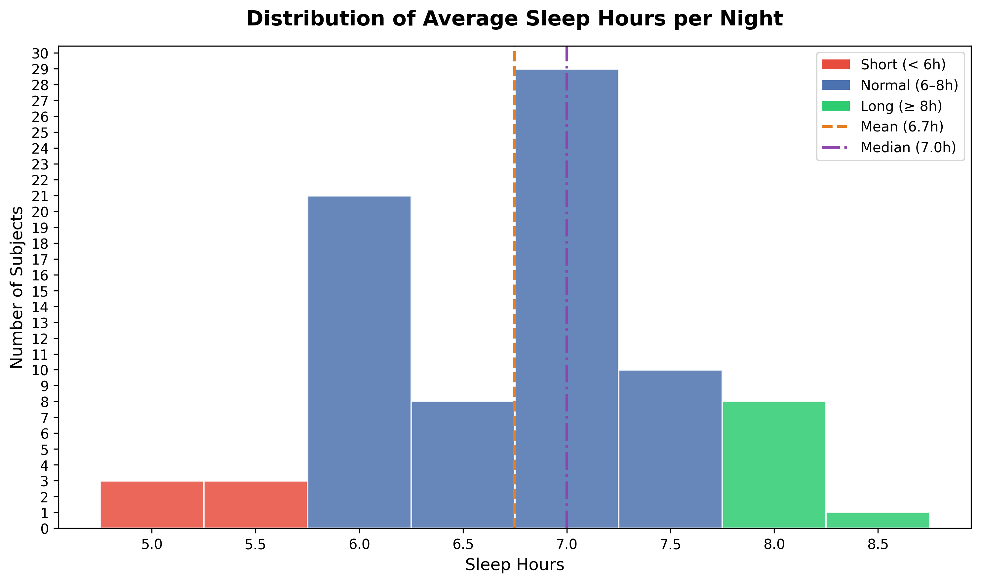
Figure 1. Distribution of average sleep hours across all 83 subjects. Red = short sleepers (< 6 h), blue = normal (6–8 h), green = long (≥ 8 h). Short: ~6 subjects; Normal: ~66 subjects; Long: ~9 subjects (8 at 8.0 h, 1 at 8.5 h).
Key insight: The narrow distribution of sleep hours (std = 0.78 h, nearly all subjects within a 2-hour range) is the single most important factor explaining why individual EEG features show weak linear correlations with sleep. There is simply very little variance to predict. This motivates a multivariate ML approach rather than simple correlation analysis.

2.2 EEG Setup and Features
EEG was recorded using an Emotiv EPOC headset with 14 channels: AF3, F7, F3, FC5, T7, P7, O1, O2, P8, T8, FC6, F4, F8, AF4. Two types of features are available:
- FFT band power (POW columns): Theta, Alpha, BetaL, BetaH, Gamma — one value per channel per row. These are the primary ML features.
- Performance Metrics (PM): Attention, Engagement, Excitement, Relaxation, Focus, Stress, Interest — proprietary Emotiv scores derived from the EEG signal.
Signal quality is tracked via CQ (Channel Quality) columns per channel and a global interpolation flag. Both were used during data preparation to filter out unreliable sessions.

2.3 Task Protocol
Each participant completed approximately 60 distinct cognitive tasks, grouped into six functional domains:
- Cognitive/Language: word generation, sentence construction, reading aloud (prefrontal1-3, frontal3)
- Memory: word/number memorisation and recall (frontal1-2, frontal3_recall)
- Visual/Spatial: dot-following, 2D/3D pattern tasks, sequence completion (occipital4, parietal tasks, valdo1-3)
- Motor/Action: left/right hand motor tasks with eyes open/closed (gyrus tasks)
- Auditory: instrument counting, category-based word generation (temporal tasks)
- Emotional: viewing images of happiness, sadness, and anger (image tasks)
Tasks are identified by a MarkerIndex column embedded directly in the data.csv EEG stream (positive value = task start, negative = task end). This inline marker approach was used during preprocessing to segment the continuous EEG recording into task-level epochs for all 83 subjects, independently of the marker.csv timestamp column.

3. Data Preparation Phase
Data preparation was completed in two stages: a pilot stage on 10 randomly selected subjects, followed by full-dataset processing once the pipeline was validated.

3.1 Pipeline Scripts
- load_data.py — maps subject IDs from DatasetSub_shorten.csv to their corresponding data.csv and marker.csv files; extracts Sleep_Hours and Gender per subject.
- clean_pilot_dataset.py — processes the pilot 10 subjects: synchronises using inline MarkerIndex events in data.csv, segments EEG into task epochs, applies signal quality filters (CQ columns, interpolation threshold), and outputs pilot_task_ready.csv and pilot_categorized_tasks.csv.
- clean_whole_dataset.py — extends the same pipeline to all 83 subjects, outputting all_task_ready.csv (n=83 subjects) and associated summary files.
- signal_quality_check.py — produces pilot_signal_quality.csv and pilot_data_map.csv, showing per-subject and per-channel quality metrics.

3.2 Output Files
File | Subjects | Description
pilot_task_ready.csv | 10 | Pilot subjects, task-level rows, FFT + PM + Sleep_Hours + Gender
pilot_categorized_tasks.csv | 10 | Same as above with task_category labels added
pilot_signal_quality.csv | 10 | Per-subject signal quality scores (CQ, interpolation, final retained %)
pilot_data_map.csv | 10 | Subject ID → file paths + Sleep_Hours + Gender mapping
all_task_ready.csv | 83 | Full dataset, all subjects, quality filter applied row-level. Primary input for ML models.
task_vs_bands_median.csv | 83 | Median Z-score band power per task (aggregated)
task_vs_channels_median.csv | 83 | Median Z-score channel power per task (aggregated)

Note on synchronisation: Task segmentation uses the MarkerIndex column embedded in each subject's data.csv, not the timestamp column in marker.csv. This approach is robust to marker file mismatches and ensures all 83 subjects are correctly processed. The marker.csv is used only as a name lookup (marker_id → task name).

4. Exploratory Data Analysis — Findings

4.1 EEG Physiological Validity (Task vs. Bands Heatmap)
The first analytical question was whether the EEG data reflects known physiological patterns. A Z-score heatmap of median band power per task confirms that the signal is physiologically valid:
- Speech tasks (baseline_talk, frontal3_saying_outloud, saying_words_based_on_cat) show broadband activation across Theta, Beta, and Gamma — consistent with expected EMG/muscle artifact from jaw and facial movement during vocalisation.
- Eyes-closed and imagination tasks (imagine_way_home, temporal_how_many_instruments) show strong Alpha enhancement — the classic alpha-blocking-release pattern seen when visual cortex is not processing external input.
- Passive image-viewing tasks (image_happiness, image_sad, image_angry) are uniformly suppressed across all bands, reflecting reduced active processing relative to the Z-scored baseline.
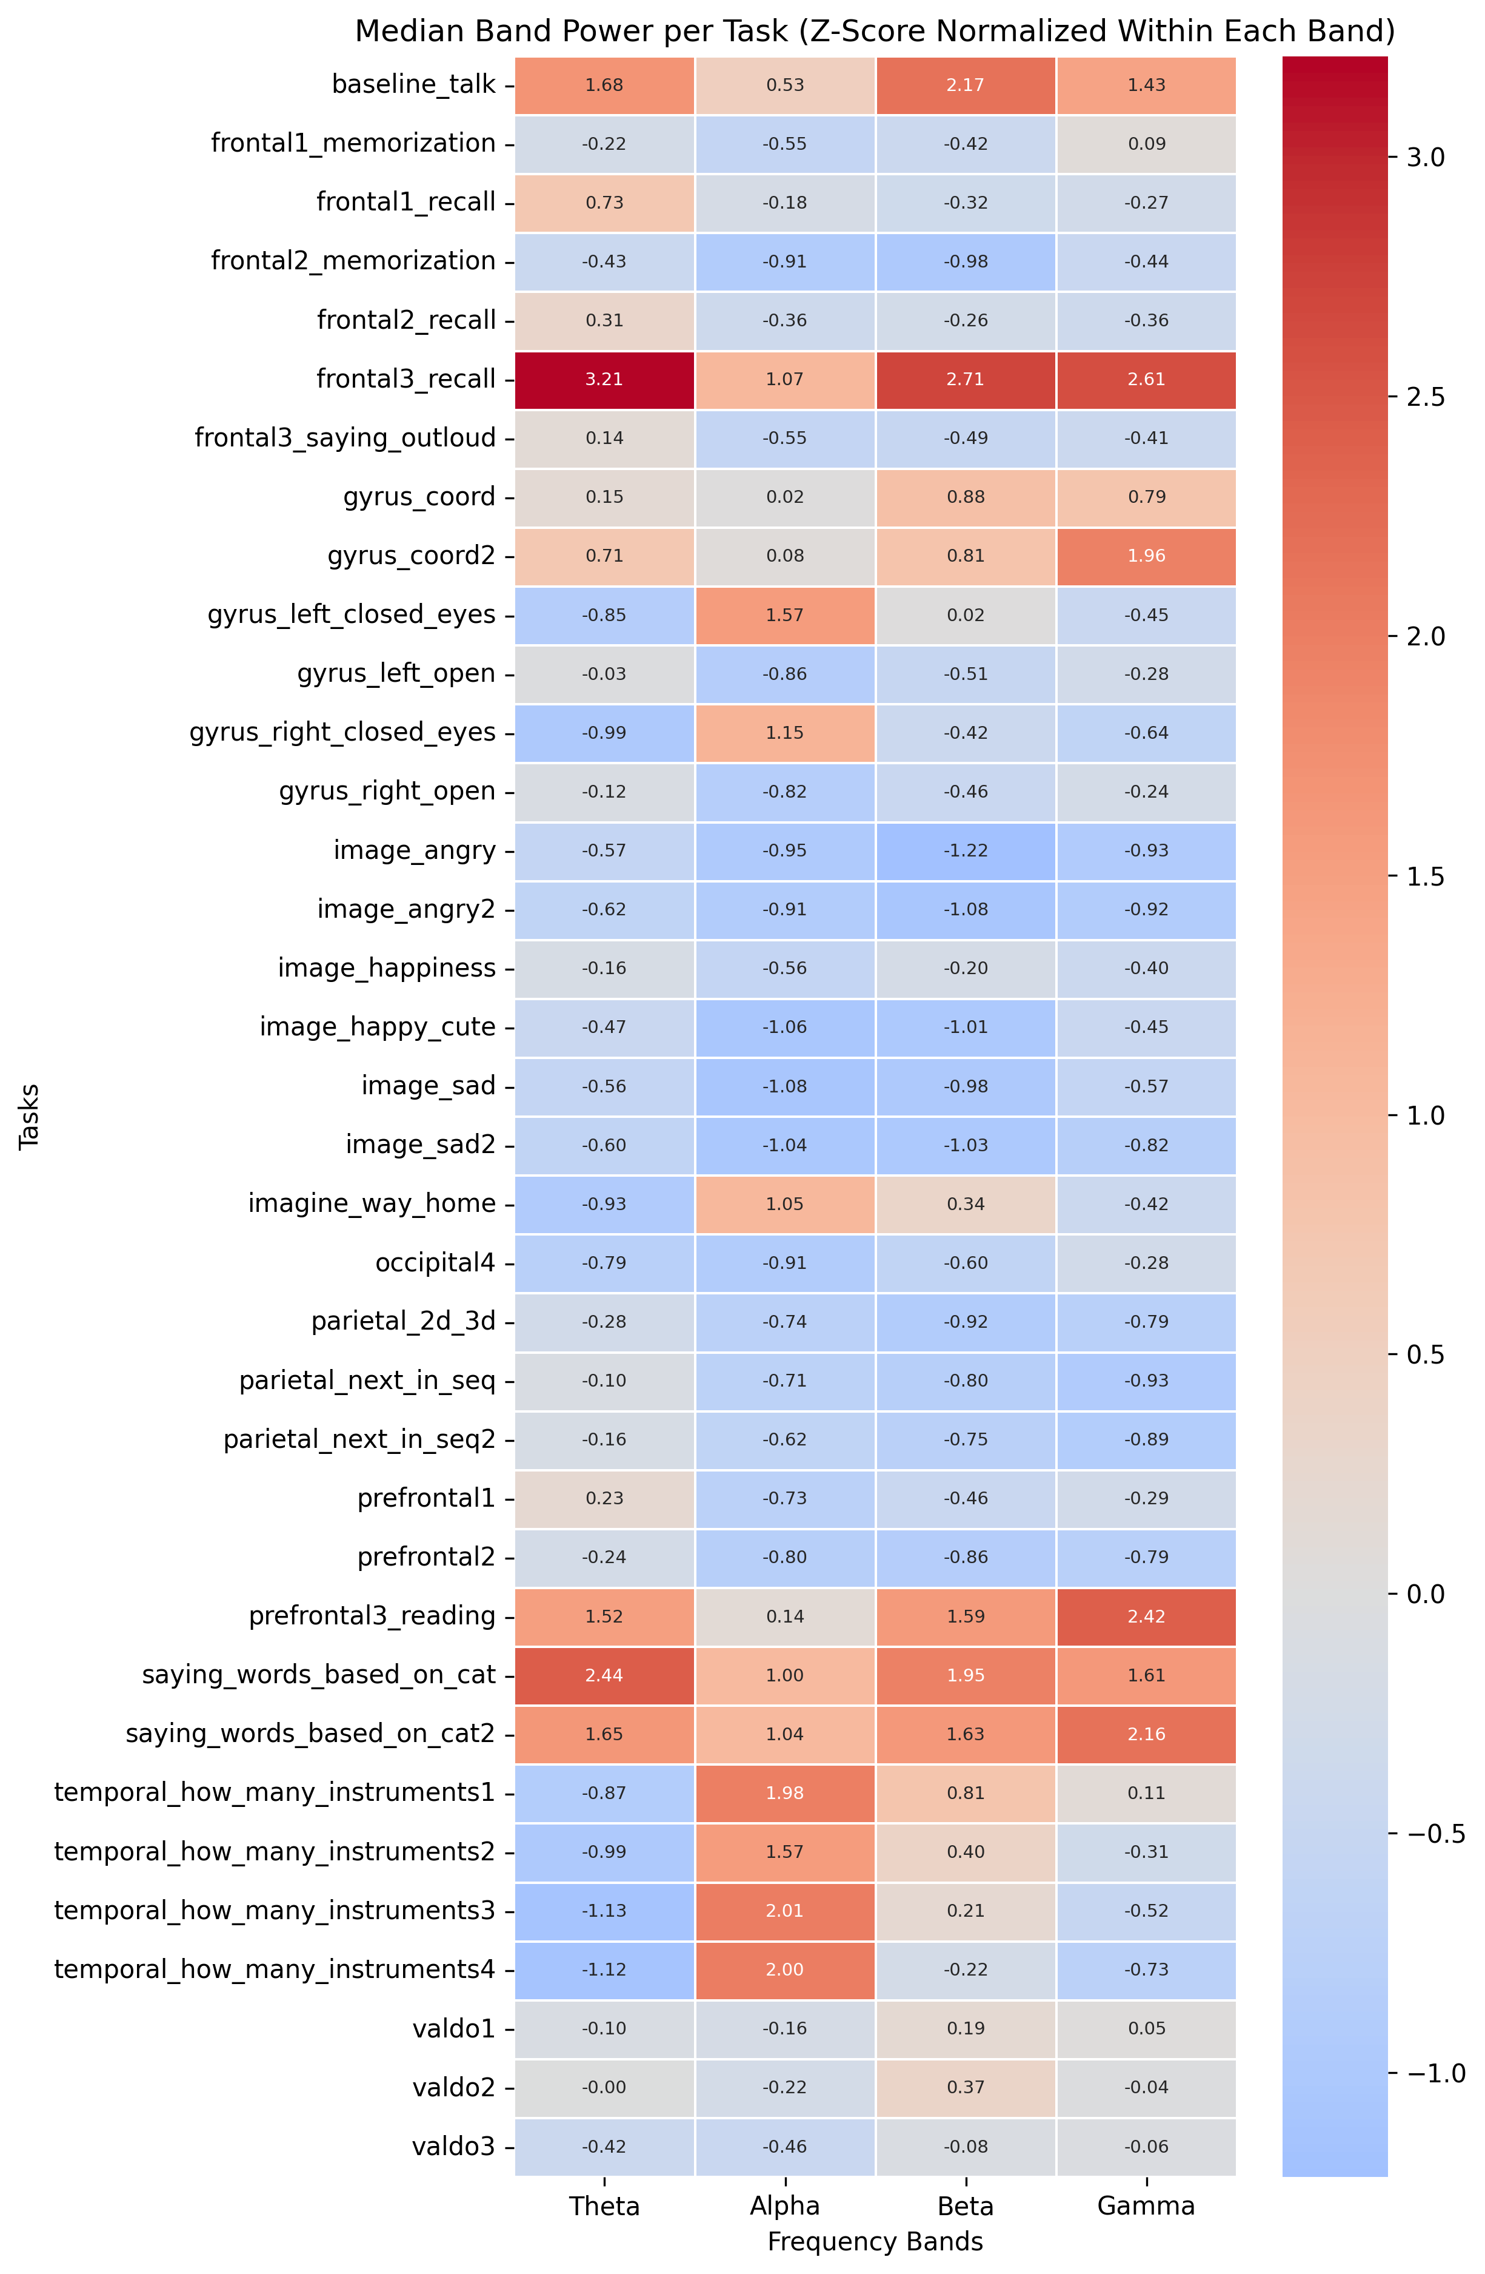
Figure 2. Median band power (Z-score normalised within each band) per task. Red = above average activation, blue = below average. Confirms physiologically expected EEG patterns across task types.
This graph serves as the "sanity check" section of the thesis — it demonstrates that data collection and preprocessing did not introduce systematic artifacts, and that the EEG device captured meaningful neural signals.

4.2 Sleep Duration Distribution
Already shown in Figure 1. Key statistics: mean = 6.7 h, median = 7.0 h, std = 0.78 h, range = 5.0–8.5 h. The distribution is heavily concentrated in the 6–7.5 h range, with very few truly short sleepers (< 6 h: ~6 subjects) or long sleepers (≥ 8 h: ~9 subjects). This narrow variance in the target variable is the primary challenge for prediction and is why no single EEG feature shows statistically significant correlation with sleep at the subject level.
Note on binning: The original script used auto-generated bins (bins=12) which placed a bin boundary at ~5.875 h, causing subjects who sleep exactly 6.0 h to appear as "Short" sleepers in the visualisation. This was corrected by switching to fixed bin edges [4.75, 5.25, 5.75, 6.25, ...] centred on half-hour values, aligning bin boundaries precisely with the 6 h and 8 h group thresholds.

4.3 FFT Features vs. Sleep Duration (Row-Level Correlations)
A Pearson correlation was computed between each FFT feature (channel × band) and Sleep_Hours at the row level across the full all_task_ready.csv dataset. The top positive and negative correlates are shown below.
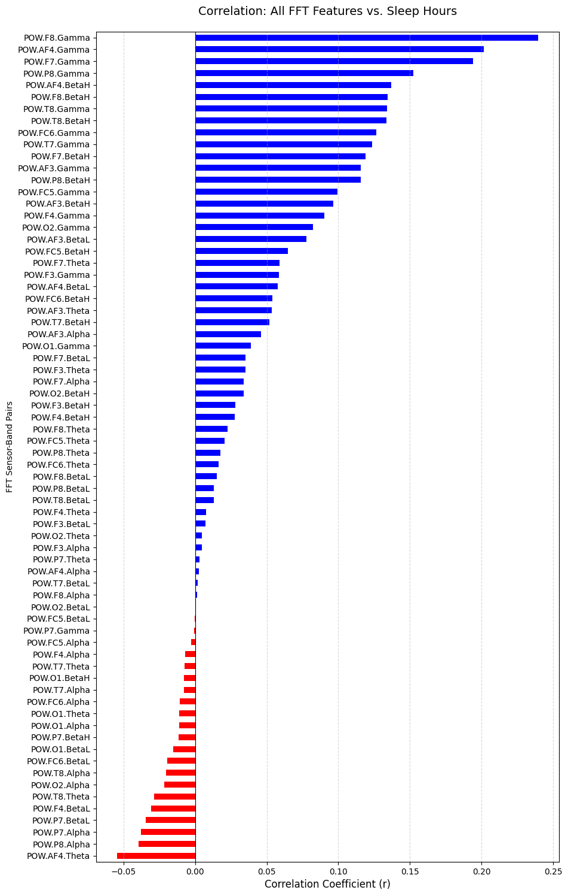
Figure 3. Pearson correlation between each FFT feature and Sleep_Hours (row-level, n = all rows in all_task_ready.csv). Blue = positive, red = negative. Values up to r ≈ ±0.27.
Key findings from this analysis:
- Top positive correlates: Gamma and BetaH bands at right-hemisphere channels (F8, F7, T8, P8). Correlation r up to ~+0.27.
- Top negative correlates: Theta and Alpha bands at prefrontal channels AF3 and AF4, with r down to ~−0.15.
- Interpretation: More sleep is associated with higher high-frequency power (Gamma, BetaH) and lower frontal Theta/Alpha. This aligns with neuroscientific literature suggesting that well-rested individuals have greater cognitive bandwidth and reduced drowsiness-related slow-wave activity.
Important caveat: These are row-level correlations computed over many rows per subject (one per task). The effective sample size is inflated because within-subject variance contributes to the correlation. The "top positive" features (F8.Gamma, F7.Gamma) actually reverse direction when computed at the subject level — see Section 4.5.

4.4 FFT Features vs. Emotiv Performance Metrics
Separate heatmaps were produced for frontal, parietal/occipital, and temporal brain regions, showing Pearson correlations between FFT band-power values and the seven Emotiv performance metrics.
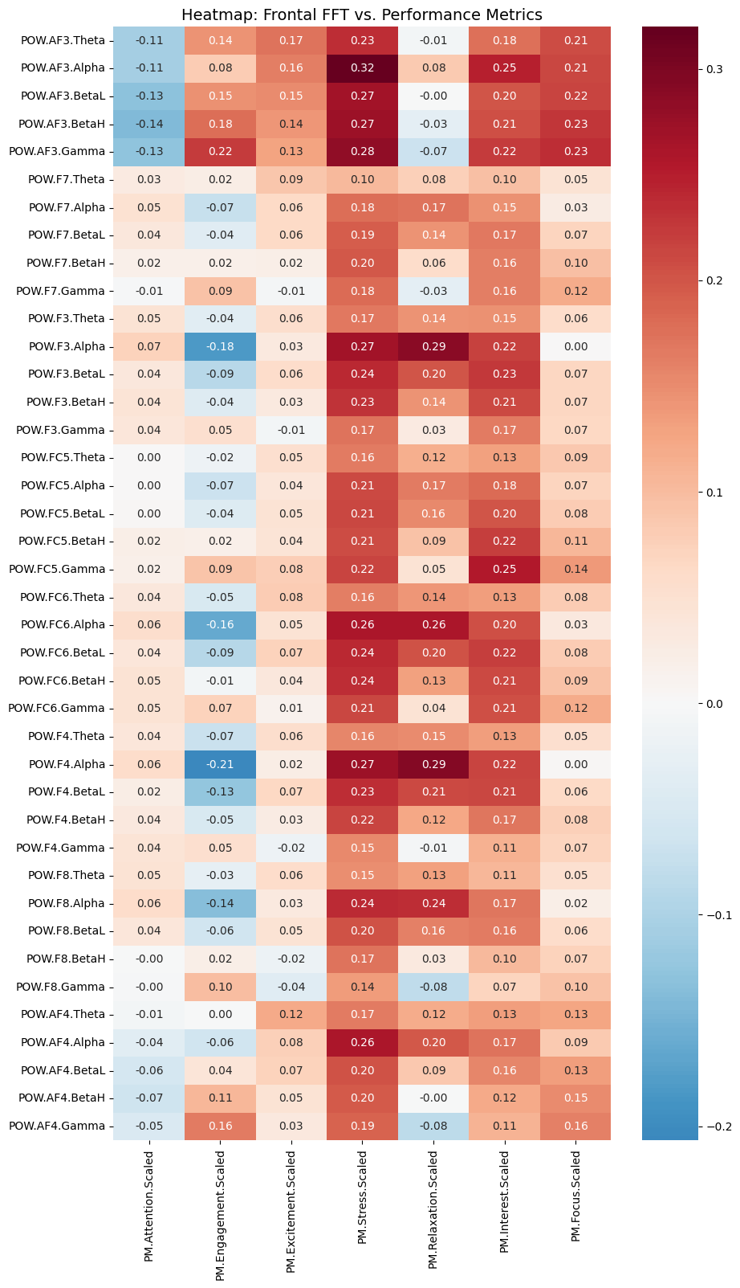
Figure 4. Frontal region: FFT band power vs. Emotiv performance metrics. Annotated with Pearson r values.
Key findings:
- Frontal Alpha power negatively correlates with Engagement (r ≈ −0.21 at AF3.Alpha) — the classic alpha-blocking effect: when a person is more engaged, frontal alpha is suppressed.
- Stress correlates positively with multiple frontal bands (r up to ~0.30), consistent with the Emotiv stress metric being derived partly from high-frequency frontal power.
- Posterior (parietal/occipital) Alpha shows the strongest single correlation in the dataset: P8.Alpha vs. Relaxation at r = +0.41, and a strong negative correlation with Engagement at P8 (r = −0.35). This confirms the alpha-relaxation link well-established in EEG literature.
- Temporal region correlations are weak (mostly r < 0.20) — this region appears least informative among the three.
- Most inter-metric correlations (Stress–Interest r = 0.73, Stress–Relaxation r = 0.61) reflect internal structure within Emotiv's proprietary algorithm rather than independent physiological constructs. This limits the PM metrics' usefulness as independent features for sleep prediction.

4.5 Subject-Level Scatter Plots (FFT Features vs. Sleep)
To move from the row-level correlations (Section 4.3) to a subject-level view, the top 5 positive and top 4 negative FFT features were averaged per subject and plotted against Sleep_Hours. Features were Z-score normalised within each band to address the large scale differences (Theta power ≈ 100×, Gamma power ≈ 1×). Outliers beyond ±3 SD were clipped for readability. This analysis uses n = 83 subjects.
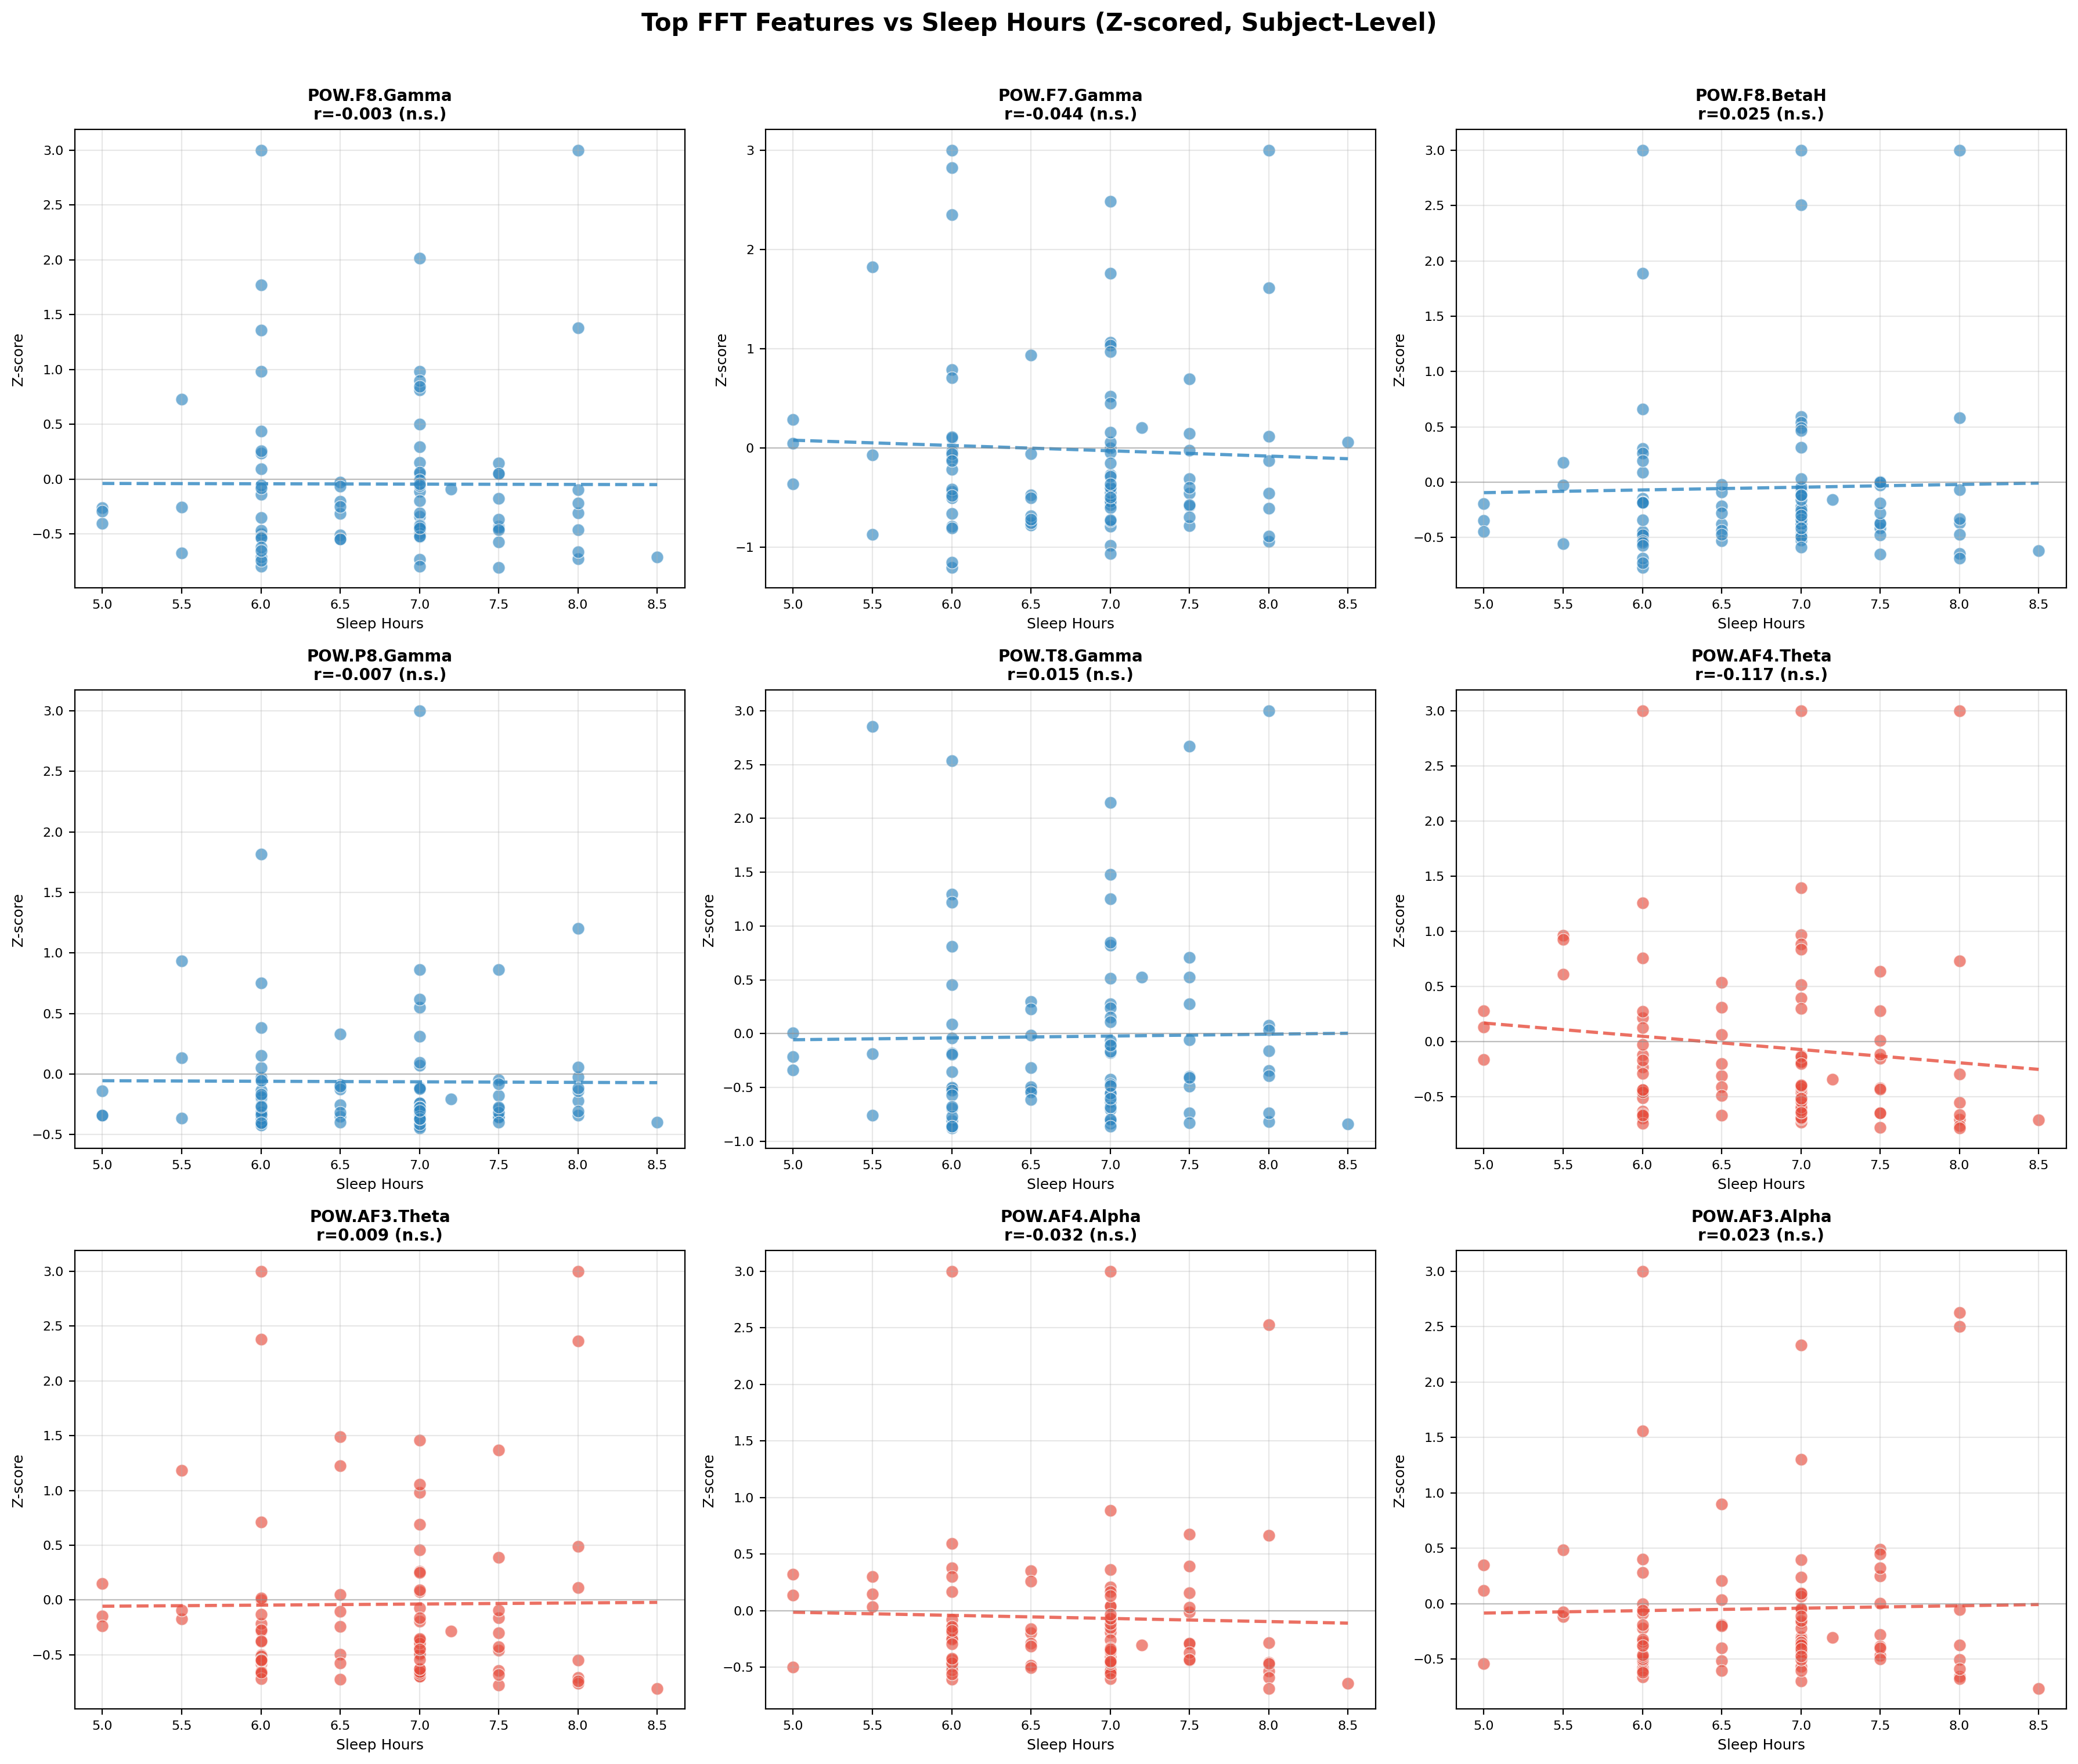
Figure 5. Subject-level scatter plots: top FFT features vs. Sleep_Hours. Blue = features with positive row-level correlations; red = negative. All r values shown are non-significant (all p > 0.05).
Key findings:
- None of the 9 features reach statistical significance at the subject level (all p > 0.05, n = 83).
- Direction reversal (important): F8.Gamma and F7.Gamma flip from positive at row-level to slightly negative at subject level. This means the row-level positive signal was driven by within-subject variance across tasks — not genuine between-subject sleep effects. The row-level correlations should be used for feature ranking only, not for directional interpretation.
- Strongest subject-level signal: AF4.Theta — the most consistent with the row-level finding and the largest in magnitude, but still non-significant. Exact r values to be updated after re-running scatter analysis with n = 83.
- Conclusion: No single FFT feature linearly predicts sleep hours at the subject level. Multivariate modelling is needed to combine weak signals across features.
Narrative for the thesis: The scatter plots pair with the correlation bar chart to tell a complete story. The bar chart shows which features are most associated with sleep at the population level; the scatter plots show why a univariate approach is insufficient. Together, they motivate the Random Forest model as the logical next step.

4.6 Performance Metrics as Sleep Predictors
The complete_performance_heatmap.png shows correlations between all performance metrics and Sleep_Hours. The strongest association is Engagement at r = +0.28 — all others are below |0.28|. These correlations are too weak to be useful as primary predictors. The sleep-group bar charts in visuals_tasks_per_metric/ (pilot data only, n = 9) confirm this: while consistent directional trends exist (e.g., 7h+ sleepers score slightly higher on Engagement in Cognitive_Language tasks), no comparison reaches statistical significance with n = 9. These charts have been set aside.

These final two EDA analyses were completed after the main graph series.

4.7 Sleep-Group FFT Bar Charts — Full Dataset
FFT band power (16 features: Gamma, BetaH, Theta, Alpha across frontal and posterior channels) was compared across sleep groups using Mann-Whitney U tests with Bonferroni correction. Two split strategies were tested.
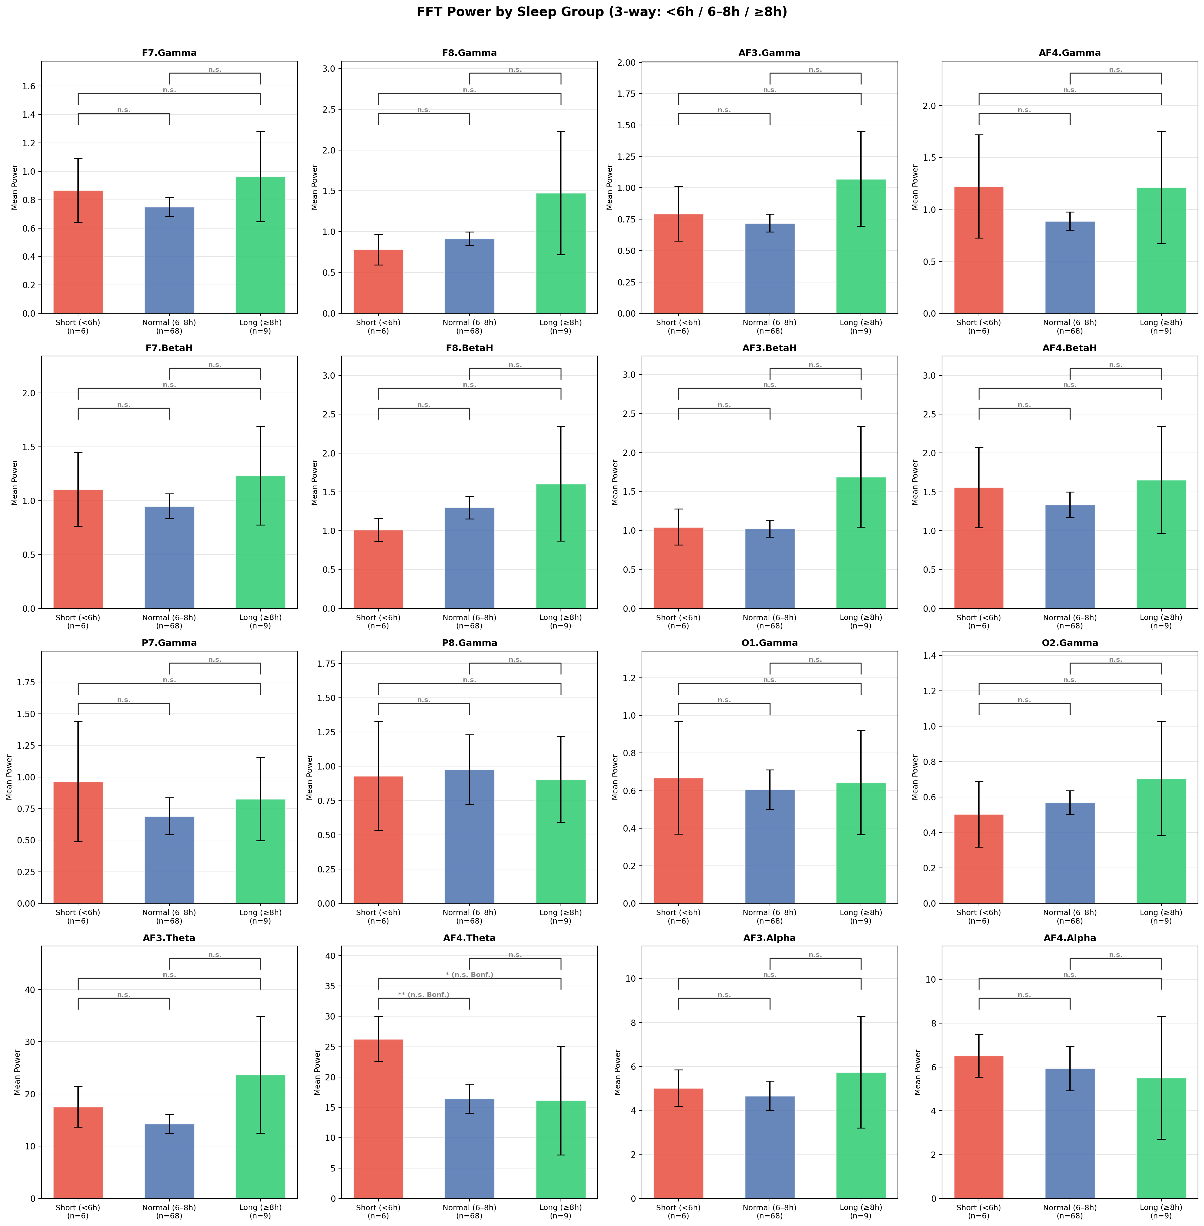
Figure 6. FFT power by sleep group (3-way: Short <6h / Normal 6–8h / Long ≥8h). Groups: n=6 / n=68 / n=9. Brackets show Bonferroni-corrected significance (α=0.05/48≈0.001). All comparisons n.s. after correction.
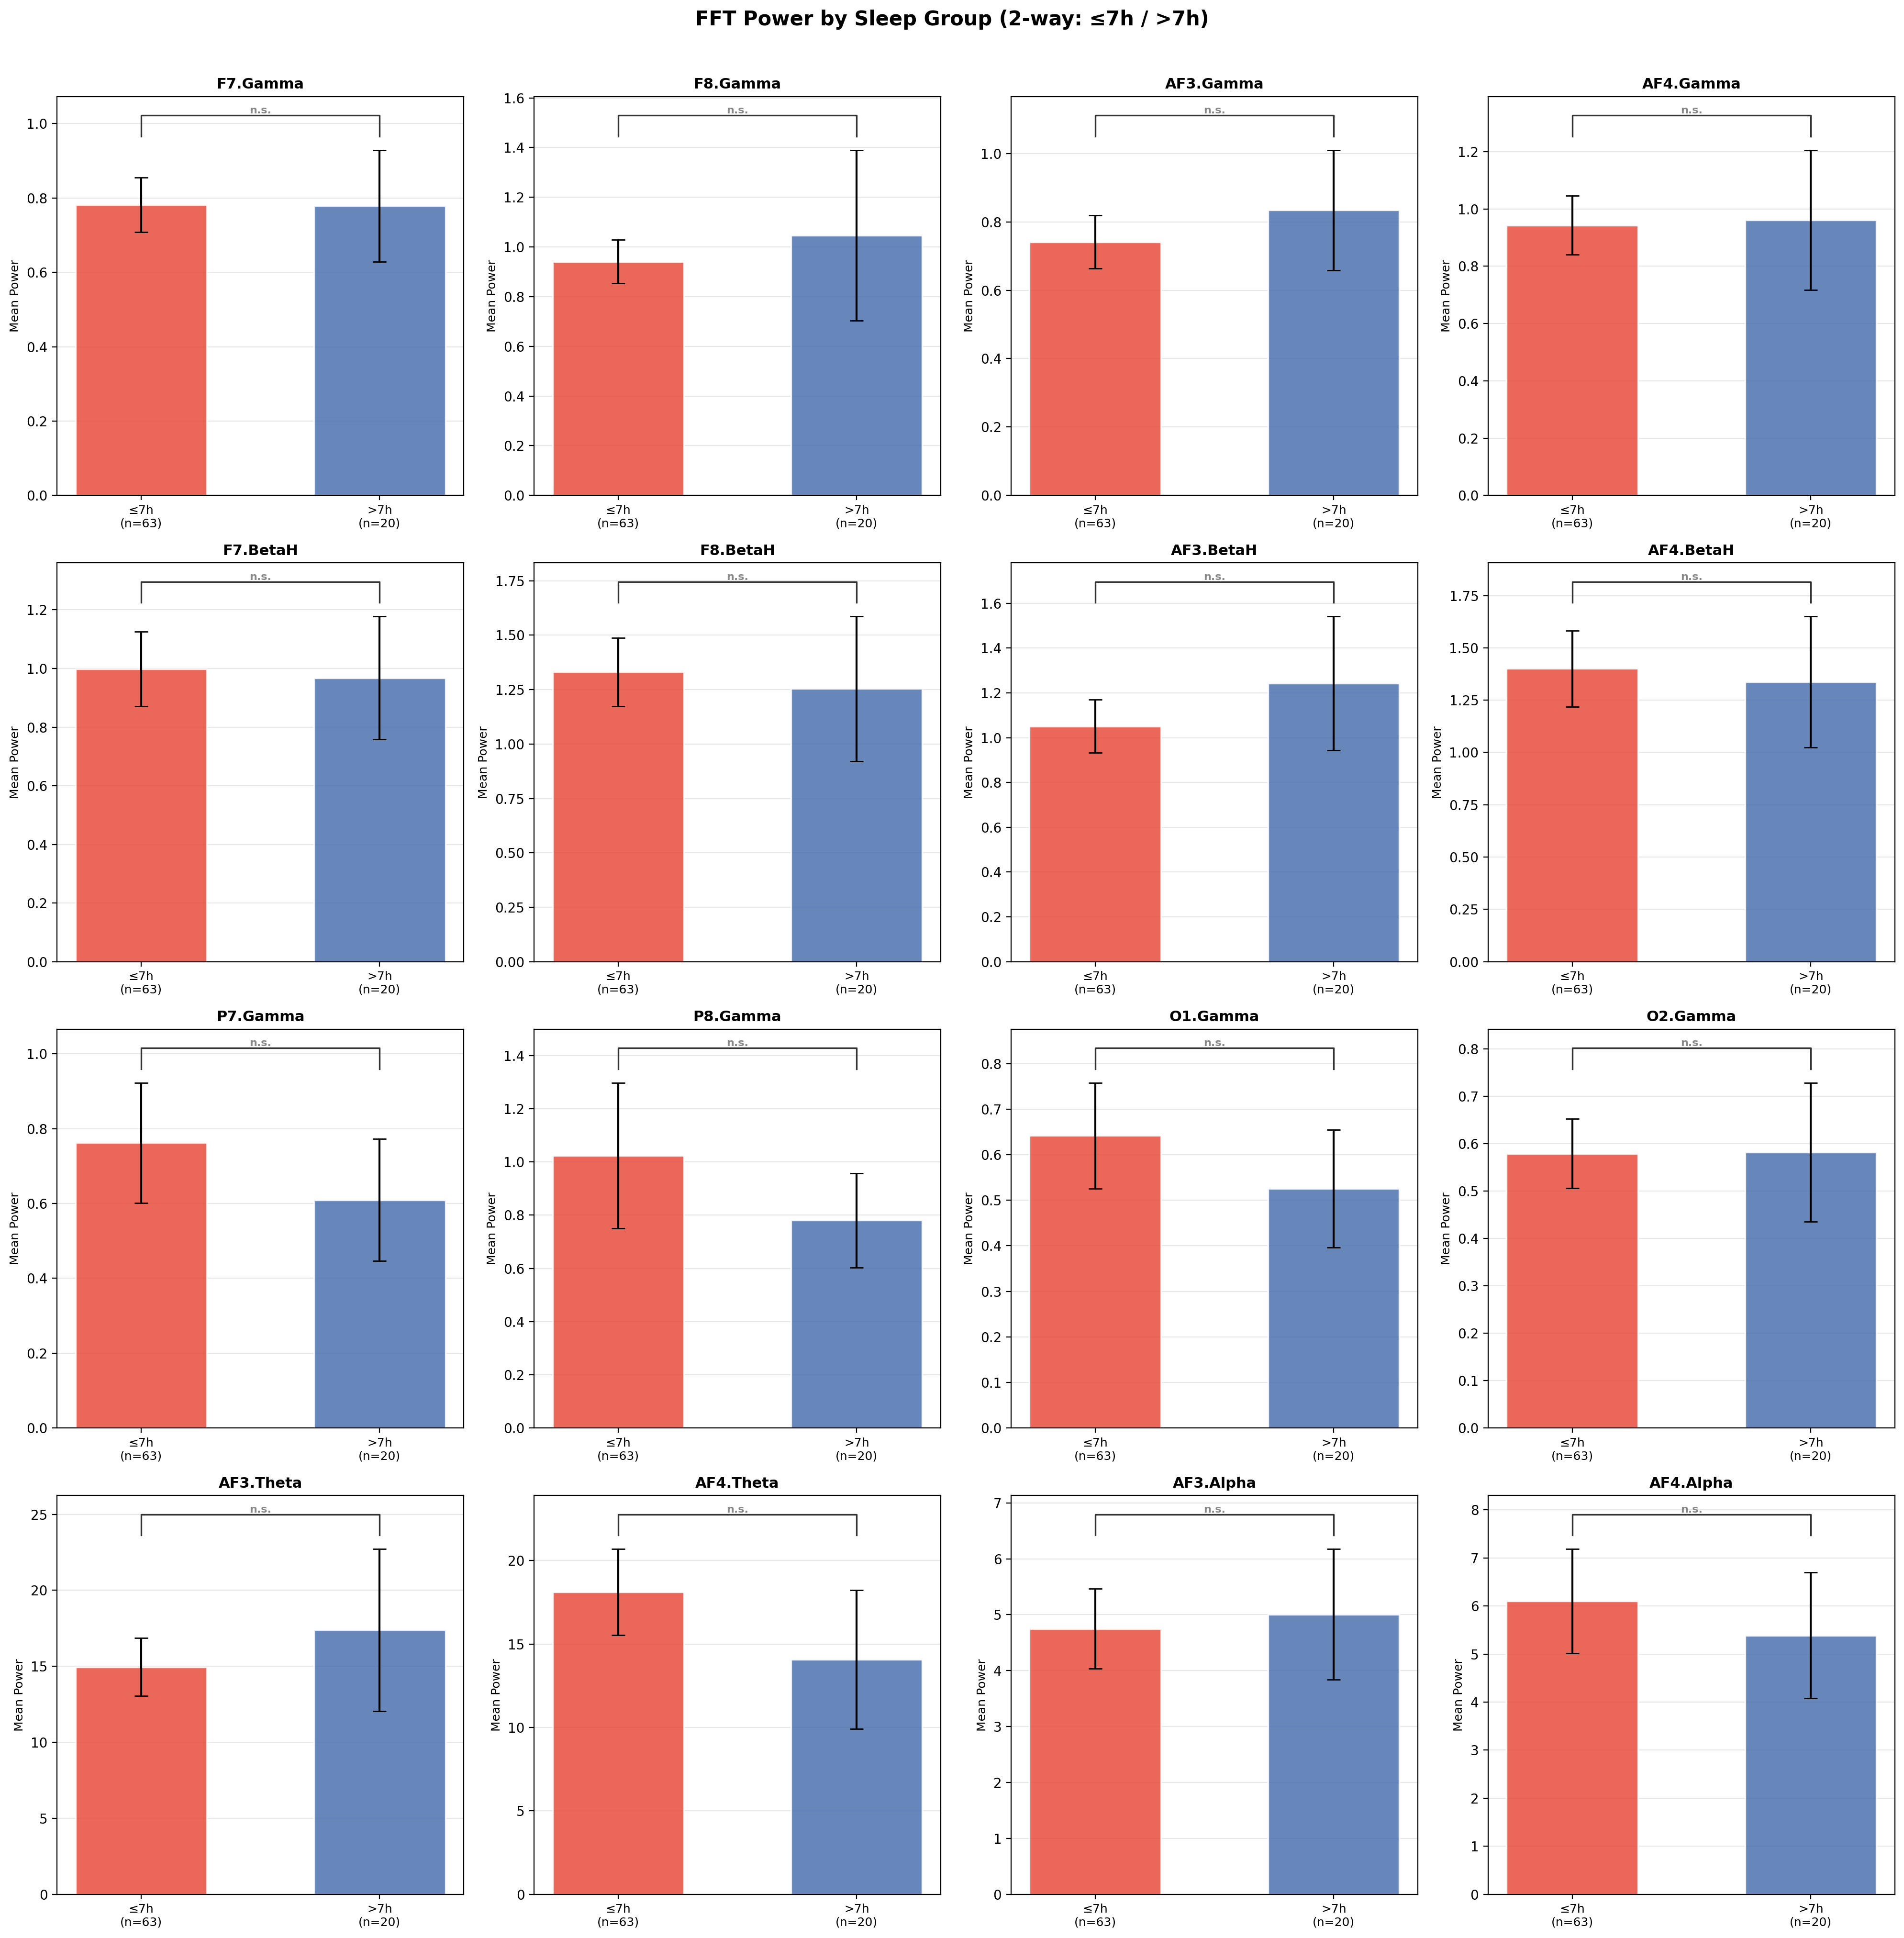
Figure 7. FFT power by sleep group (2-way: ≤7h vs >7h). Groups: n=63 / n=20. All 16 comparisons n.s. (lowest p≈0.10 for AF4.Theta).
Key findings:
- 3-way split: AF4.Theta showed Short vs Normal p=0.009 — nominally significant but does not survive Bonferroni correction (α_corrected ≈ 0.001). AF3.Theta and AF4.Alpha show borderline trends (p≈0.07–0.08), also n.s. after correction.
- 2-way split (≤7h vs >7h): All 16 comparisons n.s. Bar heights are nearly identical — even the median split reveals no detectable univariate group difference.
- Conclusion: No single FFT feature significantly separates sleep groups in a univariate comparison, even with the full 83-subject dataset. This is the expected result given the narrow sleep distribution and reinforces the need for multivariate ML.
Note on multiple comparisons: 48 pairwise tests (3-way) and 16 tests (2-way) were computed. Bonferroni correction was applied throughout (α_corrected = 0.05/n_tests). The one nominally significant result (AF4.Theta, p=0.009) does not survive correction and should not be reported as a finding. With n=6 short sleepers, statistical power is fundamentally limited.

4.8 Per-Task FFT–Sleep Correlation Analysis
For each of the 36 cognitive tasks, Pearson r was computed between subject-level mean FFT band power (averaged per subject within that task only) and Sleep_Hours. This directly answers the mentor's question: "Does FFT from some tasks better explain the difference in sleep hours?"
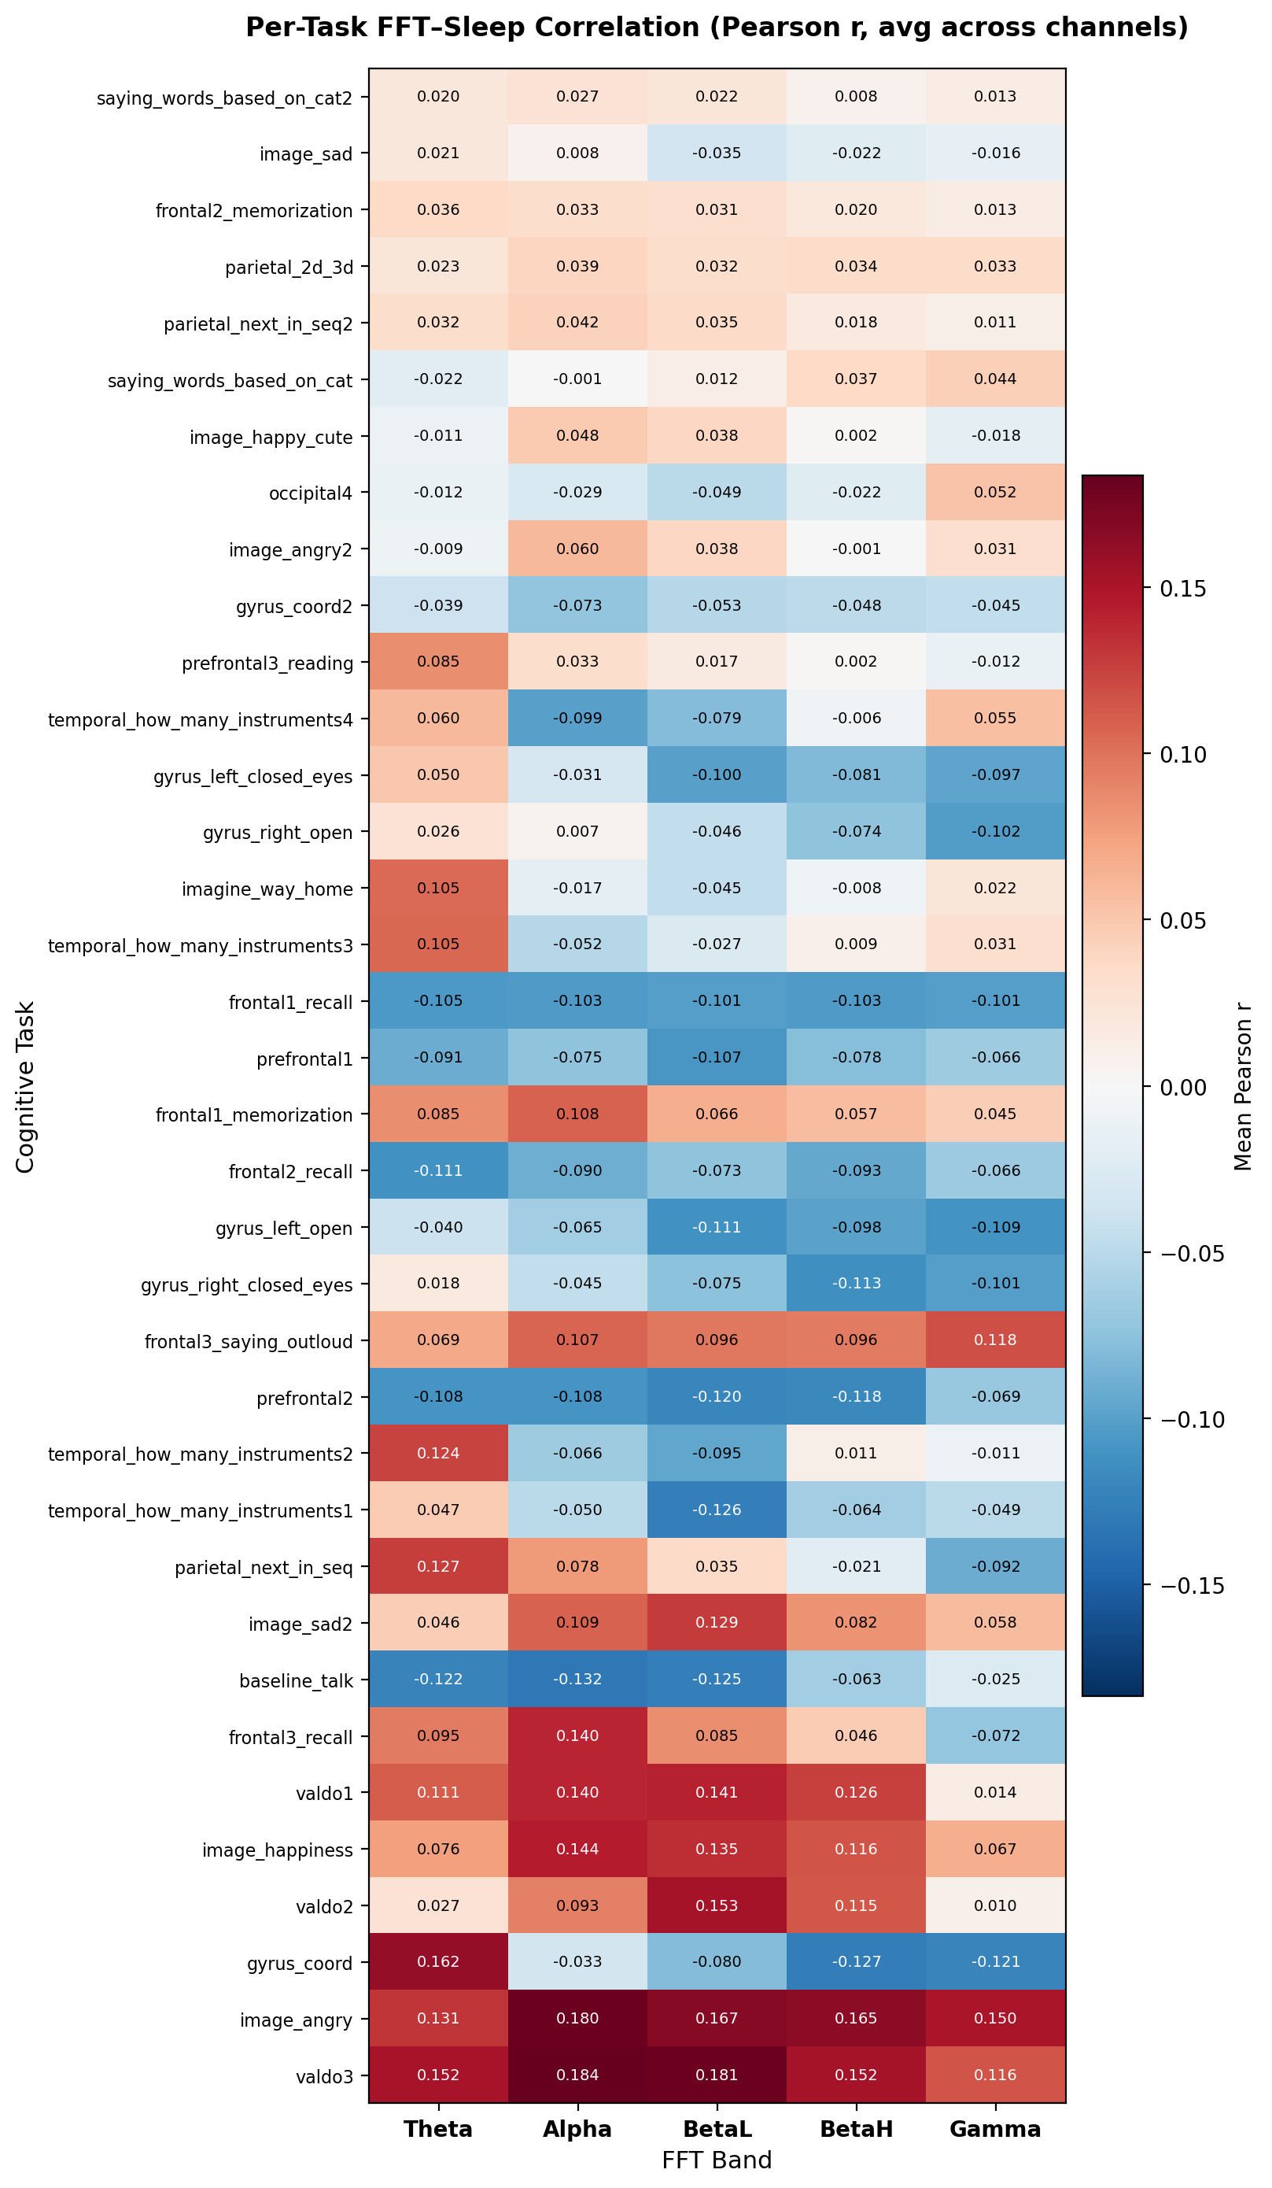
Figure 8. Per-task FFT–Sleep correlation heatmap (Pearson r, averaged across 14 channels). Tasks sorted by max |r| — most predictive at top. Red = positive correlation with sleep, blue = negative.
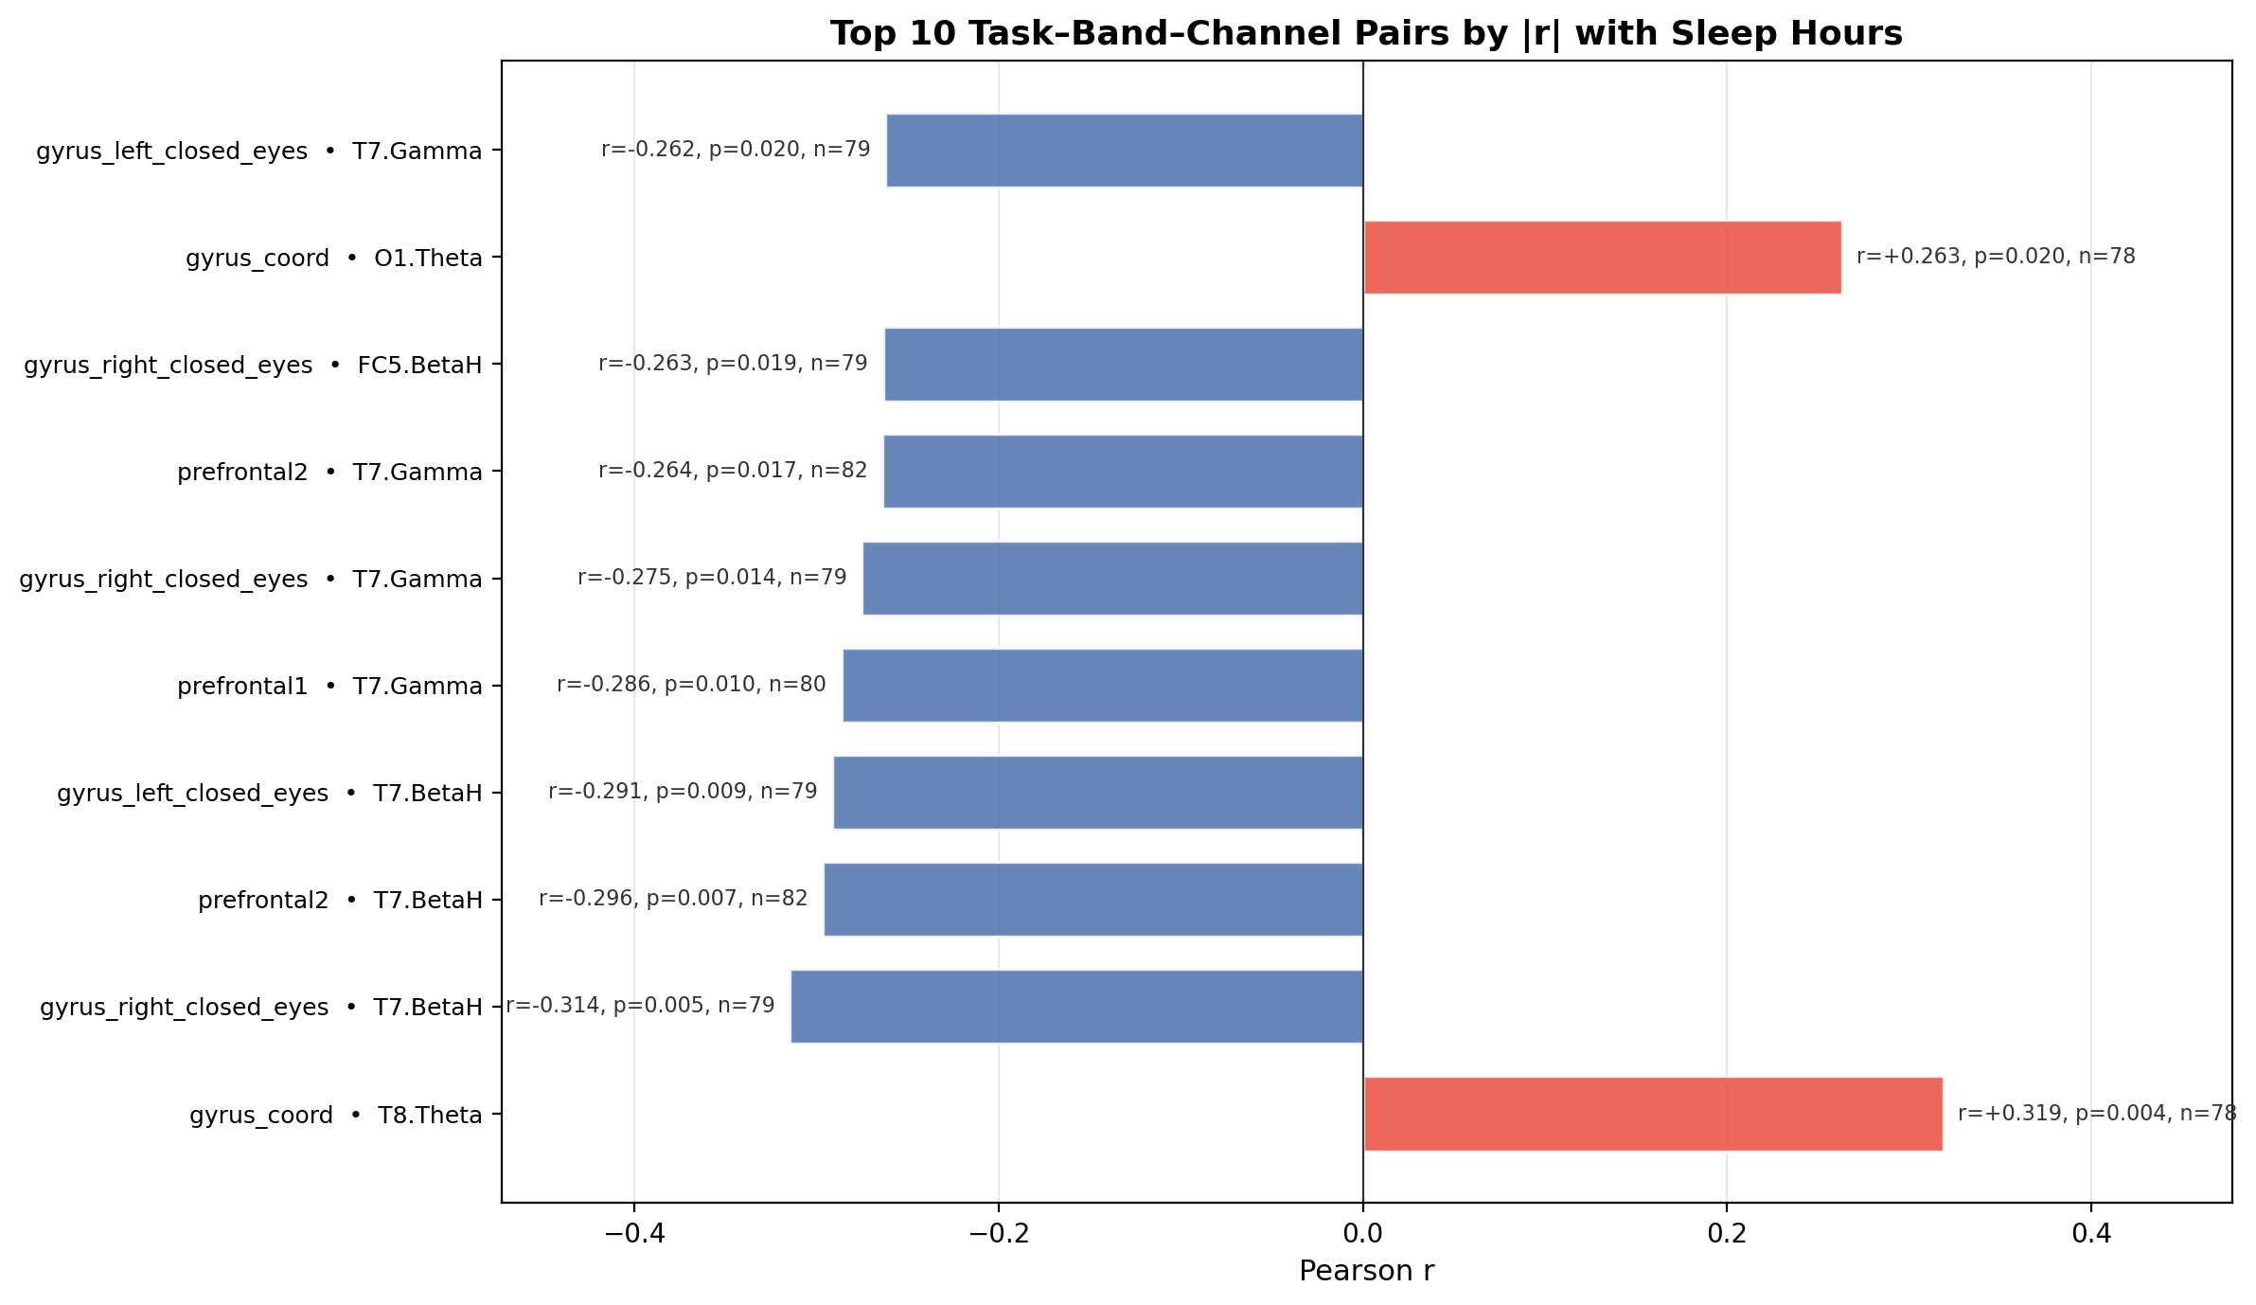
Figure 9. Top 10 task–band–channel pairs by |r| with Sleep_Hours. All 10 are statistically significant (p < 0.05). Red = positive correlation, blue = negative.
Key findings:
- Motor/coordination tasks are most predictive: gyrus_left_closed_eyes, gyrus_right_closed_eyes, and gyrus_coord (hand motor tasks with eyes closed) dominate the top 10. This is biologically plausible — sleep deprivation most directly impairs motor control and coordination.
- Prefrontal working memory tasks are also highly informative: prefrontal1 (r=−0.298, p=0.010) and prefrontal2 (r=−0.296, p=0.007) for T7.BetaH/Gamma. Sustained attention and working memory are well-known to degrade with insufficient sleep.
- T7 (left temporal) BetaH and Gamma dominate: T7 appears in 6 of the top 10 pairs across multiple independent tasks — this is convergent evidence, not noise. Left temporal high-frequency power is consistently negatively correlated with sleep hours.

All 10 top pairs reach p < 0.05:
# | Task | Feature | r | p (raw)
1 | gyrus_coord | T8.Theta | +0.319 | 0.004
2 | gyrus_right_closed_eyes | T7.BetaH | −0.314 | 0.005
3 | prefrontal2 | T7.BetaH | −0.296 | 0.007
4 | prefrontal1 | T7.Gamma | −0.298 | 0.010
5 | gyrus_left_closed_eyes | T7.BetaH | −0.291 | 0.009
6 | gyrus_right_closed_eyes | T7.Gamma | −0.275 | 0.014
7 | prefrontal2 | T7.Gamma | −0.264 | 0.017
8 | gyrus_left_closed_eyes | FC5.BetaH | −0.263 | 0.019
9 | gyrus_coord | O1.Theta | +0.263 | 0.020
10 | gyrus_left_closed_eyes | T7.Gamma | −0.262 | 0.020

⚠️ These are raw, uncorrected Pearson p-values. With ~2,520 correlations computed
(36 tasks × 70 features), ~126 false positives are expected at α=0.05 by chance.
Bonferroni correction would require p < 0.00002 — none of these survive that threshold.
The convergent pattern (T7 appearing across 6 independent tasks) is the stronger evidence.
These results are exploratory findings only; the RF model is the confirmatory test.

- Direction: More sleep → less T7 BetaH/Gamma during motor and prefrontal tasks. Two positive exceptions: gyrus_coord • T8.Theta (r=+0.319, p=0.004) and gyrus_coord • O1.Theta (r=+0.263, p=0.020) — more sleep associates with more occipital/temporal Theta during coordination, possibly reflecting a more relaxed, efficient motor state.
- Least predictive tasks: saying_words_based_on_cat2, image_sad, frontal2_memorization, parietal_2d_3d — near-zero r across all bands.
Important — multiple comparisons: ~2,520 correlations were computed (36 tasks × 70 features). At α=0.05, ~126 false positives are expected by chance. However, T7 appears consistently across multiple independent tasks and bands — this convergent pattern is unlikely to be random noise. Report these as strong exploratory findings, not confirmed hypotheses.

Implication for RF model: The tasks identified here (gyrus_left_closed_eyes, gyrus_right_closed_eyes, gyrus_coord, prefrontal1, prefrontal2) and T7 channel features should be prioritised in the Random Forest feature set. This also answers the mentor's final bullet point — if raw EEG prediction is attempted, these are the tasks to use.

5. Graph Inventory — Use in Thesis
The following table summarises every graph produced, its verdict, and whether it should be included in the final thesis.
Graph / File | Folder | Verdict | Use in Thesis?
task_vs_bands_median.png | visuals/ | ✅ Very Informative | Yes — EEG sanity check
task_vs_channels_median.png | visuals/ | ✅ Informative | Optional — complements bands
task_explainer_heatmap.png | visuals/ | ⚠ Dense but useful | Yes — category sleep-sensitivity
complete_performance_heatmap.png | visuals/ | ⚠ Limited | Maybe — metric inter-correlations
sleep_hours_distribution.png | visuals/ | ✅ Very Informative | Yes — essential context
fft_sleep_correlation_bars.png | visuals_fft/ | ✅ Very Informative | Yes — primary finding
fft_vs_metrics_frontal.png | visuals_fft/ | ✅ Informative | Yes — strongest correlations
fft_vs_metrics_parietal_occipital.png | visuals_fft/ | ✅ Informative | Yes — alpha/engagement finding
fft_vs_metrics_temporal.png | visuals_fft/ | ⚠ Weak | Maybe — low correlations
fft_vs_metrics_overview.png | visuals_fft/ | ⚠ Redundant | Skip if region breakdowns included
scatter_grid_top_features.png | visuals_scatter_plots/ | ✅ Informative | Yes — motivates ML approach
scatter_POW_*_vs_sleep.png ×9 | visuals_scatter_plots/ | ⚠ Supplementary | Optional — appendix
clustered_map_BA*.png ×9 | individual_graphs/ | ❌ Not useful | No — inconsistent, pilot only
*_Comparison.png ×7 | visuals_tasks_per_metric/ | ❌ Not informative | No — no significance, pilot only
per_task_fft_heatmap.png | visuals_per_task/ | ✅ Very Informative | Yes — key finding: task-specific FFT vs sleep
top_task_band_pairs.png | visuals_per_task/ | ✅ Very Informative | Yes — top-10 T7 finding, with table
sleep_group_fft_3way.png | visuals_sleep_groups/ | ✅ Informative | Yes — shows no univariate significance
sleep_group_fft_2way.png | visuals_sleep_groups/ | ⚠ Limited | Optional — confirms 3-way result

6. Key Findings Summary
Finding 1: EEG data is physiologically valid.
Task-level band-power patterns match known neuroscience: speech tasks produce broadband activation, eyes-closed/imagery tasks show alpha enhancement, and passive image-viewing tasks are uniformly suppressed. The EEG recordings are trustworthy.

Finding 2: Sleep distribution is narrow, which limits prediction difficulty.
With std = 0.78 h and nearly all subjects in the 6–7.5 h range, there is very little variance in the target variable. This explains why all univariate correlations are weak.

Finding 3: FFT features show weak but consistent directional associations with sleep.
At the row level, Gamma and BetaH power (especially at right-hemisphere electrodes F8, F7) positively associate with sleep, while frontal Theta/Alpha (AF3, AF4) negatively associate. The effect sizes are small (max r ≈ ±0.27) but directionally consistent.

Finding 4: Row-level and subject-level correlations diverge.
When computed at the subject level (n = 83), the top "positive" row-level features (F8.Gamma, F7.Gamma) reverse direction. This indicates within-subject task variance inflated the row-level signal. The frontal Theta/Alpha negative association is more stable across levels.

Finding 5: No single feature linearly predicts sleep hours.
All subject-level correlations are non-significant (p > 0.05, n = 83). This makes multivariate ML modelling a necessity rather than an enhancement.

Finding 6: Emotiv performance metrics are internally correlated and weakly related to sleep.
Inter-metric correlations (e.g., Stress–Interest r = 0.73) suggest the seven PM metrics do not represent independent physiological constructs. Their individual correlations with Sleep_Hours are all below |0.28|. They may still contribute useful signal when combined with FFT features in a Random Forest, but they should not be expected to dominate.

Finding 7: Frontal and parietal/occipital regions are most informative.

Finding 8: No single FFT feature significantly separates sleep groups.
Sleep-group bar charts (3-way: Short/Normal/Long and 2-way: ≤7h vs >7h) showed no significant differences after Bonferroni correction. The one nominally significant result (AF4.Theta, p=0.009) does not survive correction (α_corrected≈0.001). This is expected given the narrow sleep distribution (std=0.78h) and small group sizes, and reinforces the need for multivariate ML rather than univariate testing.

Finding 9: Motor and prefrontal tasks have the strongest task-specific FFT–sleep correlations.
Per-task Pearson r analysis across all 36 tasks found that gyrus (hand motor, eyes-closed) and prefrontal working memory tasks dominate the top-10 strongest individual correlations with Sleep_Hours. T7 (left temporal) BetaH and Gamma appear in 6 of the top 10 pairs across independent tasks — a convergent pattern unlikely to be random noise. These task-channel combinations are prioritised for the task-specific RF experiment. Note: all p-values are raw/uncorrected (exploratory analysis).

The frontal region shows clear Alpha–Engagement and high-band–Stress relationships. The parietal/occipital region shows the strongest single correlation in the dataset (P8.Alpha vs. Relaxation, r = +0.41). The temporal region is the weakest.

7. Modelling Tables Built
Six modelling tables have been built across two categories: subject-level tables (one row per subject, 81 rows) and task-level tables (multiple rows per subject). All tables draw their features from the 70 POW columns (14 channels × 5 frequency bands). Subject-level tables are used with run_cv.py; task-level tables are used with run_task_cv.py.

Exp | CSV file | Type | Description | Rows
exp1 | exp1_fft_only.csv | Subject-level | All 36 tasks averaged per subject, 70 features | 81
exp2 | exp2_fft_gender.csv | Subject-level | Same as exp1 + Gender (M=0, F=1) | 81
exp3 | exp3_task_specific.csv | Subject-level | Top-5 tasks averaged, top-15 features selected | 81
exp4 | exp4_fft_aggregated.csv | Task-level | 1 row per subject x task, all 36 tasks, 70 features | 2,758
exp5 | exp5_fft_windowed.csv | Task-level | 1 row per subject x task x 2s window, 70 features | ~32,360
exp6 | exp6_top5_task_level.csv | Task-level | Top-5 tasks only, task-level aggregated, top-15 features | 388

7.1 Subject-level tables (exp1, exp2, exp3)
Each of the three subject-level tables has exactly one row per subject (81 rows after holding out ba16 and ba45 for the defense demo). Features are the mean POW values averaged across all tasks and recording segments for that subject, giving one stable representative EEG feature vector per subject. Because there is only one row per subject, any k-fold split is automatically leak-free.

File | Shape | Key details
exp1_fft_only.csv | 81 × 72 | Subject_ID + 70 POW features + Sleep_Hours. Baseline experiment — all tasks, all features.
exp2_fft_gender.csv | 81 × 73 | Same as exp1 with Gender column added (M=0, F=1). 42 male, 41 female.
exp3_task_specific.csv | 81 × 17 | Top-5 tasks only (gyrus_left/right_closed_eyes, gyrus_coord, prefrontal1/2), top-15 features selected by RF importance. NaN-free.

7.2 Task-level tables (exp4, exp5, exp6)
Task-level tables have multiple rows per subject, enabling the model to learn from within-subject variation across tasks or time windows. The split strategy matters critically: GroupKFold keeps all rows of a subject together (no leakage), while StratifiedKFold may place different tasks of the same subject into train and test (leakage). See Chapter 9 for the impact on results.

File | Shape | Rows/subject | Key details
exp4_fft_aggregated.csv | 2,758 × 72 | ~34 rows | One row per subject x task. 70 features. Mean POW within each task window.
exp5_fft_windowed.csv | ~32,360 × 72 | ~400 rows | One row per subject x task x 2-second window (256-row windows). 70 features.
exp6_top5_task_level.csv | 388 × 72 | ~5 rows | Top-5 tasks only (same as exp3), task-level aggregated. 70 features available; top-15 selected at runtime.

8. Modelling Scripts
Two main scripts handle all six experiments. Both are fully automated: change the settings variables at the top and run. A third pair of scripts (train_final_model.py and predict.py) is reserved for the live defense demonstration.

8.1 run_cv.py — subject-level CV (exp1, exp2, exp3)
Runs k-fold cross-validation on the subject-level tables. Because each table has exactly one row per subject, there is no subject leakage regardless of the split method used. The script runs both a regression mode (predicting continuous Sleep_Hours) and a classification mode (Short / Normal / Long or binary Below7h / Above7h) automatically. Feature importance is computed on the full dataset after CV.

Setting | Options and meaning
EXPERIMENT | 'exp1_fft_only' | 'exp2_fft_gender' | 'exp3_task_specific'
K | Number of folds (default 5)
TOP_N | None = use all 70 features; int = select top-N by RF importance before CV

Outputs saved to results/{EXPERIMENT}/: regression metrics (RMSE, MAE, R²), scatter plot, classification metrics (accuracy, F1, confusion matrix), confusion matrix heatmap, feature importance chart, and predictions CSV.

8.2 run_task_cv.py — task-level CV (exp4, exp5, exp6)
Handles task-level and windowed tables where each subject contributes multiple rows. The critical setting is SPLIT_MODE, which controls whether subjects are kept together across folds (honest) or allowed to appear in both train and test (inflated but interpretive, as recommended by the mentor for this thesis).

Setting | Options and meaning
EXPERIMENT | 'exp4_fft_aggregated' | 'exp5_fft_windowed' | 'exp6_top5_task_level'
SPLIT_MODE | 'group' = GroupKFold, subjects never split across folds (honest generalization estimate). 'stratified' = StratifiedKFold, same subject can appear in train and test (inflated metrics, used for pattern interpretation per mentor guidance).
K | Number of folds (default 5)
TOP_N | None = all 70 features; int = top-N selected by RF importance before CV
BINARY | True = 2 classes (Below7h / Above7h); False = 3 classes (Short / Normal / Long)

Outputs saved to results/{EXPERIMENT}_{SPLIT_MODE}/: same regression and classification outputs as run_cv.py, plus a task_vote_summary.csv (GroupKFold mode) showing how each task voted per subject, and a vote confidence chart showing prediction confidence vs actual sleep hours.

8.3 train_final_model.py and predict.py — defense demo
train_final_model.py trains one RF model on all 81 subjects and saves it to models/{experiment}_model.pkl. This is NOT used for evaluation. predict.py loads the saved model and produces a single sleep prediction for one new subject:

python predict.py subject_ba16.csv → Predicted sleep hours: 6.8 h
At the defense, ba16 and ba45 are the held-out subjects. Their EEG data is fed into the trained model live to demonstrate the end-to-end pipeline.

9. Modelling Results
All six experiments have been run. Results are presented below across two categories: honest cross-validation (subjects never seen in training appear in test) and StratifiedKFold cross-validation (same subject can appear in train and test, inflated metrics used for pattern interpretation per mentor guidance).

9.1 Summary of all experiments

Exp | Script | Split | Rows evaluated | R² | RMSE (h) | Accuracy | F1 macro
exp1 | run_cv.py | 5-fold KFold | 81 subjects | -0.12 | 0.81 | 81.5% | 0.30
exp3 | run_cv.py | 5-fold KFold | 81 subjects | 0.05 | 0.75 | 60.5% | 0.39
exp6 | run_task_cv.py | 5-fold GroupKFold | 81 subjects* | 0.10 | — | 58.0% | 0.54
exp4 | run_task_cv.py | 5-fold Stratified | 2,758 rows | 0.65 | 0.46 | 88.7% | 0.86
exp5 | run_task_cv.py | 5-fold Stratified | 32,360 rows | 0.67 | 0.45 | 90.2% | 0.88
exp6 | run_task_cv.py | 5-fold Stratified | 388 rows | 0.39 | 0.61 | 72.2% | 0.63

*exp6 GroupKFold: binary classification (Below7h / Above7h). All other experiments: 3-class (Short / Normal / Long). exp6 StratifiedKFold was run with 3-class for direct comparison with exp4/exp5.

9.2 Honest results (GroupKFold / KFold)
The three honest experiments evaluate generalization to unseen subjects. All show weak predictive power, which is expected given the narrow sleep distribution (std = 0.78 h) documented in the EDA phase.

exp1 (all tasks, all 70 features) achieves R² = -0.12 and accuracy = 81.5%, but the accuracy is entirely driven by predicting Normal for almost every subject. F1 macro = 0.30 confirms that Short and Long classes are not predicted at all (both zero recall).

exp3 (top-5 tasks, top-15 features) improves to R² = 0.05 and F1 macro = 0.39. Accuracy drops to 60.5% because the model now attempts to predict Short subjects rather than defaulting to Normal. This is a meaningful improvement: the task-specific feature selection from the EDA carries real signal.

exp6 GroupKFold (top-5 tasks, task-level, top-15 features) achieves R² = 0.10 and F1 macro = 0.54 (binary), the highest honest result across all experiments. The task-level representation gives the model slightly more signal per subject than the single-row subject-level table used in exp3.

Key insight: GroupKFold R² plateaus around 0.05–0.10 across all experiments. This is the honest estimate of how well EEG-derived FFT features generalize to new subjects for sleep duration prediction. The narrow target distribution (std = 0.78 h) fundamentally limits what any univariate or multivariate model can achieve with this dataset.

9.3 StratifiedKFold results and the leakage effect
StratifiedKFold allows the same subject to appear in both train and test across different folds. For task-level tables, this means the model can see 27–30 tasks from subject BA42 in training and be tested on the remaining 6–7 tasks of the same subject. The model learns each subject’s EEG fingerprint rather than a generalizable EEG→sleep pattern.

Evidence for this is the within-subject prediction standard deviation, which is approximately 0.18 h: all tasks of the same subject receive nearly identical predictions regardless of task type. The model has effectively memorized BA42 → 8.5 h.

The leakage magnitude scales directly with rows per subject. exp4 (~34 rows/subject) reaches R² = 0.65, exp5 (~400 rows/subject) reaches R² = 0.67. exp6 has only ~5 rows per subject, so the fingerprint cannot be established from just 4 training tasks — R² drops to 0.39, much closer to the honest estimate.

Experiment | Rows/subject | R² (Stratified) | R² (Group) | Leakage gap
exp4 | ~34 | 0.65 | — | Large — model memorizes subject fingerprint
exp5 | ~400 | 0.67 | — | Very large — hundreds of windows per subject
exp6 | ~5 | 0.39 | 0.10 | Moderate — too few rows to form a fingerprint

9.4 Mentor’s framing: model as interpretation tool
The mentor confirmed that the StratifiedKFold leakage is accepted for this thesis because the primary goal is not pure generalization but dataset interpretation. The model serves as a pattern detector rather than a prediction system. The analysis focuses on which tasks of the same subject are predicted as Low/Medium/High and whether these patterns group meaningfully across subjects who share similar sleep durations.

Thesis framing: Both approaches are reported. GroupKFold results (R² ≈ 0.05–0.10) represent the honest generalization estimate and confirm that EEG-based sleep prediction is a hard problem with this dataset. StratifiedKFold results (R² up to 0.67) are used as an interpretive lens to identify which EEG task patterns are most associated with sleep duration within this cohort, consistent with the mentor’s guidance that the model serves for dataset interpretation rather than clinical prediction.

9.5 Per-task interpretation findings
The analyse_task_predictions.py script was run on exp6 (StratifiedKFold, top-5 tasks, top-15 features) to extract per-subject, per-task predictions. The outputs are saved to results/exp6_task_interpretation/. The following findings directly address the mentor’s guidance to use the model as a pattern detector rather than a predictor.

Overall majority-vote accuracy (5 tasks per subject, majority determines final prediction):

Sleep class | N subjects | Majority-vote accuracy | Interpretation
Short (≤6h) | 27 | 55.6% (15/27) | Hard — model gets roughly half right
Normal (6–8h) | 46 | 95.7% (44/46) | Easy — dominant class, well represented
Long (≥8h) | 8 | 37.5% (3/8) | Hardest — small group, often predicted as Normal

Finding 1: Two distinct subgroups of Short sleepers
Short sleepers split clearly into two groups based on whether the model detects their sleep deprivation across all tasks.

Subgroup | Subjects (n) | Description
EEG-visible (n=8) | BA5, BA7, BA24, BA25, BA28, BA48, BA56, BA87 | All 5 tasks unanimously predict Short. EEG consistently carries the deprivation signature regardless of task type.
EEG-invisible (n=6) | BA11, BA49, BA68, BA70, BA73, BA36 | All 5 tasks predict Normal despite actual short sleep. BA70 sleeps only 5.0h (shortest in dataset) yet every single task predicts Normal.

Key insight: The EEG-invisible subgroup suggests genuine biological heterogeneity: some short sleepers do not show neural markers of sleep deprivation, possibly reflecting cognitive resilience. This is a documented phenomenon in sleep science and is a meaningful finding for the thesis beyond what any aggregate metric captures.

Finding 2: Long sleepers split into detected and missed groups

Outcome | Subjects | Task vote pattern
Correctly detected (n=3) | BA4, BA6, BA89 | 3 or more of 5 tasks vote Long. Majority vote correct.
Partially detected (n=2) | BA42, BA82 | Only 1–2 tasks vote Long (prefrontal1 most often the correct one). Majority vote still wrong.
Completely missed (n=3) | BA9, BA65, BA72 | All 5 tasks vote Normal unanimously. EEG indistinguishable from Normal sleeper.

Finding 3: prefrontal1 is the most reliable task across all sleep classes
Per-task accuracy broken down by actual sleep class (from task_sensitivity.csv):

Task | Short (n≈26) | Normal (n≈44) | Long (n=8) | Notes
prefrontal1 | 59.3% | 95.3% | 62.5% | Best overall — only task above 60% on both extreme classes
prefrontal2 | 55.6% | 88.9% | 12.5% | Good for Short and Normal; poor for Long
gyrus_coord | 56.0% | 83.7% | 12.5% | Weakest for Normal and Long; ties prefrontal2 for Short
gyrus_left_closed_eyes | 52.0% | 93.2% | 37.5% | Strong for Normal; moderate for extremes
gyrus_right_closed_eyes | 48.0% | 88.6% | 37.5% | Weakest for Short; similar to gyrus_left for Long

Most misclassifications land on Normal, but direct extreme-to-extreme confusion does occur in a small number of cases.

Finding 4: Motor and prefrontal tasks disagree in interpretable ways
When tasks within the same subject give conflicting predictions, the disagreement follows a consistent pattern between the two task families (gyrus motor tasks vs. prefrontal working memory tasks):

Subject | Actual | Gyrus tasks predict | Prefrontal tasks predict | Who is right?
BA89 | Long (8h) | Long, Long, Long | Normal, Normal | Gyrus correct — motor signal detects Long
BA78 | Normal (7h) | Short, Short, Short | Normal, Normal | Prefrontal correct — motor fires false alarm
BA6 | Long (8h) | Short, Long, Long | Long, Short | Mixed — tasks disagree even within families
BA4 | Long (8h) | Normal, Long, Long | Long, Normal | Mixed — majority correct despite disagreement

This suggests that motor coordination tasks (gyrus) and working memory tasks (prefrontal) capture different aspects of sleep-related EEG changes. When they agree, the prediction is reliable; when they disagree, the subject likely sits near a class boundary or shows an atypical neural profile.

Summary for interpretation chapter: The per-task analysis reveals that sleep class prediction is not uniform across subjects or tasks. Normal sleepers are robustly identified by all tasks. Short and Long sleepers split into detectable and undetectable subgroups, with prefrontal1 being the most sensitive single task. Disagreements between motor and cognitive tasks are informative rather than noise, pointing to different neural mechanisms of sleep-duration effects on brain activity.

10. Phase 2 Preview — Deep Learning on Raw EEG
Phase 2 will use raw EEG channels as time-series input to RNN/GRU/LSTM networks in PyTorch, focusing only on the task types identified as most informative by the Random Forest feature importance in Phase 1.
Based on the EDA findings so far, the most likely candidates for Phase 2 tasks are frontal-lobe tasks (prefrontal1-3, frontal1-3) and auditory/imagination tasks (imagine_way_home, temporal tasks), as these showed the most consistent EEG patterns across subjects. Final selection should be guided by Phase 1 feature importance.
The Phase 2 modelling work (architecture design, training, evaluation) is beyond the current scope and will be documented separately once Phase 1 is complete.

11. Project File Structure
THESIS/ | Project root
DatasetSub_shorten.csv | Metadata: 83 subjects, Sleep_Hours, Gender, etc.
all_task_ready.csv | Main analysis dataset: 83 subjects, task-level rows
pilot_task_ready.csv | Pilot subset: 10 subjects
pilot_categorized_tasks.csv | Pilot data with task category labels
pilot_signal_quality.csv | Per-subject CQ and signal quality summary
pilot_data_map.csv | Subject ID → file path mapping
task_vs_bands_median.csv | Aggregated band power per task (median Z-score)
task_vs_channels_median.csv | Aggregated channel power per task (median Z-score)
all_data/ | Raw EEG data: one subfolder per subject (data.csv + marker.csv)
src/ | All analysis scripts
1_data_preparation/ | load_data.py, clean_pilot_dataset.py, clean_whole_dataset.py, signal_quality_check.py
2_graphs_generator/ | All visualisation scripts (one per graph type)
visuals/ | Main visualisations: task heatmaps + sleep distribution
visuals_fft/ | FFT correlation heatmaps and bar charts
visuals_scatter_plots/ | Subject-level scatter plots (new)
visuals_tasks_per_metric/ | Sleep-group bar charts (pilot only — not for thesis)
individual_graphs/ | Ward clustering maps per subject (pilot only — not for thesis)
PLAN_GUIDE/ | Project planning documents
graph_audit.md | Graph-by-graph audit: verdicts, findings, suggestions
tasks.md | Full task name list
gemini_plan.md | Project plan (Croatian)
mail_convo.md | Mentor email exchange

