AI Ontology Architecture Exploration and Readiness Assessment
Proposal for Approval

1. Executive Summary
The Bank's AI journey is evolving from productivity-focused capabilities towards process automation, and this transition fundamentally changes the knowledge AI solutions require. An assistant that summarises policies or retrieves information can operate effectively with a degree of ambiguity. An agent that executes actions, approving transactions, updating records, triggering workflows, must interpret business concepts, relationships, authority, and constraints with much higher precision. Document-centric AI tolerates ambiguity; action-oriented AI does not.
Ontology has emerged as the capability that addresses this gap. By explicitly representing business concepts, relationships, dependencies, and rules, it improves AI understanding, reasoning, and consistency within business domains. Beyond business enablement, it can complement existing security, risk, and platform governance by providing a semantic control layer that aligns AI reasoning and actions with enterprise policies and business controls.
Rather than beginning with standards, modelling techniques, repositories, or tooling evaluations, the assessment is anchored on two workstreams representing two complementary architectural patterns for the use of Ontology within the AI ecosystem of the Bank of Canada.
Here, pattern refers to a reusable architectural role that ontology plays in solving a particular class of AI problems. It does not refer to competing implementation alternatives or mutually exclusive deployment models. The distinction is not simply between business and enterprise scope, but between how ontology is used:
- Ontology Usage Pattern 1 — Business Domain Value.
  - Purpose: Ontology for semantic reasoning, helping AI understand the business domain and relationships
  - Status: The MBD & ITS-FMBO & CMCO Agent: an initiative already in development by DDS, MBD, and ITS-FMBO whose pilot phase has itself surfaced the need for a dedicated ontology layer. Fully resourced and in flight.
- Ontology Usage Pattern 2 — Enterprise AI Governance & Semantic Risk Control.
  - Purpose: Ontology for semantic governance, constraining and validating AI behavior before or during actions execution
  - Status: A Semantic Firewall for AI agents, at an early ideation stage that addresses a challenge associated with a more advanced phase of AI evolution that the Bank is not expected to reach in the short term. Proposed by DDS architects and SMEs; it represents a necessary complement to existing APIM and MCP architectures and will require greater development effort, as well as a clear assessment of DDS operationalization requirements and capabilities. No resources are currently assigned.
These patterns are complementary and may coexist within the target architecture, often sharing common semantic assets. Organizations may implement them simultaneously or adopt them incrementally as AI maturity evolves. The distinction is not the scope of the ontology (business versus enterprise), but the way the ontology is employed: as a semantic reasoning capability in one pattern and as a semantic governance capability in the other
The assessment evaluates them independently because they address different objectives, operate at different stages of AI maturity, and require different architectural, governance, and investment considerations.
The IQ and AI platforms used in the assessment are determined by the use-case selection criteria rather than by vendor preference. This approach directly supports the mandate to avoid adding unnecessary licences, integration surfaces, or specialist skill sets for the assessment.
The assessment will determine whether any in-scope use case requires AI and ontology capabilities beyond the selected semantic platform. It also distinguishes ontology from adjacent AI and data architecture layers, which provide data engineering, analytics, and machine learning capabilities that support the semantic layer but are not intended to host ontology.
The assessment will produce an evidence-based recommendation on the role and investment level for semantic infrastructure, a target architecture proposal verdict on the Bank's semantic stack, the minimum viable ontology for the first generation of action-oriented agents, and a lessons-learned analysis. The final deliverables the assessment will produced are presented in the section 8 of this document.

1.1 Ontology Accuracy, Accountability and Adoption concerns
Ontology can be analyzed from three distinct concerns that are worth separating, because each has a different answer:
- Accuracy — is the ontology itself a correct representation of our business?
- Accountability — when an agent acts, who is responsible, and does the ontology change that?
- Adoption — how do we get others to trust the ontology and the agents that use it?

The ontology doesn't make decisions; it makes the agent's reasoning inspectable so a human can stay accountable. The agent reasons over the ontology; a human remains in the loop at the points that matter. So, the ontology is not a new autonomous actor we have to learn to trust blindly — it is the opposite. It is the artefact that makes the agent's reasoning visible and checkable, which is precisely what lets a human stay accountable.
Concern 1: Accuracy — How do we ensure the ontology layer is meaningful and accurate, so we can trust it?
We can trust the ontology when it is continuously validated against measurable quality criteria, approved by the business experts who own the meaning, shown to improve real tasks, and fully traceable—not because we assume it is correct. These principles also support the decentralized, business-owned ontology model in Pattern 1 and frame the questions this use case—the MBD Operational Intelligence Agent—will help answer.
Concern 2: Accountability — We remain accountable for actions taken by "robots." How does that work?
The robot or AI Agent never becomes accountable. We stay accountable, and the ontology plus the governance layer are what give us the bounded authority, explainability, and audit trail we need to discharge that accountability responsibly, rather than signing off blind.
Concern 3: Adoption — How do we build trust in the ontology and the agents that use it?
Trust is built through demonstrated value in a business-owned domain, transparent reasoning, clear human oversight, alignment with external standards, and candour about what is and is not ready. These principles support the proposed ontology assessment approach: developing practical, real-world use cases rather than relying on theoretical analysis or tool comparison alone.

2. Background and Problem Statement
Gartner predicts that by 2028 at least 15% of day-to-day work decisions will be made autonomously by AI agents and, at the same time, that more than 40% of agentic AI projects will be cancelled by the end of 2027, highlighting the difficulty organisations face when moving from AI-assisted work to AI-driven execution (Gartner, June 2025). The AI agents require more than access to data and systems, they must understand business context, organisational relationships, policies, processes, and decision boundaries.
Much of an organisation's knowledge is not captured in structured data or documents. It resides in the experience of employees and leaders who have learned to interpret information, navigate business processes, apply judgement, and connect knowledge across organisational domains. These individuals effectively are the organisation's knowledge integrators, which is why the departure of key personnel often creates knowledge gaps that are difficult to replace. Organisations also operate through multiple business domains, each with its own terminology, processes, data, and expertise. Organisational knowledge is naturally distributed rather than centralised. The challenge is to establish a coherent approach for representing and connecting knowledge across domains, preserving local ownership and expertise instead of a single model for the entire organisation
The Ontology technology landscape reflects this reality. No single ontology platform or semantic technology has emerged as the industry standard, including within vendor ecosystems such as Microsoft, where capabilities are distributed across Foundry IQ, Fabric IQ, Work IQ, and Web IQ, each addressing a different aspect of organisational knowledge and context.
In practice, organisations combine multiple technologies, governance practices, and knowledge-management approaches to represent and manage business meaning. Ontology should therefore not be viewed as a standalone technology initiative: it is an architectural capability that captures, organises, connects, and governs organisational knowledge so that AI agents can operate consistently and reliably across increasingly complex business processes. Three factors make this assessment timely for the Bank:
- Agents are moving from answering to acting. A new category of risk emerges semantic errors, where an agent misunderstands business meaning, policy intent, ownership, authority, or operational context. Existing controls like identity mgmt.., API mgmt., network security govern authentication, access and authorization; none of them governs meaning.
- Semantic capabilities are becoming embedded in AI platforms. Foundry IQ grounds agents in documents knowledge assets; Work IQ captures collaboration context; Fabric IQ provides context about business data entities. These capabilities address different aspects of organisational knowledge introducing the risk of multiple disconnected semantic models in the lack of a coherent architectural approach.
- The Bank is already developing semantic assets. DDS teams have identified business use cases that require ontology modelling and have begun developing related capabilities. The question is no longer whether semantic models will be created, but whether they evolve coherently within a defined architectural framework or fragment across projects and domains.

3. Assessment Structure: Two Patterns, Two Workstreams
The assessment validates whether ontology can serve two complementary but fundamentally different architectural purposes. Each Ontology Usage Pattern is tested through a concrete workstream (practical use case).

3.1 Ontology Usage Pattern 1 — Business Domain Value
Ontology used for semantic reasoning to enhance AI understanding, reasoning, and explainability within specific business domains deployed close to business problems and managed as a capability owned by the business domain.
Selected workstream: MBD & ITS-FMBO & COOP Operational Intelligence Agent. An ongoing initiative by DDS, CMCO, MBD, and ITS-FMBO whose pilot phase has itself highlighted the need for a dedicated ontology layer. The agent assists FMBO and CMCO teams by explaining incidents across the FMBO ecosystem, identifying affected business processes, understanding relationships between applications, services, infrastructure, and operational dependencies, supporting what-if analysis and impact assessment, and improving incident investigation and operational decision-making.
Project background. The initial pilot was developed without an ontology and relied on dispersed, loosely connected information sources documents, emails, meeting notes. This traditional retrieval approach produced useful outputs and partial success but struggled to consistently support deeper reasoning across complex dependency relationships, particularly for impact analysis and what-if exploration. This is precisely where ontology introduces value: a structured semantic layer enabling AI systems to reason over relationships in a consistent, traceable, and explainable manner. In collaboration with the MBD and FMBO teams, a structured data model has already been developed, consolidating previously fragmented information into the semantic foundation on which the ontology will be built. The effort has also surfaced process implications on the client side, prompting a reassessment of information consolidation and ingestion workflow design.
IQ technology stack. Currently based on Microsoft Fabric IQ. The pilot has made evident that the structured data model must be complemented with unstructured knowledge sources to fully capture domain context; the introduction of Microsoft Foundry IQ is therefore being considered to extend coverage into documentation, narratives, and other unstructured artefacts.
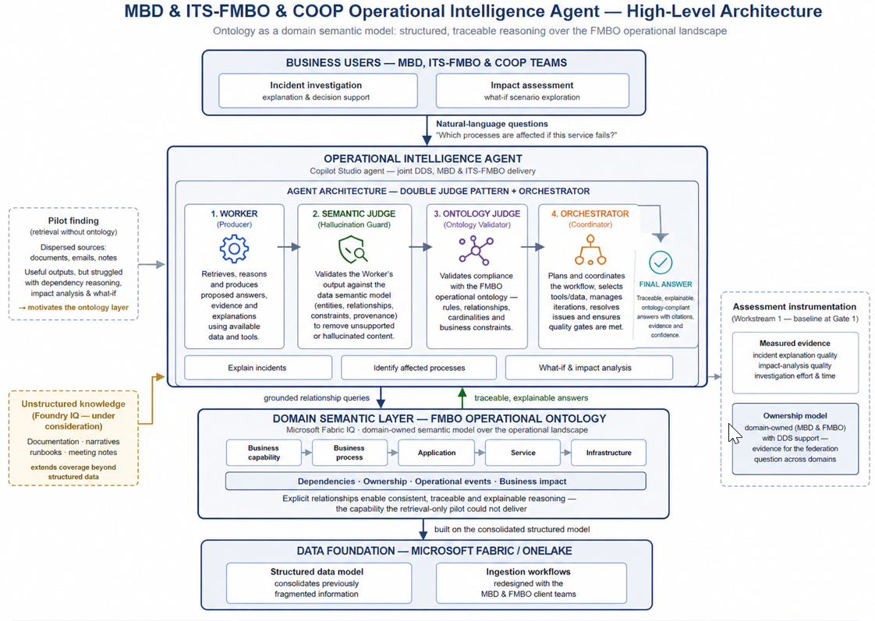
Figure – MBD operational intelligence Agent high level architecture

Resources (committed and in flight):
This is an in-flight project under the leadership of Richard Dea with the active participation and support of the departments of MBD and ITS-FMBO.
Key questions this workstream answers:
- Does ontology measurably improve incident explanation quality and impact analysis, and does it reduce investigation effort?
- How can domain teams retain ownership of their business semantics while maintaining consistency across the enterprise?

3.2 Ontology Usage Pattern 2 — Enterprise AI Governance & Semantic Risk Control
Ontology for semantic governance, constraining and validating AI behavior before or during actions execution, used as an enterprise AI governance capability addressing semantic execution risk: cases where an AI system executes a technically valid action that is nonetheless misaligned with business intent, policy constraints, ownership structures, or operational context. Unlike hallucinations, semantic errors arise from misunderstood business meaning, executing actions outside delegated authority, misinterpreting approval workflows, violating organisational responsibility boundaries, or acting on incorrect assumptions about business rules and constraints.
Selected workstream: Semantic Firewall for AI Agents. Ontology acts as an Enterprise Semantic Firewall (semantic control plane), validating agent reasoning and intended actions before execution. The intent is not to replace existing governance mechanisms but to complement them with a layer of control focused on meaning and intent:
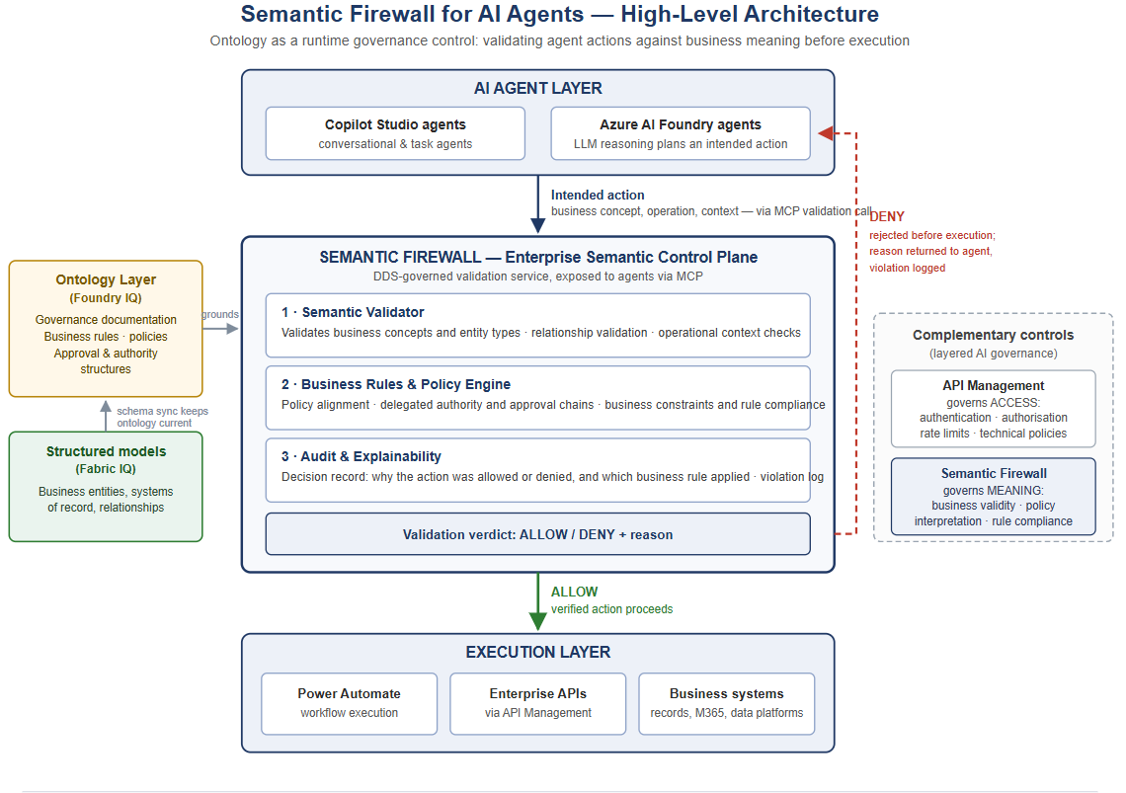
Figure -Semantic Firewall High Level Architecture

Design considerations. From a platform perspective, this pattern raises questions about how semantic validation is performed at runtime and how governance controls can be applied without negatively impacting performance, cost efficiency (AI credits), or innovation velocity. The workstream explores whether ontology can serve as a runtime governance mechanism for agentic AI, providing explainable validation of agent decisions while remaining scalable and operationally efficient.
Maturity stated plainly. The Semantic Firewall pattern is still emerging, but it is gaining support through ontology-based validation research, defence-in-depth semantic control layers, and early practitioner implementations developed in response to documented production failures. No mature, production-proven commercial product currently exists. However, public code repositories already contain practical implementations that can help accelerate the Bank's exploration. A controlled internal assessment is therefore the most appropriate and cost-effective way to build the Bank's own evidence base, with success criteria defined at Gate 1 and no production enforcement included in scope.
IQ technology stack. Microsoft Foundry IQ is considered the platform on which to build the ontology layer based on governance documentation and rules.
Resources. No resources have been formally assigned to this workstream, which remains in early ideation with DDS AI Infrastructure experts. DDS has the internal expertise needed by the use case, for the infrastructure, AI development and ontology areas with complementary assistance from the Microsoft TAM team.
Key questions this workstream answers:
- Can ontology reduce semantic execution risk of agent decisions, like:
  - Ensures requested action(s) are logical and allowed based on policies, etc.
  - Can detect instruction(s) unrelated to the user task and block it before it reaches the agent (prompt injection)
  - Ensures that agents execute only technically valid and organizationally appropriate actions
  - Enforces data classification, domain boundaries, need-to-know.
  - Mitigates uncertain reasoning
- Can ontology become a governance control point for agentic AI — and which semantic controls can be enforced at runtime without negatively impacting AI credits, performance, execution, or innovation?

3.3 Summary of Patterns
The assessment selects AI and semantic platforms based on use-case fit rather than vendor preference, avoiding unnecessary licences, integration points, and specialist skill requirements. It will also determine whether any in-scope use case requires capabilities beyond the selected semantic platform, while distinguishing ontology from adjacent AI and data architecture layers that support the semantic layer but are not intended to host it.

 | Pattern 1 — Business Domain Value | Pattern 2 — Enterprise AI Governance & Semantic Risk Control
Core concept | Ontology as a domain semantic model embedded in business operations | Ontology as a semantic firewall / control plane for agentic AI execution
Scope | Business domains: business operational intelligence | Broad enterprise: cross-domain AI governance
Selected workstream | Operational Intelligence Agent for MBD & FMBO | Semantic Firewall for AI Agents
Primary purpose | Better AI reasoning over complex business relationships; improved impact analysis and what-if scenarios within a specific business domain | Prevention of semantically invalid AI actions; provide enterprise-level governance for AI agents by reducing semantic execution risk and enforcing policy-aligned behaviour
Key problem addressed by Ontology | Fragmented information sources limiting reasoning quality and consistency | Semantic execution risk: technically correct but business-invalid AI actions
Ontology role | Structured semantic layer enabling consistent domain reasoning | Runtime semantic validation layer enforcing meaning, intent, and policy alignment
Integration model | Embedded in domain data model and business processes | Cross-cutting governance layer in the AI agent execution lifecycle
Data & knowledge coverage | Structured data (Fabric IQ) plus unstructured integration (Foundry IQ) | Governance documentation, business rules, policies (Foundry IQ as primary enabler)
Organisational ownership | Business-domain-owned capability (MBD/FMBO with DDS support) | Enterprise/shared governance capability (DDS-led with cross-domain reach)
Key dependencies | Data model maturity, business process alignment, ingestion redesign | Governance definition maturity, runtime integration with agents, performance constraints
Implementation complexity | Medium — domain-bounded, partially grounded in existing pilot and data model | High — requires runtime enforcement, cross-system integration, governance alignment
Implementation effort | Medium — incremental build on existing pilot and structured model foundation | High to very high — new architectural pattern requiring runtime control mechanisms and enterprise adoption
Maturity of starting point | High — pilot transitioning to production | Early — conceptual stage with design exploration required
Expected impact horizon | Short term — value realisation within a defined use case | Mid to long term — foundational impact on enterprise AI governance

4. Ontology Implementation Roadmap
This roadmap links ontology adoption to the Bank's evolution in AI maturity, from AI for productivity (assistive intelligence) to AI for process automation (agentic execution), establishing a planned progression of ontology complexity and responsibility. The strategic question is not whether to build an ontology; it is which role semantic infrastructure should play in the Bank's AI ecosystem at each stage, and at what level of investment.
AI maturity stage | Ontology Role | What it means | Evidence from
AI for Productivity | A — Supporting capability focused on information and insight | Ontology applied only in specific high-value use cases; a targeted enabling role rather than a systemic one. | MBD & ITS-FMBO & COOP Operational Intelligence Agent
AI for Assisted Automation | B — Domain semantic integration layer focused on business domain understanding & integration | Ontology becomes, for each business domain, the shared business vocabulary connecting data, processes, policies, and agents. | MBD & ITS-FMBO & COOP Operational Intelligence Agent
AI for autonomous Process Automation | C — AI infrastructure layer focused on governance trust and autonomous execution | Ontology becomes the semantic foundation for agent-to-agent collaboration and governance of agent actions. | Semantic Firewall for AI Agents

Reported industry experience shows that organisations frequently aim for Role A and are then pushed towards Roles B or C as process automation scales by drift rather than decision, accumulating fragmented semantics along the way. The Bank can make that choice deliberately, before the drift occurs.
Working position, to be validated by this assessment:
- Role A is the appropriate starting point because it reflects the Bank's current AI maturity;
- Role B is the next goal, aligned with the strategic evolution towards AI for process automation;
- Role C is a future stage, appropriate when process automation becomes a capability of autonomous AI agents.
Ontology Usage pattern 1 provides the evidence to confirm or adjust the A-to-B progression; Ontology Usage pattern 2 provides the evidence to determine whether, when, and how Role C is justified and operationally possible for BoC. The assessment either confirms this position with evidence or corrects it both outcomes are valuable.
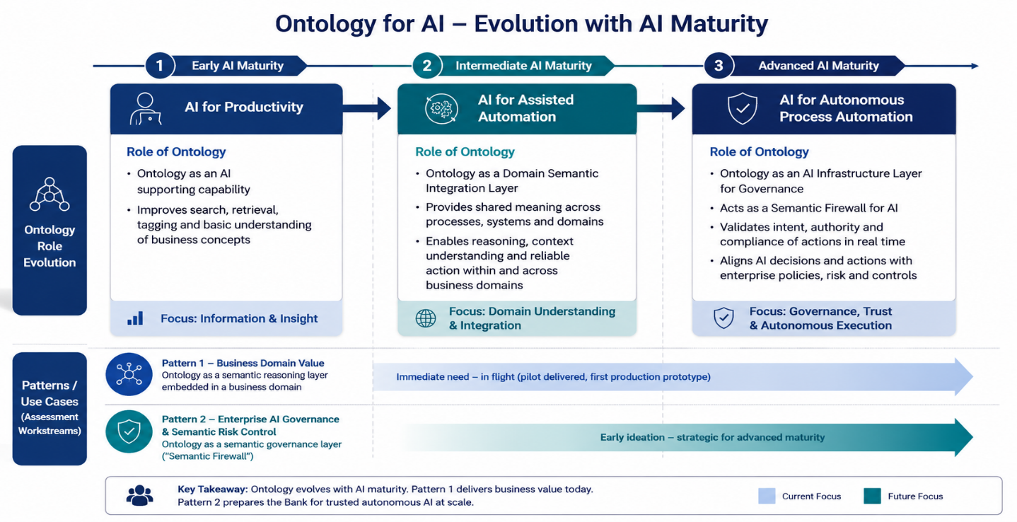
The objective at each stage is not a perfect or complete ontology: it is sufficient semantic precision for safe automation. A retrieval chatbot may only need Customer, Account, and Product; an action-taking agent needs account ownership, delegated authority, approval rights, regulatory classification, and risk category.

5. The Central Architectural Question: The BoC Semantic Stack
The assessment does not choose between Microsoft IQ services; Fabric IQ, Foundry IQ, Work IQ or any other vendor capability currently in operation across the Bank's AI and data infrastructure. It answers two questions about all of them:
- Composition. How do these capabilities compose into one coherent semantic architecture mapped into, not duplicated alongside, one another avoiding fragmentation between data and documents and across business domains?
- Sufficiency. Can Microsoft-native semantic capabilities provide sufficient ontology and semantic reasoning for the recommended role, or does the Bank require a dedicated ontology / knowledge-graph capability alongside them?
Engagement with our Microsoft Technical Account Manager is considered critical: providing direct access to the product groups during the assessment and validating that our architecture aligns with the strategic direction of the products.
6. Delivery Plan and Control Structure
The assessment runs 12 weeks in four phases with three decision gates. You receive a written status report every two weeks covering progress against plan, risks, and decisions required, supported by a maintained risk log and decision log. Any change to scope, schedule, or resourcing is brought to you for decision — none is made within the team.
Weeks | Phase | Key activities and deliverables | Gate
1–2 | Phase 0 — Mobilise | - Confirm both teams and ways of working | Gate 1: approval of the evaluation framework before any evaluation begins.
3–10 | Phase 1 — Workstream 1 evaluation | - Instrument the Operational Intelligence Agent against the baseline; measure explanation quality, impact analysis, and investigation effort;  - Assess the Fabric IQ + Foundry IQ composition for structured plus unstructured coverage;  - Document ontology scope and domain-federation requirements. | Gate 2 (week 6): Interim findings reviewed; confirm or adjust Phase 2 scope.
3–10 | Phase 2 — Workstream 2 exploration | - Design and stand up the non-production Semantic Firewall exploration on Foundry IQ against a defined action set;  - Test business-context, authority, relationship, and policy-alignment validation;  - Measure runtime impact on performance and AI credits; record explainability output and failure modes. | —
11–12 | Phase 3 — Synthesis | - Validated roadmap position (Roles A/B/C) with supporting evidence;  - Target architecture for the BoC semantic stack  - Governance and operating model (central versus domain-owned); minimum viable ontology for the first action-oriented agents;  - Go/no-go recommendation with costed next phase; lessons-learned analysis. | Gate 3 (week 12): Decision on whether and how to proceed.

Phase 2 overlaps Phase 1 deliberately: the exploration environment is prepared while Workstream 1 evaluation runs, so neither team idles.

7. Risks and Mitigations
Risk | Impact if unmanaged | Mitigation
Shared resources across workstreams (one architect for both; one developer on both teams) | Contention; delay to the in-flight MBD/FMBO delivery | - Independent resources for each team. OR  - Effort split where Workstream 1 delivery takes precedence
Semantic Firewall pattern immaturity | Exploration results overstated; premature governance commitment | - Non-production scope; reported as evidence, not as a product decision  - Close support from Microsoft TAM team
Microsoft IQ products may change or experience issues | Rework of evaluation artefacts | - Microsoft TAM channel for roadmap visibility; architecture options designed to tolerate product change
Client-side ingestion redesign (MBD/FMBO) progresses slower than the assessment | Workstream 1 delayed | - Baseline scoped to the data model already built;  - Ingestion redesign tracked as a dependency, not a deliverable
Scope creep in particular, drift towards modelling everything | Schedule and credibility loss | - Sufficient-precision as a goal principal changes only by DDS leadership (PMG) decision at gates or via bi-weekly reporting

8. Deliverables
- A validated ontology roadmap for BoC.: which ontology Role A, B, or C the Bank should adopt now, next, and later, supported by measured evidence from both workstreams
- Evidence on whether ontology improves operational AI outcomes for Ontology Usage Pattern 1 — Business Domain Value.: Quality measures centered around explanation quality, impact analysis, investigation effort
- A grounded assessment of the Semantic Firewall’s feasibility, runtime cost, and limitations for Ontology Usage Pattern 2 — Enterprise AI Governance & Semantic Risk Control.
- A target architecture for the BoC semantic stack, including Fabric IQ, Foundry IQ, and Work IQ.: A verdict on whether Microsoft-native capabilities suffice or a dedicated knowledge-graph capability from a different vendor is required
- An ontology governance and operating model defining what is centrally governed, what remains domain-owned, and the roles required to sustain it.
- A lessons-learned analysis covering both workstreams and the assessment process.

