
Project Report
On
“Secure BLE Mesh Communication System Using STM32 for Industrial Automation”
Submitted in partial fulfillment of the requirements for the III semester
Course Code: ECE221
Bachelor of Engineering In
Electronics and Communication Engineering
Of
Kalasalingam Academy of Research and Education
By
D. SANDEEP (9925005091)
P. GOWTHAM KUMAR REDDY (9925005104)
P. VENKATA SUBBAIAH (9925005120)
G. SANJEEVA KUMAR (9925005053)
Team No: 9 | Team Name: Embedded Eagles
Mr. Pavan Kumar E Prof.Mrs. Loyola Jasmine
External guide Internal Guide
Manager - R&D Assistant Professor
Elevium - by Nanochip Dept. of ECE, KARE

Department of Electronics and Communication Engineering
Kalasalingam Academy of Research and Education
2026-2027

Kalasalingam Academy of Research and Education
Krishnankoil, Srivilliputhur, Tamil Nadu 626126
Department of Electronics and Communication Engineering

CERTIFICATE
It is certified that Mr. D. Sandeep, Mr. P. Gowtham Kumar Reddy, Mr. P. Venkata Subbaiah and Mr. G. Sanjeeva Kumar are bonafide students of Kalasalingam Academy of Research and Education, and have completed the requirements of the project entitled “Secure BLE Mesh Communication System Using STM32 for Industrial Automation” in partial fulfillment of the requirements for the III semester Bachelor of Engineering in Electronics and Communication Engineering during the academic year 2026-27. It is certified that all corrections/suggestions indicated for Project Assessment have been incorporated in the report. The project report has been approved as it satisfies the academic requirements in respect of the project work prescribed for the Bachelor of Engineering degree.

Mr. Pavan Kumar E Prof. Mrs. Loyola Jasmine
External guide Internal guide
Manager - R&D Assistant Professor
Elevium - by Nanochip Dept. of ECE, KARE
Dr. J. Charles Pravin
Head of the Dept.
Dept. of ECE, KARE
External Viva
Name of the Examiners Signature with date
1.
2.

DECLARATION
We, D. Sandeep, P. Gowtham Kumar Reddy, P. Venkata Subbaiah and G. Sanjeeva Kumar are bonafide students of Kalasalingam Academy of Research and Education, declare that the project entitled “Secure BLE Mesh Communication System Using STM32 for Industrial Automation” has been completed in partial fulfillment of the requirements for the III semester Bachelor of Engineering in Electronics and Communication Engineering during the academic year 2026-27.
We also declare that, to the best of our knowledge and belief, the work reported here does not form part of any other report on the basis of which a degree or award was conferred on an earlier occasion on this or any other student.

Date:
Place:

ABSTRACT
This project presents the design and implementation of a Secure Bluetooth Low Energy (BLE) Mesh Communication System built around STM32 microcontrollers for industrial automation. Modern plants depend on dense networks of sensors and actuators, yet wired installations are costly and inflexible, and simple single-hop wireless links suffer from limited coverage, single points of failure and weak or absent security. The proposed system addresses these problems with a low-cost, self-healing, multi-hop mesh that also enforces authentication, encryption and key management end-to-end.
Each node is built on an STM32F446RE microcontroller (Arm Cortex-M4 core) paired with an external BLE radio module and is attached to industrial-style sensors (temperature, proximity, vibration) or actuators (relay, DC motor). Nodes are admitted to the mesh through authenticated provisioning based on Elliptic Curve Diffie-Hellman (ECDH) key exchange with out-of-band confirmation, after which they receive a Network Key (NetKey), Application Key (AppKey) and unique Device Key (DevKey). All traffic is protected with AES-CCM, and sequence numbers with IV indices prevent replay. Messages travel across the plant by managed flooding with Time-To-Live (TTL) control, so the network keeps working when a relay node fails.
A designated STM32 border node acts as a gateway to a SCADA-style dashboard that displays live sensor data and node health, accepts operator commands, and inspects traffic for anomalies such as unauthorized provisioning attempts or replayed sequence numbers. The project evaluates latency, packet delivery ratio and power consumption, including the overhead introduced by the security mechanisms, and demonstrates that a secure, multi-hop BLE Mesh testbed can be realised at low cost for smart-factory monitoring and control.

Contents
Chapter 1: Introduction
Chapter 2: Case Study
Chapter 3: Methodology
Chapter 4: Literature Survey
Chapter 5: Implementation
Chapter 6: Flow Chart / Algorithm
Software and Hardware Used
Chapter 7: Simulation / Result Analysis
Chapter 8: Conclusion and Future Scope
Chapter 9: References

CHAPTER-1 INTRODUCTION
Industry 4.0 has turned conventional manufacturing lines into interconnected systems in which machines sense, communicate and adapt in real time. At the heart of this shift is the Industrial Internet of Things (IIoT), where large numbers of sensors and actuators exchange data with supervisory systems. The communication layer that links these devices is therefore a critical part of any smart factory: it must be reliable, scalable, low-power, and above all secure.
Bluetooth Low Energy (BLE) Mesh extends BLE beyond simple point-to-point links. Using a publish-subscribe, managed-flooding model in which every node can relay messages, it gives many-to-many coverage across large areas without a central router. The STM32F446RE, a Cortex-M4 microcontroller, combined with an external BLE radio module lets a compact node run the BLE Mesh stack together with sensing and control firmware. This project combines the two to build a secure, multi-hop industrial communication testbed.

1.1 Problem Statement
Modern industrial automation depends on dense networks of sensors and actuators that monitor machinery, environmental parameters and process states in real time. Conventional wired installations are costly and inflexible, while simple point-to-point wireless links (single-hop BLE, Wi-Fi) suffer from limited coverage, single points of failure and poor scalability on plant floors with metal structures and interference. Wireless industrial data is also frequently transmitted with weak or no security, leaving it exposed to eavesdropping, spoofing, replay attacks and unauthorized device injection, which can lead to unsafe operation, downtime or data theft.
There is therefore a need for a low-cost, self-healing, multi-hop wireless communication system, built on STM32 microcontrollers and BLE Mesh networking, that extends reliable coverage across industrial environments while enforcing strong authentication, encryption and key management to protect automation data end-to-end.

1.2 Objectives
- To design STM32-based BLE Mesh nodes: develop sensor and actuator nodes around STM32 microcontrollers with BLE Mesh connectivity suitable for industrial deployment.
- To implement secure device provisioning: provision every node using authenticated key exchange (ECDH-based, out-of-band authentication) so that only trusted devices can join the network.
- To enable reliable multi-hop mesh routing: implement managed-flooding relay with TTL control so messages reach distant nodes and the network self-heals when a node fails.
- To integrate real-time monitoring and control: acquire sensor data (temperature, proximity, vibration) and issue actuator commands (relays, motors) over the secure mesh, visualised on a central dashboard.

1.3 Scope of the Project
The project covers the complete hardware-software stack of a small BLE Mesh testbed: STM32 node firmware, sensor and actuator interfacing, secure provisioning, encrypted multi-hop messaging, a gateway (border) node, a monitoring and control dashboard, and a security and performance evaluation. The design can be scaled from a small testbed to the hundreds of nodes typical of a factory-wide deployment.

1.4 Organization of the Report
Chapter 2 presents a case study of secure wireless networking in industrial automation. Chapter 3 details the methodology and architecture. Chapter 4 surveys relevant literature. Chapter 5 describes the implementation. Chapter 6 gives the system flowchart and algorithms. Chapter 7 covers the test plan and result analysis. Chapter 8 concludes with the future scope, and Chapter 9 lists the references.

CHAPTER-2 CASE STUDY

2.1 Wireless Networking on the Industrial Plant Floor
Plant floors are difficult radio environments: metal structures, moving machinery and interference from other 2.4 GHz devices all reduce range and reliability. Established industrial wireless standards such as WirelessHART, ISA100.11a and Zigbee already show the value of mesh topologies for plant-floor monitoring, but they typically need dedicated gateways and proprietary stacks. BLE Mesh offers a standards-based alternative that runs on widely available, low-cost silicon and can be provisioned from an ordinary smartphone.

2.2 Security Exposure of Industrial Wireless Data
Wireless sensor networks operate over a shared medium and are often physically accessible on the factory floor, which makes them prime targets for eavesdropping, node impersonation and replay attacks. A forged actuator command or a tampered sensor reading can cause unsafe operation or unplanned downtime, so security cannot be an afterthought in an industrial deployment.

2.3 Case: STM32-Based Secure BLE Mesh Testbed
This project builds a prototype testbed to demonstrate these principles. The table below compares a conventional single-hop wireless link with the proposed secure BLE Mesh system.
Parameter | Single-hop wireless / wired | Secure BLE Mesh (proposed)
Coverage | Limited to radio range of one hop; cabling for wired | Extended by multi-hop relay across the plant
Fault tolerance | Single point of failure | Self-healing, multi-path managed flooding
Scalability | Poor; each link configured individually | Many-to-many; scales toward hundreds of nodes
Device admission | Often open or shared password | ECDH-based authenticated provisioning with OOB check
Data protection | Weak or none | AES-CCM with NetKey / AppKey / DevKey hierarchy
Replay protection | Usually absent | Sequence numbers and IV index
Installation cost | High cabling cost / gateway per area | Low-cost STM32F446RE nodes, no extra routers

2.4 Impact and Expected Results
The project is expected to deliver the following, which are to be confirmed by the measurements described in Chapter 7:
- A working multi-node BLE Mesh network with at least one multi-hop relay path.
- Authenticated node onboarding and AES-CCM encrypted traffic, verifiable through packet capture.
- Continued message delivery when a relay node is powered off (self-healing).
- Rejection of replayed or spoofed packets from an unauthorized device.
- Measured latency, packet delivery ratio and power consumption, including the overhead of the security mechanisms.

CHAPTER-3 METHODOLOGY

3.1 System Architecture
The proposed system follows a layered approach that combines secure BLE Mesh networking with STM32-based sensing and actuation. Field nodes (sensor and actuator nodes) and relay nodes form the mesh; a border node bridges the mesh to a central monitoring system that hosts the dashboard and a security monitor. Figure 3.1 shows the block diagram of the sensor-node circuit that is validated by simulation in Proteus (Chapter 7): two sensor inputs, an STM32 controller, and LED, buzzer and serial-terminal outputs. The BLE radio, mesh and gateway layers are shown as the proposed extension, which is not simulated.
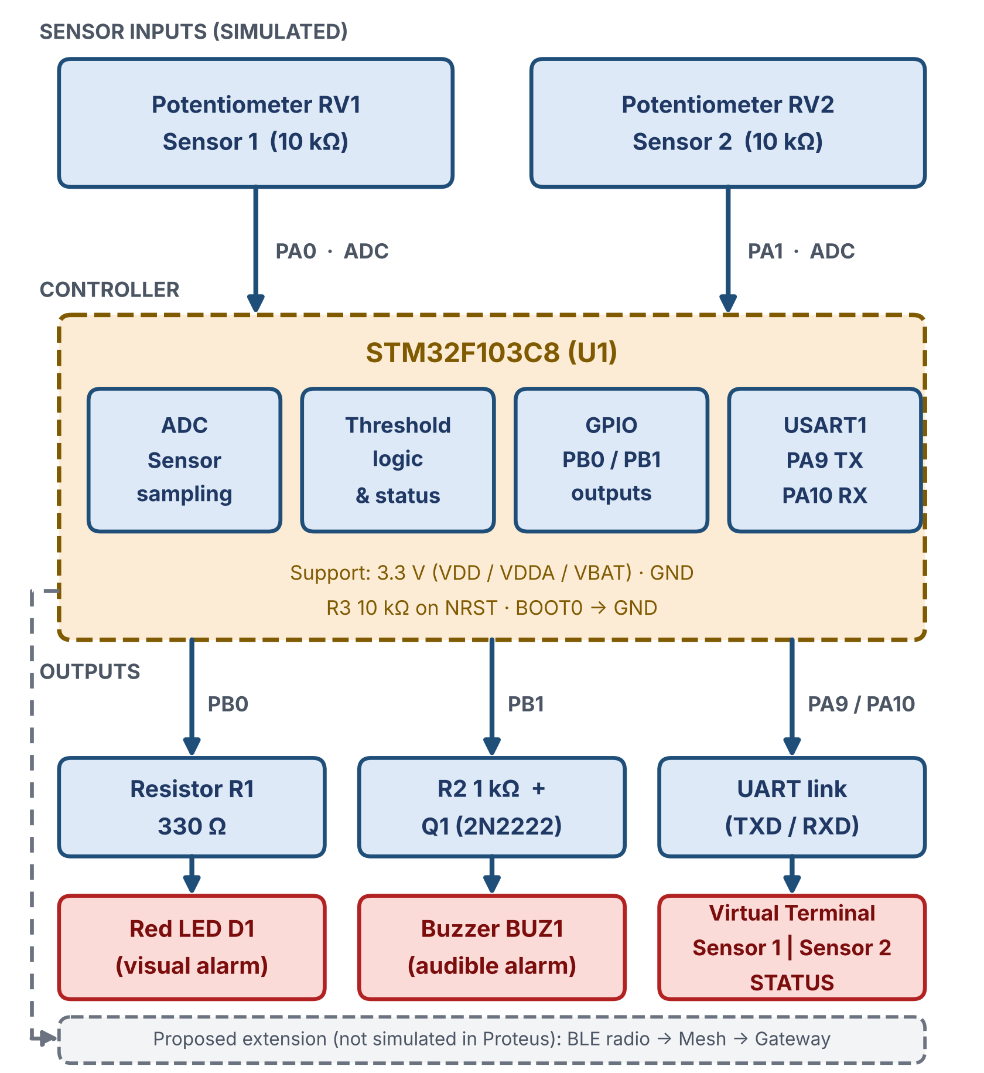
Figure 3.1: Block diagram of the sensor-node circuit simulated in Proteus, with the proposed BLE Mesh extension

3.2 Methodology Stages
- Node design: each STM32 node (with BLE radio) interfaces with sensors (temperature, proximity, vibration) or actuators (relays, motors) representing industrial field devices.
- Secure provisioning: new nodes are authenticated and admitted using ECDH key exchange and out-of-band confirmation, after which they receive the NetKey, AppKey and a unique DevKey.
- Secure communication layer: all published messages are encrypted and integrity-protected with AES-CCM; sequence numbers and IV indices prevent replay of captured packets.
- Multi-hop relay and routing: relay-capable nodes forward messages using managed flooding with a TTL counter, giving self-healing, multi-path coverage.
- Gateway / border node: a designated STM32 node bridges the mesh to the central monitoring system, forwarding aggregated sensor data and control commands.
- Monitoring and control dashboard: a SCADA-style dashboard shows live sensor readings and node health and lets operators send control commands back into the mesh.
- Security monitoring: the gateway inspects traffic for unauthorized provisioning attempts, replayed sequence numbers or unexpected node behaviour and raises alerts.

3.3 Hardware Architecture

Mesh nodes
- STM32F446RE (Nucleo-F446RE) development boards with an external BLE module, several units for sensor, actuator and relay nodes.
- Sensors: temperature/humidity, proximity/IR, vibration as required.
- Actuators: relay modules and a small DC motor for the control demonstration.
- ST-Link programmer/debugger, USB cables and a power supply or batteries.

Gateway / border node and dashboard host
- One STM32 node acting as the mesh-to-PC bridge (for example over UART/USB).
- Laptop/PC hosting the dashboard and, optionally, an MQTT broker.

3.4 Software Design
- STM32CubeIDE and STM32CubeMX for project configuration and firmware build in embedded C.
- STM32F446RE firmware with a Bluetooth LE Mesh stack / BLE Mesh SDK for the mesh models, provisioning and security.
- Smartphone provisioner app (for example nRF Mesh) for initial node provisioning.
- Wireshark with a BLE sniffer for protocol verification and security testing.
- Python (Flask or Dash) for the monitoring dashboard; optional MQTT broker.

3.5 Security Design
The BLE Mesh specification mandates network-layer and application-layer encryption (AES-CCM) and separate key hierarchies, and defines an authenticated provisioning procedure based on ECDH. The project uses these mechanisms as follows:
Mechanism | Role in the system
ECDH provisioning with OOB | Establishes a shared secret between provisioner and new node; out-of-band confirmation blocks unauthorized devices from joining.
NetKey | Network-layer encryption and authentication shared by all mesh nodes.
AppKey | Application-layer encryption, binding data to a particular application (e.g. sensing vs. control).
DevKey | Unique per device; protects configuration messages between provisioner and that node.
AES-CCM | Authenticated encryption giving confidentiality and integrity (message integrity check) for every mesh message.
Sequence number + IV index | Receivers reject packets with stale sequence numbers, preventing replay.
TTL | Limits how many hops a message may be relayed, controlling flooding.

CHAPTER-4 LITERATURE SURVEY

4.1 BLE and BLE Mesh in the IoT Ecosystem
Koulouras et al. (2025) review the evolution of Bluetooth technology and the role of BLE in the IoT ecosystem, highlighting the move from point-to-point links toward mesh networking for wide-area coverage. BLE Mesh integration guides (Sidekick Interactive, 2025) describe the publish-subscribe, managed-flooding model that allows every node to relay messages and removes the need for a central router.

4.2 STM32 and BLE Mesh Application Development
STMicroelectronics application note AN5292 explains how to build a BLE Mesh application on STM32WB microcontrollers, which combine a Cortex-M4 application core with an integrated BLE radio; the same mesh concepts are applied in this project on the STM32F446RE with an external BLE module. AN5247 covers over-the-air and wireless firmware update, and AN5129 gives guidelines for low-cost meander PCB antenna design at 2.4 GHz. Together these form the practical basis for the node design in this project.

4.3 Security of Mesh Networks and Provisioning
Industrial IoT security studies consistently identify eavesdropping, node impersonation and replay attacks as the main threats to wireless sensor networks, because they use a shared medium and are physically accessible. Ambimat Electronics (2025) discusses security hardening of Zigbee and BLE mesh networks. A runtime admission-control scheme for industrial IoT over BLE Mesh (Ad Hoc Networks, 2025) addresses unauthorized node admission. Savant (2025) compares provisioning techniques and trust models for embedded systems, and Agarwal et al. (2026) explore device authentication and data encryption using fog-blockchain integration.

4.4 Lightweight Cryptography for Constrained Devices
Several 2025 studies examine lightweight cryptography for battery-limited IoT devices, including AES-8 (Dhanda et al.), the comprehensive analysis by Zinabu, the systematic review in Discover Computing, the IAESR authenticated-encryption design (Zhang et al.), and a chaotic/quantum-inspired lightweight scheme in Scientific Reports. They show the trade-off between security strength and energy use, which this project evaluates experimentally on STM32F446RE hardware using the standard AES-CCM mandated by BLE Mesh.

4.5 Intrusion Detection for Industrial IoT
Recent reviews of intrusion detection in the Internet of Things (Sensors, 2026; IoT, 2026), generative-AI-driven IDS for IIoT (MDPI, 2026), and lightweight, energy-aware TinyML/edge-AI detection (Scientific Reports, 2026; Hosseini, 2026) point toward anomaly detection at the gateway. This project implements a simpler rule-based gateway monitor (unauthorized provisioning, replayed sequence numbers, abnormal node behaviour) and identifies ML-based detection as future work.

4.6 Industry 4.0, Wireless Sensor Networks and Market Context
Qiu et al. (2025) review the integration of IoT, IIoT and Industry 4.0 toward smart manufacturing. Aeromesh Systems (2025) discusses resilient mesh connectivity for Industry 4.0 factories, and Transparency Market Research (2026) projects strong growth of the industrial wireless sensor network market. Energy-efficient wireless sensor network designs (STM Journals, 2026) and the IEEE review of wireless sensor networks (2025) provide background on low-power node design.

4.7 Research Gap Addressed
The building blocks (BLE Mesh, AES-CCM, ECDH provisioning, intrusion detection) are individually well studied, yet many low-cost industrial automation prototypes still rely on unsecured or single-hop wireless links. This project fills that gap by implementing a complete, secured, multi-hop STM32-based mesh testbed for industrial sensing and control, and by evaluating the practical trade-off between security overhead and communication performance.

CHAPTER-5 IMPLEMENTATION

5.1 System Overview
The implementation consists of STM32F446RE node firmware (sensor, actuator and relay roles), a gateway/border-node firmware that bridges the mesh to a PC, and a Python dashboard with a security monitor. Nodes are provisioned once with a smartphone provisioner; afterwards all traffic is encrypted mesh traffic.

5.2 Node Roles
Node role | Function
Sensor node | Reads temperature, proximity or vibration and publishes the value to a mesh group address at a fixed interval or on change.
Actuator node | Subscribes to a control address; drives a relay or small DC motor when an authorised command arrives, and publishes its state.
Relay node | Relay feature enabled; forwards received messages with TTL decremented, extending range and providing alternate paths.
Border / gateway node | Joins the mesh, forwards aggregated data to the PC, injects operator commands, and reports anomalies.

5.3 Node Firmware

Provisioning and configuration
- The unprovisioned node advertises a provisioning beacon.
- The provisioner (smartphone app) starts provisioning; ECDH public keys are exchanged and out-of-band authentication is confirmed.
- The node receives the NetKey; the provisioner then configures it with an AppKey (using the DevKey), model bindings and publish/subscribe addresses.
- The node enables the relay feature where required and stores keys and sequence state in non-volatile memory.

Sensing and publishing
Sensor data is sampled by the STM32 peripherals (ADC or GPIO), packed into a vendor or generic sensor model message and published; the stack applies AES-CCM encryption and increments the sequence number automatically.

Actuation
On receipt of a control message the actuator node checks that it arrived under the correct AppKey, then switches the relay or sets the motor drive and publishes a status message so that the dashboard shows the actual state.

5.4 Gateway and Dashboard
The border node forwards decoded messages to the PC over a serial link. A Python (Flask/Dash) application stores recent readings and renders a SCADA-style dashboard with:
- Live sensor readings and trend plots per node.
- Node health: online/offline status, last-seen time and hop count where available.
- Operator control panel for relays and motors.
- Security panel listing alerts and an event log of provisioning and command events.

5.5 Security Monitoring
The gateway monitor raises an alert when it observes (a) a provisioning attempt that is not initiated by the authorised provisioner, (b) a message whose sequence number is lower than or equal to the last accepted value from the same source (replay), or (c) unexpected node behaviour such as a silent node or an abnormal publish rate. Alerts are shown on the dashboard and logged.

5.6 Project Timeline
Activity | Duration
Literature review and system design | 2 weeks
Node hardware setup and base firmware | 3 weeks
BLE Mesh networking and security implementation | 4 weeks
Gateway integration and dashboard development | 2 weeks
Testing, security evaluation and performance analysis | 2 weeks
Documentation and reporting | 1 week

CHAPTER-6 FLOWCHART / ALGORITHM

6.1 System Flowchart
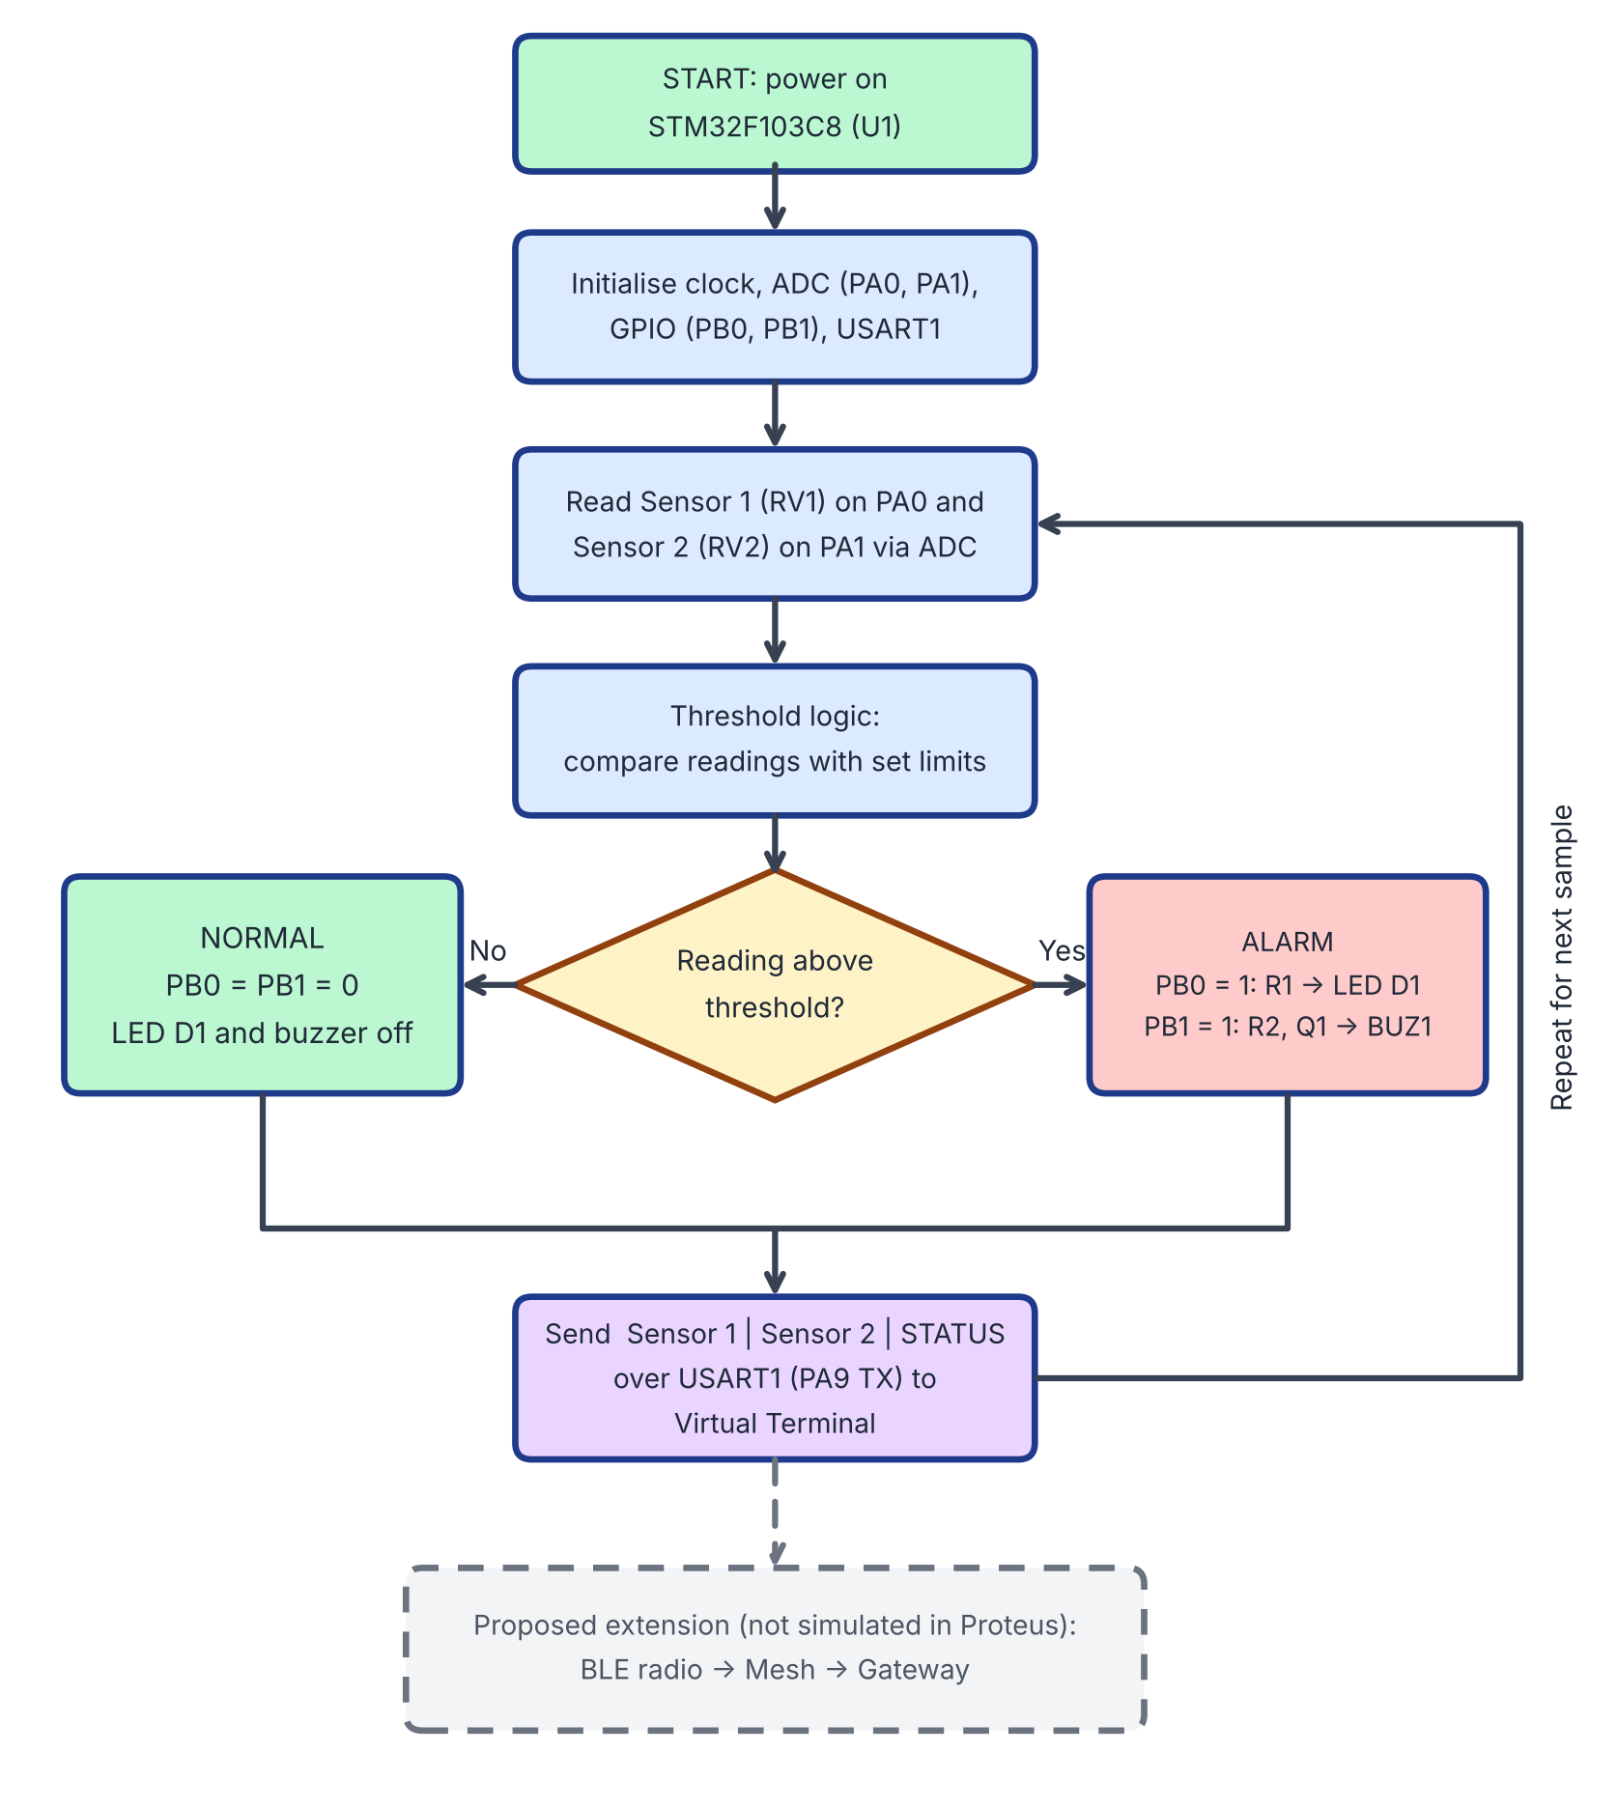
Figure 6.1: Flowchart of sensor-node operation based on the block diagram (Figure 3.1)

6.2 Overall System Algorithm

Node initialisation and provisioning
- Power on and initialise the STM32F446RE and its BLE Mesh stack, sensors and actuators.
- If the node holds no network keys, broadcast an unprovisioned-device beacon.
- Perform ECDH key exchange with the provisioner and confirm out-of-band authentication.
- Receive NetKey, AppKey and DevKey; save to non-volatile memory.
- Apply model bindings and publish/subscribe addresses; enable relay if configured.

Sensor node loop
- Sample the sensor at the configured interval or on a threshold change.
- Build the sensor message and encrypt it with AES-CCM using the AppKey; attach the sequence number and IV index.
- Publish to the group address with an initial TTL.

Relay node behaviour
- Receive a mesh packet and verify the network-layer integrity check.
- If the packet is new (not in the message cache) and TTL > 1, decrement TTL and retransmit.
- Otherwise discard the packet.

Receiver / actuator node
- Verify the message integrity check; reject on failure.
- Compare the sequence number with the last accepted value from that source; reject if not greater (replay).
- Process the command (for example, switch the relay) and publish the status.

Gateway monitoring loop
- Receive decoded messages from the border node and update the dashboard.
- Check for provisioning events, sequence-number anomalies and silent nodes.
- Raise and log an alert if any rule is violated.

6.3 Performance Metrics
Metric | Definition
End-to-end latency | Time from sensor publish to dashboard display (or command issue to actuation), per hop count.
Packet delivery ratio (PDR) | Messages received / messages sent × 100 %.
Security overhead | Difference in latency and current consumption with and without the security mechanisms under test.
Node current / power | Average current of a node over a test interval, measured with a multimeter or power analyser.
Recovery time | Time for delivery to resume after a relay node is powered off.

SOFTWARE AND HARDWARE USED

Hardware
- STM32F446RE (Nucleo-F446RE) + BLE module development boards – multiple units for mesh nodes
- Temperature/humidity, proximity/IR and vibration sensors
- Relay modules and a small DC motor
- ST-Link programmer/debugger, USB cables, power supply/batteries
- Laptop/PC for development and dashboard hosting

Software
- STM32CubeIDE and STM32CubeMX
- STM32F446RE firmware with a Bluetooth LE Mesh stack / BLE Mesh SDK
- Smartphone provisioner app (nRF Mesh)
- Wireshark / BLE sniffer
- Python (Flask/Dash); optional MQTT broker
- Proteus 8 Professional (schematic capture and simulation)
- MS Word / Google Docs, MS PowerPoint / Canva for documentation

Representative Code Outline
The listing below is an illustrative outline of the sensor-node application logic, not the final firmware; function names stand for the corresponding calls of the BLE Mesh stack running with the STM32F446RE and should be replaced with the actual API calls used.
/* Sensor node application loop (outline) */
void app_init(void) {
mesh_stack_init(); // BLE Mesh stack
if (!mesh_is_provisioned())
mesh_start_unprov_beacon(); // wait for provisioner
mesh_load_keys_from_nvm(); // NetKey, AppKey, DevKey
mesh_enable_relay(RELAY_ON);
}

void app_sensor_task(void) {
int16_t temp = sensor_read_temperature();
if (abs(temp - last_temp) >= TEMP_DELTA || publish_timer_expired()) {
mesh_msg_t m = build_sensor_msg(NODE_ID, temp);
mesh_publish(&m, APPKEY_IDX, TTL_DEFAULT); // AES-CCM + SEQ
last_temp = temp;
}
}

void on_control_msg(const mesh_msg_t *m) {
if (!mesh_msg_authenticated(m)) return; // MIC / AppKey check
relay_set(m->value);
mesh_publish_status(relay_get());
}

CHAPTER-7 SIMULATION AND RESULT ANALYSIS
Note: this chapter defines the test setup and the acceptance criteria. The "Measured" columns are to be filled in with the values recorded on the final prototype; no measured values have been assumed in this report.

7.1 Test Setup
The testbed consists of a provisioner (smartphone), a minimum of four STM32F446RE nodes (sensor, actuator, relay and border node) placed so that at least one path requires two hops, and a PC hosting the dashboard. A BLE sniffer with Wireshark is used to capture over-the-air traffic.

7.2 Proteus Simulation
The sensor-node logic was first checked in a Proteus schematic before hardware testing. Figure 7.1 shows the circuit and the virtual terminal output, and its block-level view is the diagram in Figure 3.1.
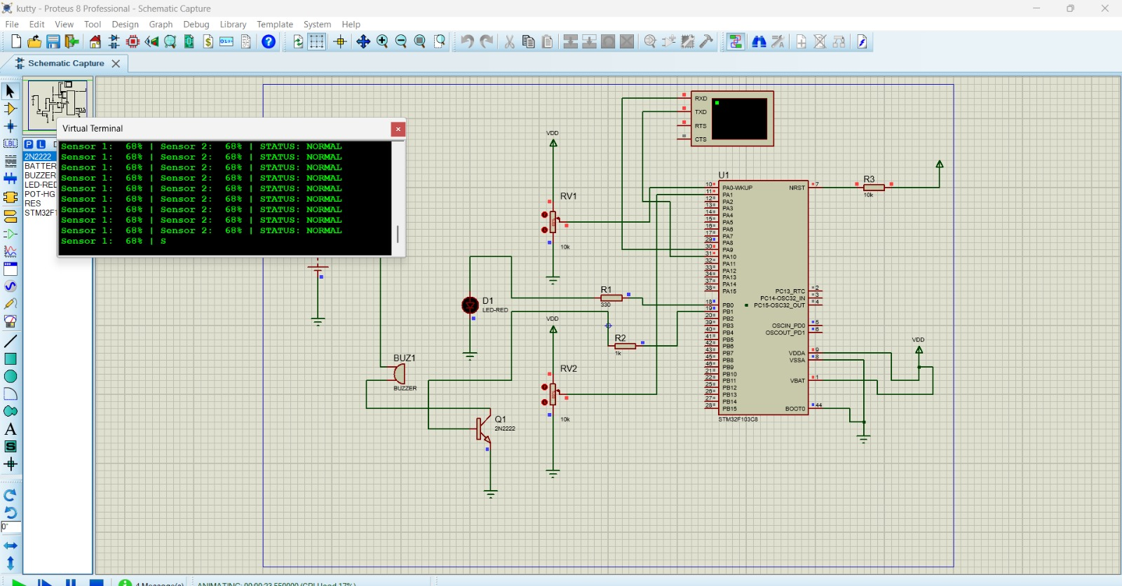
Figure 7.1: Proteus schematic and virtual terminal output of the sensor-node circuit
- Controller: STM32F103C8 (U1) with a 10 kΩ pull-up (R3) on NRST, BOOT0 grounded and a 3.3 V supply.
- Sensor inputs: potentiometers RV1 and RV2 simulate two sensor readings applied to the ADC inputs PA0 and PA1.
- Outputs: red LED D1 through R1 (330 Ω) on PB0, and buzzer BUZ1 driven by transistor Q1 (2N2222) through R2 (1 kΩ) on PB1.
- Serial monitor: USART1 (PA9 / PA10) is connected to the virtual terminal, which prints Sensor 1, Sensor 2 and the system status.
In the captured run, both potentiometers are set to 68 % and the terminal reports "STATUS: NORMAL". This demonstrates sensor sampling, threshold logic, GPIO output control and serial reporting. The BLE Mesh radio is not simulated in Proteus, and the simulated STM32F103C8 has no integrated BLE radio, so the mesh, provisioning and security behaviour are verified only on the hardware testbed described in Section 7.1.

7.3 Functional Validation
Test | Expected behaviour | Measured / Result
Provision an authorised node | Node joins and receives keys
Provision attempt without correct OOB value | Provisioning rejected
Sensor publish to dashboard | Reading appears on dashboard
Dashboard command to actuator | Relay/motor switches; status returned
Multi-hop path (2 hops) | Message delivered via relay

7.4 Security Validation
Test | Expected behaviour | Measured / Result
Packet capture of published data | Payload not readable (AES-CCM)
Replay of a captured packet | Packet rejected; alert raised
Spoofed packet from unprovisioned device | Packet rejected
Command with wrong AppKey | Command ignored

7.5 Resilience (Self-Healing) Test
Traffic is sent continuously while a relay node is powered off. The expected result is that delivery continues through an alternate relay path after a short recovery interval.
Metric | Target | Measured
Delivery after relay failure | Continues via alternate path
Recovery time | To be recorded
PDR during failure | To be recorded

7.6 Performance Evaluation
Metric | With security (as designed) | Measured
Latency, 1 hop (ms)
Latency, 2 hops (ms)
Packet delivery ratio (%)
Average node current (mA)

7.7 Analysis
Once the table values are recorded, the analysis should compare latency and PDR between one-hop and two-hop paths, discuss the recovery time observed in the self-healing test, and quantify the latency and current overhead attributable to authentication and encryption. These results answer the central question of the project: how much performance is traded for the security gained.

CHAPTER-8 CONCLUSION AND FUTURE SCOPE
This project designs a secure, multi-hop BLE Mesh communication system on STM32 microcontrollers for industrial automation. By combining ECDH-based authenticated provisioning, AES-CCM encryption with a NetKey/AppKey/DevKey hierarchy, replay protection through sequence numbers and IV indices, and managed-flooding relay with TTL control, the system addresses the coverage, reliability and security weaknesses of single-hop wireless links.
The gateway, dashboard and security monitor provide a complete path from field device to operator, and the evaluation plan quantifies latency, packet delivery ratio and power consumption including the security overhead. The work shows that a low-cost, self-healing and tamper-resistant wireless network is feasible for smart-factory monitoring and control.
Key outcomes of the project:
- A working BLE Mesh testbed of multiple STM32 nodes with at least one multi-hop relay path.
- Authenticated node onboarding and encrypted messaging, verifiable by packet capture.
- Self-healing delivery when a relay node fails.
- Rejection of replayed or spoofed packets.
- A real-time monitoring and control dashboard.
- A performance and security-overhead evaluation report.

Future Scope
- Scaling: extend from the small testbed to hundreds of nodes typical of factory-wide deployment.
- Cloud and IIoT integration: connect the gateway to Industry 4.0 / IIoT cloud analytics platforms, for example through MQTT.
- Intrusion detection: extend the rule-based monitor with anomaly detection or lightweight machine learning (TinyML) at the gateway.
- Protocol bridging: bridge the mesh to other industrial protocols such as Zigbee, Wi-Fi and MQTT.
- Over-the-air firmware update: secure remote update of node firmware using OTA update mechanisms on the STM32F446RE (bootloader plus BLE module).
- Predictive maintenance: use continuous vibration and temperature data to anticipate equipment failure.

CHAPTER-9 REFERENCES
- G. Koulouras, S. Katsoulis, and F. Zantalis, "Evolution of Bluetooth Technology: BLE in the IoT Ecosystem," Sensors, vol. 25, no. 4, p. 996, 2025.
- Ambimat Electronics, "Mesh Network Security Hardening for IoT (Zigbee & BLE)," White Paper, 2025.
- Sidekick Interactive, "Bluetooth Mesh IoT Integration: Ultimate Guide 2025," 2025.
- "A Runtime Admission Control for Industrial IoT over Bluetooth Low Energy Mesh Networks," Ad Hoc Networks, ScienceDirect, 2025.
- R. K. Dhanda et al., "AES-8: A Lightweight AES for Resource-Constrained IoT Devices," Transactions on Emerging Telecommunications Technologies, 2025.
- B. Zinabu, "Comprehensive Analysis of Lightweight Cryptographic Algorithms for Battery-Limited Internet of Things Devices," International Journal of Distributed Sensor Networks, 2025.
- "A Systematic Review of Lightweight Cryptographic Schemes for Security and Privacy in IoT," Discover Computing, Springer, 2025.
- Y. Zhang, L. Li, H. Bao, X. Qin, Z. Zhang, and X. Duan, "IAESR: IoT-Oriented Authenticated Encryption Based on iShadow Round Function," PeerJ Computer Science, 2025.
- "A Lightweight Encryption Algorithm for Resource-Constrained IoT Devices Using Quantum and Chaotic Techniques with Metaheuristic Optimization," Scientific Reports, 2025.
- "Generative AI-Driven Intrusion Detection Systems for the Industrial Internet of Things: A Systematic Review," Big Data and Cognitive Computing, MDPI, 2026.
- "Intrusion Detection in the Internet of Things: A Comprehensive Review of Techniques, Architectures, Datasets, and Emerging Trends," Sensors, vol. 26, no. 11, p. 3405, 2026.
- "Intrusion Detection on the Internet of Things: A Comprehensive Review and Gap Analysis Toward Real-Time, Lightweight, Adaptive, and Autonomous Security," IoT, vol. 7, no. 1, p. 16, 2026.
- "Lightweight and Energy-Aware Intrusion Detection for Industrial IoT Using TinyML and Edge AI," Scientific Reports, 2026.
- Y. Hosseini, "AI-Driven Intrusion Detection in Industrial IoT," WSEAS Transactions on Computer Research, 2026.
- STMicroelectronics, AN5292 – "How to Build a Bluetooth Low Energy Mesh Application for STM32WB Series Microcontrollers," Application Note, 2025.
- STMicroelectronics, AN5247 – "Guidelines for Over-the-Air Application and Wireless Firmware Update for STM32WB Series Microcontrollers," Application Note, 2025.
- STMicroelectronics, AN5129 – "Guidelines for Meander Design Using Low-Cost PCB Antennae with 2.4 GHz Radio for STM32WB/WB0 MCUs," Application Note, 2025.
- STMicroelectronics, "STM32WBA Bluetooth Low Energy – STM32CubeMX Application Conception," ST Wiki Documentation, 2025.
- Y. Qiu et al., "A Review on Integrating IoT, IIoT, and Industry 4.0: A Pathway to Smart Manufacturing and Digital Transformation," IET Information Security, 2025.
- H. Agarwal, K. Pareek, and U. Jain, "Secure Device Authentication and Data Encryption Using Fog-Blockchain Integration in H-IoT," in Proc. 5th Int. Conf. Computing and Communication Networks (ICCCN 2025), Lecture Notes in Networks and Systems, vol. 1774, Springer, 2026.
- N. V. Savant, "Secure and Scalable Provisioning for Embedded Systems: A Comparative Study of Techniques, Trust Models, and Future Trends," ResearchGate, 2025.
- Transparency Market Research, "Industrial Wireless Sensor Networks Market to Reach USD 27.29 Billion by 2036 as Industry 4.0 and Industrial IoT Accelerate Smart Factory Adoption," Market Report, 2026.
- "Design and Implementation of an Energy-Efficient Wireless Sensor Network for Remote Monitoring," STM Journals, 2026.
- "Wireless Sensor Networks: From Fundamentals and Applications to Innovations and Future Trends," IEEE Journals & Magazine, 2025.
- Aeromesh Systems, "Industrial WiFi Mesh & Industry 4.0: Resilient Factory Connectivity," 2025.

