|  |  |
| --- | --- |
|  | **2012-2013** |
|  | IUT Blagnac Département Informatique S3  Pierre-André LEMOINE  Sébastien NAVECH  Nicolas YONG  Groupe : 3B |

ACSI Course

Mr. Jean-Michel BRUEL

|  |
| --- |
| **[*ACSI PROJECT*]** |
| Case study : CMS |

Sommaire

[Introduction 3](#_Toc346374649)

[I. Composition des pages 5](#_Toc346374650)

[II. CSS 6](#_Toc346374651)

[III. Code (recherche.php / saisieunevisite.php) 7](#_Toc346374652)

[a) recherche.php 7](#_Toc346374653)

[b) saisieunevisite.php 9](#_Toc346374654)

[IV. Captures écrans 10](#_Toc346374655)

[a) base.php 10](#_Toc346374656)

[b) consultcat.php 10](#_Toc346374657)

[c) consultprix.php 11](#_Toc346374658)

[d) detailbien.php 11](#_Toc346374659)

[e) recherche.php 12](#_Toc346374660)

[f) saisieunevisite.php 12](#_Toc346374661)

# Introduction

The **CMSS system** is a distributed crash management system that has been imaginated for coordinating the communication between a fire station coordinator (FSC) and a police station coordinator (PSC) to handle a crisis in a timely manner. Internal communication among the police personnel (including the PSC) is outside the scope of the desired system. The same assumption applies to the fire personnel (including the FSC). Information regarding the crisis as it pertains to the tasks of the coordinators will be updated and maintained during and after the crisis.

We are responsible to propose a solution to this problem. This report include our analysis.

# I. MOT

## a) Present MOT

## F:\IUT info\S3\Projet_ACSI_S3\Present MOT.jpeg

At the moment, the proceed to held a crisis is this one :

- A witness (or a victim) calls the Fire Station or the Police Station and gives informations of the situation occurring.

- Both of Fire Station Coordinator and Police Station Coordinator have to determinate how many resources they have to send, and the strategy they want to apply

- Then they give these informations to policemen and firemen on the field. Both policemen and firemen can give updates about the situation to the coordinators.

- When new informations are collected, coordinators might update their strategies to resolve the crisis. If they do, they have to inform policemen and firemen about the new strategy to apply.

The 2 last steps can be repeated many times.

## b) Future MOT

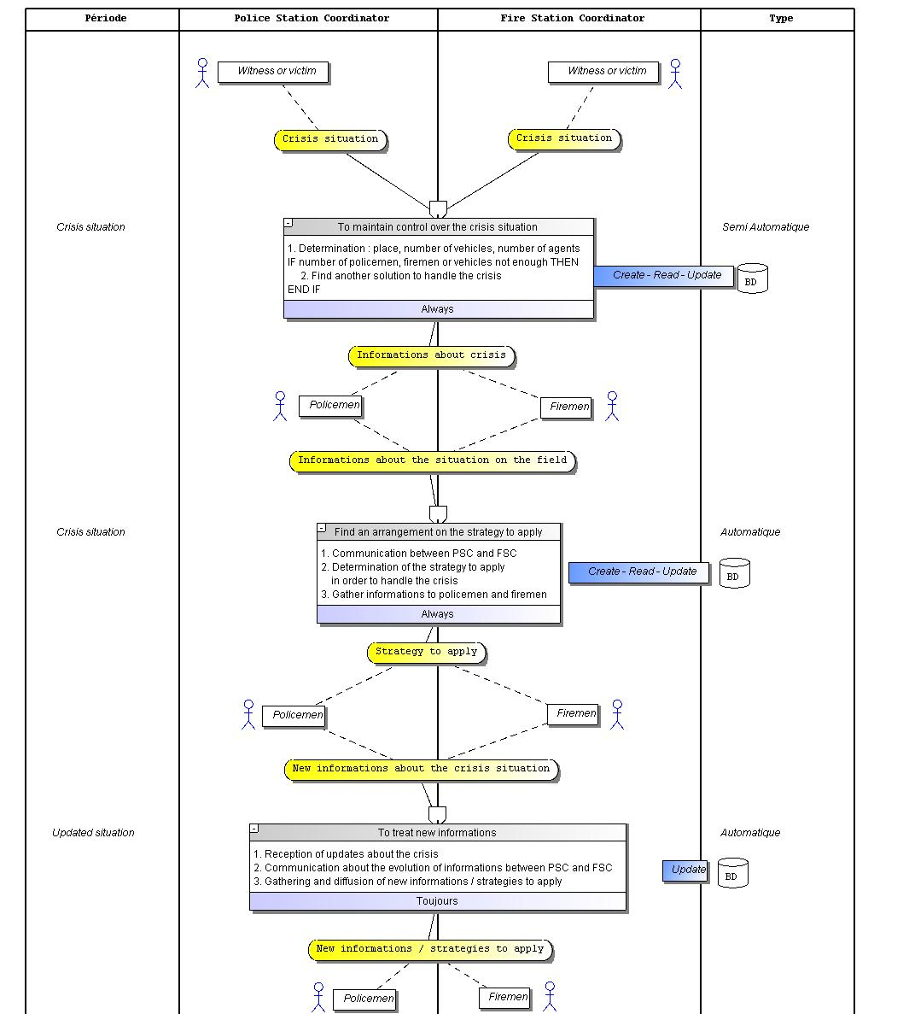

# II. Use Case Diagram

This use case diagram is a set of scenarios that the system must perform to produce an observable result by an actor.

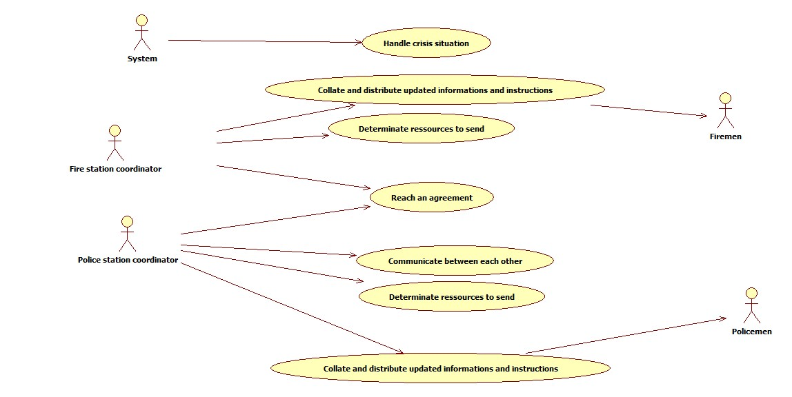

# III. MVC Architecture

# VI. Sequence System Diagram

We have developped two sequence system diagram. The first one illustrates the use case "Handle Crisis" and the second one illustrates the use case "Historic". These diagrams determine informations exchanged between the user and the system.

## Sequence system diagram of the use case "Handle Crisis"

This DSS represent the user (FSC or PSC) who sets all the informations of a new crisis.

**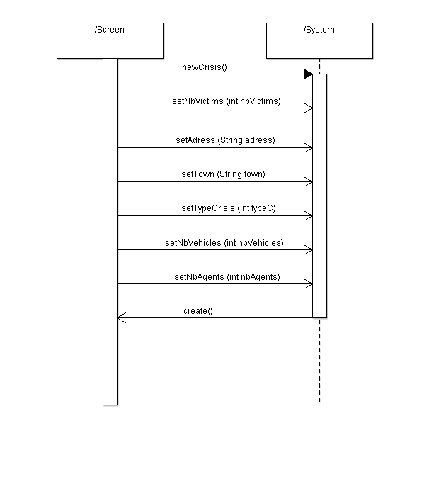**

## b) Sequence system diagram of the use case "Historic"

This DSS represent the user (FSC or PSC) who wants to see the historic of all the past crisis.

**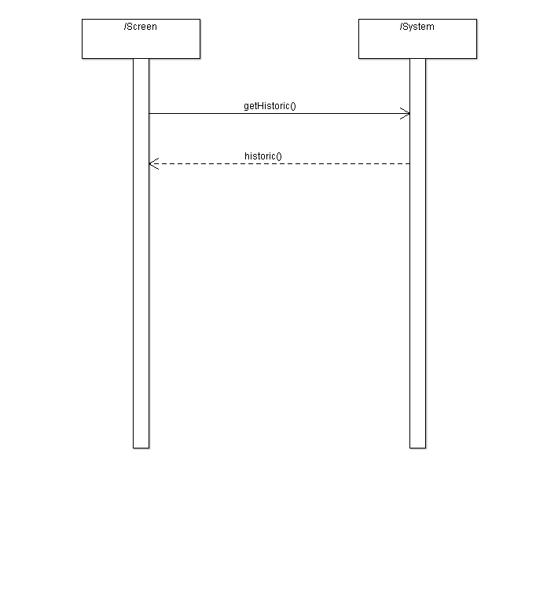**

# VIII. Sequence Diagram

We have develop two sequence diagram who correspond to the two previous sequence system diagram. These diagrams describe how the object who compose the system collaborate for realise the process.

## a) Sequence diagram of the use case "Handle Crisis"

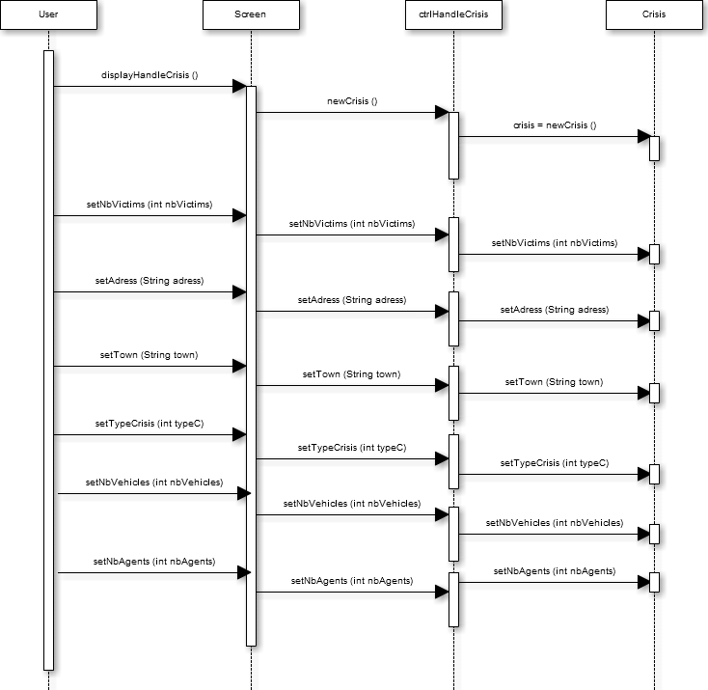

## b) Sequence diagram of the use case "Historic"

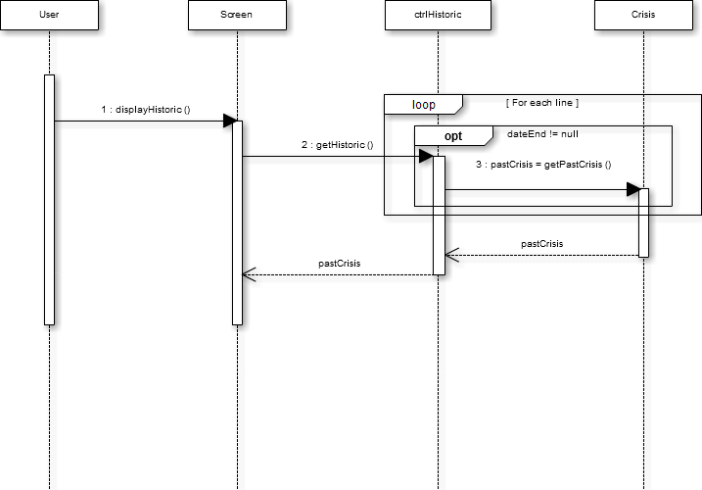

DCP

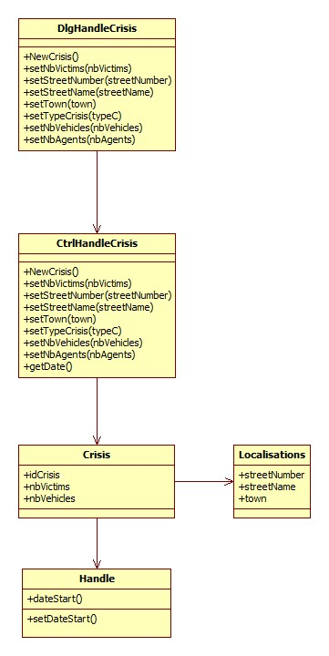

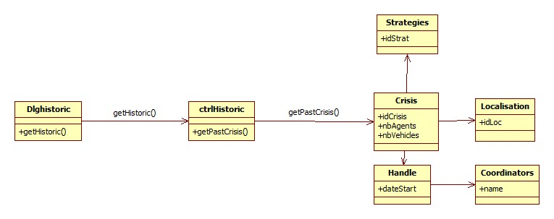

SNI

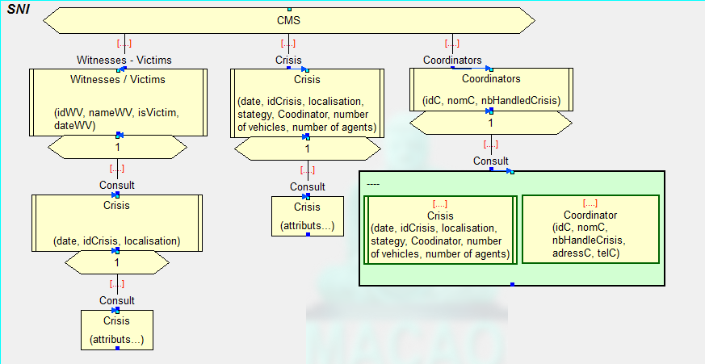

SEF

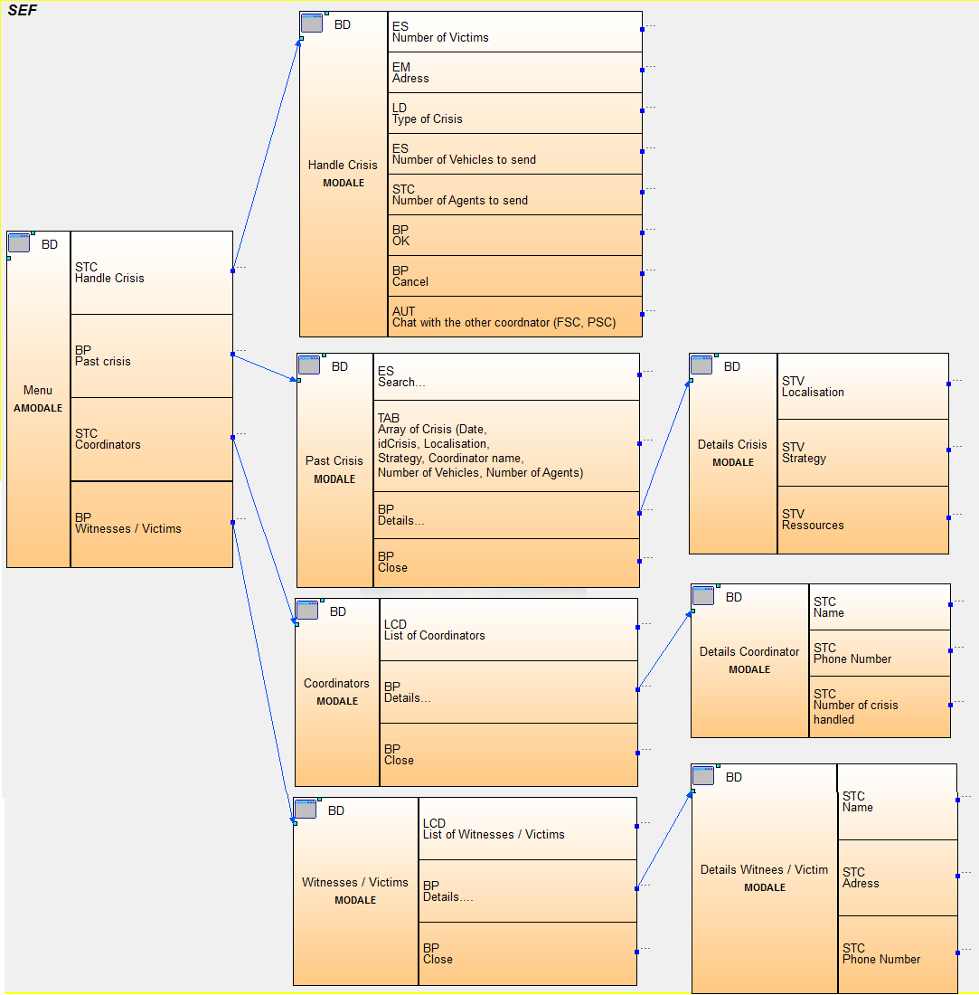

Maquettes écran

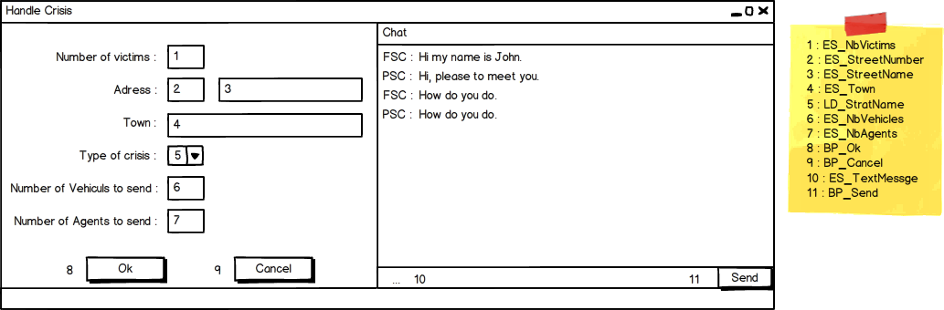

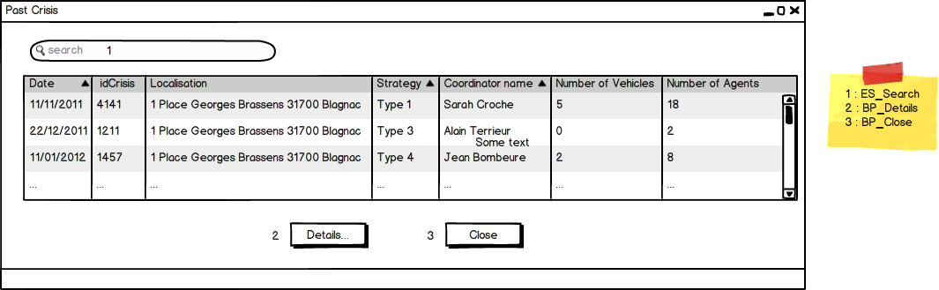

Dessins écran