Modelling deformation and horizontal sectioning of lake sediments

Dewey Dunnington (1), Ian Spooner (1) (1) Department of Earth & Environmental Science, Acadia University, 12 University Ave. Wolfville, Nova Scotia, Canada B4P 2R5

# Abstract

Not yet...

# Introduction

That deformation and compression of lake sediment occurs during coring has long been known (Martin and Miller 1982; Wright 1993), and designs of new coring devices have strived to minimize the conditions that promote deformation during coring (Martin and Miller 1982; Lane and Taffs 2002). Compression of sediment occurs during coring is a widely accepted phenomenon (Glew et al. 2001), however convex upwards deformation, while widely observed (Wright 1993; Rosenbaum et al. 2010), is infrequently discussed. The idea that horizontal sectioning (extrusion) of deformed sediment is undesirable has been previously noted (Rosenbaum et al. 2010), however the degree to which this deformation occurs and the effect that deformation has on paleolimnological data derived from horizontal sectioning has never been investigated quantitatively.

Rather than suggest that deformation does not occur or that a particular coring method prevents this from happening, we take the approach that acknowledging deformation and its effect on paleolimnological data is a the most reasonable approach. We suspect, given the innumerable paleolimnological studies that use coring and extrusion to produce reasonable and reproducible results, that either deformation or its effect on the data is minimal. This paper is our attempt to quantify and constrain the degree to which convex upwards deformation adds bias to horizontally sectioned paleolimnological data.

# Methods

We used R statistical software (R Core Team 2013) to model, manipulate, and visualize our data. Packages *dplyr* and *ggplot2* were used for manipulation and visualization of data, respectively (Wickham et al. 2016; Wickham and Francois 2016).

## Core photo analysis

To calculate parameters for the deformation model, we loaded 12 scale photos of deformed cores from 4 sources into ImageJ software and digitized deformed strata (Table 1). Coordinates were transformed to r and d values for individual strata by subtracting the minimum d value from the rest of the values, and subtracting the central x value from the rest of the values. Power regression (quadratic) was performed on the data to obtain reasonable coefficients for minimum, maximum, and mean levels of deformation.

## Deformation model

We modeled horizontal sections with height *H* and diameter *D* as a 3-dimensional raster grid with a cell size of 0.005 mm (Figure 1). For each cell *i*, an original depth *d0i* was calculated with reasonable minimum, maximum, and mean parameters obtained from digitized strata. Density histograms were then obtained to estimate the contribution of each original depth *d0* to the slice. For each slice, *d*=0 refers to the middle of the slice. We produced these models for *D*=6 cm, as this represents the barrel width of our Glew (1989) gravity corer. Compression was not modelled using this method, although modification of this model would make including compression possible.

## Effect on paleolimnological data

To model the concentration (mass fraction) we would obtain by sectioning and homogenizing a sample with variable concentration and density, we need to calculate total mass of the target substance divided by the mass of the slice. With a 3-dimensional raster grid using *n* cells, this value can be written as a sum of the product of concentration ($w$), density ($ρ$), and volume (*V*) divided by the sum of the product of *V* and $ρ$ (1).

$$w_{avg}=\frac{\sum_{i=1}^{n}{w_{i}}ρ_{i}V_{i}}{\sum_{i=1}^{n}{ρ_{i}}V_{i}}$$

We can remove *Vi* from the summation in both the numerator and denominator because the cell size is constant for each *i*, and write $w$ and $ρ$ as functions of *d0i*.

Equation (2) in combination with our deformation model allows for modelling the effect of sectioning, homogenization, and deformation given high-resoution un-altered data. We used fictional generated data to test our deformation model inspired by 1 mm resolution XRF core scanner data (Guyard et al. 2007; Brunschön et al. 2010; Kylander et al. 2011), and a linear dry density gradient from 0.1 to 0.5 g/cm3. Generated data was transformed and smoothed random log normal data with a set seed for repeatability purposes.

# Results

## Core photo analysis

We digitized 0 deformed layers from 0 scale photos of split cores. The quadratic regression produced an excellent fit of the data (*r2* from 0.58 to 1). Coefficients for *x2* ranged from 0.054 to 0.51, with a mean of 0.21.

## Deformation model

Notes on distribution and such.

## Effect on paleolimnological data

Using the formulas, if we model extrusion, this is the effect on the data:

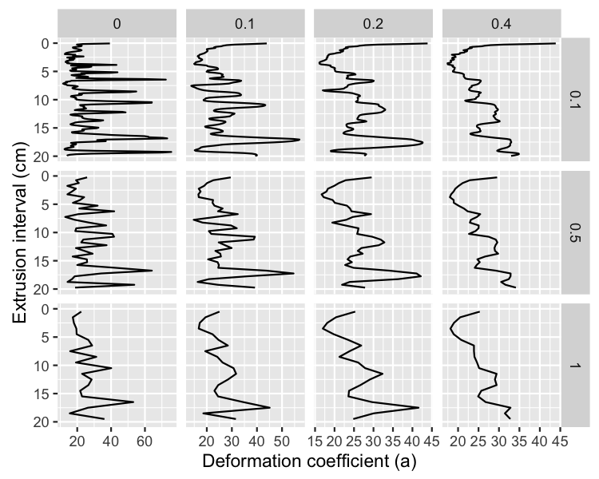

Figure 7. Extrusion and deformation modelled for artificial 0.5 mm resolution concentration data.

# Discussion

Any other literature out there? Haven't yet checked...

# Conclusions

There is a limit to how small extrusion intervals can get based on deformation. For minor deformation, even small extrusion intervals are ok.

# Acknowledgements

Thanks to...

# Tables

Table 1. Sources of core photos that contained digitized layers used in this study.

|  |  |  |
| --- | --- | --- |
| Photo ID | Layers Digitized | Reference |
| crevice_lake | 12 | Rosenbaum et al. 2010 |
| ds_unpubl1 | 1 | Dunnington and Spooner (unpublished data) |
| ds_unpubl2 | 2 | Dunnington and Spooner (unpublished data) |
| ds_unpubl3 | 1 | Dunnington and Spooner (unpublished data) |
| ds_unpubl4 | 1 | Dunnington and Spooner (unpublished data) |
| longlake_pc1 | 1 | White 2012 |
| menounos_cheak1 | 8 | Menounos and Clague 2008 |
| menounos_cheak2 | 8 | Menounos and Clague 2008 |
| suzielake_1 | 4 | Spooner et al. 1997 |
| suzielake_2 | 9 | Spooner et al. 1997 |
| whistler_gc4 | 1 | Dunnington 2015 |
| whistler_gc8 | 1 | Dunnington 2015 |

# Figures

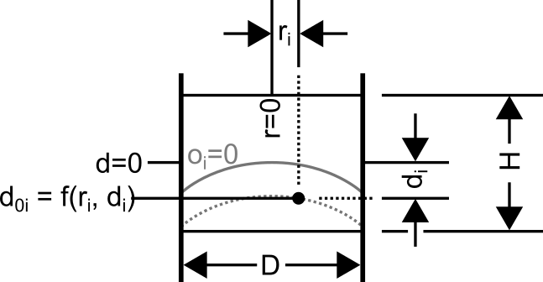

Figure 1. Schematic of variables used in the deformation model.

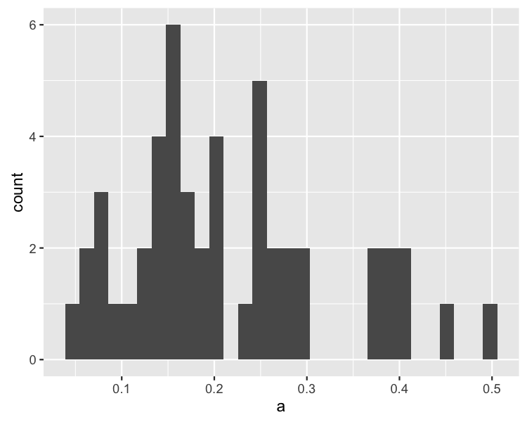

Figure 2. Histogram of deformation coefficients from digitized layers.

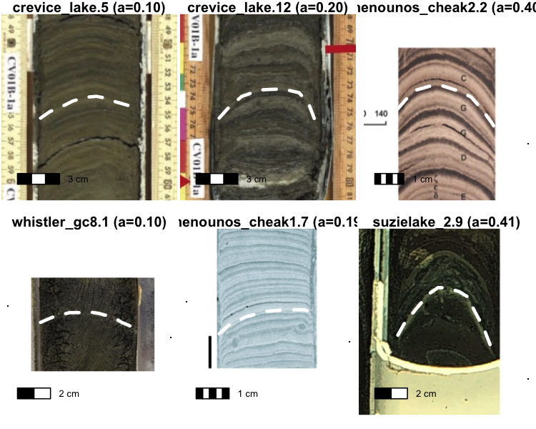

Figure 3. Representative layers for selected deformation coefficients.

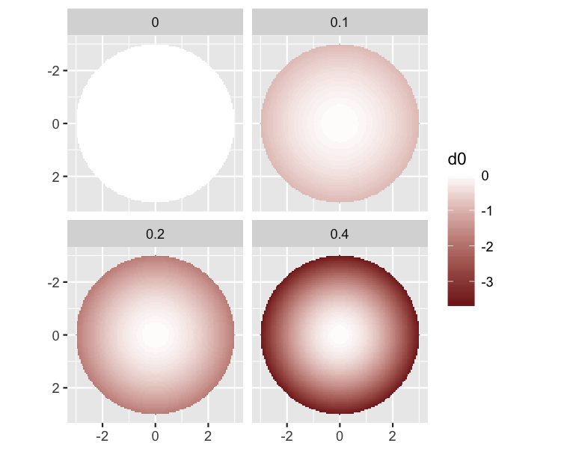

Figure 4. Distribution of d0 for d=0 by deformation coefficient.

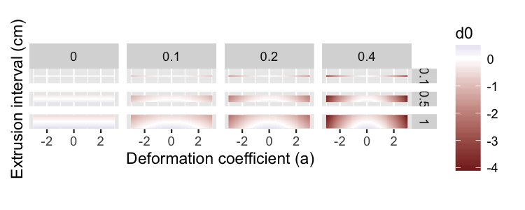

Figure 5. Distribution of d0 of a vertical sliced section for multiple deformation coefficients and slice sizes.

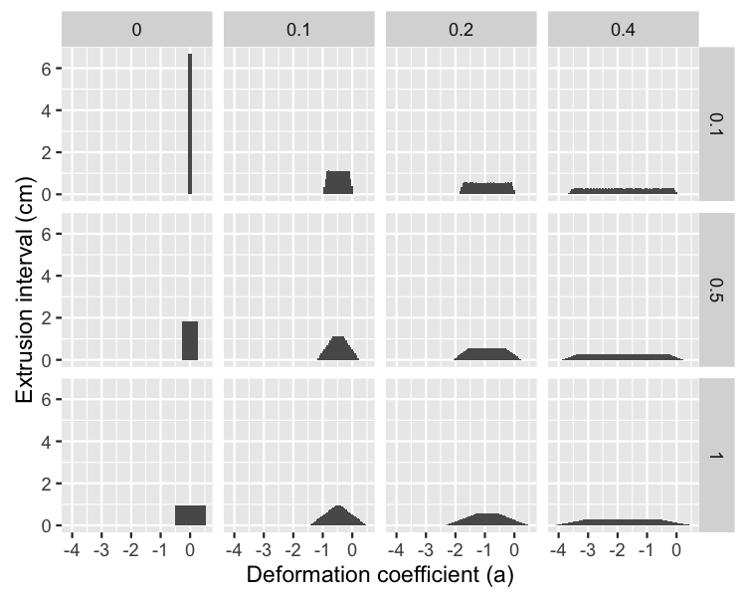

Figure 6. Distribution of d0 values modelled for multiple deformation coefficients and slice sizes.

# References

Brunschön C, Haberzettl T, Behling H (2010) High-resolution studies on vegetation succession, hydrological variations, anthropogenic impact and genesis of a subrecent lake in southern ecuador. Vegetation History and Archaeobotany 19:191–206. doi: [10.1007/s00334-010-0236-4](https://doi.org/10.1007/s00334-010-0236-4)

Dunnington DW (2015) A 500-year applied paleolimnological assessment of environmental change at alta lake, whistler, british columbia, canada. M.Sc. Thesis, Acadia University

Glew JR (1989) A new trigger mechanism for sediment samplers. Journal of Paleolimnology 2:241–243. doi: [10.1007/BF00195474](https://doi.org/10.1007/BF00195474)

Glew JR, Smol JP, Last WM (2001) Sediment core collection and extrusion. In: Last WM, Smol JP (eds) Tracking environmental change using lake sediments. Kluwer Academic Publishers, The Netherlands, pp 73–105

Guyard H, Chapron E, St-Onge G et al (2007) High-altitude varve records of abrupt environmental changes and mining activity over the last 4000 years in the western french alps (lake bramant, grandes rousses massif). Quaternary Science Reviews 26:2644–2660. doi: [10.1016/j.quascirev.2007.07.007](https://doi.org/10.1016/j.quascirev.2007.07.007)

Kylander ME, Ampel L, Wohlfarth B, Veres D (2011) High-resolution x-ray fluorescence core scanning analysis of les echets (france) sedimentary sequence: New insights from chemical proxies. Journal of Quaternary Science 26:109–117. doi: [10.1002/jqs.1438](https://doi.org/10.1002/jqs.1438)

Lane CM, Taffs KH (2002) The LOG corer – a new device for obtaining short cores in soft lacustrine sediments. Journal of Paleolimnology 27:145–150. doi: [10.1023/A:1013547028068](https://doi.org/10.1023/A:1013547028068)

Martin EA, Miller RJ (1982) A simple, diver-operated coring device for collecting undisturbed shallow cores.

Menounos B, Clague JJ (2008) Reconstructing hydro-climatic events and glacier fluctuations over the past millennium from annually laminated sediments of cheakamus lake, southern coast mountains, british columbia, canada. Quaternary Science Reviews 27:701–713. doi: [10.1016/j.quascirev.2008.01.007](https://doi.org/10.1016/j.quascirev.2008.01.007)

Menounos B, Clague JJ, Gilbert R, Slaymaker O (2005) Environmental reconstruction from a varve network in the southern coast mountains, british columbia, canada. Holocene 15:1163–1171. doi: [10.1191/0959683605hl888rp](https://doi.org/10.1191/0959683605hl888rp)

R Core Team (2013) R: A language and environment for statistical computing. R Foundation for Statistical Computing, Vienna, Austria

Rosenbaum JG, Skipp G, Honke J, Chapman C (2010) A composite depth scale for sediments from crevice lake, montana. United States Geological Survey, Reston, Virginia

Spooner IS, Hills LV, Osborn GD (1997) Reconstruction of holocene changes in alpine vegetation and climate, susie lake, british columbia, canada. Arctic and Alpine Research 29:156–163. doi: [10.2307/1552042](https://doi.org/10.2307/1552042)

White HE (2012) Paleolimnological records of post-glacial lake and wetland evolution from the isthmus of chignecto region, eastern canada. M.Sc. Thesis, Acadia University

Wickham H, Chang W, RStudio (2016) Ggplot2: An implementation of the grammar of graphics.

Wickham H, Francois R (2016) Dplyr: A grammar of data manipulation.

Wright HE (1993) Core compression. Limnol Oceanogr 38:699–701. doi: [10.4319/lo.1993.38.3.0699](https://doi.org/10.4319/lo.1993.38.3.0699)