Modeling the effect of convex upward sediment deformation and horizontal core sectioning on paleolimnological data

Dewey Dunnington (1), Ian Spooner (1)

(1) Department of Earth & Environmental Science, Acadia University, 12 University Ave. Wolfville, Nova Scotia, Canada B4P 2R5

Corresponding author e-mail:XXXXXXXXXX

# Abstract

We analyzed photos of convex upward deformation in split sediment cores to obtain reasonable parameters with which to model the effect of convex upward deformation on paleolimnological data. Using a 3-dimensional raster model, we modeled the effect of this deformation on a hypothetical dataset. Model results indicated that convex upward sediment deformation integrates samples from an increasingly broader range of stratigraphic layers with an increasing degree of deformation. After applying deformation, extruded concentration profiles were nearly identical, despite varying the extrusion interval between 0.1 cm and 1 cm, suggesting there is a limit to the resolution that can be attained by horizontal sectioning if deformation occurred during sampling. Our data suggest that it is essential to determine the degree of sediment deformation caused by coring prior to conducting high-resolution analyses on horizontally sectioned samples.

Sediment c

# Introduction

Deformation of lake sediment during the coring process has long been recognized (Martin and Miller 1982; Wright 1993; Glew et al. 2001) and coring equipment has been designed in an attempt to minimize the conditions that promote deformation during coring (Martin and Miller 1982; Lane and Taffs 2002). Glew et al. (2001) provided a detailed examination of the forces that act on sediments as a result of coring, including displacement of sediment during core tube penetration that results in core shortening. Convex upward sediment deformation, although commonly observed (Wright 1993; Rosenbaum et al. 2010), is rarely discussed. Kegwin et al. (1998) noted a radial bias in paleomagnetic data from Ocean Drilling Program (ODP) piston cores and proposed a logarithmic function to model the observed deformation. Aubourg and Oufi (1999) noted development of a "conical fabric" as a consequence of "edge smearing" in soft sediments, also in relation to paleomagnetic data from ODP piston cores. Acton et al. (2002) revised the logarithmic function proposed by Kegwin et al. (1998) and created a model to correct paleomagnetic data for this bias. The logarithmic function proposed by Kegwin et al. (1998) is a function of radius (*r*), core barrel radius (*R*), and degree of deformation (*b*).

Acton et al. (2002) estimate the *b* parameter of the equation is generally less than 0.2, but can range up to 0.4 in ODP piston cores (Fig. 1).

When deformed sediment is sectioned horizontally, adjacent strata are incorporated into each sampled section (Fig. 2). Rosenbaum et al. (2010) noted that horizontal sectioning (extrusion) of deformed sediment is not ideal, however the degree to which this deformation occurs and the effect of deformation on paleolimnological data has not been investigated quantitatively. We suspect, given the large number of paleolimnological studies that use coring and extrusion to produce reproducible results, that deformation, or its effect on the data, is minimal. This paper attempts to quantify and constrain the degree to which convex upward deformation biases paleolimnological data from horizontally sectioned cores.

# Materials and methods

We used R statistical software (R Core Team 2013) to model, manipulate, and visualize our data. Packages *dplyr* and *ggplot2* were used to manipulate and visualize data, respectively (Wickham et al. 2016; Wickham and Francois 2016).

## 

## Core photo analysis

To obtain reasonable parameters for *b* in our deformation function (Acton et al. 2002), we loaded 12 scale photos of deformed cores from six sources into image analysis software and digitized deformed strata (Table 1). We performed a regression on the digitized coordinates to estimate the degree of deformation (*b*) for each layer.

## 

## Deformation model

We modeled horizontal sections with height *H* and diameter *D* as a 3-dimensional raster grid with a cell size of 0.5 mm (Fig. 3). For each cell *i*, an original depth *d0i* (i.e. depth prior to convex upward deformation) was calculated, with a reasonable range of *b* parameters obtained from digitized strata. Density histograms were then produced to estimate the contribution of adjacent strata (represented by the original depth *d0*) to the slice. For each slice, *d*=0 refers to the middle of the slice. We produced these models for *D*=6.5 cm, as this represents the barrel width of our Glew (1989) gravity corer. More complex deformation was not modeled using this method, although the model could be modified to enable inclusion of more complex deformation.

## 

## Effect on paleolimnological data

To model the concentration (mass fraction) we would obtain by sectioning and homogenizing a sample with variable concentration and density, we needed to calculate the total mass of the target substance divided by the mass of the slice. With a 3-dimensional raster grid that uses *n* cells, this value can be written as a sum of the product of concentration (), density (), and volume (*V*) divided by the sum of the product of *V* and (2).

We can remove *Vi* from the summation in both the numerator and denominator because the cell size is constant for each *i*, and write and as functions of *d0i*.

Equation (3), in combination with our deformation model, enables modeling the effect of sectioning, homogenization, and deformation, given high-resolution, un-altered data. We used a generated dataset to test our deformation model, designed to resemble 1-mm-resolution XRF core scanner data (Guyard et al. 2007; Brunschön et al. 2010; Kylander et al. 2011), and a linear dry density gradient from 0.1 to 0.5 g/cm3. Generated data were transformed, smoothed, random log-normal data, with a set seed for replicability purposes.

# Results

## 

## Core photo analysis

We digitized 49 deformed layers from 12 scale photos of split cores. The logarithmic function modeled most layers well (median *r2* of 0.84), but some layers poorly. This suggests that deformation forces other than those modeled by the logarithmic function also act on sediments during coring, and that these forces may not be applied predictably. The *b* coefficient ranged from 0.15 to 5.24, with a median of 0.78 (Fig. 4). We chose 0, 0.5, 1, and 2 as coefficients for our model to produce a reasonable summary of the deformation that was observed (Fig. 5). Many analyzed photos of deformed cores were of cores collected by percussion coring, which can produce intense, convex upward deformation (Reasoner 1993), however photos of split gravity cores also contained observable deformation.

## 

## Deformation model

Slice thicknesses of 0.1 cm, 0.5 cm, and 1 cm were modeled with a core-barrel diameter of 6.5 cm. When *d*=0, *d0* values ranged from 0 cm to -4 cm and were more negative with increasing deformation (Figs. 6 and 7). Slices represented a wider range of *d0* values with increasing deformation (Figs. 7 and 8), and when deformation was >0.5, slices smaller than 1 cm did not decrease the range of *d0* values. In the model, *d0* values of high magnitude were concentrated in the outer few millimeters of the section.

## 

## Effect on paleolimnological data

As expected, increasing the thickness of the extrusion interval decreased the detail visible in the data (Fig. 9). The original data include thin (<0.5 cm) layers of high concentration (>60 units), only some of which were resolvable at extrusion intervals greater than 1 mm. Peak values were lower with increasing extrusion interval size, reflecting the inclusion of less concentrated material within the interval. High values in the topmost sample are an artifact of the model; it is likely that the effect of deformation at the top of the core differs from the effect of deformation deeper in the section. Increasing the degree of deformation also decreased the ability to resolve high-concentration layers, decreased the peak concentration, and also resulted in increasing the depth at which peak values were observed. When deformation occurred, decreasing the extrusion interval size did not result in increasing the effective resolution of the data. In particular, extrusion intervals of 0.1 cm and 0.5 cm produced nearly identical results when any deformation was applied in our model.

# Conclusions

The model indicates that even minimal convex upward deformation has an effect on paleolimnological data. Even when deformation was small, reducing the extrusion interval did not result in an appreciable difference in the paleolimnological data (Fig. 9) or decrease the range of depths represented by the slice (Fig. 8). Extrusion methods can produce sediment intervals of less than 0.1 cm (Cocquyt and Israël 2004). Our data, however, suggest that reducing the extrusion interval does not increase the effective resolution of the data if sediments were deformed by coring. The data also suggest that it is essential to check for deformation caused by coring before conducting high-resolution analyses of horizontally sectioned samples, and that eliminating the outer several millimeters of extruded core sections may mitigate the effects of deformation. We recognize the limits of applying a simple idealized model to cases where many deformation forces exist. We leave the modeling of more complex deformation to future investigators.

# Acknowledgements

We acknowledge funding from the Natural Sciences and Engineering Research Council (NSERC) of Canada, the insightful comments on this manuscript from both anonymous reviewers, and Mark Brenner for editorial handling.

# Tables

**Table 1** Sources of core photos that contained digitized layers used in this study

|  |  |  |  |
| --- | --- | --- | --- |
| Photo ID | Layers Digitized | Reference | Coring Method |
| cheak1 | 8 | Menounos and Clague (2008) | Percussion or gravity |
| cheak2 | 8 | Menounos and Clague (2008) | Percussion or gravity |
| crevice_lake | 12 | Rosenbaum et al. (2010) | Percussion piston |
| ds_unpubl1 | 1 | Dunnington and Spooner (unpublished data) | Gravity |
| ds_unpubl2 | 2 | Dunnington and Spooner (unpublished data) | Gravity |
| ds_unpubl3 | 1 | Dunnington and Spooner (unpublished data) | Gravity |
| ds_unpubl4 | 1 | Dunnington and Spooner (unpublished data) | Gravity |
| longlake_pc1 | 1 | White (2012) | Percussion |
| suzielake_1 | 4 | Spooner et al. (1997) | Percussion |
| suzielake_2 | 9 | Spooner et al. (1997) | Percussion |
| whistler_gc4 | 1 | Dunnington (2015) | Gravity |
| whistler_gc8 | 1 | Dunnington (2015) | Gravity |

# 

# Figures

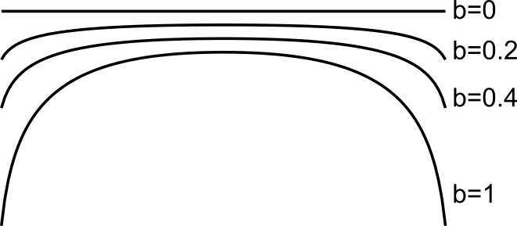

**Fig. 1**

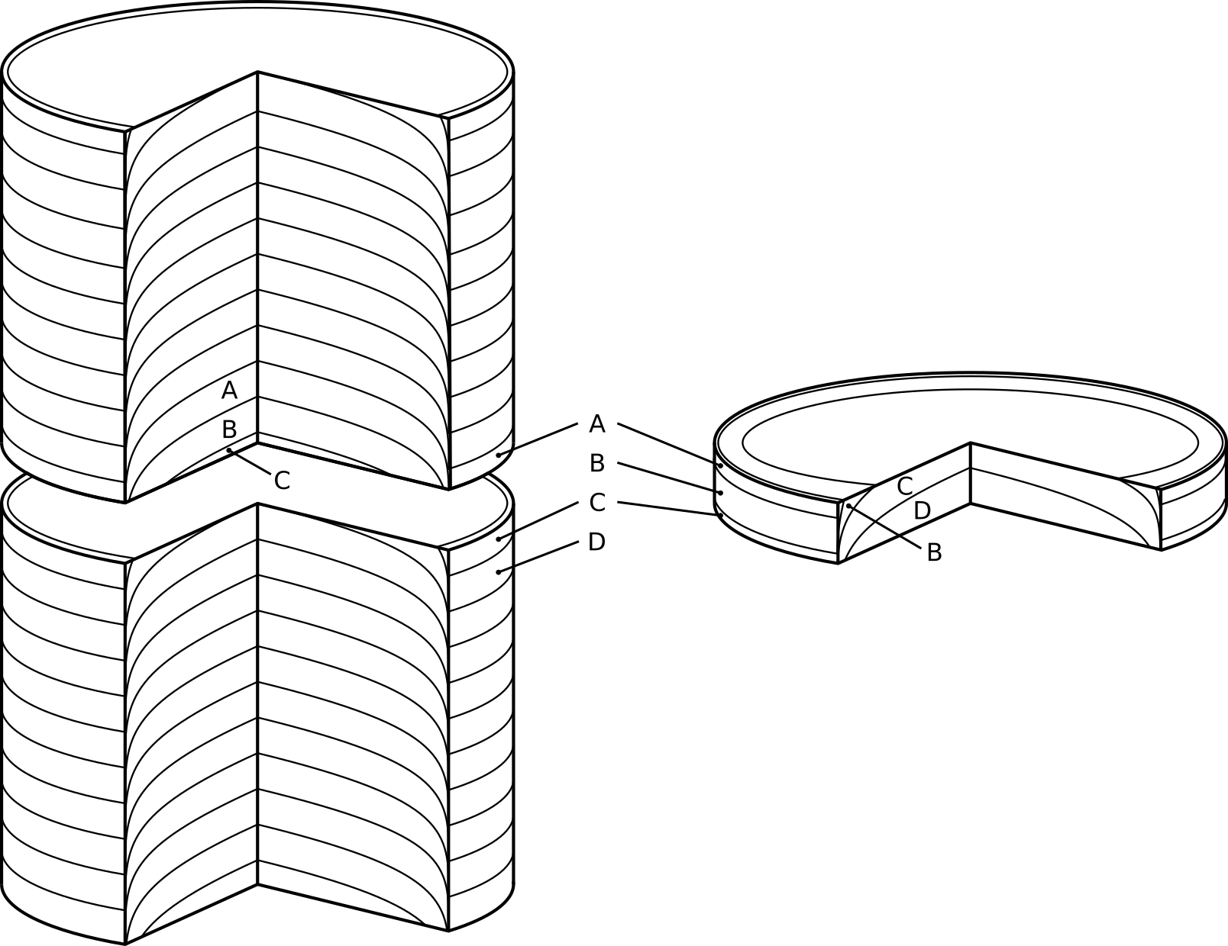

**Fig. 2**

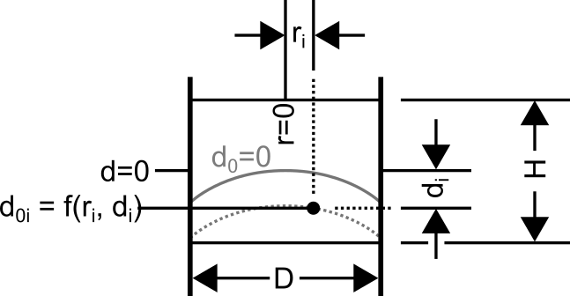

**Fig. 3**

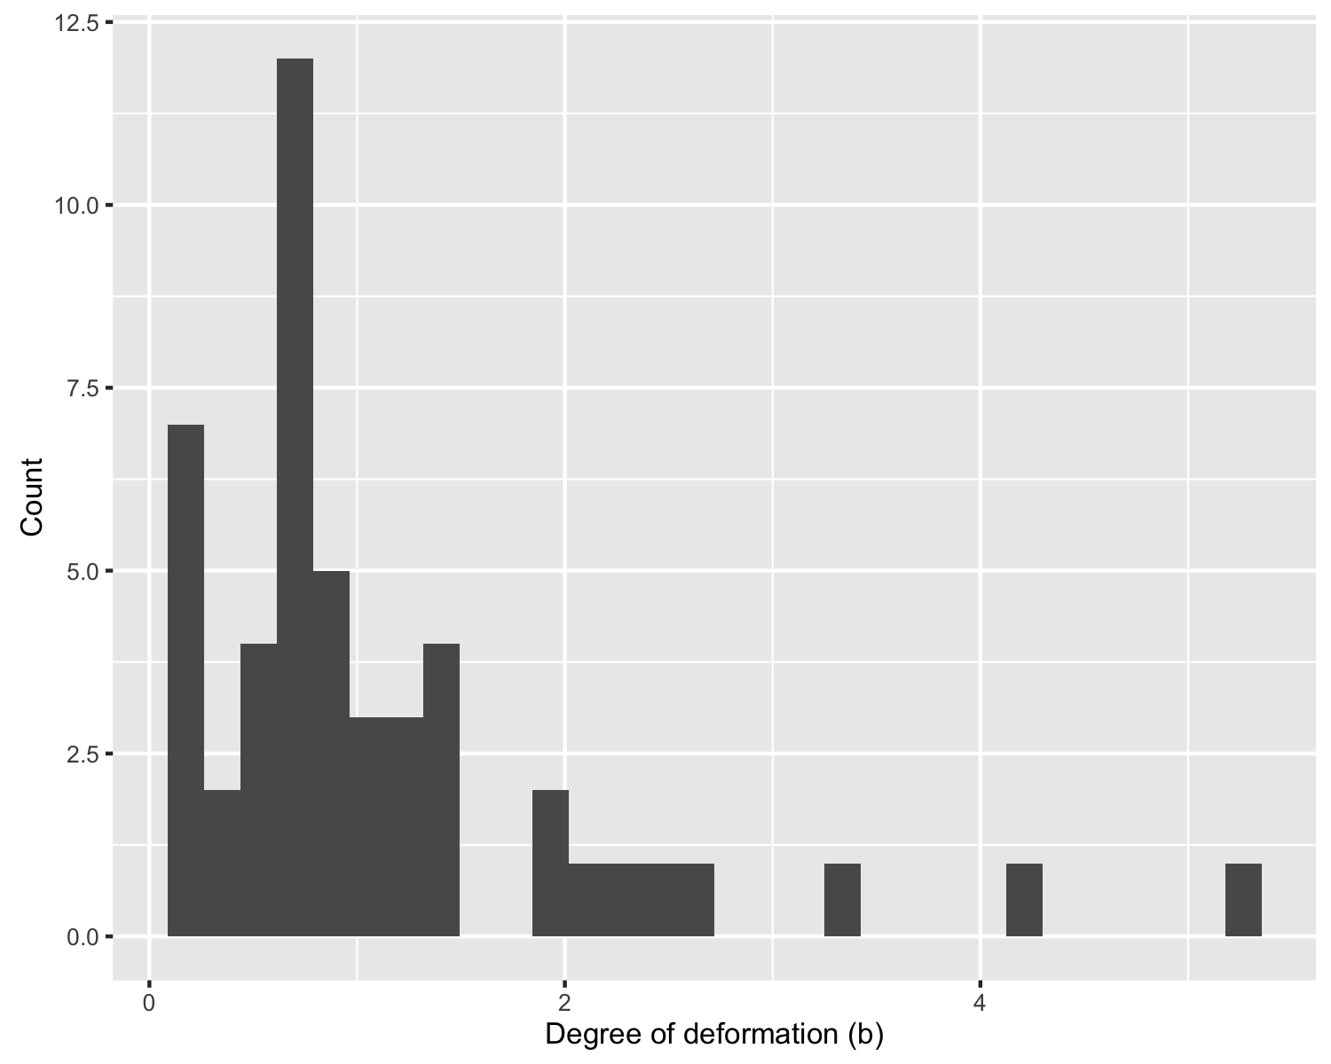

**Fig. 4**

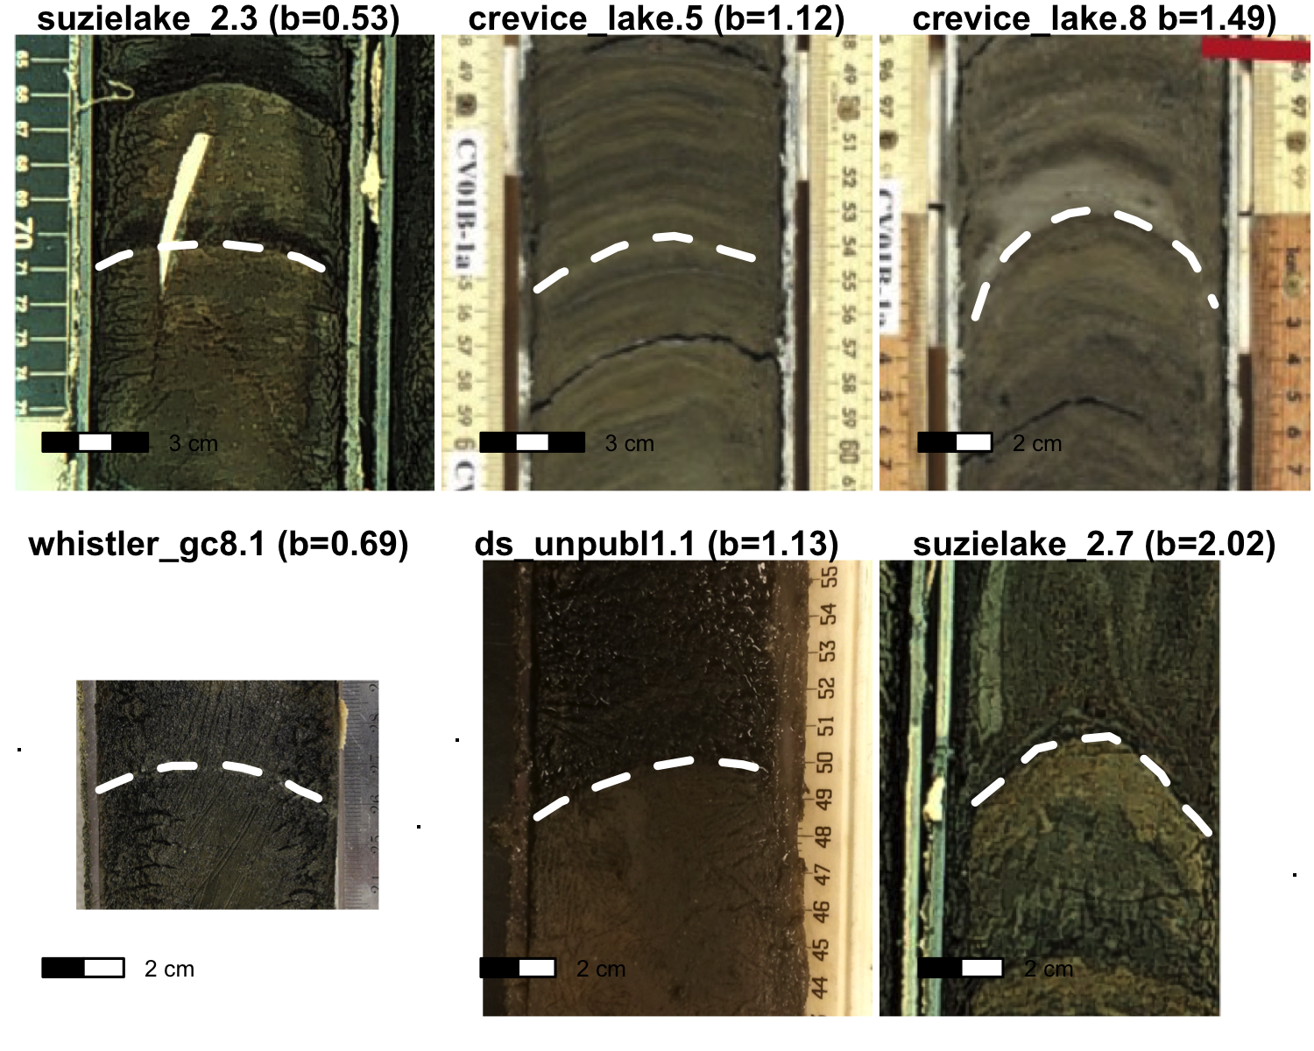

**Fig. 5**

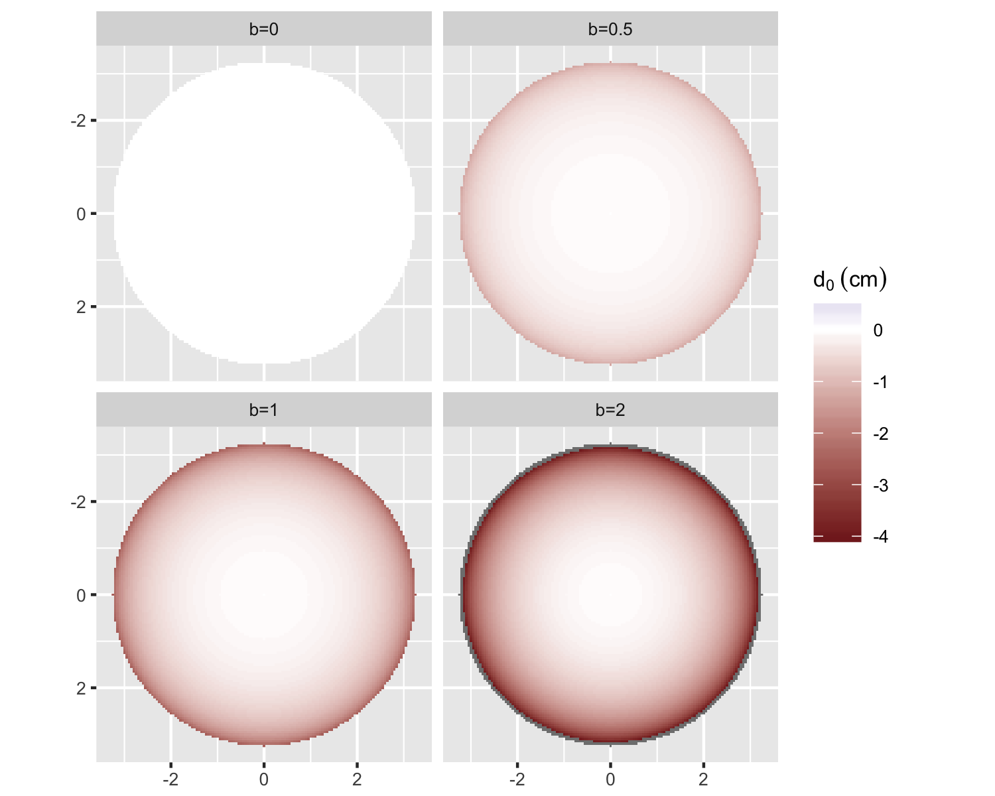

**Fig. 6**

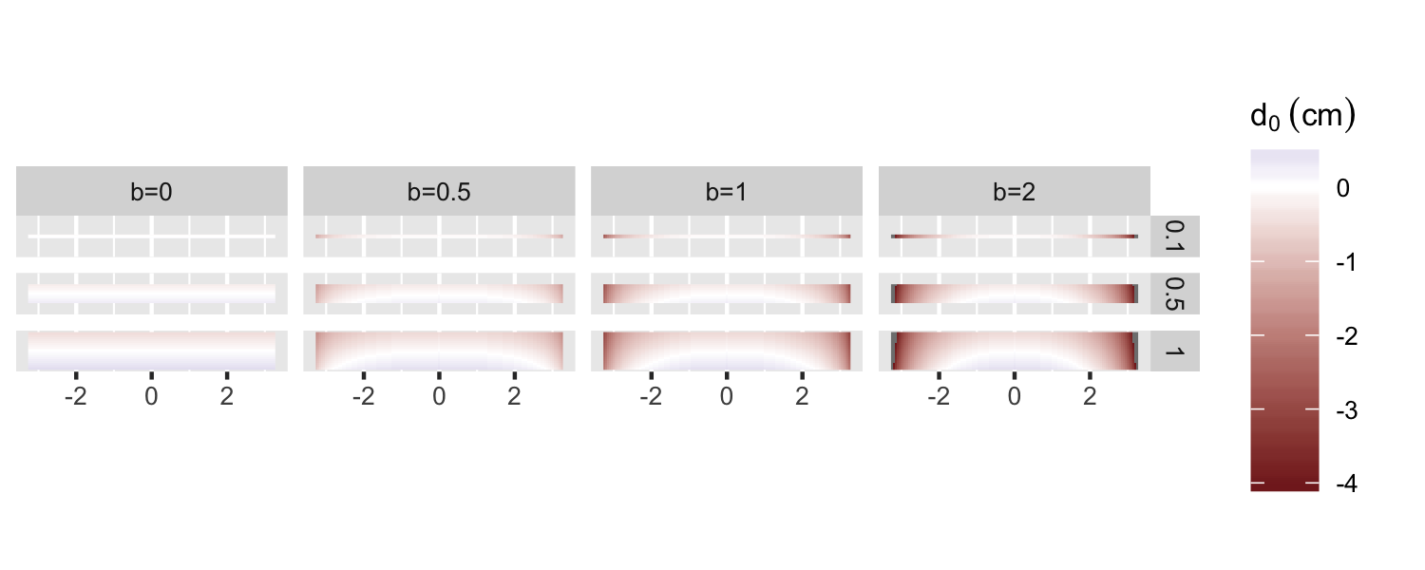

**Fig. 7**

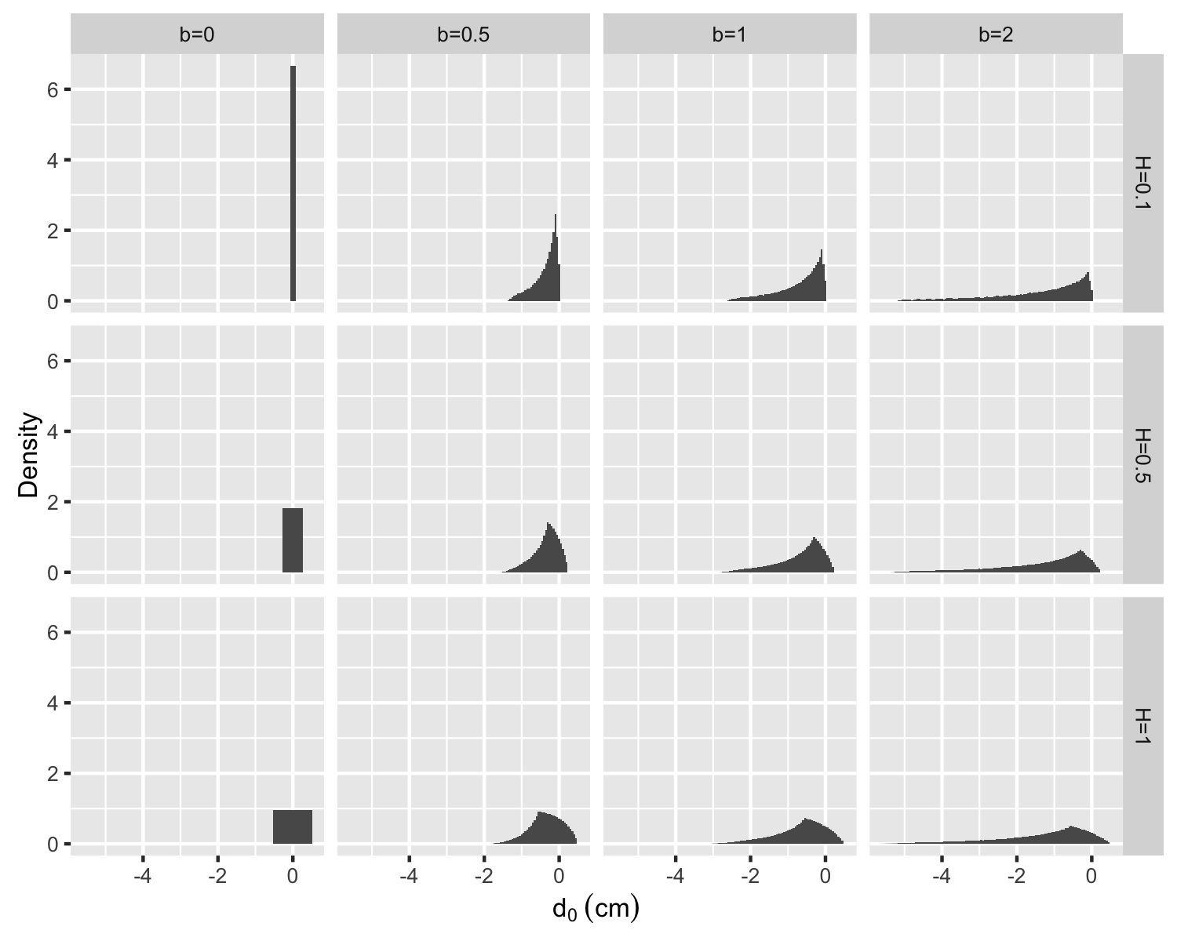

**Fig. 8**

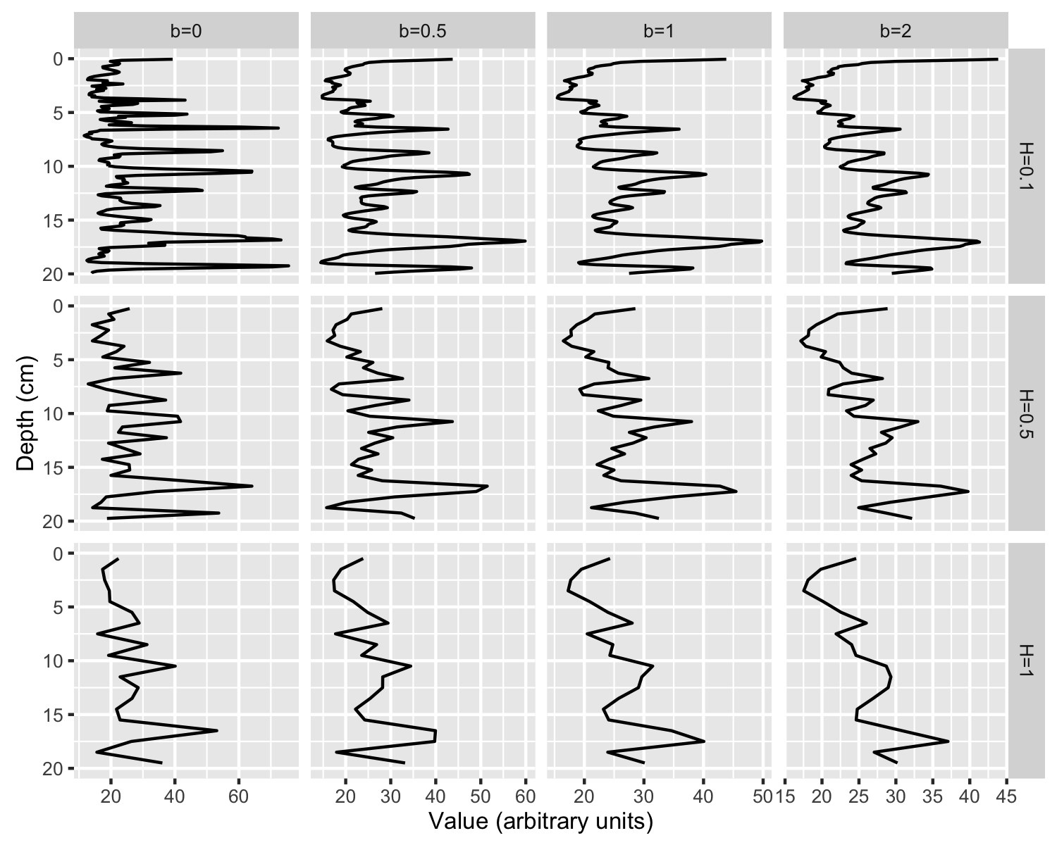

**Fig. 9**

# Figure Legends

**Fig. 1** Ideal patterns of deformation according to the logarithmic deformation function (Acton et al. 2002)

**Fig. 2** Schematic of how adjacent deformed strata may become incorporated into a single horizontal section of a core

**Fig. 3** Schematic of variables used in the deformation model. Models were produced for sections of diameter D and thickness H. Each point i in the section had a coordinate di and ri, which were used to calculate the depth prior to convex upward deformation (d0i)

**Fig. 4** Histogram of degrees of deformation (b) from digitized layers. Higher degrees of deformation corresponded to strata that were more deformed; lower degrees of deformation corresponded to strata that were less deformed

**Fig. 5** Representative layers for selected degrees of deformation

**Fig. 6** Distribution of d0 for d=0 by degree of deformation. Value b=0 indicates no deformation; b=2 indicates maximum deformation in the model. Coordinates are in centimeters

**Fig. 7** Distribution of d0 of a vertically sliced section for multiple degrees of deformation and slice sizes. Coordinates are in centimeters. Slice thickness is in centimeters and is indicated at right

**Fig. 8** Distribution of d0 values modeled for multiple deformation coefficients and slice sizes. Wide distributions indicate that a wide range of original depths (d0) contributed to that slice. Negative d0 values in the distribution indicate the inclusion of strata from above the center depth of the slice

**Fig. 9** Extrusion and deformation modeled for artificial 0.5-mm-resolution concentration data. Original data are at top left. Degree of deformation increases to the right; slice thickness increases toward the bottom

# Table Headers

**Table 1** Sources of core photos that contained digitized layers used in this study

# References

Acton GD, Okada M, Clement BM et al (2002) Paleomagnetic overprints in ocean sediment cores and their relationship to shear deformation caused by piston coring. J Geophys Res 107:EPM 3–1. doi: 10.1029/2001JB000518

Aubourg C, Oufi O (1999) Coring-induced magnetic fabric in piston cores from the Western Mediterranean. Proc Ocean Drill Prog Sci Results 161: 129–136

Brunschön C, Haberzettl T, Behling H (2010) High-resolution studies on vegetation succession, hydrological variations, anthropogenic impact and genesis of a subrecent lake in Southern Ecuador. Veg Hist Archaeobot 19:191–206. doi: 10.1007/s00334-010-0236-4

Cocquyt C, Israël Y (2004) A microtome for sectioning lake sediment cores at a very high resolution. J Paleolimnol 32:301–304. doi: 10.1023/B:JOPL.0000042995.59566.85

Dunnington DW (2015) A 500-year applied paleolimnological assessment of environmental change at Alta Lake, Whistler, British Columbia, Canada. M.Sc. Thesis, Acadia University

Glew JR (1989) A new trigger mechanism for sediment samplers. J Paleolimnol 2:241–243. doi: 10.1007/BF00195474

Glew JR, Smol JP, Last WM (2001) Sediment core collection and extrusion. In: Last WM, Smol JP (eds) Tracking environmental change using lake sediments. Kluwer Academic Publishers, The Netherlands, pp 73–105

Guyard H, Chapron E, St-Onge G et al (2007) High-altitude varve records of abrupt environmental changes and mining activity over the last 4000 years in the Western French Alps (Lake Bramant, grandes rousses massif). Quat Sci Rev 26:2644–2660. doi: 10.1016/j.quascirev.2007.07.007

Kegwin L, Rio D, Acton GD (1998) Intermediate depth Blake outer ridge, sites 1056, 1057, 1058, and 1059. Proc Ocean Drill Prog Initial Reports 172:77–156. doi: doi:10.2973/odp.proc.ir.172.104.1998

Kylander ME, Ampel L, Wohlfarth B, Veres D (2011) High-resolution X-ray Fluorescence core scanning analysis of Les Echets (France) sedimentary sequence: New insights from chemical proxies. J Quat Sci 26:109–117. doi: 10.1002/jqs.1438

Lane CM, Taffs KH (2002) The LOG corer – a new device for obtaining short cores in soft lacustrine sediments. J Paleolimnol 27:145–150. doi: 10.1023/A:1013547028068

Martin EA, Miller RJ (1982) A simple, diver-operated coring device for collecting undisturbed shallow cores. J Sed Res 52: 641

Menounos B, Clague JJ (2008) Reconstructing hydro-climatic events and glacier fluctuations over the past millennium from annually laminated sediments of Cheakamus Lake, Southern Coast Mountains, British Columbia, Canada. Quat Sci Rev 27:701–713. doi: 10.1016/j.quascirev.2008.01.007

R Core Team (2013) R: A language and environment for statistical computing. R Foundation for Statistical Computing, Vienna, Austria

Reasoner MA (1993) Equipment and procedure improvements for a lightweight, inexpensive, percussion core sampling system. J Paleolimnol 8:273–281. doi: 10.1007/BF00177859

Rosenbaum JG, Skipp G, Honke J, Chapman C (2010) A composite depth scale for sediments from Crevice Lake, Montana. United States Geological Survey Open File Report 2009-1277, Reston, Virginia

Spooner IS, Hills LV, Osborn GD (1997) Reconstruction of holocene changes in alpine vegetation and climate, Susie Lake, British Columbia, Canada. Arctic and Alpine Research 29:156–163. doi: 10.2307/1552042

White HE (2012) Paleolimnological records of post-glacial lake and wetland evolution from the Isthmus of Chignecto region, eastern Canada. M.Sc. Thesis, Acadia University

Wickham H, Chang W, RStudio (2016) Ggplot2: An implementation of the grammar of graphics. R Package version 2.1.0

Wickham H, Francois R (2016) Dplyr: A grammar of data manipulation. R Package version 0.4.3

Wright HE (1993) Core compression. Limnol Oceanogr 38:699–701. doi: 10.4319/lo.1993.38.3.0699