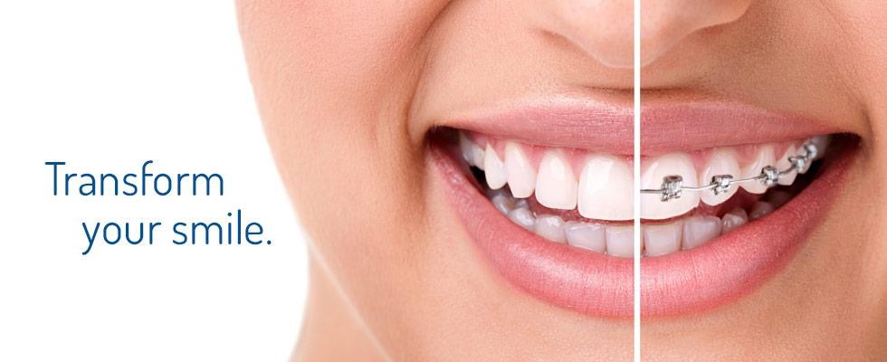

CS 5551 Project Proposal

Aulner, Wayne (2)

Huang, Wei (18)

Vundela, Karthik Reddy (57)

Palep, Naren (40)

# Introduction

For our project we wanted to create something that would actually be useful in the real world, something that could make a difference in people’s lives. To that end we decided that something in the healthcare space fit that desire well. As we thought about this we realized that there are not many mobile applications out there that assist with oral health, at least that we knew of or could find. This seemed like an area that we could do something in that no one else has, which leads us to the following project goals and objectives for a mobile application that will help those with malocclusion issues get the treatment they need in the most effective manner.

# Project Goal and Objectives

* Motivation

It is estimated that nearly 30% of the world’s population have malocclusions severe enough to benefit from orthodontic treatment. Malocclusions of the teeth can lead to serious oral health complications such as crowded teeth, crossbite, overbite, underbite, openbite, etc. These complications can prevent the teeth from performing their vital function, which can lead to oral health problems such as discomfort when chewing, choking, breathing problems, speech problems etc. all of which are preventable with proper treatment.

There are many people in the United States, and throughout the world, who have malocclusions and do not get the proper treatment. For some it may be that they are just too busy; for others it may be for financial reasons, or because orthodontic care is not readily accessible. For those that are too busy, or where cost is an issue, we will give them the ability to determine if treatment is necessary, and get competitive estimates, from the couch in their living room. Where accessibility is an issue, such as those who live in rural areas or possibly in parts of the world that are not as developed as what we are used to here in the United States, we will connect them with the closest orthodontic resources, to include potentially charitable organizations such as OperationSmile, that may be able to offer treatment.

* Significance/Uniqueness

After doing some research we could not find any mobile application on either the Apple or Android application stores that did what we are proposing. We feel that the application we would be creating would be more than just a class project but could actually be used in the real world. As such we have contacted an orthodontist, Dr. David Christensen with Christensen Orthodontics, and discussed the idea with him. He was very enthusiastic about such a mobile application, and even offered to act as an actual alpha client as we develop the application. If the application is successful, at some point, we would even like to contact the charitable organization OperationSmile and see if they could somehow leverage the application in their charitable work (as they are partnered with Invisalign which provides malocclusion treatment).

* Objectives

The primary objective of this project is to create a mobile application that can provide a means whereby individuals can more easily, and in a more cost effective manner, access the resources necessary to determine if they have a form of malocclusion, and if so whether treatment is necessary. Additionally, to be really successful we will need to get buy in from the actual orthodontists in the areas where it is used. However, I don’t see this as a problem since the application would actually be funneling business to them.

* System Features

The application will require the mobile user to enter a minimal amount demographic information; things like first and last name, phone number, home address, email address, etc. The application will use the home address they enter to determine the location of the nearest orthodontic offices in the area, and allow the user to select the desired radius to limit the results.

The application will require the user to fill out an oral health template. The template will contain questions such as, if they are currently having any oral health problems, things they would like to change about their oral health, potential treatments they would like to know more about, any concerns they have, insurance information (may require additional demographics), etc.

The application will walk them through a wizard that will assist them in taking several pictures of their face, teeth and jaw that will be sent to an orthodontist. These pictures along with the oral health template will help the orthodontist make an initial assessment of their oral health, and whether or not they may have a malocclusion condition that needs to be treated. The application will have some machine intelligence to assist the user in taking the photos. For instance, making sure the picture taken is in focus and positioned correctly on the screen. We envision this logic being similar to logic one might find on a bank application for scanning in checks from a mobile device.

Once all the information is entered and the pictures taken the user will be able to select one or more orthodontic offices that they would like to email the information. Once received by the orthodontist, they will review the information and reply with an initial assessment of the users oral health state, along with a cost estimate (taking into account any insurance information that was provided) if they feel treatment is needed.

# Related Work

* We did some research and we could not find any application in the Android or Apple application stores that come close to doing anything the application we are proposing would do.

# Project Plan

* Increment Schedule: There will be 4 increments with the following due dates (see image).

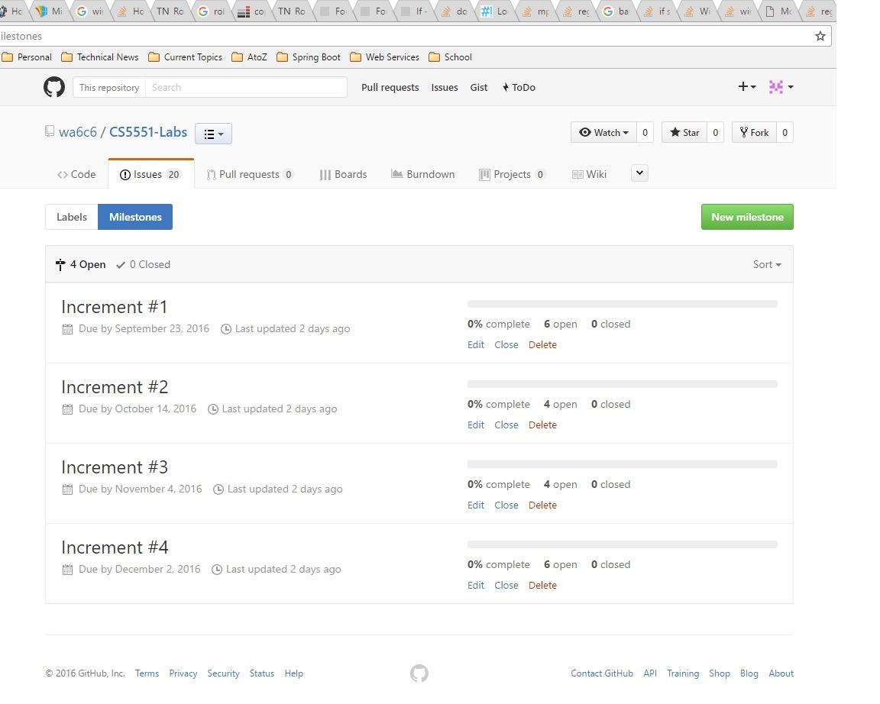

* Stories: These are the stories for iteration #1, for additional iterations click [here](https://github.com/wa6c6/CS5551-Labs/milestones).

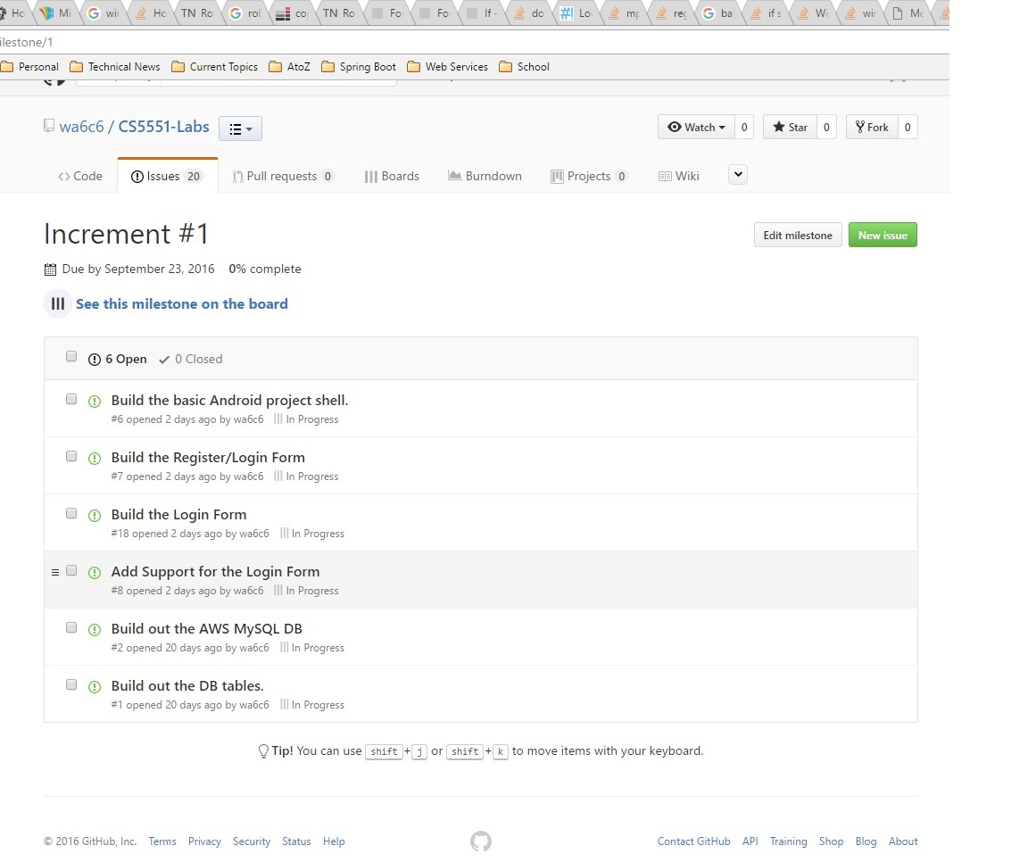

* Burndown Chart: This is the burndown for increment #1. There isn’t really much to see at this point since we are just getting started. This image will be updated as the increment progresses.

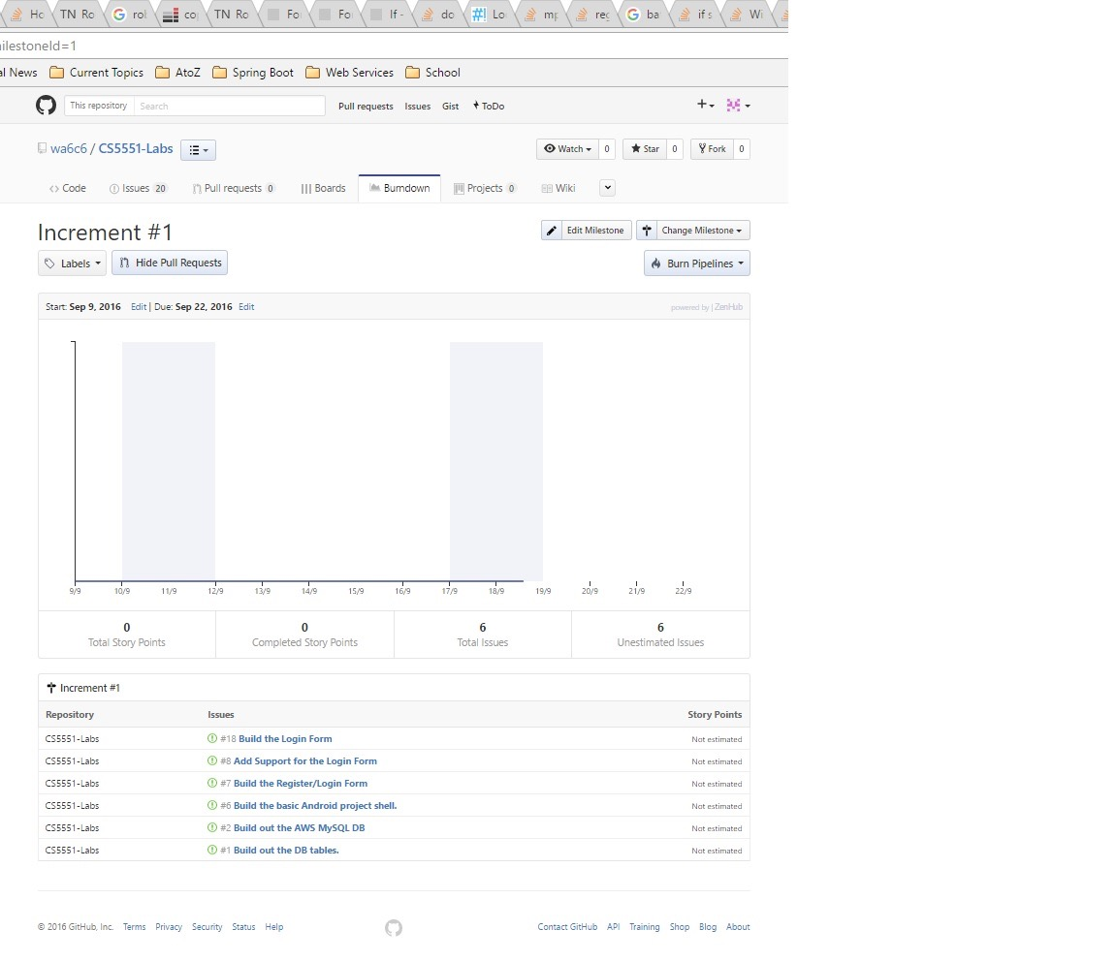

# First Increment Report

* Architecture diagram/Class diagram/Sequence diagram

Architecture diagram:

In this architecture diagram we have a user, server , database and orthodontist. First if the user is new he will register and if he is old he will directly login. The registered user details will be saved in database all the pages will be stored in server who is responsible to server the pages to user. After login if successfully validated then the user will be displayed with the google maps page with the nearest orthodontist available to your location. Now user will select one base on the reviews shown which will be taken from google api. Next user will be directed to the form page where the user is required to take pics and fill in the form which asks minimum fields, all these will be stored in data base of later reference. The last thing is the user will send the details to orthodontist which he selected initially and he will be displayed with the summary page of the document he sent. The orthodontist will get all the information the user sent.

This is how our architecture of our system will work.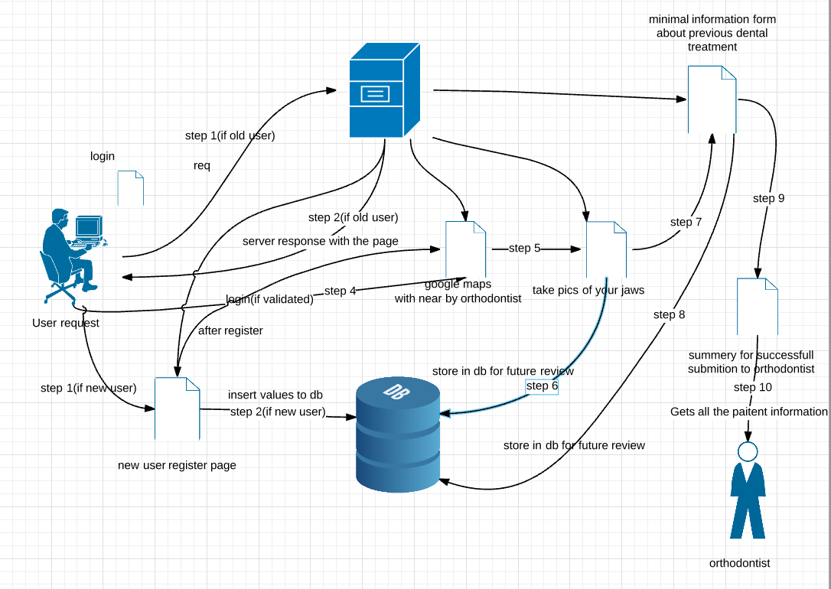

Class Diagram: Our class diagram consists of three class Patient, System and Orthodontist.

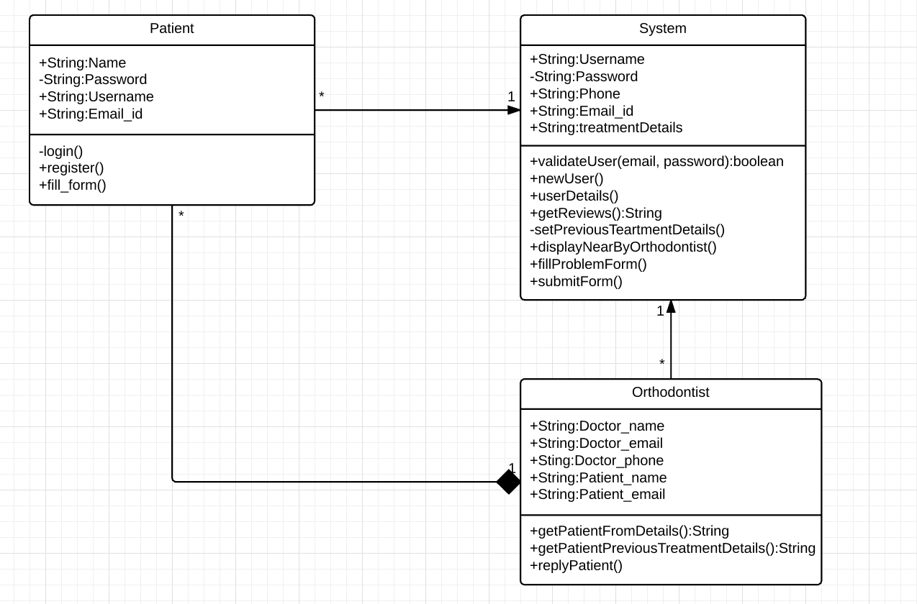

Sequence Diagram: The work flow of our sequence diagram is shown below:

Bibliography

1. Dr. David Christensen DMD, MS with Christensen Orthodontics ([www.christensenorthodontics.com](http://www.christensenorthodontics.com))
2. Wikipedia (<https://en.wikipedia.org/wiki/Orthodontics>)
3. HealthLine (<https://healthline.com/health/malocclusion-of-teeth#Overview1>)
4. Operation Smile (<http://www.operationsmile.org/content/invisalign-brand-celebrates-major-milestone>)