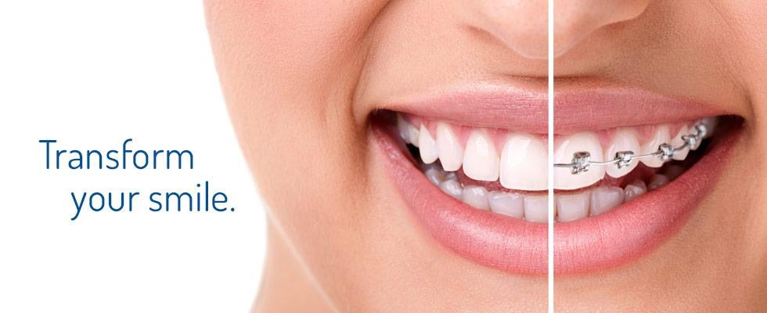

Smiles User Manual

CS 5551 Final Project

Aulner, Wayne (2)

Palep, Naren (40)

Huang, Wei (18)

Vundela, Karthik Reddy (57)

Contents

[Introduction 3](#_Toc469058571)

[Installation 3](#_Toc469058572)

[Sign In 3](#_Toc469058573)

[Existing User 3](#_Toc469058574)

[New User 3](#_Toc469058575)

[Profile 3](#_Toc469058576)

[Demographic 3](#_Toc469058577)

[Insurance 3](#_Toc469058578)

[Medical/Dental History 4](#_Toc469058579)

[Complaints 4](#_Toc469058580)

[Treatment 4](#_Toc469058581)

[Pictures 4](#_Toc469058582)

[Provider Search 4](#_Toc469058583)

[Map 4](#_Toc469058584)

[Email 5](#_Toc469058585)

[Radius 5](#_Toc469058586)

[Error Handling 5](#_Toc469058587)

[Sign In 5](#_Toc469058588)

[username 5](#_Toc469058589)

[password 5](#_Toc469058590)

[Profile 5](#_Toc469058591)

[Known Bugs 5](#_Toc469058592)

[Email Limitation 5](#_Toc469058593)

[Delay in Maps 6](#_Toc469058594)

[Null Checks 6](#_Toc469058595)

[Minimizing 6](#_Toc469058596)

[Sample Interaction 6](#_Toc469058597)

[Install 7](#_Toc469058598)

[Approve Permissions 7](#_Toc469058599)

[Sign In Screen 8](#_Toc469058600)

[Select REGISTER 8](#_Toc469058601)

[Profile 9](#_Toc469058602)

[Enter Profile Information 9](#_Toc469058603)

[Capture 6 Photos 10](#_Toc469058604)

[Provider Search 11](#_Toc469058605)

[View Provider 11](#_Toc469058606)

[Adjust Radius 11](#_Toc469058607)

[Select Provider 12](#_Toc469058608)

[Send Email 13](#_Toc469058609)

[View Photo(s) 14](#_Toc469058610)

# Introduction

The Smiles application was written to connect users that may have *malocclusions* to Orthodontists in their local area. Specifically, users that by virtue of their remote location, or busy schedules, simply cannot easily access an Orthodontist. However, on a larger scale its meant to show that that patents can directly communicate with their healthcare providers without having to go through a obtrusive layer of bureaucracy.

# Installation

The first thing a user needs to do is install the Smiles application. At this time that is done through the Android Studio.

# Sign In

## Existing User

If the user has previously registered they simply need to enter in their *username* and *password* at the sign in screen, and hit the **SIGN IN** button. If they type either in incorrectly an error will be displayed the current credentials are not valid.

## New User

If this is a new user then they will need to register, which essentially means they need to create a profile. To do this the new user just needs to click on the **REGISTER** button.

# Profile

The profile is where the user will enter pertinent information needed by the Orthodontist to identify the user, evaluate their condition, determine treatment options, and to provide them with estimated cost.

## Demographic

The following demographic information is needed for the user to be correctly identified by the Orthodontist clinic.

1. First Name
2. Last Name
3. Age
4. Gender
5. Address

## Insurance

The following insurance information is needed if the user desires the Orthodontists office to provide them with an estimate, or financing options.

1. Insurance Provider
2. Plan Number
3. Any Interest in 3rd party financing?

## Medical/Dental History

The following medical and dental history is necessary to determine the current state of the user’s medical and health. There are conditions, that if they user has, will disqualify them from Orthodontic treatment.

1. Current Dentist
2. Date of last clean dental cleaning
3. Any know medical or dental conditions?
4. Any history of orthodontic treatment?
5. Any known cavities?

## Complaints

He the use can communicate to the orthodontist what they are unhappy about, or things they would like changed.

1. What about your smile would you like to change?
2. What about your teeth would you like to change?
3. What about your profile would you like to change?

## Treatment

Here the user can specify any treatment they have been considering.

1. Braces
2. Invisalign
3. Lingual Braces

## Pictures

The user needs to provide the Orthodontist with 6 pictures of their facial profile and mouth. The application will take the user through a wizard, which has example pics of what the user needs to capture.

# Provider Search

Once the user has completed their profile they can navigate here to start searching for an Orthodontist to contact.

## Map

The first thing the user will see is a map with a marker on their current location. The map is loaded with a default location of 5 miles. It should be noted that this distance is from point to point. This means that while the Orthodontic clinic might only be 5 miles from the user’s current location. It will almost certainly be slightly longer by car, or whatever transportation they will use to get there because the user cannot drive, or walk in an exact straight line to get from their current location to the clinic.

To see the details of clinic the user only needs to hit the smiley face, which represents each orthodontic clinic. This will pull up a dialogue with information about the clinic. The following is what is displayed currently but items can be add to, or taken from, this list easily.

1. Google Rating
2. Address
3. Phone
4. Hours of Operation

### Email

If the user finds an orthodontist clinic they would like to contact, they just need to hit **YES** (lower right hand corner) on the clinic’s dialogue. This will prompt the user to select an email client, of their choice, to send the email. The user can also review the information for accuracy and make any changes or add any comments as well.

### Radius

If the user wants to look outside of the five-mile default radius they can select this option and increase the search radius. Currently the options are from five to one hundred miles but we could modify the dialogue to go out farther but it seemed superfluous to do so.

# Error Handling

## Sign In

### username

If the user tries to enter an email with no “@” then we will display an error and prompt them for new input.

### password

If the user tries to enter a password that is shorter than 6 characters, then we will display an error and prompt them for new input

## Profile

Additional error handling needs to be added to the profile to validate the data entered.

# Known Bugs

## Email Limitation

Since this application is only a class project we ***did not*** want users to be able to send to an actual Orthodontic clinic at this time. So instead the application simply sends the email right back to the user. However, when reviewing the email to send they will see the ***clinics email*** address in the subject line. For example, the subject line might look like “Orthodontic Template From - Wayne Aulner (<mailto:info@some-clinic.com)>”. We put it here so that the person ***grading this project*** could see that we looked up the actual email address (via Hunter API) and we could send it to the clinic if this were are a production application.

## Delay in Maps

You will notice a delay sometimes when selecting a clinic from the maps. The reason for this is because we have to make four API calls to get the clinics information, and that can sometimes take a couple of seconds.

## Null Checks

There are several places where better null checking should be happening. Because of this the user could experience the application crashing unexpectedly.

## Minimizing

Occasionally, when minimizing the application, it will log the user out and they will be forced to log back in when the set focus on their application again.

# Sample Interaction

This interaction is based on a new user registering and starting from scratch.

# Install

## C:\Users\wa4101\Downloads\Photos (2)\p2.pngC:\Users\wa4101\Downloads\Photos (2)\p3.pngC:\Users\wa4101\Downloads\Photos (2)\p1.pngC:\Users\wa4101\Downloads\Photos (2)\p4.pngApprove Permissions

# Sign In Screen

## C:\Users\wa4101\Downloads\Photos (2)\sign_in.pngSelect REGISTER

# Profile

## C:\Users\wa4101\Downloads\Photos (2)\profile_2.pngC:\Users\wa4101\Downloads\Photos (2)\profile_3.pngC:\Users\wa4101\Downloads\Photos (2)\profile_1.pngEnter Profile Information

## C:\Users\wa4101\Downloads\Photos (3)\pic_6.pngC:\Users\wa4101\Downloads\Photos (3)\pic_5.pngC:\Users\wa4101\Downloads\Photos (3)\pic_4.pngC:\Users\wa4101\Downloads\Photos (3)\pic_2.pngC:\Users\wa4101\Downloads\Photos (3)\pic_3.pngC:\Users\wa4101\Downloads\Photos (2)\pic_1.pngCapture 6 Photos

# Provider Search

## View Provider

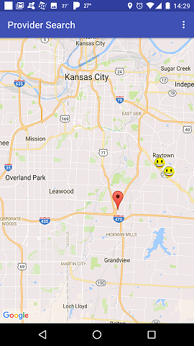

## Adjust Radius

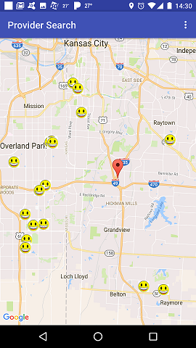

## C:\Users\wa4101\Downloads\Photos (4)\pro_info.pngSelect Provider

## Send Email

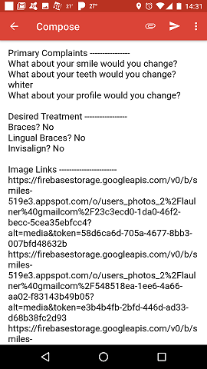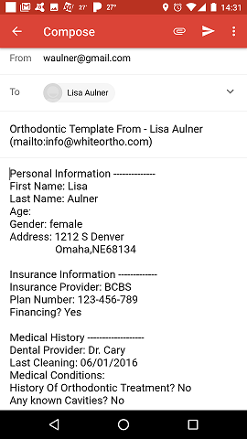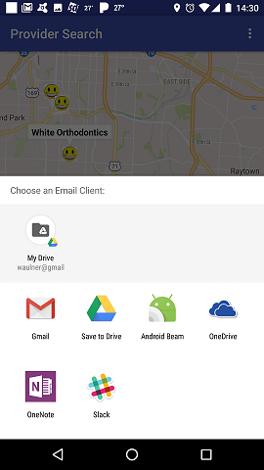NOTE: I adjusted the **To address** to send to my email account at work because the email in there is bogus.

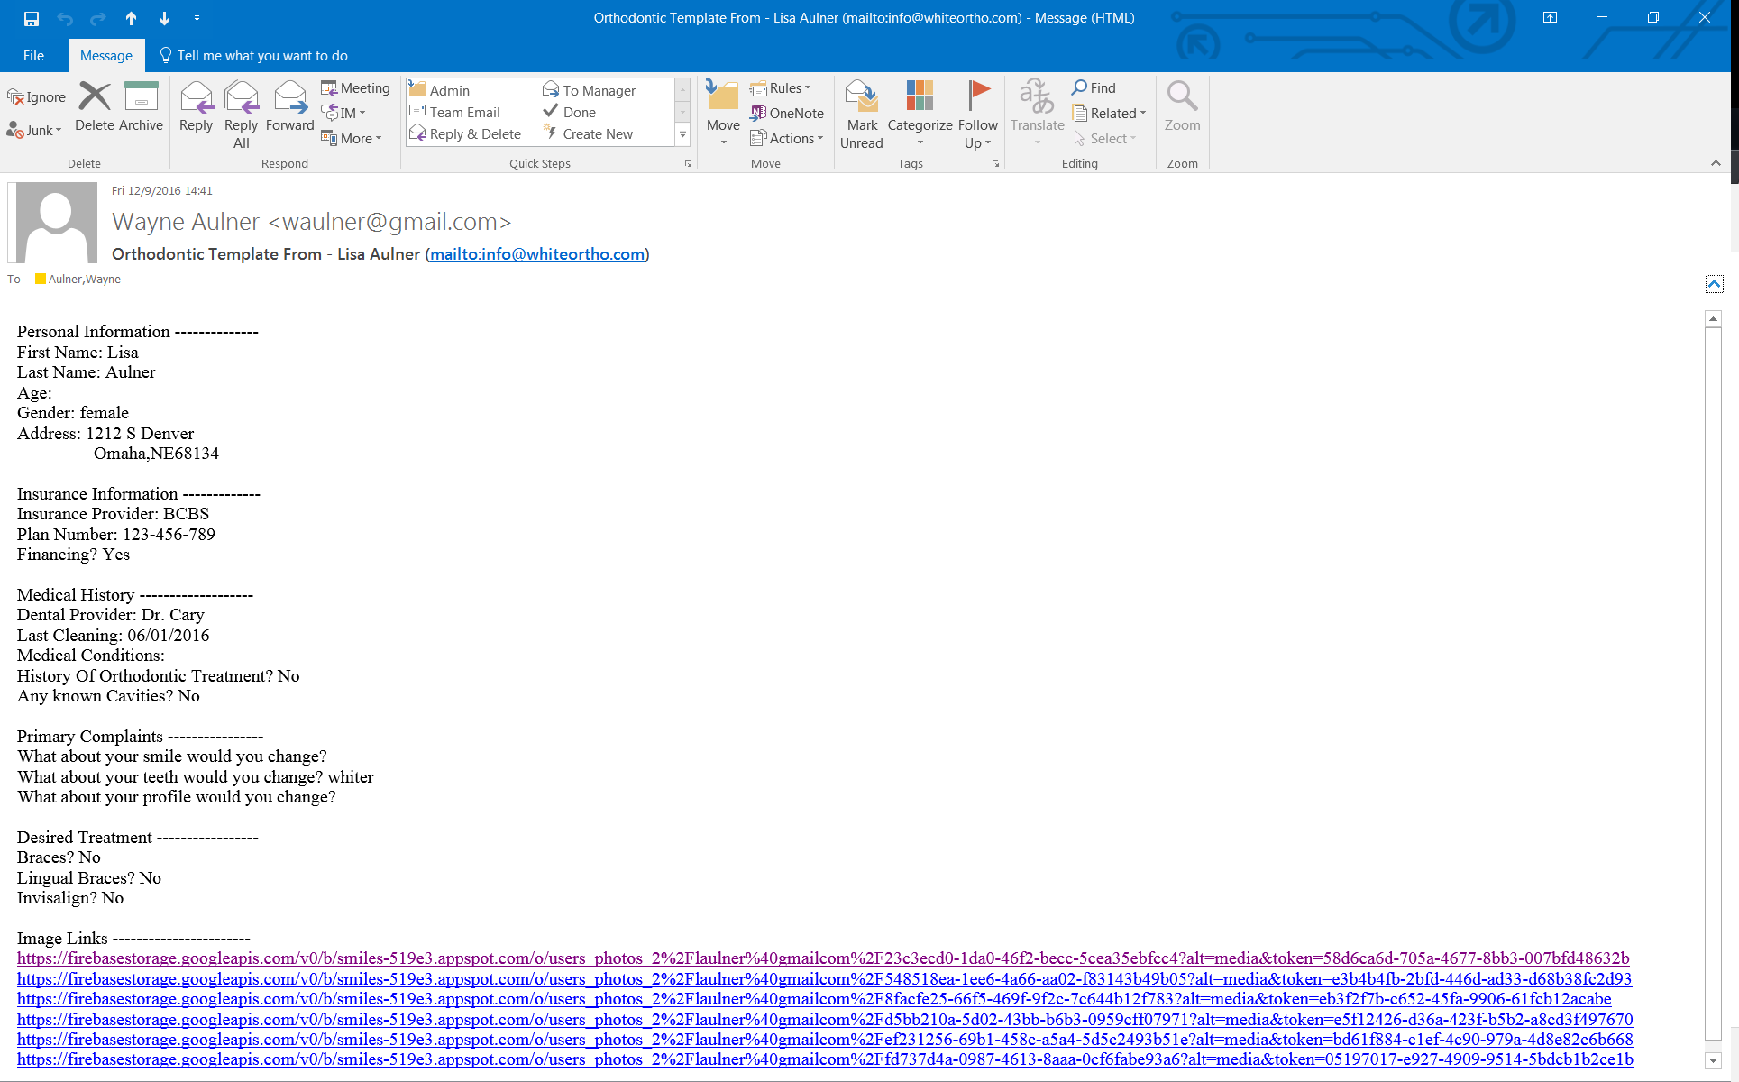Email I received at work, by clicking on each link the Orthodontist can view the photos.

## View Photo(s)

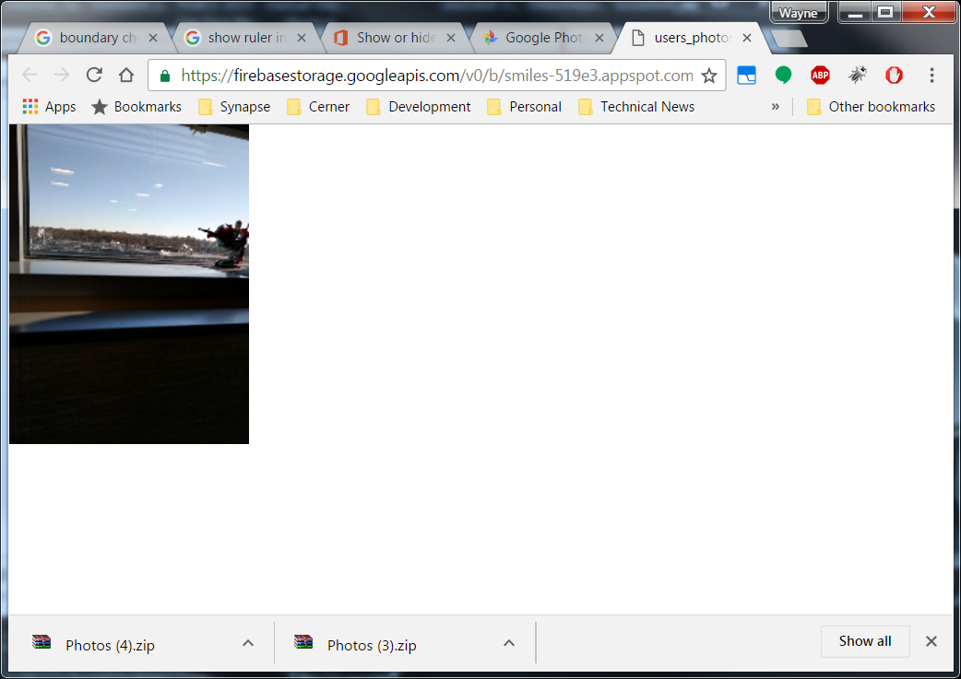I am only showing one photo for the sake of brevity.