RANGEFORGE
Fast Bayesian Poker Range Engine
Product Requirements Document and Rust Learning Plan
Project thesis
Build a correct, inspectable, and benchmarked Rust engine that maintains a posterior distribution over an opponent’s feasible Texas Hold’em hole-card combinations, computes hero equity, and quantifies the information contained in actions and future card reveals.

Prepared for James
Version 1.1
June 22, 2026
Google Docs-compatible DOCX
Suggested scope: 8–10 weeks, roughly 60–100 focused hours

Document Control
Field | Definition
Status | Build-ready specification
Release target | v0.1.0 MVP
Primary interface | Command-line application plus reusable Rust libraries
Game scope | Heads-up Texas Hold’em; one known hero hand and one hidden opponent hand
Inference scope | Discrete Bayesian inference over feasible two-card opponent combinations
Computation scope | Exact postflop equity, Monte Carlo fallback, entropy, KL divergence, and expected information gain
Modeling stance | Inference is exact conditional on the supplied prior and action-likelihood model; the bundled model is illustrative, not empirically calibrated
Document revision | 1.1 — adds Appendix G with component, class, sequence, and activity diagrams

How to Use This PRD
- Start with Section 2. It defines the MVP and the point at which you should deliberately stop.
- Build in module order. Each module has a public API sketch, invariants, tests, Rust prerequisites, and an exit criterion.
- Learn just in time. Do not attempt to master all of Rust first; complete the prerequisite topics listed immediately before each module.
- Preserve model honesty. Never present output from the toy action model as a prediction of real-player behavior unless you later calibrate and validate it on data.
- Benchmark only release builds. Correctness comes first; optimize only after a baseline benchmark identifies the bottleneck.

Contents
1. Product Definition and Mathematical Contract
2. MVP Definition and Hard Stopping Point
3. Architecture and Engineering Conventions
4. Build Order and Module Dependency Map
5. Extremely Specified Module Requirements
6. Rust Learning Curriculum
7. Milestones, Schedule, and Scope-Reduction Rules
8. Testing, Verification, and Benchmarking
9. Risks, Assumptions, and Design Decisions
10. Post-MVP Roadmap
11. Interview Packaging
Appendices: Schemas, Example Inputs, Formula Reference, Sources, and UML Diagrams

1. Product Definition and Mathematical Contract

1.1 One-Sentence Product Definition
Definition
RangeForge is a Rust command-line engine that updates a probability distribution over an opponent’s legal hole-card combinations from card blockers and observed actions, then computes equity and information-theoretic diagnostics.

1.2 Problem Statement
In heads-up Texas Hold’em, the opponent’s two private cards are hidden, but they are constrained by known cards and partially revealed through actions. The product must represent that hidden state explicitly, update it under a stated probabilistic model, and answer three questions:
- What hands are currently plausible, and with what posterior probability?
- What is the hero hand’s equity against that posterior range?
- How much information did an observed action reveal, and how informative could a future action or public card be?

1.3 Why This Is a Strong Summer Project
Interview dimension | What the project demonstrates
Software engineering | API boundaries, data modeling, error handling, tests, CLI design, documentation, profiling, and deterministic parallelism.
Quantitative reasoning | Conditional probability, Bayesian updating, exact enumeration, Monte Carlo estimation, numerical stability, uncertainty, entropy, KL divergence, and model risk.
Rust competence | Ownership, borrowing, enums, traits, iterators, dense memory layouts, bit operations, Serde, Rayon, benchmarking, and quality tooling.
Defensibility | Every output is tied to a clear assumption, an explicit formula, a reproducible input, and a testable invariant.
Novelty | The emphasis is not “another poker evaluator”; it is a hidden-state inference engine with information-value analysis and a replaceable behavioral model.

1.4 Product Goals
- Correctly enumerate and index all 1,326 unordered two-card combinations from a 52-card deck.
- Condition any prior range on known hero and board cards without leaving blocked combinations in the support.
- Update the range with one or more action observations using a validated, pluggable likelihood model.
- Compute exact weighted equity on the flop, turn, and river; provide Monte Carlo for preflop and optional faster estimates.
- Report Shannon entropy, effective number of hands, KL divergence, total variation, observed-action surprisal, and expected information gain.
- Expose a polished CLI and versioned JSON output suitable for demos, tests, and future integrations.
- Provide exhaustive correctness tests for the hand evaluator and reproducible benchmarks for the performance-critical path.

1.5 Explicit Non-Goals for v0.1.0
- A poker bot, real-time assistance tool, game client integration, or automated wagering system.
- A GTO solver, counterfactual regret minimization implementation, or bet-sizing optimizer.
- A claim that the bundled action model accurately represents any real population or player.
- Multiway pots, tournaments, side pots, rake, stack dynamics, or complete betting-tree legality.
- A web UI, database, authentication system, cloud deployment, or live data pipeline.
- Unsafe Rust, SIMD, GPU acceleration, or hand-written assembly before profiling proves a need.

1.6 Mathematical Contract
Let H be the opponent’s hidden two-card combination, B the known hero and public cards, and E₁…Eₜ the observed action events. RangeForge computes:P(H = h | B, E₁…Eₜ) ∝ P(H = h | B) × ∏ₖ P(Eₖ | H = h, contextₖ)
The implementation must perform the multiplicative update in log space and normalize with log-sum-exp. This prevents underflow when multiple small likelihoods are multiplied.
Quantity | Definition and interpretation
Entropy H(H) | −Σₕ p(h) log₂ p(h). Measures uncertainty in bits.
Effective hand count | 2ᴴ. The number of equally likely hands that would have the same entropy.
KL divergence | Σₕ q(h) log₂(q(h)/p(h)). Measures posterior movement from prior p to posterior q.
Total variation | ½Σₕ |q(h) − p(h)|. A bounded, intuitive measure of distribution shift.
Surprisal | −log₂ P(observed action). Rare observed actions have higher surprisal.
Expected action information | H(H) − Σₐ P(a)H(H|a), equal to mutual information I(H;A).
Equity | P(win) + 0.5 × P(tie), weighted by the posterior range and future runouts.

Critical modeling statement
RangeForge’s Bayesian arithmetic can be correct while its posterior is still behaviorally wrong if the prior or action-likelihood model is wrong. The product must therefore report model metadata and describe the bundled model as synthetic or illustrative.

1.7 Decision Context for Action Models
The action alphabet must be coherent. v0.1.0 uses two decision contexts rather than treating every poker action as simultaneously available:
Decision context | Allowed actions
Unopened decision | check, bet_small, bet_large
Facing a bet | fold, call, raise

The model is indexed by street, decision context, and a deterministic hand-feature bucket. Position, pot size, stack size, and exact bet size are post-MVP context variables.

2. MVP Definition and Hard Stopping Point

2.1 The MVP User Experience
A user supplies one scenario file and one action-model file, then runs a single analysis command:
cargo run --release -p rangeforge-cli -- \
analyze examples/flop_large_bet.json --format human

The command prints a deterministic report containing:
- validated hero hand, board, street, prior support, and action evidence;
- prior and posterior entropy, effective hand count, KL divergence, total variation, and action surprisal;
- the top N posterior combinations and aggregated hand-feature buckets;
- hero win, tie, loss, and equity against the posterior range;
- expected information gain of the legal actions at an optional current decision node;
- expected information gain of each possible next public card on the flop or turn;
- method metadata, random seed when applicable, model identifier, and elapsed timing.

2.2 MVP Scope Matrix
Capability | MVP requirement
Cards and states | Parse, validate, display, and bit-mask a standard 52-card deck; reject duplicates and invalid board sizes.
Opponent range | Uniform prior plus a compact notation parser and explicit per-combination weights.
Bayesian inference | Sequential postflop action observations using a validated bucketed likelihood model.
Equity | Exact on flop/turn/river; seeded Monte Carlo on any street, including preflop.
Information metrics | Entropy, effective hand count, KL, total variation, surprisal, action mutual information, and next-card information.
Interfaces | Human-readable CLI output and versioned JSON output.
Quality | Unit, integration, property, exhaustive evaluator, and benchmark coverage.
Parallelism | Rayon parallelization of exact equity after a correct sequential baseline; deterministic final reduction.

2.3 Hard MVP Stopping Point
Stop at v0.1.0 when all conditions below are true
Do not add a UI, training pipeline, GTO logic, or additional poker variants before tagging the release. The purpose of the stopping point is to leave you with a finished, explainable project rather than an indefinitely expanding codebase.

☐ All workspace crates compile on stable Rust with edition 2024.
☐ `cargo fmt --check`, Clippy with warnings denied, and all non-ignored tests pass.
☐ The evaluator’s ignored exhaustive five-card test reproduces all nine known category counts across 2,598,960 hands.
☐ Every posterior is finite, nonnegative, normalized to within 1e−12, and assigns zero mass to blocked combinations.
☐ Exact river, turn, and flop equity agree with an independent slow reference implementation on fixture scenarios.
☐ Monte Carlo is deterministic for a fixed seed and agrees with exact equity within a stated statistical tolerance on test fixtures.
☐ Action probabilities sum to one for every required model row; impossible evidence produces a typed error rather than NaN.
☐ Expected action and next-card information are nonnegative within numerical tolerance, and predictive probabilities sum to one.
☐ `rangeforge analyze` produces both human and JSON reports for at least three checked-in examples.
☐ A Criterion benchmark report records evaluator, inference, exact-equity, and information-analysis baselines.
☐ README, architecture notes, model limitations, and a two-minute terminal demo script are complete.
☐ Release `v0.1.0` is tagged with a clean repository and reproducible commands.

2.4 MVP Performance Gates
Workload | Shipping gate | Aspirational target
Posterior update over 1,326 combos and three observations | No visible delay in CLI; benchmark recorded | < 5 ms release on the development machine
Exact river equity versus a dense range | < 1 second | < 100 ms
Exact turn equity versus a dense range | < 3 seconds | < 500 ms
Exact flop equity versus a dense range | < 15 seconds with hardware documented | < 5 seconds after Rayon
100,000-sample Monte Carlo | < 15 seconds with hardware documented | < 5 seconds

These are project-management gates, not universal hardware claims. Record CPU, thread count, compiler version, release profile, and scenario alongside every benchmark result.

2.5 MVP Deliverables
- A public repository with a Cargo workspace, examples, fixtures, benchmarks, and CI.
- A library API that can be used without the CLI.
- A CLI binary named `rangeforge`.
- At least one synthetic action model with explicit metadata and validation.
- Three example scenarios: flop action inference, turn exact equity, and preflop Monte Carlo.
- A README containing a system diagram, mathematical contract, benchmark table, limitations, and demo commands.
- This PRD checked into `docs/PRD.md` or exported to Markdown for project tracking.

3. Architecture and Engineering Conventions

3.1 Recommended Workspace Layout
rangeforge/
├── Cargo.toml
├── rust-toolchain.toml
├── crates/
│ ├── rangeforge-poker/
│ │ └── src/
│ │ ├── card.rs
│ │ ├── mask.rs
│ │ ├── state.rs
│ │ ├── combo.rs
│ │ ├── combinatorics.rs
│ │ ├── range_spec.rs
│ │ ├── hand_rank.rs
│ │ ├── evaluator.rs
│ │ └── features.rs
│ ├── rangeforge-engine/
│ │ └── src/
│ │ ├── distribution.rs
│ │ ├── evidence.rs
│ │ ├── action_model.rs
│ │ ├── bayes.rs
│ │ ├── metrics.rs
│ │ ├── equity_exact.rs
│ │ ├── equity_monte_carlo.rs
│ │ ├── information_action.rs
│ │ ├── information_card.rs
│ │ └── scenario.rs
│ └── rangeforge-cli/
│ └── src/
│ ├── main.rs
│ ├── commands.rs
│ └── output.rs
├── models/
│ └── toy_postflop_v1.json
├── examples/
├── fixtures/
├── benches/
└── docs/

3.2 Dependency Direction
rangeforge-cli
│
├──────────────┐
▼ ▼
rangeforge-engine ──► rangeforge-poker
Rules:
1. rangeforge-poker depends only on small domain-level libraries.
2. rangeforge-engine may depend on rangeforge-poker, rand, Rayon, and Serde.
3. rangeforge-cli may depend on both libraries, clap, serde_json, and anyhow.
4. Domain crates never import CLI types or print directly to stdout.

3.3 End-to-End Data Flow
1. Parse scenario and action-model JSON into typed configuration structures.
2. Validate cards, street progression, action legality, probabilities, and file references.
3. Expand the prior range into dense weights indexed by ComboId 0…1325.
4. Condition the prior on hero cards and the current public board.
5. Apply action observations sequentially in log space and record an inference trace.
6. Compute exact or Monte Carlo equity against the final posterior.
7. Compute optional action and next-card information reports.
8. Serialize one versioned analysis report; render it as a table or JSON without recomputation.

3.4 Design Principles
- Make invalid states difficult to construct. Use private fields and validated constructors for cards, boards, distributions, and models.
- Dense over sparse. A fixed universe of 1,326 states makes a dense `Vec<f64>` simpler, faster, and more deterministic than a hash map.
- Separate behavior from inference. The Bayesian engine consumes a likelihood trait; it does not hard-code a claim about human behavior.
- Correctness before speed. Implement a slow reference path and exhaustive tests before parallelism or lookup-table optimization.
- Reproducibility by default. Seed randomized methods, version JSON schemas, preserve the lockfile, and report compiler and model metadata.
- No hidden panics at boundaries. User input, I/O, and model validation return structured errors; `panic!` is reserved for violated internal invariants.

3.5 Core Representation Conventions
Concept | Required representation
Card | Newtype around `u8`, values 0…51. Rank and suit are derived without allocation.
Card set | Newtype around `u64`; only the low 52 bits may be set.
Hole cards | Two distinct cards stored in canonical ascending card-index order.
Combo ID | `u16` newtype in 0…1325, with a deterministic bijection to hole cards.
Range | Dense vector of length 1,326. Fields remain private so length and normalization invariants cannot be bypassed.
Hand rank | Compact ordered integer plus category accessor; a greater value always means a stronger hand.
Probability | `f64`, finite and nonnegative. Public constructors validate; log computations use natural logs internally.
Information units | Bits; use base-2 logarithms for reported entropy, KL, and surprisal.
Randomness | Explicit seed and named generator; seed is included in output.

3.6 Dependency Policy
Library/tool | Purpose | MVP status
serde + serde_json | Typed configuration and versioned reports | Required
thiserror | Typed library errors | Required
anyhow | Top-level CLI context and error reporting | Required
clap | Derived command-line parser and generated help | Required
rand + a named seedable RNG | Monte Carlo sampling | Required
rayon | Data-parallel exact-equity calculation | Required after sequential baseline
criterion | Statistical microbenchmarks and regression tracking | Required for project completion
proptest | Property-based invariants for cards, ranges, and probabilities | Recommended; may be dev-only

Versioning rule
Use the stable Rust toolchain, edition 2024, and commit `Cargo.lock`. Add dependencies with Cargo rather than copying version numbers from this document. Record the exact toolchain and crate versions in benchmark output.

UML reference. Appendix G translates these boundaries into component, class, sequence, and activity views. The module contracts in Section 5 remain authoritative if a diagram and an API sketch ever diverge.

4. Build Order and Module Dependency Map
Order | Module | Depends on | Visible artifact
M0 | Workspace and quality scaffolding | Nothing | Three compiling crates and CI commands
M1 | Cards and card masks | M0 | Round-trip parser for all 52 cards
M2 | Hole cards, boards, streets, known state | M1 | Validated scenario state
M3 | Combo IDs, combinatorics, and range notation | M1–M2 | All 1,326 combos and parsed prior weights
M4 | Five/seven-card hand evaluator | M1 | Correct ordered hand ranks
M5 | Current-hand features and model buckets | M2, M4 | Deterministic feature label per combo and board
M6 | Probability distribution and base metrics | M3 | Normalized dense range with entropy
M7 | Evidence and action-likelihood model | M5–M6 | Validated JSON behavior model
M8 | Bayesian update and inference trace | M6–M7 | Posterior after one or more observations
M9 | Exact weighted equity | M2–M4, M6 | Exact flop/turn/river equity
M10 | Monte Carlo equity | M2–M4, M6 | Seeded preflop and approximate equity
M11 | Action and card information value | M6–M8 | Mutual-information and next-card reports
M12 | Scenario schema, CLI, and output | All functional modules | Single-command end-to-end demo
M13 | Hardening, benchmarks, docs, release | M0–M12 | v0.1.0 release

Critical path
M4 → M9 is the largest correctness and performance risk. M7 → M8 → M11 is the project’s distinctive Bayesian and information-theoretic path. Do not spend time polishing the CLI before both paths work through library tests.

5. Extremely Specified Module Requirements

M0. Workspace and Quality Scaffolding
Crate: workspace root
Primary files: `Cargo.toml`, `rust-toolchain.toml`, crate manifests, `.github/workflows/ci.yml`
Responsibility: Create the project boundaries and a fast feedback loop before domain code exists.
Inputs and outputs: Input is the repository layout. Output is a workspace in which every crate builds, tests, lints, and generates documentation independently and together.
Public API sketch
# workspace Cargo.toml (shape, not a pinned dependency list)
[workspace]
members = ["crates/*"]
resolver = "3"
[workspace.package]
edition = "2024"
license = "MIT OR Apache-2.0"
[workspace.lints.rust]
unsafe_code = "forbid"

Required behavior
- Create `rangeforge-poker` and `rangeforge-engine` as library crates and `rangeforge-cli` as a binary crate.
- Configure `rustfmt` and Clippy; deny warnings in CI, not necessarily during exploratory local work.
- Add a workspace-level README containing the one-sentence product definition and build commands.
- Create an empty integration-test directory and one smoke test that calls a public function from each library.
- Configure release builds with debug symbols retained if you plan to profile; do not change optimization flags until benchmarks exist.
Invariants
- No crate may depend on a crate above it in the dependency diagram.
- No unsafe code is permitted in v0.1.0.
- Every public item added later must either be documented or intentionally hidden from the public API.
Implementation sequence
1. Install stable Rust through rustup with `rustfmt` and `clippy` components.
2. Create the workspace and crate manifests.
3. Add one minimal public function per library and call it from the CLI.
4. Add CI commands: format check, Clippy, tests, and rustdoc warnings.
5. Commit the initial lockfile and tag the repository baseline.
Required tests
- `cargo check --workspace` succeeds.
- `cargo test --workspace` runs at least one unit and one integration test.
- `cargo clippy --workspace --all-targets -- -D warnings` succeeds.
- `RUSTDOCFLAGS="-D warnings" cargo doc --workspace --no-deps` succeeds.
Rust to learn first: Cargo packages, crates, modules, visibility, `use`, unit versus integration tests, and the difference between debug and release builds.
Module exit criterion
All three crates compile and the full quality command set passes before any card type is implemented.

M1. Cards and Card Masks
Crate: `rangeforge-poker`
Primary files: `card.rs`, `mask.rs`, `error.rs`
Responsibility: Provide allocation-free, canonical representations for individual cards and sets of cards.
Inputs and outputs: Inputs are rank/suit values or two-character strings such as `As`. Outputs are `Card` values and `CardMask` sets used by every downstream module.
Public API sketch
#[repr(u8)]
pub enum Rank { Two, Three, Four, Five, Six, Seven, Eight,
Nine, Ten, Jack, Queen, King, Ace }
#[repr(u8)]
pub enum Suit { Clubs, Diamonds, Hearts, Spades }
#[derive(Copy, Clone, Eq, PartialEq, Ord, PartialOrd, Hash)]
pub struct Card(u8);
impl Card {
pub fn new(rank: Rank, suit: Suit) -> Self;
pub fn rank(self) -> Rank;
pub fn suit(self) -> Suit;
pub fn index(self) -> usize;
pub fn bit(self) -> u64;
}
#[derive(Copy, Clone, Eq, PartialEq, Default)]
pub struct CardMask(u64);
impl CardMask {
pub const EMPTY: Self;
pub fn contains(self, card: Card) -> bool;
pub fn insert(&mut self, card: Card) -> bool;
pub fn union(self, other: Self) -> Self;
pub fn intersects(self, other: Self) -> bool;
pub fn count(self) -> u32;
pub fn iter(self) -> impl Iterator<Item = Card>;
}

Required behavior
- Use rank characters `2`–`9`, `T`, `J`, `Q`, `K`, `A` and suit characters `c`, `d`, `h`, `s`.
- Parsing may be case-insensitive; display is canonical with uppercase rank and lowercase suit.
- Card indexing must be stable and documented. One acceptable mapping is `suit_index × 13 + rank_index`.
- Mask iteration returns cards in ascending card-index order.
- Mask insertion returns whether the card was newly inserted, allowing duplicate detection without a second lookup.
- Implement `FromStr` and `Display` for `Card`; do not expose the raw integer constructor publicly.
Invariants
- `Card` is always in 0…51.
- Only the low 52 bits of a `CardMask` may be set.
- Every card maps to exactly one bit, and every valid single bit maps back to exactly one card.
- All types are `Copy`; creating or comparing cards allocates nothing.
Implementation sequence
1. Implement `Rank`, `Suit`, and `Card` with private raw storage.
2. Implement parsing and display before masks so failures are easy to inspect.
3. Implement mask algebra and iteration using trailing-zero bit operations.
4. Add rustdoc examples for parsing, union, membership, and iteration.
Required tests
- Round-trip all 52 cards through `Display` and `FromStr`.
- Reject malformed lengths, unknown ranks, unknown suits, and trailing characters.
- For every pair of cards, test that equal cards share a bit and unequal cards do not.
- Property test: `count(a ∪ b) ≤ count(a) + count(b)` and union is commutative.
- Property test: iterating a mask and reinserting the results reconstructs the original mask.
Performance note: No heap allocation in any card or mask operation. This module should disappear into the noise of downstream benchmarks.
Rust to learn first: Enums, `#[repr]`, newtypes, `Copy` versus `Clone`, derived traits, bitwise operators, `FromStr`, `Display`, `Result`, and iterator construction.
Module exit criterion
A test enumerates all 52 canonical card strings, and every mask operation is allocation-free and documented.

M2. Hole Cards, Boards, Streets, and Known State
Crate: `rangeforge-poker`
Primary files: `state.rs`
Responsibility: Make illegal card states unrepresentable at the boundary and provide compact views for hot loops.
Inputs and outputs: Inputs are parsed cards and concatenated board strings. Outputs are validated `HoleCards`, `Board`, `Street`, and `KnownState` values.
Public API sketch
#[derive(Copy, Clone, Eq, PartialEq, Hash)]
pub struct HoleCards { /* canonical, private */ }
impl HoleCards {
pub fn new(a: Card, b: Card) -> Result<Self, StateError>;
pub fn cards(self) -> [Card; 2];
pub fn mask(self) -> CardMask;
}
pub enum Street { Preflop, Flop, Turn, River }
#[derive(Clone, Eq, PartialEq)]
pub struct Board { /* [Card; 5] + len + mask, private */ }
impl Board {
pub fn parse(text: &str) -> Result<Self, StateError>;
pub fn cards(&self) -> &[Card];
pub fn mask(&self) -> CardMask;
pub fn street(&self) -> Street;
pub fn is_prefix_of(&self, later: &Board) -> bool;
}
pub struct KnownState { pub hero: HoleCards, pub board: Board }
impl KnownState {
pub fn new(hero: HoleCards, board: Board) -> Result<Self, StateError>;
pub fn dead_cards(&self) -> CardMask;
}

Required behavior
- Canonicalize hole-card order by card index; `AsKd` and `KdAs` construct the same value.
- Valid board lengths 0, 3, 4, and 5 only. Board order represents reveal order and must be preserved.
- Reject duplicate board cards and hero/board overlap.
- Expose board cards as a borrowed slice; do not clone are
- A board snapshot is a prefix of a later board only when every earlier card matches in order.

- in evaluator or inference loops.
InvariantsHole cards contain exactly two distinct cards.
- Board cards are unique and length is one of the four legal values.
- Known state has exactly `2 + board_len` distinct known cards.
- Street is derived from board length, never stored independently in user input.
Implementation sequence
1. Implement `HoleCards` and canonicalization.
2. Implement a fixed-capacity board representation with private length.
3. Implement parsing of concatenated card strings such as `QsJh2c`.
4. Implement state overlap validation and board-prefix checks.
5. Add display methods used by CLI reporting.
Required tests
- Reject identical hole cards.
- Reject board lengths 1, 2, and greater than 5.
- Reject duplicate board cards and hero/board overlap.
- Verify `street()` for all valid board lengths.
- Verify board prefix logic across flop, turn, river, reordered cards, and unrelated boards.
Rust to learn first: Private struct fields, validated constructors, arrays and slices, borrowing, pattern matching, `Option`/`Result`, and why domain invariants belong in types rather than comments.
Module exit criterion
No downstream module can construct a duplicate-card hero/board state without deliberately bypassing the public API.

M3. Combo IDs, Combinatorics, and Range Notation
Crate: `rangeforge-poker`
Primary files: `combo.rs`, `combinatorics.rs`, `range_spec.rs`
Responsibility: Define the fixed hidden-state universe and convert user-friendly range notation into deterministic dense weights.
Inputs and outputs: Inputs are `HoleCards`, `ComboId`, dead-card masks, and notation strings. Outputs are a bijection over 1,326 states, combination iterators, and unnormalized per-combo weights.
Public API sketch
pub const NUM_HOLE_COMBOS: usize = 1326;
#[derive(Copy, Clone, Eq, PartialEq, Ord, PartialOrd, Hash)]
pub struct ComboId(u16);
impl ComboId {
pub fn from_hole_cards(hole: HoleCards) -> Self;
pub fn hole_cards(self) -> HoleCards;
pub fn index(self) -> usize;
}
pub fn all_combos() -> impl ExactSizeIterator<Item = (ComboId, HoleCards)>;
pub fn remaining_cards(dead: CardMask) -> impl ExactSizeIterator<Item = Card>;
pub fn unordered_pairs(cards: &[Card]) -> impl Iterator<Item = [Card; 2]> + '_;
pub struct ComboWeights { /* dense length 1326, private */ }
pub enum RangeSpec { Uniform, Notation(String), Explicit(Vec<(HoleCards, f64)>) }
pub fn expand_range(spec: &RangeSpec) -> Result<ComboWeights, RangeParseError>;

Required behavior
- Use one documented pair-enumeration order and preserve it permanently once examples are published.
- MVP notation grammar: `random`; exact combo `AsKd`; pair class `QQ`; suited class `AKs`; offsuit class `AKo`; both `AK`; optional positive weight suffix `:0.35`; comma-separated terms; whitespace ignored.
- `QQ` expands to 6 combinations, `AKs` to 4, `AKo` to 12, and `AK` to 16 before blockers.
- Class rank order may be canonicalized, but pairs with `s` or `o` suffixes are errors.
- Overlapping notation terms that expand to the same exact combo are rejected in the MVP rather than silently double-counted.
- Use a custom parser based on character inspection; a regex is unnecessary and obscures error locations.
Invariants
- There are exactly 1,326 valid `ComboId` values and each maps to one unique unordered card pair.
- `from_hole_cards(id.hole_cards()) == id` and `hole_cards(from_hole_cards(h)) == h`.
- `ComboWeights` length is always 1,326; values are finite and nonnegative but need not yet sum to one.
- Combination iterators never emit duplicate cards or duplicate unordered pairs.
Implementation sequence
1. Write the triangular-index formula or a precomputed deterministic universe; test the inverse exhaustively.
2. Implement remaining-card and pair iterators.
3. Implement exact-combo parsing, then class expansion, then weights.
4. Add precise error variants containing the offending token and reason.
5. Add examples showing notation expansion and blocker conditioning later in M6.
Required tests
- Exhaustively enumerate IDs 0…1325 and confirm 1,326 unique masks.
- Test inverse mapping for every ID and every unordered deck pair.
- Test expansion counts for pair, suited, offsuit, both, exact, and random terms.
- Reject duplicate expansion, invalid weight, pair suffix, repeated card, and malformed token.
- Property test pair iteration count `n(n−1)/2` for random distinct-card slices.
Rust to learn first: Collections, deterministic ordering, custom iterators and `ExactSizeIterator`, basic lifetime annotations for borrowed iterators, parser design with enums, and error propagation.
Module exit criterion
The full universe round-trips exhaustively, and a user can express a nontrivial weighted prior without JSON-level per-combo boilerplate.

M4. Five- and Seven-Card Hand Evaluator
Crate: `rangeforge-poker`
Primary files: `hand_rank.rs`, `evaluator.rs`
Responsibility: Return a total ordering for poker hands that is obviously correct, exhaustively testable, and fast enough for a first exact-equity engine.
Inputs and outputs: Input is a five-, six-, or seven-card `CardMask`. Output is a compact `HandRank` whose natural ordering matches Texas Hold’em showdown ordering.
Public API sketch
#[repr(u8)]
pub enum HandCategory {
HighCard, OnePair, TwoPair, ThreeOfAKind, Straight,
Flush, FullHouse, FourOfAKind, StraightFlush,
}
#[derive(Copy, Clone, Eq, PartialEq, Ord, PartialOrd)]
pub struct HandRank(u32);
impl HandRank {
pub fn category(self) -> HandCategory;
}
pub fn evaluate_five(cards: CardMask) -> Result<HandRank, EvalError>;
pub fn evaluate_best(cards: CardMask) -> Result<HandRank, EvalError>; // 5..=7 cards

Required behavior
- Encode category and tie-break ranks lexicographically so derived integer ordering is sufficient for comparison.
- Five-card evaluation counts ranks, detects flush, detects straights including the A-2-3-4-5 wheel, and emits ordered kickers.
- Six- and seven-card evaluation enumerates all five-card subsets and returns the maximum. Seven cards require exactly 21 subsets.
- Keep the first implementation simple and safe. A direct seven-card lookup evaluator is a post-MVP optimization.
- Document whether Ace is represented high internally and how wheel straight-high is encoded.
Invariants
- Greater `HandRank` always means a stronger showdown hand.
- Equal ranks imply a tie under standard high-hand Texas Hold’em rules.
- Input masks contain exactly 5, 6, or 7 cards; other counts return a typed error.
- Category ordering is fixed and included in serialized output by name, not raw integer.
Implementation sequence
1. Implement rank counts and straight-high detection independently with focused tests.
2. Implement five-card categories from strongest to weakest to minimize ambiguous branching.
3. Pack tie-break ranks into a `u32` and prove ordering with table-driven tests.
4. Implement a static table of 5-of-6 and 5-of-7 index combinations.
5. Add a slow ignored exhaustive frequency test over all 2,598,960 five-card hands.
6. Benchmark before considering any alternate evaluator.
Required tests
- One canonical fixture for every category and every major kicker comparison.
- Wheel straight loses to six-high straight; flush and high-card kickers compare lexicographically.
- Seven-card evaluator selects the correct best five when irrelevant cards are present.
- Exhaustive category counts: 40 straight flushes; 624 four of a kind; 3,744 full houses; 5,108 flushes; 10,200 straights; 54,912 trips; 123,552 two pair; 1,098,240 one pair; 1,302,540 high card.
- Property test: permuting card order cannot change a mask-based evaluation.
Performance note: A useful initial target is at least one million seven-card evaluations per second in release mode on the development machine. Treat measured correctness as the gate and this rate as a tuning signal.
Rust to learn first: Fixed-size arrays, integer packing, `Ord`, bit manipulation, static constants, hot-loop discipline, ignored tests, and Criterion basics.
Module exit criterion
The exhaustive five-card distribution test passes in release mode, and benchmark output establishes a credible baseline without unsafe code.

M5. Current-Hand Features and Model Buckets
Crate: `rangeforge-poker`
Primary files: `features.rs`
Responsibility: Convert a hole-card combination plus a postflop board into a small, deterministic feature bucket consumed by the toy action model.
Inputs and outputs: Inputs are opponent `HoleCards` and a flop, turn, or river `Board`. Outputs are objective made-hand and draw flags plus one model bucket.
Public API sketch
pub struct DrawFlags { /* flush_draw, straight_draw */ }
pub enum ModelBucket {
Air,
Draw,
OnePair,
TwoPairOrTrips,
StraightOrFlush,
FullHousePlus,
}
pub struct HandFeatures {
pub category: HandCategory,
pub draws: DrawFlags,
pub bucket: ModelBucket,
}
pub fn extract_features(hole: HoleCards, board: &Board)
-> Result<HandFeatures, FeatureError>;

Required behavior
- Postflop only: board length must be 3, 4, or 5.
- Made-hand category comes from `evaluate_best(hole ∪ board)`.
- Flush draw means exactly four cards of a suit are present and no made flush exists.
- Straight draw means at least one five-rank straight pattern has exactly four distinct ranks present and no made straight exists.
- Use fixed bucket precedence: FullHousePlus → StraightOrFlush → TwoPairOrTrips → OnePair → Draw → Air.
- A pair plus a draw is classified as OnePair in v0.1.0. This is simplistic but deterministic and documented.
Invariants
- Every legal postflop combo/board pair maps to exactly one `ModelBucket`.
- Bucket assignment depends only on cards, not the action model or prior probability.
- Draw flags are false on the river because no future public card remains.
Implementation sequence
1. Reuse evaluator category logic; do not implement a second made-hand evaluator.
2. Implement suit counts and draw detection with rank/suit bitsets.
3. Implement bucket precedence in one exhaustive `match` or clearly ordered function.
4. Create a fixture matrix covering borderline hands and wheel-related straight draws.
Required tests
- Air, pure flush draw, pure straight draw, one pair, two pair, trips, straight, flush, full house, quads.
- Pair-plus-draw precedence is stable and documented.
- River never reports a draw.
- Blocked or duplicate input is rejected through the state types before this function runs.
Rust to learn first: Reuse of domain types, bitset reasoning, exhaustive matching, helper-function design, and the distinction between an objective feature extractor and a subjective statistical model.
Module exit criterion
Every feasible postflop combination can be bucketed deterministically, with edge cases covered by table-driven tests.

M6. Dense Probability Distribution and Base Metrics
Crate: `rangeforge-engine`
Primary files: `distribution.rs`, `metrics.rs`
Responsibility: Turn raw combo weights into a safe probability distribution and provide reusable distribution-level statistics.
Inputs and outputs: Inputs are `ComboWeights`, known dead cards, or probability vectors. Outputs are a normalized `RangeDistribution` and scalar or aggregated metrics.
Public API sketch
pub struct RangeDistribution { /* Vec<f64>, length 1326, private */ }
impl RangeDistribution {
pub fn from_weights(weights: ComboWeights) -> Result<Self, DistributionError>;
pub fn uniform_conditioned(dead: CardMask) -> Result<Self, DistributionError>;
pub fn condition_on_dead(self, dead: CardMask) -> Result<Self, DistributionError>;
pub fn probability(&self, id: ComboId) -> f64;
pub fn iter(&self) -> impl ExactSizeIterator<Item = (ComboId, f64)> + '_;
pub fn support_size(&self) -> usize;
}
pub fn entropy_bits(p: &RangeDistribution) -> f64;
pub fn effective_hand_count(p: &RangeDistribution) -> f64;
pub fn total_variation(p: &RangeDistribution, q: &RangeDistribution) -> f64;
pub fn kl_bits(q: &RangeDistribution, p: &RangeDistribution)
-> Result<f64, MetricError>;

Required behavior
- Constructors reject negative, NaN, infinite, wrong-length, and all-zero weights.
- Normalization uses a stable sum and divides once; posterior normalization later uses log-sum-exp.
- Conditioning zeros every combo intersecting the dead-card mask and renormalizes.
- Entropy treats `0 log 0` as zero.
- KL returns infinity or an explicit support error when q assigns mass where p assigns zero; choose one policy and test it.
- Top-N and bucket aggregation must use deterministic tie-breaking by `ComboId`.
Invariants
- Length is exactly 1,326.
- Every probability is finite and nonnegative.
- The sum is one within 1e−12 after every public operation.
- No blocked combo has positive probability after conditioning.
Implementation sequence
1. Implement constructor validation with a private normalization helper.
2. Implement dead-card conditioning.
3. Implement entropy and effective count.
4. Implement total variation and KL with explicit support behavior.
5. Add deterministic top-N and feature-bucket aggregation.
Required tests
- Uniform over N states has entropy `log₂ N` and effective count N.
- Point mass has entropy zero and effective count one.
- Conditioning on no new cards is identity.
- Conditioning removes all intersecting combos and preserves normalization.
- KL(p‖p) and total variation(p,p) are zero within tolerance.
- Property test every generated valid distribution for finite metrics and normalized output.
Rust to learn first: Encapsulation of vector invariants, slices and iterators, floating-point edge cases, deterministic sorting, property tests, and numerical tolerances.
Module exit criterion
No public API can produce a malformed distribution, and all basic probability identities pass unit and property tests.

M7. Evidence and Bucketed Action-Likelihood Model
Crate: `rangeforge-engine`
Primary files: `evidence.rs`, `action_model.rs`
Responsibility: Represent observed decisions and load a coherent, replaceable likelihood model from JSON.
Inputs and outputs: Inputs are board snapshots, decision contexts, observed actions, and a model file. Output is a validated function that returns `P(action | hand bucket, street, decision)`.
Public API sketch
pub enum DecisionKind { Unopened, FacingBet }
pub enum Action { Check, BetSmall, BetLarge, Fold, Call, Raise }
pub struct ActionObservation {
pub board: Board,
pub decision: DecisionKind,
pub action: Action,
}
pub trait ActionLikelihoodModel: Send + Sync {
fn distribution(
&self,
street: Street,
decision: DecisionKind,
bucket: ModelBucket,
) -> Result<ActionDistribution, ModelError>;
fn model_id(&self) -> &str;
}
pub struct BucketedActionModel { /* validated tables + metadata */ }

Required behavior
- Legal action sets are `{check, bet_small, bet_large}` for Unopened and `{fold, call, raise}` for FacingBet.
- The model must contain every required row for flop, turn, and river × both decision kinds × all six buckets.
- Each row contains finite probabilities in [0,1] summing to one within 1e−9.
- Zero probability is allowed. If an observed action is zero for every remaining hand, inference returns impossible evidence.
- Model metadata must include an ID, version, description, and calibration label such as `illustrative`.
- The trait boundary must allow a future learned model without changing Bayesian inference code.
Invariants
- An action is valid for exactly one decision context in the MVP.
- A validated model can always return a complete distribution for every supported postflop query.
- Model loading performs no silent defaults for missing rows.
Implementation sequence
1. Define enums and action-legality helpers.
2. Design the Serde JSON schema with tagged enums and explicit metadata.
3. Implement model validation before implementing the trait.
4. Implement `BucketedActionModel` and one checked-in toy model.
5. Add a CLI-independent model validation test that loads the real example file.
Required tests
- Reject missing row, extra unknown action, invalid action for context, negative probability, NaN/infinity, and row sums outside tolerance.
- Round-trip the model through Serde without semantic change.
- For every supported row, iterate returned actions and verify sum one.
- Verify the toy model declares itself illustrative rather than calibrated.
Rust to learn first: Traits and generic interfaces, `Send`/`Sync`, Serde derives and tagged enums, JSON schema design, BTreeMap versus fixed arrays, and typed validation errors.
Module exit criterion
The checked-in toy model validates completely, and a mock likelihood implementation can be substituted in a unit test without modifying inference code.

M8. Bayesian Update and Inference Trace
Crate: `rangeforge-engine`
Primary files: `bayes.rs`
Responsibility: Apply observations sequentially, preserve numerical stability, and expose enough intermediate information to audit every posterior change.
Inputs and outputs: Inputs are a known current state, an initial range, chronological action observations, and a likelihood model. Output is an `InferenceTrace` containing the final posterior and one metrics record per observation.
Public API sketch
pub struct InferenceStep {
pub observation: ActionObservation,
pub predictive_action_probability: f64,
pub surprisal_bits: f64,
pub entropy_before_bits: f64,
pub entropy_after_bits: f64,
pub kl_from_previous_bits: f64,
pub total_variation_from_previous: f64,
}
pub struct InferenceTrace {
pub conditioned_prior: RangeDistribution,
pub steps: Vec<InferenceStep>,
pub posterior: RangeDistribution,
pub log_evidence_nats: f64,
}
pub fn infer<M: ActionLikelihoodModel>(
state: &KnownState,
prior: RangeDistribution,
observations: &[ActionObservation],
model: &M,
) -> Result<InferenceTrace, InferenceError>;

Required behavior
- Condition the prior on hero plus the current final board before evaluating evidence.
- Validate observations are chronological board prefixes of the current board and use only postflop streets.
- For each nonzero combo and observation, extract features at that observation’s board snapshot and retrieve the observed-action likelihood.
- Accumulate `log prior + Σ log likelihood`; normalize with log-sum-exp.
- Record step metrics using the distribution immediately before and after each action.
- Report both predictive action probability and surprisal. A realized entropy change may be negative even though expected information is nonnegative.
- Return a typed `ImpossibleEvidence` error when all log weights are negative infinity.
Invariants
- The posterior remains conditioned on every currently known card.
- Sequential updating equals a single product-of-likelihoods update within tolerance.
- The final log evidence is the log probability of the observed action sequence under the conditioned prior and model assumptions.
- Inference never emits NaN, silently resurrects a zero-prior state, or mutates the caller’s input distribution.
Implementation sequence
1. Implement and test a standalone `log_sum_exp` helper.
2. Implement a one-observation update using a mock model.
3. Add trace metrics and sequential iteration.
4. Integrate real feature extraction and the bucketed model.
5. Add aggregation helpers for top combos and model buckets.
Required tests
- Constant likelihood across all hands leaves the distribution unchanged.
- A hand-specific likelihood reproduces a hand-calculated two-state Bayes example.
- Sequential updates equal a batch likelihood product.
- Zero likelihood for the observed action across all support returns `ImpossibleEvidence`.
- Blocked combinations remain zero after every step.
- Posterior sums to one within 1e−12 and all reported metrics are finite when mathematically finite.
Rust to learn first: Generic trait bounds, borrowing immutable inputs, log-space arithmetic, iterator folds, `f64::NEG_INFINITY`, designing trace structs, and separating pure computation from formatting.
Module exit criterion
A three-observation fixture produces a reproducible posterior and an auditable step-by-step trace with no numerical underflow.

M9. Exact Weighted Equity
Crate: `rangeforge-engine`
Primary files: `equity_exact.rs`
Responsibility: Compute exact heads-up equity against a weighted posterior on the flop, turn, and river, with a correct sequential baseline followed by deterministic parallelism.
Inputs and outputs: Inputs are hero, current board, and opponent range. Output is weighted win/tie/loss probabilities, equity, evaluated-case count, and timing metadata.
Public API sketch
pub struct EquityResult {
pub win_probability: f64,
pub tie_probability: f64,
pub loss_probability: f64,
pub equity: f64,
pub method: EquityMethod,
pub evaluated_cases: u64,
}
pub fn exact_equity(
state: &KnownState,
villain: &RangeDistribution,
) -> Result<EquityResult, EquityError>;

Required behavior
- Support boards of length 3, 4, or 5. Preflop exact enumeration returns an explicit unsupported error in v0.1.0.
- For each villain combo, enumerate all legal future board runouts conditional on that combo and weight outcomes by the combo posterior.
- Precompute runouts against hero-known cards: flop has 1,081 candidate two-card runouts before villain-overlap filtering; turn has 46 candidate river cards; river has one empty runout.
- Precompute hero rank for each candidate runout, then skip runouts intersecting the current villain combo. This avoids reevaluating hero for every combo.
- For a fixed villain combo, normalize over its legal runouts. The legal counts are 990 from the flop, 44 from the turn, and 1 on the river.
- Implement a straightforward sequential version first. Then parallelize over indexed villain combos with Rayon, collect per-combo contributions in ID order, and sum sequentially for deterministic output.
- Return `equity = win + 0.5 × tie` and verify win + tie + loss = 1.
Invariants
- Every joint state contains distinct hero, board, villain, and runout cards.
- Opponent posterior weights are applied exactly once.
- Every legal runout conditional on a villain combo is equally weighted.
- Parallel and sequential results agree within a very tight tolerance and are stable across repeated runs.
Implementation sequence
1. Write a deliberately slow reference implementation for tests.
2. Implement river exact equity and fixture tests.
3. Implement turn runout enumeration and tests.
4. Implement flop two-card runouts and hero-rank precomputation.
5. Benchmark sequential dense-range scenarios.
6. Add Rayon parallelism without changing the public API.
7. Record hardware and before/after benchmark results.
Required tests
- River nuts versus any legal range yields win probability one unless the board forces a tie.
- A forced board tie yields equity 0.5.
- Point-mass villain ranges match direct hand comparison.
- Optimized and slow reference implementations agree on random small-support ranges for flop, turn, and river.
- Sequential and parallel implementations agree and remain normalized.
- No runout overlapping villain cards is evaluated.
Performance note: The full joint-state counts are approximately 1,070,190 on the flop and 45,540 on the turn for a dense legal range. This is the central performance benchmark for the project.
Rust to learn first: Nested hot loops, preallocation, avoiding clones, cache-aware data layout, Rayon parallel iterators, `Send`/`Sync`, deterministic reduction, and Criterion comparison benchmarks.
Module exit criterion
Exact equity is correct on all fixtures, the flop dense-range benchmark satisfies the documented shipping gate, and the parallel implementation has a measured comparison to sequential.

M10. Seeded Monte Carlo Equity
Crate: `rangeforge-engine`
Primary files: `equity_monte_carlo.rs`
Responsibility: Provide a scalable approximation for preflop and a cross-check for exact postflop equity.
Inputs and outputs: Inputs are known state, posterior range, sample count, and seed. Output is estimated outcome probabilities, equity, standard error, confidence interval, seed, and sample count.
Public API sketch
pub struct MonteCarloConfig {
pub samples: u64,
pub seed: u64,
}
pub struct MonteCarloResult {
pub equity: f64,
pub standard_error: f64,
pub ci95_low: f64,
pub ci95_high: f64,
pub win_probability: f64,
pub tie_probability: f64,
pub loss_probability: f64,
pub samples: u64,
pub seed: u64,
}
pub fn monte_carlo_equity(
state: &KnownState,
villain: &RangeDistribution,
config: MonteCarloConfig,
) -> Result<MonteCarloResult, EquityError>;

Required behavior
- Build a cumulative distribution over legal villain combos once, then sample a combo by posterior probability for each trial.
- Given the sampled combo, sample the missing board cards uniformly without replacement from the remaining deck.
- Use payoff 1 for win, 0.5 for tie, 0 for loss. Compute online mean and variance with a numerically stable algorithm such as Welford’s method.
- Use a named seedable generator and preserve `Cargo.lock`; output the seed and generator identifier.
- The 95% interval may use a normal approximation for the MVP, with a warning for very small sample counts.
- Keep Monte Carlo sequential in v0.1.0 unless exact equity is already complete. Deterministic parallel chunking is post-MVP.
Invariants
- Sampling is from the joint distribution `P(villain combo) × uniform legal runout conditional on combo`.
- No sampled card overlaps hero, board, villain, or another sampled runout card.
- Repeated calls with identical input, lockfile, generator, samples, and seed are reproducible.
- Reported interval is clamped to [0,1] and standard error is nonnegative.
Implementation sequence
1. Implement weighted combo sampling and test it separately on a tiny synthetic distribution.
2. Implement sampling without replacement from a remaining-card vector.
3. Implement one complete trial and direct hand comparison.
4. Add online mean/variance and interval reporting.
5. Compare to exact equity on postflop fixtures.
Required tests
- Fixed seed produces identical output in repeated tests under the committed dependency lockfile.
- A point-mass river state has zero standard error and the exact payoff.
- On selected exact fixtures, a sufficiently large sample lies within three estimated standard errors of exact equity.
- Weighted sampling frequencies approximate a known small categorical distribution in a non-flaky statistical test.
- Every sample has distinct cards.
Rust to learn first: RNG traits, explicit seeds, cumulative distributions, binary search, sampling without replacement, online statistics, and the difference between deterministic tests and probabilistic assertions.
Module exit criterion
Preflop scenarios produce a seeded estimate with an uncertainty interval, and postflop convergence tests validate the estimator against exact results.

M11. Action and Next-Card Information Value
Crate: `rangeforge-engine`
Primary files: `information_action.rs`, `information_card.rs`
Responsibility: Quantify how informative a future action or public card is about the hidden opponent hand.
Inputs and outputs: Inputs are the current posterior, board, decision context, and likelihood model. Outputs are predictive event probabilities, conditional posteriors, entropy changes, and expected information gain.
Public API sketch
pub struct ActionInfoRow {
pub action: Action,
pub predictive_probability: f64,
pub posterior_entropy_bits: f64,
pub realized_entropy_change_bits: f64,
pub kl_from_current_bits: f64,
}
pub struct ActionInformationReport {
pub prior_entropy_bits: f64,
pub expected_posterior_entropy_bits: f64,
pub mutual_information_bits: f64,
pub rows: Vec<ActionInfoRow>,
}
pub struct CardInfoRow {
pub card: Card,
pub predictive_probability: f64,
pub posterior_entropy_bits: f64,
pub information_gain_bits: f64,
}
pub struct CardInformationReport {
pub expected_information_gain_bits: f64,
pub rows: Vec<CardInfoRow>,
}

Required behavior
- For each legal action a, compute `P(a) = Σₕ p(h)P(a|h)` and `p(h|a) ∝ p(h)P(a|h)`.
- Compute action mutual information as current entropy minus probability-weighted conditional entropy.
- Retain per-action rows even when realized entropy increases; only the expectation is guaranteed nonnegative.
- For a next public card c, use `P(c) = (1/N)Σ_{h:c∉h}p(h)`, where N is the number of legal next cards after a specific hidden hand is fixed.
- Condition on a card reveal by zeroing hands containing c and renormalizing. Support next-card information only on flop and turn.
- Sort rows by action enum order for stable machine output; optionally sort a human “most informative cards” view by information gain.
- Clamp tiny negative expected information caused by floating error only after asserting it is within a strict tolerance.
Invariants
- Predictive action probabilities sum to one for a validated model.
- Predictive next-card probabilities sum to one.
- Expected information gain is nonnegative within tolerance and cannot exceed current entropy.
- An event independent of the hand has zero expected information.
- A perfectly revealing event over N equiprobable states yields `log₂ N` bits.
Implementation sequence
1. Implement a generic helper that builds a posterior from current probabilities and per-state event likelihoods.
2. Implement action predictive probabilities and per-action posteriors.
3. Implement mutual information and metric rows.
4. Implement next-card predictive probabilities with blocker-aware conditioning.
5. Add stable report ordering and top-card views.
Required tests
- Constant action distributions across hand states produce zero mutual information.
- A synthetic deterministic action partition produces the hand-calculated entropy reduction.
- Action predictive probabilities sum to one and conditional posteriors normalize.
- Card probabilities sum to one on flop and turn fixtures.
- A card that appears in high-probability villain hands is less likely to be revealed than an otherwise equivalent unblocked card.
- Expected information identities match direct joint-distribution calculations on tiny synthetic cases.
Rust to learn first: Closures and reusable higher-order helpers, conditional distributions, entropy identities, numerical tolerances, deterministic sorting, and writing tests from mathematical equalities.
Module exit criterion
The CLI can explain both “what the observed action changed” and “how much information the next decision or card is expected to reveal.”

M12. Scenario Schema, CLI, and Output Reports
Crate: `rangeforge-engine` and `rangeforge-cli`
Primary files: `scenario.rs`, `main.rs`, `commands.rs`, `output.rs`
Responsibility: Turn the libraries into a reproducible product demo without leaking CLI concerns into computation.
Inputs and outputs: Inputs are scenario/model files and CLI flags. Output is a versioned analysis report rendered as human-readable text or JSON.
Public API sketch
# Commands
rangeforge validate <scenario.json>
rangeforge validate-model <model.json>
rangeforge analyze <scenario.json> [--format human|json]
# Core scenario shape
{
"schema_version": 1,
"hero": "AsKh",
"board": "QsJh2c",
"prior": { "type": "uniform" },
"observations": [ ... ],
"action_model": "../models/toy_postflop_v1.json",
"equity": { "method": "exact" },
"current_decision": { "decision": "facing_bet" },
"top_n": 10
}

Required behavior
- Resolve relative model paths relative to the scenario file, not the process working directory.
- Validation performs all parsing and cross-field checks without running expensive equity.
- The `analyze` command runs one pipeline and constructs one `AnalysisReport`; human and JSON renderers consume the same report.
- JSON output contains `schema_version`, model metadata, method metadata, input echo, trace metrics, posterior summaries, equity, information reports, and warnings.
- Human output uses stable sections and enough decimal precision to reveal normalization issues without overwhelming the reader.
- Invalid user input returns a concise message plus a nonzero exit code; `--format json` returns a machine-readable error object.
- No library module writes to stdout or reads environment variables implicitly.
Invariants
- A scenario’s current board must contain every observation board as a chronological prefix.
- Observed action must be legal for its decision context.
- Exact equity is rejected preflop before expensive work starts.
- The JSON schema is versioned and backward-incompatible changes require a version increment.
- Human and JSON output reflect the same underlying numeric report.
Implementation sequence
1. Define Serde input structs and validate them into domain types.
2. Implement `validate` and `validate-model` commands first.
3. Implement `AnalysisReport` independent of presentation.
4. Implement `analyze` with JSON output, then human formatting.
5. Add example files and golden integration tests.
6. Add `--help` examples and README demo commands.
Required tests
- Scenario path resolution works from a different working directory.
- Invalid cards, overlapping cards, invalid action, missing model, malformed probability row, and unsupported exact preflop return useful errors.
- Golden JSON output is stable except explicitly excluded timing fields.
- Human output contains all required sections and does not contain `NaN` or raw debug formatting.
- CLI exit codes distinguish success, invalid input, and unexpected internal failure.
Rust to learn first: Serde input/output models, clap derive macros, `Path`/`PathBuf`, filesystem I/O, anyhow context, process exit codes, integration testing a binary, and keeping presentation separate from domain logic.
Module exit criterion
A fresh clone can run three checked-in example scenarios with one documented command each and receive reproducible human or JSON results.

M13. Hardening, Benchmarks, Documentation, and Release
Crate: workspace-wide
Primary files: `benches/`, `tests/`, `README.md`, `docs/`, CI workflow
Responsibility: Convert a functioning prototype into a finished portfolio project with evidence of correctness, performance, and honest limitations.
Inputs and outputs: Inputs are all completed modules. Outputs are a passing release checklist, benchmark report, public documentation, and tagged v0.1.0.
Public API sketch
# Required release commands
cargo fmt --check
cargo clippy --workspace --all-targets -- -D warnings
cargo test --workspace
cargo test --release --test evaluator_exhaustive -- --ignored
RUSTDOCFLAGS="-D warnings" cargo doc --workspace --no-deps
cargo bench --workspace
cargo run --release -p rangeforge-cli -- analyze examples/flop_large_bet.json

Required behavior
- Create named Criterion groups for evaluator throughput, one-action inference, exact river/turn/flop equity, Monte Carlo, action information, and next-card information.
- Record baseline and optimized measurements with CPU, thread count, OS, rustc version, and scenario hash.
- Use a slow independent reference in tests; do not test optimized code only against itself.
- README must include architecture, formulas, model caveat, benchmark table, examples, and at least one simplified diagram derived from Appendix G.
- Add crate-level rustdoc with examples for the primary API path.
- Create a release checklist and tag only after running every command from a clean checkout.
Invariants
- No ignored correctness test is forgotten during release.
- Benchmark claims are tied to a documented machine and commit.
- The README never implies the illustrative likelihood model is empirically predictive.
- The repository contains no generated benchmark megabytes, credentials, or local absolute paths.
Implementation sequence
1. Add the exhaustive evaluator test and slow reference equity tests.
2. Add Criterion benches and capture the first baseline.
3. Profile exact flop equity and make at most one or two evidence-driven optimizations.
4. Write the README and architecture notes from the completed system, not from aspirations.
5. Run a clean-clone rehearsal and two-minute demo.
6. Tag v0.1.0 and stop feature development for at least one week.
Required tests
- All commands in the release block pass from a clean checkout.
- Benchmark results are reproducible within normal noise and show no accidental debug execution.
- Rustdoc examples compile.
- Every README command is copy-paste tested.
- The release artifact identifies known limitations and the exact action model used.
Rust to learn first: Criterion methodology, Clippy categories, rustdoc, GitHub Actions, profiling basics, release hygiene, and communicating benchmark uncertainty.
Module exit criterion
The repository is tagged v0.1.0, the demo works from a fresh clone, and you can explain every benchmark and limitation without hand-waving.

6. Rust Learning Curriculum

6.1 Minimum Rust Knowledge Before Starting M0–M2
Spend approximately 10–15 focused hours on the following. The goal is functional familiarity, not mastery:
- Variables, scalar types, functions, control flow, structs, enums, `match`, and methods.
- Ownership, moves, immutable and mutable borrowing, slices, and the difference between `String` and `&str`.
- `Option<T>`, `Result<T,E>`, the `?` operator, and when a panic represents a bug rather than user error.
- Cargo packages, crates, modules, `pub`, imports, unit tests, and integration tests.
- Common derived traits: `Copy`, `Clone`, `Debug`, `Eq`, `Ord`, and `Hash`.

6.2 Four Pre-Project Exercises
Exercise | Required output | Rust concept
Card parser | Parse and display `As`, reject malformed input | `FromStr`, enums, `Result`, tests
Bit-mask set | Insert, remove, count, and iterate values 0…51 | newtypes, bit operations, iterators
Pair iterator | Yield unordered pairs from a borrowed slice | borrowing, lifetime annotation, custom `Iterator`
JSON config | Load a tiny probability table and validate row sum | Serde, file errors, floating-point checks

Keep each exercise under roughly 100 lines. Delete or archive them after the concepts feel comfortable; they are preparation, not project modules.

6.3 Just-in-Time Learning Matrix
Before module | Learn or review | You do not need yet
M0 | Cargo workspace, modules, tests, rustfmt, Clippy | async, macros beyond derive
M1 | enums, newtypes, traits, bitwise ops, `FromStr`/`Display` | lifetimes beyond simple borrows
M2 | private fields, validated constructors, slices, arrays | smart pointers
M3 | custom iterators, `Vec`, deterministic maps, simple lifetimes | generic associated types
M4 | integer encoding, `Ord`, static arrays, Criterion basics | unsafe, SIMD
M5 | bitsets, exhaustive `match`, composition | trait objects
M6 | f64 edge cases, encapsulation, property tests | arbitrary precision
M7 | traits, generics, Serde tagged enums, `Send`/`Sync` meaning | manual serialization
M8 | iterator folds, borrowing, log-sum-exp | advanced type-level programming
M9 | hot loops, preallocation, Rayon parallel iterators | lock-free structures
M10 | RNG traits, seeds, online variance | parallel RNG streams
M11 | higher-order helpers, numerical identities | symbolic math
M12 | clap derive, paths, anyhow context, binary tests | Tokio or web frameworks
M13 | rustdoc, CI, profiling, benchmark interpretation | FFI or deployment infrastructure

6.4 Concepts to Deliberately Postpone
- Async Rust and Tokio: this project is CPU-bound and local; asynchronous I/O adds no MVP value.
- Unsafe Rust: a safe implementation is already fast enough to make the project impressive and defensible.
- Procedural macros: derive macros from libraries are sufficient.
- Pinning, FFI, custom allocators, atomics, lock-free queues, and GPU programming.
- A generic “framework” before the concrete poker engine works end to end.

6.5 Recommended Daily Development Loop
# While implementing a module
cargo check -p <crate>
cargo test -p <crate> <focused_test_name>
# Before committing
cargo fmt
cargo clippy --workspace --all-targets
cargo test --workspace
# Only for performance work
cargo bench --bench <benchmark_name>
cargo run --release -p rangeforge-cli -- analyze <scenario>

- When the borrow checker rejects a design, first ask which type should own the data and how long the borrow truly needs to live.
- Prefer returning owned small values such as `Card`, `HoleCards`, and `HandRank`; borrow large vectors and models.
- Do not add `clone()` merely to silence an error until you can explain its allocation and why ownership cannot be rearranged.
- Keep public APIs small. Most helpers should be private until another module genuinely needs them.

7. Milestones, Schedule, and Scope-Reduction Rules

7.1 Suggested Eight-Week Build
Week | Primary work | End-of-week gate
0 | Rust exercises, repository setup, M0 | Workspace quality commands pass
1 | M1–M3 cards, state, combos, notation | 1,326-state universe and parsed priors
2 | M4 evaluator | All category fixtures pass; exhaustive test running
3 | M5–M8 features, action model, Bayesian update | Posterior trace for a toy action scenario
4 | M9 exact river/turn/flop equity | Exact result agrees with slow reference
5 | Rayon optimization and M10 Monte Carlo | Performance baseline plus seeded preflop estimate
6 | M11 entropy and information value | Action and next-card information reports
7 | M12 CLI, examples, JSON output | One-command end-to-end demo
8 | M13 hardening, docs, benchmarks, release | v0.1.0 tagged and feature work stopped

7.2 Milestone Gates Instead of Calendar Pressure
- Gate A — Domain correctness: M1–M3 complete; no invalid card state can enter later modules.
- Gate B — Evaluator correctness: M4 exhaustive counts pass before equity work begins.
- Gate C — Inference correctness: M8 passes hand-calculated Bayes fixtures before action information is implemented.
- Gate D — Exact baseline: M9 slow and optimized paths agree before Rayon is introduced.
- Gate E — Product completion: M12 runs end to end before README polish and extra features.

7.3 Scope-Reduction Order if Time Runs Short
Cut scope in this order
Protect the mathematical core: evaluator correctness, dense posterior inference, exact postflop equity, and action information value. Reduce convenience features before cutting the distinctive reasoning.

1. Drop advanced range shorthand; retain `random` and explicit exact-combo weights.
2. Keep exact equity sequential and record its benchmark; move Rayon to v0.1.1.
3. Reduce human-output polish while preserving JSON and one clear table.
4. Limit next-card information to turn-to-river only, where enumeration is simplest.
5. Use Monte Carlo only for preflop and do not parallelize it.
6. Do not cut exhaustive evaluator validation, Bayesian trace metrics, exact postflop equity, or expected action information.

8. Testing, Verification, and Benchmarking

8.1 Test Layers
Layer | Purpose | Examples
Unit | Local behavior and error cases | card parser, straight detection, log-sum-exp, model row validation
Property | Broad invariant checking | combo bijection, normalization, mask algebra, nonnegative expected information
Exhaustive | Finite-domain proof by enumeration | all 2,598,960 five-card hands
Reference comparison | Detect optimized-logic mistakes | exact equity versus deliberately slow nested loops
Integration | Cross-module scenario behavior | scenario → posterior → equity → info report
Golden output | Stability of external interface | versioned JSON excluding timing
Benchmark | Measure and guard performance | evaluator throughput, dense flop equity

8.2 Non-Flaky Statistical Testing
- Use fixed seeds and generous, mathematically justified tolerances.
- Prefer comparing `|estimate − exact|` to a multiple of the estimator’s standard error over a fixed absolute threshold.
- Do not create tests that pass with only 95% probability; select sample counts and bounds that make failure extraordinarily unlikely.
- Keep performance assertions out of ordinary unit tests; benchmark separately because CI hardware varies.

8.3 Benchmark Matrix
Benchmark | Input | Reason
evaluate_best_7 | Pre-generated valid seven-card masks | Core inner-loop throughput
infer_three_actions | Dense conditioned range and toy model | Trait/feature/log-space overhead
exact_river_dense | 990 legal villain combos | Evaluator and range weighting
exact_turn_dense | 1,035 combos × 44 rivers | Runout enumeration
exact_flop_dense | 1,081 combos × 990 legal runouts | Primary CPU benchmark and Rayon story
mc_100k_preflop | Uniform range, fixed seed | Sampling and evaluator throughput
action_info | Six-bucket model over dense range | Multiple posterior construction
next_card_info | Flop posterior | Blocker-aware event probabilities

8.4 Acceptance Traceability
Requirement | Primary verification
All 1,326 states represented once | Exhaustive combo bijection test
Evaluator ordering correct | Category fixtures + exhaustive frequency counts
Posterior arithmetic correct | Two-state hand calculation + batch/sequential equivalence
No blockers survive | Property test after every conditioning/update path
Exact equity correct | Independent slow-reference comparison
Monte Carlo unbiased in practice | Convergence against exact fixtures and weighted-sampling tests
Information formulas correct | Synthetic independence and perfect-revelation identities
External interface stable | Versioned JSON golden tests
Performance claim defensible | Criterion result plus documented hardware and commit

9. Risks, Assumptions, and Design Decisions
Risk or decision | Why it matters | Mitigation / trigger
Toy action model mistaken for truth | A numerically precise posterior can look authoritative. | Label model illustrative in file metadata, CLI, README, and interview explanation.
Evaluator bug contaminates everything | Equity and features share the evaluator. | Finish exhaustive five-card counts before using evaluator output elsewhere.
Premature optimization | Lookup tables or unsafe code can hide correctness errors. | Retain slow reference; optimize only benchmarked bottlenecks.
Floating-point underflow | Products of small likelihoods can become zero. | Use log weights and log-sum-exp; test extreme likelihood fixtures.
Incorrect weighted enumeration | Combining range weights and runouts is easy to bias. | Define the joint distribution explicitly and compare to slow reference.
Monte Carlo reproducibility drift | RNG implementations can change across dependency updates. | Commit lockfile, name generator, print seed, and treat cross-version bit identity separately.
Over-engineered crate graph | Too many abstractions slow a learner. | Use only three crates; keep most boundaries as modules.
Range-parser rabbit hole | Poker notation has many dialects. | Freeze the compact MVP grammar and reject ambiguity.
CLI polish displaces math | Visible work can feel productive while core remains unfinished. | Do not begin M12 until inference and equity library tests pass.

9.1 Important Modeling Assumptions
- The opponent has exactly two private cards and the deck is standard and uniformly shuffled.
- Given a hidden hand and observation context, action evidence is combined multiplicatively. This is a conditional-independence simplification unless the model explicitly encodes history.
- The toy model uses only street, decision context, and hand bucket. It ignores position, pot size, stack depth, player identity, and strategic adaptation.
- Future public cards are uniformly dealt from the remaining deck conditional on both hidden hands.
- Equity measures showdown share only; it is not expected profit and does not account for future betting or fold equity.

10. Post-MVP Roadmap
Choose at most one major extension after v0.1.0. The ranked order below maximizes interview value while preserving a coherent story:
Priority | Extension | Why it is valuable
1 | Empirical likelihood calibration and scoring | Fit action probabilities from legally obtained data; report log loss, Brier score, calibration plots, and out-of-sample uncertainty.
2 | Richer context features | Add position, pot fraction, stack-to-pot ratio, board texture, and previous action history behind the same model trait.
3 | Suit-isomorphism compression | Canonicalize strategically equivalent suit patterns to reduce exact preflop state enumeration.
4 | Direct seven-card evaluator | Replace 21-subset evaluation after profiling; compare lookup memory, cache behavior, and throughput.
5 | Counterfactual information/equity analysis | Compare which actions reveal hands versus which future cards create large equity dispersion.
6 | Generic discrete hidden-state engine | Extract poker-independent Bayes and information modules only after the concrete engine proves the abstraction.
7 | TUI or small local web viewer | Visualize range heatmaps and entropy traces after the computational product is complete.

10.1 Extensions to Avoid as the First Follow-Up
- A live poker client overlay or real-time gameplay assistant.
- A giant neural model without a validated baseline and out-of-sample scoring.
- Multiway pots before heads-up state and weighting logic are airtight.
- Unsafe/SIMD optimization without a profile showing the evaluator is still the limiting factor.

11. Interview Packaging

11.1 Ninety-Second Explanation
Suggested answer
“I built RangeForge, a Rust engine for Bayesian inference over an opponent’s hidden poker hand. The hidden state is only 1,326 combinations, so I represent the range as a dense probability vector, condition it on blockers, and update it from actions through a pluggable likelihood model. I then compute exact weighted postflop equity, seeded Monte Carlo preflop, and information metrics such as entropy, KL divergence, and mutual information. The interesting engineering work was building a correct evaluator, keeping updates numerically stable in log space, and parallelizing roughly a million flop states while preserving deterministic reduction. I am explicit that the included behavioral model is synthetic; the inference engine is correct conditional on that model.”

11.2 Strong Software-Engineering Discussion Threads
- Why a dense 1,326-element vector beats a `HashMap` for speed, cache locality, and deterministic output.
- How private fields and validated constructors prevent duplicate cards and malformed probability distributions.
- Why libraries return typed errors while the CLI adds user-facing context.
- How a slow reference implementation made the optimized and parallel paths defensible.
- How deterministic parallel reduction avoids floating-order drift in exact results.
- How benchmark evidence—not intuition—determined whether the evaluator or enumeration was the bottleneck.

11.3 Strong Quant Discussion Threads
- The distinction between a prior, a likelihood model, and posterior certainty.
- Why exact enumeration is preferable postflop while Monte Carlo is useful preflop.
- How log-sum-exp prevents numerical collapse.
- Why realized entropy can increase after a particular observation while expected information remains nonnegative.
- How blocker effects make some future cards less probable because they may already be in the hidden hand.
- Why equity is not expected value and how model calibration would be measured out of sample.

11.4 Likely Interview Questions and Answer Anchors
Question | Answer anchor
Why Rust? | Compact value types, predictable memory, no GC pauses, safe parallelism, strong enums/traits, and credible systems-performance work.
What was hardest? | Evaluator correctness and weighted exact enumeration, not the Bayes formula itself.
What is novel? | Pluggable hidden-state inference plus information-value analysis; not merely hand ranking.
How do you know it is correct? | Exhaustive category counts, analytic Bayes fixtures, probability invariants, and independent exact-equity reference.
What is the biggest limitation? | The included action model is synthetic and low-dimensional; posterior quality is conditional on it.
How would you calibrate it? | Fit on training hands, evaluate held-out log loss/Brier score/calibration, and retain uncertainty rather than point estimates only.
Why not exact preflop? | Naive heads-up enumeration is about 2.10 billion opponent/runout cases; Monte Carlo or symmetry compression is a better next step.
What would you optimize next? | Profile first; likely direct seven-card evaluation or suit-isomorphism compression, not arbitrary unsafe code.

11.5 Resume Bullet
Draft bullet
Built RangeForge, a Rust Bayesian inference engine over 1,326 hidden poker states; implemented exact and Monte Carlo equity, pluggable action likelihoods, entropy/KL/mutual-information diagnostics, exhaustive evaluator validation, and deterministic Rayon-parallel enumeration.

11.6 Two-Minute Demo Script
1. Show the scenario JSON and toy model metadata; explicitly point out the “illustrative” calibration label.
2. Run `validate` to demonstrate typed input and probability checks.
3. Run `analyze` and point to the entropy change, top posterior combos, exact equity, and expected action information.
4. Run the same scenario as JSON to show a stable programmatic interface.
5. Show one benchmark comparison and one exhaustive correctness test result.
6. End with the limitation and one evidence-driven extension you would build next.

Appendix A. Example Scenario JSON
{
"schema_version": 1,
"hero": "AsKh",
"board": "QsJh2c",
"prior": {
"type": "uniform"
},
"observations": [
{
"board": "QsJh2c",
"decision": "unopened",
"action": "bet_large"
}
],
"action_model": "../models/toy_postflop_v1.json",
"equity": {
"method": "exact"
},
"current_decision": {
"decision": "facing_bet"
},
"include_next_card_information": true,
"top_n": 10
}

Expected behavior: condition the uniform prior on hero and flop blockers; update with the observed large bet; compute exact flop equity against the posterior; evaluate fold/call/raise information at the current decision; and evaluate possible turn-card information.

Appendix B. Toy Action-Model JSON Shape
The following is a compact example for one street. The actual MVP file must include equivalent validated tables for `flop`, `turn`, and `river`. Values are intentionally illustrative rather than empirical.
{
"schema_version": 1,
"model_id": "toy-postflop-v1",
"description": "Illustrative bucketed model for engineering demos",
"calibration": "illustrative",
"streets": {
"flop": {
"unopened": {
"air": {"check": 0.65, "bet_small": 0.25, "bet_large": 0.10},
"draw": {"check": 0.30, "bet_small": 0.45, "bet_large": 0.25},
"one_pair": {"check": 0.40, "bet_small": 0.40, "bet_large": 0.20},
"two_pair_or_trips": {"check": 0.15, "bet_small": 0.35, "bet_large": 0.50},
"straight_or_flush": {"check": 0.10, "bet_small": 0.25, "bet_large": 0.65},
"full_house_plus": {"check": 0.05, "bet_small": 0.15, "bet_large": 0.80}
},
"facing_bet": {
"air": {"fold": 0.75, "call": 0.20, "raise": 0.05},
"draw": {"fold": 0.35, "call": 0.50, "raise": 0.15},
"one_pair": {"fold": 0.25, "call": 0.60, "raise": 0.15},
"two_pair_or_trips": {"fold": 0.05, "call": 0.55, "raise": 0.40},
"straight_or_flush": {"fold": 0.02, "call": 0.38, "raise": 0.60},
"full_house_plus": {"fold": 0.01, "call": 0.19, "raise": 0.80}
}
}
}
}

Appendix C. Range-Notation Grammar
Example | Meaning | Expansion before blockers
random | Every unordered two-card combo | 1,326
AsKd | One exact combination | 1
QQ | Any two Queens | 6
AKs | Ace-King of the same suit | 4
AKo | Ace-King of different suits | 12
AK | All suited and offsuit Ace-King | 16
QQ:2.0,AKs:0.5 | Relative unnormalized class weights | 6 + 4 combos with stated weights

MVP grammar intentionally excludes `QQ+`, ranges such as `A5s-A2s`, percentages, and overlapping terms. Add them only after v0.1.0 if parser work remains interesting.

Appendix D. Formula and Combinatorics Reference
Item | Value / formula
Opponent hole-card universe | C(52,2) = 1,326 unordered combinations
Legal villain combos with hero + flop known | C(47,2) = 1,081
Legal runouts for a fixed villain on flop | C(45,2) = 990
Naive flop joint cases | 1,081 × 990 = 1,070,190
Legal villain combos with hero + turn known | C(46,2) = 1,035
Legal river cards for fixed villain on turn | 44
Naive turn joint cases | 1,035 × 44 = 45,540
Naive exact preflop joint cases | C(50,2) × C(48,5) = 2,097,572,400
Posterior update | q(h) = p(h)L(h) / Σⱼ p(j)L(j)
Entropy | H(p) = −Σ p(h)log₂p(h)
Action mutual information | I(H;A) = H(H) − ΣₐP(a)H(H|a)
Equity | P(win) + 0.5P(tie)

Appendix E. Release Definition of Done
Area | Required evidence
Correctness | Exhaustive evaluator counts; analytic Bayes tests; independent exact-equity comparison
Numerics | No NaN; normalized distributions; log-space inference; information identities
Performance | Criterion baselines; release build; hardware and commit documented
Rust quality | fmt, Clippy, tests, rustdoc; no unsafe code
Product | validate/analyze commands; human and JSON output; three examples
Documentation | README, architecture, formulas, model caveat, benchmark table, demo script
Release | Clean clone rehearsal; all commands pass; v0.1.0 tag

Appendix F. Primary Rust Learning Sources
Use current official documentation and crate-maintainer documentation. The links below were selected for the exact concepts used in this project:
The Rust Programming Language — primary language learning path; use the edition 2024 version.
Ownership and borrowing — read before domain types and iterators.
Packages, crates, and modules — read before workspace design.
Error handling — read before public parsing and validation APIs.
Generics, traits, and lifetimes — read before likelihood traits and borrowed iterators.
Automated testing — use throughout the project.
Iterators and closures — read before combinatorics and distribution operations.
Concurrency — review before Rayon and `Send`/`Sync`.
Cargo workspaces — reference for the three-crate layout.
Clippy documentation — quality and idiom checks.
rustdoc book — public API documentation and examples.
Rayon crate documentation — parallel iterators and thread-pool behavior.
rand crate documentation — random-number generation and explicit seeding interfaces.
Serde documentation — typed serialization and deserialization.
clap crate documentation — derived CLI definitions and generated help.
Criterion.rs book — statistics-driven microbenchmarking and regression comparison.
proptest crate documentation — property-based test strategies.
thiserror crate documentation — typed library errors.
anyhow crate documentation — application-level error context in the CLI.
END OF PRD — TAG v0.1.0 WHEN THE MVP CHECKLIST PASSES, THEN STOP.

Appendix G. UML Reference Diagrams
These views are implementation aids, not a second specification. Filled diamonds denote composition; dashed arrows denote dependency, derivation, or return messages; and module identifiers map directly to Section 5.

G.1 Component Architecture and Crate Boundaries
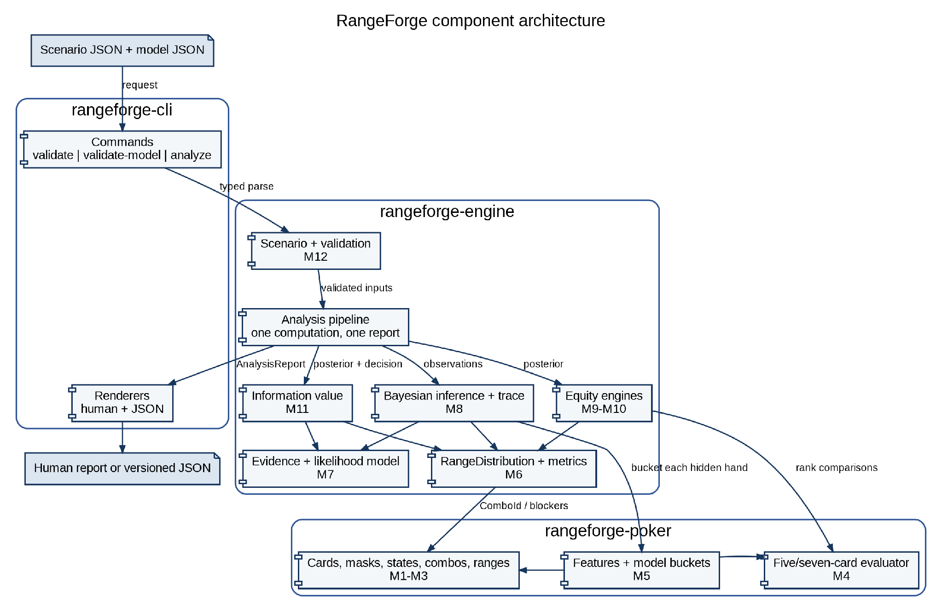
Figure G-1. Component architecture and permitted dependency direction.
Use this diagram when deciding where new code belongs: presentation remains in the CLI, orchestration and probability live in the engine, and poker-domain rules remain in rangeforge-poker.

G.2 Core Domain Class Diagram
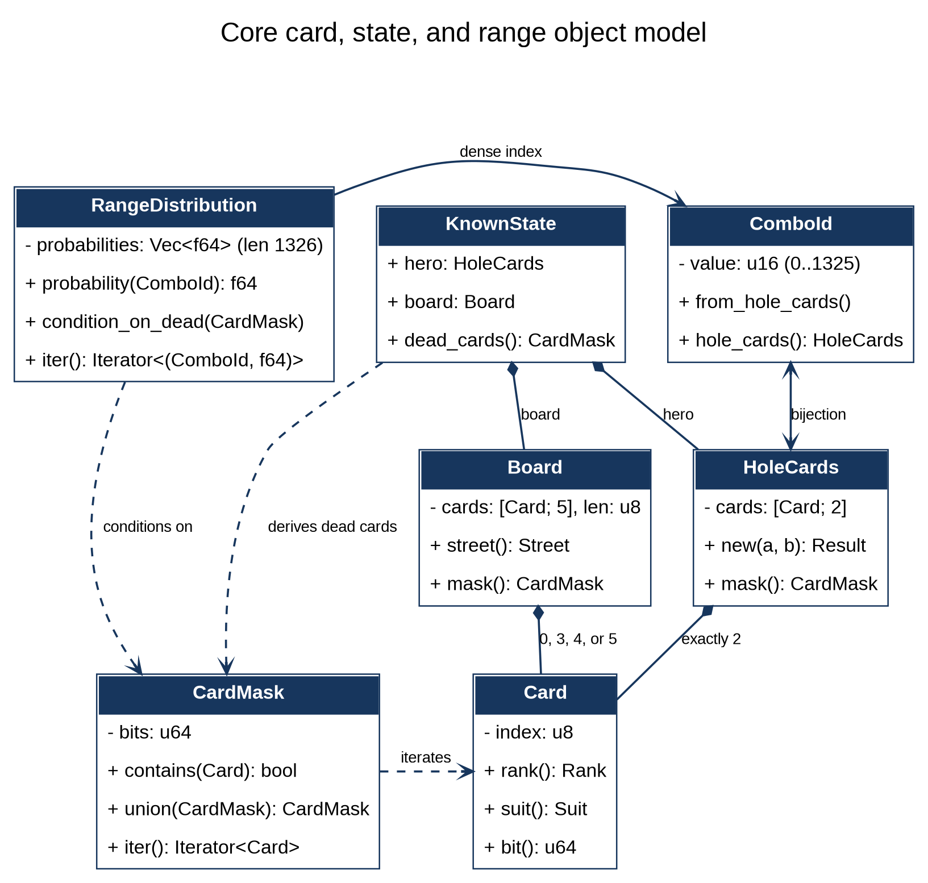
Figure G-2. Core card, state, and dense-range object model.
The private fields are intentional. Constructors and conversion methods enforce distinct cards, canonical ordering, legal board sizes, a 0–1325 ComboId bijection, and a normalized 1,326-element distribution.

G.3 Bayesian Action-Update Sequence
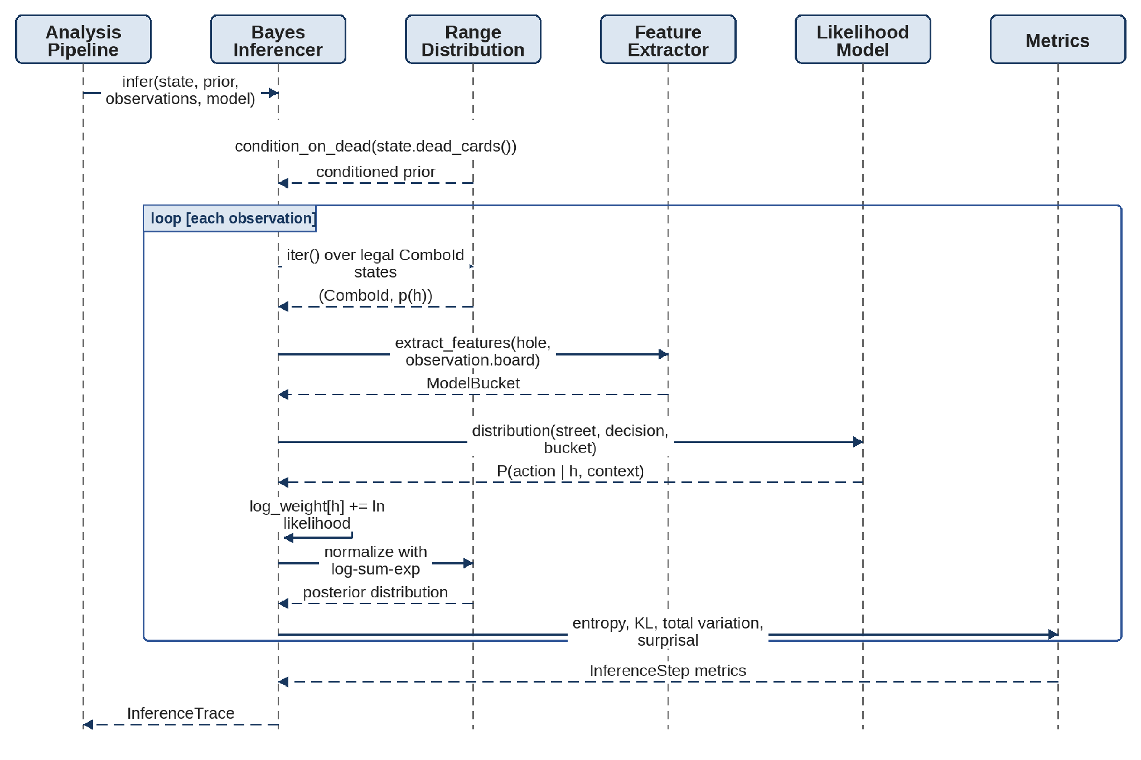
Figure G-3. Per-observation Bayesian update and inference-trace sequence.
Implement M8 in this order. The action model supplies likelihoods; it never owns the posterior. Normalization and metrics remain centralized so every observation produces the same auditable trace fields.

G.4 End-to-End Analysis Activity
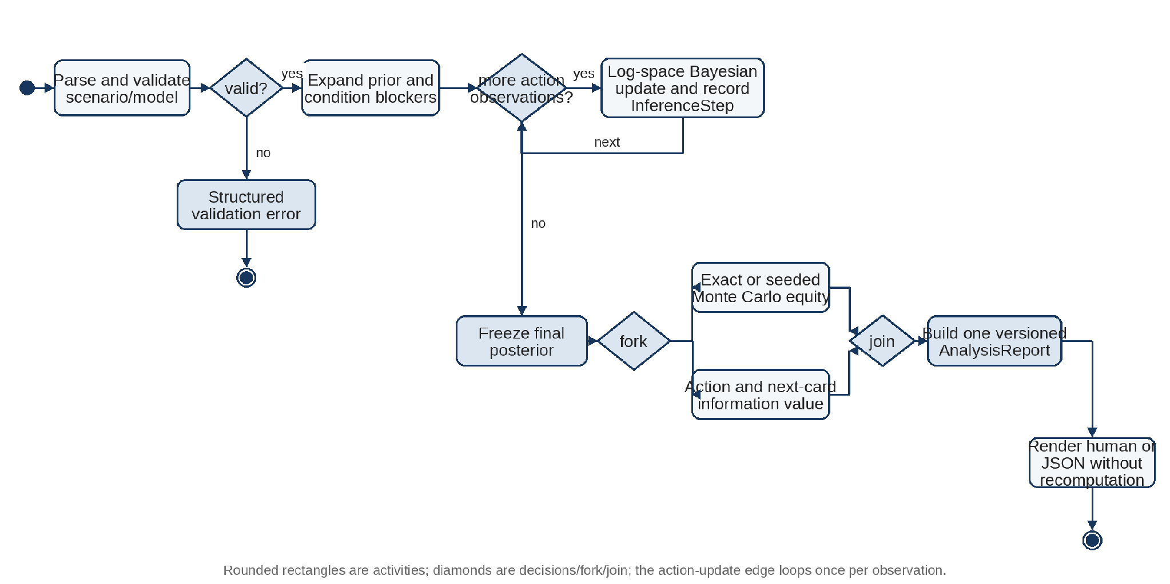
Figure G-4. End-to-end MVP analysis pipeline and stopping boundary.
The MVP is complete when this activity runs from a checked-in scenario to one reproducible AnalysisReport. Rendering is downstream of computation, and post-MVP strategy or calibration work is outside this boundary.

