DIGITAL HEALTH CLINIC & DIAGNOSTIC LAB PORTAL
MEMBER 2 — TEST EVIDENCE
Database triggers • Billing records

1. Trigger test: Preventing doctor double-booking
Test performed: An appointment INSERT was attempted for doctor_id = 4, patient_id = 11, appt_date = 2026-10-13, appt_time = 10:00:00, with status Scheduled. This was the exact slot of existing appointment 10 on the day the data was loaded; 07_trigger_stress_tests.sql now reads that slot from the table, so the test works on any day.
Observed result: MySQL rejected the INSERT with the message “ERR_DOUBLE_BOOKING: Doctor already has an appointment at this time”. This indicates that the trigger blocked the conflicting appointment.

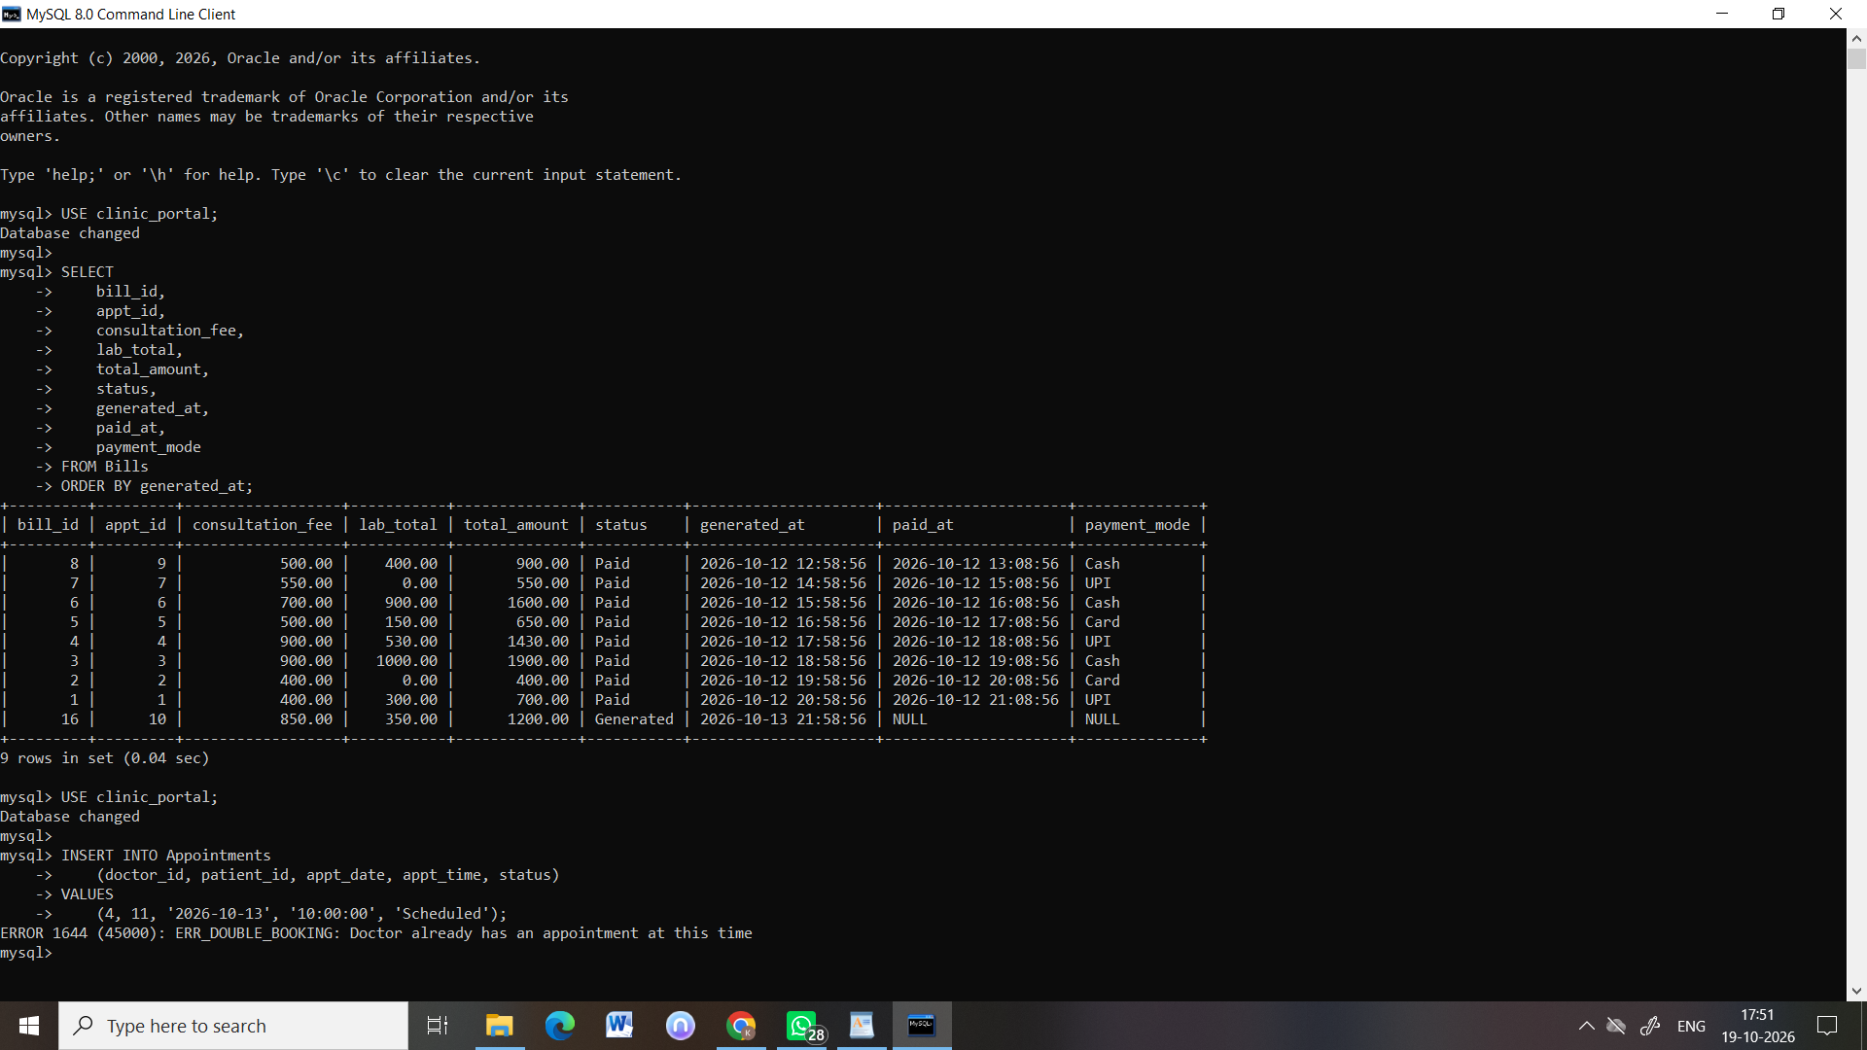

2. Trigger test: Appointment status audit
Test performed: Appointment status changes were checked in the Audit_Logs table.
Observed result: The Audit_Logs output showed entries for appointment record 16, including CANCELLED and STATUS_CHANGE actions. Test 3 then restored appointment 16 to Scheduled, which logged the STATUS_CHANGE row.
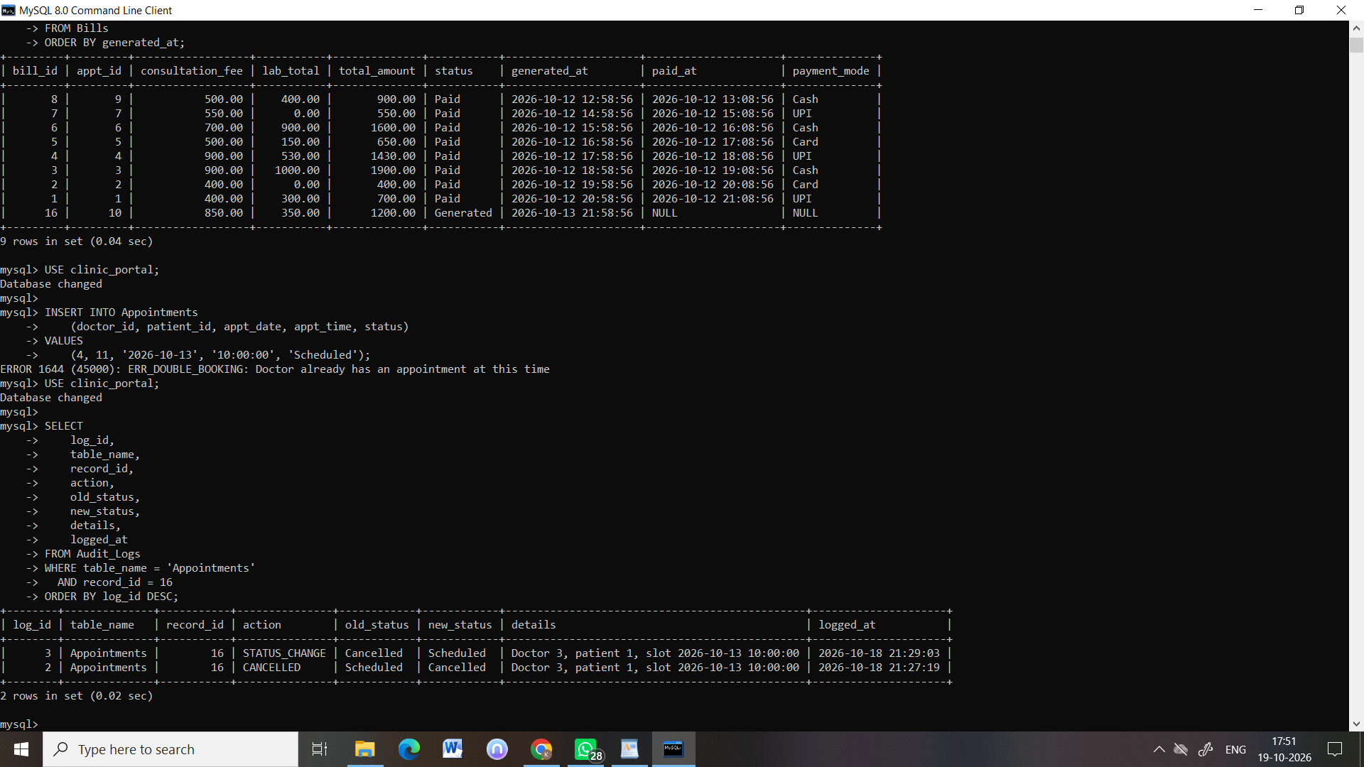

3. Billing records verification
Test performed: Queried Bills with bill_id, appt_id, consultation_fee, lab_total, total_amount, status, generated_at, paid_at, and payment_mode, ordered by generated_at.
Observed result: The query returned 9 rows. Eight bills had status Paid. One bill for appointment 10 had status Generated, consultation_fee = 850.00, lab_total = 350.00, and total_amount = 1200.00. Its paid_at and payment_mode were NULL, consistent with a bill awaiting payment.

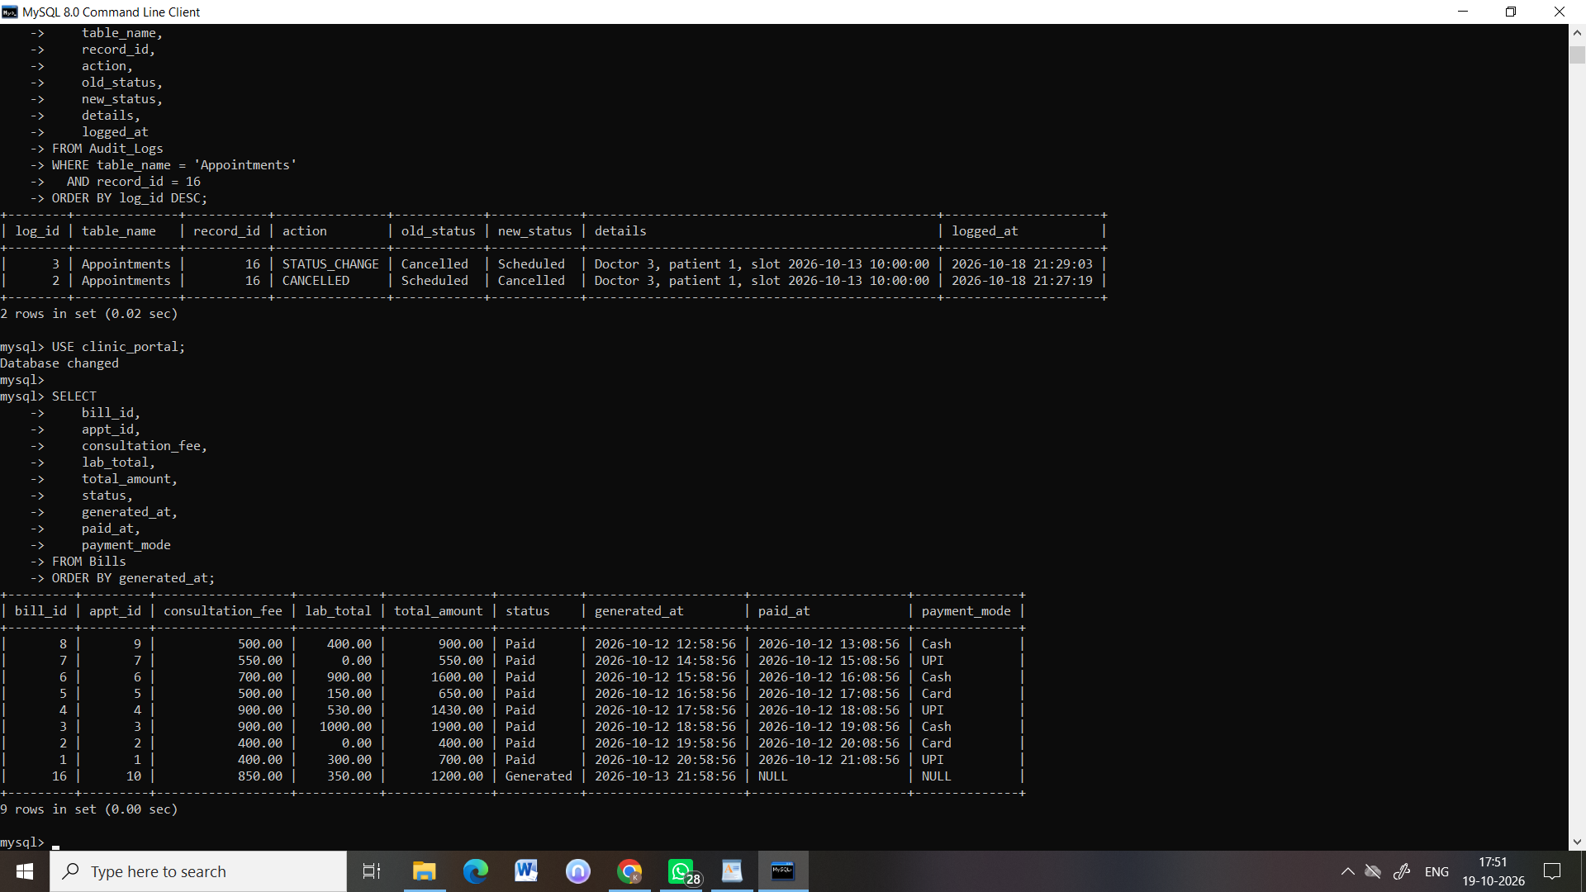

4. Further trigger tests (07_trigger_stress_tests.sql, Tests 4–7)
Tests performed: Rescheduling appointment 12 into appointment 11's slot; re-booking the slot of cancelled appointment 8 and then trying to un-cancel appointment 8; ordering a test on paid appointment 1; ordering and removing an extra test on appointment 10, whose bill is Generated. Added in Week 3 integration (Member 3).
Observed result: Reschedule and un-cancel were both rejected with ERR_DOUBLE_BOOKING (re-booking a cancelled slot was allowed); the order on the paid visit was rejected with ERR_BILL_PAID and no lab order was added; the extra test re-priced appointment 10's bill from ₹1,200 to ₹1,300 and returned it to Draft, and removing it brought the total back to ₹1,200. The script restores all data, so it can be run again.

5. Diagnostic Lab interface
Where tested: The lab tab (sample collection, result entry, HIGH/LOW flags, abnormal-results list) was tested inside the full app: see docs/Integration_Test_Cases.md, tests IT2 and IT6, with screenshots in Integration_Test_Screenshots.pdf (Fig 12, the lab tab flagging a HIGH result).

