DIGITAL HEALTH CLINIC & DIAGNOSTIC LAB PORTAL
MEMBER 2 — TEST EVIDENCE
Database triggers • Billing records • Diagnostic Lab interface

1. Trigger test: Preventing doctor double-booking
Test performed: An appointment INSERT was attempted for doctor_id = 4, patient_id = 11, appt_date = 2026-10-13, appt_time = 10:00:00, with status Scheduled.
Observed result: MySQL rejected the INSERT with the message “ERR_DOUBLE_BOOKING: Doctor already has an appointment at this time”. This indicates that the trigger blocked the conflicting appointment.
SCREENSHOT NEEDED: Paste the MySQL output showing the rejected INSERT and error message here.

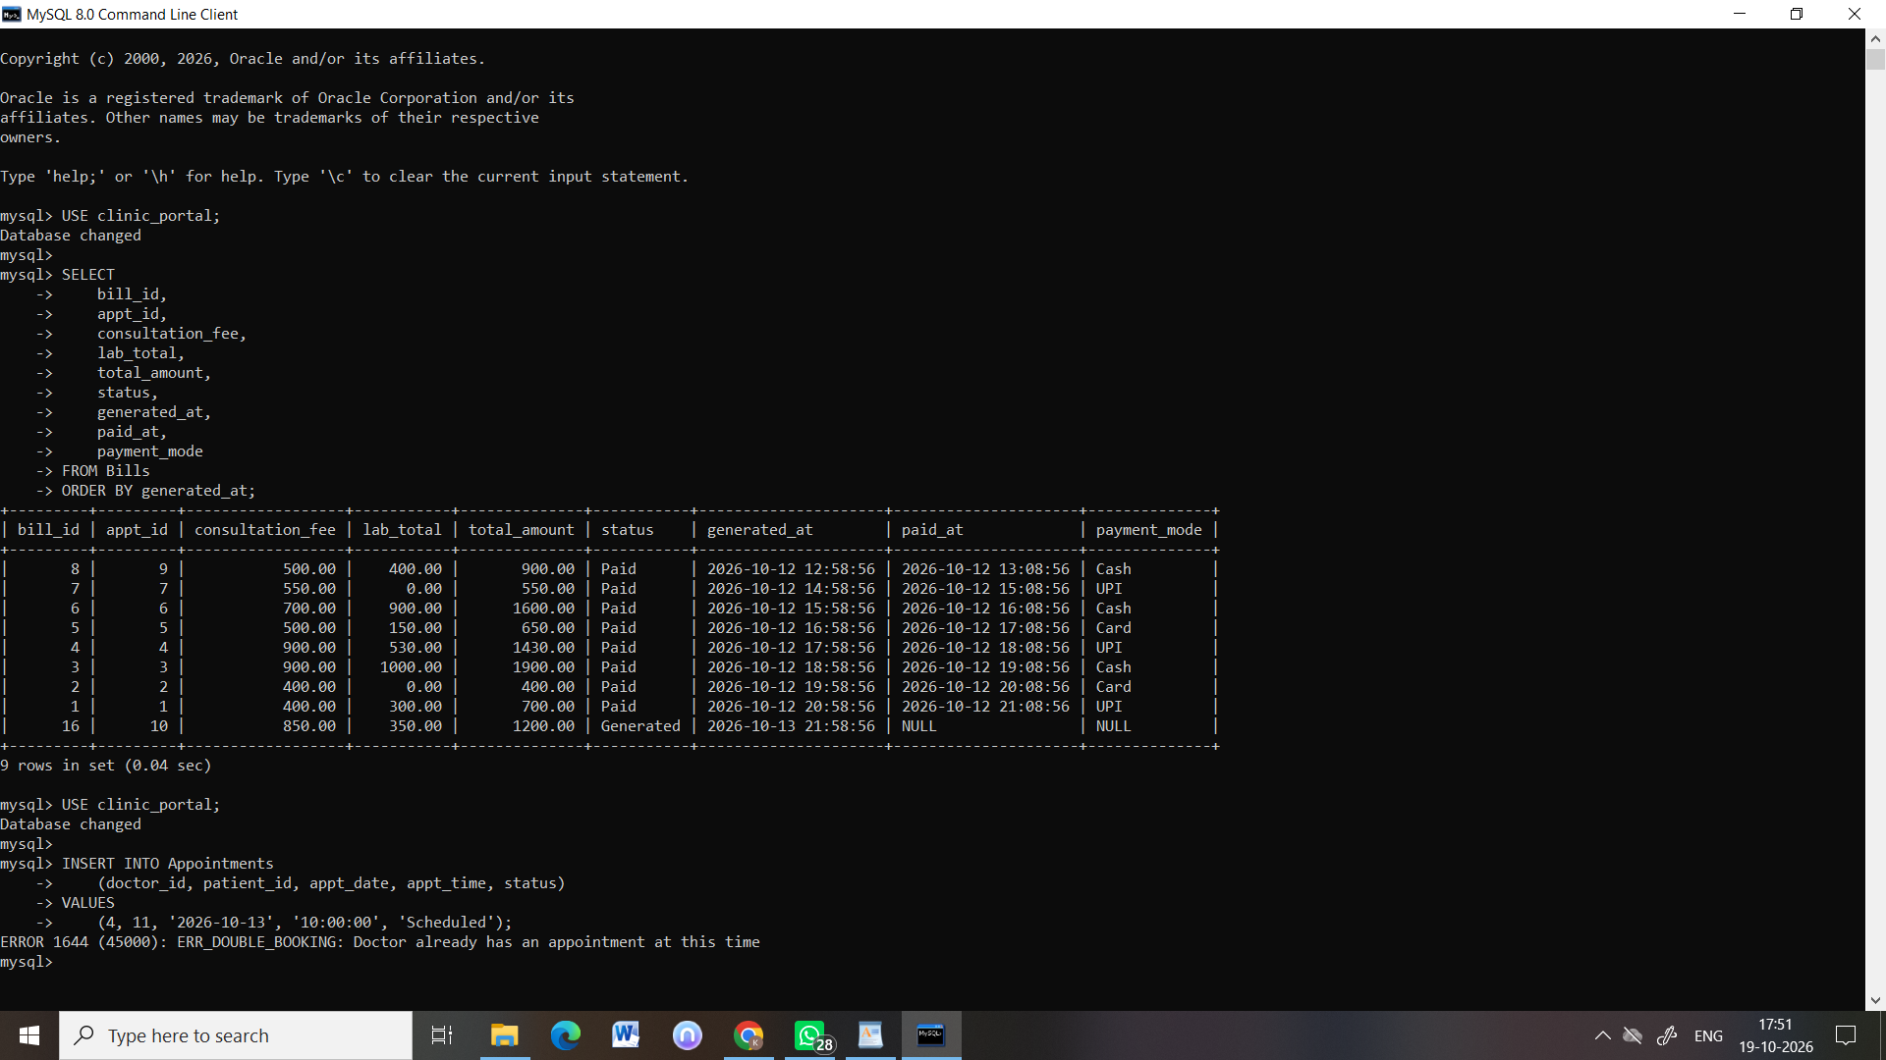

2. Trigger test: Appointment status audit
Test performed: Appointment status changes were checked in the Audit_Logs table.
Observed result: The Audit_Logs output showed entries for appointment record 16, including CANCELLED and STATUS_CHANGE actions. Verify the current appointment status in the live database before presenting.
SCREENSHOT NEEDED: Paste the Audit_Logs query output here.
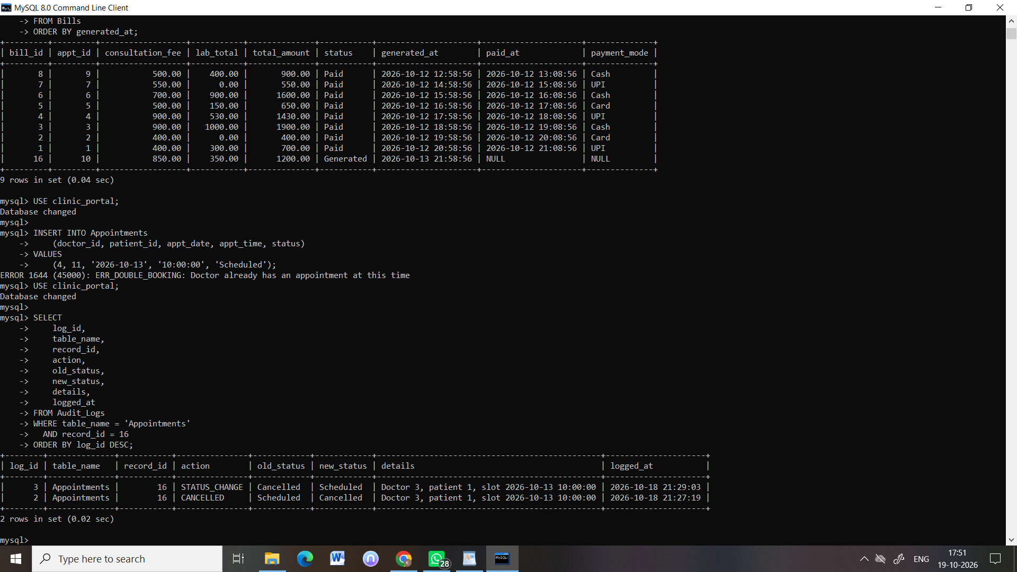

3. Billing records verification
Test performed: Queried Bills with bill_id, appt_id, consultation_fee, lab_total, total_amount, status, generated_at, paid_at, and payment_mode, ordered by generated_at.
Observed result: The query returned 9 rows. Eight bills had status Paid. One bill for appointment 10 had status Generated, consultation_fee = 850.00, lab_total = 350.00, and total_amount = 1200.00. Its paid_at and payment_mode were NULL, consistent with a bill awaiting payment.
SCREENSHOT NEEDED: Paste the Bills query output here.

