Contents

1 Contents 1
2 Introduction 4
3 Installation 4
3.1 Minimum Hardware Requirements 4
3.2 Software Requirements 4
3.2.1 DirectX 5
3.3 CDROM 5
3.4 Internet 5
4 Playing 5
4.1 Starting DarkSpace 5
4.2 Tutorial 6
4.3 Setup 6
4.4 Lobby 7
4.4.1 Login 8
4.4.2 Lobby 8
4.4.3 Selecting a server 8
4.5 Main Menu 9
4.6 Options 10
4.7 Observe 10
4.8 Team Selection 10
4.9 Factions 11
4.9.1 United Galactic Trade Organization (UGTO) 11
4.9.2 Interstellar Cultural Confederation (ICC) 11
4.9.3 K’Luth 12
4.9.4 New Factions 12
4.10 Prestige 12
4.10.1 Rank 13
4.10.2 Medals and Badges 13
4.11 Ship Selection 14
4.11.1 Scout 14
4.11.2 Frigate 14
4.11.3 Destroyer 15
4.11.4 Cruiser 15
4.11.5 Dreadnaught 15
4.11.6 Engineering 15
4.11.7 Supply 15
4.11.8 Transport 15
4.12 Tactical 15
4.12.1 Changing the view 16
4.12.2 Zooming 16
4.12.3 Helm 16
4.12.4 Contacts 16
4.12.5 Targeting 16
4.12.6 Manual Target 17
4.12.7 Actions 17
4.12.8 Ship Status 17
4.12.9 Systems Icons 18
4.12.10 System Display 18
4.12.11 Groups 19
4.12.12 Alpha Strike 19
4.12.13 Point Defense 19
4.12.14 Cargo 19
4.12.15 Boarding 19
4.12.16 Sending Messages 20
4.12.17 Distress Signals 20
4.12.18 Mission Recorder 20
4.13 Navigation 20
4.13.1 Jumping 22
4.13.2 Emergency Jumps 22
4.13.3 Jump Fuel 22
4.13.4 Sending Orders 22
4.13.5 Navigation Filters 23
4.14 Engineering 23
4.14.1 Repair Queue 23
4.14.2 Repairing 24
4.15 Communications Log 24
4.16 Planets 24
4.16.1 Planet Types 24
4.16.2 Governing 25
4.16.3 Structures 28
4.16.4 Planetary Invasions 29
4.16.5 Population 29
4.16.6 Bombardment 30
4.16.7 Infantry 30
4.16.8 Revolts 30
4.17 Nebula 30
4.18 Stars 30
4.19 Hazards 31
4.20 Refitting Ships 31
4.20.1 Device Types 31
4.20.2 Weapon Systems 32
4.20.3 Defensive Systems 36
4.20.4 Drives 36
4.20.5 Jump Drives 37
4.20.6 Special 37
4.20.7 Cloak 38
4.21 Scouting 38
4.21.1 Fog of War 38
4.21.2 Beacons 38
4.21.3 ECM/ECCM 38
4.21.4 Scanner 39
4.22 Engineering 39
4.22.1 Building 39
4.23 Transport 40
4.23.1 Loading Infantry 40
4.23.2 Unloading Infantry 40
4.23.3 Near Jumps 40
4.24 Supply 41
4.24.1 Distress Signals 41
4.25 Trading 41
4.25.1 Star Ports 41
4.25.2 Trading with ships 42
4.25.3 Piracy 42
4.25.4 Trade Goods 42
5 Mission Viewer 46
6 Map Editor 47
7 Key Reference 48
8 History 50
8.1 Timeline 50
8.2 History of explored space 50
8.3 A Close look at the UGTO from 2077 to the present 56
8.4 History of the “M” Class Constellation Cruiser hull 59
8.5 Defender of Cephid 61

Introduction

DarkSpace is a massively multiplayer action strategy game that puts you in command of a massive starship.

- The ship you choose determines your role within the universe…
  - Scouts use advanced sensors to find the enemy.
  - Engineers can build structures on the surface of planet such as defense bases and barracks to defend the planet from attack.
  - Supply ships carry fuel, ammo, and can repair ships close to the battlefield.
  - Transports bring troops deep into enemy territory to take control of the planets surface making it yours.
  - Frigates are fast and nimble perfect for quick strikes into enemy territory.
  - Destroyers are the main combat vessel of your fleet.
  - Cruisers are the perfect combination of firepower and speed for engaging and destroying the enemy.
  - Dreadnaughts the ultimate weapons platform allows you to launch wings of fighters or bombard a planet into the Stone Age from orbit.
- Give orders to other players using the command structure.
- Navigate your ship through nebula’s and the rings of Saturn.
- Govern a planet to control its production, diplomatic efforts, budget, and technology.
- Ban together with other players and form an empire stretching from Epsilon to Cygnus.
- Trade goods from port to port to make profit.
- Hundreds of players will engage in online scenarios and even multi game campaigns, providing compelling and dynamic game play with a multitude of objectives, ship types and strategies to reach ultimate conquest.

Installation
DarkSpace can be installed two different ways, either from a CDROM or by download from the Internet.

Minimum Hardware Requirements
- 300mhz Intel/AMD
- Windows 95/98/Me/2000
- 2nd generation 3d Card (GeForce, Matrox G400, Graphics Blaster)
- 64 MB of ram, 300 MB of hard drive space
- Internet connection, 56kbits modem or faster
- Direct Input compatible Mouse

Software Requirements
- Internet Explorer 4.0
- DirectX 8.0

DirectX
DarkSpace requires DirectX 8.0, if you do not have DirectX 8.0 or don’t know, you can download the installer from http://www.microsoft.com/directx .

CDROM
Insert the DarkSpace CDROM into your CD drive, the installer should automatically start.

Internet
DarkSpace can be downloaded from www.darkspace.net. Simply, download and run the downloaded installer DarkSpaceFull.exe to install the game onto your machine.

Playing

Starting DarkSpace
Playing DarkSpace is done through the shortcut installed into your “Start Menu” or on your desktop. Running the shortcut you will start the DarkSpace panel; the following buttons will be available:

Lobby: Sends you directly to the DarkSpace lobby. If this is the first time to play DarkSpace, then you will need to create a new account at the login window. Simply click on New Profile.

Tutorial: This starts the DarkSpace offline tutorial, which will teach you the game basics.

Mission Viewer: While playing DarkSpace, you can save your game to your local hard drive, this program allows you to load these “Mission” files (ending with the .MIS extension) and view them again.

Map Editor: The map editor included with DarkSpace allows you to create your own star systems, and then run them on your own DarkSpace server.

Setup: Clicking on this button can change the client graphics and audio settings.

Quit: Leave the startup screen.

Tutorial
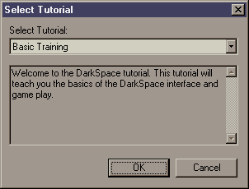
The tutorial offers several offline scenarios for teaching you how to play DarkSpace. It is highly recommended that you play the Basic Training tutorial before going online against other players.

Start the tutorial by running DarkSpace from the install shortcut, and then click on the Tutorial button.

Setup
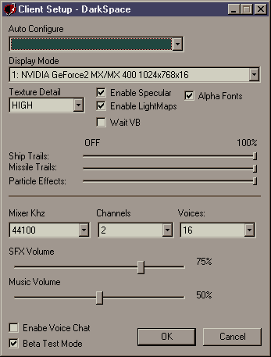

Auto Configure: You can select from this control to automatically configure the best graphics settings for the speed of your PC and graphics card.

Display Mode: This setting controls what graphics card DarkSpace will use when playing. The display mode also controls what resolution the game will initialize as well. The minimum resolution is 800x600, but it is recommended that you use 1024x768 since it provides the best game play experience.

Texture Detail: This setting controls how much video and system memory is used by the game. High detail uses the most memory. Low detail uses the least amount.

Enable Specular: Specular highlights make objects appear shiny. Disable this option to avoid the calculations to perform specular highlights.

Enable Lightmaps: Lightmaps make portholes on the ships illuminated. Disable this setting to turn off Lightmaps.

Wait VB: Toggle this option if your experiencing graphics glitches or slow render speeds.

Alpha Fonts: This option controls how text is drawn in game. Turn off this option if text appears corrupted.

Ship Trails: This slider controls the length of the ship trails.

Missile Trails: This slider controls the length of missile and fighter trails in DarkSpace.

Particle Effects: This slider controls how many particles are used for explosions and other effects in the game.

Mixer KHz: This option controls the mixer rate of the audio system.

Channels: This option controls how many sound channels to use for DarkSpace.

Voices: This option controls the number of sound effects that can play at the same time. Lowering this value will reduce the amount of CPU time needed for sound.

SFX Volume: This controls the sound effects volume.

Music Volume: This controls the volume of the music.

Lobby
Entering the lobby begins by clicking on the “Lobby” button from the DarkSpace panel.

Login
When the lobby is started you will be asked to login. If this is your first time to play DarkSpace, you should click on the “New Profile” button to create a new profile.

Lobby Views
The lower plane of the application is your chat window. The upper plane can be changed to view different areas of the lobby. The default view is to show the homepage of DarkSpace.

You will see several diamond buttons at the top…

Lobby: A different lobby for GameCQ can be selected by clicking on this button.

Servers: Click on this button to select a game server to play DarkSpace. In this view you will see the name of the server, a description, the lag, and the number of players already on that server.

Download: Clicking on this button will display the download page for DarkSpace. If you have already installed DarkSpace it will download the latest code and data update.

Home: The homepage for DarkSpace is contained within this view.

Rooms: Clicking on this button will display a list of available chat rooms to join.

New Room: Click on this button to create a new chat room.

Friends: Click on this button to display your friends and their locations. The submenu allows you to send a message directly to them, or remove them from your friend list. You can add friends by right clicking on their name in the lower right window, and selecting Add Friend.

Clan: If you belong to a clan then clicking on this button will display all the members of your clan and their location.

Profile: This view allows you to see your current DarkSpace profile.

Selecting a server
Starting DarkSpace first requires you to select a server to play. There are 4 basic types of DarkSpace servers on which you can play DarkSpace.

Scenario Server: This type of server is scenario based. While playing on the scenario server you will go through a series of scenarios. The next scenario is determined by the outcome of the previous scenario.

Combat Server: This server allows you to just have fun blowing other players up. There are not any statistics tracked on this type of server, so you can’t gain or lose rank.

MetaVerse Server: This server is linked to other MetaVerse servers creating a huge universe. This type of server runs continuously until one faction completely conquers all the servers in the MetaVerse.

Clan Server: This server is restricted to players who belong to a clan. Players of the same clan are always on the same team against other clans.

Server Details
When you click on a server it will bring up the server description, where you can view additional details on that server.

Time: This displays how many hours, minutes, and seconds the server has been running. If the server has a time limit, then the remaining time is also displayed.

Balanced: If the server is balanced, then teams are balanced by player rank to keep the teams equal.

Ladder: If yes, then you can gain rank and prestige on the server. If no, then the server will not record your stats into your profile.

Clan: If yes, then all clan members are joined to the same team unless the server is balanced.

Linked: If yes, then this server is linked to other servers forming a cluster of servers into a single universe.

Persistent: If yes, then the state of the server is saved to disk.

Max Rank: This indicates the maximum rank of ships allowed. This doesn’t mean that you cannot join the server if your rank is higher; it simply means you cannot select ships above this rank.

Version: This displays the current code version of the server. This is almost always the same as your client; the only time it will change is when code has been updated. The servers will automatically update with 30 minutes after a new code update.

Connecting
You can double click on a server to launch DarkSpace and join the selected server.

If you right-click on a server it will bring up a menu. Select Connect to join the server or Refresh to update the server list.

Main screen
Once you use the lobby to connect to a server. The DarkSpace client will start and the main screen will be displayed.

Play: Click on the play button to continue onto the team selection screen. If you are a member of a clan then you will go directly to the ship selection screen. If you already have a ship, then you will go directly to your ship tactical view.

Options: Click on this button to view the in-game options screen.

Observe: This button takes you into observe mode so you can watch the action without joining into the game.

Logout: Click on this button to exit DarkSpace and return to the lobby.

Options
The options screen allows you to set various in-game options for DarkSpace.

Border Color: Click on the arrows to change the border color of your HUD.
Background Color: This option changes the background color of your HUD.

Observe
The observe mode allows you to view the action on the server without joining a team or selecting a ship.

There is a group of buttons located in the lower right corner of your screen:

Next: This button selects the next object.
Prev: This button selects the previous object.
Exit: This returns you to the main screen.

There are 4 different cinematic cameras you can use, which display the current object from different angles.

Follow: This shows the object from behind.
Fly By: This shows the object from the front.
Isometric: This angle shows the object from above.
Chase: This angle is like follow, but has a better motion.

There are 4 different camera modes, which will automatically find new objects for you to view.

Auto: This button puts you into auto camera mode, which will automatically find interesting objects.
Battle: This camera mode shows you the current battles occurring on the server. If no battles are occurring, it will stay on the current object.
Planets: This camera enumerates through all the planets in the current system.
Lock: This locks the camera onto the current target. Click this, when you want to camera to remain on the current object.

Team Selection
The team selection screen is where you select whom you want to play with. If the server is balanced, then some teams may not be available for selection; this is done to keep the games balanced and fair for all players.

Simply select a team by clicking on the name, then click on Select to continue onto the ship selection screen. The Cancel button will take you back to the main screen.

If this is a Clan/MetaVerse server you may not get the team selection screen.

Factions
In the year 2125, Humanity has split into 2 warning factions for control of known space. This war has been interrupted by first contact with an unknown aggressive alien race called the K’Luth.

When playing DarkSpace, you will choose to play as 1 of the follow 3 factions currently available.

United Galactic Trade Organization (UGTO)
Established in 2024 after the colonization of mars, The UGTO is the conglomeration of the Old World United Nations and various other socio-political organizations of Earth. The “goal” of the UGTO is to unite humanity under one allegiance of progress and prosperity, although some elements do not see their intentions as being pure and noble. The UGTO spreads across seven systems, has colonies on 12 planetary bodies, and supports a massive collection of outposts and orbiting space stations. It also exerts its power over a number of “independent” planets.
With the advent of interstellar travel humans first sought out their nearest neighbor, the Centauri system, it was here that the harsh nature of the galaxy revealed itself for the first time. Within the Centauri system there was only one planetary body that was not too hostile for humans to visit, Centauri 1-2365. This barren moon was the only planet within the system that was not super-dense and therefore possessing a surface gravity just too high for humans (or human manufactured devices) to endure. Centauri 1-2365 was found to posses trace amounts of metals (about the same quantity as Earth) and so resource extraction development was undertaken. From the Centauri system it was a relatively short hop to the Barnard system where the nature of the galaxy was further confirmed. It turned out that the vast majority of planetary bodies were too hostile for development of any kind, although the Barnard system did have three planetoids that could be developed for resource extraction, one of these even had unheard of amounts of heavy metals present.
It was not until the Wolf system was explored that a planet capable of supporting human life was found. Unfortunately for the first colonists, the contaminants in the atmosphere weren’t discovered until later. Now Ocotat boasts the largest population of any non-Sol system planet ever colonized, thanks to strictly enforced medical policies.

Interstellar Cultural Confederation (ICC)
The ICC was established first as the Free Trade League (est. 2094), and then after a series of violent uprisings and political coups against the UGTO, The Free Trade League splintered from the United Worlds to form the ICC. in 2125. The ICC is currently the strongest opposition against the United Worlds, and is the primary force that hinders the UGTO from gaining majority control of the known universe and the worlds that lie within it. The confederation’s resources, technology, and infrastructure are a fraction of that of the United Worlds, but strong patriotic ideals, resourcefulness and clandestine networks keep the ICC intact, for now.

K’Luth
On August 3, 0645 MST, a UGTO Expeditionary Fleet encountered a force of unknown origin while charting a new quadrant in the outer reaches of the Sirius B system and contact was lost shortly thereafter. Concerned families and opposing organizations demanded immediate answers, which the UGTO Department of Defense responded by stating that a space anomaly, most likely, a black hole was responsible. Since the “Sirius incident”, unidentified spacecraft have been recorded and documented around human worlds and outposts.
The UGTO position on the existence of the K’Luth or any other extra terrestrial presence for that matter, is officially denied on all fronts. On the other hand, certain parties of the ICC claim to have made “contact” with this mysterious race of aliens. It is rumored that the ICC has acquired technology from the K’Luth, which has put some members of the UGTO council in a state of concern, but the majority of the council believe its just a propaganda ploy inseminated by confederate forces to send the United Worlds into panic. Realizing that the utilization of “new alien technology” could tip the balance of power within the astropolitical power structure, the UGTO. is conducting a full investigation on the matter.
The K’Luth are rumored to be from somewhere beyond the Sirius system.

Prestige
Prestige is calculate directly from the actions you perform in the game, destroy an enemy ship, capture an enemy planet, build a structure on a planet, or repair another players ship will all go towards increasing your. However, Self-Destruct your ship, fire on friendly players, or slam your vessel into a planet will cause you to lose prestige.

Your prestige is calculated from the following values in your player profile:

Games Played | This is the number of times you’ve joined a server.
Time Played | Amount of time, in seconds, you’ve been playing DarkSpace.
Kills | How many ships you’ve made the final kill shot. Note: This value does not increase your prestige; see “Ships Damaged”.
Killed | How many times your ship has been destroyed.
Bonus Prestige | Additional bonus prestige awarded in game.
Ships Damaged | How much damage you’ve inflicted against enemy ships.
Planets Damaged | Damage caused to enemy planets.
Planets Captured | Number of planets you’ve captured.
Friendly Fire | Damaged caused to friendly ships and planets.
Kamikaze | Damage caused to enemy ships from your ship explosion.
Self Destructs | Times you’ve self-destructed.
Jumps | Number of jumps you’ve completed.
Planet Collisions | Number of times you’ve collided with a planet.
Credits | Amount of credits you have or owe.
Scout | Number of ships you’ve tagged with a beacon.
Resources Lost | Value of the ships you’ve lost.

Note: The prestige calculation is subject to change for balancing purposes.

Rank
Gaining prestige increases your rank within the game. The higher the rank, the more ships you will have to select. Additionally, as your rank increases you can send orders to other players within the game who rank lower than yourself.

Rank | Prestige Required | Abbreviation
Midshipman | None | MS
Ensign | > 40 | EN
2nd Lieutenant | > 80 | 2L
1st Lieutenant | > 160 | 1L
Lieutenant Commander | > 320 | LC
Commander | > 640 | CM
Captain | > 1280 | CP
2nd Rear Admiral | > 2560 | 2A
1st Rear Admiral | > 5120 | 1A
Vice Admiral | > 10240 | VA
Admiral | > 20480 | AD
Fleet Admiral | > 40960 | FA

Medals and Badges
Medals and badges are awarded to players for achievements in DarkSpace. The right combination of medals or badges will make new ships available to you, for example, earn the “Bronze Transport” badge and gain access to the Heavy Transport.

Badge/Medal | Required
Bronze Navigator | 50 Jumps
Silver Navigator | 500 Jumps
Gold Navigator | 1000 Jumps
Bronze Engineer | 50 Construction
Silver Engineer | 500 Construction
Gold Engineer | 1000 Construction
Bronze Combat | 50 Ships Damaged
Silver Combat | 500 Ships Damaged
Gold Combat | 1000 Ships Damaged
Bronze Transport | 25 Planets Captured
Silver Transport | 50 Planets Captured
Gold Transport | 100 Planets Captured
Bronze Bomber | 50 Planets Damaged
Silver Bomber | 500 Planets Damaged
Gold Bomber | 1000 Planets Damaged
Bronze Support | 50 Repair
Silver Support | 500 Repair
Gold Support | 1000 Repair
Sirius Combat Medal | Bronze Combat, Bronze Bomber, Bronze Transport
Bronze Star | Bronze Navigator, Bronze Engineer, Bronze Combat, Bronze Transport, Bronze Bomber, Bronze Support
Silver Star | Silver Navigator, Silver Engineer, Silver Combat, Silver Transport, Silver Bomber, Silver Support
Gold Star | Gold Navigator, Gold Engineer, Gold Combat, Gold Transport, Gold Bomber, Gold Support
Medal of Bravery | Silver Combat, Silver Bomber, Silver Transport
Medal of Valor | Gold Combat, Gold Bomber, Gold Transport
Defense Medal | Gold Engineer, Silver Combat
Star Fury Medal | Silver Transport, Silver Bomber
Medal of Conquest | Gold Transport, Gold Bomber

Ship Selection
Once your team has been selected, you must now select which ship to commission from the shipyards. There are several factors, which can affect which ships you can commission, most importantly is your current rank. Additionally, badges and medals will make other ship types available to you. Finally, your faction may have limited resources to build certain ships.

Simply select a ship in the list, and then click on the Select button to begin play. Click on Cancel to return to the team selection screen.

You can filter the selection of ships by clicking on the ship icons to the left. Initially all ships are displayed, those that are darker you cannot select because of rank or badge requirements.

Some ships although available because of your rank may not be disabled because the resources are not available.

Scout
The scout is the primary vessel used for reconnaissance of enemy planets and ships. This ship is usually very lightly armed but some assault scouts are available for quick strikes against the enemy ships. However, the primary role for the ship is to stay outside the range of enemy weapons and provide this intelligence to the larger combat vessels.

Frigate
This vessel is the first true combat vessel above the scout. Although not as fast and nimble as the scout, it can take far more punishment. This type of ship is usually used for patrolling friendly space and attacking incoming transports and scouts.

Destroyer
The destroyer is a step up from the frigate and is good for providing escort for transports and other larger combat vessels.

Cruiser
The cruiser is the main attack ship for engaging targets deep in enemy space. The ship is sturdy and more maneuverable than the larger dreadnaught. The weapon systems of the cruiser can be numerous and usually carries armaments for planetary bombardment.

Dreadnaught
The dreadnaught is the largest of the available combat vessels. It can penetrate deep into enemy space and has numerous weapons systems, usually including bombs and fighter wings.

Engineering
The engineering ship is used for carrying supplies and equipment necessary to build new structures on newly colonized or captured planets.

Supply
The supply ship carries fuel, armaments, and the equipment necessary to keep a fleet of ships maintained deep in enemy space. This ship is absolutely necessary to until a foothold is established in a new system and the infrastructure has been built to support a fleet of combat vessels.

Transport
The transport is vital because it’s the only ship that can carry a substantial amount of infantry or resources deep into enemy territory. This ship is usually very lightly armed and needs constant escorts otherwise it’s very vulnerable to any enemy combat vessel.

Tactical
Once you select a ship, your ship arrives from the home system to its destination via the Jump Gate. Your ship will appear at the center of your display.

Status Bar: This is displayed in the lower left of the screen; this contains vital information about your ship. Your velocity and heading are displayed on this bar.
Systems Icons: This buttons are displayed in the lower center of the screen above the status bar.
Systems Target: The current selected system is display in the lower left corner above the status bar.
Target: The current target is display in the lower right corner of the screen.

Changing the view
Holding down the Right Mouse button, then move you mouse to move around the exterior of your ship.

Zooming
The Mouse Wheel or the “X/Z” keys will zoom towards and away from your ship, zoom out to get a larger view of the space around your ship. This works for the tactical view and the navigation window.

Helm
You ship navigates space using a rudder system. This allows you to set your turn, port or starboard, and then move onto performing other tasks such as giving to the order to fire your weapons.

A - Turn your ship left
S - Stop turn
D - Turn your ship right
Q - Decrease set velocity
W - Increase set velocity

Contacts
All objects that your ship can currently detect are indicated by colored box or triangle over the center of the object. Arrows along the edge of the screen indicate objects that are not within your view. You simply Left Click on the indicator to target that contact.

Red - Hostile contacts.
Yellow - Neutral contacts
Green - Friendly contacts

Box – Planets, ships, stars
Triangle – Missiles, bombs
Arrow – Off screen contact

You can increase your scanner range by using the “]” key. You can decrease your scanner range by using the “]” key.

Detecting objects simply amounts to how much signature that object is generating, the more signature the further away that object can be detected. The signature of a ship can be affected by several factors, most importantly is the velocity of the ship. The faster a ship moves, the more signature it generates. Ships with ECM and ECCM devices can also affect ship signature. Nebulas and Stars are considered natural ECM; they always lower the signature of ships within their area of effect.

Targeting

Left Clicking on a contact indicator makes that object your current target. The current target is always displayed in the lower right corner of the screen. Depending on the type of object you have selected; text and icons will be displayed in the target window. Additionally, buttons will appear in the target window for different actions on that target.

You will see the name of the target and the distance to the target displayed on the top line within the target window.

Manual Target
Holding down the Control button will allow you manually target a position in the tactical and navigation displays. This is useful to jump to an empty destination or to fire on a ship that you cannot target.

Actions
The following action buttons are available within the target window…
 | Dock with the current target, this is only valid if you have a ship targeted.
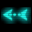 | Follow this button will follow the current target.
 | Load this loads the target into your cargo. You must be orbiting the planet to load objects from the surface of the planet.
 | Orbit: This button will cause your ship to orbit the targeted planet.

Ship Status

The ships vital information is displayed in the lower left corner of the screen.

Hull: The hull bar indicates the state of your ships hull, when this reaches zero your ship has been destroyed and your already dead.

Energy: This bar indicates the amount of available energy you have in stored away. When this bar reaches zero then ships systems will no longer charge, this includes all weapons and shields. Note: Your current velocity affects how much energy is routed from the engines to the rest of your ship. The higher your velocity the less energy available for other ship systems.

Signature: The emissions from your ship are displayed in this bar. The lower your ship emissions, the harder your ship is to detect. If you want to minimize your signature, keep your velocity low and use ECM if available.

Velocity: This bar indicates how fast your ship is moving through space. The triangle indicates your current set velocity, while the bar indicates your actual velocity. You can increase/decrease your velocity by Left Clicking with the mouse and dragging the mouse left or right. You can also use the Q/W keys to decrease and increase your velocity.

Heading: This indicates your current heading, and your turn direction if any. You can control your heading with the A/S/D keys on your keyboard. The “A” key turns your ship to the left, “S” key stops your ship from turning, and the “D” key turns your ship to the right.

Mission Time: This indicates the current mission time. The time is how long the server has been running the current scenario. If the scenario has a time limit, then the time remaining is displayed directly to the right of the current time.

Systems Icons
All of your ships systems are displayed in the lower center of the screen above the status bar as icons. Left Clicking on a systems icon will activate/use that system, in the case of weapons they are used on your current target. Displayed on the icon is the systems current status. For weapons, ammo will be displayed if the weapon uses ammo.

The brightness of the icon indicates if the device can be used. If the device icon highlights then the device can be used on the current target.

If the system is a weapon, the target must be within the range and firing arc of the weapon. Additionally, the weapon must be charged and in some cases have ammo.
In the lower right of the icon will be displayed the currently assigned group and hotkey.

All available ship weapon systems are listed in section 4.20.2

System Display

If you Right Click on a system icon, this will bring up the system display in the lower left corner of the screen. The system display shows that system status including the current damage to the system.

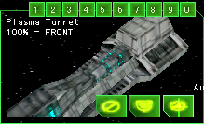

If this is a weapons system, then the range and arc of the weapon are displayed around your ship above indicated by the red lines.

Also displayed within the system status window are action buttons for that system, depending on the type of system some buttons may or may not be displayed…

 | Auto Defend: This button is available only for beam weapons, when clicked it will enable the weapon to automatically shoot down incoming missiles and bombs.
 | Auto Off: This button returns the weapon system to manual control.
 | Repair Now: Thus button is displayed when the system has been damaged. Clicking on this button will move that system to the top of the repair queue.
 | Repair Later: This button will move the system to the bottom of the repair queue.

TIP: You can quickly set a weapon for Auto Defense or Auto Attack by just holding down the Shift key and left clicking on the system icon.

Groups

All ships systems can be assigned to the number keys for grouping purposes. Assign a group by first right clicking on the system icon, the either click on the group button or press the “1-9” keys. You can ungroup a system by pressing the “0” key.

Once a system has been grouped, you can simply press the number on your keyboard to use all systems assigned to that group.

Alpha Strike
The Space bar will fire all available weapons at your current target. Special weapons such as bombs and mines will not be fired. Beam weapons set for Auto Defend will also fire if available, making them unavailable until they are recharged.

Point Defense
Beam weapons can be set to defend your ship from incoming projectiles. The easiest way to toggle point defense is to press “Control-B”.

You can set individual beam weapons to point defense by Shift-Clicking on their icon or right clicking on the icon then selecting the “Auto Defend” button.

Cargo
Some ships are capable of carrying cargo. If cargo is loaded onto a ship, then the cargo will be displayed directly to the right the system icons. Cargo can be unloaded onto ships and planets. The ability to unload is indicated when the cargo button highlights.

Right clicking on a cargo icon will target that cargo, allowing additional functions. Targeted cargo can be jettisoned into space, by either clicking on the jettison button or using the shortcut Control-E.

Left clicking on a bright cargo item will unload that cargo onto the selected target.
Cargo can be unloaded onto a specific position on a planet by first selecting a drop target on the planet.

Boarding
Infantry can also be used to board enemy ships. When at very close range, unload the infantry by left clicking on the infantry you want to unload. The infantry will be lost, but will cause major damage to the ships systems or even capture the ship.

Infantry can be transferred to another friendly ship in the same way, provided that ship has enough cargo space.

Sending Messages
Sending messages to your team is done by first pressing the Enter key, typing your message, and then pressing the Enter key again to send the message. You can abort a message your sending by pressing the ESC key.

Commands can also be entered on the chat line to perform special functions. Online help with the chat commands can by displayed by typing “/?” and pressing enter.

Distress Signals
There are 2 types of distress signals you can send…

Control-H will send an attack distress signal. Send this signal if you need help and you are currently losing the battle.

Shift-H will send a supply distress signal. This lets your team know you need more ammo, fuel, or repairs.

Pressing the “H” key will target the last distress signal you received.

Mission Recorder
The mission recorder can be used to record the entire events within the game for playback later with the Mission Viewer 5.

The mission recorder can be toggled on and off by holding down the Alt key and pressing R.

Navigation
The navigation window gives an overview of the entire system. You can either click on the navigation button in the lower right panel or use the “F2” key to bring this display up.

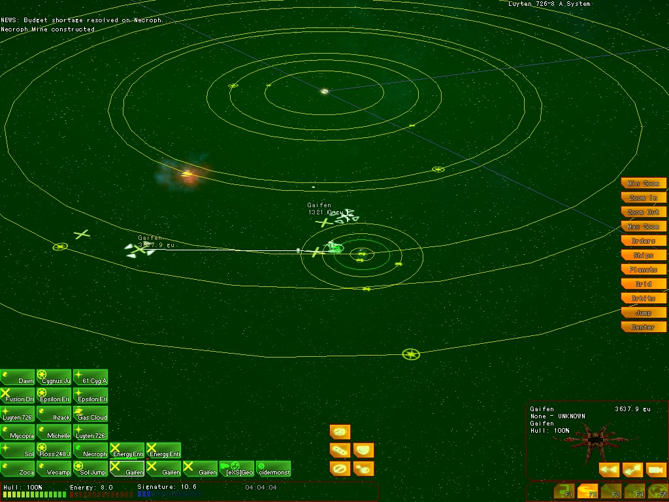
Holding down the right mouse button and dragging the mouse can rotate the navigation display. The mouse wheel or the “X/Z” keys can be used to zoom the display closer or further away from your current target.

You can center the map on your current target by pressing the spacebar.

Near the bottom of the screen are display the contact icons. These icons are divided into 3 groups.

The first group, starting at the left consists of planets and other major objects your ship/team can detect. If a flag is displayed on the icon, then this planet is an objective planet. Completing all your teams’ objectives will win the scenario.

The second group displays all enemy and neutral ships that are currently detected.

The last group to the right shows all currently detected friendly ships.

The icons for items in the navigation display are show in the follow table:

…. Asteroid | …. Cruiser | …. Destroyer
…. Dreadnaught | …. Engineer | …. Fighters
…. Frigate | …. Hazard | …. Jump Gate
…. Nebula | …. Planet | …. Orbital Platform
…. Scout | …. Star | …. Station
… Supply | …. Transport | … Unknown

Jumping
Jumping to a target is usually done through the navigation window. When you select a target, such as a distant planet, you will see a line drawn between your current position and that target. If the line is solid and white, then a jump is considered safe. If the line is red and blinking, then a jump is considered hazardous.

Pressing the “J” key initiates a jump to a destination. Once you either click on the icon or hit the J key, it will take a moment for your ship to align to the destination and slow to a stop before beginning the jump.

Emergency Jumps
In some cases a quick exit from the battle is necessary to avoid being destroyed. Holding down the Shift button and pressing the “J” key will initiate an emergency jump. Your drives will engage immediately and only for few seconds, however this is enough to get you out of the sticky situation.

Jump Fuel
Jumping requires fuel, a common mistake is to jump to far into enemy space and not have enough to get back.

Watch your fuel at all times, if you do run low you can refuel by orbiting a friendly planet. You can also call for a supply ship with Shift-H; if one is available they will come to your aid. Finally, you can orbit any planet with hydrogen. Your ship will scoop the fuel from the upper atmosphere.

Sending Orders
You can set orders for other ships, provided your rank is higher or equal by using the order buttons.

Simply, target the ship you wish to order, click an order button, and then select the target of the order.

For example, select “Bob” the transport, then click on “Capture” order, then select the planet “Mycopia” to send an order to “Bob” to capture “Mycopia”.

You can also do orders in reverse, select the order target, select the order, then select the player to send the order.

Note: A ship can only have one order at any time.

 | Attack: The target ship should attack the target you select.
 | Capture: Capture the selected target.
 | Defend: Defend the select target.
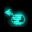 | Move: Move to the selected target position.
 | Cancel: This button cancels any previous order.

Navigation Filters
The navigation filters allow you to filter what information is displayed on the navigation screen.

Orbits: This filter toggles the display of orbit paths.
Grid: This filter toggles the display of the color overlay indicating which areas are friendly or hostile.
Planets: Toggle the display of planet icons and their orbits.
Ships: Toggles the display of ships.
Orders: Toggles the display of ship orders.

Engineering
The engineering window provides an overview of your ships systems and the current repair queue. You display the engineering screen by either clicking on the engineering button in the lower right panel or by pressing the “F3” key on the keyboard.

The right portion of the window provides an overview of your ships systems and their state.

Repair Queue
The left sub window shows the currently damaged systems onboard the ship and the order in which they are being repaired. When not in orbit around a friendly planet or being repaired by a supply ship only the first listed system is being repaired. The order of the systems can be changed by first selecting a system with the left mouse button, then using one of the buttons at the bottom of the window.

Top – Moves the selected system to the top of the repair queue.
Up - Moves the selected system up one level.
Down – Moves the selected system down one level.
Last – Repairs the system last.

Tip: Right clicking on a system icon, will display the “Repair Now” and “Repair Last” buttons in the system display.

Repairing
Your ship has some capacity to repair it’s own internal systems slowly. However, they can only be repaired one at a time and your hull cannot be repaired unless you have auto-hull repair.

You can get your ship fully repaired by orbiting a friendly planet. If the planet has a depot, then make sure you’re within 100gu of the depot to get repaired even faster.

You can also call for a supply ship by pressing “Shift-H”. If a supply ship is available it will come to your position and repair your ship in space.

Alternatively, Pressing “Control-R” will target the nearest depot or supply ship allowing you to jump to their position.

Communications Log
The communications window provides a log of all received messages. You can bring up the communications window by clicking on the communications button in the lower right console or by pressing the “F4” key.

Planets
Planets are the source of all resources in DarkSpace; resources are vital because they are used to build additional ships.

Additionally most scenarios required the team to capture and control most of the planets in a system.

Planets come in all types, some more hospitable than others…

Planet Types
All planets are classified into one of the following types:
Terran |  | This type of planet is ideal for supporting life; this allows populations to grow quickly.
Arid | 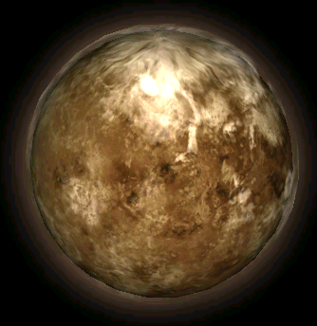 | Vast expanses of desert, this type of planet is completely devoid of water.
Ocean |  | Unlike the arid type of planet, this planet has an abundance of water. This type of planet is almost as hospitable as the Terran planet.
Barren | 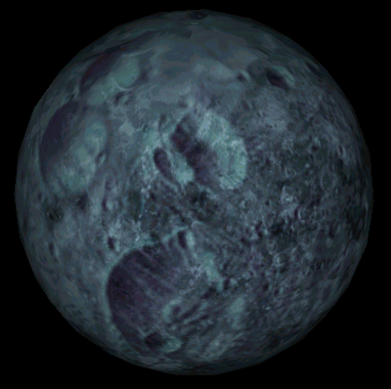 | This type of planet has no atmosphere; it’s simply a big rock in space. However these types of planets are usually abundant in mineral resources making them ideal for mining facilities.
Ice | 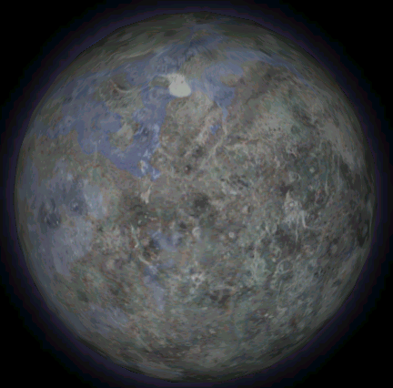 | Usually found far out from the heat of a star, this planet is cold however usually more capable of support life than the barren type of planet.
Inferno | 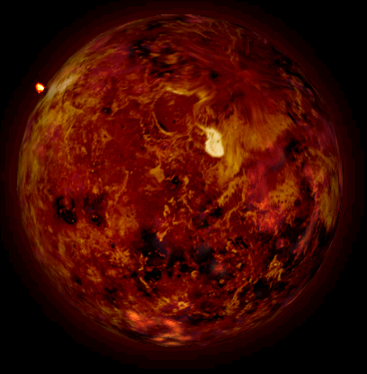 | The inferno is nothing by a molten rock in space, usually to close to the primary star or a huge gas giant. Nothing can survive on its surface.
Gas | 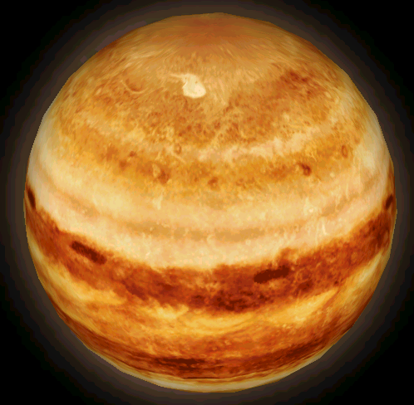 | This type of planet consists mainly of gases, usually with a very strong gravity field because of its size. The lack of a surface makes this planet impossible for supporting life.

Governing

Once a planet is under control of a faction, the planet can be managed by clicking on the Details button when the planet is the current target. A sub-window is display, with the following tabs:

Status
This tab displays the general status of the planet and some controls for the tax rates and locking the planet economy from changes by other players.

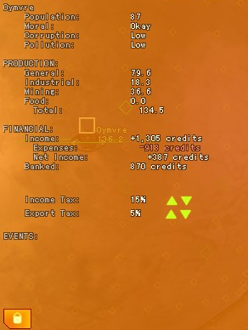
Population: The total population of the planet, each unit represents 10,000 actual sentient beings. Population requires food as a basic need; lack of food can directly result in a reduction of a planets population.

Moral: The moral of the population represents how the population is feeling about the current government. A low moral can reduce production output, and even cause the planet to revolt. Reducing tax rates, providing luxury goods, and protecting the planet from orbital bombardments can increase the moral.

Corruption: High corruption means the payoffs, kickbacks, and criminal activity is increased. Increasing the Security Budget is one of the means of reducing corruption.

Pollution: Pollution levels represents the amount of waste and contamination of the environment is occurring. High levels can reduce food production and cause the population to decrease. Increasing the Environment Budget allocations can reduce pollution.

Production: This represents the ability to produce general goods. This value represents the amount of goods that can be made in a amount of time.

Industrial Production: Constructing industrial complexes on the planets surface can increase the industrial production. Certain types of goods require high amounts of industrial labor to create.

Mining Production: Extracting the mineral riches of a planet require this type of production, which can be increased by building mines on the planet.

Food Production: Growing food requires a hospitable environment. Building Hydro farms is one method to increase food production.

Income Tax Rate: Credits for the planet budget and planet projects are aqquired from the population based on the current income tax rate. A high tax rates can reduced the population moral, thusly having an overall negative effect on the planets economy.

Export Tax Rate: All goods bought from the planets star ports include an export tax. A high export tax rate can increase the levels of corruption and smuggling activity.

Budget
This tab displays the current budget allocations for the planet.

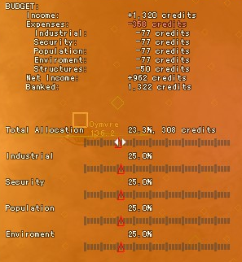
Total Allocation: This controls how much of the planets bank credits are taken for the other budget categories.

Population: The budget allocated for this category is used for increasing the population of the planet. This includes housing, health, and other services to promote the general welfare of the population.

Industrial: Credits allocated for industrial usage is used to improve transportation and the general efficiency of the planets production of goods.

Environment: Credits allocated for the environment are used to clean up industrial production waste and pollution.

Security: Polices forces and internal intelligence are paid from this budget; which helps to keep corruption and crime under control.

Production
The production tab displays the current production allocation for all the different goods that a planet can produce.

Left click to select a good and display it’s current status. While displayed you can adjust the Production input to control how much is made.

You can also adjust the Reserve amount to determine how much is kept on the planet. The excess is sent to the star port to be sold.

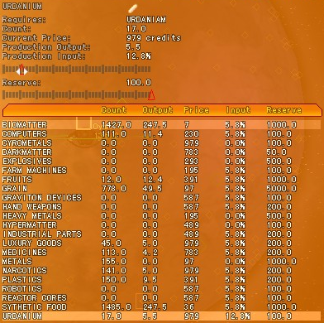

Trade Routes
In Development

Projects
In Development

Structures
Once a planets surface is controlled, infrastructure can be built to improve the planets resource production. Resources ultimately are sent back to the home system where they are used to manufacture additional ships.

Structures are built by using construction drones. The ship must first orbit the planet, and then select a drop target as the building site. Once a site is selected, press the “B” key to select a structure to begin building.

Mine
Mines generate resources from the mineral contents of the planet.

Factory
Building a factory will add industrial production to a planet. The factory will produce a static amount of resources no matter the planets population or mineral content.

Barracks
Building a barracks on a planets surface will train the planets population into infantry that can be loaded onto a transport and used to capture additional planets.

Defense Base
This structure provides defense against orbital bombardment. Incoming missiles and bombs will be destroyed before they impact onto the surface.

Planetary Shield
A planetary shield provides additional protection against planetary bombardment.

Interdictor Base
The interdictor base generates a jump disruption field 1000gu around the planet. This prevents any enemy ships from using their jump drives within this area.

Sensor Base
The sensor base uses ECCM to increase the signature of all ships in the area. This makes it easier to detect ships for planet defenses.

Anti-Sensor Base
The anti-sensor base uses ECM to mask the signature of nearby ships.

Hydro farm
The Hydro farm increases the food production of the planet.

Planetary Invasions
Controlling the planets surface is necessary to build structures on a planet and extract the resources. Gaining control of the surface is accomplished by landing ground troops onto the planets surface; enemy troops already on the surface will attack any invaders. Ultimately, the last man standing is who controls the planet.

Bombardment
Before troops are dropped onto a planet, it can be softened from orbit. However, orbital bombardment can destroy infrastructure and kill off millions of the planets population. Almost always if a planet can be captured by troops alone, this leaves all of the infrastructure and population unhurt.

Planets can be bombed if a ship has the armaments, simply target the planet and press the “B” key to release the deadly payload onto the surface.

Infantry
Controlling the planets surface requires that only your forces be on the planets surface. When enemy infantry is dropped onto the surface from orbit, it will seek and destroy any other enemy infantry and units. Once all enemy units have been eliminated, the victor controls the planet.

Some ships come with Infantry units already onboard, specifically the transport. However, most infantry must be trained by building a barracks on a controlled planet.

Units can gain experience for each battle that they survive. This experience will increase the units combat abilities.

Green – Fresh troops, no or very little combat experience
Veteran – Some combat experience
Hardened – Good combat experience
Elite – Excellent combat experience, all attacks are double

Revolts
Although a planet may be controlled by a military presence, sometimes the population of the planet will revolt.

Nebula
Gas clouds in space, which are the remains of a star that has lost since died. Nebulas and gas clouds provide a natural source of ECM, making it almost impossible for ships sensors to function.

TIP: Moving your ship into a nebula usually makes it possible to escape enemy vessels.

Stars
Stars provide another source of natural ECM like Nebulas, however get to close and no ships hull can withstand the radiation and heat.

Hazards
All kinds of other hazards exist in space, from a hidden black hole to an unknown form of life.

Refitting Ships
All ships can have the ability to change their systems. Ships come fully configured when commissioned, to change a device you must first remove it from your ship.

You can do this by right clicking on the icon of the system you wish to replace, then clicking on the remove button in the systems display.

You must have space in your cargo hold to remove the item. Once removed, you can either sell the item at the nearest star port or jettison it into space.

If you remove devices from the ship make sure you replace it with something of greater or equal value. You will be charged the difference in credits if you attempt to embezzle equipment.

Once removed, you can install a new device into the empty slot by first right clicking on the item in your cargo hold. If the slot is compatible with the device you have selected it will highlight. Left click on the highlighted slot to install or right click on the empty slot then click on the install button.

Device Types
All ship devices fall into one of the following categories. If you plan to refit your ship, only devices of the same type can replace each other.

Unknown
These types of devices are of unknown origin.

Drive
Drives move the ship at sub-light speeds. They are also the primary source of energy for other systems onboard the ship.

Special
Special devices include ECM, ECCM, and tractor beams. Usually small and power consumption is nominal.

Jump Drive
Jump drives move the ship at FTL speeds.

Weapon
Most projectile weapons fall into this category, this includes rail guns, gauss, and particle cannons.

Heavy Weapon
Heavy weapons require extra space and energy to operate.

Beam
Beam weapons by nature require large amounts of energy to operate, thus they have special requirements.

Heavy Beam
Heavy beam weapons require additional space and energy over normal

Armor
Armor is mounted on the outer hull of the ship to protect the inner hull from damage.

Shields
Shields are specially mounted into the hull to provide optimal resonance and protection.

Fighter Bay
Fighter bays require large amounts of internal space.

Drone Bay
Similar to fighter bays, but not as much space is needed.

Mine
Mines require special mounts near the rear of the ship.

Cloak
Cloaking devices require special hull considerations to work properly.

Hull
Hull type devices are integrated directly into the hull, such as the K’Luth auto-repair.

Interdictor
An interdictor device requires a huge amount of space and energy to function.

Weapon Systems
This is a list of currently available weapon systems.

CL-300 Chemical Laser
The CL-300 is a standard strength laser weapon. Like all beam weapons it is quite destructive at close range, but lacks punch at a distance. A beam weapon at close range is one of the most destructive arms available.

Price: 1,000 credits
Type: Beam

CL-500 Chemical Laser
The CL-500 is the increased strength version of the CL-300 laser weapon.

Price: 2,000 credits
Type: Beam

CL-1000 Chemical Laser
The CL-1000 is the increased strength version of the CL-500 laser weapon.

Price: 6,000 credits
Type: Heavy beam

CL-2000 Chemical Laser
The CL-2000 is the most powerful Chemical laser available and can only be found on large dreadnaughts and battle stations.

Price: 10,000 credits
Type: Heavy Beam

Rail Gun
The Rail gun is an accelerated projectile weapon. The gun advances on its mounting while releasing it’s projectiles thus increasing both the range and acceleration of the projectiles. The projectiles are hardened alloy shells and do not contain any explosives.

Price: 500 credits
Type: Weapon

Ion Tracking Missile
The Ion Tracker is a smart missile that homes in on the ion energy wake trail of space faring vessels generated by their fusion engines. The missile is designed with an armor-piercing tip that upon impact sets off a delayed trigger, this allows the missile to penetrate the ships hull before it detonates its payload. As with most missile weapons range is not as much of a factor as maintaining a lock on the targeted craft.

Price: 4,000 credits
Type: Heavy Weapon

Anti-Sensor Missile
The Anti-Sensor missile is a smart missile that homes in on the sensor/radar equipment of the targeted vessel. It requires no energy to fire, but when compared to other missiles does far less damage than what would be expected.

Price: 2,000 credits
Type: Weapon

Mirv Fusion Bomb
The Mirv Fusion Bomb is a planetary anti-personnel device. Its primary use is to remove armies from hostile planets prior to dropping friendly troops. When deployed it creates a wave of intense atomically engineered lethal radiation with a half-life measured in minutes, this allows follow up troops to be deployed with no risk of contamination.

Price: 3,000 credits
Type: Heavy Weapon

Flux Cannon
The Flux Cannon is an advanced design beam weapon. The Flux cannon operates by creating a beam that ruptures molecular cohesion. The main advantage of the Flux cannon over a laser weapon is its faster firing rate.

Price: 2,500 credits
Type: Beam

Ion-Pulse Beam
The Ion-Pulse Beam is another of the UGTO’s experimental beam weapons. It operates by flooding the target with positive and negative electrons in successive waves.

Price: 2,500 credits
Type: Beam

Particle Cannon
The Particle cannon fires vast quantities of super accelerated sub-atomic particles as a cohesive whole.

Price: 1,000 credits
Type: Weapon

Electro-Magnetic Pulse Mine
The EMP mine is a low energy-consuming device that is primarily used to guard sensitive areas. It works by releasing a huge electrical charge when encountered. The EMP mine is stationary when deployed, however plans are in the works to make seeker EMP mines that would “chase down” any craft coming too close.

Price: 3,000 credits
Type: Mine

Proton Cruise Missile
It is capable of locking onto a target across an entire solar system and is “smart” as well. It can be used against planets in order to depopulate them, and also makes a supreme ship-to-ship weapon capable of dealing out massive damage when detonated.

Price: 5,000 credits
Type: Heavy Weapon

Proton Torpedo Launcher
This weapon is a very useful mid-range device. Delivering the same type of payload as the Proton Cruise Missile (even if it is not as large) it is a respectable weapon.

Price: 3,000 credits
Type: Heavy Weapon

Gauss Gun
The Gauss Gun is a projectile device with extreme range. The weapon uses carefully timed triple acceleration chambers, each pumping up the velocity of the projectile by another factor over the chamber before.

Price: 750 credits
Type: Weapon

Fusion Torpedo
The Fusion Torpedo is the mainstay of the ICC fleet. It is an old-fashioned “small” nuke device. It makes up for its high-energy consumption with its rapid firing rate and high damage.

Price: 4,000 credits
Type: Heavy Weapon

Thermonuclear Mine
The nuke mine is used by the ICC to discourage incursions into sensitive areas. It is a stationary device, staying where placed and relying on its obscurity to lead enemy ships into hitting it.

Price: 3,000 credits
Type: Mine

SABOT Rocket
The SABOT rocket is a small unguided missile, it is a fairly quick projectile. Its main allure is the fact that it requires no energy to fire as the rocket itself supplies the propulsion.

Price: 800 credits
Type: Weapons

Disruptor Beam
The Disruptor Beam is unusual for a beam weapon as it is just as effective at long range as it is up close. It works by stopping the sub-atomic activity of all matter that it encounters.

Price: 7,000 credits
Type: Heavy Beam

Psi-Wave Cannon
This K’Luth weapon is a source of mystery. It is a medium range weapon and consumes 300su of energy per shot. The effect of being hit by a Psi-Cannon is where the mystery lies, some believe that it makes the crew of the ship that is hit by the cannon behave in an irrational manner.

Price: 1,000 credits
Type: Weapon

Anti-Matter Torpedo
The Anti-Matter Torpedo is the most dreaded of the K’Luth arsenal. Energy cost is slightly high.

Price: 6,000 credits
Type: Heavy Weapon

Bio-Cluster Bomb
This is the K’Luth most dreaded anti-personnel device. It is a fast acting biological weapon capable of quick and mass depopulation of planetary targets. Upon entering the atmosphere of the targeted planet it breaks into many smaller bomblet pods that swarm outward to spread their destruction.

Price: 6,000 credits
Type: Heavy Weapon

Defensive Systems
Defensive systems protect the ship from damage by space hazards and other dangers.

Heavy Armor
Armor is an outer casing that takes damage before the ships hull can be damaged.

Price: 4,000 credits
Type: Armor

Light Armor
A lighter version of heavy armor has less mass, which makes the ship more maneuverable for less protection.

Price: 2,000 credits
Type: Armor

Reactive Shields
Shields protect the hull from damage. Reactive shields remain dormant using no energy unless an incoming projectile is detected. When a projectile is detected the shield comes up and expends only the energy needed to deflect or absorb the impact.

Price: 2,000 credits
Type: Shields

Drives
Drives move the ship at sub-light speeds. They are also the primary source of energy for other systems onboard the ship.

Atomic Fusion Engine
Acceleration and energy generation are good.

Price: 6,000 credits
Type: Drive

Anti-Matter Engine
Hard to acquire since this is K’Luth technology.

Price: 8,000 credits
Type: Drive

Ion Engine
Slightly better performance than the PFE, still in use on many ICC ships.

Price: 3,000 credits
Type: Drive

Proton Fusion Engine
The oldest drive technology still in use.

Price: 2,000 credits
Type: Drive

Jump Drives
Jump drives allow a ship to travel at FTL (Faster than Light) speeds.

Tachyon Drive
This drive works by creating a tachyon wave, which warps space allowing the ship to travel at FTL speeds.

Price: 10,000 credits
Type: Jump Drive

Anti-Matter Drive
The anti-matter jump drive improves upon the tachyon drive by using an anti-matter energy source.

Price: 15,000 credits
Type: Jump Drive

Special
Special ship systems often take much energy but very little space.

Tractor Beam
The tractor beam works by generating cohesive particles, which can be used to move an object from a distance.

Price: 2,500 credits
Type: Special

ECM
The ECM (Electric Counter Measure) is an electro-magnetic pulse that confuses sensors trying to lock on to a ship.

Price: 500 credits
Type: Special

ECCM
The ECCM (Electric Counter-Counter Measure) sends out a negative pulse to counteract the ECM or just enhance the signature of any ships around.

Price: 500 credits
Type: Special

Cloak
Cloaking devices require special modifications to the hull to operate.

K’Luth Cloaking Device
The K’Luth cloaking device warps light and energy around the hull of the ship, making it almost impossible to detect.

Price: 10,000 credits
Type: Cloak

Scouting
Scout ships play an important role in any fleet; do not neglect them because they help lift the fog of war.

Fog of War
You only see what your fleet can detect. Scout ships are equipped more so with many special devices to increase their ability to detect other ships. Additionally, scouts have a very low signature making them very hard to detect.

Beacons
All scouts are equipped with beacons. Beacons allow the scout to tag an object making it visible at any range within the current star system.

Most beacons are not guided, so care must be taken to make sure they hit a moving target. This is usually accomplished by moving into close range on the rear of the target, otherwise the scout may be subject to hostile fire.

Beacons can also be used to mark planetary targets, making it possible for larger ships to attack the planet from a long range.

ECM/ECCM
Most scouts are equipped with ECM and/or ECCM. ECM masks the signature of all ships within the area of effect. ECM is also additive, so the more ECM devices active the lower the signature of all ships in the area.

If enough ECM is active, a fleet can enter enemy space without being detected to launch surprise attacks against planets and other ships.

Scanner
The scanner device equipped on many scouts increases the sensitivity of the scout’s sensors when used. This in effect increases the detection range of the scout.

Using the scanner will also increase the signature of the scout itself, making it more likely you’ll be detected when using it.

The scanners effect is similar to ECCM; the difference is that it does not provide intelligence to your enemy as well. ECCM increases the signature of ALL ships in the area.

Engineering
The engineer plays a very important role in DarkSpace. Once a planet is captured and controlled by your faction, the next step is to build structures on the planet to increase its ability to produce resources. Second to protect the planet from invasion and enemy vessels.

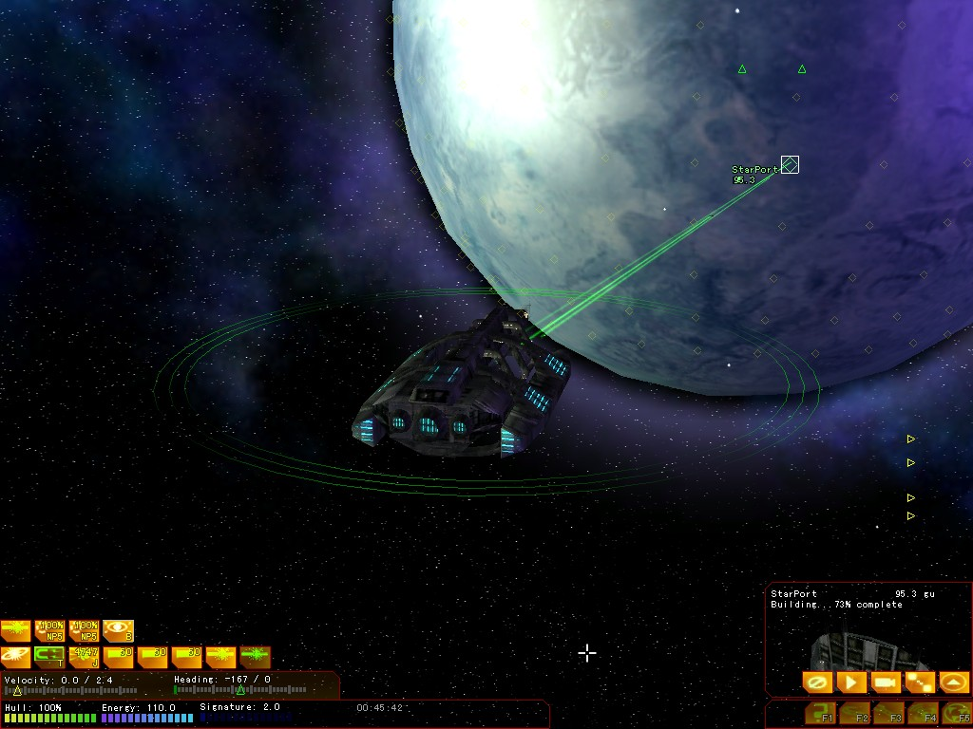

Building
Building a structure is done by firstly entering orbit around the planet. You can do this by targeting the planet, then pressing the “O” key or clicking on the orbit button.

Once in orbit, drop targets will appear on the surface of the planet. Select an empty drop target, which will be yellow, and press the “B” key or click on your build icon.

The next step is to select the structure to build on the planet. You can do this by using the arrow keys then clicking on the build button in the systems display window.

Once building has started drones will leave your ship and descend to the building site and construct the building. The progress will be displayed in your build icon with a blue bar; once the building is completed you will be notified.

If you leave orbit before building is completed, the construction will be aborted. If this happens, you can continue building by selecting the incomplete building and press the “B” key after you are orbiting the planet again.

Transport
The transport is primarily a troop transport. The transport can carry up to 10 infantry units for planetary invasion. Additionally, it can be used to transport cargo from one planet to another.

Loading Infantry
Firstly, you can determine if a planet has infantry by targeting the planet. The number of units will be displayed in the target window.

Once you find a planet with trained infantry. Loading infantry is accomplished by orbiting the planet. Once in orbit, select the infantry as your target and press the “L” key to load. Optionally, you can click on the “Load” button in the target display. If you have enough cargo space, then infantry will be loaded into your cargo hold.

Unloading Infantry
Unloading the infantry also requires you to be in orbit around the planet. Enter orbit by selecting the planet, and pressing the “O” key or clicking the “Orbit” button.

Once you’re in orbit, select a drop target on the planets surface. Then either click on the infantry icon in your cargo window or press the “U” key to unload the last item you loaded.

Near Jumps
Using the transport to invade enemy planets can be risky especially if the planet is heavily defended. Jumping to a planet, then trying to enter orbit can take some time. Making the transport vulnerable to being destroyed before dropping the infantry.

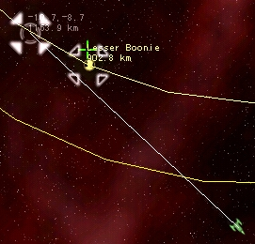
One technique is to near jump to the planet. You do this by bringing up the navigation screen, then holding down control key to set a manual jump destination that goes past the planet, but not through the planet (unless your very daring).

This will allow you to practically enter orbit right after you leave jump saving valuable time.

Supply
The supply ship allows a fleet to be maintained deep into enemy territory. It carries not only fuel and ammo, but also has the capacity to fully repair ships.

Moving within 100gu of the ship, then using the “Reload Drones” will repair the other ship. You can do this by pressing the “Y” key or using the reload icon.

Distress Signals
Distress signals are the most effective method for your fleet to communicate quickly. When a player presses “Shift-H” they send out a “Supply Distress signal”. You can target this player by pressing the “H” key immediately after seeing this distress signal displayed.

Trading
Trading goods from planet to planet is a respectable way to make a profit. Many planets need certain types of goods to manufacture others, making it absolutely vital that trading occurs.

Star Ports
A star port is required for a planet to trade. If no star port structure is available, then no goods can be bought or sold.

Trading with a planet is firstly done by entering orbit around the planet. You can do this by selecting the planet, then pressing the “O” key to enter orbit.

Once in orbit, press “Control-T” to target the nearest star port and open the trade window to begin trading.

Available: The icons in this window show the goods that are available to purchase from the planet. Simply click an icon to move it into the Selected window.
Selected: This window shows the items you intend to purchase.
Offer: This window shows the items you want to sell to the star port. Clicking on a icon will remove it from the offer window.
Cargo: You current cargo is displayed in this window. Click on an icon to move it into the offer window.

Once you have selected what you want to buy and sell, then click the Trade button to perform the trade. If successful, then a message will display the credits added or subtracted from your account.

Trading with ships
Trading with another ship is similar to unloading cargo onto another ship. Move within 25gu, and press “Control-T” to begin trading.

Piracy
You can acquire trade goods through piracy as well. This can be accomplished by unloading infantry onto an enemy transport. Your boarding party will jettison the cargo in most cases.

Another method is to simply destroy the transport. Usually the cargo will be lost in the ship explosion, but sometimes it will survive allowing you to load it into your cargo hold.

Trade Goods
Trade goods are vital to the economy of a star system. Certain trade goods require other goods to manufacture. This makes it vital that goods are transported at efficiently as possible between planets.

Biomatter
Also known as fertilizer, a needed component on some planets to grow many foodstuffs it is also need to make plastics.

Base Price: 10 credits

Computers
Device used for automation and administration, can perform trillions of complex calculations per second. This resource increase the production of the population when available.

Base Price: 175 credits
Requires: Metals

Cyrometals
Advanced ship hulls and other devices can use this intelligent metal.

Price: 500 credits

Darkmatter
Darkmatter is extremely rare and extremely heavy. It’s the primary material used to create Reactor Cores.

Base Price: 400 credits

Explosives
Explosives have many industrial uses.

Base Price: 150 credits
Requires: Biomatter

Farm Machines
Farm machines are used to produce foodstuffs; the demand is highest on Terran type planets were food production is high.

Base Price: 100 credits
Requires: Metals, Industrial Parts

Fruits and Vegetables
Fresh fruits are considered a valuable foodstuff in outlying mining planets. Food is used to feed the population of the planet; too little food can lead to mass starvation.

Base Price: 200 credits
Requires: Biomatter

Grain
Grain is a standard foodstuff primarily grown on Terran planets. Food is used to feed the population of the planet; too little food can lead to mass starvation.

Base Price: 50 credits
Requires: Biomatter

Graviton Devices
Graviton devices are a primary component of propulsion devices often used in personal transport craft.

Base Price: 300 credits
Requires: Hypermatter, Metals

Hand Weapons
Hand weapons are required to train and equip infantry.

Base Price: 300 credits
Requires: Metals, Explosives

Heavy Metals
Used in some as a primary component for reactors and other industrial components.

Base Price: 100 credits

Hypermatter
Hypermatter is a unique material that can generate gravitons.

Base Price: 250 credits

Industrial Parts
Parts needed for industrial production in factories and mines.

Base Price: 250 credits
Requires: Metals, Heavy Metals, Plastics

Luxury Goods
Luxury goods can include jewelry, furs, and perfumes. When luxury goods are available the moral of the population is increased.

Base Price: 500 credits

Medicines
Medicines are important to the health of the population. A lack of available medicines can cause a high death rate, or even worse outbreaks of disease, which can decimate the population.

Base Price: 400 credits
Requires: Biomatter

Metals
A primary component used in the construction of many devices.

Base Price: 50 credits

Narcotics
Illegial trade good, often in demand on remote mining facilities.

Base Price: 500 credits
Requires: Biomatter

Plastics
Plastics are often formed into industrial parts.

Base Price: 200 credits
Requires: Biomatter

Robotics
Robots are used in mining and manufacturing areas of industry. Often used to perform the most dangerous and tedious work, they can increase productivity of a factory or mine.

Base Price: 300 credits
Require: Metals, Industrial Parts

Reactor Core
The reactor core uses Darkmatter to generate energy, which is a vital element of industrial and ship production.

Base Price: 600 credits
Require: Darkmatter, Industrial Parts

Synthetic Food
A paste of vitamins and proteins, it's fairly bland but can be flavored to taste almost like anything. Food is used to feed the population of the planet; too little food can lead to mass starvation.

Base Price: 50 credits
Requires: Biomatter

Urdanium Crystals
Urdanium crystals are rare. This materials unique atomic structure allows it to convert energy from one form to another.

Base Price: 500 credits

Mission Viewer
You can record your games for playback with the Mission Viewer by holding down the Alt key and pressing “R” within the game. Simply run the “Mission Viewer” from the DarkSpace panel, and open the saved mission file from disk. The mission files are stored in the program directory with the extension .MIS.

Map Editor

Documentation In Development

Key Reference

GLOBAL
F1 | Help
F2 | Navigation
F3 | Engineering
F4 | Chat Log
F5 | Profile
Alt-F4 | Exit
Alt-R | Toggle mission recorder
Control-D | Self Destruct
H | Target Last Distress
Control-H | Send Distress Signal
Shift-H | Send Supply Distress Signal
TACTICAL
A/Left | Turn Left
S | Stop Turn
D/Right | Turn Right
Q/Down | Decrease velocity
W/Up | Increase Velocity
X/Z | Zoom Camera
ENTER | Begin chat message / Send chat message
SPACE | Fire all weapons
1-9 | Use Group
E | Next enemy target
Shift-E | Closest enemy target
R | Next friendly target
Shift-R | Closest friendly target
Control-R | Closest Supply/Depot
Control-J | Closest friendly jump gate
[ | Decrease contact range
] | Increase contact range
/ | Toggle Shield/Armor/Turn displays
F | Follow Target
G | Dock Target
O | Orbit Target
L | Load cargo
U | Unload cargo
Control-T | Trade
NAVIGATION
X/Z | Zoom
Shift-Z | Min Zoom
Shift-X | Max Zoom
SPACE | Center on target
J | Initiate jump
Shift-G | Toggle control zones
Shift-O | Toggle orbit paths
Shift-P | Toggle planets
Shift-S | Toggle ships
Shift-K | Toggle orders
A | Order attack
C | Order capture
D | Order defend
N | Order cancel
DEVICE SPECIFIC
B | Bombs
Shift-B | Explode bombs
K | ECM
P | ECCM
K | Cloak
J | Jump
Shift-J | Emergency Jump
T | Tractor beam
Shift-T | Reverse tractor beam
Y | Reload
Shift-Y | Reload self
N | Fighters
Shift-N | Recall fighters
DEBUG
Alt-P | Profile Information
Alt-T | Capture screen shot
Alt-M | Capture movie
Alt-W | Wireframe

History

Timeline
- 2000 the beginning of the end of the national political system on Earth
· 2007 general restructuring measures were enacted by the Global Trade Organization
· 2007 final development of the space station
· 2009 first ion-emitting plasma thruster
· 2014 Construction began on the Luna Dome
· 2019 Luna Dome was completed
· 2015 the DMP (Deep Mars Probe) returned to Earth with its findings and a manned expedition was undertaken
· 2022 the Martian Terraforming project was begun
· 2024 The UGTO was formed
· 2049 The Centauri project launched
· 2054 Barnard system reached
· 2067 Ocotat joined the UGTO
· 2077 First Stellar Conflict, UGTO appoints Whitworth as Grand Chancellor
· 2094 The Stellar Freedom Alliance begins anti UGTO activities in the Farstars
· 2112 The Second Stellar Conflict begins
· 2114 Tthe Sol loyal systems once again prevailed over the Farstars
· 2125 The Free Trade League declared the Farstar systems as an independent sovereign government, the ICC is formed.

History of explored space

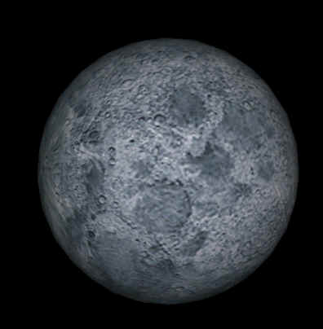
In order to understand the current state of affairs in known space one must delve back all the way to the beginning of the millennium on the planet Earth. Events unfolding at that time on the Mother Planet laid the foundations for the current socio-economic situation across the known galaxy.
Most historians agree that the year 2000 was the beginning of the end of the national political system on Earth and the beginning of the global economic era. The result of free trade agreements between all nations led to world spanning corporations wielding more power than any individual government could muster. The national governments found that the multinational corporations had tied their hands and in order to survive they played along with whatever corporate interests were strongest in their region. After the general restructuring measures were enacted by the Global Trade Organization in 2007 the establishment of worldwide economic zoning further undermined the importance of national governments. Under zoning mandated by the GTO local areas were given a productivity rating that had more of an impact on the zoned areas than their own national governments. From this point on national governments were no more than elaborate stages that the global corporations used to publicly communicate.
Meanwhile space exploration was booming on two fronts, the first was heavy industry, the second was tourism. These went hand in hand at the Luna Station.
Industrial development was spurred by the inability to extract resources inexpensively from the Earth itself any longer. Large concentrations of valuable resources had already been exploited for centuries and the easy pickings were gone. The methods used to extract valuable ores and materials from Earth became more expensive as the materials became harder to find. In 2007 several corporations got together and put their muscle behind the final development of the space station that was begun by the national governments in 1999. They altered the plans for the station to include several experimental manufacturing modules along with a prototype refinery. On Luna small scale mining operations were begun. The companies now faced off against the problem of making travel to and from the space station and Luna less expensive. For over twenty years all materials had been lifted to the station from the old NASA shuttles. It was agreed by all involved that the shuttles were wasteful and small, something else was needed and the corporations shifted into gear. Soon Overhouse Enterprises came up with the breakthrough, their first ion-emitting plasma thruster. This engine was fitted into a modified NASA shuttle built with reinforced ceramic alloys developed at the station refinery and the results were spectacular, all the thrust needed could be achieved at a relatively inexpensive price.
Space-tourism had been going on to a small degree since 2003, a handful of companies booked passage on NASA shuttles to the space station for those wealthy enough to pay the fee for a two week excursion of a lifetime. The incredibly high price tag for these vacations was the only thing making space-tourism a profitable business at the time. When Overhouse came out with the 700 series thrusters in 2011 the floodgates of tourism were opened wide, approximately 25% of the Earth’s population could now afford at least one space vacation in their lifetimes. Larger tourist pods were built onto and around the station. Plans were also drawn up to build a small tourist colony on the moon near the mining outposts already operational there. Construction began on the Luna Dome in 2014.
Luna Dome was completed in 2019 and was a huge success. Many hotel chains, restaurants, tour guides, and casinos were built into Luna dome along with the specialized industries needed to keep the dome habitable. A small village was established for the permanent employees of Luna Dome and they unwittingly became the first true space colonists. Many of the miners working at the now expansive mining stations across Luna also opted to stay at Luna dome on a full time basis visiting Earth only for vacations. Luna dome became full and several more domes were soon built.
The success of Luna Dome inspired the corporations to expand even further. In 2015 the DMP (Deep Mars Probe) returned to Earth with its findings and a manned expedition was undertaken. Unlike previous space expeditions this one was capable of being put together quickly, and with the Overhouse thrusters the trip could be made to Mars in a record four days. The ship built at the new orbital construction station was capable of carrying a large crew and a huge payload. Due to the fact that the probe indicated fair quantities of usable resources the payload included a small mining platform and prefab temporary housing modules in case it was deemed feasible to keep a crew onsite. The expedition was a success, mining proved affordable, and with the Overhouse thrusters a new operation could be set up quickly. Tourism was quick to follow the mining operations and in only a few years a substantial colony was in place. At this time labor became a problem for the Lunar and Martian colonies as only those with enough cash to pay for the still somewhat expensive ticket could get to the colonies. In order to deal with the overpopulation crises on Earth and get labor to the colonies the Galactic Colonization Act was passed; this act gave free passage to all those who agreed to become permanent citizens of an off-Earth colony. Quickly millions who had suffered from the establishment of worldwide economic zoning were flocking to the Lunar and Martian colonies. In 2022 the Martian Terraforming project was begun and another call for settlers was issued. By 2024 the populations of the Moon and Mars had reached a combined total of 700 Million people with 3/5ths of them living on Mars. Mars now had her own orbital refineries and was building what was then the systems largest shipyard.
During this juncture in history it is important to take a close look at what the conditions on Mars were like and to examine what her relationship was concerning Earth, for if these two factors had not been as they were when Tachyon-jump capabilities were discovered, things may have turned out quite differently in the known galaxy at the present.
First we must remember that the majority of the population on Mars consisted of those who were unhappy with the global economic system on Earth, in fact they were refugees escaping lives of forced labor and continual poverty enforced by the policies of the Earth corporations. This meant that the population of Mars already had deep-seated resentments against the Earth system. Also we must take into consideration the status of the corporations themselves. Fueled by the prospect of lucrative profits the GTO agreed to consider Luna and Mars as undefined trade zones outside of standard Earth economic policies until such a time as a Galactic Trade Board could be formed. The main purpose in granting Mars and Luna undefined status was so that the “foot in the door” corporations could expand without check and make as much profit as possible before the latecomers got organized enough to join in the feeding frenzy. What the Earth corporations hadn’t counted on was independent operations starting up on Mars. The Martian independents had one huge advantage over the Earth corporations in that they could get labor. No Martian would work for an Earth based company as long as there was a Martian company that offered them the same job. In 2024 Mars had everything that Earth had with the exception of a breathable atmosphere, but that was coming fast. The Martians were suffering under the heavy burden of Earth-corporation policies and taxes and were fully aware that they had no need to endure them. It became apparent even to the Earth based corporations that Earth could no longer dictate terms, as she had no way to enforce them. Embargo’s were meaningless as the Lunar and Martian colonies were self sufficient, and military recourse was impossible, as the space-shipyards were located at Luna and Mars respectively. Earth found herself in a position of isolation and agreed to meet with newly appointed Martian officials in order to work out a new agreement with the colonies.
The outcome of the meetings between the Martian colonial government and the Earth’s newly appointed Galactic Coordination Committee was the independence of Luna and Mars as their own sovereign worlds, and the formation of a Galactic governing body to be known as the United Galactics Trade Organization (UGTO). The UGTO was formed to look out for the well being of all the member planets and was made up of representatives chosen from all of the planets. Tensions ran high between Earth and Mars for years and although there were quite a few “incidents, no conflicts broke out. “Olympus Mons on Mars was soon chosen as the site for the UGTOs new headquarters and campus, and Earth was no longer the prime focus of human activity.
The first undertaking of the UGTO was the complete survey, exploration, and colonization of the Sol system. The undertaking took only seven years and the results were less spectacular than had been expected. Mercury had some valuable and rare heavy metals and a mining operation was set up there. Venus was deemed too inhospitable for any practical uses. The asteroid belt contained useful ores and extraction stations were soon in place. Skimming and distilling operations were set up around Jupiter and Saturn in order to extract rare gasses. Other than that little of use was found in the home system. The initial excitement fostered by the success of the Lunar and Martian operations waned quickly when the rest of the system turned out to be so barren. Interest soon shifted to the Tachyon-system experiments that had been taking place on Gamma station.
In 2049 the UGTO gave the go ahead to project Centauri, this was the first interstellar mission for humanity. Three ships were built for the mission and outfitted with the tachyon drive systems, the Steadfast, the Welcomer, and the Farseer. These ships were massive; they included their own small mining, extracting, and shipbuilding facilities to be used in creating a fleet of exploratory vessels upon arrival at the Centauri system. New sensor, transmission, and course plotting technology were first put to the test with these ships. The voyage was long by today’s standards, taking seven months, and not without mishap. There was a malfunction in what historians agree was the Farseers sensor system. As the ship was approaching what is now the border between sectors 0/0 and 1/0, it failed to avoid a debris field while traveling at hyper-light speeds; there were no survivors. The Steadfast and Welcomer made the trip with only negligible problems. Now project Centauri was in full swing. The Centauri project turned out to be less of a success than hoped for. The surviving ships slowed at the edges of the Centauri trinary system and began to scan; the scan showed only two gas giants and their moons. Most of the matter in the area had gone into the three stars. The only planetary body of any value in the system was a small moon around the inner gas giant, it contained enough metals for the mining and refining equipment to be set up. It was decided that the establishment of a permanent starbase and science station in the Centauri system would be feasible but that any further development was pointless. Centauri would be used as a stepping stone for further exploration but would never be highly developed by humans.
The next system to be explored was the Barnard system. This system was just about as far from Centauri as Centauri was from Sol. A newer and faster tachyon drive system had been developed for the Barnard expedition so things went much faster than with the exploration of Centauri. It took two years to build and outfit the ships, while the trip itself only took two months. Arrival took place in the year 2054. Barnard was found to be a small system, however one of the planets in the system was very valuable, Barnard I contained heavy metals of the type found only on Mercury back in Sol, however in quantities that astounded the early explorers. A mining colony was soon founded and Barnard joined the UGTO.
Ross 154 was the next system to be explored, only one moon was found to contain resources worth extracting. After Ross 154 the BD 59+1519 system was explored, it was found to contain an asteroid belt and two moons rich in ore. Mining colonies were set up in 2059 in the BD 59 system.
Exploration now turned in a different direction and the Wolf 359 system was explored. Finally the exploration of space revealed one of the rare jewels of the cosmos, a terran type planet. Actually it was a moon and not a planet, orbiting a gas giant and drawing heat and energy from the giant as well as the feeble red sun. The atmosphere was found to be breathable by humans although it contained a high level of contaminants. Gravity was only slightly higher than on Earth and Mars. Colonization began immediately and in 2067 Ocotat joined the UGTO.
The Ross 154 system was next explored and once again a terran type planet was found. Although Ross 3 is somewhat hostile to human life it has still been heavily colonized.
Scientists led the way on the next mission, analyzing data from the previous missions and using it to predict the nearest system that was most likely to have useful resources in abundance, they picked the BD4344 binary system bypassing the Ross148 system. At the missions arrival the scientist’s predictions were proved correct. The BD4344 system was found to have five planets containing useful resources in sufficient quantities. Ross 148 was later explored and found to contain nothing of great interest.
The next system developed was Luyten 789, notable for the ice planet Nome. Soon after CD36 was explored and another terran type planet was found, Exathra. Exathra soon became host to a large colony of settlers. Naturally the colony on CD36 became the base for all operations in the area. Human influence at this point in history spans across 11 solar systems, 10 of these systems have a permanent settlement of some kind, and there were a total of four terran-class planets settled.
At this point colonization slowed to a crawl, as there wasn’t the population base to support it. Activities focused on development within the systems already colonized. This was a relatively peaceful period of prosperity and free trade between systems, however in the depths of the Great Void trouble was stirring in the form of pirates. It was easy for anyone to hide in the vast emptiness of the Void and several pirate clans sprung up. The pirates took advantage of ships traveling from the Systems near Sol to the systems near CD36, knocking them out of hyperspace in order to pillage. It became common practice to send armed guardships out with any vessel traveling through the Void. Also during this period small independent factions began to colonize systems outside of the UGTO sphere of control, trading security for greater freedom.
Around the year 2077 things began to change, if one looks to their starcharts it is easy to see how things came to pass. The CD36 system and its neighbors controlled far more resource rich planets than the systems closer to Sol. The systems closer to Sol however had more power within the UGTO bureaucracy. The situation brewing was similar in many ways to the Earth/Mars conflict in the 2020’s, the main difference being that of scale. Unfortunately in this situation the Sol loyal systems were more stubborn than Earth had been with Mars. Conflict ensued, war was never declared yet many small battles were fought between the Sol loyal systems and those allied with the CD36 system. This became known as the First Stellar Conflict. Peace was finally enforced through a large occupational police fleet that was dispatched to patrol the CD36 loyal systems. At this time the CD36 loyal systems became known as the Farstars.
Although peace had been achieved through superior firepower the causes that generated the conflict had not been dealt with. The Farstar systems were still producing most of the materials being used by the UGTO while not having much say in the senate councils. The heavy-handed tactics of the occupational police further aggravated the people of the Farstars. In 2094 a group calling themselves the Stellar Freedom Alliance began covert operations against the police fleet in the Farstars. The government then responded by putting into effect a decree stating that all stellar shipyards were to be shut down in the Farstar systems. This created uproar and all of the senators from the Farstar systems resigned from their posts. Soon conflict ensued, this time more bloody and prolonged, this became known as the Second Stellar Conflict. During the Second Stellar Conflict the independent factions flourished by supplying both sides with the resources they needed. Finally in 2114 the Sol loyal systems once again prevailed over the Farstars due to their superior firepower. It must be remembered that even though the Farstars produced most of the resources in the galaxy, they had been forced to ship the majority of what they produced to the near-Sol systems. The Farstar Management Operation was set up by the UGTO to deal with matters local to the Farstars after the Second Stellar Conflict. Remnants of the Stellar Freedom Alliance responded by setting up the Free Trade League. The Free Trade League worked with the UGTO on the surface but secretly operated as a local congress.
For almost thirty years the Free Trade League slowly built up a following and stockpiled resources on hidden bases throughout the Farstar systems. In 2125 the Free Trade League formally declared the Farstar systems as an independent sovereign government henceforth to be known as the Consolidated Confederate Marine Corp and revolution was begun. A series of highly organized surprise attacks drove the UGTO forces from ICC space in such a decisive way that the UGTO had no thought of retaliation at the time. What followed has been a period of 15 years with little contact between the ICC and the UGTO in which both sides are busy rebuilding themselves for the all out war to come.
It is believed that hostilities may flare up at any moment now, as both sides seem to have amassed fleets and strengthened their positions sufficiently. The entire galaxy sits fearfully on the verge of war.

A Close look at the UGTO from 2077 to the present
The UGTO in the year 2077 was quite different than it is today. In those days all policies were enacted only after all three houses came to a two-thirds agreement on an issue. It is clear to see why so little real progress was made during the years that led up to 2077. With the onset of the First Stellar Conflict it became obvious that a strong presence was required to coordinate the “war” efforts. Although hesitant to give up their individual power, the Senators passed a resolution calling for the appointment of an elected Imperial officer, in this way the office of the Grand Chancellor was formed. The Senate houses ruled that any person could be nominated for the position of Grand Chancellor as long as they had the requisite two-thirds vote in a single house, each house could nominate one person for the office and the nominee to gain the office would be the one who received a two-thirds majority in all three houses. Nominees were brought forth and voting proceeded for the next seven months, it seemed that the Houses of Senate would be deadlocked for eternity. To this day nobody knows exactly what transpired to break the deadlock, (although several Senators resigned, retired, and disappeared just before the vote) but suddenly an overwhelming majority elected Westley Whitworth as the First Grand Chancellor.
The Grand Chancellor wasted no time, reinforcing the fleets and passing legislation calling for a drastic increase in military spending. He cultivated the favor of the armed forces. Soon the Grand Chancellor passed resolutions that further weakened the Houses of Senate; none dared to oppose these resolutions. His iron rule was precisely what was needed to bring the UGTO a quick victory over the rebel systems in the Farstars, however several of the senators became quite resentful of his heavy handed policies and sought to disband the office of the Grand Chancellor. It was uncovered that these disloyal senators had collaborated with several Farstar officials and were planning an assassination attempt. The conspiratorial Senators were quickly tried for treason and executed. It is not surprising that all was quiet in the Senate afterwards.
It has been said many times throughout history that absolute power corrupts absolutely. The first Chancellor did not have absolute control, but he was close. The people were torn, through his power the UGTO had gained a greater glory than had ever been known before, yet any who stood up against the Grand Chancellors whims were swept away.
In 2082 Grand Chancellor Whitworth began the construction of his United Worlds Imperial Palace on Mars as a symbol of the greatness of the UGTO. According to the charter that appointed the Grand Chancellor, elections for the next Grand Chancellor were to take place in the fall of 2083. In May of 2083 Whitworth announced that in the best interest of the United Worlds there would be no election for Chancellor that fall. This was the wrong move. Those that were already upset with the Chancellor became violent. Those who were inclined to look the other way could not believe the audacity of their chosen leader, if he had rigged the election they would probably considered it business as usual, but to blatantly call it off was unforgivable. The public called for Whitworth’s resignation. Whitworth full of his false sense of eminence made another mistake by unleashing his personal guard against the mob that gathered around his still unfinished palace. The carnage was brutal beyond all measure and thousands of protesters were slaughtered. The Houses of Senate called an emergency secret meeting and began to gather an army within the Barnard system. Early in the year 2084 the First Chancellor of the United Worlds was routed from his Palace stronghold and brought before the Senates for trial. The Senators remembering clearly their recent cruel treatment at the Chancellors hands were unusually quick in reaching a common decision. The First Chancellor of the United Worlds Space Federation was executed on October 3rd 2084 in a live telecast.
The Senate Houses revised the charter of Chancellorship weakening it considerably and appointed Miniya Keiji as the Second Grand Chancellor. Keiji was exactly what the Senates wanted, a ruler who would be putty in their hands. She did have the effect of unifying the Senate houses somewhat and several important measures were passed during her reign. The measures passed by Grand Chancellor Kaiji dealt with economic reform and gave the Farstars a very limited autonomy in their governance (it must be remembered that the First Chancellor kept the Farstars under martial law during his entire reign). The economic reforms stimulated the rapid growth of many outlying sectors and the leniency regarding the Farstars kept public sentiment from boiling over in that volatile area. It was during Keiji’s reign that a drastic increase in piracy near the Farstars began.
In the year 2190 another election was held, and Oringo Louis Zozia was elected on the anti-piracy platform. Early while in office in his efforts to combat piracy Oringo placed further restrictions on the already tightly controlled Farstar systems, on several planets within the Farstars riots took place but were smothered by the authorities without much trouble. A new station was commissioned in the Farstars in 2091. The majority of United Worlds continued to prosper. In 2093 sanctions and restrictions against the Farstar systems were lifted to a great degree and the Houses of Senate approved a measure that granted the Farstars the right to build ships and maintain a regional fleet. 2094 marked the emergence of the renegade Stellar Freedom Alliance and their subsequent attacks against trade vessels. The Stellar Freedom Alliance was seen by the Sol loyal systems as merely a reconfiguration of the pirate activity that had already been going on in the area. Not realizing that the Stellar Freedom Alliance was actually a growing underground movement among the Farstars, it was left to the sympathetic regional fleet to deal with the renegade alliance.
2096 saw the election of Adrian Yukio to the post of Grand Chancellor. Yukio yearned for the great power of the first Chancellor. Operating covertly in the Farstars Yukio actually gave support to the Stellar Freedom Alliance in order to increase his military budget from the Houses of Senate. Both the Sol loyal systems and the Farstars seemed quite happy with the ongoing skirmishes and Yukio was re-elected in 2102. The continuing skirmishes had two effects worth noting, first that of increasing the dependency of some major weapon developing corporations on further conflict, and secondly that of creating a skilled military presence in the Farstars. Close to the end of Yukios second term some details regarding his double-dealings leaked out but had little effect on public sentiment. In 2108 the Vice-Chancellor Renaldo Messinia, the Chancellors chosen successor, was elected Chancellor.
It is unlikely that Renaldo had a deep understanding of his predecessor’s activities, for if he had things would have probably gone on as they were. It is now known that the funding for the SFA dried up as soon as Renaldo assumed office. The SFA assuming that the current Chancellor was being parsimonious decided that an act of extortion would bring him around. On June 20th 2109 the SFA occupied the multi-purpose station Redemption orbiting the planet Exathra in the CD 36 system. Several freighters, a few patrol vessels, and two passenger liners were captured. The SFA set forth their demands; in the main they desired a system to themselves and complete autonomy from the United Worlds. They threatened destruction of the ships that they had captured if their demands were not met. Chancellor Messiaia spent precious time consulting his advisors and the Senate houses before coming up with a plan of action. This unfortunately made the SFA angry and they retaliated by destroying two of the UG patrol cruisers that they had in their possession, all of the ships crews were on board when the ships were destroyed. Now the Chancellor had no hesitation, a fleet of warships was launched with orders to retake the Redemption. Before the fleet arrived the SFA took the ships that they had captured along with a great deal of supplies from the station and fled. The SFA crippled the Redemption station when they left forcing the arriving fleet to focus their attention on saving the station rather than pursuing the escaping criminals. Until this incident the majority of the population within the Farstar systems had been sympathetic with the SFA, now a division was created within the population of the Farstars and civil unrest became rampant. The government responded quickly by sending a large occupational force to maintain order, once again the Farstars were under military occupation.
The leaders of the SFA remained underground and local popular sentiment swung in their favor after several ugly incidents of brutality were perpetrated by the military police sent from the Sol loyal systems. The situation became worse as time went by in 2112 massive riots broke out across several planets in the Farstar systems. The SFA reemerged from hiding and a large percentage of the population of the Farstars rallied under their banner. Another fleet was sent by the government to the Farstars to insure that peace was kept. When it arrived it was met with resistance by the SFA and the Second Stellar Conflict ensued.
The SFA had several victories early in the conflict using ships that they had stolen and outfitted along with the ships that they had acquired from the Redemption. The occupational fleet was driven out of the Farstar systems and an offensive was launched against the Sol system. A hard battle was fought in the Great Void less than a light year from Sol resulting in the rout of the SFA forces. From this point on the Sol loyal systems continued to be the victorious in almost every conflict pushing the SFA back to the Farstars. In 2114, a mere two years after the beginning of the conflict, the SFA was defeated and the government had restored order in the disloyal systems.
2114 not only marked the end of the Second Stellar Conflict, but was also an election year; Trahern Nahima was elected by a narrow margin to the office of Grand Chancellor. Chancellor Nahima decided that a new tact was needed in dealing with the Farstars and put before the Houses of Senate the Reformation Proposal. The proposal funded the rebuilding of the Farstar systems along with many economic and social reforms. Immediately the Farstar systems began to thrive and public opinion of the government soared throughout known space. In order to guarantee the future well being of the Farstar systems the Stellar Management Operation was formed in 2116 as a local governing agency under the control of the UGTOs economic ministry. Throughout Nahima’s reign prosperity and good will in the Farstars grew, not so in the Sol loyal systems though. A backlash in public sentiment began to take place in the Sol loyal systems as they saw the Farstars prospering at what the public considered to be the expense of the systems that had stuck by Sol from the beginning.
2120 saw Marik Falcia elected to the position of Grand Chancellor on the loyalist platform. Immediately the reforms put into place by Nahima were declared null and the Farstar Restoration Tax was imposed. The populous of the Farstars were given to believe that the tax was to last only as long as it took for them to pay off the outstanding debts that they had accrued during the conflict and restoration. The underground remnants of the SFA responded by setting up the Free Trade League in opposition to the Stellar Management Operation. This time the FTA kept very quiet as they gained popular support and began building up their armies. In 2124 Chancellor Falcia instead of repealing the Restoration Tax as was expected, proposed that all ships originating in the Farstars and traveling to the near-Sol systems pay a special traveling fee, the situation came to a crises. With public opinion firmly on their side the Free Trade League proclaimed the Farstars to now be the ICC (Intersteller Cultural Confederation), a separate and sovereign government. All communication between the UGTO and the ICC came to a halt and both sides put blockade fleets into place.
The new Chancellor of the UGTO, Dobry Mato was elected in 2126 and has yet to prove himself in this conflict with the ICC.

History of the “M” Class Constellation Cruiser hull
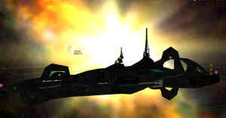
In June 2070 the initial design for the first M-049 version of the Benchford Constellation was brought forward. This was to be a completely different starliner than models preceding her. At the time, the most successful starliners in service were the JDC 30 from Da Trang and the BJU 52 from Allied. Both models, although revolutionary at their time, were relatively short-range starliners that could not give passenger ships a run for their money in Great Void crossings. What was needed was a larger craft that was capable of crossing the Void at a high rate of speed and with a comfort level that would draw people away from the old stately large engine ships.
What was envisioned was a three-engine transport, capable of 300gu. This transport should be shielded to allow the ship to fly in the relative safety of higher tachyon frequencies (beyond the effect of the regular storms of the Great Void) without the need for cabin pressure dumps or extreme contaminant shielding. The Constellation would fly at frequencies that would cause lesser vessels to tear themselves apart within a few minutes.
What was designed was truly beautiful. The starship was a phenomenal 95gu long. The hull was inspired by another Benchford starship, the FP-38. Other touches included a three-engine tail housing, which was used to give the Constellation access to existing shipyards, which would have been too small if the Constellation had retained a standard single above mounted engine. Power would be provided by Hergstrom-Overhouse Pulsar II’s, that eventually would generate 2,500 bmhp per engine.
Construction of the first model of the Constellation began in 2073. Unfortunately, the First Stellar Conflict put a hold on any production of the Constellation for civilian use. The model was to be converted for military use and the first model, the MC-69, was delivered to the UGTO in April of 2143. A total of 180 MC-69s were produced for the UGTO. Although greatly appreciated by the people who flew in her (especially when the flight included a trip over the stormy Great Void), the ship’s high cost in relation to the cheaper LC-47 (ADC-23) and its need for baked alloy, reinforced hanger mounts, limited its total use in FSC.
It wasn’t until after the conflict that the merits of the airframe became apparent. The end of the Second Stellar Conflict meant that there were literally thousands of shipyards all across the galaxy that could handle large, multiengine starships, also there was an excess of pilots with thousands of hours behind three-engine starships. People were ready to travel all over the galaxy and large engine ships were still relatively slow methods of getting there. Benchford easily converted the M-049 spaceframe, initially selling military models with minimal modifications, then updating the model to the M-649 and the M-0749. Each subsequent model superceded the previous with improved range, speed, and comfort.
The culmination of the design was in the M1049 and M-1649 models, known as Super Constellation and Mega-Starliner, respectively. These Constellations were stretched an extra 18.4 gu by the use of fuselage plugs in the fore portions of the ship. Engine power increased to 3205 bmhp. The 1049 model was flown by most major starlines, including TGA, KSM, Space Ross, and North Void Spacelines. The final version, the 1649 Starliner, redesigned the engine to increase range and to allow it to compete with other long-range spacecraft, like the ADC-27.
The advent of the ST class ships led to the downfall of the M class ships in commercial applications. Most of the M class ships were relegated to making runs in backwater systems. The endurance of the M class is apparent by how many of these starships are still in service in the Farstars today.
Notes:
UGTO, United Galactic Trade Organisation
ICC, Interstellar Cultural Confederation

Defender of Cephid
This is the personal account of Admiral Owen, at the time Ensign, and his lone successful defense of the Cephid system during the Third Colonies War against the K’Luth.
I’ve been sent to patrol the Cephid System, a remote backwater colony of the Confederation of Free Worlds. It doesn’t seem like much is going on around here, but I’m sure brass has its reasons.
A blip appears on my HUD, it’s coded yellow for unknown contact. Its probably just one of our ships, but to be safe I bring my A-2 Osprey interceptor up to speed and set my heading to intercept the contact. I get within 300 kilometers and the contact disappears. This is not good, immediately, I think, cloaking device. Supposedly only K’Luth ships possess cloaking technology, so I bring the reactive shields online and begin charging weapon systems and move in for a closer look. However, the contact doesn’t reappear. “I wonder if this is a probe for a larger K’Luth force”, but I dismiss the thought. It is very unlikely that a large K’Luth force would strike in this quadrant. It was probably a United Worlds surveillance craft doing a fly by, or more likely a smuggler.
I set my course back to the core of the Cephid star system. The unknown contact appears again inside the system. I think, “either the radar system needs an overhaul, or this ship slipped past me cloaked.” The elusive contact is now in orbit around Cephid II, a populated terran world, and also the location of Camp Schwartzkopff, one of five basic training Marine Corps stations. I bring my interceptor up to full thrust and close on the intruder. However, the ship evades contact, and breaks orbit and jumps out before I can close within strike range.
Certain this was a enemy probe, I send a subspace transmission to the flagship, “Cephid has most likely been scanned by an unidentified contact, attack possible.” Hopefully help will arrive soon; there is no way I can stop anything more than a couple of scouts without support. I short-jump to the system core, so I can defend the system from any direction.
It doesn’t take long before four new contacts appear just outside the system. My pulse begins to race as I kick in the interceptor’s afterburner to get the contacts into IFF sensor range. Moments later, the IFF scanner detects that there is a squadron of scavenger class K’Luth space bombers armed with 12,000 pound bio-plasm cluster bombs that wreak massive destruction streaking on a course towards Cephid II.
“Damn, K’Luth bombers!”
I send an emergency transmission to fleet command and all vessels in the area. This force was sent to shatter Cephid II defenses. Fleet “pings” back to me shortly thereafter saying, “The main body of the fleet has just encountered a large K’Luth armada heading towards the Howard system and we are on an intercept trajectory with the enemy force. The Howard system is a strategic key to holding the K’Luth presence at bay in addition to being a free trade route link way. Fleet then ended the message saying they would try to send a support wing to assist ASAP. ETA ten minutes...
“ETA is ten damn minutes! “This isn’t going to be pretty”, I sighed.
I increase my velocity to maximum thrust and set off to intercept the K’Luth bombers. The bombers have already begun their attack run, but they are too far out to release when I close in on weapons range. I unleash a spread of four fusion torpedoes at the lead bomber, it attempts evasive maneuvers, but with a six ton bomb hanging off the underbelly, the maneuver is futile. Two torpedoes slam into the fuselage, and the ship erupts in a brilliant green flare, which also engulfs another bomber.
The other two scavengers manage to slip past my salvo returning fire. The space around me is ripping with glowing ribbons of anti-spacecraft plasma bolts. I begin evasive action as adrenaline surges through my system. I close quickly, but they are already breaking off. My warning sensors blare to life, signifying that the two remaining K’Luth craft have just released their lethal payload, and then change course, heading away from Cephid II.
I thought, “I must try to take the bombs out before they impact.” They take priority over destroying the two remaining K’Luth bombers, so I break engagement from the two fleeing craft and target the bio-bombs.
“ Where the hell are the reinforcements!” I scream. I target my particle cannon and fire a three-bolt burst at the bombs managing to take one out, but the other bomb descends into the atmosphere of Cephid II. I stare at the planet for what seems like forever hoping a sub orbital defense satellite zaps it out of the stratosphere before it can cause any significant damage, but moments later I see several rolling, ominous, bright yellow green shockwaves ripple over the surface of the planet.
I quickly bring up the status of Cephid II, half of it’s defense network is down and the casualty rate will probably be astronomical. The bombers have done their job.
I send another urgent message to the flagship, “Cephid II hit with Space to Ground heavy bio munitions, I repeat, Cephid II hit with Bio weapons. The defense network is crippled, major population centers destroyed. I say again, Cephid II is crippled, situation critical !” The flagship soon responds with “Support element en route, ETA six minutes, hold on as long as you can.”
Minutes later, four more enemy contacts appear on my HUD, two “mussel” transports and two “widow” class escorts. A sense of dread washes over me, as I know these escorts outclass my ship. The only hope is to delay the invasion until help arrives, so I bring my ship to full throttle and set a course running perpendicular to the invaders vector. I begin laying EMP proximity mines on their course heading hoping to disable the invading force, which apparently got their attention because both escorts broke from formation in pursuit.
My little diversion seems to be working, the transports are forced to change their heading, and the “widows” break formation and head towards my position. The lead escort launches a “Hellhound” ion emissions guided missile. Fortunately, the Cephid system is also inhabited with nebulas; a natural ECM and safe cover from the most energy and guided weapons. I fly into the nebula, and power down the particle cannon and torpedo tubes offline. The “Hellhound” guidance systems go haywire when it enters the nebula and is rendered ineffective tumbling through gaseous space away from me.
“Whew, that was close”, I croaked.
They follow me into the nebula, bad mistake on their part. I bring my Gauss cannon online, an outdated weapon that propels magnetically charged depleted uranium alloy rods at supersonic speed, and very effective inside nebulas. I turn hard directly into the escorts, they attempt to fire but their energy weapons ignite the gases and short out the weapons systems. I lock the gauss cannon on the bridge of the first unfortunate escort and take out the command and control center.
“That should keep him busy for a while.” I growled.
The second escort realizes what is happening and attempts to accelerate out of the nebula, but I fall in right behind it and pepper the engines hoping to penetrate the buffer plate and puncture the core. Soon I see the telltale signs of escort’s engine core overloading with trails of ionized particles streaming out of the riddled engines.
“I hope that buys me enough time”, I whisper, as I emerge from the nebula and reactivate all weapon systems.
The transports have navigated around the EMP minefield, and heading directly towards Cephid II. “I would love to see the look on those squids’ faces as I came barreling out of the nebula without the escorts in pursuit.”
I’m on them well before they orbit Cephid II, lining the lead transport up for a torpedo straight up its six. The transports immediately engage in evasive maneuvers and vector back home. It’s a good thing, because I emptied all of the rods on the escorts, the particle cannon was still in flux from flying through the nebula, and I only had two torpedoes left in the tubes.
I breathe a sigh of relief, and “ping” fleet, “ Two legless widows at sector 21 and I sent the buses back home, I repeat, the buses are going home.” Three CFW cruisers warp in shortly thereafter and mop up the escorts.
My comm. console flickers on and I receive an official subspace transmission from HQ that I’ve been promoted to Wing leader and I will be upgraded to the new Banshee class tactical interceptor. Despite that, I’ll stick with this old Osprey for a while, it has served me well.

