Dashboard Design

Date | 19 September 2026
Team ID | MCA
Project Name | Online learning Education and Student Performance Analysis
Maximum Marks | 5 Marks

Creating an effective dashboard involves thoughtful design to ensure that the presented information is clear, relevant, and easily understandable for the intended audience. Here are some key principles and best practices for dashboard design.
Activity 1: Interactive and visually appealing dashboards
Creating interactive and visually appealing dashboards involves a combination of thoughtful design, effective use of visual elements, and the incorporation of interactive features. Here are some tips to help you design dashboards that are both visually appealing and engaging for users, so take care of the below points:
- Clear and Intuitive Layout
- Use Appropriate Visualizations
- Colour and Theming
- Interactive Filters and Slicers
- Drill-Down Capabilities
- Responsive Design
- Custom Visuals and Icons
- Use of Infographics
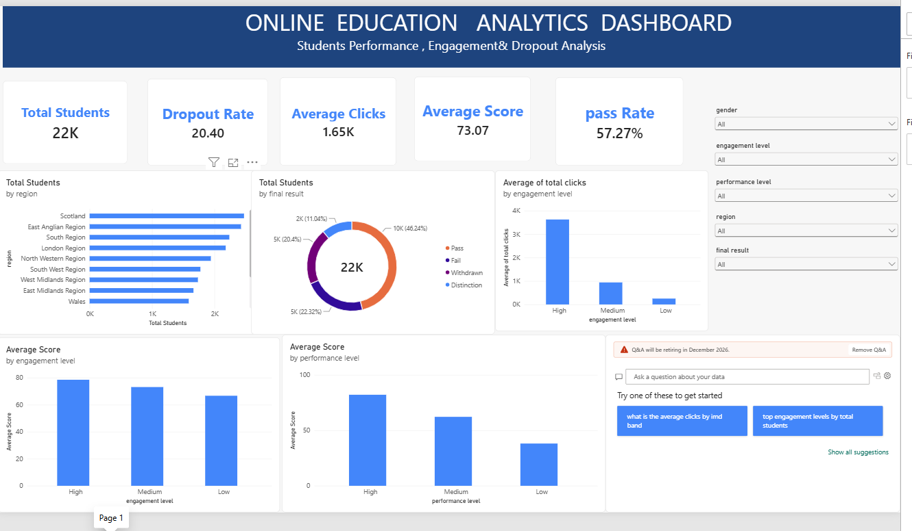

Sample
Here are six key outcomes from the Online Education Analytics dashboard shown above, covering student engagement and performance:
- Overall Scale and Retention Risk: The dashboard tracks 22K enrolled students with a dropout rate of 20.40%, meaning roughly one in five learners disengage before completing their course — flagging retention as a priority area for intervention.
- Final Result Distribution: Of all students, 46.24% achieved a Pass, 22.32% Failed, 20.4% Withdrew and 11.04% earned Distinction. Combined, Fail and Withdrawn outcomes account for over 42% of students, reinforcing the dropout concern seen above.
- Engagement Drives Performance: Students with High engagement generate close to 4K average clicks and the highest average scores, while Low-engagement students click under 1K times on average and score noticeably lower — a clear positive link between platform activity and academic outcome.
- Regional Enrolment Variation: Scotland and the East Anglian Region report the highest student counts, while Wales and the East Midlands Region show the smallest cohorts, indicating uneven regional reach that could guide targeted enrolment or support campaigns.
- Score Gaps by Performance Band: Average score declines steadily from the Distinction band down to the Fail band, and the same pattern repeats across engagement levels — together these confirm that consistent participation is the strongest visible driver of the 73.07 overall average score.
- Moderate Pass Rate Signals Room for Support: With an overall Pass Rate of 57.27%, less than two-thirds of students are passing outright, suggesting that early-warning triggers based on clicks and engagement level could help advisors identify at-risk students before they withdraw.

