1.Call Api {{baseURL}}/video/screenshot

2. An Error occurred   
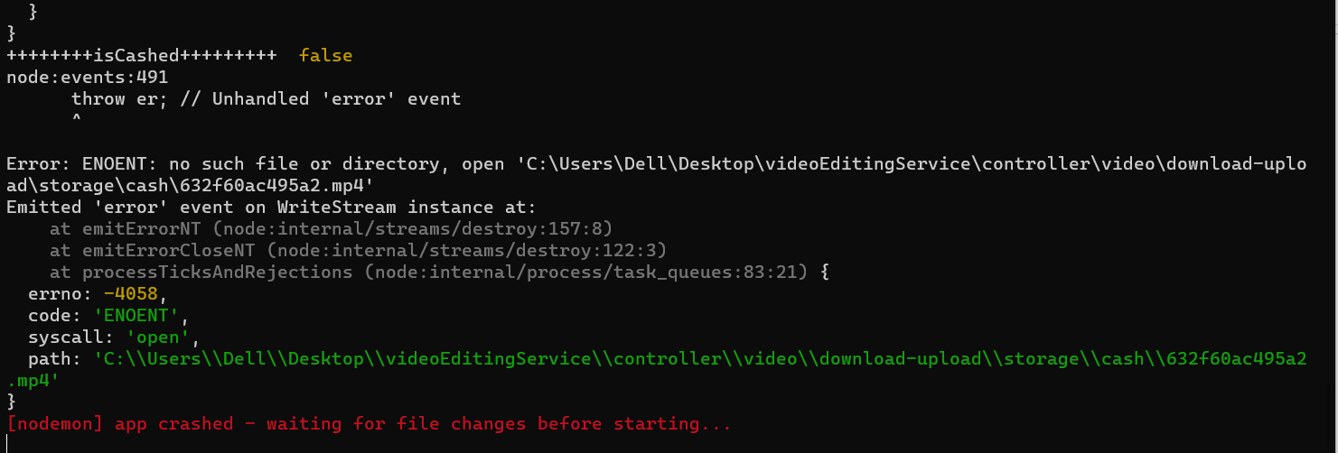which means that the video can't be downloaded to backend (Fixed)  
3. Didn’t Cash the Video After download (Fixed)

4. An Error occurred with the use of Library or the library it self   
