sSe

**SHIV SHAKTI ENTERPRISES**

**Guru Govid Singh Marg, Guru Nanak Nagar ,**

**Ghatkopar (W), Mumbai-400086**

 +91-9867246017

**+91-22-25021185**

**Email: support@shivshaktienterprises.co.in**

**Web: www.shivshaktienterprises.co.in**

**COMPANY PROFILE:**

The company Shiv Shakti Enterprises was established in 2011 serving the Industry with the proven record, based in Mumbai, India. SSE is a unique systems integrator and turnkey contractor offering out-of-the-box solutions in Integrated Building Management Systems. Our competent teams of engineering professionals use collective industry expertise to specify requirements, confirm business benefits and deliver on time and on budget.

**PROJECTS:**

Our proven approach to project management quantifies business benefits, reduces risk of failure and maximizes business results. We, at SSE offer a highly reliable, intelligent, value engineered, complete and integrated security system covering every aspect of building automation and security. The system comprises of several automation solutions: Building Automation System, Fire Detection System, Access Control, CCTV, public announcement system and Rodent Repellent System and so on…

**OUR QUALITY SERVICE ON EVERY VISIT:**

At SSE we are committed to uphold the highest level of service and installation in the industry, all backed by our 100% Customer Satisfaction Guarantee. From our 24/7 emergency services to routine care, you can always depend on us to answer your call personally and our technicians to arrive promptly. Our professional technicians are licensed by the Board of technical education which certifies them to solve all problems of comfort equipment for different brands. We believe in maintaining respect for You & Your Company / Office and treat your company/office as if they are our own. We always listen closely, communicate clearly and value your opinions. We ensure that it will be Always Easy to Work with us. Whether it's flexible payment options, convenient scheduling or personalized customer service, we guarantee our commitment.

**PREVENTIVE MAITENANCE:**

Our mission is to do "Whatever It Takes" to provide the best possible service through our Comprehensive preventative system maintenance and replacement program. This industry-changing Program provides our commercial customers with lower operating costs, reduced service calls, and helps to extend the life of the equipment. It's a worry-free planned replacement program that ensures the Safety, heating and cooling in your building is always reliable and energy-efficient.

**PROJECT MANAGEMENT:**

The key to success for any Integrated Building Automation Contracting company is responsive and effective Project Management. Our Project Management Team comprises of: Execution Department: Design Team, Installation/ Execution Team & Commissioning Team Commercial and Accounts Department With years of practical and extensive experience in executing projects of varying complexity and magnitude, our project management team identifies project objectives and maximizes business results by employing the following techniques:

• Reviewing Contracts.

• Scheduling project activities using bar charts and ensuring smooth & timely execution.

• Conducting regular goods inspection and testing.

• Conducting weekly site progress review meetings.

• Maintaining excellent documentation and drawings.

• Effective co-ordination with all concerned agencies at site.

• Stringent checks on contractor workmanship and time schedule.

**Services Offered by M/s Shiv Shakti Enterprises:**

**Electrical & Low Voltage Contractor**

**(Installation, Commissioning and Programming)**

1. Fire Alarm System (FAS)

2. Public Address System (PAS)

3. Fire Protection System (Hydrant & Sprinkler)

4. Fire Suppression System (FM-200, CO2 & Other)

5. Rodent System

6. Access Control System

7. CCTV System

8. Alarm Communicator system

9. Intrusion System

10. Video Door phone

**Service Available: Allahabad *Bhopal *Jaipur * Lucknow* Mumbai *New Delhi* Patna*Pune**

**FIRE ALARM & PROTECTION SYSTEM:**

A Fire Alarm System is a set of Electric/Electronic device/equipment working together to detect and alert people through visual and audio appliances when smoke/Fire is present. These alarms may be activated from smoke detectors, heat detectors, water flow sensors, which are automatic or from a manual fire alarm pull station.

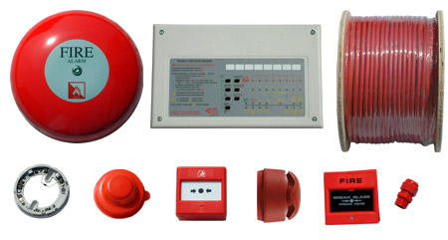

**FIRE PROTECTION SYSTEM:**

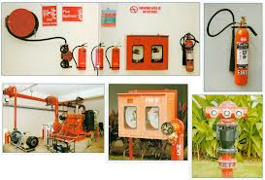 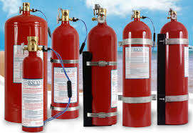

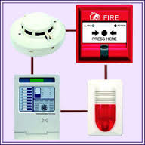 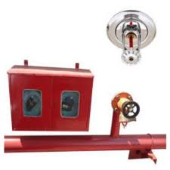

**CCTV SYSTEM:**

CCTV equipment may be used to observe parts of a process from a central control room, for example when the environment is not suitable for humans. CCTV systems may operate continuously or only as required to monitor a particular event. A more advanced form of CCTV, utilizing [digital video recorders](http://en.wikipedia.org/wiki/Digital_video_recorders) (DVRs), provides recording for possibly many years, with a variety of quality and performance options and extra features (such as [motion detection](http://en.wikipedia.org/wiki/Motion_detection) and email alerts). More recently, decentralized [IP cameras](http://en.wikipedia.org/wiki/IP_camera), some equipped with megapixel sensors, support recording directly to [network-attached storage](http://en.wikipedia.org/wiki/Network-attached_storage) devices, or internal flash for completely stand-alone operation. [Surveillance](http://en.wikipedia.org/wiki/Surveillance) of the public using CCTV is particularly common in many areas around the world. In recent years, the use of [body worn video](http://en.wikipedia.org/wiki/Body_worn_video) cameras has been introduced as a new form of surveillance.

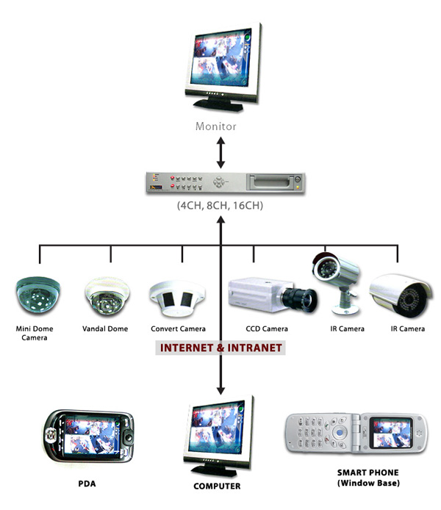

**ACCESS CONTROL SYSTEM:**

Access Control system is physical or electronics systems which are designed to control who has access to premises. The simplest example of a physical access control system is a door which can be locked, limiting people to on e side of the door or the other. Strong sturdy doors with good lock is the front line defence against break-in. however, no matter how good the lockset, how sturdy the door, its greatest weakness is lies in the way we manage the distribution and allocation of keys.

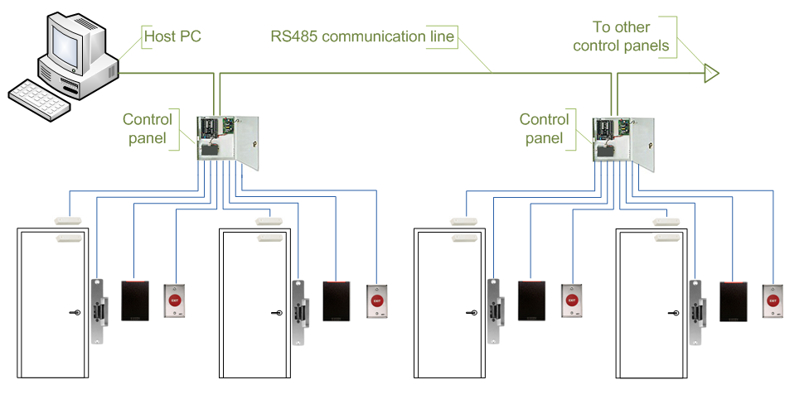

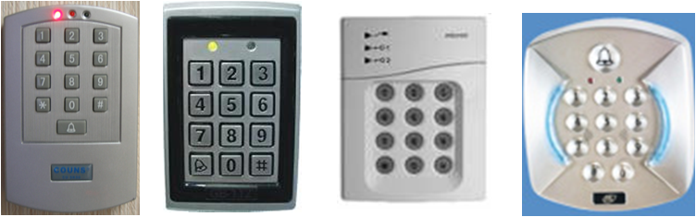

**BIOMETRIC ATTENDANCE SYSTEM:**

Biometric identifiers are the distinctive, measurable characteristics used to label and describe individuals. Biometric identifiers are often categorized as: Physiological versus behavioral characteristics.

Physiological characteristics are related to the shape of the body. Examples include. But are not limited to fingerprint, face recognition, DNA, palm print, hand geometry, iris recognition and retina,

Behavioral characteristics are related to the pattern of behavior of a person, including but not limited to typing rhythm, gait and voice.

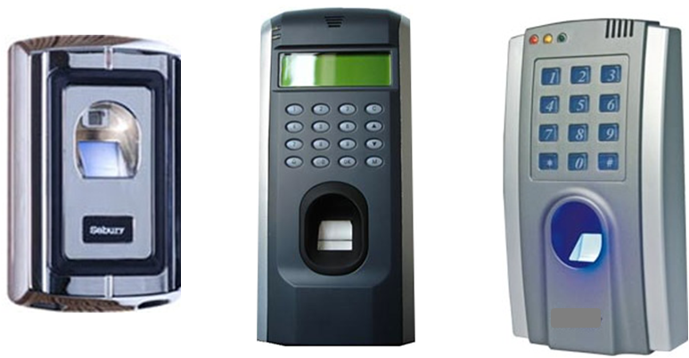

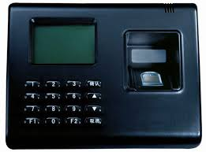

**INTRUSION DETECTION SYSTEM:**

An intrusion detection system is a device or software application that monitors networks or system activities for malicious activities or policy violations and produces reports to a management station. IDS come in a variety of flavors and approach the goal of detecting suspicious traffic in different ways.

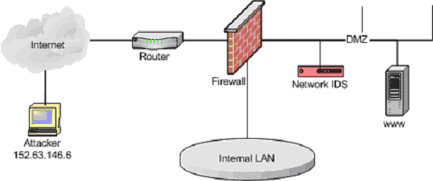

**PUBLIC ADDRESS SYSTEM:**

A public address system (PA system) is an electronic sound amplification and distribution system with a microphone amplifier and loudspeaker, used to allow a person to address a large public, for announcements of movement at large and noisy air and rail terminals.

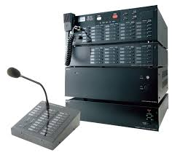 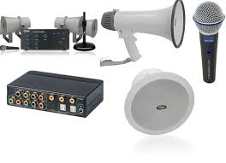 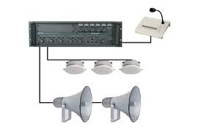

**RODENT SYSTEM:**

Electronic Rat Control System is a high technology electronic device like transmitter andemits high frequency sound called ultrasonic sound. Ultrasonic sound waves have frequency, above 20 KHz, which is the upper limit of the hearing range of the human ear. The powerful ultrasonic sound waves hit the eardrums of rats. As the rats do not have the ability to close their ear, they have to listen to the sound waves, causing pain, fear and anxiety and enabling them to leave the place

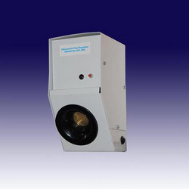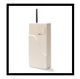

RODENT SYSTEM ALARM COMMUNICATOR SYSTEM

**VIDEO DOOR PHONE:**

Video door Phone that not only allows you to see who’s at door, but also enables to communicate with the visitor before you open the door. The indoor monitor can be easily installed anywhere in the house, giving you the convenience of viewing the visitors, unlocking the door and viewing any suspicious activity- All at the press of a button , without having to walk up to the door.

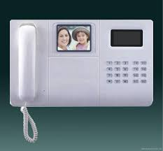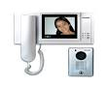

* **Electical Cabling**
* **Skilled and un-skilled workman supply**