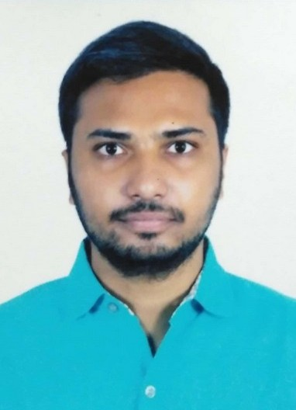HIMANSHU SHEKHAR

Location: Mumbai

[palhimanshu786@gmail.com](mailto:palhimanshu786@gmail.com) | +91-9112811563 Portfolio: [https://himanshu-shekhar.in](https://himanshu-shekhar.in/)

Github ID: https://github.com/palhiman

Stackoverflow ID:

|  |
| --- |
| <https://stackoverflow.com/users/4319416/himanshu-shekhar> |

Available: Immediate

# PROFILE SUMMARY

* Computer Science Engineering Graduate
* Good knowledge of Project Management Life Cycle.
* Hands on experience in scripting language i.e. Python3 and Bash shell.
* Experience in web application, web hosting.
* Well versed in SQL Database Management.
* Good understanding of Version Control System.

# TECHNICAL SKILLS

* Database management: **MySql, SQLite**
* Programming Languages: **Python3, C/C++**, Bash shell.
* Operating System: **Linux(Ubuntu 16.04+)**, Windows.
* Frameworks: **Django, Codeigniter4**.
* Web Technology: **HTML5, CSS3**, Bootstrap.
* Project Management Tool : Altassian
* Version Control System : **Git (Github)**.

# EDUCATION

***B.E. in Computer Engineering***

K.K.Wagh Institute of Engineering & Research, Nashik, MH,IN. **Modules**: Data Structure, Computer Networks, Object Oriented Programming, Operating Systems, Computer Graphics, Software Engineering, Embedded Operating Systems, Data Mining, Software Design & Testing, High Performance Computing, Information & Cyber Security.

Final Year Project:

* Image Processing: Developed a project on Inpainting of Degraded Document Image. Ostu’s Thresholding method was used to obtain the final binarized image.
* Deep Learning : A Deep Neural Network model was created to learn and enhance the final binarized image.

# EXPERIENCE

* Company : World Class Services Pvt. Ltd. Position : Junior Consultant (IT).

Period : Aug-2021 to Till date.

Work Profile : Currently I am working with Directorate of Census Operations, Maharashtra, a central government body on contract basis. My job profile includes a wide range of tasks from handling various kinds of demographic data to developing small applications as required by the department. Currently our team is working on developing a web application called Asset Management System.

Hands-on training with ***STATA software*** (Statistical Software)

# CERTIFICATIONS

* Completed Certificate of Continuing Education Completion in

**Cryptography** from Cybrary.it

* Completed Certificate of Continuing Education Completion in

**CompTIA Linux+** from Cybrary.it

* Micro-Certification in **TCP/IP** from Cybrary.it
* Micro-Certification in **Subnet** from Cybrary.it
* Certificate of Completion in **HTML an CSS fundamentals**.
* Certificate of Completion in **Building a Quiz App using HTML, CSS and Javascript**.
* Certificate of Completion in **Basics of Linux Shell**.
* Certificate of Completion in **Git started with Github** (version control system).

LANGUAGES

* English (Fluent written & oral)
* Hindi