Fast Travel

This system is intended to allow PCs to quickly travel in an *expedition* from a home base to an area on a map where they can have an “adventure”. The concept is to reduce travel time to a 10min game time montage that allows more time for players at the table to play the main part of a campaign.

The Expedition

Before embarking on an outgoing expedition, each companion in the travelling party will need to have ***s upplies*** and the party will need to have a ***destination*** in mind. They will all face ***hardships*** on the journey that will influence the difficulty of the ***skill test*** they are working on while travelling.

***Supplies*** can be used on the journey to help negate ***hardships*** and results of the parties ***skill tests*** will be combined to determine how successful the expedition turned out to be.

Supplies

***Supplies*** represent how prepared the adventurer is for the travel ahead. It encompases rations, water and any specialist equipment needed for the journey.

These are used to off-set any ***h ardships*** a character might endure during the expedition.

Each character can only start a journey with a maximum number of ***s upplies*** equal to their **Strength** stat.

***Supplies*** can be purchased within a town for 1sp each.

Example

Ghorthak the Skarlish fighter has a strength of 19, therefore has a maximum supply level of 19. Kilix the Kinling rogue however has a strength of 11, therefore is only able to carry a maximum of 11 supplies.

Extra Supplies

When an expedition ends successfully, each of the traveling party gains a number of ***s upplies*** equal to the ***expedition total****.* This may result in a character having more ***supplies*** than they can travel with, then the excess can either be distributed to other members of the party or sold.

A town will buy extra ***s upplies*** for 1sp each. If there is no-one at the end of a journey available to buy these, they have to be abandoned.

Abandoned ***s upplies*** have a chance to remain in the area to be collected on future expeditions, but will deteriorate over time.

Out of supplies

When an expedition fails, each of the traveling party will lose a number of supplies equal to the ***expedition total.*** This can result in a character having zero or fewer ***supplies****.* If this is the case they will suffer 1 level of *exhaustion.*

Other members of the party may distribute their own ***supplies*** *to* characters who have used all of theirs. This will only negate the *exhaustion* if it brings their ***supplies***to a positive number.

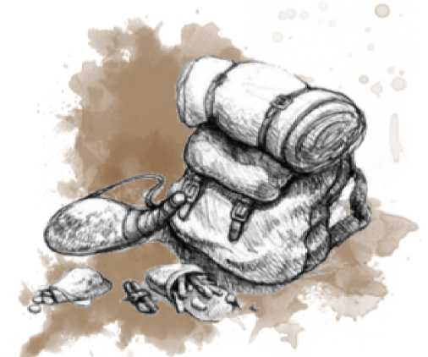

If a character's ***supplies*** drop below what they can endure (negative their **Constitution** stat.) they will suffer an additional point of *exhaustion.*

Example

Kilix started the journey with full rations but used most of them on the journey . The expedition ended poorly which used the last of Kilix’s rations.

Ghorthak both started with more rations, rolled better on his hardships, and succeeded in foraging, so ended the expedition with additional rations.

Showing some compassion rare to the Sharlish he throws a couple of rations to Kilix.

Hardship

The ***h ardship*** represents how difficult the expedition will be for those travelling. This is determined by the ***travel distance*** (measured in squares), any dangers on the route and is modified by any difficulties the party members get into along the way.

Each character will later determine what they were doing to aid in the expedition and a relevant ***skill test*** will be rolled. The target difficulty of this is the group ***h ardship.***

Group Hardship

The number of squares that the party travels through between the starting point and the *destination* will give a ***travel distance****.*

* Each square travelled through that contains a danger or particularly difficult terrain will increase the ***travel distance*** by 1. (Determined by the GM)
* Each travelling companion who begins the journey with no ***supplies*** will increase the relative ***travel distance*** by 1.
* Each travelling companion who has never been to the *destination* before will increase the relative ***travel distance*** by 1

If the ***travel distance*** is less than 3, then the expedition automatically succeeds at the cost of 1 supply per party member and the expedition ends without ***h ardship*** rolls, ***skill challenges*** or *rewerds.*

Example

Ghorthak, Kilix, Roghan, Grundel and Eldinwynd want to travel to the *broken tower* that three of them discovered on their previous expedition lying north of the *forest edge.*

The GM decides that this is 8 squares worth of travel and has only 1 square of danger they need to pass through. However Roghan and Eldinwynd have never journeyed beyond the *forest edge* before.

The GM informs the party that the **travel distance** will be 11

Each player makes a ***hardship roll*** by rolling a number of D6 equal to the ***travel distance****,* maxing out at 10.

* The starting group ***hardship*** equals the ***travel distance****.*
* Each roll of 1 will increase the group ***h ardship*** by 1
* Every ***travel distance*** over 10 counts as an automatic roll of 1 for every character.
* A character can negate a 1 rolled on their own ***h ardship roll*** by using one of their ***supplies****.*

As noted above, the group ***h ardship*** takes the initial ***hardship*** and adds 1 for every 1 not negated by the characters in the party.

Example

Each player rolls 10 D6 for their hardship roll and takes an automatic 1:

* Ghorthak 6,2>6>5>4>5>6>3>6>**2** <- 2 replaced by a 1
* Kilix **1**,**1,**5,3,**1**,6,5,**1,**4,**1**
* Roghan 6,4,**1**,**1**,3,3,5,**1**,2,3
* Grundel **1**,4,4,3,5,6,5,2,**1**,5
* Eldinwynd 3,2,2,2,5,4,**1**,3,**1**,2

Each character agrees to expend 2 rations to negate their automatic 1 and a rolled 1 in their hardship rolls (Ghorthax only needs to spend 1). Kilix had a particularly bad time on this journey and decides to expend another 3 rations (total 5) to keep the hardship down.

Skill Challenge

Once the ***h ardship*** of the expedition has been set, the party will then enter into a group ***skill challenge****,* taking turns to select a skill and rolling against the ***hardship****.* Each success gets the party closer to their destination, whilst each failure represents a difficulty encountered along the way.

Once a character has used a specific *skill* in their ***skill challenge****,* any other characters wishing to use the same *skill* will suffer a +5 ***hardship*** penalty that cannot be off-set with ***supplies****.* This is cumulative and affects individual skill challenges too.

While traveling almost every task is a “Survival” skill check - this ***skill challenge*** should be considered to be using a crossover *skill* in conjunction with it. The use of *skills* in creative ways should be encouraged to accomplish the task.

Any character who is proficient in the “Survival” *skill* can reduce their own ***h ardship*** by 1 on any task.

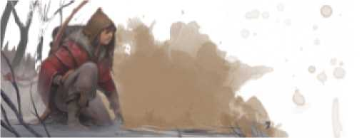

Individual Hardship

If a character is engaged in a task that does not aid the party during the expedition, they suffer an individual penalty to their ***h ardship****.*

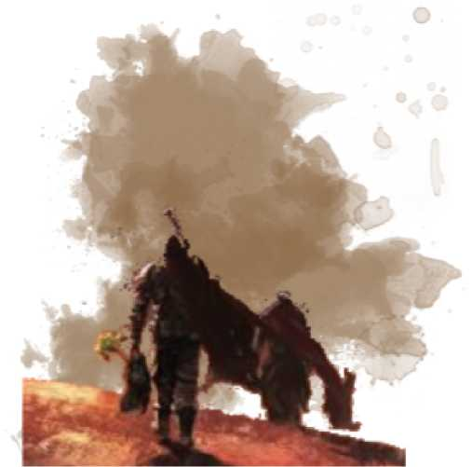This can be off-set by the character expending their own ***supplies*** *to* reduce the penalty.

Roghan’s last hardship he didn’t negate takes the group hardship to 12

Individual tasks

* Scavenging for stuff they can use or sell at the next settlement
* Looking after a ward, captive or untrained ani mal
* Carrying a heavy load, body, or additional ***supplies*** (up to STR)
* Focused on crafting or repairing an individual item
* Researching a subject, composing a song or drawing pictures

| +5 | Easy | Common | Average |
| --- | --- | --- | --- |
| +10 | Standard | Uncommon | Good |
| +15 | Difficult | Rare | Excellent |

The individual hardship penalty will be determined by the level of difficulty, or scarcity of the resource or quality of work the character is trying to accomplish:

**Penty Difficulty Scarcity Quality**

This penalty can be reduced by 1 for each ***s upply*** that a character spends. (A character cannot accept ***s upplies*** from any other party member for this purpose.)

The *skills* are used in exactly the same way as group ***skill challenges*** with the same +5 penalty if you are using a previously used skill.

The outcome of an individual ***skill challenge*** will have the same effect as a group one on the expedition total.

Example

Kilix has a map of the tower they will be visiting and the party have agreed that he can spend the journey studying it so that they will have advantage on any investigation skill checks within it. As such the GM assigns it an ‘easy’ difficulty and gives a +5 to his hardship when rolling for his skill challenge (12+5 = 17).

Kilix only has 6 rations left and decides to spend 5 of them to off-set this completely, reducing the hardship from 17 back down to 12.

Ghorthak wants to range out from the party to find some *resources* that will sell well back at the town. He decides to look for “good” quality *resources* giving him a +10 to his personal hardship making it a 22.

He is confident in his skill and has only spent 1 supply so far, leaving him with 18. He will use another 8 to negate his penalty bringing the hardship down from 22 to 14. (Leaving him with 10 supplies remaining.)

A character's ***skill challenge*** relates to their experience during the whole journey: any spells or magic effects that expire before the completion of the expedition will not have an effect on these rolls.

Example

Ghorthak will spend the journey using his **Survival** skills to hunt in the wilds for some precious *resources.*

Roll: 19 Proficiency: +3 Stat: +1 TOTAL: 23

Kilix will spend the journey examining his map with an **Investigation** skill.

Roll: 3 Proficiency: +3 Stat: +3 TOTAL: 9

Roghan will spend the journey scouting ahead and watching for any troubles on the trail using his **Perception**skill.

Roll: 5 Proficiency: +3 Stat: +3 TOTAL: 11

Grundel will spend the journey hunting with her **short bow** for deer or perhaps some smaller game she can carry .

Roll: 1 Proficiency: +5 Stat: +4 TOTAL: 1

Eldinwynd will use **Arcana** to manipulate his mage-hand and other cantrips to setup/break camp and maintain equipment during every rest..

Roll: 14 Proficiency: +3 Stat: +3 TOTAL: 20

Expedition total

Each character rolling a successful ***skill challenge*** will increase the ***expedition total*** by 1. (+2 for a critical.)

Each character failing in their ***skill challenge*** decreases the ***expedition total*** by 1. (-2 for a fumble.)

Example

Ghorthak got a 23 on their skill challenge with a -1 on the hardship giving him a target DC of11: Success. **Expedition total = +1**

Kilix got a 9 on his target DC of 12, failing to learn the map

**Expedition total = 0**

Roghan failed his group skill challenge : **Expedition total = -1**

Grundel fumbled his challenge for two fails:

Eldinwynd succeed on his skill challenge:

**Expedition total = -3**

**Expedition total = -2**

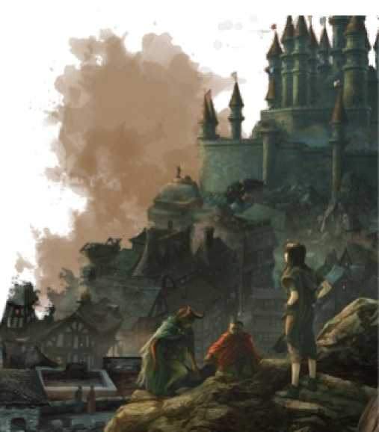Expedition End

Each character in the traveling party adjusts their ***s upplies*** up or down in accordance with the ***expedition total****.* (Players should also ensure that any supplies used by their characters during the journey are accounted for.)

The ***expedition total*** is then compared to the table below to determine how the expedition ended:

* 3 Party find a *treasure* on the journey

**Expedition  
Total**

**Result**

* 2 Party recovered all the supplies used during the journey.
* 1 Party find a *shortcut* and complete the journey as if 1 square shorter 0 Party complete the journey
* 1 Party get *waylaid* and complete the journey as if 1 square longer
* 2 Party get *missdirected* and end in a square adjacent to destination
* 3 Party have to *turn back* during journey, ending at starti ng location
* 4 Party become *lost* and have to journey again immediately, The negative expedition total translates to automatic 1’s on hardships.

Example

Ghorthak started with 19 *supplies,* used 1 to offset his hardship roll and another 8 to reduce his personal hardship. The journey cost another 2 reducing his supplies to 8 for his returning journey, but he does have some *resources* that he can sell when they get back to civilisation.

Kilix started with 11 *supplies,* used 5 to offset some poor hardship rolls and spent another 5 to offset some studying penalties. This leaves him with 1 to start the return journey with.

Roghan, Grundel and Eldwynd all spent 2 *supplies* on their hardship rolls and the journey cost them 2 more.

On an ***expedition total*** of -2, the party ends their journey in a square adjacent to the tower they were aiming for. They have never been here before... let us hope that it’s safe..

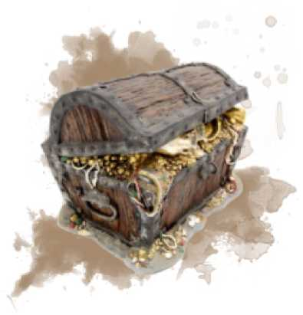Rewards

The higher the success of an expedition, the more value the rewarded *treasure* should hold, however the value of a *treasure* is not normally measured in gold. (Although it could probably be traded if the party are strapped for cash and are able to find the right person to buy it.)

It is possible for the party to find *resources* or items of equivalent gold value along with the *treasure,* depending on its nature and potential future benefit.

The below table is a guideline for GM inspiration and is intended to be scaled to match the level of success.

**D10 Treasure**

1. *Monster*: The party had a relatively easy encounter on the journey

and gained additional XP at the end of the Expedition.

1. *Map:* The party found information that enables them to have prior knowledge of/to a location they have not yet visited.

*Clue:* The party found a fragment of information that will confirm 3 / rule out a theory that they have about the surrounding

area.

*NPC:* An NPC (or creature) interrupted their expedition with news or supplies or a warning of a near-by danger.

*Back-story:* The party came across something that only has relevance to one of the people travelling in the party.

1. *Magic:* The party experienced a “wild magic” event during the

journey that changed something of the party/equipment.

*Lead:* The party found a piece of information that could lead them to a physical treasure or magic item.

1. *Horde:* The party discovered a *resourcethat* can be traded in the next settlement. (see below or DMG for appropriate horde)

*LocalKnowledge:Each* member of the party can reduce their individual hardship by 1 on their next expedition.

10 *Trail:* One of the squares travelled through has now been worn enough that it grants a -1 hardship to future expeditions.

If the party discover a valuable *resource* either while on an expedition or on completion of one, the GM can use the below as a guideline for its type and value:

**D10 Resource type**

1 Unusual stone or wood

1. Small animal pelts

**D10 Resource type**

6 Spell components

1. Cooking herbs or spices
2. Ripe berries , fruits or nuts
3. Shells, carapaces or scales
4. Unusual plant or flower
5. Animal bones and/or skull

5 Rope like vines or fibres

**GP Value** = group hardship x average party level

10 Shiney rock or crystal

Personal Rewards

If a character is attempting to create an item, look for a particular resource, or scavenge for something of worth, the below table can give an indication of the value that they can expect to fetch if they can find the right buyer.

**Penalty Equivalent value on successful skill challenge**

+5 Character level in gp

+10 Character level x 10 in gp

+15 Character level x 100 in gp

Note that the actual value of any resource is dependent on the demand for it. The roll determining the outcome of the ***skill challenge*** may also have an impact on the item created or the resource found. (All subject to GM approval).

(These values are intended to be relatively low compared to what a character could expect for dedicated down-time activities as the tasks are completed while traveling.)

Time

The ***travel time*** of an expedition is calculated by taking the ***travel distance*** and subtracting the ***xxpedition total****.* Remember to take into account any times the party had to re-travel a route or got lost.

The ***travel time*** represents the number of half-day's travel.

Normally an expedition will find camp and rest after a full day of travel: The number of **days** that the journey has taken is calculated by dividing the ***travel time*** by 2.

Hiking

Before an expedition begins the party can decide to travel quicker by going longer between rests, not taking as much time to forage and set up camp, and generally moving faster.

Personal skill ***challenges*** can only be done at a normal pace of travel.

Push

A party can decide to *p ush* their pace to try and reduce the length of an expedition at a cost of the journey becoming more dangerous.

* The group ***hardship*** will increase by the initial ***travel distance*** divided by 3.
* On conclusion of the expedition the actual number of **days** it took is calculated by dividing the ***travel time*** by 3

Forced March

A party can decide to travel at a *f orced march* to half the number of days the journey would take.

This will both make it more dangerous to travel and will end the expedition with each member of the party taking one point of *exhaustion.*

* The group ***h ardship*** will increase by the initial ***travel distance*** divided by 2.
* On conclusion of the expedition the actual number of **days** it took is calculated by dividing the ***travel time*** by 4

Fast Travel:

Going deeper

As a party explores the world and travels further from civilisation they will find themselves going on longer and longer journeys. These long expeditions (normally a week’s worth of travel or more) will develop almost impossible ***hardship*** levels that can use most of a party’s ***supplies*** *to* complete.

To explore beyond this boundary a party will either have to find *transport* or form a *way station.*

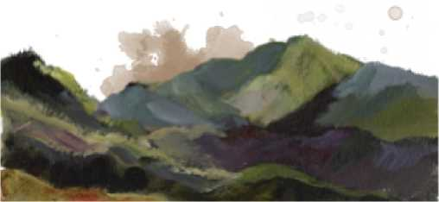

Transport

Characters in an expedition who are on separate *m ounts* or *vehicles* can use the same *skill* in a ***skill challenge*** without incurring the usual personal ***h ardship*** penalty of -5 if the *skill* relates to the *mounts* or *vehicles* they are traveling on.

The use of vehicles may not be viable to certain destinations without first establishing a *way station* or completing a *track* or *bridge* to improve travel through a specific area (square).

Mounts

The **travel distance** is halved if all travelling companions are *mounted,* or on/within a *aarriage,* or on a *chariot.*

Any/all characters will ride and take turns looking after the *mounts* as part of standard travel without requiring a dedicated skill test.

Pack animals

Each *pack animal* can carry twice it’s **strength** stat of ***supplies*** that can be used by any party member and travel at the same speed as the expedition.

Any/all characters will take turns looking after the animals as part of the travel without requiring a dedicated skill test.

The group ***hardship*** *is* increased by 1 for each *pack animal* within the expedition.

Carriages & Chariots

Travel within a *aarriage* will decrease the individual ***hardship*** by 5 for the characters within it.

A character driving a vehicle with passengers will only have to use their proficiency with *land vehicles* as a ***skill challenge*** if they are keeping pace with a mounted party.

Any/all characters will take turns looking after the *draught animals* as part of the travel without requiring a dedicated skill test.

Carts & Waggons

A *aart (or waggon)* can carry maximum ***supplies*** equal to five times the **strength** stat of the creature(s) pulling it.

Any character traveling on the back of a *a art* will displace a number of supplies equal to their **strength** stat, however their individual ***hardship*** will be reduced by 5.

Any/all characters will take turns driving a *aart* and looking after the *draught animals* as part of the travel without requiring a dedicated skill test.

The presence of a *aart* in an expedition will negate any deductions to **travel distance** and any dangers used in the **travel distance** calculation should be doubled.

The group ***h ardship*** *is* increased by 1 for each *a art* within the expedition.

Boats

Each square travelled by *boat* will only count as a half square for **travel distance** calculations. If over half the journey is by boat then the group ***hardship****is* reduced by 2.

A character piloting a *boat* with passengers will only have to use their proficiency with *water vehicles* as a ***skill challenge*** if they are traveling over half the journey by boat and they have no other pilot.

Sky ships & Magic

There is currently no known technology to enable flying vehicles - flying creatures tend to rip any prototypes out of the sky before progress can be made to develop them.

Individual flight spells and magic items that fly are used at the owners risk.

Teleportation circles are only for the magic users belonging to specific schools.

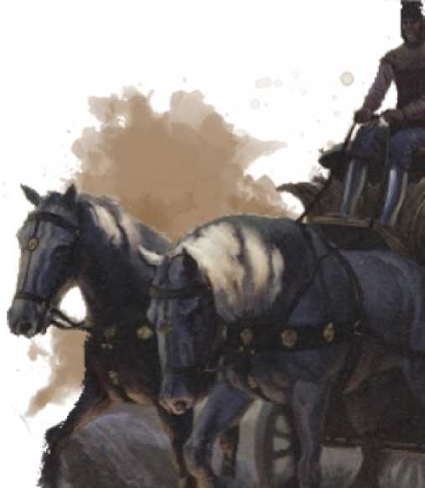

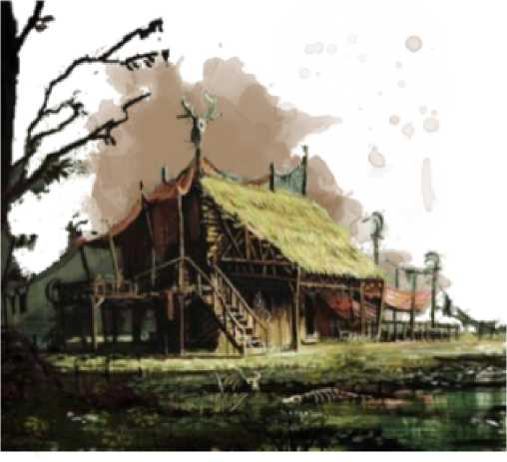

Way Stations

A party can invest ***supplies*** *to* create a *way station* in the form of a *supply dump, cabin* or *staging post* within a square they have previously visited.

Travel through a square with one of these in it will only count the ***travel distance*** from the *way station* to the **destination**.

Players' plans to form a *way station* should be discussed between several sessions with only the ***skill challenge*** taking place at the start of a session (before any other travel).

Way stations are formed in the wilderness with little protection from the surrounding dangers. A party visiting a *way station* that has previously been established can find that it has been *aaided,* ***supplies*** plundered, and dropped down a level.

The GM should determine this before any **travel distance** calculations; if the expedition decides to stop at a *aaided way station* and return to the starting point, then the expedition to this point is considered successful with an **expedition total** of zero.

To help prevent this the party can invest the **support** value of ***resources*** in it on each visit to upgrade the defenses of a *way station* (assuming there is still something to defend).

Abandoned ***s upplies*** left in the wilderness will deteriorate at the rate of 1 per day unless *aaided.*

Any ***supplies*** left in a *way station* will not deteriorate, but might be lost or depleted due to a ***aaid****.*

Way stations

|  |  |  |  |  |
| --- | --- | --- | --- | --- |
| **Lvl** | **Name** | **Establish** | **Support** | **Defense** |
| 0 | Abandoned supplies | 1 | 1 | - |
| 1 | Supply dump | 60 | 20 | 10 |
| 2 | Cabin | 300 | 50 | 15 |
| 3 | Staging post | 1000 | 200 | 19 |
| - | (Track/bridge) | 80 | 20 | 18 |

Supply Dump

A cave or sheltered area repurposed and secured where travellers deposit and retrieve supplies for onward journeys.

The *supply dump* will be hidden from casual discovery by a combination of natural location and a disguised or camouflaged entrance. This can be improved to give a maximum **defense** value of 15.

Cabin

A building or series of buildings with a well, log store, cooking fire pit and enough indoor beds to comfortably house 12 people.

The area around the *cabin* has a perimeter to keep most wild creatures from wandering into the area. This can be upgraded to give a maximum **defense** value of 19.

A *cabin* can be used as a base of operations.

Staging post

A large building that is manned with stables, rooms, a tap room, and serving hearty meals. The proprietor will be self-sufficient with a small garden and a few farmyard animals.

The party will have established this staging post and so are not expected to pay for room and board any time they are passing.

There are no effective upgrades that a party can invest in a staging post: if it was *aaided* then it would have been from an accident, disaster or powerful foe.

A party can trade at a *staging post* with most common items sold by the proprietor at 150% of the PHB prices and bought at 50% of the PHB.

A *stagingpost* can also be used as a safe place to rest and can be used as a base of operations.

Way Station Ski ll Challenges

After a party have gathered the ***establishing supplies i****n* the intended location of a *way station,* they are required to perform a ***skill challenge*** similar to an expedition in order to create it:

* The party decide on a character to perform a ***skill challenge***
* The character will decide on a task they can contribute towards constructi ng the way station and the *skill* they would like to use to execute it.
* The GM and party work together to establish a DC for the intended ***skill challenge*** (base of 15 +/- any modifiers)
* The ***skill challenge*** is rolled
* Success counts as +1 towards the completion of the *way station.* At +3 it has been completed.
* Failure reduces the ***supplies****by* the **support** value.

If the ***supplies*** drop below twice the **support** value then the ***skill challenge*** has failed and everyone heads back home again.

* The next character is chosen and the group ***skill challenge*** continues until the *way station* is created or ***supplies*** are diminished.

The same *skill* may be chosen by a different character for a ***skill challenge*** with a +5 modifier for each time it has been used before.

Other characters cannot use the “help” /”aid” actions and spells should be considered in the DC.rather than affecting the roll.

A character can perform additional *s****kill challenge****s* only after each other member of the party has been challenged.

A party may start the challenges with more ***supplies*** than required to **establish** a *way station.* Only remaining ***supplies*** in excess of those used may be invested to bolster it’s ***defense*** when created.

Way station levels

When a *way station* is created or loses a **level** as the result of a ***aaid****,* the **defense** value immediately becomes the base value for the new **level** as per the above table.

Way Station Raids

Every time a party visits a *way station* they may discover that it has succumbed to the dangers of being left in the wilderness and been *raided.*

A *way station* can only be *raided* if there are no active PC’s within it when the expedition come across it..

The GM will roll against the **defense** of the *way station:* If this rolls over the **defense** then it has been *raided.* If not, the expedition will reset the **travel distance** to zero and continue from the *way station* to the **destination.**

**Actions of a raid:**

* The **defense** rating of the *way station* will drop by 1
* The number of ***supplies*** stored within the *way station* will be halved.
* If this takes the number of ***supplies*** below twice the **support** number then the *way station* will drop one ***level***.

A party discovering a *raided way station* will have to decide among themselves what to do about it before the expedition can resume.

**Actions of a party discovering a raid:**

* *Investigation:* The party will abandon the intended expedition to take stock of the situation. This can lead to the group’s session being centred on the *way station* rather than the intended **destination**.
* *Move on:* The party can deposit supplies or spend them to repair it’s **defense** rating as they normally would.

They can then continue thei r expedition to the i ntended **destination.**

* *Turn back:* If the *way station* has dropped to simply being *abandoned supplies* (level 0) then the **travel distance** will not be reset and the party can simply decide to turn back to the starting point.

If the party chooses to turn back then the expedition to this point is considered complete with an **expedition total** of 0.

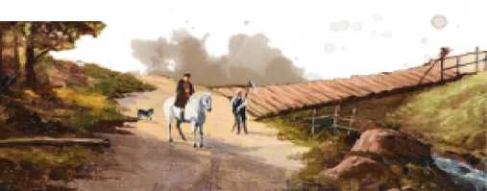

Tracks & Bridges

A party can spend 80 ***supplies*** with a **skill challenge** in the same way as they would to form a *way station* to prepare a path through a difficult area (square) so that they can move easier through it and be able to travel through it with a vehicle.

This can be cutting down trees, pouring gravel in a swamp, laying slats over sand, clearing rocks, building bridges or finding other ways to prepare an area.

This reduces the relative **travel distance** by 1 for any future expedition traveling through it.

Similar to a *way station,* a track or bridge starts with a **defense** of 18. This cannot be upgraded.

Although a track or bridge cannot be *aaided,* the GM rolls against the **defense** every time the party pass to see if it has deteriorated. A fail will negate the **travel distance** bonus as the party pause to repair it, and it will also reduce the **defense** by 1. When the **defense** falls below 10 it has been destroyed and will have to be re-formed.

Limping Home

Travel in the world should be hard, but the main part of this style of game is the **destination** rather than the traveling. These rules can escalate failure into a downward spiral that is not fun to play. An expedition should always be able to limp home with their tail between their legs.

If a party becomes so lost that their ***h aadship*** is over 20 and have run out of ***supplies****,* the party members can start using their *class featuaes* and *spells* to get back home:

* A character can spend a bardic inspiration, rage, superiority dice, ki point, wild-shape or sorcery point to reduce anyone’s personal ***haadship****by* 5.
* A character can cast *spells* to reduce anyone’s personal ***haadship*** by the equivalent level of spell slot used for the spell.
* Resources can be spent by any character to reduce anyone’s ***haadship*** value after each ***skill challenge*** roll has been made.
* The characters will end the expedition with a reduced HP to represent the trials they faced: Each point of reduction taken will inflict the character’s level of HP in damage to the recipient. If this reduces the character to zero or below they finish unconscious and carried by other members of the party.

If any character in the party reduces ***h aadship*** in this way, it negates any collection of *rewards* or *treasure* that may have been gathered during the expedition.

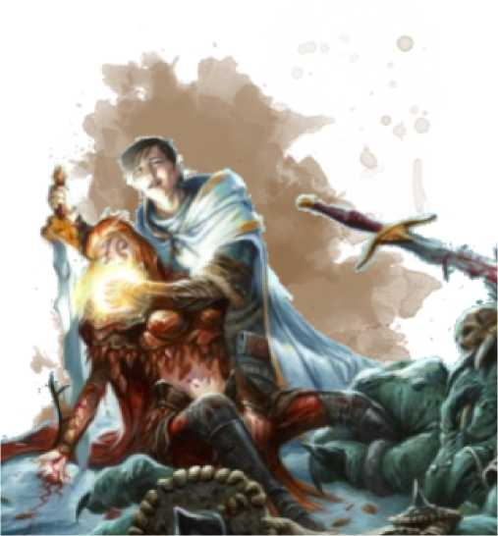

Credits

This document is intended for use with the *West Marches* style of 5e D&D campaign (see accompanying document.) This was published to the [DMsGuild](https://www.dmsguild.com/) and the author can be contacted at [gadget2020@hotmail.com](mailto:gadget2020@hotmail.com)