Parthia

**A fearsome sight to behold:** Armored head-to-toe in scale mail, and wielding lance, mace and bow, Cataphracts strike fear into the hearts of enemies that live long enough to see them up close. Raised on the back of a horse, Cataphracts are selected at an early age to train at arms, forgoing a civilian life for one spent preparing for war.

While skilled with the bow, the Cataphract’s real advantage is fighting up close. A chain fastens the rider’s lance to the horse’s hind leg, helping transfer much of the mount’s forward momentum into the thrust of the lance during a charge- devastating to even the most heavily armored combatants.

|  |  |
| --- | --- |
| Cataphract Cavalry  *Medium humanoid, any alignment* | *Heavily Armored Mount.* The Cataphract Cavalry is mounted on a Warhorse (Basic Rules pg. 157), which acts on the Cataphract Cavalry's turn. The Warhorse's AC is 19 and speed is 45.  *Withering Charge.* While mounted, if the Cataphract Cavalry moves at least 15 feet straight toward a creature and hits it with a lance attack on the same turn, add 4D12 to the damage roll (5D12 if the creature is prone). If this attack hits, the creature and all creatures friendly to it within 10 feet of it must make a DC 15 Wisdom saving throw. On a failed save, they are |
| Armor Class 16 (scale mail)  Hit Points 130 (20d8+40)  Speed 30 ft.  **STR DEX CON INT WIS CHA** |
| 16 (+3) 15 (+2) 14 (+2) 10 (+0) 13 (+1) 12 (+1) | Frightened until the end of the Cataphract Cavalry's next turn. |
| Saving Throws Str +6, Dex +5, Con +5  Skills Athletics +9, Perception +4, Survival +4  Senses passive Perception 14  Languages Common  Challenge 8 (3,900 XP) | Actions  *Multiattack.* The Cataphract Cavalry makes two attacks, one with its lance and one with its mace, or two with its shortbow.  *Lance. Meiee Weapon Attack:* +6 to hit, reach 10 ft., one target. *Hit:* 9 (1 d12 + 3) piercing damage.  *Mace. Melee Weapon Attack:* +6 to hit, reach 5 ft., one target. *Hit:* 6 (1 d6 + 3) bludgeoning damage.  *Shortbow. Ranged Weapon Attack:* +5 to hit, range 80/320 ft., one target. *Hit:* 5 (Id6 + 2) piercing damage. |



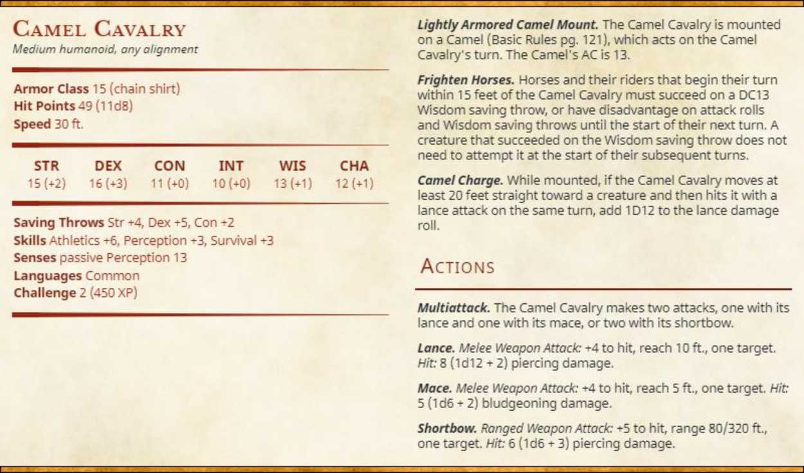

**Desert survivalists:** A vast expanse of desert can prove an insurmountable obstacle to people raised in more fertile environs- any numerical or technological advantage is quickly forgone once the water runs out- a fate that has doomed ill-prepared and overzealous armies since time immemorial.

Those raised in these harsh conditions must learn to adapt- forgoing the horses of more humid climates for the humble camel. While slower than horses, camels can survive 15 days without water, making them well suited to cross the desert in search of oases. In combat, camels provide a distinct advantage, as horses not raised around camels are naturally pre-disposed to fear their scent, disordering even the most fearsome warhorses.

