тез GAMKS »

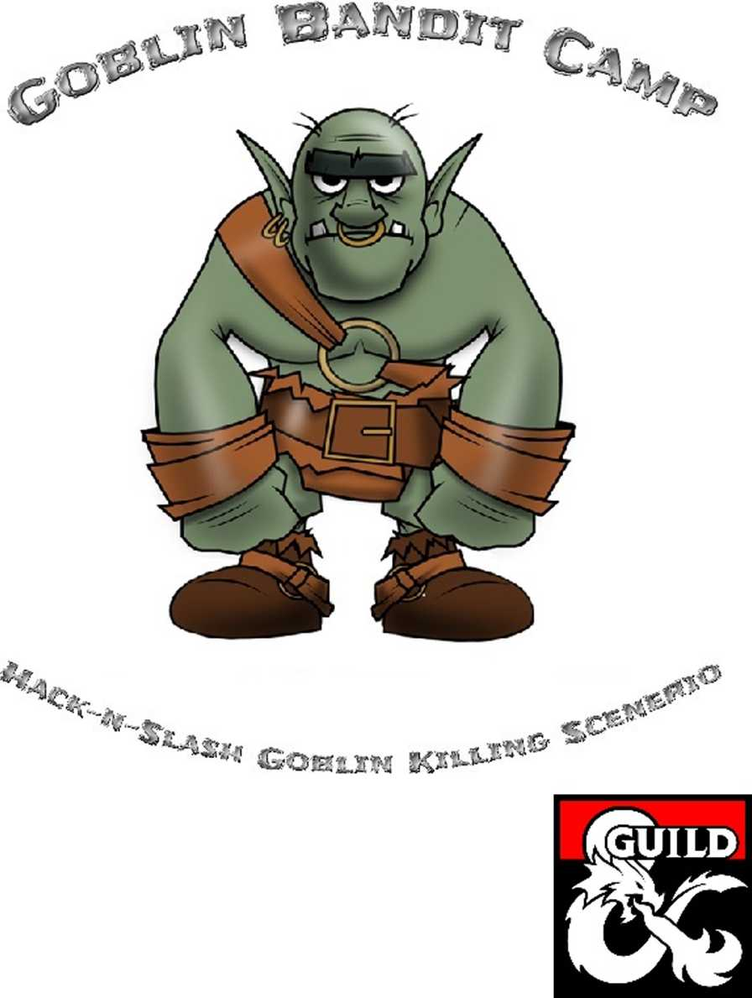

There are many differant ways to hook players into this  
scenerio. Below is just a few simple ideas.

* The party is hired by a merchant to act as guards for a  
  delivery of goods and is attacked by some goblins
* A village is in need of a party to search and clear out a  
  group of goblins that is stealing from the farmers
* The party is traveling from point A to point В and gets  
  ambushed by a party of goblins
* While adventuring, the party finds a map that shows  
  the location of this cave with an X on it
* The party comes across a freshly burned down farm  
  and goblin tracks leading away
* The party is hired by a local millitia to help out with  
  a sweep of the area hills for goblins
* The goblins either have an item or information that  
  is needed by the party for an on-going campaign

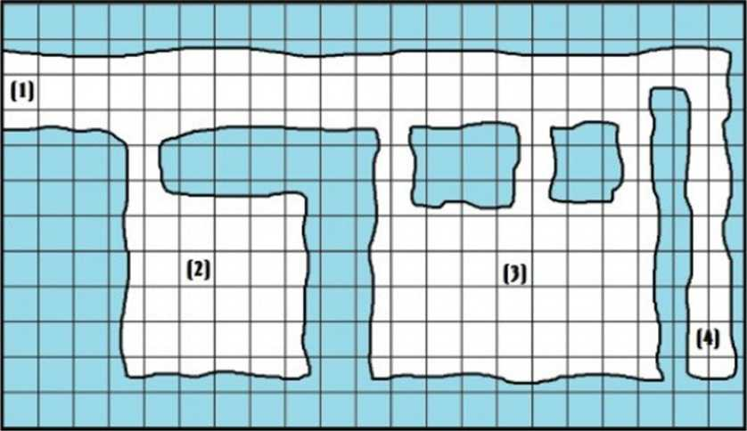

1. Entrance: 6 Goblins are standing guard here at all times. If not surprised, 2 will alarm rooms 2 & 3 while the remaining 4 will fight while slowly retreating to room 2. They are using short swords.
2. Guard Quarters: 12 Goblins doing various things. If alarm is raised, 6 will respond immediately while the remaining 6 will respond in 304 turns. The room contains 18 beds and 18 chests. They are armed with short swords
3. Elite Quarters: 6 Elite Goblins and 4 Normal Wolves live here along with 13 females and 9 young that do not fight. The room contains 19 beds and various crates, chests, and sacks full of various items both valueable and worthless. They are armed with short swords.
4. Garbage Hallway: Gelatinous Cube lives here. This is where the Goblins throw all their garbage. So far there has been enough garbage to keep it satisfied enough to not go after any of the goblins or wolves.

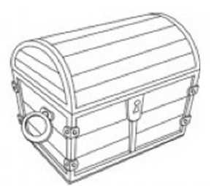

Encounter/Treasure

Master Treasure

Matrix

1. ... 10 electrum coins each in simple belt pouches
2. ... 5 electrum coins each in simple belt pouches

2 gems (v = 10 silver coins) in 1 of the chests

1. ... 10 silver coins each in simple belt pouches

1,000 copper coins, 1 gold ring (v = 10 gold coins) and general items [v = 90 silver coins) in the crates, chests, and sacks.

1. ... 400 electrum coins, 540 gold coins, 60 platinum coins, 3 gold neck chains (v = 10 gold coins)

ring of healing (1D6+1 once per day per character)

This matrix can be used as is, not used at all, or  
modified at the Dungeon Master's descretion,  
as in giving the party a map or special item you  
want them to have.

Master Monster Matrix

To Keep The File Size To A Minimum, Only The Monster Manual Page Number Is Given. Please Support Your Favorite Game System By Buying Their Books And Suppliments.

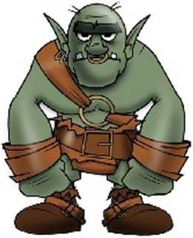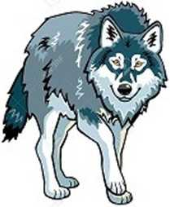Gelatinous Cube  
Pages 240-243

Goblin/Boss Goblin  
Pages 165-166

Consider Any Goblin Listed Within The Text As "Elite" As

Having Boss Goblin Stats. All Goblins Are Armed With Short

Swords Instead Of Scimitars As Listed In The Monster Manual

Wolf

Page 341

This work is licensed under a Creative Commons  
AttributionNonCommercial-NoDerivatives 4.0

International License.

Attribution - You must give appropriate credit, provide a link  
to the license, and indicate if changes were made. You may  
do so in any reasonable manner, but not in any way that  
suggests the licensor endorses you or your use.

NonCommercial - You may not use the material for  
commercial purposes.

NoDerivatives - If you remix, transform, or build upon the  
material, you may not distribute the modified material.

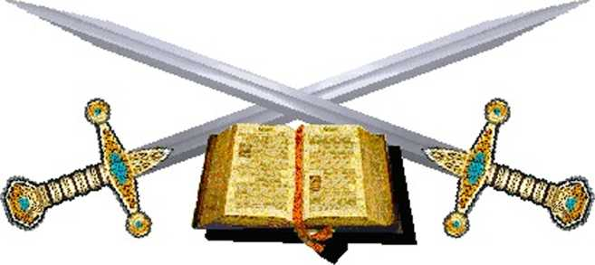

All Art Images Was Downloaded From The Google Image Public Domain Library And Are Public Domain To The Best Of My Knowledge.