Tribes and Warbands

Goblin, Kobold, and Orc Tribe Charts

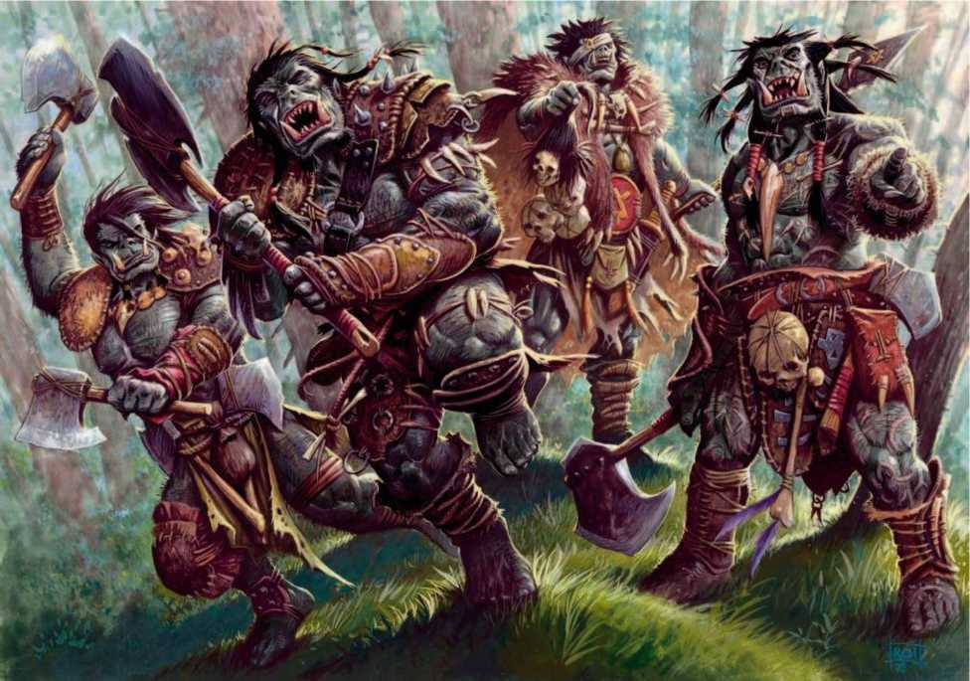

By Benjamin Combe

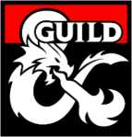

Credits

**Designer:** Ben Combe

**Playtesters**: Joe Adams, Jess Thomas

Template Created by William Tian

DUNGEONS & DRAGONS, D&D, Wizards of the Coast, Forgotten Realms, the dragon ampersand, *Player’s Handbook, Monster Manual, Dungeon Master’s Guide,* D&D Adventurers League, all other Wizards of the Coast product names, and their respective logos are trademarks of Wizards of the Coast in the USA and other countries. All characters and their distinctive likenesses are property of Wizards of the Coast. This material is protected under the copyright laws of the United States of America. Any reproduction or unauthorized use of the material or artwork contained herein is prohibited without the express written permission of Wizards of the Coast.

©2018 Wizards of the Coast LLC, PO Box 707, Renton, WA 98057-0707, USA. Manufactured by Hasbro SA, Rue Emile-Boechat 31, 2800 Delemont, CH. Represented by Hasbro Europe, 4 The Square, Stockley Park, Uxbridge, Middlesex, UB11 1ET, UK.

Introduction

These tables are based on the *Creating A Gnoll War Band* tables in Volo’s Guide To Monsters (Page 39). I found it incredibly freeing to try out, and found myself frustrated that there were no such tables for any other faction in the book.

I think these tables work fairly well. They are for use if you need to deploy any of these groups, but don’t have the time or inclination to build them for yourself.

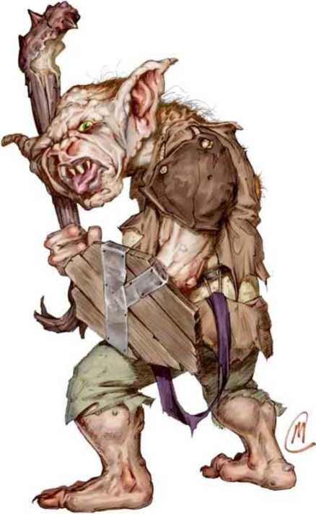They are also, hopefully, easy to customize. If you don’t like special allies, just ignore them. If you just want the feel of the tribe, rather than hard numbers of Goblins and Bugbears, just roll on the tables that don’t provide numbers. If your players have just gone off in a random direction and you need to drop something in, take a five-minute break and roll on the tables, and you’ve got a unique, detailed faction for your players to interact with. Depending on your group’s style, you could have a whole session or two of content just based on a few rolls. Enjoy!

Goblin Warband

Goblins, while chaotic, are able to hold together as a tribe for a surprisingly long time. Their bands tend to be run by Hobgoblins, or the occasional Bugbears, who rule via either intelligence or physical might respectively.

They don’t particularly like taking orders, but their lack of intelligence (even the smartest Hobgoblins are only as smart as a relatively bright human) means that they can be tricked into doing what others want them to do.

Name

|  |  |  |  |
| --- | --- | --- | --- |
| **Part 1** | **Part 2** | | |
| **1d8** | **Or Where They Live** | **1d8** | |
| 1 | Broken | 1 | Rippers |
| 2 | Fanged | 2 | Raiders |
| 3 | Feral | 3 | Brutes |
| 4 | Scraggly | 4 | Breakers |
| 5 | Jagged | 5 | Slashers |
| 6 | Snapping | 6 | Invaders |
| 7 | Charging | 7 | Strikers |
| 8 | Thrashing | 8 | Howlers |

|  |  |
| --- | --- |
| **Special Creatures**  Roll Twice  1 | 1d4 Guard Drakes |
| 2-3 | 1d4 Hobgoblin Devastators |
| 4 | 1d6 Dire Wolves |
| 5 | 3d6 Bulywugs |
| 6 | Cockatrice |
| 7 | Allosaurus |
| 8 | Displacer Beast |
| 9 | 1d4 Ettencaps |
| 10-11 | 1d6 Hobgoblin Iron Shadows |
| 12 | 1d4 Gricks |
| 13 | Barghast |
| 14 | 2d6 Orcs |
| 15 | Owlbear |
| 16 | 4d4 Troglodytes |
| 17 | 1d4 Trolls |
| 18 | Wyvern |
| 19 | 1d4 Brown Bears |
| 20 | Basilisk |

|  |  |
| --- | --- |
| **Composition**  Goblins | 6d8 |
| Goblin Bosses | 2d4 |
| Hobgoblins | 2d6 |
| Hobgoblin Captains | 1d4+2 |
| Bugbears | 2d4 |
| Wolves | 1d8+2 |

|  |  |
| --- | --- |
| **Leadership** | |
| 1-3 | Hobgoblin Warlord |
| 4-5 | Bugbear Chief |
| 6 | Half-Dragon |

Shared Physical Trait

Notable Behavior/Tactics

|  |  |
| --- | --- |
| 1 | Ear piercings |
| 2 | Covered in dirt |
| 3 | Large eyes |
| 4 | Loud |
| 5 | Lots of missing teeth |
| 6 | Covered in short, wispy hair |
| 7 | Always smiling |
| 8 | Speak Common together |
| 9 | Barefoot |
| 10 | Scarred cheeks |

|  |  |
| --- | --- |
| 1 | Swarms the nearest target |
| 2 | Rushes for the high ground |
| 3 | Frequent use of fire |
| 4 | Use improvised weapons |
| 5 | Take prisoners for ransom |
| 6 | Attempts to steal weapons |
| 7 | Favors sneak attacks |
| 8 | Defends the spellcaster |

Lair Location

|  |  |
| --- | --- |
| 1 | Cave by a river |
| 2 | Repurposed prison |
| 3 | Purpose-built Goblin camp |
| 4 | Township with civilians |
| 5 | In the mouth of a dead beast |
| 6 | Volcanic lair |

Lair Features

|  |  |
| --- | --- |
| 1 | Infested with Stirges |
| 2 | Contains a trap that the Goblins can’t get past |
| 3 | Fortified with the armor of their enemies |
| 4 | Digging to expand |
| 5 | Mobile |
| 6 | Also home to another creature |

Kobold Tribe

Being tiny Dragon Spirits, Kobolds tend to follow their masters blindly. I run them as naturally occurring from the rock whenever Dragons are nearby, and worshiping Dragons as a God. Should their Dragon abandon them, they might decide to follow a new master, or resort to squabbling among themselves. They will only attack if they’re absolutely certain they have the advantage.

|  |  |
| --- | --- |
| **Name**  **Roll** | **From where they get their name** |
| 1 | The place they live |
| 2 | The Dragon they follow |
| 3 | An item one of them invented |
| 4 | Their shared physical trait (below) |
| 5 | A boast about their numbers/power |
| 6 | A creature they have slain |
| 7 | One of their special creatures (below) |
| 8 | Their notable behavior/tactics (below) |

Composition

|  |  |
| --- | --- |
| Kobolds | 4d8 |
| Winged Kobolds | 2d10 |
| Dragonshields | 1d6 |
| Inventors | 1d4 |
| Pseudodragons | 2d6 |
| Giant Rats | 2d4 |

Special Creatures

|  |  |
| --- | --- |
| 1-2 | 3d4 Troglodytes |
| 3 | Cave Fisher |
| 4 | Flail Snail |
| 5 | 1d4 Guard Drakes |
| 6 | 1d6 Thorny Vegepygmies |
| 7 | 1d4 Swarms of Rot Grubs |
| 8 | Ankheg |
| 9 | 1d4 Myconid Adults |
| 10-11 | 2d6 Giant Weasels |
| 12 | Ettencap |
| 13 | Bullette |
| 14 | 2d4 Gricks |
| 15 | 3d4 Giant Bats |
| 16 | Banderhob |
| 17 | Carrion Crawler |
| 18 | Earth Elemental |
| 19 | Wyvern |
| 20 | Red Dragon Wyrmling |
| **Leadership** |  |
| 1-3 | A Kobold Chief (regular Kobold, 14 AC, 12 (4d6-2) hp) |
| 4-5 | Kobold Scale Sorcerer |
| 6 | A Young Dragon |

|  |  |
| --- | --- |
| 1 | Smooth, scaleless skin |
| 2 | Tiny eyes |
| 3 | Constantly Fidgeting |
| 4 | Gems encrusted in their scales |
| 5 | Crawl on all-fours |
| 6 | Little t-rex arms |
| 7 | Feet with opposable toes for climbing |
| 8 | Powerful sense of smell |
| 9 | Shed scales |
| 10 | Tiny, non-functioning wings |
| **Notable Behavior/Tactics** | |
| 1 | Mushroom Farmers |
| 2 | Treat a Dragon as their parent |
| 3 | Trappers |
| 4 | Surprisingly advanced inventors |
| 5 | Ride giant weasels into battle |
| 6 | Aggressively expansionist |
| 7 | Looking for a new Dragon to serve |
| 8 | Can cast *Produce Flame* |
| **Lair Location** |  |
| 1 | Caverns and tiny tunnels |
| 2 | High in the mountains |
| 3 | Close to a pool of magma |
| 4 | Following a Dragon wherever it goes |
| 5 | Near a Dwarf Camp |
| 6 | Inside the skeleton of a long-dead Dragon |

|  |  |
| --- | --- |
| 1 | Silence is mandatory, don’t let them know we’re here! |
| 2 | Infested with termites |
| 3 | Surrounding a central pile of treasure |
| 4 | Bones are littered about the place |
| 5 | Rudimentary barricades have been erected |
| 6 | Traps at every turn, so many that the Kobolds often get caught in them |

OPTIONAL: Joke Kobolds

For when you don’t want your Kobolds to be taken seriously, or when your PCs are high enough level for Kobolds to be nothing but a nuisance.

|  |  |
| --- | --- |
| 1 | Always travel in pairs, usually giving piggybacks |
| 2 | They treat a Dragon as if it’s their dog |
| 3 | They believe the floor is lava. This started as a game, but it’s been 200 years and they seem to have forgotten |
| 4 | Nose-boops are the standard greeting |
| 5 | They’re obsessed with a gemstone lodged in the roof. They’re looking for people to join their Kobold Pyramid to try to reach it |
| 6 | Basically the Martians from Sesame Street |

Orcs are the biggest, toughest, and most organized of the low-level enemies. Through their intelligence and power, they are also the hardest to control, meaning that while they are strongest in of themselves, they tend not to be part of larger armies or schemes. It takes a truly mighty Orc Chief to unite large numbers of Orcs, as they are often challenged from within.

Orc Encampment

Special Creatures

|  |  |  |  |
| --- | --- | --- | --- |
| **Name**  Part 1 | | Part 2 | |
| 1 | Black | 1 | Rock |
| 2 | Red | 2 | Fang |
| 3 | White | 3 | Tooth |
| 4 | Grey | 4 | Crag |
| 5 | Vile | 5 | Hand |
| 6 | Great | 6 | Eye |
| 7 | Broken | 7 | Tusk |
| 8 | Stone | 8 | Mark |

Composition

|  |  |
| --- | --- |
| 1 | 1d4 Worgs |
| 2-3 | 2d6 Bugbears |
| 4 | 2d4 Winter Wolves |
| 5 | 1d4 Sabre-Toothed Tigers |

|  |  |
| --- | --- |
| 6 | Ahnkeg |
| 7 | Bullette |
| 8 | Half-Dragon |
| 9 | Wyver |
| 10-11 | 1d6 Ogres |
| 12 | Otyugh |
| 13 | Gorgon |
| 14 | Cyclops |
| 15 | Hippogryph |
| 16 | 2d4 Hellhounds |
| 17 | 1d4 Minotaurs |
| 18 | Tyrannosaurus Rex |
| 19 | Basilisk |
| 20 | Hydra |

|  |  |
| --- | --- |
| Orcs | 5d10 |
| Eyes of Gruumsh | 2d4 |
| Orogs | 1d6+2 |
| Dire Wolves | 2d8 |
| Claws of Luthic | 1d4-1 |

Trolls

1d6

|  |  |
| --- | --- |
| **Leadership** |  |
| 1-3 | Orc War Chief |
| 4-5 | Half-Ogre |
| 6 | Glabrezu |

Shared Physical Trait

Notable Behavior/Tactics

|  |  |
| --- | --- |
| 1 | A significant number of broken tusks |
| 2 | They all grow their hair long |
| 3 | Numerous piercings and rings |
| 4 | Battle-scars are worn with pride |
| 5 | Spikes. Lots of spikes. |
| 6 | Hunched backs |
| 7 | Standing upright, height is a sign of strength |
| 8 | Armour is ornate and personal |
| 9 | Dark, almost black irises |
| 10 | Milky-white skin |

|  |  |
| --- | --- |
| 1 | Stop trying to hit me and hit me! |
| 2 | Magic is a tool, use it whenever possible |
| 3 | Lone survivors are glorified |
| 4 | There is no crime worse than turning on your clan |
| 5 | Disputes are settled in single combat |
| 6 | Days are for fighting, nights are for music |
| 7 | Strategy over violence |
| 8 | Service to the Chief over personal glory |
| **Lair Location** |  |
| 1 | Purpose-Built Orc Stronghold |
| 2 | Abandoned Human Castle |
| 3 | Caves in the Mountains |
| 4 | Mobile Camp |
| 5 | Ruined Town |
| 6 | The lair of a Dragon, which they have now enslaved |

Lair Features

|  |  |
| --- | --- |
| 1 | Always be fortifying, even if it makes it harder to move around |
| 2 | Built to flow with earthquakes, which are frequent |
| 3 | Spoils are displayed prominently |
| 4 | Made of the bones of great beasts |
| 5 | Cleanliness is a virtue, keep everything shining |
| 6 | The Encampment stops for no reason, always be moving |