**[Terrain - Swamps, Marshes, Fens, Bogs (Oh my)](https://www.thepiazza.org.uk/bb/viewtopic.php?p=287762" \l "p287762)**

* [**Quote**](https://www.thepiazza.org.uk/bb/posting.php?mode=quote&p=287762)

[Post](https://www.thepiazza.org.uk/bb/viewtopic.php?p=287762#p287762) by **[DJShade](https://www.thepiazza.org.uk/bb/memberlist.php?mode=viewprofile&u=370)** » Tue Jul 20, 2021 10:59 am

I was wondering if folks use the different wetland terrains that have been created in there maps. The wetlands terrain (as I know it) is usually the one of the following:

* Marsh
* Swamp
* Bog
* Bog, Mud
* Fens

I am also curious to see how folks define them, what makes them special (plants, animals, hazards).  
  
I'm at a point I want to re-evaluate some of the hex art I've made over the year and was just thinking it might be easier to trim a couple out to make maps more easily read.

DJShade (Birchbeer)  
[DND Horizons](https://sites.google.com/view/ddhorizons/home?authuser=1) My home on the internet for maps, hexgimp and other things.  
[HexGimp](https://sites.google.com/view/ddhorizons/cartography/hexgimp?authuser=1)

[Top](https://www.thepiazza.org.uk/bb/viewtopic.php?t=27568#top)

**[](https://www.thepiazza.org.uk/bb/memberlist.php?mode=viewprofile&u=17637)**

[**Philosopher_X**](https://www.thepiazza.org.uk/bb/memberlist.php?mode=viewprofile&u=17637)

Orc

Posts: 39

Joined: Mon Sep 14, 2020 9:45 pm

Gender: male

[**Re: Terrain - Swamps, Marshes, Fens, Bogs (Oh my)**](https://www.thepiazza.org.uk/bb/viewtopic.php?p=287774#p287774)

* [**Quote**](https://www.thepiazza.org.uk/bb/posting.php?mode=quote&p=287774)

[Post](https://www.thepiazza.org.uk/bb/viewtopic.php?p=287774#p287774) by **[Philosopher_X](https://www.thepiazza.org.uk/bb/memberlist.php?mode=viewprofile&u=17637)** » Tue Jul 20, 2021 12:38 pm

I use three different categories in my maps:  
  
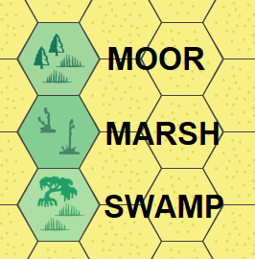  
  
Now, this is not chiseled in stone, (and definitely not scientific at all), but roughly I use them as follows:  
  
MOOR is found in highlands and colder climates - think Scotland, they have lots of this. May, or may not, have evergreen vegetation.  
  
SWAMP can be found in the warm to hot climates; think mangrove swamps in southern Florida.  
  
MARSH is somewhere in between.  
  
Now, in a second perspective, I use it as an indicator for "danger level" ... that is, in a Moor area, I may designate the innermost and therefore most dangerous parts as "Marsh". And in a Marsh area, the innermost and most dangerous parts may get the "Swamp" symbol.  
  
And in a third and totally unrelated perspective, I am trying to make the map somewhat aesthetically looking ^^  
  
Hope that helps.

[Top](https://www.thepiazza.org.uk/bb/viewtopic.php?t=27568#top)

[**mah9**](https://www.thepiazza.org.uk/bb/memberlist.php?mode=viewprofile&u=2433)

Bugbear

Posts: 141

Joined: Thu Jul 16, 2009 7:36 pm

Gender: prefer not to say

[**Re: Terrain - Swamps, Marshes, Fens, Bogs (Oh my)**](https://www.thepiazza.org.uk/bb/viewtopic.php?p=288251#p288251)

* [**Quote**](https://www.thepiazza.org.uk/bb/posting.php?mode=quote&p=288251)

[Post](https://www.thepiazza.org.uk/bb/viewtopic.php?p=288251#p288251) by [**mah9**](https://www.thepiazza.org.uk/bb/memberlist.php?mode=viewprofile&u=2433) » Mon Jul 26, 2021 9:53 am

I tend to use the below designations:  
  
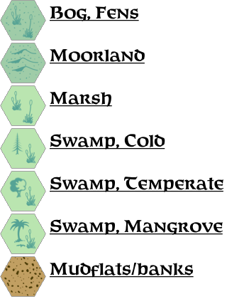  
  
Broadly speaking (I'm thinking from a British perspective):  
Bogs/Fens: Irish peat bogs, Fens of Norfolk (England)  
Moorland: Scottish Highlands, Exmoor, Dartmoor (South West England)  
Marsh: River estuaries along the Essex coast (South East England)  
Swamp, Mangrove: any tropical od sub-tropical swamp  
Swamp, Temperate/Cold: no real world comparisons, but no reason why they could not exist in Mystara.  
  
I've found this quite helpful as well:  
  
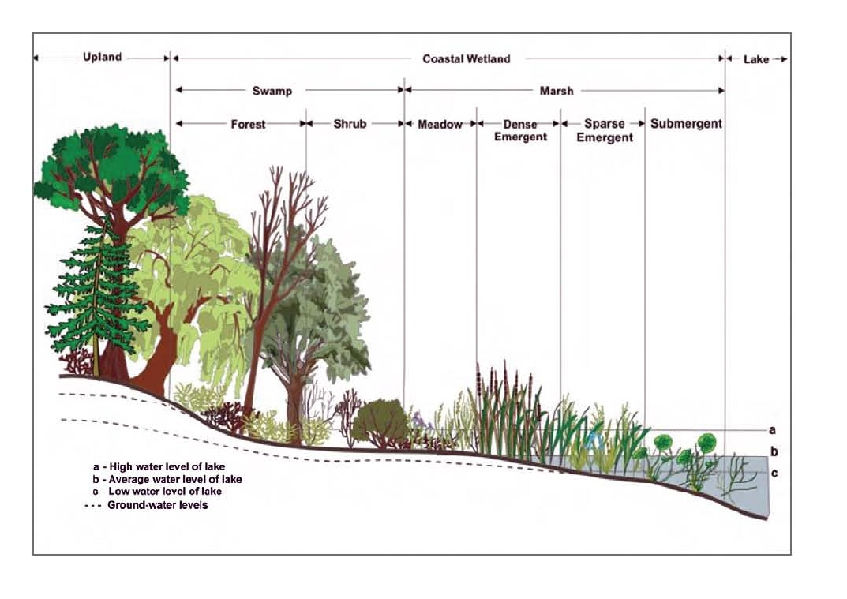

Last edited by [mah9](https://www.thepiazza.org.uk/bb/memberlist.php?mode=viewprofile&u=2433) on Tue Aug 24, 2021 1:44 pm, edited 1 time in total.

Blog: [Urt's Outer Skin](https://urtsouterskin.blogspot.com/)

[Top](https://www.thepiazza.org.uk/bb/viewtopic.php?t=27568#top)

**[](https://www.thepiazza.org.uk/bb/memberlist.php?mode=viewprofile&u=370)**

[**DJShade**](https://www.thepiazza.org.uk/bb/memberlist.php?mode=viewprofile&u=370)

Shade

Posts: 811

Joined: Mon Jan 12, 2009 3:58 pm

Gender: male

Location: Niagara Frontier

Contact:

[**Contact DJShade**](https://www.thepiazza.org.uk/bb/viewtopic.php?t=27568)

[**Re: Terrain - Swamps, Marshes, Fens, Bogs (Oh my)**](https://www.thepiazza.org.uk/bb/viewtopic.php?p=288274#p288274)

* [**Quote**](https://www.thepiazza.org.uk/bb/posting.php?mode=quote&p=288274)

[Post](https://www.thepiazza.org.uk/bb/viewtopic.php?p=288274#p288274) by **[DJShade](https://www.thepiazza.org.uk/bb/memberlist.php?mode=viewprofile&u=370)** » Mon Jul 26, 2021 3:20 pm

[**mah9**](https://www.thepiazza.org.uk/bb/memberlist.php?mode=viewprofile&u=2433)**wrote:**[**↑**](https://www.thepiazza.org.uk/bb/viewtopic.php?p=288251#p288251)Mon Jul 26, 2021 9:53 amI tend to use the below designations:  
  
Broadly speaking (I'm thinking from a British perspective):  
Bogs/Fens: Irish peat bogs, Fens of Norfolk (England)  
Moorland: Scottish Highlands, Exmoor, Dartmoor (South West England)  
Marsh: River estuaries along the Essex coast (South East England)  
Swamp, Mangrove: any tropical od sub-tropical swamp  
Swamp, Temperate/Cold: no real world comparisons, but no reason why they could not exist in Mystara.

I've seen similar diagrams before and it does help. There's a wetland by my house that has the diagram and they explain how they keep pumping water into the area to keep it a wetland. Otherwise it would just become a mixed forest like the rest of the land around here (Niagara Falls). Also, other country perspectives counts a lot too, as I lack first hand knowledge of different terrain.  
  
I'd say where I live has areas that are "Swamp, Temperate/Cold" - more or less wetlands with trees. Some are forested to the point where the trees block all the sun. Ground is still a mess to walk through though. Other areas are "Marshy" in that they are covered in tall grass that looks like a field till you run through it and sink into a bunch of water. A good tell tale sign of any wetland here is the presence of cat tails. (I'm not sure that is present in the UK as a plant, or in other wetland areas around the globe). Maybe it is though as I was reviewing swamp hex art and it shows cattails on it.

DJShade (Birchbeer)  
[DND Horizons](https://sites.google.com/view/ddhorizons/home?authuser=1) My home on the internet for maps, hexgimp and other things.  
[HexGimp](https://sites.google.com/view/ddhorizons/cartography/hexgimp?authuser=1)

[Top](https://www.thepiazza.org.uk/bb/viewtopic.php?t=27568#top)

**[](https://www.thepiazza.org.uk/bb/memberlist.php?mode=viewprofile&u=370)**

[**DJShade**](https://www.thepiazza.org.uk/bb/memberlist.php?mode=viewprofile&u=370)

Shade

Posts: 811

Joined: Mon Jan 12, 2009 3:58 pm

Gender: male

Location: Niagara Frontier

Contact:

[**Contact DJShade**](https://www.thepiazza.org.uk/bb/viewtopic.php?t=27568)

[**Re: Terrain - Swamps, Marshes, Fens, Bogs (Oh my)**](https://www.thepiazza.org.uk/bb/viewtopic.php?p=288280#p288280)

* [**Quote**](https://www.thepiazza.org.uk/bb/posting.php?mode=quote&p=288280)

[Post](https://www.thepiazza.org.uk/bb/viewtopic.php?p=288280#p288280) by **[DJShade](https://www.thepiazza.org.uk/bb/memberlist.php?mode=viewprofile&u=370)** » Mon Jul 26, 2021 3:55 pm

[**Philosopher_X**](https://www.thepiazza.org.uk/bb/memberlist.php?mode=viewprofile&u=17637)**wrote:**[**↑**](https://www.thepiazza.org.uk/bb/viewtopic.php?p=287774#p287774)Tue Jul 20, 2021 12:38 pmI use three different categories in my maps:  
  
  
  
Now, this is not chiseled in stone, (and definitely not scientific at all), but roughly I use them as follows:  
  
MOOR is found in highlands and colder climates - think Scotland, they have lots of this. May, or may not, have evergreen vegetation.  
  
SWAMP can be found in the warm to hot climates; think mangrove swamps in southern Florida.  
  
MARSH is somewhere in between.  
  
Now, in a second perspective, I use it as an indicator for "danger level" ... that is, in a Moor area, I may designate the innermost and therefore most dangerous parts as "Marsh". And in a Marsh area, the innermost and most dangerous parts may get the "Swamp" symbol.  
  
And in a third and totally unrelated perspective, I am trying to make the map somewhat aesthetically looking ^^  
  
Hope that helps.

Thanks for the input. It's gives me some food for thought where I place my hexes/update old maps and their danger levels.

DJShade (Birchbeer)  
[DND Horizons](https://sites.google.com/view/ddhorizons/home?authuser=1) My home on the internet for maps, hexgimp and other things.  
[HexGimp](https://sites.google.com/view/ddhorizons/cartography/hexgimp?authuser=1)

[Top](https://www.thepiazza.org.uk/bb/viewtopic.php?t=27568#top)

**[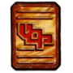](https://www.thepiazza.org.uk/bb/memberlist.php?mode=viewprofile&u=172)**

[**stanles**](https://www.thepiazza.org.uk/bb/memberlist.php?mode=viewprofile&u=172)

Frost Giant

Posts: 893

Joined: Sat Jun 07, 2008 2:22 am

Gender: prefer not to say

Contact:

[**Contact stanles**](https://www.thepiazza.org.uk/bb/viewtopic.php?t=27568)

[**Re: Terrain - Swamps, Marshes, Fens, Bogs (Oh my)**](https://www.thepiazza.org.uk/bb/viewtopic.php?p=290108#p290108)

* [**Quote**](https://www.thepiazza.org.uk/bb/posting.php?mode=quote&p=290108)

[Post](https://www.thepiazza.org.uk/bb/viewtopic.php?p=290108#p290108) by **[stanles](https://www.thepiazza.org.uk/bb/memberlist.php?mode=viewprofile&u=172)** » Sun Aug 22, 2021 10:28 pm

[**mah9**](https://www.thepiazza.org.uk/bb/memberlist.php?mode=viewprofile&u=2433)**wrote:**[**↑**](https://www.thepiazza.org.uk/bb/viewtopic.php?p=288251#p288251)Mon Jul 26, 2021 9:53 amI tend to use the below designations:

Mah9, this image isn't coming through - it appears to be on somebodies Google site that isn't open access ...

Visit the Vaults of Pandius [http://pandius.com](http://pandius.com/), the official website for the Dungeons and Dragons setting of Mystara.  
  
Submissions to the Vaults can be made directly to webmaster@pandius.com

[Top](https://www.thepiazza.org.uk/bb/viewtopic.php?t=27568#top)

[**mah9**](https://www.thepiazza.org.uk/bb/memberlist.php?mode=viewprofile&u=2433)

Bugbear

Posts: 141

Joined: Thu Jul 16, 2009 7:36 pm

Gender: prefer not to say

[**Re: Terrain - Swamps, Marshes, Fens, Bogs (Oh my)**](https://www.thepiazza.org.uk/bb/viewtopic.php?p=290239#p290239)

* [**Quote**](https://www.thepiazza.org.uk/bb/posting.php?mode=quote&p=290239)

[Post](https://www.thepiazza.org.uk/bb/viewtopic.php?p=290239#p290239) by [**mah9**](https://www.thepiazza.org.uk/bb/memberlist.php?mode=viewprofile&u=2433) » Tue Aug 24, 2021 1:45 pm

[**stanles**](https://www.thepiazza.org.uk/bb/memberlist.php?mode=viewprofile&u=172)**wrote:**[**↑**](https://www.thepiazza.org.uk/bb/viewtopic.php?p=290108#p290108)Sun Aug 22, 2021 10:28 pm

[**mah9**](https://www.thepiazza.org.uk/bb/memberlist.php?mode=viewprofile&u=2433)**wrote:**[**↑**](https://www.thepiazza.org.uk/bb/viewtopic.php?p=288251#p288251)Mon Jul 26, 2021 9:53 amI tend to use the below designations:

Mah9, this image isn't coming through - it appears to be on somebodies Google site that isn't open access ...

I've updated the link to another site. Let me know if this works better.

Blog: [Urt's Outer Skin](https://urtsouterskin.blogspot.com/)

[Top](https://www.thepiazza.org.uk/bb/viewtopic.php?t=27568#top)

**[](https://www.thepiazza.org.uk/bb/memberlist.php?mode=viewprofile&u=4227)**

[**Khedrac**](https://www.thepiazza.org.uk/bb/memberlist.php?mode=viewprofile&u=4227)

Ostego

Posts: 709

Joined: Wed May 04, 2016 10:19 am

Gender: male

Location: Andover, UK

[**Re: Terrain - Swamps, Marshes, Fens, Bogs (Oh my)**](https://www.thepiazza.org.uk/bb/viewtopic.php?p=290254#p290254)

* [**Quote**](https://www.thepiazza.org.uk/bb/posting.php?mode=quote&p=290254)

[Post](https://www.thepiazza.org.uk/bb/viewtopic.php?p=290254#p290254) by **[Khedrac](https://www.thepiazza.org.uk/bb/memberlist.php?mode=viewprofile&u=4227)** » Tue Aug 24, 2021 7:17 pm

[**mah9**](https://www.thepiazza.org.uk/bb/memberlist.php?mode=viewprofile&u=2433)**wrote:**[**↑**](https://www.thepiazza.org.uk/bb/viewtopic.php?p=290239#p290239)Tue Aug 24, 2021 1:45 pmI've updated the link to another site. Let me know if this works better.

I see neither image

"If it looks like a duck and quacks like a duck, it might just be a crow".

[Top](https://www.thepiazza.org.uk/bb/viewtopic.php?t=27568#top)

**[](https://www.thepiazza.org.uk/bb/memberlist.php?mode=viewprofile&u=172)**

[**stanles**](https://www.thepiazza.org.uk/bb/memberlist.php?mode=viewprofile&u=172)

Frost Giant

Posts: 893

Joined: Sat Jun 07, 2008 2:22 am

Gender: prefer not to say

Contact:

[**Contact stanles**](https://www.thepiazza.org.uk/bb/viewtopic.php?t=27568)

[**Re: Terrain - Swamps, Marshes, Fens, Bogs (Oh my)**](https://www.thepiazza.org.uk/bb/viewtopic.php?p=290272#p290272)

* [**Quote**](https://www.thepiazza.org.uk/bb/posting.php?mode=quote&p=290272)

[Post](https://www.thepiazza.org.uk/bb/viewtopic.php?p=290272#p290272) by **[stanles](https://www.thepiazza.org.uk/bb/memberlist.php?mode=viewprofile&u=172)** » Wed Aug 25, 2021 12:31 am

[**mah9**](https://www.thepiazza.org.uk/bb/memberlist.php?mode=viewprofile&u=2433)**wrote:**[**↑**](https://www.thepiazza.org.uk/bb/viewtopic.php?p=290239#p290239)Tue Aug 24, 2021 1:45 pm

[**stanles**](https://www.thepiazza.org.uk/bb/memberlist.php?mode=viewprofile&u=172)**wrote:**[**↑**](https://www.thepiazza.org.uk/bb/viewtopic.php?p=290108#p290108)Sun Aug 22, 2021 10:28 pm

[**mah9**](https://www.thepiazza.org.uk/bb/memberlist.php?mode=viewprofile&u=2433)**wrote:**[**↑**](https://www.thepiazza.org.uk/bb/viewtopic.php?p=288251#p288251)Mon Jul 26, 2021 9:53 amI tend to use the below designations:

Mah9, this image isn't coming through - it appears to be on somebodies Google site that isn't open access ...

I've updated the link to another site. Let me know if this works better.

thanks, that's working here now