Rome

**Masters of Discipline:** The Roman military differentiated itself through rigorous, standardized training, tactical flexibility on the battlefield and unyielding discipline at all levels of its military organization.

Primarily comprised of volunteer citizens, Legionaries represent the backbone of the Roman army. Each Legionary undergoes rigorous training in weapons, tactics, construction and marching. Following training, each soldier is assigned to a *contubernia* of eight soldiers, eight of which comprises a *century* of 80 soldiers (led by a Centurion). Six centuries comprise a *cohort* and 9-10 cohorts comprise a *legion* (totaling 4,300-4,800 soldiers).

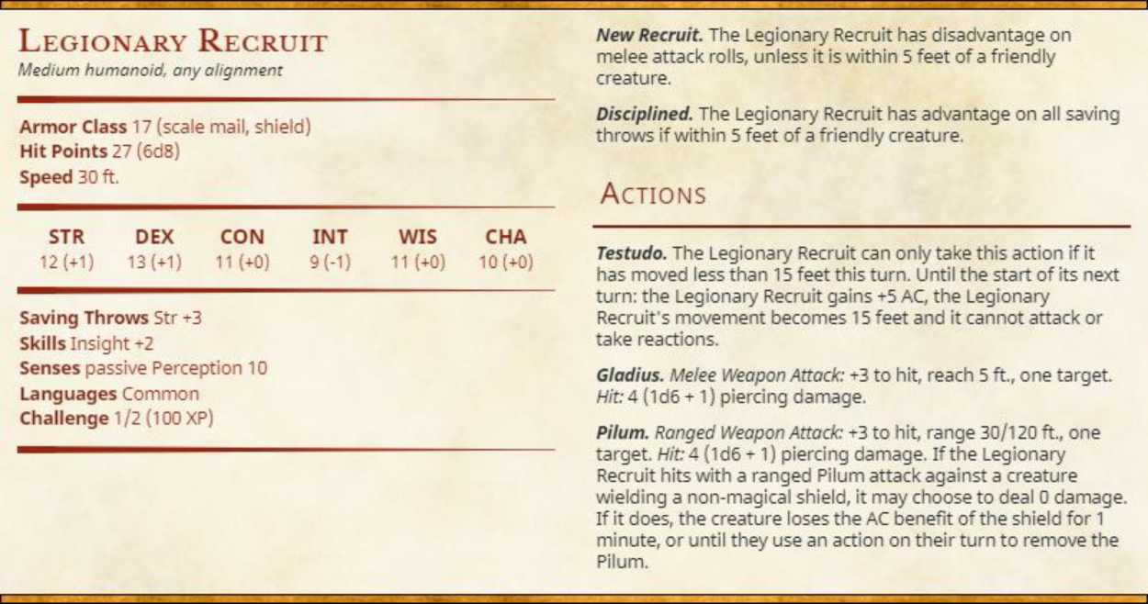

In battle, Legionaries are armed with a Gladius (a short, thrusting sword) and a Pilum- a javelin with a narrow metal shaft that ends in a small point. Pilum are designed to disable enemy shields- when thrown, the point penetrates the shield and the shaft bends, rendering the shield unusable.



In addition to their mastery with weapons, Roman soldiers employed specialized tactics and formations, such as the *Testudo* (tortoise formation). In a Testudo, soldiers in the front rank hold their shields in front of them, while those in subsequent ranks hold their shields above their heads. Slow moving, this protective ‘shell’ sacrifices speed for protection.

Life for Legionaries is far from easy. Punishments are severe, with minor infractions resulting in floggings and reduction in rank, while major infractions often leading to death. When not on campaign, soldiers frequently contribute on infrastructure projects, such as building roads.

**Signs and Sigils:** Contrary to the rote discipline and sanitized standardization of the Roman military structure, the average Roman is quite superstitious. Haruspex provide an important service in this area- sacrificing animals and reading futures yet to come from the creature’s entrails.

From the wealthiest *patrician*, down to the lowliest *plebian*, Haruspex provide a key service, identifying portents and offering guidance on topics ranging from petty disputes and family drama to political gambits and international policy.

Haruspex

Medium humanoid, ony alignment

**Armor** Class 10 (padded armor)

**Hit Points** 36{8d8)

**Speed** 30 ft.

**STR DEX CON INT WIS CHA**

7 (-2) 9(-1) 11 (+0) 13(4-1) -5(4-2) 12(+1)

**Saving Throws** Wis +4

**Skills** Religion -3

**Senses** passive Perception 12

**Languages** Common

**Challenge** 11/2 (100 XP)

Actions

***Spellcasting.*** The Haruspex is a 4th-level spellcaster. Its spellcasting ability is Wisdom (spell save DC 12, +4 to hit with spell attacks). The Haruspex has the following Divination spells prepared:

Cantrips (at will): *Guidance. True Strike*

1st level **(4** slots): *Gift of Alacrity, Hunter's Mark, Identify*

2nd level (3 slots): *Augury, Mind Spike, See Invisibility*

3rd level (2 slots): *Clairvoyance*

***Dagger.*** *Melee Weapon Attack:* 4-1 to hit, reach 5 ft... one target. *Hit:* 1 **(Id4 -**1) slashing **damage.**

