Siege on Estelminas

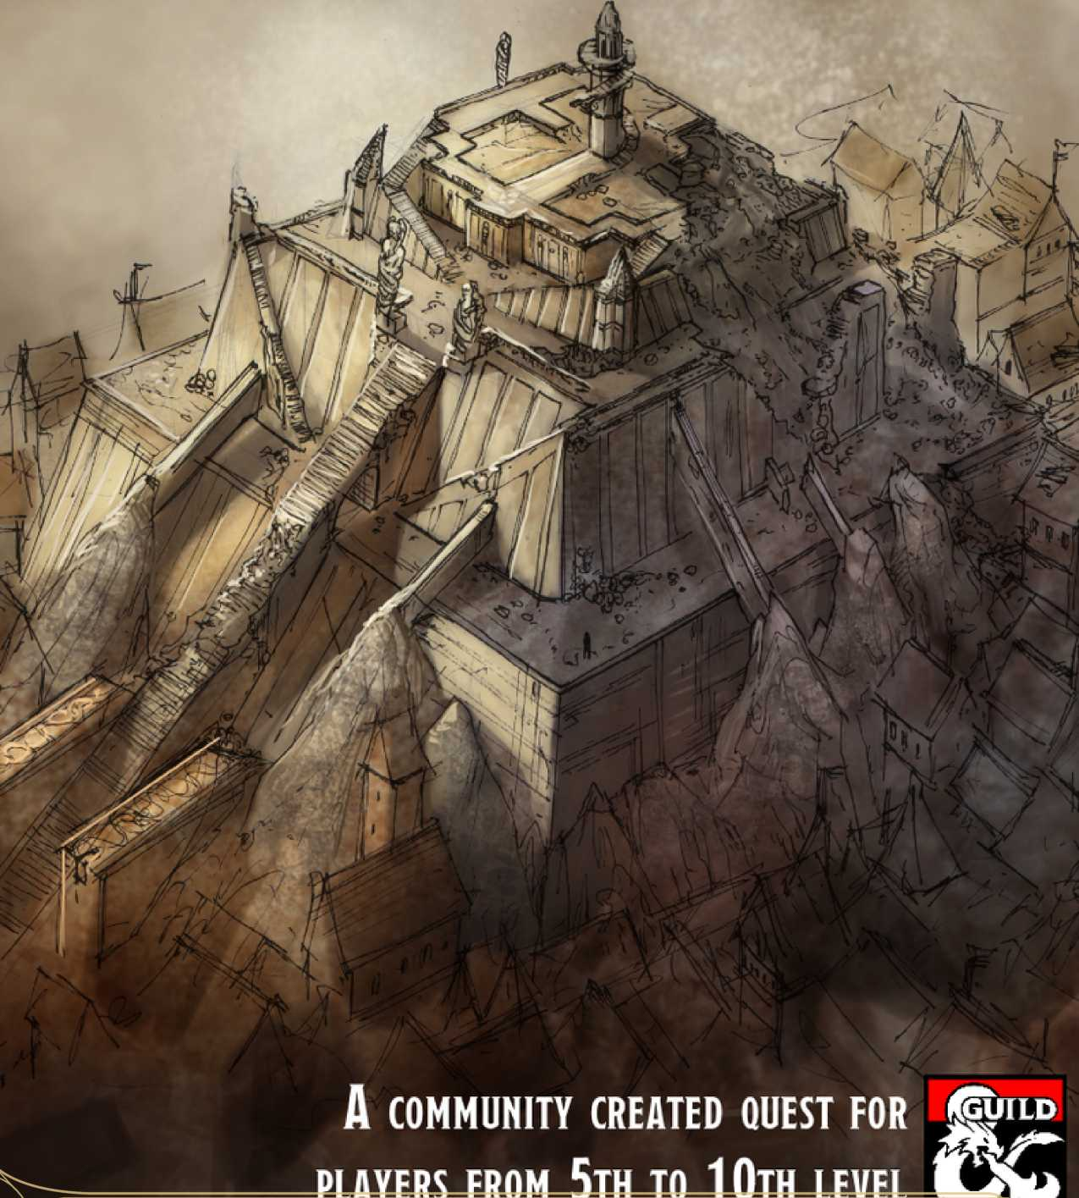

St  
A

n evil has crept into the land. What once was green and lush has now become tinged with a growing frost, and the beating drums of goblinoid hordes and orc warbands can be heard far off at all hours of the day. When you are unexpectedly drawn into this fray, will you have the resolve to fight - or will you, too, fall?

Table Of Contents

**1 Introduction** pg.2

1. **Scene One: Race for Estelminas** pg.3
2. **Scene Two: Siege on Estelminas** pg.5
3. **Scene Three: Secret of Estelminas pg.7**
4. **Appendix A: Optional Modules pg.8**
5. **Appendix B: Treasure pg.9**

**7 Appendix C: Maps** pg. 10

Introduction

*Siege on Estelminas* is a D&D adventure designed for 3-5 players between levels 5-10, with an estimated running time of 3-5 hours. It takes place in the Forgotten Realms setting, but the exact location is left to the DM to decide. By default, Estelminas is found in the Forgotten Forest, west of the ancient elven city of Evereska.

In this adventure, players stumble across a pilgrimage gone awry; a group of elven priests have been brutally murdered and looted whilst on the road. A dying orc nearby reveals the cause: an orc warband is passing through the area, bent on claiming a certain temple they know is somewhere nearby. The priests had been heading there too, having heard of strange and dangerous changes in the local area. That temple is called Estelminas - in Elvish, 'the tower of hope'.

From there it's a race between the players and the orcs to see who can claim Estelminas first. Whoever does will have to contend with the slower party once they finally arrive. But roaming orcs aren't the players' only worry: the cause of the disturbances to the local flora and fauna is the presence of a deadly white dragon which has turned the holy temple into its corrupted lair. Can the players fend off these threats to restore order to the land once more?

How to use this document

As with any good D&D material, this quest is designed to be flexible for the wants and needs of DMs and their players. Though this document includes a plethora of setting descriptions, new items, optional modules and more, feel free to change any aspect to better suit your campaign and players. Note boxes entitled 'DM's Discretion' are provided throughout with suggestions on how you could change this quest to be more suitable for you.

Read it, run it, and enjoy!

k.

Lore: Estelminas

Estelminas - 'the tower of hope' in the Elvish tongue - is a temple with a long history. It was one of the first shrines built to honour Eldath, the goddess of peace, pools, and quiet places. Druids, rangers, clerics and pacifists of all colour and stripe would make regular pilgrimages to sit in silence in the temple's underground spring, meditating and finding inner peace. These pilgrims left feeling spiritually renewed, but they also discovered an even more powerful effect of their trip: they could be physically healed as well. As word spread, there were soon whole hosts of people flocking to the temple to cure everything from blindness to broken bones.

No peace lasts forever, though, and as time moved in its inexorable gyre, those that came to Eldath's pool without true faith in their hearts would find their wounds remained open. Resentment and bitterness began to set in, and before long the river of pilgrims slowed to a trinkle. There may be few outside of druidic circles that even recall the name, let alone the location, of Estelminas.

Today there are a few priests who still visit the temple. The main group of Eldathyns, as they are known, is the Sect of Eldath, a loosely-connected group of elven druids and pacifists scattered across Faerun. The Northern Sect in particular is known to still make annual pilgrimages to the temple. In recent times; however, there have been rumours of strange occurances near the temple in recent times, with an unnatural frost blanketing the land.

Adventure Hooks

By default, players discover the murdered priests by accident whilst wandering the wilderness. However, you might want to provide a more tangible reason for the adventurers to be out there. Some options might include:

* If any players are druids or rangers, they might have already heard of Estelminas and wish to visit it
* Nearby towns and villages may ask the players to investigate the unnatural changes to the local area
* If players visit any shrines, temples, or other holy sites in the vicinity, they might find a survivor from the attacked pilgrim's group who will ask the party to track the orc warband and destory it
* Half-orcs or players with close orc ties (friendly or otherwise) might have heard that a large warband was on the move through the nearby area and should be stopped
* Rumours might still circulate far and wide about a temple with legendary healing properties that hasn't been properly visited for many years

0 n this scene, players find the remains of a massacred pilgrim's party and a lone orc at the doors of death.

I With a warband on the march and something shady

I in the nearby forest, it's not looking good - will the

* Л heroes be smart and swift enough to nip this problem kf/ in the bud?

The Pilgrims' Plight

You've been travelling without incident for a few days now, and though it's been a while since you've seen a tree trunk scarred by an owlbear or the darting shadows of giant spider between the branches, still there is an ominous feeling in your heart. Everywhere there are small signs that something isn't quite right with the area you've wandered into: the streams that criss-cross the ground here are edged with frost, and every time it rains you think you can feel a few flecks of snow catch your face. Such weather is quite unusual for this time of year, and what’s even more disconcerting is that you can't figure out what might cause such a change.

Still, you press on, and it's not long before this underlying anxiety is joined by a more present sense of threat: ahead you can see a rising plume of smoke, and the scent of burning wood is being carried on the chill breeze.

Coming closer to the scene, you can see that a small wagon that had been following this small dirt road has been all but burnt away. A dismal sight surrounds it: four elven men and three women, priests by the look of their white-blue robes and lack of weapons, are scattered in broken and bloodied positions around the wagon. Each of them have been brutally murdered in some stomach-wrenching way. One appears to have had all his limbs torn from his body, whilst another's head has been twisted a full 1 80 degrees around. If there was any wealth in the wagon, it has long since been carried off.

A little farther off you can hear a rasping cough. Sitting against a tree, clutching a wide wound in his side from which his black blood is swiftly escaping, is a battered orc. It takes him a great amount of effort to raise his head to look at you and spit at your feet.

"Come, let me kill a few more before I roam the planes of Acheron!" he coughs, though he is clearly in no condition to stand up, let alone kill you.

The orc will happily use the last remaining breaths he has to boast about his warband, and players that push him for further information may be able to get it out of him. Potential intel, and the relevant checks, are detailed in the table to the right.

The players may decide to heal the orc, but he will not be particularly grateful and will attempt to murder the players at the earliest possible opportunity.

*A*

DM's Discretion

To make the start of this scene more action- packed, consider having the players arrive just as **three orcs** are finishing off the priests. Players might even be able to save one of the priests, who, though too shaken to join them in following the orcs, will gladly give the players any information they desire.

If you use this optional addition, be sure to make it clear that the orcs that killed the priests must have been stragglers from the main warband - otherwise you might lose some of the tension and excitement of the race for Estelminas.

What the orcs know

**Charisma**

**DC Information**

— The orc will gladly reveal that he is part of a larger warband who killed the priests on the road, although the massacre was not their primary goal.

14 The warband are seeking to claim a nearby power that will make them glorious in the eyes of Gruumsh.

1 6 The warband consists of a war chief with his war wagon, a large number of orcs, and even two Eyes of Gruumsh.

1 8 The warband's goal is the fabled temple of Estelminas. Their Eye of Gruumsh has received a vision about the temple, and the war chief wants to plunder its secrets for the glory of Gruumsh. The Eyes of Gruumsh know generally where the temple is - somewhere to the northeast of the party's current location - but not its exact position. This, combined with the slowness of moving the war wagon, means the warband is not making particularly fast progress.

Treasure

There is ld20 cp and a necklace made with small bird skulls on the dying orc, and IdlO sp and some trinkets (see Appendix B) spread amongst the bodies of the priests, as well as a letter on one of the male elves that reads:

*Dearest Falvanel,*

*The Southern Sect of Eldath sends the Northeast Sect welcome and good fortune - however, we must sadly bear sad news. It has reached our ear that the forests near Estelminas have begun to wilt and wither. We fear the worst for this most sacred ofEldath's temples. It is nearly the time of year for your annual pilgrimage, I believe? Please, if you go, take extra care - and inform us if any slither of corruption dares to spoil Eldath's purity.*

*With best hopes and wishes,*

*Alehandria Hand of the Southern Sect of Eldath*

Finding Estelminas

Tracking the orc warband would seem the obvious method for finding the location of Esteminas, but the players' speed, route and random encounters can all have an effect on how long it takes them to arrive, and, therefore, how much time the orcs have to set up defences around the temple.

Tracking the Warband (Slow Pace)

Players may use survival skills to track the warband, which is relatively easy considering their size and the presence of a war wagon. If players move at a slow pace, they are easily able to spot that a **three orc scouts** are trailing behind the main body of the warband to watch for anything following them. This allows the players to surprise the scouts and take them out, or circumvent them. However, due to the players' slow progress, by the time they reach Estelminas it will have been completely taken over by the orc warband (skip to Scene Two).

DM's Discretion

To add some flavour to the players' hunt for Estelminas, consider running a **random encounter** every few hours the players are in the wilderness (a sample random encounter table is provided in Appendix A).

Alternatively, you might include a few small **communities** living near the temple; particularly appropriate groups would include druids or wood elves. These communities may well have been destroyed by the rampaging orc warband, but if they are alive then they will be suffering from the unnatural frost that is plauging the land. As such, they might offer the players extra rewards in return for investigating Estelminas and returning the local area to its usual state. Some sample communities are provided in Appendix A.

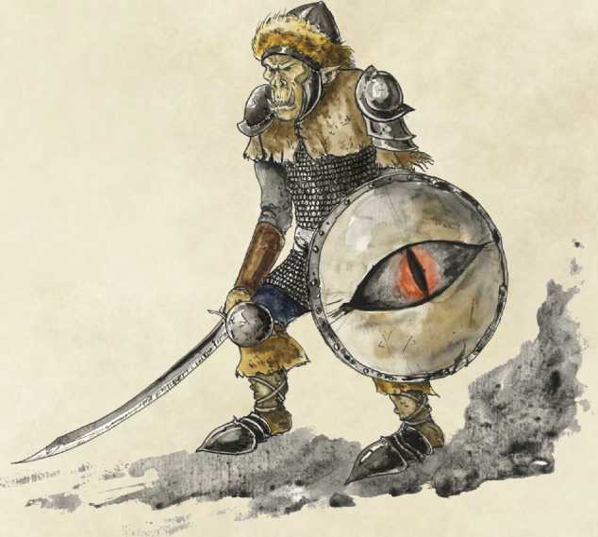

Tracking the Warband (Normal Pace)

If players move at a normal pace, contest the players' passive Wisdom (Perception) against the Dexterity (Stealth) checks of the **three orc scouts.** If the players spot the scouts, they might surprise them or circumvent them; if they don't spot the scouts, the players will be ambushed. Either way, they will arrive at Estelminas after the orcs have claimed it, but before they can really set up a defence (skip to Scene Two}

Tracking the Warband (Fast Pace)

If players move at a fast pace, they will definitely be ambushed by the **three orc scouts** trailing behind the main body of the warband. However, if they defeat the scouts quickly, the players will be able to overtake the warband and reach Estelminas five minutes before the orcs do (skip to Scene Two).

Other Methods

Players may attempt a variety of other methods to reach Estelminas before the orcs. A few options are detailed below:

**Method**

**Check**

**Effect**

Using knowledge of temples in the *DC 16* A player that succeeds on this check recalls that there is an old pilgrim's area to remember the exact location *Intelligence* path that cuts through a dense part of the forest. Taking this path avoids of Estelminas. *(Religion)* the orc scouts and lets players arrive at Estelminas half an hour before the

orc warband.

Using knowledge of famous *DC 16* A player that succeeds on this check recalls that there is an old pilgrim's landmarks in the area to remember *Intelligence* path that cuts through a dense part of the forest. Taking this path avoids the exact location of Estelminas. *(History)* the orc scouts and lets players arrive at Estelminas half an hour before the orc warband.

A player that succeeds on this check deduces that there is an old pilgrim's path that cuts through a dense part of the forest. Taking this path avoids the orc scouts and lets players arrive at Estelminas half an hour before the orc warband.

Using evidence of animal *DC 18* movements, weather conditions, or *Wisdom* other natural phenomena to search *(Survival)* for alternate paths to the northeast.

Using the spirits of the dead priests *Speak with* A player that uses this method can discover the old pilgrim's path through to discover the exact location of *dead spell* a dense part of the forest. Taking this path avoids the orc scouts and lets Estelminas. or similar players arrive at Estelminas half an hour before the orc warband. Players

might also learn extra information about Estelminas and Eldath.

n this scene, players must either lay siege to the temple of Estelminas to reclaim it from the orc warband, or they must defend the temple themselves from the warband's onslaught. The state of the temple will depend on players' actions in Scene One.

Tracked the Warband (Slow Pace)

**OR WERE OTHERWISE WAYLAID**

If the players were too slow in following the warband, or they were otherwise waylaid (because of player mistakes, random encounters, or getting lost, for example} then the orc warband will have had time to claim Estelminas for Gruumsh and begin to set up traps and defences at their new stronghold.

From the edge of the treeline the temple of Estelminas comes into view: the building, constructed from white marble with streaks of brilliant blue, consists of a wide foundation, about ten feet high and fifty feet across, a second, smaller level atop it, and a thin tower that rises up from the centre about thirty feet into the air. There are wide steps on each side of the foundation level, although you can already see that the orcs have begun to set up gruesome barricades out of wooden planks, battered shields, and animal corpses. A vivid red flag has been haphazardly stuck onto the side of the central tower, and you can spot a number of orcs wielding crossbows along the edge of the foundation level.

The warband consists of three distinct waves: a vanguard of **twelve orcs** outside; two **Eyes of Gruumsh** and **eight orcs** inside the temple's antechamber; and **one orc warchief** and **eight orcs** inside the tower. Each wave will join the fight on initiative count 20 (losing initiative ties) ten rounds after combat has been initiated with the previous wave. The barricades provide three-quarters cover, and three bear traps have been set up inbetween the tree line and the temple; stepping on one (DC 16 Perception to spot) restrains the caught creature and deals ld6 piercing damage per turn (DC 12 Strength check to escape}

A frontal assault is not the only option open to the players. On a DC 14 Intelligence (Investigation} Wisdom (Perception) or Wisdom (Survival) check, players might discover a trapdoor hidden by bracken about 15 feet into the forest from the treeline. This trapdoor is a secret escape route which leads into the temple's antechamber. Furthermore, players might be able to convince the orcs that they have come to aid them, or that they wish to challenge the war chief in single combat (successful DC 22 Charisma (Persuasion) or DC 18 Charisma (Deception) check required} For half-orcs, the DC required for such checks is halved.

*Л* b

DM's Discretion

To make the encounter harder, replace three of the orcs in any wave with **one orc Blade of Ilneval**, or replace one orc in any wave with **three orc Nurtured Ones ofYurtrus**.

Tracked the Warband (Normal Pace)

If the players tracked the warband normally, assuming they were not otherwise waylaid, they arrive after the orcs have taken control of Estelminas but before they have had chance to dig in. In your description of the temple, do not include the section about barricades or the red flag. The size of the warband remains the same, but there are no bear traps.

Tracked the Warband (Fast Pace) or

**WENT BY ANOTHER WAY**

If the players overtook the warband then they will have a certain amount of time to set up traps or defences on the temple themselves.

From the edge of the treeline the temple of Estelminas comes into view: the building, constructed from white marble with streaks of brilliant blue, consists of a wide foundation, about ten feet high and fifty feet across, a second, smaller level atop it, and a thin tower that rises up from the centre about thirty feet into the air. There are wide steps on each side of the foundation level, and from its relatively clean condition and absence of life, you can assume you've managed to beat the orcs to it. However, it's unlikely they're far off - with perhaps only a few minutes before the warband arrives, how might you best defend this holy place?

If the players tracked the warband but overtook them, they will have ten minutes before the orcs arrive; if they discovered the secret pilgrim's path or overtook them in some other way (by using vehicles or mounts, or through teleportation magic, for example) then they have half an hour. The list below provides some examples of what players could use this time to do.

Other acceptable activities, as well as the time and materials required and effects, are at the DM's discretion. The second wave will attempt to use the secret passage into the antechamber to surprise the players from behind, unless it has been blocked off. Two of the orcs in the warchief's wave pull the **war wagon,** providing three-quarters cover to any orcs in or behind the wagon. All orcs gain advantage against being frightened whilst they can see the war wagon, but disadvantage if the wagon is destroyed.

Defences

|  |  |  |  |
| --- | --- | --- | --- |
| **Activity** | **Time** | **Materials** | **Effects** |
| Set up crude barricades | 10 mins per 10 ft. square | Wood, metal, shields, etc. | Provides a certain amount of cover depending on the quantity and quality of materials used (DM's discretion). |
| Set up traps | 10 mins per 10 ft. square | Bear traps, sharp spikes, oil, etc. | Dependant on the trap used; traps made from natural materials (like sharp sticks) deal 1 damage of a type appropriate to their design (DM's discretion). |
| Block the doors of 10 mins the antechamber or tower | | Heavy barrels, Blocked doors require a successful DC 1 6 Strength (Athletics) check to open. logs, crates, etc. | |
| Dig a pit | 30 mins per 10 ft. square | Shovel | Creatures that fall in the pit take 1d6 bludgeoning damage for each 10 ft. they fall, and must succeed on a DC 12 Strength (Athletics) or Dexterity (Acrobatics) check to escape. |

Temple Exterior

Now that you're actually on the temple, you can see more clearly that there is a door leading into the tower, but also a spiral staircase that must lead underneath the building.

Antechamber

Taking the spiral staircase down leads you into a square antechamber, about forty feet across, which is dimly lit by a shimmering blue light. It takes you a moment to realise the source is the curtains of ice that surround this room. They look like they might have once been waterfalls flowing from the mouths of face reliefs on each of the four walls, but now they, like much of this area, have been touched by an unnatural frost. A huge wooden door on the far wall is also flecked with snow and ice, partially covering the impressive engravings of rural life that adorn it.

If the players entered via the secret passage (the entrance to which can be discovered whilst in the Antechamber with a successful DC 18 Intelligence (Investigation) check) then the second wave of orcs, including the two Eyes of Gruumsh, will be puzzling over how to open the double doors in this room.

Now that you're closer to it, you can see that the door has no handles or obvious opening mechanisms: it does, however, have a small inscription that you can now read:

*The good are happy when I am known, Though I sound like one who is not whole.*

*Keep me and you shall die in your sleep; Break me and all the world will weep.*

*Speak my name to beckon the quiet.*

The engravings on the doors depict a group of people sat around a pool into which a waterfall flows; all of the worshippers have their fingers to their lips.

The riddle, which is written in Elvish, is an old one amongst Eldath's followers, and druids can attempt a DC 16 Intelligence (History) check to recall it.

Saying the answer - 'peace' - causes the doors to creak open, leading to the Pool of Tranquility (skip to Scene Three). If players are inside the antechamber for more than thirty minutes without opening the door, the **adult white dragon** inside the Pool of Tranquility bursts the door open from the other side (contest the dragon's Dexterity (Stealth) check with the players' Wisdom (Perception) in this case, and skip to Scene Three}

Tower

This tower is hollow, and has a winding spiral staircase around the edge leading up to the top. The stone of the staircase looks old, and you can see some sections of it have already begun to crumble away.

If the warband took control of Estelminas, the third wave, including the orc war chief, will be spread across this tower. Any players wearing heavy armour or carrying a heavy weapon that climb the stairs cause a section about halfway up to collapse; these players, and any creatures 5 ft. in front or behind them, must make a DC 12 Dexterity saving throw to cling to the edge of the stairs, falling to the ground and taking ld6 bludgeoning damage per 10 ft. fallen on a failed save.

The top floor of the tower has a few small windows that look out onto the land below. This room appears to have been a storeroom for pilgrims to keep food and other items. A study chest looks particularly inviting.

Treasure

There are three days of food rations and ld20 cp scattered around the room, and one random Ist-level spell scroll and magical item in the chest (see Appendix B).

n this scene, players finally discover what has been causing the unnatrual changes in the local area: a white dragon has taken over Estelminas, turning its magical waters to ice, and now orc war drums have awoken it. How players first meet the dragon will depend on their actions in Scene Two.

During the battle

On initiative count 20 (losing initiative ties) ten rounds after the players initiate combat with the third wave of orcs, unless they defeat the orcs, the dragon smashes through the stone of the temple's second level and joins the battle, attacking orcs and players indiscriminately. It will retreat to the Pool of Tranquility if it drops to 50 Hit Points or less.

In the antechamber

If players stay in the antechamber for too long without opening the doors, the dragon smells them and attempts to sneak up on them and smash through the doors, attacking them in the antechamber. It will retreat to the Pool of Tranquility if it drops to 50 Hit Points or less.

Pool of Tranquility

After descending some short stairs, you find yourself on a marble balcony in a huge underground cavern, perhaps as much as a hundred feet in diameter. Numerous waterfalls that once flowed from elvish face reliefs are now frozen solid, as is the wide pool which they used to fill. In the centre of the pool is a snow-topped altar, upon which you can still see the glint of gold and silver.

If the players have not yet encountered the dragon, add:

However, this seemingly still and tranquil sight is disturbed by the slow and languid movement of the humungous white- scaled dragon that was curled around the central altar, but now rises to gaze at you with sapphire-blue eyes. A wide, menacing grin begins to form on its face, and it shakes the icicles that had begun to form on its wings as it clambers to its feet. It pulls its head back and gives a deafening roar that shakes the foundation of the cavern and causes icicles the size of spears to drop from the roof, shattering painlessly against the dragon's scales.

This **adult white dragon,** known as Umraneth, has taken up residence here and corrupted the waters that feed the entire area. Six waterfalls around the edge of the room used to form small streams that lead to the central pool, but now they are all frozen. Creatures can jump over the streams with a successful DC 10 Dexterity (Acrobatics) check, slipping on the ice and falling prone on a fail For every 15 feet of movement a creaure takes on an icy surface, they must succeed on a DC 8 Dexterity (Acrobatics) check or fall prone.

Furthermore, creatures that wear heavy armour or wield weapons with the heavy property are at risk of cracking the ice and falling through. Whilst standing on the frozen pool, if such a creature takes the Attack, Shove, or Grapple actions, roll ld20. On a 1, the ice underneath the creature cracks and they fall into the chill waters below. Creatures in the water take ld4 cold damage per turn, and must succeed on a DC 10 Strength (Athletics) check to pull themselves out.

Players might decide to parley with Umraneth inside of fight him. Dragonborn or draconic sorcerers with a chromatic dragon ancestor might be able to form a shaky trust with the dragon, perhaps convincing him that he deserves a more resplendent lair. Players that offer the promise of valuable wealth or powerful magical items might also be able to persuade Umraneth to seek a different home.

Defeating the dragon or convincing it to leave causes the waters to thaw and the local area to return to normal It also dissolves the snow that covers the altar, revealing the treasures of Estelminas.

Treasure

There is 3d20 gp scattered on the altar, along with three silver chalices (worth 10 gp each), two random 2nd-level spell scrolls (see Appendix B), and *Eldath's Pendant.*

Eldath's Pendant

This silver necklace is riddled with streaks of blue, and it holds a small glass sphere that is filled with a slow-moving sapphire-coloured liquid. Whilst you are wearing and attuned to this pendant, you are immune to diseases, have advantage against being frightened, and once per day you can cast either *mass cure wounds, mass healing word,* or *greater restoration,* without any material components. However, if you cause a creature to lose Hit Points or to come under a negative magical effect (the DM decides what constitutes such scenarios), then you lose attunement to the pendant and must re­attune to it during your next short or long rest.

Developments

Once the white dragon has been defeated or driven off, the magical pool at the heart of Estelminas regains its life-giving qualities. Creatures of a good alignment that spend a long rest in the Pool of Tranquility are cured of any poisons, diseases, or negative magical effects afflicting them. Breaking up the orc warband and restoring the natural order of the local area will be a great relief to any local communities and may also draw the attention and patronage of groups such as the Order of the Gauntlet or the Lord's Alliance. However, both the orc tribe that sent out the warband and other chromatic dragons might seek revenge against the heroes.

Appendix A: Optional Modules

TlI  
**dp a**

'or a fuller adventure experience when running *Siege on Estelminas,* consider including or adapting any of these optional modules. These are designed to add customisable flavour to your quest suitable to your wider campaign, setting, and players.

Random Encounters

The following random encounters are designed for the default location of Estelminas in the Forgotten Forest, but they are applicable to many other similar areas.

Random Combat Encounters

**1d10 Encounter**

1. 3d4+2 goblins
2. 2d4+3 hobgoblins
3. 2d4+3 gnolls
4. 1d6 + 3 dryads
5. 1d6 + 3 bugbears
6. 1d6 + 3 dire wolves
7. 1d4 ogres
8. 1d4 centaurs
9. 1d4 displacer beasts
10. 1 banshee

Random Non-Combat Encounters

**1d10 Encounter**

1. Fall into a mass grave of sheep
2. Find a lone mad goblin talking to himself
3. Shoelaces tied together by a quickling
4. Find some carefully arranged stick figures
5. Meet two rangers silently drinking ales
6. Meet a monk meditating in a tree
7. Find the dead body of an armoured knight
8. See the ghost of an elven woman
9. Hear music and laughter for an hour
10. See three female druids bathing in a pond

Random Major Encounters

**1d4 Encounter**

1. Accidentally activate an ancient mythal, causing the weather system in the area to be perpetually misty
2. Discover an abandoned hut with an old shield and a note imploring someone to carry the shield for a year
3. Come across two rival dwarf clans just as they are about to clash over a territory disupte
4. Meet a half-dragon carrying a greatsword and a sack full of gold coins who challenges anyone he meets to a duel, offering the sack as a reward

Communities near Estelminas

If your players prefer more NPC interaction, consider having them stumble across some of these communities whilst they hunt down the location of the temple.

Seeremen'

A dozen wood elves have constructed some simple treehouses high above the forest floor and connected them with thin wooden bridges. They call their home Seeremen' - "place of peace" in the Elvish tongue - because of the serene pool nearby. However, due to the influence of the white dragon, the pool has been frozen over for months, and the wood elves fear the dryads that tended it have died or turned evil from anger. As such, they rarely visit the pool anymore, but they implore any who pass through to try to discover the cause of the forest's unnatural change.

Rednarth's Copse

Three small huts huddle close amongst a dense thicket of trees here, housing three brothers and their families. The Rednarths have lived quiet lives in these huts for generations, with the men travelling north on the twentieth birthday in search of a suitable wife to bring back to the copse. They are simple folk with a close tie to the land and a reverence for Mielikki, the goddess of the forest, which is why they are distraught at the sudden changes the area has undergone. They will happily offer food and shelter to those that promise to cure the forest's woes.

Malar's Watch

This small tower is difficult to spot, considering the blanket of vines and moss that are growing across the exterior. Four rangers eek out a brutal existance here, following the dogma of Malar the Beastlord, the god of hunting and bloodlust. The rangers, who call themselves "the Hunt", spend their days sharpening their skills and senses by tracking down all manner of creatures, sentient or not. Though they will not immediately attempt to kill any players who approach, they will certainly be less than friendly, and if they think the heroes might prove enough of an enjoyable hunt, they might stalk them once they leave.

Balenberg

Two dozen enterprising dwarves have discovered an overlooked vein of silver running underneath the forest floor, and have carved out a small village underground. They are friendly enough, but considering their relatively isolated existence, they are somewhat suspicious of strangers. Nevertheless, they're in no position to turn away good trade, and will be happy to let players stay in the safety of the town - for a price, of course. The dwarves are in particular need of coin considering their mining operations have hit a dead end. It seems a few months ago the silver all but dried up, though the dwarves have no idea how such a thing could happen. The cause, of course, is the powerful aura of the nearby white dragon, which is warping even the substance of the earth. The dwarves will be very grateful if the adventurers manage to restore the rock to its former profitable glory.

se the tables here to randomly generate the

M treasure in this adventure, or select the

***jl ■*** treasure you feel best suits your campaign ***Я*** I and players.

Adi

Trinkets

These small items are practically worthless, but they may carry sentimental attachments for some.

**1d20 Trinket 1d20 Trinket**

|  |  |  |  |
| --- | --- | --- | --- |
| 1 | A small crystal that floats above water | 11 | A small voodoo doll of an unknown figure |
| 2 | A star-shaped copper coin | 12 | A pendant with a sun­shaped symbol |
| 3 | A small figurine of a cow | 13 | A pyramid-shaped piece of stone |
| 4 | Two cotton shoelaces tied together | 14 | A drity handkerchief |
| 5 | A map of an unknown region | 15 | A pair of darned purple socks |
| 6 | A small pouch of old teeth | 16 | A collection of coloured sticks |
| 7 | Seven buttons on a piece of string | 17 | A small box of matches |
| 8 | A wooden spoon | 18 | A battered quill |
| 9 | A pair of spectacles | 19 | Three simple earrings |
| 10 | A sack with pieces of coal inside | 20 | A collection of differently-shaped dice |

2nd-Level Spell Scrolls

**1d10 Spell**

1. *Augury*
2. *Blur*
3. *Cordon of Arrows*
4. *Darkness*
5. *Enhance Ability*
6. *In visibility*
7. *Lesser Restoration*
8. *Mirror Image*
9. *Pass Without Trace*
10. *Suggestion*

3rd-Level Spell Scrolls

**1d10 Spell**

1. *Bestow Curse*
2. *Counterspell*
3. *Dispel Magic*
4. *Fear*
5. *Glyph of Warding*
6. *Haste*
7. *Magical Circle*
8. *Mass Cure Wounds*
9. *Remove Curse*
10. *Revivify*

Spell Scrolls

These scrolls contain intructions for casting particular spells, but they crumble to ash when used. Full descriptions of these spells can be found in the *Player's Handbook.*

1st-Level Spell Scrolls

**1d10 Spell**

1. *Armour of Agathys*
2. *Burning Hands*
3. *Comprehend Languages*
4. *Cure Wounds*
5. *Detect Magic*
6. *Identify*
7. *Sanctuary*
8. *Sleep*
9. *Unseen Servant*
10. *Witch Bolt*

Magical Items

These artefacts can confer powerful magic effects on their wielders and wearers. Full descriptions of these magical items can be found in the *Dungeon Master's Handbook.*

**1d10 Magical Item**

1. *Bag of holding*
2. *Driftglobe*
3. *Potion ofgreater healing*
4. *Potion of resistance*
5. *Elemental gem*
6. *Cap of water breathing*
7. *Goggles of night*
8. *Mariner's armour*
9. *Wand of secrets*
10. *Robe of useful items*

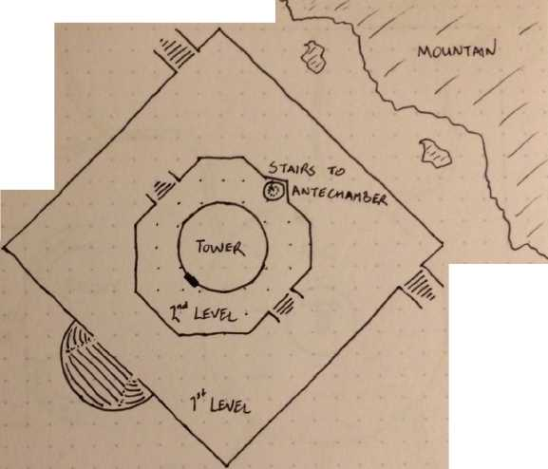

hough these maps be little, yet they be fierce. Use them to give you a sense of the scale and dimensions of Estelminas, but adapt them in whatever ways seem best for your purposes.

ft ? fl ґ ft

ft

4

ft

ft

o" R;

П *n a л* A *Sector* 1

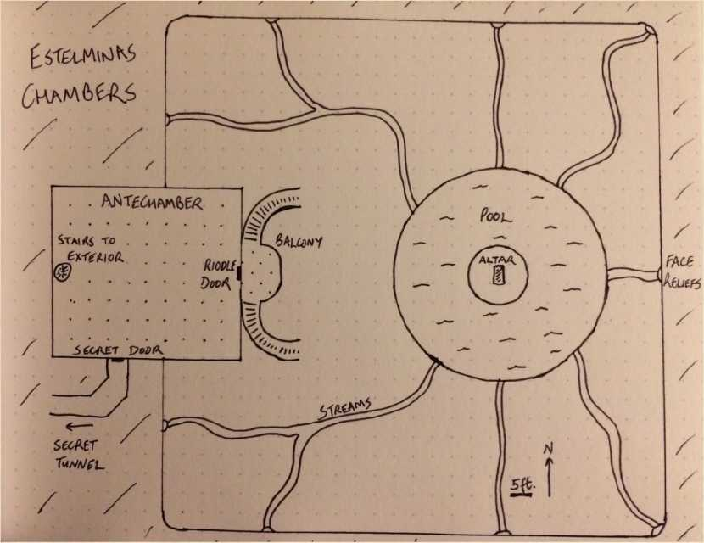

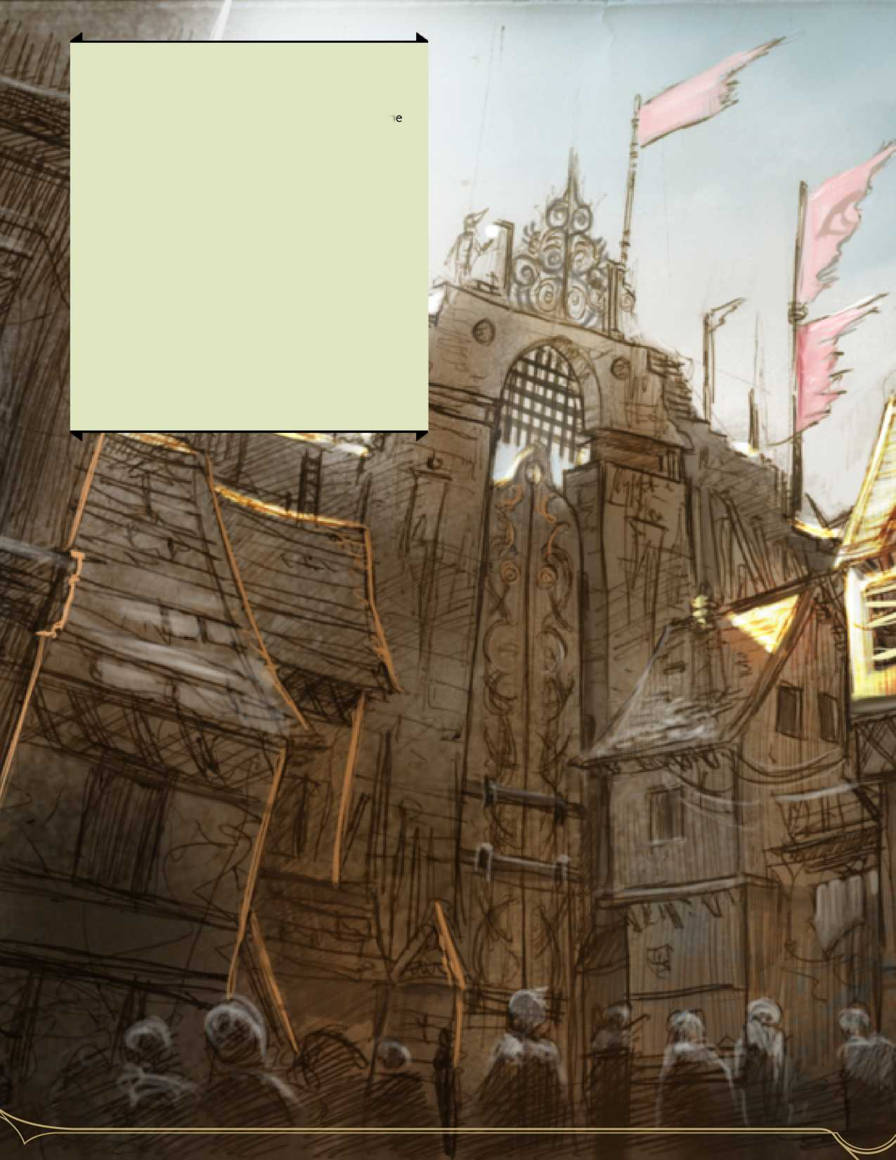

ms,

names,

are

labelled for commercial reuse. Please contact the

author immediately if you believe image copyright has been infringed.

This work contains material that is copyright Wizards of the Coast and/or other authors. Such material is used with permission under the Community Content Agreement for Dungeon Masters Guild.

All other original material in this work is copyright [201 7] by Benjmain Campbell and published under the Community Content Agreement for Dungeon Masters Guild.

All images used in this document have been

**Credits**

Written and created by Benjamin Campbell (a.k.a. bangbangyouaredead) using the Homebrewery.

DUNGEONS & DRAGONS, D&D, Wizards of th Coast, Forgotten Realms, Ravenloft, the dragon ampersand, and all other Wizards of the Coast product names, and their respective logos trademarks of Wizards of the Coast in the USA and other countries. >