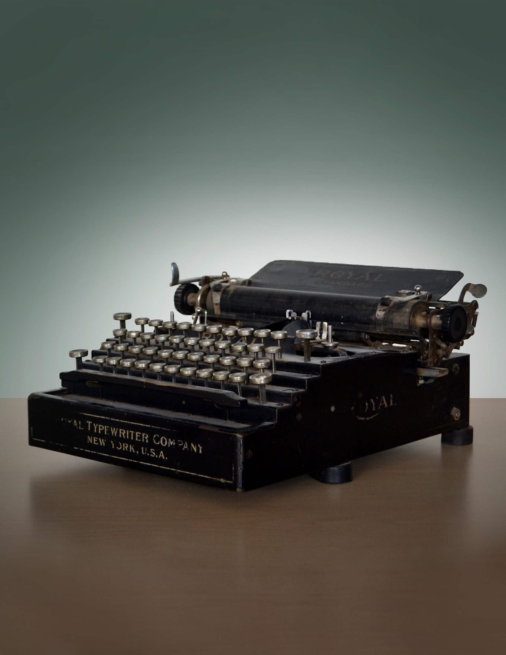
Put Your
Title Here
And a Subtitle if you Wish



Your Name Here
Write a tagline for this supplement
for the world’s greatest roleplaying game

Credits
Designer: (Credit here)
Editor: (If you have an editor, credit them here)
Art Director: (If you have an art director, credit them here)
Graphic Designer: (Credit here)
Template: Simple Microsoft Word Template by Laura Hirsbrunner
Cover Illustrator: (Credit here)
Interior Illustrators: (Credit here)
Special Thanks: (Credit here)
Playtesters: (Credit here)

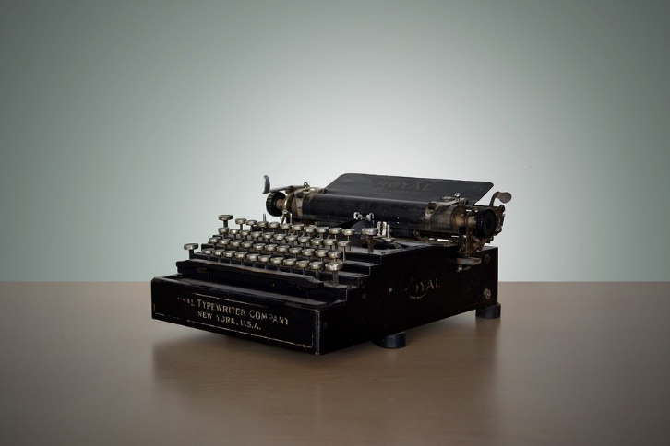
ON THE COVER
This is how you can give more information about your pretty cover art and interior art, a la Wizards hardcovers. In this case, the lovely typewriter photo was taken by Wild0ne.
To replace the picture inside the above frame (while keeping the frame), click on the picture, then select the Picture Format tab. Click Change Picture, and you can select a new picture to put in its place.
Disclaimer: The designer of this template did not come up with a clever disclaimer, but felt obligated to format this template with it nonetheless.
DUNGEONS & DRAGONS, D&D, Wizards of the Coast, Forgotten Realms, Ravenloft, Eberron, the dragon ampersand, Ravnica and all other Wizards of the Coast product names, and their respective logos are trademarks of Wizards of the Coast in the USA and other countries.
pp
This work contains material that is copyright Wizards of the Coast and/or other authors. Such material is used with permission under the Community Content Agreement for Dungeon Masters Guild.

All other original material in this work is copyright 2020 by YOUR NAME HERE and published under the Community Content Agreement for Dungeon Masters Guild.

Table of Contents
Tip: Update the Table of Contents
Once all your Chapter Titles, Heading 1s, and Heading 2s are properly labeled with paragraph styles, it’s easy to auto-generate a table of contents. Right click on the TOC on this page and click Update Field, then Update Entire Table.
Note: by default, it willalso pull in any chapter titles from before it in the document; e.g. the Credits and About sections above. You can always manually delete any line in the TOC after updating, if you don’t want those to show here.

Credits 1
Table of Contents 2
Using This Template 3
Quick Style Guide 4
Heading 1 4
Heading 2 4
Samples to Copy 5
Sample Spell 5
Sample Magic Item 5
Sample Tables 5
Sample Monster 6
Sample Class 7
Class Features 7
Spellcasting 8
Sample Sidebar 8
Sample List 8
Publishing Your Finished Document 9
Using Images 10
Inserting Art 10
Positioning Your Image 10
Image Effects 10
Miscellaneous FAQ 11

Samples to Copy
This section provides specialized text that you might commonly encounter, designed for easy copy-and-paste.

Sample Spell
This is a sample spell, formatted using this template so you can see the text styles in action. Note: spells generally use H3 even if they don’t have an H2 before them.

Expeditious Retreat
1st-level transmutation
Casting Time: 1 bonus action
Table in Text Box—You Can Drag This Around
Level | Max. CR | Limitations | Example
2nd | 1/4 | No flying or swimming speed | Wolf
4th | 1/2 | No flying speed | Crocodile
8th | 1 | - | Giant Eagle

Range: Self
Components: V, S
Duration: Concentration, up to 10 minutes
This spell allows you to move at an incredible pace. When you cast this spell, and then as a bonus action on each of your turns until the spell ends, you can take the Dash action.
Two Side-by-Side Tables—In Text Box
d100 | Result |  | d100 | Result
01-08 | This is a result |  | 59-64 | This is a result
09-13 | This is a result |  | 65-74 | This is a result
14-19 | This is a result |  | 75-78 | This is a result
20-22 | This is a result |  | 79-80 | This is a result
23-27 | This is a result |  | 81-83 | This is a result
28-42 | This is a result |  | 84-85 | This is a result
43-44 | This is a result |  | 86-92 | This is a result
45-53 | This is a result |  | 93-94 | This is a result
54-56 | This is a result |  | 95-96 | This is a result
57-58 | This is a result |  | 97-00 | This is a result

Sample Magic Item
This is a sample magic item, formatted using this template so you can see the text styles in action. Note that magic items generally use H3 (even if they don’t have an H2 before them, as in this section).

Boots of the Winterlands
Wondrous item, attunement (requires attunement)
These furred boots are snug and feel quite warm. While you wear them, you gain the following benefits:
- You have resistance to cold damage.
- You ignore difficult terrain created by ice or snow.
- You can tolerate temperatures as low as −50 degrees Fahrenheit without any additional protection. If you wear heavy clothes, you can tolerate temperatures as low as −100 degrees Fahrenheit.

Sample Tables
Tables use the “5E – TABLE CELL” paragraph style; for headers, use the same style, but add the “*5E – CHAR BOLD” character style to it.
There are two ways you can display tables, depending on your needs. They can either be placed in-line with your body text (as if they’re just another block of text), or they can be placed in a text box (which allows them to float freely so you can move them to different sections of the page). This section contains samples of each for easy copy-and-pasting. If you click on a table then go to the Table Design tab, under Table Styles there is a “5E TABLE” style that produces the alternating colored rows seen in this section.
Table Inline with Text—This Moves With Text
Level | Max. CR | Limitations | Example
2nd | 1/4 | No flying or swimming speed | Wolf
4th | 1/2 | No flying speed | Crocodile
8th | 1 | - | Giant Eagle
Two Side-by-Side Tables—Inline With Text
d100 | Result |  | d100 | Result
01-08 | This is a result |  | 59-64 | This is a result
09-13 | This is a result |  | 65-74 | This is a result
14-19 | This is a result |  | 75-78 | This is a result
20-22 | This is a result |  | 79-80 | This is a result
23-27 | This is a result |  | 81-83 | This is a result
28-42 | This is a result |  | 84-85 | This is a result
43-44 | This is a result |  | 86-92 | This is a result
45-53 | This is a result |  | 93-94 | This is a result
54-56 | This is a result |  | 95-96 | This is a result
57-58 | This is a result |  | 97-00 | This is a result

Sample Monster

Single-Column Stat Block Title
Stat block metadata
Armor Class 10
Hit Points 9 (2d8)
Speed 30 ft.
STR DEX CON INT WIS CHA
10 (+0) 10 (+0) 10 (+0) 10 (+0) 14 (+2) 11 (+0)
Saving Throws enter here
Skills enter here
Damage Resistances enter here
Damage Immunities enter here
Condition Immunities enter here
Senses darkvision 60 ft., passive Perception 12
Languages enter here
Challenge 1/4 (50 XP)
Inline Subhead. The inline header has the bold/italic character style, and this paragraph uses the “5E – STAT BLOCK BODY PARA1” style.
Rarely, you may need to have a second paragraph for a particular monster feature; when you do, use the PARA2 style to remove the space before it and add a first-line indent.

Stat Block Heading
Multiattack. This continues using the same stat block body style as in the previous section.
Really Big Stick. Melee Weapon Attack: +9 to hit, reach 10 ft., one target. Hit: 12 (2d6 + 5) bludgeoning damage.

This is a sample monster, formatted using this template so you can see the text styles in action.

Two-Column Stat Block Title
Stat block metadata
Armor Class 10
Hit Points 9 (2d8)
Speed 30 ft.
STR DEX CON INT WIS CHA
10 (+0) 10 (+0) 10 (+0) 10 (+0) 14 (+2) 11 (+0)
Saving Throws enter here
Skills enter here
Damage Resistances enter here
Damage Immunities enter here
Condition Immunities enter here
Senses darkvision 60 ft., passive Perception 12
Languages enter here
Challenge 1/4 (50 XP)
Inline Subhead. The inline header has the bold/italic character style, and this paragraph uses the “5E – STAT BLOCK BODY PARA1” style.
Rarely, you may need to have a second paragraph for a particular monster feature; when you do, use the PARA2 style, which removes the space before it and adds a first-line indent.
Spellcasting. The creature is a 1st-level spellcaster. Its spellcasting ability is Wisdom (spell save DC 12, +4 to hit with spell attacks). The acolyte has following cleric spells prepared:
Cantrips (at will): light, sacred flame, thaumaturgy
1st level (3 slots): bless, cure wounds, sanctuary

Stat Block Heading
Multiattack. This continues using the same stat block body style as in the previous section.
Really Big Stick. Melee Weapon Attack: +9 to hit, reach 10 ft., one target. Hit: 12 (2d6 + 5) bludgeoning damage.
Another Really Big Stick. Melee Weapon Attack: +9 to hit, reach 10 ft. one target. Hit: 15 (3d6 + 5) bludgeoning damage.

Legendary Actions
Legendary action instructions use “5E – STAT BLOCK BODY PARA1” just as the text in previous section did.
Legendary Action. Be sure to use the “5E – STAT BLOCK HANGING” style for your legendary actions, not the body style. And use the bold character style for each one’s title.
Legendary Action. This is another legendary action.
Legendary Action. This is another legendary action.

Sample Class
Column-Width Class Table
Level | Proficiency Bonus | Features
1st | +2 | Fighting Style, Second Wind
2nd | +2 | Action Surge (one use)
3rd | +2 | Martial Archetype
4th | +2 | Ability Score Improvement
5th | +3 | Extra Attack
6th | +3 | Ability Score Improvement
7th | +3 | Martial Archetype feature
8th | +3 | Ability Score Improvement
9th | +4 | Indomitable (one use)
10th | +4 | Martial Archetype feature
11th | +4 | Extra Attack (2)
12th | +4 | Ability Score Improvement
13th | +5 | Indomitable (two uses)
14th | +5 | Ability Score Improvement
15th | +5 | Martial Archetype feature
16th | +5 | Ability Score Improvement
17th | +6 | Action Surge (two uses)
18th | +6 | Martial Archetype feature
19th | +6 | Ability Score Improvement
20th | +6 | Extra Attack (3)

This has samples of class/subclass features, formatted using this template so you can see the text styles in action, along with the class tables for easy copy and paste.

Class Features
Use the following templates to format your class features.

Hit Points
Hit Dice: Use the “5E – CORE HANGING” style, bolding the text before colon using “*5E CHAR BOLD.”
Hit Points at 1st Level: Same as above.
Hit Points at Higher Levels: Same as above.

Proficiencies
Armor: Likewise, all of these proficiencies should use “5E – CORE HANGING” style, bolding the text before colon using “*5E CHAR BOLD.”
Weapons: Insert weapons here
Tools: Insert tool proficiencies here
Saving Throws: Insert saving throws here
Skills: Choose two from [list here]

Equipment
Equipment lists should use “5E – CORE BULLETS”:
- (a) a wooden shield or (b) any simple weapon
- (a) a scimitar or (b) any simple melee weapon
- Leather armor, an explorer's pack, and a druidic focus
Full-Width Class Table
Level | Proficiency Bonus | Features | Cantrips Known | 1st | 2nd | 3rd | 4th | 5th | 6th | 7th | 8th | 9th
1st | +2 | Druidic, Spellcasting | 2 | 2 | — | — | — | — | — | — | — | —
2nd | +2 | Wild Shape, Druid Circle | 2 | 3 | — | — | — | — | — | — | — | —
3rd | +2 | — | 2 | 4 | 2 | — | — | — | — | — | — | —
4th | +2 | Wild Shape Improvement,  Ability Score Improvement | 3 | 4 | 3 | — | — | — | — | — | — | —
5th | +3 | — | 3 | 4 | 3 | 2 | — | — | — | — | — | —
6th | +3 | Druid Circle feature | 3 | 4 | 3 | 3 | — | — | — | — | — | —
7th | +3 | — | 3 | 4 | 3 | 3 | 1 | — | — | — | — | —
8th | +3 | Wild Shape Improvement,  Ability Score Improvement | 3 | 4 | 3 | 3 | 2 | — | — | — | — | —
9th | +4 | — | 3 | 4 | 3 | 3 | 3 | 1 | — | — | — | —
10th | +4 | Druid Circle feature | 4 | 4 | 3 | 3 | 3 | 2 | — | — | — | —
11th | +4 | — | 4 | 4 | 3 | 3 | 3 | 2 | 1 | — | — | —
12th | +4 | Ability Score Improvement | 4 | 4 | 3 | 3 | 3 | 2 | 1 | — | — | —
13th | +5 | — | 4 | 4 | 3 | 3 | 3 | 2 | 1 | 1 | — | —
14th | +5 | Druid Circle feature | 4 | 4 | 3 | 3 | 3 | 2 | 1 | 1 | — | —
15th | +5 | — | 4 | 4 | 3 | 3 | 3 | 2 | 1 | 1 | 1 | —
16th | +5 | Ability Score Improvement | 4 | 4 | 3 | 3 | 3 | 2 | 1 | 1 | 1 | —
17th | +6 | — | 4 | 4 | 3 | 3 | 3 | 2 | 1 | 1 | 1 | 1
18th | +6 | Timeless Body, Beast Spells | 4 | 4 | 3 | 3 | 3 | 3 | 1 | 1 | 1 | 1
19th | +6 | Ability Score Improvement | 4 | 4 | 3 | 3 | 3 | 3 | 2 | 1 | 1 | 1
20th | +6 | Archdruid | 4 | 4 | 3 | 3 | 3 | 3 | 2 | 2 | 1 | 1

Spellcasting
This section is included to show how to format the spellcasting ability lines, as well as bonus spells.

Spellcasting Ability
You can format the below spell save DC and spell attack modifier lines using “5E – CORE SPELLCASTING ABILITY.”

Spell save DC = 8 + your proficiency bonus + your Wisdom modifier
Spell attack modifier = your proficiency bonus + your Wisdom modifier

Bonus Spells
If a subclass grants bonus spells, use the standard table format, which is copied below for ease of use. It’s recommended that you use an inline table, not one floating in a text box, since these should always fall immediately after the bonus spells section.

Sample Spells Table
Class Level | Spells
3rd | spell name, another spell name
5th | spell name, another spell name
7th | spell name, another spell name
9th | spell name, another spell name

Sample Sidebar
You can copy and paste the following sidebars or read-aloud text boxes. Within each box are examples of the formatting used. Note that both boxes use the same sidebar text styles; read-aloud boxes are formatted the same way.
These are easily resized to be full-width or single-column, so this template doesn’t provide a separate example of full-width sidebars.

Sample List
Rarely, you may need to make a list that has two half-columns within the standard column. You can see this in chapter 11 of the PHB, where it lists all the spells by class list. The simplest way to create such a list in Word is to use a table with two columns, a single row, and no borders or shading. When you enter text, enter all of it within the same row instead of splitting across rows, as follows.
Read-Aloud Text (Uses Sidebar Styles)
To create a read-aloud text box, click on this text box, then insert your content here. This paragraph’s style is “5E – SIDEBAR PARA1.” (yes, it uses the same text style as sidebars.)
The second paragraph of your read-aloud text should be formatted using “5E – SIDEBAR PARA2.” The sidebar title is “5E – SIDEBAR TITLE.”
You can also copy and paste this read-aloud text from within the text box into the main text of your document. Pros: it will be perfectly aligned with your text, you don’t have to drag it around. Cons: you can’t drag it around unless you leave this read-aloud text within the text box that contains it.

List Title  Lists should use “5E – List Item” for a hanging indent  List item  List Title  List item  List item | List Title  List item  List item  List Title  List item  List item  List item

You can also create single-column lists using the same “5E – LIST ITEM” style within the main body of the document.

List Title
List item
List item
List item
Sidebar Title
To create a sidebar, click on this text box, then insert your content here. This paragraph’s style is “5E – SIDEBAR PARA1.”
The second paragraph of your read-aloud text should be formatted using “5E – SIDEBAR PARA2.” The sidebar title is “5E – SIDEBAR TITLE.”
You can also copy and paste this sidebar from within the text box into the main text of your document. Pros: it will be perfectly aligned with your text, you don’t have to drag it around. Cons: you can’t drag it around unless you leave this sidebar within the text box that contains it.
This sidebar has an example of bulleted text:
- These bullets use the “5E – SIDEBAR BULLETS” style.
- This is another bullet.
And for good measure, some hanging indents too.
Hanging Indent. This uses the “5E – SIDEBAR HANGING” style, which functions just like the hanging indents in body text.
And if you wanted to put a spell in here, you can reuse the sidebar title, as seen with the spell title below. However, by default, the sidebar title doesn’t have any space before it, so you can either insert a line break before the title, or change the paragraph spacing on the sidebar title.

Expeditious Retreat
1st-level transmutation
Casting Time: 1 action
Range: Self
Components: V, S
Duration: Concentration, up to 10 minutes
This spell allows you to move at an incredible pace. When you cast this spell, and then as a bonus action on each of your turns until the spell ends, you can take the Dash action.



Your Back Cover
Blurb Here
Lorem ipsum dolor sit amet, consectetur adipiscing elit. Maecenas mattis felis vel dapibus condimentum. Donec eget tellus mauris. Vestibulum lacinia facilisis elit vitae volutpat. Aliquam id pellentesque ligula. Nulla rutrum dapibus turpis in tincidunt. Morbi laoreet maximus ante et elementum. Donec ut massa nunc. Suspendisse erat lectus, elementum eget leo id, pellentesque aliquet magna.
Phasellus condimentum dolor lobortis justo sagittis, id rhoncus ante pellentesque. In hac habitasse platea dictumst. Integer vitae aliquet felis. Lorem ipsum dolor sit amet, consectetur adipiscing elit. Vestibulum bibendum eu velit quis vehicula. Nunc pharetra tellus vitae sem sodales.
Etiam quis hendrerit turpis. Praesent iaculis tellus vel est tempor viverra. Ut ac faucibus lacus. Sed nunc lorem, porttitor in consequat at, volutpat nec mi. Pellentesque in massa lorem.

