WATERDEEP  WAZOO NEWS
Editor: Shah Chien
We Dig Deep
Since 1400
Lord Neverember Returns!

Renear Neverember, the estranged son of ousted and once most hated man of Waterdeep, Lord Dagult Neverember, has returned! Or has he? Historians and human great grandparents will remember the role of Neverember during the days of Tiamat but modern day Waterdavians love a bit of gossip. Naturally, all manner of wild speculation have been thrown about from ward to ward; from talks about vast undead armies in the north coming to reclaim the thrown, to talk of a vast hidden treasure within the city, there really is no tale to far-fetched for the locals. The truth of the matter however, may never emerge but all stories share one thing in common. People swear they have seen Renear in Waterdeep. If true, that alone could mean great changes are on the horizon but what are they? Does he plan to seize back the thrown in his fathers name, take his families so –called embezzled fortune, or is he simply passing by. Either way perhaps this reporter should stop writing articles and get digging or packing depending on which is true? Hmm maybe an autograph will suffice. Anyone who has seen this man? Contact Shah Chien.

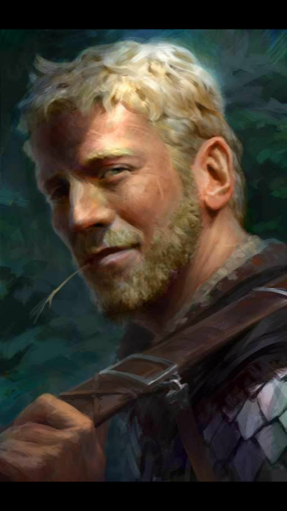

“Growing” Epidemic
The Devil Grass, known colloquially as “Sewer rot”, epidemic continues to spread. Popular among half-lings and gnomes, and notorious for providing users with a heightened sense of awareness, this rose smelling herb is becoming something of a public health threat. Clerics conclude that while initial usage may be euphoric, continued use can lead to muscle spasms, body deterioration and even death. Researchers and herbalists, with financial backing from House Thann and Cassalanter have been working on a cure for those already experiencing side-effects. See you local Herbalist for details.

Religious fervor or fever?
Should Waterdeep look to changing its age old pantheon? Well, reilgious skeptics and certain guild officials are calling for it. Recently Asmodeus ‘cultists’ and Lathandar ‘worhipers’ have been clashing in a series of escalating violent protest in the trade ward and others. When asked for a statement Seath Cromley of the city watch stated, “Enough is enough. Religion should be kept in the mind and temples of our glorious city and off the streets to allow businesses, traffic and above all public well-being to flourish.”
Continued on w-1

From W-1
Naturally supporters of the groups insist that the multifaceted pantheon is what helps to give Waterdeep it’s flavor and so far city higher up have agreed with them, stating “Freedom of worship is akin to a freedom of speech issue. All beliefs and deities are welcome in Waterdeep” But views akin to those of Sergeant Cromley are not as rare as they once were. So will Waterdeep eventually see some sort of religious reformation? Only time and public opinion will tell.

Day of Wonder Clean up begins
As with every year the great Day of wonder celebration bring all Waterdavians out of their homes and out into the street. And the highlights of the day and night are still a buzz in local taverns. Garloths ‘wonderful apparatus’ was the talk of the Dock Ward and the Karns ‘wax figures’ were as fascinating as they were mesmerizing. But everyone was disappointed at the absecence of the proclaimed “Xoblob Orb” which despite the build-up could not be found on the day. Eccentric owner of the orb itself as well could not be located for details. Perhaps it was cold feet that led Xoblob to withdraw his invention this year. Regardless grand parades of Marpenoh are not finished. The large house size floats of Marp. 30th are being made by the Carpentry guild city wide for the Months most elaborate festivities and before that a large public clean up initiative is underway lead by the Emerald Enclave to help clear room down the bustling streets for guild members participating in Stoneshal. With so much going on in one month, one always must ask themselves, do the people of Waterdeep every do anything ELSE but party?
The Urmbrusk Gala
The Urmbrusk manor in Undercliff entrepreneurial gala was also held that night. The sparkling cocktail hour saw all of the noble houses in their evening best though many were disappointed that the lovely Ammalia Cassalanter could not attend to the ceremonies. The dance hour saw its own spectacle during the waltz as three unknowns took to the floor. A handsome Tabaxi and gorgeous elf took the stage first to the ooh’s and aah’s of the crowd until a tall slim noble gentleman cut in to clearly steal the show. Who are these three onlookers? Attendees say the Tabaxi is a man named Tiberious Crawford, ladies, perhaps a new eligible bachelor in Waterdeep? Though people seemingly could not remember the names of the other two. Regardless all three had charmed much of the crowd. Soon the unlikely couple of a homely looking druid woman and a rather nimble footed dwarf took the floor before all the rest of the onlookers stormed the stage. Finally the presentation portion of the evening, which for many is a time to beat the traffic home, came and went but there were still some standouts. Notably the dancing dwarf of previous mention displayed a finely made armor that we may presumably see in shops by the Drawing Down it seems his ability on the dance floor are matched only by those at the forge.


ARTS AND ENTERTAINMENT

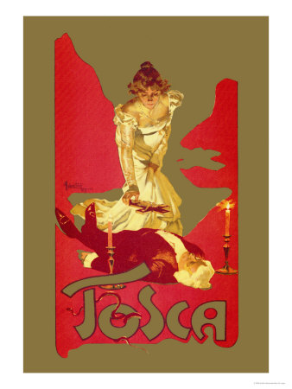

TOSCA ★★★★★

Tosca is a hit. Roland Ronquan and his marvelous production troupe at the glamourous The Seven Masks theater have outdone themselves yet again and critics are raving. This year the company takes on an exotic and epic story of love, loss and suffering set in the Far East. Malkolm Brizzenbright takes the lead roll once again in what critics are calling “the performance of a lifetime”. Performances will run twice weekly until the end of Chal. Get your tickets now!
DRUMPF: A MUSICAL. (NO STARS)
The country-rock operetta Drumpf: A musical based on the infamous deformed, horrific, and demonstrably ignorant orange troll of its name sake is, yes, still a proven insult to theater. Making it’s debut at the Whitehouse theater over 2 years ago, this dumpster fire should be avoided and ignored at all costs. And yet it seems to have its fair share of knuckle dragging supporters that pay for tickets and so it is, yes, still there. Despite the leading role delivering a performance that has been called “the most disappointing, grossly inefficient, dangerous and grotesque performance of a generation.” Make Art Great Again says this reporter and stop feeding this horrific troll.

Is Waterdeep ready for Chult?

From the distant region of Chult, this giant lizard riding athlete have travelled far and are bound to make their debut at the Field of Triumph by the end of Marpenoth. “But are its citizens ready?”, asks the head coach. “ Chult riders deliver aggressive, high-speed and often deadly action that is not for the weak of heart”. Well, he will find out soon enough as tickets go on sale from M-10. Do you have Chult blood in you? Or on you? Well you will if you get a front row seat to these incredibly exiciting and incredibly dangerous sporting events.

The Seamaidens Fair enters port!
The acclaimed pleasure and gambling vessel the Seamaidens fair has entered port last weekend and will stay in port until the end of Marpetnoth says its captain, Captain Zardoz Zord. So if you have the coin and a penchant for gambling and revelry then book a night aboard this most decadent of floating casinos. But sure to dress smart and bring a 5 platinum minimum to enter. For that cost lets hope the tables onboard the Seamaiden play ‘Fair’.

CRIME
Alleyway assassin
5 Dock ward gnomes were found with arrow wounds to the head near the Northward on M-4. The deceased all had traces of Devil grass in their system but investigators are not ruling out foul play. Any information should be reported to the city watch.
Candle Land Arson Case
Investigation into the Candle factory fire on Marpenoth 1 lead authorities to believe that several parties may have been at play. Evidence of Zhent and Sclera mob personel has been found yet details as to the mysterious Kenku and another third party are still coming in. Annonymous sources claim that recent immigrants may be responsible for the fire.
Drow Boat? Nope.
No sign of Drow invaders have been discovered on the mysterious boat landings found last week. City watch officials have made the announcement that while residue of the underdark was, in factm found in the vessel there is no evidence of Drow collusion



THE QUEENSPIRE LIGHTHOUSE WILL BE CLOSING NEXT WEEK FOR RENEVATIONS. Tourists looking to get take the long climb to the top for its remarkable view of the harbor are encouraged to go within the week as the construction is likely to continue on through the winter months.

BOOKWYRM BOOKSELLERS

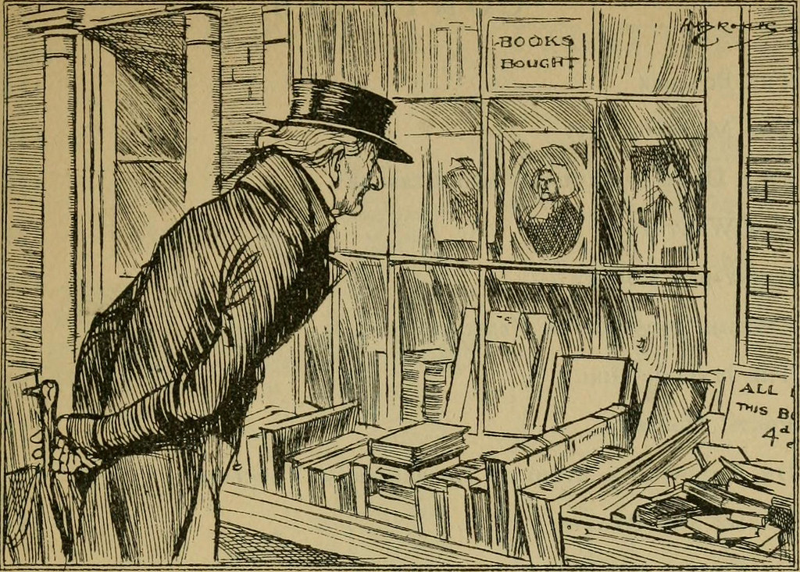

Your one shop for quality reads.

New releases on sale now
‘Rise of Tiamat and the Lords alliance: A compendium of history Figures of the Sword Coast and Waterdeep’
and
‘Roses are blue’ a compendium of B-poems.

BUSINESS IN BRIEF
STONESHAL (M-7)
The Guild of Carpenters and Stonemasons in conjunction with House Kael will be out in force to christen the many new projects around Waterdeep for Stoneshal
A new series of Lavish residential are in the Northward will begin construction overseen by Frostbear Masonry and the Urmbrusk Investment group.
(M-8)
Snobeetle Orange Wine is poised to announce a new line of sweet winter wines available on M-8.
(M-9)
The Temple of Beauty in the Seaward has open a new wing to its already luxurious bath houses after M-& construction. This new wing is meant to bring its bathers the feeling of the distant exotic sand dunes and oasis of Ahm.
REIGN OF MISRULE (M-10)
Endshift tavern ( of the field ward fame)’s newest baked hot cakes are all the rage. Curious foodies should be sure to check it out. And see if they sell, like, well, hot cakes.
GODS DAY (M-10)
Griffon academy will open its mountaintop gardens in a rare opportunity for locals to view the serene gardens.

LIARDS NIGHT (M-30)

Standing room only left available for the anticipation of the newest masterpiece by Volothamp Gedarm who will be reading form his book “The Mad Mage of Undercliff” at the Book Wyrms Trade Ward location.



SPEAK OF THE SPLENDOR

-A.S. Enough of such blatant passions. It will jeopardize the, you know what. Meet me at our spot on M9 -A

-What happened to all that gold Lady Silverhand, Tiamat needed a horde, well, what happened to it all. Screw you damn corrupt officials. Waterdeep is run by crooks!
-Can someone find my son. I believe he has gone in with the wrong crowd. A Halfling and a tielfilng Please help me find him. He is a good boy really. Goes by the name of Nathan. -B Fairkettle
-These so called Man-kins really creep me out. Are they really going to be a thing now? Id rather shop without seeing my clothes on weird human statues thanks.

-I will leave you here. Til the starving Ravens come and feast at your sumptuous eye balls. With each peck gnawing at the nerve until you perish
72 N, 200 EAST, 10 N, RAVEN
-House of Doors locksmith, we open any lock!
-Can someone find my son. I believe he has gone in with the wrong crowd. A Halfling and a tielfilng Please help me find him. He is a good boy really. Goes by the name of Nathan. -B Fairkettle
-Mar-10 CoMe meat us at ONORbul Night , U, BRAVE who Cum back to SEwarz

-Tiberius is a fraud. Don’t listen to him. -Anonymous

-Yo X? Where you hiding out. I need my rot, ya know. Hook a D. up! -57

-Seriously they print anything? Booby, booby booby. Pickle pickle. Hahaha. Hilarious. –Squiddly.

-Cellars to be dug out!? A hidden treasure? This month of all times?! It’s a conspiracy you know! The lost gold of Tiamat is here somewhere. And I am going to find it! -Z
-the Steeled Ghost should be called the Stealing Ghost as they tend to like taking other bars namesake logos and altering them slightly. All customers should be sure to visit the Bronze Bell and not the Steeled Ghost.
-Run now Waterdavians! The army is coming. I saw it myself. Run now. The army is coming. We are all doomed.

WANT TO PLACE AN AD OR COMMENT IN THE WATERDEEP WAZOO, CONTACT SHAH CHIEN FOR INFORMATION

