Adventure Format Guidelines

Beginning on the next page, this document contains the format, the paragraph styles, and the character styles that we expect you to use when writing an adventure. Please read the documentation of your word processor if you don’t know how to use such styles. The easiest way to do so is to overwrite the text included here. These styles are the same as those provided in the 5E Template.dotx file, which you should also have on hand. Study the 5E template carefully, including the header hierarchy and inline headers, so you understand how to organize the adventure’s information.

For an example of a recent adventure, refer to Dragon Heist. This adventure provides the best examples of this presentation in action. If you don’t have a copy, you may request one.

Consult The Chicago Manual of Style (17th edition) if you have questions about punctuation, grammar, and other matters of writing style. Our preferred dictionary is Merriam-Webster’s Collegiate Dictionary (11th edition).

# 

DDXX$$-$$

Adventure Title

Adventure Subtitle

\’;



Adventure description goes here. This should appear as it does in the adventure’s concept. If part of a series of adventures, it should be annotated here.

A Two/Four to Four/Six-Hour Adventure for Tier $ Characters. Optimized for APL $.

# Credits

Lead Designer: Susie Smith

Designer: Hilda Jones

Editing: Travis Woodall, Greg Marks

D&D Adventurers League Guildmaster: Chris Lindsay

Art Director & Graphic Design: Rich Lescouflair

D&D Adventurers League Wizards Team: Adam Lee, Ari Levitch, Chris Lindsay, Mike Mearls

D&D Adventurers League Administrators: Alan Patrick, Amy Lynn Dzura, Travis Woodall, Lysa Chen, Claire Hoffman, Greg Marks

Playtesters:

DUNGEONS & DRAGONS, D&D, Wizards of the Coast, Forgotten Realms, the dragon ampersand, Player’s Handbook, Monster Manual, Dungeon Master’s Guide, D&D Adventurers League, all other Wizards of the Coast product names, and their respective logos are trademarks of Wizards of the Coast in the USA and other countries. All characters and their distinctive likenesses are property of Wizards of the Coast. This material is protected under the copyright laws of the United States of America. Any reproduction or unauthorized use of the material or artwork contained herein is prohibited without the express written permission of Wizards of the Coast.

©2019 Wizards of the Coast LLC, PO Box 707, Renton, WA 98057-0707, USA. Manufactured by Hasbro SA, Rue Emile-Boéchat 31, 2800 Delémont, CH. Represented by Hasbro Europe, 4 The Square, Stockley Park, Uxbridge, Middlesex, UB11 1ET, UK.

# Adventure Primer

This adventure is designed for three to seven $- $-level characters and is optimized for five characters with an average party level (APL) of $. Characters outside this level range cannot participate in this adventure.

This adventure occurs in $.

## Background

Provide a reasonably complete BACKGROUND for the ADVENTURE in this section. The background is the story that takes place before the player characters come on the scene, but BITS AND PIECES are revealed to the PLAYERS during the course of the adventure, which allows them to make some sense of what is going on.

There’s a fine line between two little background and too much exposition. Try to stay on the side of the line that doesn’t bloat the background with backstory that isn’t ultimately important. This section can appear before or after the OVERVIEW section.

Keywords should be CAPITALIZED and BOLDED the first time they appear in the Background. This alerts the DM to the adventure’s more important aspects.

## Overview

The adventure’s story is spread over three parts and takes approximately $ hours to play. The adventure begins with a Call to Action scene. It also contains two optional bonus objectives—each taking an additional hour to play.

* Call to Action: Name The first encounter in the adventure is the Call to Action, a brief scene that sets the group on their adventure.
* Part #: Name. Each part of the adventure should have its own entry of one to two sentences describing the part. This is Story Objective A/B.
* Bonus Objective #: Name. If the adventure contains Bonus Objectives, each should have its own entry of one to sentences describing it. This is found in Appendix 1/2.

## Adventure Hooks

Every adventure needs some way for player characters to become involved. If the adventure doesn’t have an obvious hook elsewhere, you can present one or more adventure hooks in a section such as this. Once you’ve finished your first draft of the adventure, it’s possible you’ll find you’ve sprinkled another hook or two into the adventure you didn’t initially imagine. Add any further hooks into this section after you’ve finished writing.

Adventure Hook 1. Provide a few suggestions for the DM to use and for players to expand upon.

Adventure Hook 2. These individual hooks should be presented in short, individual paragraphs preceded by an Inline Subhead.

Adventure Hook 3. Keep them general so that the players can fill in the specific details for their own characters.

Adventure Hook 4. Good examples include ties to characters’ Backgrounds (sage, soldier, urchin, etc.), factions, races, and classes. Even participation in prior adventures can be used.

# Adventure Flowchart

This section provides a basic understanding of not only the flow of the adventure, but also the outline of the different paths that your players may take in reaching their stated objective.

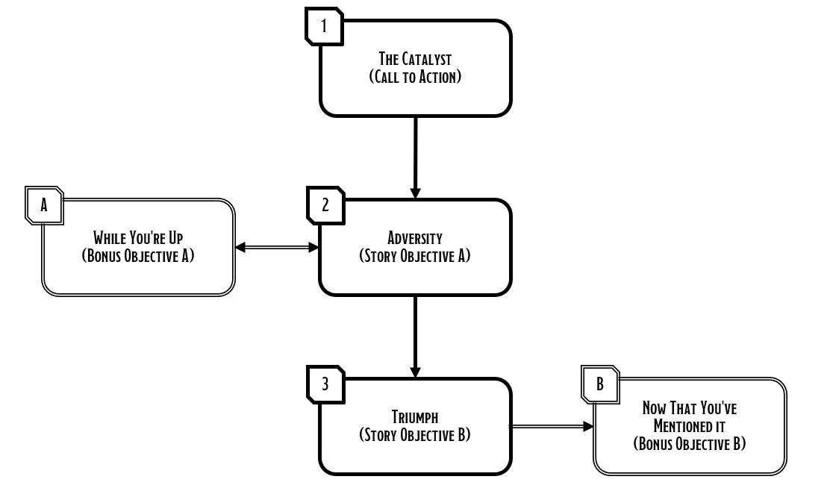

# Part #: General Area or Section Name

Estimated Duration: ## hours ## minutes

Heading 1 headers include parts (if the adventure is structured in such a fashion) and appendices. The estimated duration above should reflect the amount of time a group would spend completing the part at a normal play pace (i.e., neither rushed nor playing with heavy distractions).

## Setting Information

This section describes any features that are common throughout a location, below. Exceptions should be conveyed under an Area Information entry in specific areas.

Other subheadings might include important events, goals, or subsections (such as traps or other) that provide the DM with important information regarding such things that may be relevant over a number of different locations.

### Call to Action, Story Objective, Etc.

Identify the Call to Action or any Story Objectives contained in the part here.

## ##. Location or Event Name

If the subsection is a location on a map, then the location number precedes its name.

Boxed text should be used very sparingly—only when a particularly important event truly calls for it. Don’t use it to describe rooms or normalcy. Additionally, it should be short and to the point, no more than one or two brief and descriptive sentences.

The body of the counter should be found in the headings below; the boxed text should only provide a narrative for exciting events.

### Area/Creature Information, Treasure, etc.

Heading 3 subheaders are most commonly “Area Information,” “Creature Information,” “Treasure,” and “Objectives,” but might also feature notable events or suggestions on how to conclude an encounter or progress to the next one, etc. Within the running text under these headers, names of creatures or other significant game objects such as traps or secret doors are in bold. Use boldface judiciously. With the exception of creature names, it usually applies to important objects that are keyed on the map. Bold creature names should match the names that appear in the statistics.

Inline Header Name. The inline header sits under an H3 and can be used to organize the presented information.

### ##a-z. Sub-location

Heading 3 is also used if a location is divided into multiple smaller sections. For example, “14a. Abandoned Jail Cell,” “14b. Occupied Jail Cell.” This subdivision should only be used if the sub-locations have enough detail to merit individual descriptions.

Sidebar Heading

A sidebar should appear in close proximity to its relevant sections, but it’s not tied to a specific location in the running text. It should provide the DM with background information that may help run the location or event. With the exception of Playing the Pillars (see example, below), it shouldn’t provide directly applicable information.

For an example of the presentation in action, refer to the next page.

## 33. The Mad Dwarf

An insane dwarf named Von lives in this secret room, which was built as a shelter for the king in case the complex was overrun.

The room can be accessed only through one of two secret doors. The northern secret door requires a successful DC 20 Intelligence check to spot. To open the door, one merely presses on it and slides it into a narrow cranny to the west. For information on the southern secret door, see area 32.

A greasy, irate-looking dwarf in a stained leather apron with a bulging pocket stands between the contraptions. He clutches a handaxe in one hand and has a sock puppet on the other. “Go away!” the puppet snaps.

### Area Information

The area has the following features.

Dimensions & Terrain. The majority of this 20-by-40-foot room is occupied by three white marble tables and benches covered in various equipment and surrounded by chairs. One of the tables bears some sort of lightning coil powered by cave rats running in a carousel, another a complex contraption of spring-loaded axes and hammers, and a third with a series of beakers, tubes, and burners—no doubt some sort of alchemical distillery.

Lighting. The only light in the room is the flickering lightning emanating from the lightning coil that provides brief moments of bright light.

Lightning-Go-Round. This contraption stands apart from the others and uses a rat-powered exercise wheel (and three live cave rats) to create arcs of lightning between a pair of copper rods. Any creature touching the rods or any metal-armored character standing next to the table is zapped for 2 (1d4) lightning damage.

Alchemical Distillery. Von makes a vile “turnip beer” using an alchemical process he calls “ripen-squeezing.” The gases produced by this process are combustible; any open flame, or fire or lightning spell effect within 5 feet of the contraption causes it to explode—destroying all of the contraptions in the room and forcing each creature in the room to make a DC 15 Dexterity saving throw. On a failed save, a creature takes 30 damage of various types: 10 (3d6) fire, 4 (1d8) bludgeoning, 2 (1d4) lightning, 4 (1d8) piercing, and 10 (3d6) slashing, or half as much on a successful save.

BONUS OBJECTIVE $. If utilizing this additional content, the characters find a secret button, labeled “DON’T PRESS.”

### Creature Information

The harmless dwarf is named Von (a shield dwarf). His sock puppet, Aldo, does the talking.

Adjusting the Scene

Here are some suggestions for adjusting this scene:

* Very Weak: Use the guidance in DMG, Ch.5
* Weak: Replace a goblin with two kobolds
* Strong: Remove three yetis
* Very Strong: Aldo has 100 hit points.

What Do They Want? Von is more focused on his work here than anything else—something the characters are currently distracting him from. As long as the characters aren’t “too interested” in the contraptions, Von is happy to demonstrate how they work. Aldo, however, takes umbrage at their intrusion and tells Von (out of earshot) that “They know too much!”

What Do They Know? Von (or Aldo?) killed Larloss and knows the monster next door helped, but doesn’t freely admit to it.

Playing the Pillars

Here are some suggestions for this encounter:

Combat. Von pulls a flask of alchemist’s fire out of the bulging pocket of his apron and hurls it at the alchemical distillery which erupts in multi-colored flames—he’d rather see it destroyed than used to implicate him.

Exploration. Each contraption has an AC of 5 and 5 hit points (immune to poison and psychic damage). A contraption reduced to 0 hit points is destroyed.

Social. If the characters accuse Von of killing Larloss (see area 22), Aldo might reply, “You can’t prove anything!” If they claim to have an eyewitness, Aldo tells Von “Don’t let ‘em take us alive!” and then attacks.

### Treasure

Von has sewn a hidden pocket inside his sock puppet containing one iron coin (see Iron Safes and Iron Coins).

# Rewards

At the end of the session, the characters receive rewards based upon their accomplishments.

## Character Rewards

The characters earn the following rewards:

### Advancement

Upon successfully completing this adventure, each character gains a level. At their discretion, they may choose to decline advancement. Remind your players that the amount of gold that their characters can earn per level is limited; declining advancement means that they may reach a point where they earn no gold.

### Gold

Award each character gold for each hour of the session. Adventures typically features cues for this, but you can add it where you see fit. The maximum gold that you can award a character per hour is determined by their tier, as follows:

|  |  |  |
| --- | --- | --- |
| Tier | Hourly GP Award | GP Limit per Level |
| 1 | 20 gp | 80 gp |
| 2 | 30 gp | 240 gp |
| 3 | 200 gp | 1,600 gp |
| 4 | 750 gp | 6,000 gp |

### Magic Item(s)

If found during the adventure, the characters can keep the following magic items; these items are described in Appendix $:

* $
* $
* $
* $

## Dungeon Master Rewards

For running this adventure, one of your character gains a level. That character receives gold based on their tier prior to advancement:

|  |  |
| --- | --- |
| Tier | GP Earned |
| 1 | 80 gp |
| 2 | 240 gp |
| 3 | 1,600 gp |
| 4 | 6,000 gp |

You may also complete DM Quests for running this adventure. See the Adventurers League Dungeon Master’s Guide for more information.

# Dramatis Personae

The following NPCs feature prominently in this adventure.

Von (VAWN). This guy is nutty as a fruitcake.

* What They Want:
* Fruitcake, Meet Nuts:

Aldo (AWL doe). The actual brains behind the operation. No-nonsense. Also a puppet.

* What They Want:
* The Brains of the Operation:

# Creature Statistics

Stat Block Title

Stat block metadata

Stat Block Data Take a look at stat blocks in the Monster Manual to see how these styles translate into a finished block. The section below uses the Stat Block Ability Score style.

STR DEX CON INT WIS CHA

X (+X) X (+X) X (+X) X (+X) X (+X) X (+X)

Stat Block Data Notice that there’s no colon after the bold headings in a stat block.

Inline Subhead. Stat Block Body. The paragraphs below the data section use the Stat Block Body style.

Stat Block Heading

Inline Subhead. The Stat Block Heading style above is used for section starts like “Actions” and “Reactions.”

* Stat Block Bulleted. This is the style for a bulleted list in a stat block.

Stat Block Hanging. Use this style for things like spell lists.

Stat Block Modifications

This creature has the following modifications:

* AC 18 (plate armor), and 13 (2d10 + 2) hit points.
* Replace its resistance to cold damage with resistance to fire damage.

# Appendix ##: Objective Title (Bonus Objective A/B)

Estimated Duration: 60 minutes

# Appendix ##: Maps, Handouts, Etc.

# Appendix ##: Character Rewards

If found during the adventure, the characters can keep the following magic items; it’s suggested that you print off enough copies of this page to be able to give one to each of your players (crossing out rewards they didn’t receive during the session):

## Gauntlets of Lorem Ipsum

Item Metadata

Item description goes here. The item’s metadata (rarity, item type, etc.) goes first, then the mechanical properties from the DMG. This item is found in the <Insert Book Title>

The adventure-specific description of the item is provided in a separate final paragraph.