# Thieves’ Guild of Restov, Brevoy

* Contact: “We’ll find you we need to.”
* Restov’s criminal underworld is interested in expanding their operations and establishing new smuggling routes.

## Investment Offer

### Requirements

* A black market district is built within the capital within 2 years
* Guild operations will not be subject to law enforcement
* The guild gets to choose the candidates for either the Marshall or the Royal Enforcer position

### Benefits

* Initial investment of 20 BP
* +2 BP if the kingdom’s alignment is Chaotic
* The guild will keep the council informed of its operations to avoid any unfortunate situations
* If for some reason a guild operation goes awry and a public scapegoat is needed, a scapegoat will be provided to the council for punishment
* A generous monthly stipend will be supplied to the council in exchange for their discretion
* Buildings that increase a settlement’s Crime modifier can be built at a 10% discount
* The kingdom takes a -1 penalty to its Economy modifier
* After the black market in the capital is built, there is a 20% chance that Unrest will increase by 1 during each Event phase

# Church of Abadar, Brevoy

* Contact: Silver Keybearer Vetuse Lodovka, a jovial human female priest of Abadar
* Abadar is the unifying religious power in Brevoy, favored of the merchant and tradesman class, as well as those nobles more interested in prosperity through trade and the rule of law than the iron fist of battle. The bearers of Abadar’s golden key are pleased to offer funds to get your kingdom started, although they ask that in return create a safe place for wealth to pass hands.

## Lesser Investment Offer

### Requirements

* 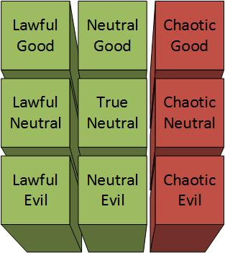A shrine to Abadar is built in the capital city within 5 turns
* The kingdom’s alignment cannot be Chaotic
* Judges or their equivalent must be approved by the church, and trials must proceed according to Abadar’s precepts
* After the kingdom has existed for a year, the church can claim dominion over one of the kingdom’s road or river hexes for its own use for a period of 5 years

### Benefits

* Initial investment of 7 BP
* Kingdom settlements with a temple district gain +2 Law and +2 Productivity

## Greater Investment Offer

### Requirements

* 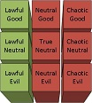A temple to Abadar is built in the capital city within 12 turns
* A market district is built in the capital city within 24 turns
* The kingdom’s alignment must be Lawful
* Judges or their equivalent must be approved by the church, and trials must proceed according to Abadar’s precepts
* After the kingdom has existed for a year, the church can claim dominion over one of the kingdom’s road or river hexes for its own use for a period of 10 years
* The High Priest must be a worshipper of Abadar in good standing with the church
* The church gets to choose the candidates for either the Treasurer or Marshall (or High Priest, if needed) position

### Benefits

* Initial investment of 20 BP
* +1 BP if the Ruler is a worshipper of Abadar in good standing with the church
* Kingdom settlements with a temple gain +2 Law and Productivity, or +4 if the settlement has a cathedral
* If the capital city has a cathedral, the kingdom gains +1 Economy.

# Church of Gorum, Brevoy

* Contact: Spear-Chaplain Krevan Surtova, a stern human male priest of Gorum
* Gorum speaks to the needs and interests of the nobility of Brevoy: strength through force of arms and prowess in battle. The ironclad priests of the church are happy to offer sponsorship to your fledgling kingdom, as long as you aim to create a warrior nation worthy of the Iron Lord.

## Lesser Investment Offer

### Requirements

* 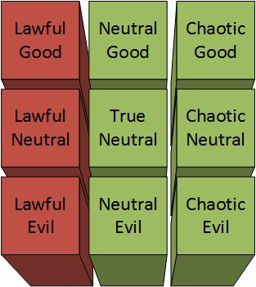A shrine to Gorum is built in the capital city within 6 turns
* The kingdom’s alignment cannot be Lawful
* Mandatory militia training for able-bodied citizens overseen by the church
* After the kingdom has existed for a year, the church can claim dominion over one of the kingdom’s border hexes for its own use for a period of 6 years

### Benefits

* Initial investment of 5 BP
* One military structure can be bought or upgraded at ¾ price in kingdom settlements with a temple district

## Greater Investment Offer

### Requirements

* 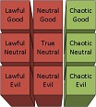A temple to Gorum is built in the capital city within 14 turns
* A barracks district is built in the capital city within 8 turns
* The kingdom’s alignment must be Chaotic
* Mandatory militia training for able-bodied citizens overseen by the church
* After the kingdom has existed for a year, the church can claim dominion over one of the kingdom’s border hexes for its own use for a period of 12 years
* The High Priest must be a worshipper of Gorum in good standing with the church
* The church gets to choose the candidates for either the General or Warden (or High Priest, if needed) position

### Benefits

* Initial investment of 18 BP
* +1 BP if the Ruler is a worshipper of Gorum in good standing with the church
* One military structure can be bought or upgraded at ¾ price in kingdom settlements with a temple district, or at ½ price if the settlement has a cathedral
* If the capital city has a cathedral, once every 5 years an elite military commander can be recruited who starts play with 1 boon, or an existing commander with no boons can be trained to gain 1 boon

# Church of Pharasma, Brevoy

* Contact: Naluska the White, an eccentric female human priest of Pharasma
* Pharasma is the divinity of the common people of Brevoy, who are far more acquainted with the local bone-thrower, midwife, and black-clad mortician-monk than they are with the splendid clerics of Abadar or Gorum. Her priests are proud to sponsor your kingdom, providing that they can ensure that it respects the cycle of life.

## Lesser Investment Offer

### Requirements

* 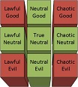A shrine to Pharasma is built in the capital city within 4 turns
* The kingdom’s alignment must have a Neutral component, on either axis
* “Black” necromancy and the undead must be barred from the kingdom
* Internment or disposal of the dead must be supervised by the church

### Benefits

* Initial investment of 4 BP
* Kingdom settlements with a temple district gain +2 Lore
* If the capital city has a temple district, there is a 1% chance each kingdom turn that Pharsma’s priests will discern the nature of the next turn’s event, if any.

## Greater Investment Offer

### Requirements

* 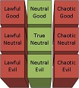A temple to Pharasma is built in the capital city within 10 turns
* A graveyard district is built in the capital city within 5 turns
* The kingdom’s alignment must be Neutral on the Law-Chaos axis
* “Black” necromancy and the undead must be barred from the kingdom
* Internment or disposal of the dead must be supervised by the church
* The High Priest must be a worshipper of Pharasma in good standing with the church
* The church gets to choose the candidates for either the Magister or Warden (or High Priest, if needed) positions

### Benefits

* Initial investment of 15 BP
* +1 BP if the Ruler is a worshipper of Pharasma in good standing with the church
* Kingdom settlements with a temple gain +2 Lore, or +4 if the settlement has a cathedral
* If the capital city has a temple district, there is a 2% chance each kingdom turn that Pharsma’s priests will discern the nature of the next turn’s event, if any. If the capital city has a cathedral, the chance is increased to 3%.

# Church of Erastil, Brevoy

* Contact: Father Wochek Kolhout, an affable human male priest of Erastil
* Practitioners of this ancient faith has heard rumors of forgotten holy sites being uncovered in the Narlmarches, and are keen to see them restored. They do not have much coin to offer, but have manpower and expertise to spare.

## Investment Offer

### Requirements

* 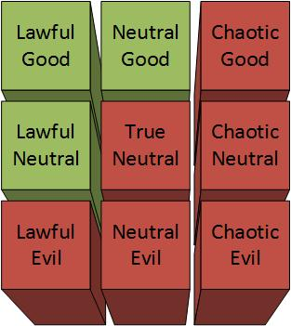A shrine to Erastil is built in the capital city within 8 turns
* The kingdom’s alignment must either Lawful or Good or both, and cannot be Chaotic or Evil
* A settlement is built at the site of the Temple of the Elk within 2 years
* The Temple of the Elk is restored within 6 turns after the settlement is founded

### Benefits

* Initial investment of 6 BP
* +1 BP if the High Priest or Ruler is a worshipper of Erastil in good standing with the church
* Kingdom settlements with a temple gain +2 Law and -2 Society

# Church of Cayden Cailean, River Kingdoms

* Contact: Gelfrord Folhopple, a witty male gnome priest of Cayden Cailean
* Local worshippers of Cayden Cailean raise a cup in honor of one of their own stumbling into a position of influence. They hope that the new kingdom will be an easy-going place that welcomes weary travelers with good ale and good company.

## Investment Offer

### Requirements

* 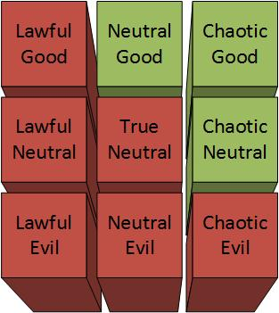An inn district is built in the capital city within 4 turns
* A brewery district is built in the capital city within 8 turns
* The kingdom’s alignment must either Chaotic or Good or both, and cannot be Lawful or Evil
* Kingdom holiday frequency cannot be less than 6/year for the first year, and 12/year thereafter

### Benefits

* Initial investment of 4 BP
* +1 BP if the High Priest is Travaris Stone
* Kingdom settlements with a temple gain -2 Law and +2 Society
* Exploration edicts cost -1 BP per month (minimum 1 BP)

# Church of Gozreh, River Kingdoms

* Contact: Adar the Rainwalker, a wild-looking male human priest of Gozreh
* Gorzeh’s faithful are not very numerous or wealthy. However, they will give what aid they can to help a new River Kingdom that respects the wild aspects of nature.

## Investment Offer

### Requirements

* A shrine to Gozreh is built in the capital city within 4 turns
* The kingdom’s alignment must have a Neutral component, on either axis
* Hexes with unusual flora or fauna (e.g. moon radishes) must be preserved
* Settlements are limited to 2 districts

### Benefits

* Initial investment of 4 BP
* +1 BP if the High Priest is Iofur
* Settlements with a temple gain a +2 bonus on rolls vs. monster attacks and bad weather events

# The Green Faith

* Contact: Mediator Druga Kahlholm, a somber female dwarf druid
* The Green Faith has long held an interest in the Stolen Lands, both because of its unusual concentration of fey and its fierce resistance to colonization. They offer their resources to a kingdom that will both respect nature and seek to maintain the balance.

## Investment Offer

### Requirements

* A grove (use shrine statistics) is built in the capital city within 5 turns
* The kingdom’s alignment must be True Neutral
* For every three developed hexes, an undeveloped hex will be set aside for preservation
* Hexes with unusual flora or fauna (e.g. moon radishes) must be preserved
* The High Priest must be a member of the Green Faith in good standing with the local druid circle
* The local druid circle gets to choose the candidates for the Councilor (or High Priest, if needed) position

### Benefits

* Initial investment of 14 BP
* +1 BP if the Ruler is a follower of the Green Faith in good standing with the local druid circle
* If a kingdom settlement has a grove and is in good standing with the local druid circle, that settlement and its surrounding hexes gain a +4 bonus on rolls vs. bad weather events

# House Halasin of Osirion

* Contact: Lord Halas Halasin, your former adventuring companion!
* While his familial responsibilities prevent him from adventuring with you, Halas is overjoyed to hear of your success, and wishes to help out your fledgling kingdom.

## Investment Offer

### Requirements

* 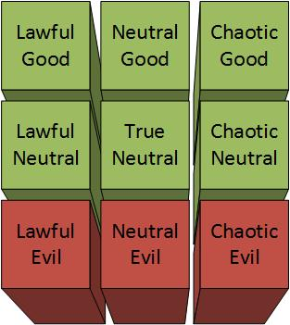The kingdom’s alignment must not be Evil
* Slavery must be outlawed throughout the kingdom
* Salar the Hunter gets first pick of leadership roles

### Benefits

* Initial investment of 2 BP

# House Balmont of Brevoy

* Contact: Lord Strathmir Balmont, an unctuous human male noble
* House Balmont is the house of Travaris Stone’s father. Strathmir, the current leader of the house, would prefer that Travaris wallow in obscurity, and is willing to give you lots of gold to keep him out of the public eye.

## Investment Offer

### Requirements

* Travaris Stone is never given a prominent and public leadership role, such as General, Grand Diplomat, High Priest, or Ruler

### Benefits

* Initial investment of 3 BP

# The Swordlords of Restov, Brevoy

* Contact: Lady Minerva Lebedev, a cultured human female noble
* The Aldori Swordlords are pleased that you have succeeded beyond their expectations. With the Greenbelt pacified, safe trade routes with the River Kingdoms to the south are within reach. They are willing to provide settlers and material to help you get your kingdom started, in the hopes that you will be the ones to finally tame the Stolen Lands.

## Investment Offer

### Requirements

* Exchange ambassadors with Restov within 6 turns
* Accept no offers from House Surtova

### Benefits

* Initial investment of 10 BP
* +1 BP if the Ruler originates from Restov or southern Brevoy
* Further investment of 10 BP when a safe trade route can be established between Restov and the River Kingdoms.

# House Garess of Brevoy

* Contact: Proctor Valmor Golka, a business-like female dwarf
* House Garess is known primarily for its relationship with the dwarves of the Golushkin mountains. They are willing to pay handsomely for exclusive mineral rights in the Greenbelt. Additionally, the House’s patriarch, Evant Garess, is keen to see his disowned son kept out of the spotlight.

## Investment Offer

### Requirements

* Send an ambassador to Greyhaven, the seat of House Garess, within 6 turns
* The House gets the right of first refusal to exploit any precious metal or gem deposits located or discovered within the kingdom’s borders for a period of 20 years
* The House’s mining operations within the kingdom may not be taxed or impeded during that same period
* When such resources are discovered, the land must be claimed by the kingdom within a reasonable timeframe

### Benefits

* Initial investment of 25 BP
* +1 BP if Kesten Garess is never given any leadership role within the kingdom
* Precious metal and gem resources within the kingdom will not produce any benefits to the kingdom while the deal is in effect

# House Lebeda of Brevoy

* Contact: Lord Vasik Lebeda, a friendly human male noble
* House Lebeda’s wealth comes from their longstanding investment in trade, mainly between north and south Brevoy. As such, they are keen to see the nation remain at peace, and are a worried that your kingdom might upset the current balance of power between north and south.

## Investment Offer

### Requirements

* Send an ambassador to Silverhall, the seat of House Lebeda, within 6 turns
* Officially recognize King Noleski Surtova as the rightful ruler of Brevoy
* Accept no offers from House Orlovsky
* Establish a trade relationship with the House after the kingdom has had 1 year to establish itself
* The House gets to choose the candidates for the Grand Diplomat position
* Boliden the Barbarian is never given the position of General or Ruler

### Benefits

* Initial investment of 8 BP
* +4 BP if the offer from House Surtova is accepted
* +1 BP if the Ruler originates from Brevoy
* +1 BP if the Ruler is a noble of Brevoy

# House Medvyed of Brevoy

* Contact: Lord Srojir Medyved, a bear-like human male noble
* The Medvyeds are a hardy folk who live a life more in tune to nature than their countrymen.

## Investment Offer

### Requirements

* Send an ambassador to Stoneclimb, the seat of House Medvyed, within 6 turns
* Accept the offer from the church of Erastil
* It must be illegal to despoil or disturb the habitats of peaceful fey
* The House gets to choose the candidates for the Marshal position

### Benefits

* Initial investment of 6 BP
* +6 BP if the offer from the church of Erastil is accepted
* +4 bonus to Diplomacy checks with non-hostile fey

# House Orlovsky of Brevoy

* Contact: Lord Kalto Orlovsky, a suspicious human male noble
* House Orlovsky was a staunch ally of House Rogarvia, the ruling family for Brevoy’s entire history. With the Rogarvians gone, Orlovsky has remained the sole voice of dissent over House Surtova’s seizure of the throne.

## Investment Offer

### Requirements

* Send an ambassador to Eagle’s Watch, the seat of House Orlovsky, within 12 turns
* Do not officially recognize King Noleski Surtova as the rightful ruler of Brevoy
* Accept no offers from House Surtova

### Benefits

* Initial investment of 4 BP
* +1 BP if the Ruler originates from Brevoy
* +1 BP if the Ruler is a noble of Brevoy

# House Surtova of Brevoy

* Contact: Lady Rumiana Surtova, a pleasant young female human noble
* House Surtova is the oldest and most influential House in Brevoy. Shortly after House Rogarvia vanished, Noleski Surtova declared himself regent. In the 10 years since, the regency has slowly changed into the foundation of a new ruling dynasty.

## Investment Offer

### Requirements

* Exchange ambassadors with New Stetven, the capital of Brevoy, within 3 turns
* Officially recognize King Noleski Surtova as the rightful ruler of Brevoy
* Swear fealty to King Noleski Surtova
* Accept no offers from House Orlovsky
* The House gets to choose the candidates for either the General or Grand Diplomat position
* Boliden the Barbarian is never given the position of General or Ruler

### Benefits

* Initial investment of 18 BP
* +1 BP if the Ruler originates from Brevoy
* +1 BP if the Ruler is a noble of Brevoy
* After the kingdom has demonstrated its loyalty for a period of 5 years, King Noleski Surtova will elevate the rulers of the kingdom to true nobility in the eyes of the gods and the great houses of Brevoy; Travaris Stone will have the taint of bastardry removed and will become a full-blooded member of his father’s house.

# Mivon of the River Kingdoms

* Contact: Swordlord Bertrand Cafagna, a braggadocios human male noble
* The River Kingdoms have long been a haven for inland pirates, anarchists, exiles, and anyone who can't seem to make it in more civilized nations. The Kingdoms are by no means a unified nation, but rather a constantly shifting group of city-states and fiefdoms, each at war with the others both to gain more power and to prevent their own demise.
* Mivon is a city-state south of the Greenbelt that shares ancient ties with Restov. They invite you to join the River Kingdoms as a fully independent nation, and to let your subjects live as truly free men and women.

## Investment Offer

### Requirements

* Exchange ambassadors with Mivon when you have a suitable candidate
* Officially adopt the Six River Freedoms (see below) as law
* Do not swear fealty to anyone
* The kingdom’s alignment must be Chaotic

### Benefits

* Initial investment of 1 BP
* The ruling council is invited to attend the next Outlaw Council in Daggermark to represent the interests of their new kingdom

## The Six River Freedoms

1. “Say What You Will, I Live Free”

(freedom of speech)

1. “Oathbreakers Die”

(you can kill someone for breaking an oath)

1. “Walk Any Road, Float Any River”

(freedom of movement; no tolls)

1. “Courts Are For Kings”

(there is no rule of law)

1. “Slavery is an Abomination”

(there is no slavery)

1. “You Have What You Hold”

(if you can’t defend what you have, maybe you don’t deserve to have it)